caArray
Requirements Management Plan

Version 0.1

Document Approvals
The list contains the name for the core project team and any key stakeholders who have an interest in the success of the project. An “S” identifies persons responsible for approval from the Business and Development. Sign off of the document would be required when a decision is made not to take action for defined gaps.

S | Name | Role | S | Name | Role
S | Anand Basu | NCICB Engineering Manager | S | Juli Klemm, Ph.D. | Product Manager
 | Brent Gendleman | Development Project Manager |  | Jerry Eads | NCICB Project Manager
 | Eric Tavela | Development Architect |  | George Komatsoulis | NCICB Independent QA
 | Don Swan | NCICB Application Support
Revision History
When you make a change to a document, you must add an entry to this Revision History table and you must manually type the Last Revised Date on the front cover.
Date | Version | Description | Revised by
05/14/2007 | 0.1 | Draft Proposal | Brent Gendleman
Table of Contents
1. Introduction 5
1.1. Purpose 5
1.2. Scope 5
1.3. Definitions, Acronyms, and Abbreviations 5
1.4. References 5
1.5. Overview 5
2. Requirements Management 6
2.1. Organization, Responsibilities, and Interfaces 6
2.2. Tools, Environment, and Infrastructure 6
3. The Requirements Management Program 6
3.1. Requirements Identification 6
3.2. Traceability 7
3.2.1. Criteria for Stakeholder Needs (NEED) 8
3.2.2. Criteria for Features (FEAT) 8
3.2.3. Criteria for Use-Case Requirements (UC) 8
3.2.4. Criteria for Supplementary Requirements (SUPP) 8
3.2.5. Criteria for Test Cases (TC) 8
3.3. Attributes 8
3.3.1. Attributes for Need (NEED) 8
3.3.2. Attributes for Feature (FEAT) 9
3.3.3. Attributes for Supplementary Requirement (SUPP) 10
3.3.4. Attributes for Use Case (UC) 11
3.3.5. Requirement Attributes for Test Case (TC) 12
3.4. Reports and Measures 13
3.4.1. Traceability Matrix 13
3.4.2. Project Baselines 13
3.5. Workflows and Activities 13
4. Milestones 14
5. Training and Resources 14

Introduction

Purpose
The Requirements Management Plan (RMP) provides a systematic approach to eliciting, organizing, and documenting the requirements of a system. The RMP supports maintenance of a common understanding of requirements between customers and the software development team. The RMP also assists in effectively controlling changes to requirements that can affect the scope of a project. In addition, the RMP prescribes traceability tags, which will be used throughout the software system lifecycle. The tags are used to track how design, development, testing, and user documentation artifacts satisfy documented requirements.

Scope
This Requirements Management Plan defines all aspects of requirements management as it applies to the caArray project.

Definitions, Acronyms, and Abbreviations
None

References
caArray Development Case
caArray Configuration Management Plan
caArray Software Development Plan
caArray Continuous Integration Environment: http://6116-caarray-int.nci.nih.gov:9191
Rational Unified Process, version 2003.06.15

Overview
The Requirements Management Plan is divided into sections. Section 2 documents the management and environment. Section 3 documents the artifacts, requirements types, criteria and attributes that will be tracked in the project’s requirements database and, thus, provide for traceability through the requirements lifecycle. Section 4 establishes traceability criteria for the various requirement types for the project.

Requirements Management

Organization, Responsibilities, and Interfaces
This will be covered in the Project Management Plan [PMP] for the specific project being developed.

Tools, Environment, and Infrastructure
The NCI’s GForge web application is the primary tool used to record and manage requirements. Located at: https://gforge.nci.nih.gov/projects/caarray2/ there are 3 main user types: project admin, developers and users. The development team – in concert with the Product and Project Management team – is the administrator of the tool.
At the completion of all iterations and as necessary, all requirements documents and reports should be made available as documents in the G-Forge project and baselined along with the general project artifact base in CM. The development also uses the continuous integration tool Cruise Control to show the results of each build, including test cases.

The Requirements Management Program

Requirements Identification
Artifact | Traceability Item | Description
Vision (VIS) | Stakeholder Need (NEED) | Key stakeholder or user need. The business or operational problem (opportunity) that must be fulfilled in order to justify use. Also known as Goal or Objective.
Vision (VIS) | Feature (FEAT) | Conditions or capabilities of the system
Use-Case Specification (UCS) | Use-Case Requirement (UC) | Individual detailed requirements as specified in the use-case specification organized in a hierarchy. Each use case will contain a brief description, pre-conditions, basic and alternative flows, exception flows and post conditions.
Supplementary Specification (SS) | Supplementary Requirement (SUPP) | Requirements (often non-functional) that transcend or do not apply to a single use-case.
Test Plan (TP) | Test Case (TC) | The specification (usually formal) of a set of test inputs, execution conditions, and expected results, identified for the purpose of making an evaluation of some particular aspect of a Target Test Item.

Traceability
The following traceability diagram is taken from the caArray Requirements Management Model and demonstrates the traceability that must be recorded between requirement types.
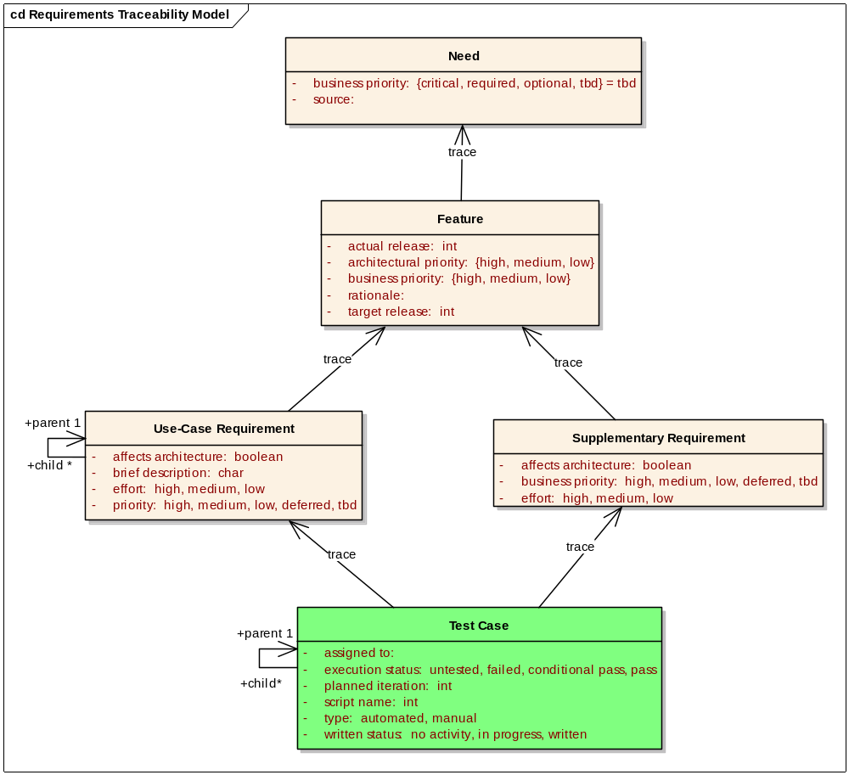
Figure 1 - Requirement Type Traceabilities

Criteria for Stakeholder Needs (NEED)
Stakeholder Needs (NEED) will be traced to Features (FEAT). Any NEED not traced to a FEAT will not be implemented.

Criteria for Features (FEAT)
Features (FEAT) will trace to Supplementary Requirements (SUPP) and/or Use-Case Requirements (UC).
A FEAT may trace directly to a UC. This allows the FEAT to be assigned to a UC before the use case sections have been written and enables impact analysis on the Use-Case Model at the Feature level and vice versa. A FEAT may trace to more than one UC in addition to the Supplementary Requirements in the Supplemental Specification [SS]. All Features that do not trace into the use case model must trace to at least one of the software requirements in the Supplementary Specification.
FEAT are distinct from Feature Requests. Once a request has been accepted as a Feature, it will follow the requirements management process detailed in this document.

Criteria for Use-Case Requirements (UC)
The top level Use-Case Requirement (UC) represents the use case in its entirety, whereas any child UC requirements represent requirements within the enclosing use case.
UCs will trace to the Test Cases (TC). This relationship allows us to see which requirements are to be tested and ensure coverage or to assess the impact of a failed test.

Criteria for Supplementary Requirements (SUPP)
Supplementary Requirements (SUPP) will trace to Test Cases (TC).
This relationship allows us to see which requirements are to be tested and ensure coverage or to assess the impact of a failed test.

Criteria for Test Cases (TC)
All Test Cases (TC) must trace from either a UC or a SUPP or a combination of the two, potentially tracing to multiple UCs or SUPPs when appropriate.

Attributes

Attributes for Need (NEED)
Requirement Text is the business Need description.

Business Priority
Used in managing scope and determining development priority.
Critical | Essential business needs that must be met by features of the system.
Required | Important business needs that should be met by features of the system.
Optional | Additional business needs that would be advantages to have incorporated into the system’s features, but are not crucial to a successful system.
TBD | Default To be determined. Represents a decision at a milestone. Business priority has not been set by the stakeholders.

Source
This text field describes how the need was first identified, which could be from a document, an external product or a stakeholder. The list will be generated from the stakeholder types detailed in the Vision document. If it is reference to a document, the need description should include a document name or a URL.

Attributes for Feature (FEAT)
Requirement Text is the feature description.

Business Priority
All requirements are not created equal. Ranking requirements by their relative benefit to the stakeholders opens a dialogue with customers, analysts, and members of the development team. Used in managing scope and determining development priority.

High | Essential features. Failure to implement means the system will not meet customer needs. All critical features must be implemented in the release or the schedule will slip.
Medium | Features important to the effectiveness and efficiency of the system for most applications. The functionality cannot be easily provided in some other way. Lack of inclusion of a required feature may affect customer or user satisfaction, or even revenue, but release will not be delayed due to lack of any required feature.
Low | Features that are useful in less typical applications will be used less frequently, or for which reasonably efficient workarounds can be achieved. No significant revenue or customer satisfaction impact can be expected if such an item is not included in a release.
Deferred | Future and nice to have features.
TBD | Default To be determined. Represents a decision at a milestone. Business priority has not been set by the stakeholders.

Rationale
This optional text field is used to track the source of the requested feature. Requirements exist for specific reasons. This field records an explanation or a reference to an explanation. For example, the reference might be to a page and line number of a product requirement specification, an important customer interview or an e.

Target Release
Records the intended product version in which the feature will first appear. This field can be used to allocate features from a Vision document into a particular baseline release. When scope management occurs, the Target Release Version Number can be increased so the item will remain in the Vision document but will be scheduled for a later release. Values: enumerates of pre-determined release names (e.g., 1.0, 2.0, 2.1, 3.0)

Actual Release
Records the product version in which the feature was first implemented, validated and verified. Values: enumerates of pre-determined release names (e.g., 1.0, 2.0, 2.1, 3.0)

Attributes for Supplementary Requirement (SUPP)
Requirement text describes what the system should do.

Affects Architecture
Set by the Software Architect, this indicates the requirement has an influence on the software architecture. Values: True or False.

Business Priority
All requirements are not created equal. Ranking requirements by their relative Priority to the stakeholder opens a dialogue with customers, analysts and members of the development team. Used in managing scope and determining development priority.

High | Essential features. Failure to implement means the system will not meet customer needs. All critical features must be implemented in the release or the schedule will slip.
Medium | Features important to the effectiveness and efficiency of the system for most applications. The functionality cannot be easily provided in some other way. Lack of inclusion of a required feature may affect customer or user satisfaction, or even revenue, but release will not be delayed due to lack of any required feature.
Low | Features that are useful in less typical applications will be used less frequently, or for which reasonably efficient workarounds can be achieved. No significant revenue or customer satisfaction impact can be expected if such an item is not included in a release.
Deferred | Future and nice to have features.
TBD | Default To be determined. Represents a decision at a milestone. Business priority has not been set by the stakeholders.

Effort
Effort is assigned values that determine the level of effort required to implement the requirement. The values for effort are:
High | Unknown complexities or haven’t done it before. Estimated to be greater than 2 person-weeks.
Medium | Average complexity. Have done it before or know how to approach it. Estimated to be around 1 to 2 person-weeks.
Low | A few hours to a few man-days. Solution is well known. Confidence is high in the estimates. No expected complexities.

Attributes for Use Case (UC)
Requirement text is the name of the use case.

Brief Description
A few sentences that describe what an actor would use the Use-Case for. It should reflect the role and purpose of the Use-Case and the value provided to the actor.

Affects Architecture
Set by the Software Architect, this indicates that the Use-Case flow of events touches a delicate point in the architecture or exercises a significant portion of the architecture. Values: True or False.

Planned Iteration
The iteration when this Use-Case is expected to be implemented. E.g. Release1 Iter2
Records the intended product version and iteration in which the feature will first appear. When combined with the status field, your team can propose, record and discuss various features of the release without committing them to development. Only features whose Status is set to Incorporated and whose Planned Iteration is defined will be implemented. When scope management occurs, the Planned Iteration Version Number can be increased so the item will remain but will be scheduled for a later release.

Priority
All requirements are not created equal. Ranking requirements by their relative Priority to the stakeholder opens a dialogue with customers, analysts and members of the development team. Used in managing scope and determining development priority.

High | Essential features. Failure to implement means the system will not meet customer needs. All critical features must be implemented in the release or the schedule will slip.
Medium | Features important to the effectiveness and efficiency of the system for most applications. The functionality cannot be easily provided in some other way. Lack of inclusion of a required feature may affect customer or user satisfaction, or even revenue, but release will not be delayed due to lack of any required feature.
Low | Features that are useful in less typical applications will be used less frequently, or for which reasonably efficient workarounds can be achieved. No significant revenue or customer satisfaction impact can be expected if such an item is not included in a release.
Deferred | Future and nice to have features.
TBD | Default To be determined. Represents a decision at a milestone. Business priority has not been set by the stakeholders.

Effort
Effort is assigned values that determine the level of effort required to implement the requirement. The values for effort are:

High | Unknown complexities or haven’t done it before. Estimated to be greater than 2 person-weeks.
Medium | Average complexity. Have done it before or know how to approach it. Estimated to be around 1 to 2 person-weeks.
Low | A few hours to a few man-days. Solution is well known. Confidence is high in the estimates. No expected complexities.

Requirement Attributes for Test Case (TC)
Requirement text is a list of steps to execute the Test Case. The steps must be unambiguous such that performance of a test case is repeatable and so that automated test scripts can be written reliably from the description.

Type
The type attribute indicates how the Test Case will be implemented as a Test Script.

Parent | This Test Case requirement is used to organized related, enclosed test cases
Automated | This Test Case has an associated automated test script.
Manual | This Test Case is performed manually according to the steps given in the requirement Text.

Assigned To
This is the test engineer responsible to write the Test Case. Ideally, this comes from an enumerated list of test engineers.

Planned Iteration
The iteration when the requirement will be implemented and tested. The test case must be written before or during this iteration.

Written Status
Set by the assigned test engineer. Tracks progress during test development.
No Activity | No work has been accomplished in implementation of the requirement.
In Progress | Test Case script, either manual or automated, that verifies the requirement is being written.
Written | Test Case has been written.

Execution Status
Set by the assigned test engineer. Tracks progress during test execution. For those test cases that are automated, the development team will use Cruise Control to show the results and at iteration completion points, update the associated G-Forge tracker.
Untested | Written Test Case has not been performed
Failed | Written Test Case Failed
Conditional Pass | Test has been completed with problems. Test assigned status of Pass upon the condition that certain actions are completed.
Pass | Test has been successfully completed

Test Script Name
This is the class name of the test script (package name is unnecessary as it is based on convention) if automated.

Reports and Measures

Traceability Matrix
Due to the current G-Forge implementation, there is no ability to create or automate this report. Currently, there is no ability to select one (much less multiple) items from one tracker to another. However, distinct “lists” will be created for Features (needs), for Use Cases and Supplemental Requirements (features and needs) and Test Cases (Use Cases and Supplemental Requirements) to allow for the selection of the primary parent element that impacts the requirement stated. The traceability matrix will be accumulated from downloads of existing trackers and represented as a spreadsheet.

Project Baselines
Baselines are created as specified in the Configuration Management Plan, including all requirements artifacts.

Workflows and Activities
5AM employs the standard RUP workflows and activities for requirements management with any exceptions noted in the [DEV_CASE].

Milestones
The sole notable milestones in the requirements process for caArray are the delivery of the requirements set to the program authority and the subsequent approval of the requirements set. This is expected to be complete in Elaboration Iteration 1.

Training and Resources
No special formal training is required for internal or external users to use G-Forge, however, the tool doesn’t contain all the desired support for traceability and it’s user interface does take some effort to get used to. The NCICB’s system team will be the source of training and customizations when and if needed.

