Iteration Plan
caArray 2.0 - Construction 1

Last Revised: | August 30, 2007
Produced By: | caArray Development Team
Version: | 0.1

Document Approvals
The list contains the name and contact information for the core project team and any key stakeholders who have an interest in the success of the project. An “S” identifies persons responsible for approval from the Business and Development. Sign off of the document would be required when a decision is made not to take action for defined gaps.

S | Name | Role | S | Name | Role
S | Anand Basu | NCICB Engineering Manager | S | Juli Klemm, Ph.D. | Product Manager
 | Brent Gendleman | Development Project Manager |  | Jerry Eads | NCICB Project Manager
 | Eric Tavela | Development Architect |  | Ron Keene | NCICB Independent QA
 | Don Swan | NCICB Application Support
Revision History
When you make a change to a document, you must add an entry to this Revision History table and you must manually type the Last Revised Date on the front cover.

Date | Version | Description | Revised by
8/30/07 | 0.1 | Initial Draft | Brent Gendleman
Copyrights and Trademarks
© Copyright 2007 by NCICB, caBIGTM. All rights reserved.

Table of Contents
1. Introduction 4
1.1. References 4
2. Plan 4
2.1. Iteration Activities 4
2.2. Iteration Schedule 5
3. Resources 7
4. Use Cases 7
4.1. Specifications to be detailed 7
4.2. Analysis to be performed 9
4.3. Architectural Prototype to be delivered 10
5. Evaluation Criteria 10
5.1. Project Management 11
5.2. Requirements 11
5.3. Analysis and Design 11
5.4. Implementation 11
5.5. Test 12
5.6. Deployment 12
5.7. Environment 12
5.8. Configuration and Change Management 12

Introduction
This Iteration Plan describes the detailed plans for the C1 Iteration of caArray 2.0. The Iteration duration will be from September 7 to October5. In addition, while E2 can claim many successes, we were unexpectedly short staffed and had misestimated the level of effort to establish the Grid API. Therefore, there was unfinished business that is to be delivered in the first two weeks of this iteration.

References
- project_management/caarray_schedule.mpp
- requirements/caarray_vision.doc
- requirements/caarray_use_case _summary.doc
- analysis_and_design/caarray_software_architecture_document.doc

Plan

Iteration Activities
The following activities, according to discipline, are planned for this iteration. The requirements and the analysis and design activities remain the focus; a significant portion of the effort will be establishing the physical architecture and proving several threads through it.
Activities | Start | End
Project Management
Requirements
Analysis and Design
Implementation
Test
Environment
Configuration and Change Management

Iteration Schedule
As the iteration evolves over time, updates will be made to the Microsoft Project schedule on at least a weekly basis with 1 hour reviews scheduled each Wednesday. However, in order to support evaluating how we execute against the plan, the schedule is produced below.
Construction - Iteration 1 | 29.7d | Fri 7/27/07 | Thu 9/6/07

Resources
The development team will be at partial strength with 7 individuals. They are:
Team Member | Role | Percentage on Project
Brent Gendleman | Project Manager/Requirements Analyst | 50%
Eric Tavela | Architect | 60%
Bill Mason | Developer/PM Support | 100%
Todd Parnell | Developer | 100%
Dan Kokotov | Developer | 20%
John Hedden | Developer | 100%
Matt Rehfuss | UI Designer | 80%
Rashmi Srinivasa | Developer | 0%

There are several vacations and other absences described below:
Dan Kokotov – out from September 15-October 8
Eric Tavela – out from September 1 – September 17 (MGED Conference + Vacation)
Rashmi Srinivasa – on maternity leave from August 13- October 13
In addition, Brent Gendleman will be onsite at the NCICB from between September 5 – 13, the 17-21, and October 2- 12.
We are considering options to fill potential gaps to ensure proper delivery by November – including moving or adding personnel.

Use Cases

Specifications to be detailed
Figure 1 represents all the use cases to be detailed by the close of Elaboration as defined in E1. However, recent changes have forced us to reconsider. Figure 2 demonstrates a slightly revised scale down of scope.
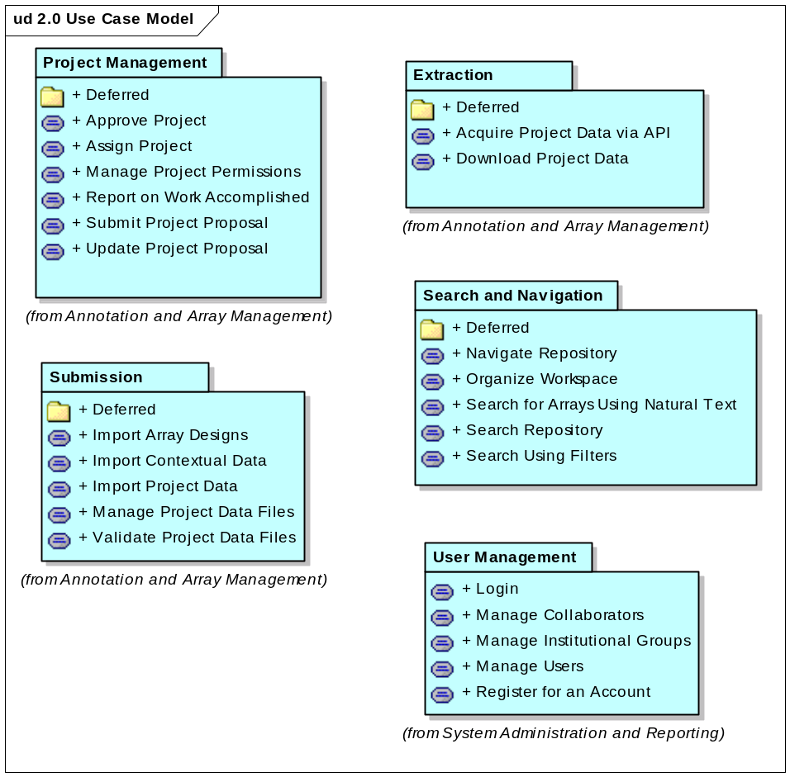
Figure 1. 2.0 Use Case Model from E1
For this iteration, we will prioritize the detailing of the following use cases:
  - UC Manage Project Permissions
  - UC Download Project Data
  - UC Manage Users
These should be done first to support analysis and design activities occurring during E2. The remainder will be tackled later in the iteration.
  - UC Navigate Repository
  - UC Search Repository
  - UC Search Using Filters
The entirety will be visualized through wireframes and html mockups culminating in a style sheet to be incorporated in C1 – with expected modifications from all stakeholders.

Analysis to be performed
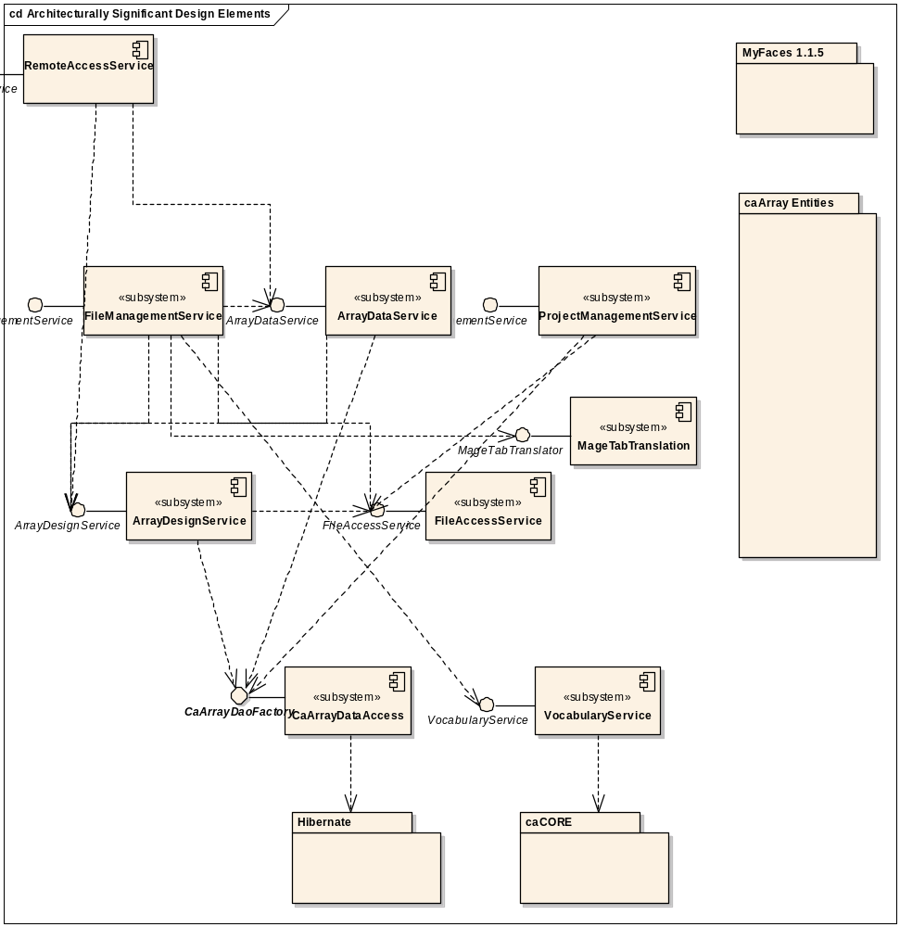
Figure 2. Architecturally Significant Design Elements

Architectural Prototype to be delivered
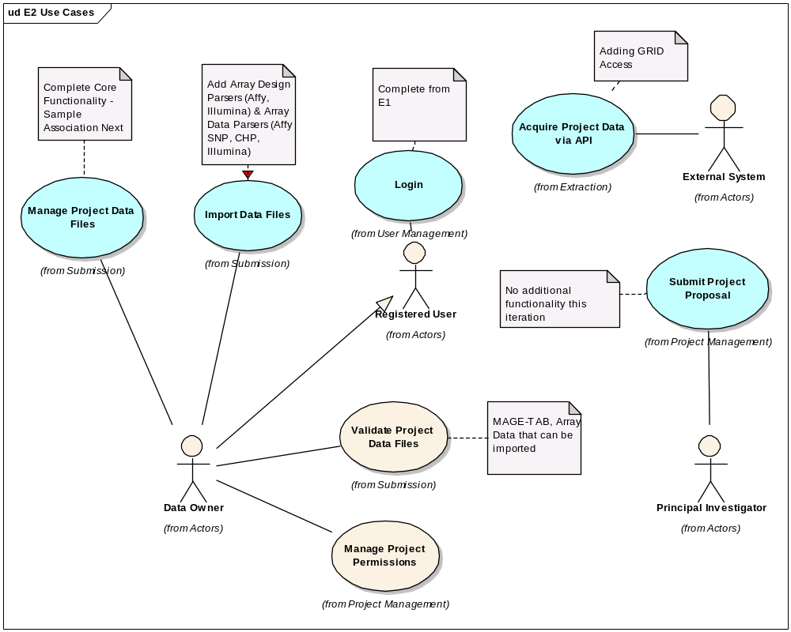
Figure 3 Use Cases for E2 Prototype
The use cases in Blue are ones initiated in E1 and the ones in white are being introduced in E2.

Evaluation Criteria
The primary goal of the E2 Iteration is to complete the analysis and design of selected use cases and to develop a working architectural prototype that eliminates significant risk. The risks to mitigated are:
- Finalizing the scope for the 2.0 release
- Upload, validation, parsing and storage of Affymetrix and Illumina data
- Grid accessibility to data
- Domain Object Model for caArray
- User Interface Design for significant use cases and supplementary requirements
- Ability to automate the deployment from DEV to QA
- Tech Stack Compatibility with Bundled Tools for the December Release
The more granular goals will be highlighted per discipline.

Project Management
The project schedule is updated in concert with the development team and reported to the external teams on a weekly basis.
The remainder of the E2 iteration is tightly planned and reported on, the C1 iteration is planned and available for the iteration review meeting, and the 2.0 Generation Plan is reviewed by all relevant teams and their input validated with the Product, Quality Assurance, Systems and Engineering Manager.
Each deliverable developed during the E2 Iteration will be peer reviewed and subject to approval from the team.
We complete the activities on time. We will end the iteration regardless based on the calendar but if we do not achieve all the tasks, it will be duly noted in the iteration review.

Requirements
All the targeted use cases for E2 plus all additional use cases that impact the architecture and/or user interface are written to ensure that the team has the appropriate time for additional analysis and design activities and the full set of use cases are available for C1 and all 2.0 use cases are available early in C1.
UC based wire frames, mockups and a representative style sheet for the use cases to be completed in C1 are available.
Begin interaction with User Documentation Team.

Analysis and Design
All targeted use cases modeled as use-case realizations in the caArray UML model.
Domain Object/Logical Model is peer-reviewed and updated to support caDSR submission and Silver Compliance at a minimum.

Implementation
Implement all identified Subsystems
Implemental use cases Login, Manage Project Permissions,
Establish GRID access through the API
Implement hybridization data file parsing and storage for Affymetrix and Illumina files (both SNP and gene expression).
Implement array design storage sufficiently to support import of Affymetrix hybridization data (SNP and gene expression).
Implement Validation for targeted formats (MAGE-TAB, Affy, Illumina)
Implement remote API for retrieval of hybridization data.

Test
Continue dialogue with Independent Quality Assurance (IQA) to establish policy and procedures for delivering tags and what they will contain depending on the iteration cycle.
Craft a test plan to incorporate all of our deliverables in concordant fashion with QA and external teams
Deploy two tags to QA – an initial handoff and an end of milestone release
Write automated tests for all implemented use case threads.

Deployment
Present a pilot for the automation of builds from DEV to QA and a plan to move forward and accommodate adjustments from respective teams

Environment
Work to establish DEV and QA Environments with Systems and QA
Manage and integrate all code and tests through Cruise Control.

Configuration and Change Management
Evaluate Requirement Priorities and manage GForge, models and documents to reflect decisions.

