Iteration Plan
caArray 2.0 - Transition 2

Last Revised: | January 7, 2008
Produced By: | caArray Development Team
Version: | 0.2

Document Approvals
The list contains the name and contact information for the core project team and any key stakeholders who have an interest in the success of the project. An “S” identifies persons responsible for approval from the Business and Development. Sign off of the document would be required when a decision is made not to take action for defined gaps.

S | Name | Role | S | Name | Role
S | Anand Basu | NCICB Engineering Manager | S | Juli Klemm, Ph.D. | Product Manager
 | Brent Gendleman | Development Project Manager | S | George Komatsoulis, Ph.D. | CBIIT IQA Manager
 | Todd Parnell | Development Architect |  | Tom Boal | NCICB Independent QA Lead
 | Don Swan | NCICB Application Support Lead
Revision History
When you make a change to a document, you must add an entry to this Revision History table and you must manually type the Last Revised Date on the front cover.

Date | Version | Description | Revised by
12/31/07 | 0.1 | Initial Draft | Brent Gendleman
1/7/08 | 0.2 | Updated with schedule | Brent Gendleman/Maki Ducan
Copyrights and Trademarks
© Copyright 2007-08 by CBIIT, caBIGTM. All rights reserved.

Table of Contents
1. Introduction 4
1.1. References 4
2. Plan 4
2.1. Tasks for General Availability Release 4
2.2. Iteration Schedule 6
3. Resources 8
4. Use Cases 8
4.1. Specifications to be detailed 8
4.2. Analysis to be performed 9
4.3. Implementation to be Performed 9
4.4. Test 10
4.5. Environment 11
5. Evaluation Criteria 11

Introduction
This Iteration Plan describes the detailed plans for the second Transition Iteration of caArray 2.0 (T2). The Iteration duration will be from December 21, 2007 to January 25, 2008. The results of the T1 Iteration were positive but incomplete. With the narrowed focus of the 2.0 Release, we were able to place a beta version of caArray 2.0 into Production on December 20, 2007.
However, some of the features are not stable enough for GA delivery, significant work remains in terms of testing, documentation and installation. In addition, how caArray 2.0 will fit into the Life Sciences Distribution (LSD) has been finalized but additional work may need to occur (particularly in terms of installation) as the Bundle’s environment is stabilized in the first full week of January. The development team’s focus will be around fixing high priority defects, writing and finalizing documentation (user, technical, installation), shepherding the model through the registration processing, improving and testing performance, coordinating with all internal teams and handling the interaction with external adopters.

References
project_management/caarray_schedule.mpp
requirements/caarray_vision.doc
requirements/caarray_scope_2_0.doc
requirements/caarray_use_case _summary.doc
analysis_and_design/caarray_software_architecture_document.doc
test/performance_test_plan.doc
caarray gforge: https://gforge.nci.nih.gov/projects/caarray2/ (specifically the trackers for defects and community change requests)

Plan

Tasks for General Availability Release
January 25th is the target for the General Availability (GA) Release. The Software is feature complete according to the 2.0 Scope but significant work remains. The goal is to deliver the final code and documentation by January 18th, so that the last week can be focused on ensuring that documentation and integration with caBIG content can be executed and attention to installation can be performed. The high level tasks are shown in table 1 below:
Table 1. High Level Tasks
Use Case or Component | State | Assigned Team Member
Domain Model | Submitted – awaiting caDSR bug fixes (assemble Compatibility Review Submission Package) – won’t be discoverable on the grid (Index) | Eric Tavela, Maki Duncan
Online Help/Requirements Documentation | Draft – commentary required from Dev Team | Brent Gendleman
Technical Guide/SAD | Draft | Todd Parnell, Eric Tavela, Brent Gendleman – others as needed
Installation and Installer | Windows Available/Linux to be completed along with documentation | Paul Duvall, Levent Gurses, Brent Gendleman, Maki Duncan
Migrate 1.x Data | Initial experiments converted to MAGE-TAB | Steve Matyas
Acquire Experiment Data Via API UC | Update according to Data Model Changes | Eric Tavela, Todd Parnell, Scott Miller, Dan Kokotov
Acquire Experiment Data Via API UC | Java and Grid Validation for Performance and Function | Rashmi Srinivasa (java), Bill Mason (Grid)
Acquire Experiment Data Via API UC | Map JNDI Ports | Systems with support from Eric, Bill
Login UC | Complete | Defects/Enhancements to be assigned to Winston Cheng
Register UC | Complete – coordination with Systems still needed | Defects/Enhancements to be assigned to Todd Parnell
Manage Experiment Data Files UC | Complete - Upload, Delete, Change File Type Complete | Defects/Enhancements to be assigned to Scott Miller
Validate Experiment Data Files UC | Complete – MAGE-TAB, Gene Expression and SNP, Affymetrix, Illumina, GenePix | Defects/Enhancements to be assigned to Eric Tavela
Import Experiment Data Files UC | Complete – choice of automated chaining only | Defects/Enhancements to be assigned to Dan Kokotov
Submit Experiment Proposal UC | Complete –tabs functional with validation, MAGE-TAB annotation displayed, conditional logic for display of appropriate array designs, controlled vocab integrated, visibility extended to users with lab roles from same organization as submitter, create id on submit | Defects/Enhancements to be assigned to Dan Kokotov
Update Experiment Proposal UC | Complete – MAGE-TAB annotation that is non-editable available, editing of chain relationships available | Defects/Enhancements to be assigned to Dan Kokotov
Manage Publications UC | Complete – validation, editing of Publications (independent of state) | Defects/Enhancements to be assigned to Dan Kokotov
Manage Vocabulary UC | Complete | Defects/Enhancements to be assigned to Dan Kokotov
Manage Permissions UC | Complete | Defects/Enhancements to be assigned to Dan Kokotov
Manage Collaborators UC | Complete | Defects/Enhancements to be assigned to Todd Parnell
Download Experiment Data UC | Complete | Defects/Enhancements to be assigned to Todd Parnell
Import Array Designs UC | Complete – Gene Pix to be added, messaging and state updates done | Winston Cheng/Eric Tavela
Navigate Repository UC | Partial– Browse Experiments, Counts, Location Displayed | Winston Cheng
Search Repository UC | Complete – Search Elements, Tabular Display (proved, not complete), Search on Home Page and All Pages in Upper Right | Winston Cheng

Iteration Schedule
As the iteration evolves, updates will be made to the Microsoft Project schedule twice a week (Monday and Thursday) and the notes of the meeting will be distributed to the Product and Engineering Manager. We will also have 1 hour reviews scheduled each Wednesday with the Product and Engineering Manager and weekly Status Meetings across the entire team each Monday. While the schedule will be updated, it’s represented here at the start of T2 to support evaluating how we execute against the plan.
Transition Iteration 2 | Duration | Start Date | End Date
Project Management | 26d | Fri 12/21/07 | Fri 1/25/08
Weekly Status Meetings | 26d | Fri 12/21/07 | Fri 1/25/08
Dev Team Iteration Plan | 1d | Fri 12/21/07 | Fri 12/21/07
Prepare GA Release Plan | 2d | Fri 12/21/07 | Mon 12/24/07
Organize Feedback from Beta Testers | 1d | Fri 12/21/07 | Fri 12/21/07
T2 Review | 1d | Mon 1/14/08 | Mon 1/14/08
Finalize Deliverables | 15d | Mon 12/31/07 | Fri 1/18/08
Deliver T2 Plan | 3d | Mon 12/31/07 | Wed 1/2/08
Prepare GA Release Plan | 1d | Fri 1/18/08 | Fri 1/18/08
December Status Report | 1d | Mon 12/31/07 | Mon 12/31/07
Finalize T2 Iteration Plan | 2d | Mon 12/31/07 | Tue 1/1/08
Update Risk List | 1d | Mon 12/31/07 | Mon 12/31/07
Requirements | 24d | Fri 12/21/07 | Wed 1/23/08
Support User Guide, Online Help | 24d | Fri 12/21/07 | Wed 1/23/08
Update Use Cases | 15d | Fri 12/21/07 | Thu 1/10/08
Update Vision and Use Case Summary (and Model) | 1d | Thu 1/10/08 | Thu 1/10/08
Analysis and Design | 24d | Fri 12/21/07 | Wed 1/23/08
Update Model Annotation for caDSR Preparation | 3d | Mon 1/7/08 | Wed 1/9/08
Register Model to caDSR Sandbox | 5d | Thu 1/10/08 | Wed 1/16/08
Register Model to caDSR Production | 5d | Thu 1/17/08 | Wed 1/23/08
Finalize SAD | 24d | Fri 12/21/07 | Wed 1/23/08
Implementation | 21d | Fri 12/21/07 | Fri 1/18/08
Incremental Bug Fixes - Beta 7 | 15d | Fri 12/21/07 | Thu 1/10/08
UI and API Performance | 15d | Fri 12/21/07 | Thu 1/10/08
Grid Fixes | 15d | Fri 12/21/07 | Thu 1/10/08
"Data Model Changes (Protocols, CSM, Array Design)" | 15d | Fri 12/21/07 | Thu 1/10/08
Edit Array Designs | 5d | Fri 1/4/08 | Thu 1/10/08
MAGE-TAB Parser/Representation | 15d | Fri 12/21/07 | Thu 1/10/08
Complete Targeted Defects for Beta 7 | 15d | Fri 12/21/07 | Thu 1/10/08
Continue Export of 1.x Data/Import into 2.0 | 8d | Mon 12/31/07 | Thu 1/10/08
Incremental Bug Fixes - GA Release | 6d | Fri 1/11/08 | Fri 1/18/08
Complete Targeted Defects for GA Release | 6d | Fri 1/11/08 | Fri 1/18/08
Environment | 5.2d | Fri 1/11/08 | Fri 1/18/08
Beta 7 | 1d | Fri 1/11/08 | Fri 1/11/08
Release Beta 7 Build to QA, Stage | 0.2d | Fri 1/11/08 | Fri 1/11/08
Release Beta 7 Build to Production | 0.2d | Fri 1/11/08 | Fri 1/11/08
Release Beta 7 to LSD | 0.2d | Fri 1/11/08 | Fri 1/11/08
Beta8/RC | 0.2d | Fri 1/18/08 | Fri 1/18/08
Release Beta 8 Build to QA, Stage | 0.2d | Fri 1/18/08 | Fri 1/18/08
Release Beta 8 Build to Production | 0.2d | Fri 1/18/08 | Fri 1/18/08
Release Beta 8 to LSD | 0.2d | Fri 1/18/08 | Fri 1/18/08
Update Build and Deploy Plan with SCM Initiative | 1d | Fri 1/11/08 | Fri 1/11/08
Configuration and Change Management | 25d | Fri 12/21/07 | Thu 1/24/08
Manage Gforge Content | 25d | Fri 12/21/07 | Thu 1/24/08
Prioritize 2.0 Defects and UC for 2.x | 1d | Thu 1/10/08 | Thu 1/10/08
Documentation | 19d | Mon 12/31/07 | Thu 1/24/08
Complete Technical Guide | 1d | Thu 1/24/08 | Thu 1/24/08
Complete User Guide | 10d | Mon 12/31/07 | Fri 1/11/08
Complete Online Help | 3d | Tue 1/8/08 | Thu 1/10/08
Complete the Draft Installation Guide | 10d | Mon 12/31/07 | Fri 1/11/08
Complete Installation Guide | 1d | Fri 1/18/08 | Fri 1/18/08
Manage Zope Site | 17d | Mon 12/31/07 | Tue 1/22/08
Update Zope Site on Dev | 7d | Mon 12/31/07 | Tue 1/8/08
Review Update on Dev | 2d | Wed 1/9/08 | Thu 1/10/08
Update with Feedback on Dev | 2d | Fri 1/11/08 | Mon 1/14/08
Update Zope Site on Stage | 3d | Tue 1/15/08 | Thu 1/17/08
Update Zope Site on Prod | 3d | Fri 1/18/08 | Tue 1/22/08
Manage Download Center | 13d | Mon 12/31/07 | Wed 1/16/08
Update Download Center on Dev | 4d | Mon 12/31/07 | Thu 1/3/08
Review Update on Dev | 1d | Thu 1/3/08 | Thu 1/3/08
Update with Feedback on Dev | 3d | Fri 1/4/08 | Tue 1/8/08
Update Download Center on Stage | 3d | Wed 1/9/08 | Fri 1/11/08
Update Download Center on Prod | 3d | Mon 1/14/08 | Wed 1/16/08
Manage Product Landing Site | 13d | Mon 1/7/08 | Wed 1/23/08
Update Product Landing Site on Dev | 2d | Mon 1/7/08 | Tue 1/8/08
Update Search Result Page on Dev | 3d | Mon 1/7/08 | Wed 1/9/08
Review Update on Dev | 1d | Thu 1/10/08 | Thu 1/10/08
Update Product Landing Site on Stage | 2d | Mon 1/14/08 | Tue 1/15/08
Update Product Landing Site on Prod | 2d | Tue 1/22/08 | Wed 1/23/08
T2 Complete | 0d | Fri 1/25/08 | Fri 1/25/08

Resources
The development team is at full strength planned (7.25 FTEs) but those resources have been shifted to support overall caArray needs. Specifically, the team will continue to support Independent Quality Assurance (IQA) by keeping Bill Mason and Rashmi Srinivasa as dedicated to QA. The team is expected to remain at this level through the entire Iteration. They are:
Team Member | Role | Percentage on Project
Brent Gendleman/Maki Duncan | Project Manager/Requirements Analyst | 50%
Todd Parnell | Developer/Tech Lead | 100%
Bill Mason | QA – UI, Dev-Build Master | 100%
Rashmi Srinivasa | QA – Performance | 100%
Eric Tavela | Developer/Design Lead | 100%
Dan Kokotov | Developer | 100%
Scott Miller | Developer | 100%
Winston Cheng | Developer | 100%
Steve Matyas | Developer – 1.x Migration | 25%
Matt Rehfuss | UI Designer | 10%

Holidays, Vacations and other absences described below:
Christmas: December 24-25
New Years Day: January 1st
Martin Luther King Day: January 21
Much of the team will be off between December 26-December 31st. In addition, Brent Gendleman will be onsite at the NCICB from between January 9th - 25th.

Use Cases
The Vision, Scope and Use Case Summary all need to be updated to incorporate changes made during Transition 1. More specific use case related tasks and details are identified in the following sections.

Specifications to be detailed
The Manage Vocabulary and Manage Protocols were newly introduced Use Cases in the previous Transition Iteration. Other use cases need to be revised to ensure coordination with changes made, validation testing and should be done by January 3rd.
For this iteration, all the use cases to be available (at least partial flows) have been written and reviewed. Alterations will be for clarity only. This is particularly important for the refinement of the User Guide and Online Help.
These use cases need to be updated:
  - Import Experiment Data
  - Validate Experiment Data
  - Manage Experiment Data
  - Download Experiment Data
  - Manage Vocabulary
  - Manage Protocols

Analysis to be performed
The Software Architecture Document, particularly the updating of the diagrams and to a lesser extent the supporting prose needs to be complete prior to January 11th.
The specific tasks are:
  - Summary of use cases: Use cases have changed - redo the summary. (Brent)
  - 5.2.1 (UI Layer): Should talk about hibernate validator, ajax libraries, and 508 compliance. Most of the work we've done to the UI over the past couple iterations has not been captured, and some of the work is significant. (Todd)
  - 5.2.2 & 5.2.3 (Remote Service): Add discussion on how we 'cut' the object graph for remote clients. (Todd)
  - 5.2.4 (Domain Model): Should make certain all the latest domain changes are captured here. (Eric)
  - Security: Add section devoted to how we implement security via CSM 4.0; particularly our mixed model. (Todd/Dan)
  - 5.2.13 (Vocab): Need to revise this section in light of the many vocabulary discussions, decisions and implementation that have taken place. (Scott)
  - 5.3 (Database): Remove MySQL 4.1, be specific about 5.0.27 and potential future addition of Postgres. (Todd)
  - 6.1 (deployment): Should talk about the datasource and mail sending dependencies for registration. (TCP) Paul and/or Levent should review this section, since they have been clients to this work.
  - All diagrams: Need to sync up EA with the methods and relationships that exist in the non-domain classes. For instance, I noticed ArrayDesignService has more methods than are documented in EA. (Todd with assistance from Eric)

Implementation to be Performed
All Implementation will be related to fixing defects that are either priority 5 or 4 that relate to the use cases or supplemental specifications. The 2.0 Use Cases are below
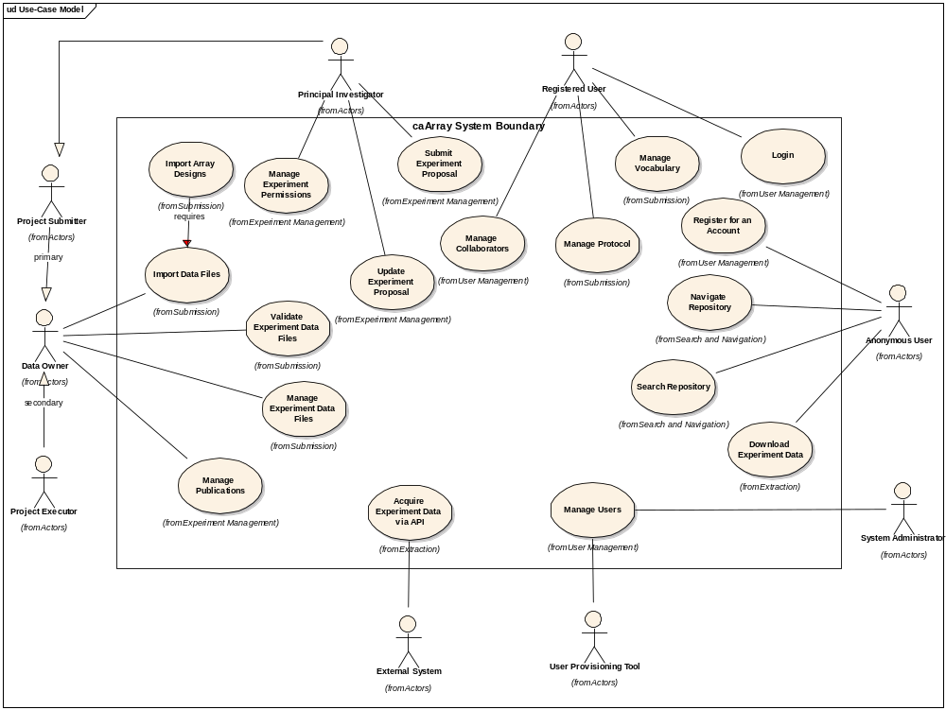
Figure 1 Use Case Diagram for 2.0

Test
This iteration is significant not only in terms of the functionality to be tested (and fixed in time for the 25th) but also Bill and Rashmi will be working in concert with the development team to support the overall testing across environments. The Testing will be split into Performance testing and User Interface Testing with a heavy weight on the API, Functional and Integration tests. Unit Tests are still the responsibility of each developer and the code coverage is expected to be:
Line: 80%
Branch: 70%
This is an incremental increase from the T1 release (70%/60%).
The Performance Benchmarks have been established (and available in the Supplemental Requirements Document) and all test data (except for what’s required for unit tests) will be stored in:
ftp://caftpd.nci.nih.gov/pub/caarray_test/
Affymetrix and MAGE-TAB files are currently there, Illumina and Gene Pix data will need to be moved to that location. It is a public with anonymous access.
All UI and Performance Test Cases (and their state) should be entered into the GForge Tracker: Test Cases: https://gforge.nci.nih.gov/tracker/?atid=1343&group_id=305&func=browse
All Defects from the BETA6 Release should be added to the Defect Tracker:
https://gforge.nci.nih.gov/tracker/?atid=1344&group_id=305&func=browse
Anyone may enter a defect, the Project Manager will assign them and if necessary, elevate the defect for resolution to the Product Manager. Entered defects will garner immediate attention but done in priority order.

Environment
The most significant hurdle is the Installation across Windows and Linux Environments and support of the LSD Bundle Environment
We have established a distinct nightly build on the Development Environment and the Development Integration Machine. However, the movement toward integrating all of our tests into automated build is on hold, but highly desirable (unit, selenium and JMeter).
A finalized version of the installer for caArray 2 is to be delivered by the close of this iteration (GUI and command line).

Evaluation Criteria
The primary goal of the T2 Iteration is deliver the complete set of assets for a GA release. There remains a high dependency on the other teams (IQA, Systems, SCM, LSD Bundle) to make this effective but the focus for development is to make the functionality as clean as possible and all documentation assets available.
The major results we need to achieve by the end of the iteration are:
  - Release stable enough for external adoption by external community members by January 25, 2008.
  - Ensure the LSD Distribution is not impacted by caArray.
  - Have the EA Model Registered and Available by the 25th to support Grid Registration
  - Continue collaboration with Documentation team to complete the User Guide, Installation Guide, Technical Guide and Help Files
  - Complete the caArray 2.0 Installer
  - Complete targeted experiment migration from caArray 1.6 to 2.0

