Manage Data Files Use Case Specification
caArray
Last Revised: | June 30, 2007
Produced By: | NCICB Development
Version: | 0.4

Document Approvals
The list contains the name and contact information for the core project team and any key stakeholders who have an interest in the success of the project. An “S” identifies persons responsible for approval from the stakeholder groups. Sign off of the document would be required when a decision is made not to take action for defined gaps.

S | Name | Role | S | Name | Role
S | Anand Basu | NCICB Engineering Manager | S | Juli Klemm, Ph.D. | Product Manager
 | Brent Gendleman | Development Project Manager |  | Jerry Eads | NCICB Project Manager
 | Eric Tavela | Development Architect |  | Ron Keene | NCICB Independent QA
 | Don Swan | NCICB Application Support
Revision History
When you make a change to a document, you must add an entry to this Revision History table and you must manually type the Last Revised Date on the front cover.

Date | Version | Description | Revised by
6/18/07 | 0.1 | Initial Draft – Basic Flow | Brent Gendleman
6/22/07 | 0.2 | Split original use case up into Manage Project Data, Validate Files and Import Project Data. Fleshed out details of each sub-component. | Rashmi Srinivasa
6/26/07 | 0.3 | Updated to reflect use case analysis of all 3 uses cases mentioned above and include “upload” as part of the basic flow | Brent Gendleman
6/30/07 | 0.4 | Changed file name to be consistent with use case analysis | Brent Gendleman
Copyrights and Trademarks
© Copyright 2007 by NCICB, caBIGTM. All rights reserved.

Table of Contents
1. Brief Description 1
1.1. References 1
1.2. Unaddressed Issues 1
1.2.1. Foreground vs. Background Uploading 1
1.2.2. Resuming Cancelled or Interrupted Uploads 2
1.2.3. Uploading Compressed Files 2
1.2.4. Keeping Directory Structures 2
2. Preconditions 2
2.1. Data Owner 2
2.2. An Available Project Exists in a Saved State 2
2.3. The Project Service and Array Types are Known 2
3. Basic Flow of Events 2
4. Alternative Flows 3
4.1. In Progress Cancellation 3
4.2. Delete Files 3
4.3. Cancel 4
5. Exception Flows 4
5.1. Connection to Server is Lost 4
5.2. Data Owner Closes Browser 4
6. Post-conditions 4
6.1. Uploaded Data Files are Saved 4
7. Special Requirements 4
7.1. Progress Meter 4
7.2. Importable Data 4
8. User Interface Wireframes 5
8.1. The Manage Project Data UI 5

Brief Description
Initiated by a Data Owner, this use case enables the uploading of annotation and array content collectively and independently into a caArray project and then provides the ability to validate, import and/or delete the uploaded files and records each action taken. Due to the large file size of array data and to a lesser extent – the annotation, the upload may take minutes or even hours to complete; so the ability to offer to run the upload in the background (allowing the user to perform other functions inside caArray) is desirable.
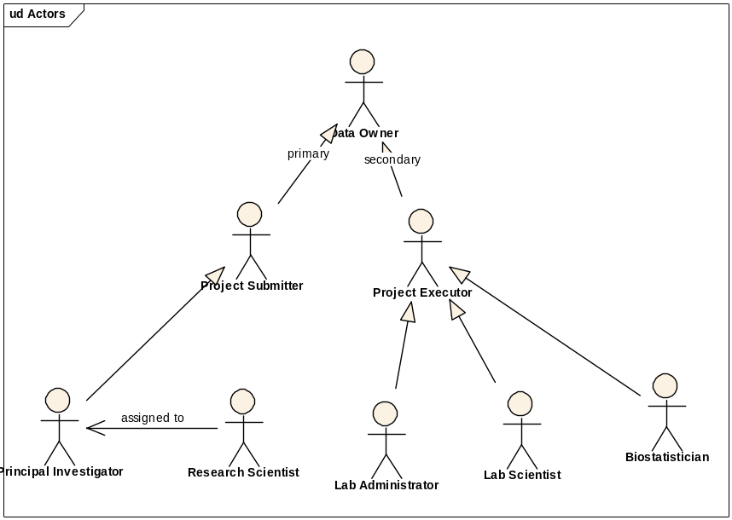
Figure 1. Data Owner Actor Depiction

References
caArray Vision – functional requirements
caArray Supplementary Specifications – non-functional requirements
caArray Use Case Summary – actor definitions and context

Unaddressed Issues

Foreground vs. Background Uploading
Need to determine if running the job in the foreground or background is important or if another approach to allow the user to navigate elsewhere while uploads are occurring could be performed.

Resuming Cancelled or Interrupted Uploads
Is there an expectation of being able to resume the loading of a file that was part of a job that was cancelled?

Uploading Compressed Files
Not all compression types (.zip, .gzip, .tar, etc.) have java libraries. Should we allow zipped files and if so which ones?

Keeping Directory Structures
Is it required to keep the structure if we do allow for zipped files to be uploaded

Preconditions

Data Owner
A Data Owner must be logged in before he/she can manage project data. A Data Owner is a project submitter from the Principal Investigator’s core facility (typically a Research Scientist), or a project executor from the research lab (a Lab Scientist or Biostatistician).

An Available Project Exists in a Saved State
At least one project owned by the contributor is available to have data uploaded, validated and imported into it. If no projects exist, the feature will be unavailable to the user.

The Project Service and Array Types are Known
The service type (complete, partial, or analysis) and the type of array (e.g., gene expression vs. SNP) are known so that the system knows what type of data it is about to receive.

Basic Flow of Events

Data Owner navigates to and selects the project of interest from their project workspace in the System that contains no uploaded data.

The System opens the project and indicates the ability to upload data to the project.

The Data Owner chooses to upload data files.

The System presents a dialogue that allows for multiple files to be selected from a local or networked location without restriction on the size or type (file extension independent) of files in addition to the ability to run the job in the foreground or background.

The Data Owner selects the file or set of files of interest and chooses to upload in the foreground.

The System indicates the progress of each file as they are uploaded (see Special Requirements: Progress Meter) and the ability to cancel the upload at any point (see Alternate Flow: In Progress Cancellation).

The System indicates to the Data Owner when all files have made it and displays the list of files, their status (Uploading, Uploaded, Validating, Validated, Importing and Imported), the ability to select or deselect any one or all of the files and these actions:

Return to Project

Upload Files – which returns the Data Owner to Step 4

Delete Files – see Alternate Flow: Delete Files

Validate – see Validate Data Files Use Case

Import – see Import Data Files Use Case

The Data Owner selects to “Return to Project” that now displays the number of files uploaded.

Alternative Flows

In Progress Cancellation

From Step 6 in the Basic Flow, the Data Owner chooses to cancel the upload job.

The System halts the uploading of the file or set of files and presents the Data Owner the list of files that were uploaded (possibly those that didn’t make it either), returning the Data Owner to Step 7 in the Basic Flow.

Delete Files

From Step 7c in the Basic Flow, the Data Owner chooses the file or files to be deleted and selects “delete.”

The System asks the Data Owner for deletion confirmation or cancellation (see Alternate Flow: Cancel).

The Data Owner confirms the deletion.

The System physically deletes the selected file or files and returns the Data Owner to Step 7 in the Basic Flow without displaying the deleted files.

Cancel
To be written

Exception Flows

Connection to Server is Lost
See Alt Flow In Progress Cancellation

Data Owner Closes Browser
See Alt Flow In Progress Cancellation

Post-conditions

Uploaded Data Files are Saved
After a successful execution of this use case, any completely uploaded files are persisted in caArray with a status of “Uploaded”, and are available for validation and import. Any deleted files are completely removed from caArray.

Special Requirements

Progress Meter
At a minimum, the ability to see the total number of files selected for upload and how many have made it numerically will be available – e.g., 1 of 4, 2 of 4, 3 of 4, 4 of 4. Additional graphical elements (progress bars) or menus

Importable Data
Currently, the only type of data supported is MAGE-TAB. All four categories of MAGE-TAB files will be supported - IDF (Investigation Description Format), ADF (Array Design Format), SDRF (Sample and Data Relationship Format) and raw/processed data files (e.g., Affymetrix .cel and .chp files).

If in the context of sample(s), Data Owner can import MAGE-TAB SDRF file(s) or raw data file(s) corresponding to those sample(s).

If in the context of a project, Data Owner can import any combination of the four categories of MAGE-TAB files – IDF, ADF, SDRF and raw/processed data files.

If Data Owner is importing from a default location, he/she can select a project from the list of projects he/she owns, and then upload any combination of the MAGE-TAB files.

User Interface Wireframes

The Manage Project Data UI
This is a rough wireframe of the Manage Project Data user interface.
