caArray 2 Systems Requirements
Last Revised: | 10/9/07
Produced By: | Paul Duvall
Version: | 0.1

Document Approvals
The list contains the name and contact information for the core project team and any key stakeholders who have an interest in the success of the project. An “S” identifies persons responsible for approval from the stakeholder groups. Sign off of the document would be required when a decision is made not to take action for defined gaps.

S | Name | Role | S | Name | Role
S | Anand Basu | CBIIT Engineering Manager |  | Doug Kanoza | SCM Initiative Leader
 | Juli Klemm, Ph.D. | caArray Product Manager |  | George Komatsoulis | CBIIT Director of QA
 | Eric Tavela | Development Architect |  | Brent Gendleman | Development Project Manager
 | Vanessa Caldwell | Database Manager |  | Sriram Kalyanasundaram | Application Manager
 | Don Swan | NCICB Application Support
Revision History
When you make a change to a document, you must add an entry to this Revision History table and you must manually type the Last Revised Date on the front cover.

Date | Version | Description | Revised by
10/9/2007 | 0.1 | Initial draft | Paul Duvall
Copyrights and Trademarks
© Copyright 2007 by NCICB, caBIGTM. All rights reserved.

Table of Contents
1. Introduction 1
2. Requirements – Local Installation 1
2.1. TBD 1
2.2. TBD 1
3. Requirements – Remote Installation 2

Introduction
This guide is designed to assist in the installation of caArray outside of NCICB.

Requirements – Local Installation
- Install JDK 1.5.0_10
  - Download from http://java.sun.com/javase/downloads/index_jdk5.jsp
- Install Apache Ant 1.7.0
  - Download from http://ant.apache.org/
- Install the SVN command line client
  - Download from http://subversion.tigris.org/project_packages.html
- Perform a check-out the project from the NCI GForge repository, e.g. from https://gforge.nci.nih.gov/svnroot/caarray2/trunk to a local working directory
- Create a temporary folder such as C:\temp\nci to store the transient build artifacts
- Obtain the environment properties files (from Systems team) and the SSH key files (id_dsa, id_dsa_qa, etc.) and modify each environment property file to point to the right key locations. Eg. Modify DEV.properties file to point to the location of the SSA private key, id_dsa, such as C:\dev\nci\keys\id_dsa
- Run the build
ant -f remote-build.xml -Denvpropertyfile=C:\tools\eclipse\workspace\caarray2-trunk\software\build\DEV.properties -Dnotest=true -Duse.tag=true -Dsvn.tag=DEV-TEST-LBL-9-19-2007

To run in different environments (such as QA), just obtain the .properties file

TBD
TBD:
- tbd (required) – TBD

TBD
TBD

Requirements – Remote Installation
TBD:

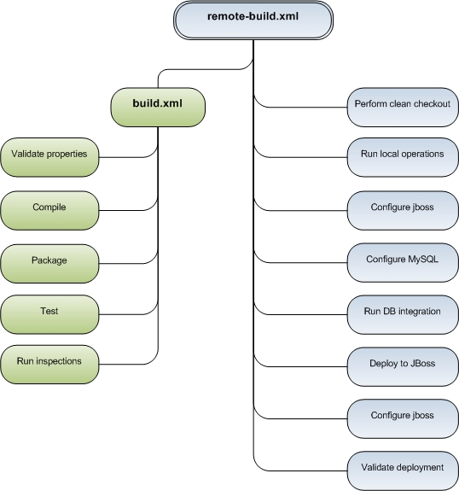
Figure 1 - TBD

