Manage Experiment Data Files Use Case Specification
caArray
Last Revised: | September 22, 2008
Produced By: | NCICB Development
Version: | 1.5

Document Approvals
The list contains the name and contact information for the core project team and any key stakeholders who have an interest in the success of the project. An “S” identifies persons responsible for approval from the stakeholder groups. Sign off of the document would be required when a decision is made not to take action for defined gaps.

S | Name | Role | S | Name | Role
S | Anand Basu | NCICB Engineering Manager | S | Juli Klemm, Ph.D. | Product Manager
 | Brent Gendleman | Development Project Manager |  | George Komatsoulis, Ph.D. | CBIIT Independent QA
 | Eric Tavela | Development Architect |  | Don Swan | NCICB Application Support
Revision History
When you make a change to a document, you must add an entry to this Revision History table and you must manually type the Last Revised Date on the front cover.

Date | Version | Description | Revised by
6/18/07 | 0.1 | Initial Draft – Basic Flow | Brent Gendleman
6/22/07 | 0.2 | Split original use case up into Manage Project Data, Validate Files and Import Project Data. Fleshed out details of each sub-component. | Rashmi Srinivasa
6/26/07 | 0.3 | Updated to reflect use case analysis of all 3 uses cases mentioned above and include “upload” as part of the basic flow | Brent Gendleman
6/30/07 | 0.4 | Changed file name to be consistent with use case analysis | Brent Gendleman
7/09/07 | 0.5 | Updated Special Requirements based on group review. | Rashmi Srinivasa
8/3/07 | 0.6 | Revised based on community feedback | Brent Gendleman
9/21/07 | 0.7 | Modified Title to reflect Experiment focus | Brent Gendleman
10/2/07 | 0.8 | Updated with additional alternate flow to support the uploading of .zip files and presentation of extracted files for management | Brent Gendleman
11/8/07 | 0.9 | Updated Pre-conditions, modified Basic Flow, Change File Alt Flow, still need to add available file types | Brent Gendleman
1/4/08 | 1.0 | Updated per Bill Mason peer review, modified basic flow, added messaging | Brent Gendleman
2/22/08 | 1.1 | Updated for 2.0.1, reflecting defects 11884 and 10457 and feature request 12344. Also cleaned up invalid hyperlinks etc. | Rashmi Srinivasa
3/11/08 | 1.2 | Updated for 2.0.1, reflecting background upload. | Rashmi Srinivasa
6/27/08 | 1.3 | Updated for 2.1.0, reflecting deletion of imported files and invalid zip formats. | Rashmi Srinivasa
7/1/08 | 1.4 | Changing file type in bulk. | Rashmi Srinivasa
9/22/08 | 1.5 | Added file-filtering requirement. | Rashmi Srinivasa
Copyrights and Trademarks
© Copyright 2007 by NCICB, caBIGTM. All rights reserved.

Table of Contents
1. Brief Description 1
1.1. References 1
2. Deferred from 2.0 1
2.1. Affymetrix .EXP files 1
2.2. Real Time Progress Meter 2
2.3. Resuming Cancelled or Interrupted Uploads 2
3. Preconditions 2
3.1. Data Owner 2
3.2. An Available Experiment Exists in a Saved State 2
3.3. The Experiment Service and Array Types are Known 2
3.4. Compressed File Formats 2
4. Basic Flow of Events 3
5. Alternative Flows 4
5.1. Upload a Compressed File 4
5.2. In Progress Cancellation - Deferred 4
5.3. Delete Files 4
5.4. Change File Type 4
5.5. Delete Imported Files 4
6. Exception Flows 5
6.1. Connection to Server is Lost 5
6.2. Data Owner Closes Browser 5
6.3. Data Owner Changes Page View 5
6.4. Invalid Compressed File 5
7. Post-conditions 5
7.1. Uploaded Data Files are Saved 5
8. Special Requirements 6
8.1. Progress Meter 6
8.2. Ability for File Upload to Continue when Navigating Elsewhere 6
8.3. Inability to import an Array Design within an Experiment 6
8.4. Expected File Types 6
8.5. User Messaging 6
8.5.1. Upon Upload 6
8.5.2. File Already Exists 7

Brief Description
Initiated by a Data Owner, this use case enables the uploading of annotation and array content collectively and independently into a caArray project and then provides the ability to validate, import and/or delete the uploaded files and records each action taken. Due to the large file size of array data and to a lesser extent – the annotation, the upload may take minutes or even hours to complete; so the ability to offer to run the upload in the background (allowing the user to perform other functions inside caArray) is desirable.
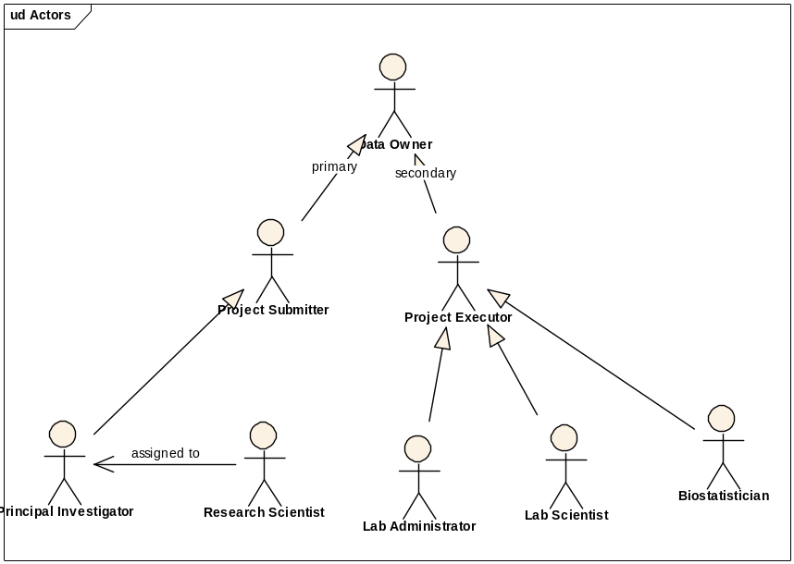
Figure 1. Data Owner Actor Depiction

References
caArray Vision – functional requirements
caArray Supplementary Specifications – non-functional requirements
caArray Use Case Summary – actor definitions and context

Deferred from 2.0

Affymetrix .EXP files
It has been suggested that Affymetrix .EXP files would support quality control metrics across a given project. This is deferred from 2.0 but we should revisit shortly to support improved quality control data and workflow for biostatisticians.

Real Time Progress Meter
The ability to see the status of files (states: uploading, validating, importing) are deferred. Several off-the-shelf open source options exist for supporting this requirement but are dependent either on applets or Flash 8. We will revisit to determine if we perform a browser check and if Flash 8 is installed provide this additional feature.

Resuming Cancelled or Interrupted Uploads
For 2.0, there is NO expectation that the ability to resume will be available. This is primarily to remain consistent with the no applet and open source supplemental requirement.

Preconditions

Data Owner
A Data Owner must be logged in before he/she can manage experiment data. A Data Owner is an experiment submitter from the Principal Investigator’s lab (typically a Research Scientist), or an experiment executor from the core facility or lab (a Lab Scientist or Biostatistician).

An Available Experiment Exists in a Saved State
At least one experiment owned by the contributor is available to have data uploaded, validated and imported into it. If no experiments exist, the feature will be unavailable to the user.

The Experiment Service and Array Types are Known
The service type (complete, partial, analysis or publish) and the assay type (e.g., gene expression vs. SNP) is known so the system can expect what data types it will receive.

Compressed File Formats
The ability to upload a .zip file is available in 2.0. Additional compression formats may be added with the same behavior expected in later releases.

Basic Flow of Events

The Data Owner navigates to and selects the experiment of interest from their experiment workspace in the System that contains no uploaded data.

The System opens the selected experiment and indicates the ability to upload data to the project.

The Data Owner chooses to upload data files.

The System opens a new window (hereafter referred to as the “Upload window”) in which it presents a dialogue that allows for a single or multiple files to be selected from a local or networked location without restriction on the size or type (file extension independent) of files.

The Data Owner selects the single file of interest or a compressed file (see Alternative Flow: Upload a Compressed File).

The System presents the ability to Upload the file or add an additional file.

The Data Owner chooses to add an additional file and can repeat this action as often as desired (Steps 5 and 6) and chooses to upload.

The System messages the user that the upload progress has begun, and warns the user that the upload process will fail of the Upload window is closed prematurely. The System gives the Data Owner the ability to navigate through the experiment in the old window.

The System indicates the progress of the upload in the Upload window. See Special Requirements: Progress Meter.

The System indicates to the Data Owner when all files have made it and displays the list of files, the file extension, the type of file (if recognized by the System – see Special Requirements: Expected File Types) and their status (Uploaded), and the ability to:

Navigate Experiment

Upload Additional Files – This returns the Data Owner to Step 3 of the Basic Flow.

Select or deselect any one or all of the files to support the following actions:
Delete Files – see Alternative Flow: Delete Files
Change File Type – see Change File Type
Validate – see Validate Data Files Use Case
Import – see Import Experiment Data Use Case

Filter the view of the files by file type and/or status.

The Data Owner selects to navigate the experiment, choosing any aspect of the experiment displayed.

Alternative Flows

Upload a Compressed File

In Step 5 of the Basic Flow, the Data Owner chooses a file that has been zipped (.zip) for upload among the files selected for upload.

The flow continues through Step 10 of the Basic Flow.

At Step 10, however, the System extracts the compressed file, discards the original and presents each of the files that were contained in the compressed file to the user, indicating that each one has been uploaded and the actions indicated in Step 10 of the Basic Flow are available on these distinct files.

In Progress Cancellation - Deferred

From Step 8 in the Basic Flow, the Data Owner chooses to cancel the upload job.

The System halts the uploading of the file or set of files and presents the Data Owner the list of files that were uploaded, and moves the Data Owner forward to Step 10 in the Basic Flow.

Delete Files

From Step 10c in the Basic Flow, the Data Owner chooses the file or files to be deleted and selects “delete.”

The System physically deletes the selected file or files and returns the Data Owner to Step 10 in the Basic Flow without displaying the deleted files.

Change File Type

From Step 10c in the Basic Flow, the Data Owner chooses all files to be changed to a particular type, and selects “change file type.”

The System presents the appropriate drop down set for a given experiment or to cancel the action.

The Data Owner chooses the file type that is appropriate for the selected file and saves.

The System changes the file type for all selected files and returns the Data Owner to Step 10 in the Basic Flow with updated file types.

Delete Imported Files

The Data Owner navigates to the Imported Data Files view.

The Data Owner chooses the file or files to be deleted and selects “delete.” Only files that are not associated with hybridizations can be selected for delete. (E.g., MAGE-TAB idf and sdrf files can be selected, but data files cannot.)

The System physically deletes the selected file or files and returns the Data Owner to the Imported Data Files view which does not display the deleted files.

Exception Flows

Connection to Server is Lost
If at any point prior to the entirety of the file or set of files chosen to be uploaded the connection is lost, the data will not be uploaded and must be done over. See Alternative Flow: In Progress Cancellation - Deferred.

Data Owner Closes Browser
If the Data Owner chooses to or inadvertently closes the Upload window, the data won’t be uploaded. See Alternative Flow: In Progress Cancellation - Deferred.

Data Owner Changes Page View
If the Data Owner browses elsewhere in the Upload window, the data will not be uploaded. See Alternative Flow: In Progress Cancellation - Deferred.

Invalid Compressed File
Attempting to upload a corrupt or invalid zip file in Alternative Flow: Upload a Compressed File will result in an upload failure and the System will present an error message indicating the same. A zip containing a directory is considered invalid.

Post-conditions

Uploaded Data Files are Saved
After a successful execution of this use case, any completely uploaded files are available in caArray with a status of “Uploaded”, and are available for validation and import. Any deleted files are completely removed from caArray.

Special Requirements

Progress Meter
The ability to see the total number of files selected for upload and the status of each file is provided.
The status indicator also indicates the percentage of the upload process complete.

Ability for File Upload to Continue when Navigating Elsewhere
The upload process should occur in the background in a new window, allowing the user to navigate elsewhere in the application while uploads are occurring.

Inability to import an Array Design within an Experiment
The Import Array Design Use Case provides the functionality for managing Array Designs independently of an experiment.

Expected File Types
All three categories of MAGE-TAB files will be supported: IDF (Investigation Description Format), ADF (Array Design Format) and SDRF (Sample and Data Relationship Format).
Raw/processed data files of the following types will be supported: Affymetrix .cel and .chp; Genepix .gpr; Illumina data files.
The following file formats will be supported for array designs: .CDF, MAGE-TAB ADF, Illumina .CSV and .txt, GenePix - GAL.
Generic files like Word documents, Excel spreadsheets, Powerpoint slides and PDFs are capable of being uploaded and imported though the only validation is that they are present. These files are not associated with any sample(s), but are uploaded at the Experiment level. They will be found under the Supplemental Documents tab for the experiment.

User Messaging

Upon Upload
Your file(s) are currently being uploaded. Depending on the speed of your connection and the size of the file or set of files, this may take significant time while the data is transferred.

File Already Exists
For every file that is uploaded that already exists in the manage file data set or that has been previously imported into the experiment, the system will produce the following message:
<<file name>> was not uploaded because a file with the same name already exists in this experiment.
# of files uploaded (takes into account how many were requested minus the ones which didn’t)

