Automated Build and Deployment - Developer
NCICB Build and Deployment
Last Revised: | 11/6/07
Produced By: | Levent Gurses  Paul Duvall
Version: | 0.3

Document Approvals
The list contains the name and contact information for the core project team and any key stakeholders who have an interest in the success of the project. An “S” identifies persons responsible for approval from the stakeholder groups. Sign off of the document would be required when a decision is made not to take action for defined gaps.

S | Name | Role | S | Name | Role
S | Anand Basu | CBIIT Engineering Manager |  | Doug Kanoza | SCM Initiative Leader
 | Juli Klemm, Ph.D. | caArray Product Manager |  | George Komatsoulis | CBIIT Director of QA
 | Eric Tavela | Development Architect |  | Brent Gendleman | Development Project Manager
 | Vanessa Caldwell | Database Manager |  | Sriram Kalyanasundaram | Application Manager
 | Don Swan | NCICB Application Support
Revision History
When you make a change to a document, you must add an entry to this Revision History table and you must manually type the Last Revised Date on the front cover.

Date | Version | Description | Revised by
8/24/2007 | 0.1 | Initial draft | Levent Gurses
9/20 | 0.2 | AntHillPro info | Paul Duvall
11/6 | 0.3 | GLOBUS Info | Levent Gurses
Copyrights and Trademarks
© Copyright 2007 by NCICB, caBIGTM. All rights reserved.

Table of Contents

1. Introduction 1
2. Goal 1
3. Running a Local Build - Linux 1
4. Running a Remote Build: Command Line 3
4.1. Dynamic build properties 4
4.2. Property Validation 4

Introduction
This guide is designed to help teams automate manual builds, configuration and deployment. The guide derives from lessons learned from the successful parallel efforts of the CaArray2 and SCM initiative multi-environment automated build and deployment pilot project and industry best practices and it aims to help simplify the creation of a new automated build project.

Goal
The goal of this guide is to provide a quick start-up reference for setting up a new project for an automated multi-environment build and deploy process.

Running a Local Build - Linux
The following steps describe how to run a caArray 2 build on a Linux workstation.

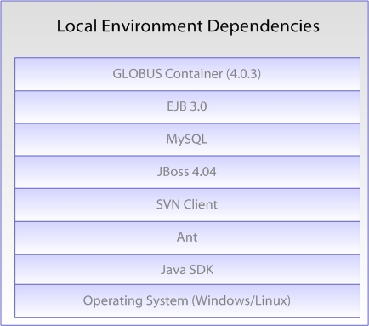

- Install Java SDK 1.5.0_10
  - Download from http://java.sun.com/javase/downloads/index_jdk5.jsp
  - After installing the JDK, create a JAVA_HOME environment variable (which points to the location of your JDK installation) and add %JAVA_HOME/bin% to the front of the System PATH environment variable.
  - To test proper installation, open a new command prompt and type java –version.
- Install Apache Ant 1.7.0
  - Download from http://ant.apache.org/
  - After installing Ant, create an ANT_HOME environment variable (which points to the location of your Ant installation) and add %ANT_HOME/bin% to the front of the System PATH environment variable.
  - To test proper installation, open a new command prompt and type ant –version. Apache Ant version 1.7.0 compiled on December 13 2006 should be displayed.
- Install the Subversion command line client
  - Download from http://subversion.tigris.org/project_packages.html
  - After installing Subversion, create an SVN_HOME environment variable (which points to location of your Subversion installation) and add %SVN_HOME% to the front of the System PATH environment variable.
  - To test Subversion, open a command prompt and type svn help. A list of SVN commands should be displayed.
- Perform a check-out the project from the NCI GForge repository, e.g. from https://gforge.nci.nih.gov/svnroot/caarray2/trunk to a local working directory
- Download JBoss 4.0.4 – GA distribution from http://labs.jboss.com/jbossas/downloads/
  - Start the JBoss server by opening a command prompt at the location of the JBoss installation. Go the $JBOSS_HOME/bin directory and type run.sh
  - Open http://localhost:8080/ and verify JBoss is running properly
- Download JBoss 4.0.5 – GA distribution from http://labs.jboss.com/jbossas/downloads/
  - Start the JBoss server by opening a command prompt at the location of the JBoss installation. Go the $JBOSS_HOME/bin directory and type run.sh
  - Open http://localhost:8080/ and verify JBoss is running properly
- Download JBoss 1.2.0 – GA JEMS installer from http://labs.jboss.com/jemsinstaller/downloads/ (version 1.2.0.GA)
  - Click on the “Run Installer” link and follow the instructions. When prompted for the type of install, select “ejb3”. Accept the defaults for the rest of the install.
  - Note: If you are unable to run the installer download the jar file and from the directory where jems-installer-1.2.0.GA.jar has been downloaded; open a command prompt and type java -jar jems-installer-1.2.0.GA.jar
- From your Linux machine, install MySQL
  - Type sudo yum install mysql-server* from the command line
    - Install MySQL
  - Increase the MySQL page size to 64M. Edit /etc/my.cnf and add the following:
[mysqldump]
max_allowed_packet=64M
- From your local working directory (in step 4), open the command prompt and type ant deploy.

Running a Remote Build: Command Line
The following steps describe how to run a caArray 2 build remotely from another machine.

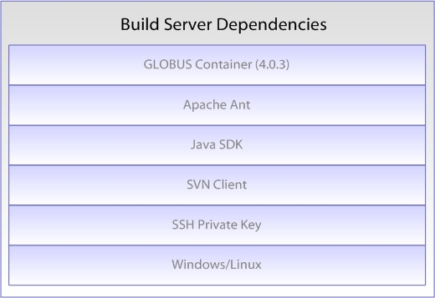

- Run steps 1-4 and then step 9 of Running a Local Build section from above.
- Obtain the environment properties files (from a private Subversion repository at NCICB) and the SSH key files (id_dsa, id_dsa_qa, etc.) and modify each environment property file to point to the right key locations. For example, modify DEV.properties file to point to the location of the SSA private key, id_dsa.
- Run the build
  - Build from tag:
ant -f remote-build.xml -Denvpropertyfile=C:\tools\eclipse\workspace\caarray2-trunk\software\build\DEV.properties -Dnotest=true -Duse.tag=true -Dsvn.tag= CAARRAY_R2_0_0_QA8

  - Build and create a new tag:
ant -f remote-build.xml -Denvpropertyfile=C:\tools\eclipse\workspace\caarray2-trunk\software\build\DEV.properties -Dnotest=true -Dcreate.tag=true -Dsvn.tag=CAARRAY_R2_0_0_QA8

To run in different environments (such as QA), just obtain the .properties file from the private SVN repository.

Dynamic build properties
The standard way to pass properties to an Ant script is through a property file. You can also pass runtime properties on the command prompt using the –D option. The following are the –D properties one can pass to the automated build and deployment script:
- envpropertyfile (required) – sets the environment property file. Has to be a fully qualified file name, e.g. c:\temp\nci\DEV.properties
- notest – when present, all tests will be skipped (required, temporary)
- nodbintegration – when present, skips database integration
- nodeploy – when present, skips JBoss deployment
- noglobus – when present, skips Globus deployment and tests (temporary)
- nocheck – Turn off static analysis source code checks
- use.tag – use the provided tag to build. Mostly needed by QA to deploy a specific tag. Needs svn.tag to work properly.
- create.tag – tells the script that a new SVN tag will be created. Needs svn.tag to work properly.
- svn.tag – specifies the tag to be used or created

Property Validation
Before each build the automated Ant script validates that the key property file stored in the public GForge repository matches the individual environment property file. The task is performed by a custom Ant task which checks two property files and looks for an exact key match. The task does not look into the values of each property. It only validates that the set of properties used by the team matches the template set supplied by the Systems team. In addition, the build master can execute the following command to validate the properties: ant -Denvpropertyfile=[Fully qualified path to environment property file, e.g. c:\temp\nci\DEV.properties] validate-properties. This command will validate the DEV environment properties against the key properties file and will fail the build if there are any discrepancies.

It's recommended that MySQL is installed on a machine that is separate from the machine where Jboss is installed.

