Automated Build and Deployment - QA
Last Revised: | 11/1/07
Produced By: | Paul Duvall
Version: | 1.0

Introduction
This guide is designed to help the QA team to run an integration build using AntHill Pro and an SVN tag from a centralized build server.

Running Automated Build and Deployment from Centralized Build Machine
- Go to http://cbiocvs2.nci.nih.gov:8080/AnthillPro/admin/
- Login with the caarray2 user
- To use the label in QA environment, select caarray2-autodeploy.trunk.autodeploy-qa

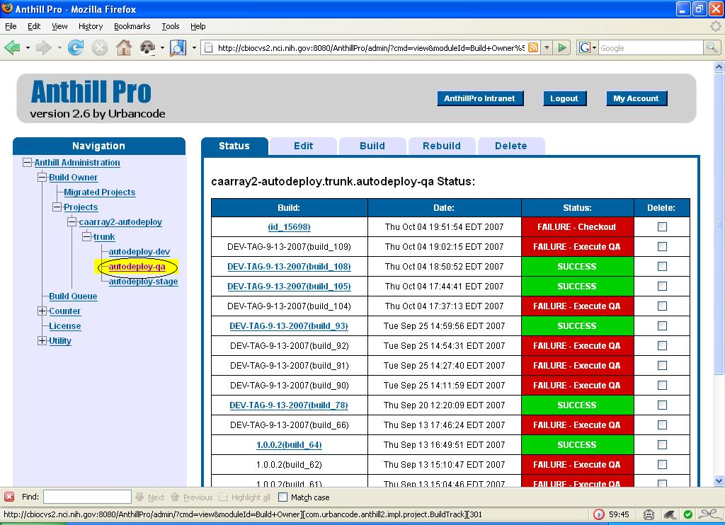
Select the QA Track in AntHill Pro

- Select the Build tab
- Once on the Build tab, enter the label in the label text box. For example, CAARRAY_R2_0_0_QA5 (Important: This should be the tag that is given to the QA team from the development team)
- Select the Force Build checkbox
- Click the Build button. See the figures below for additional information.

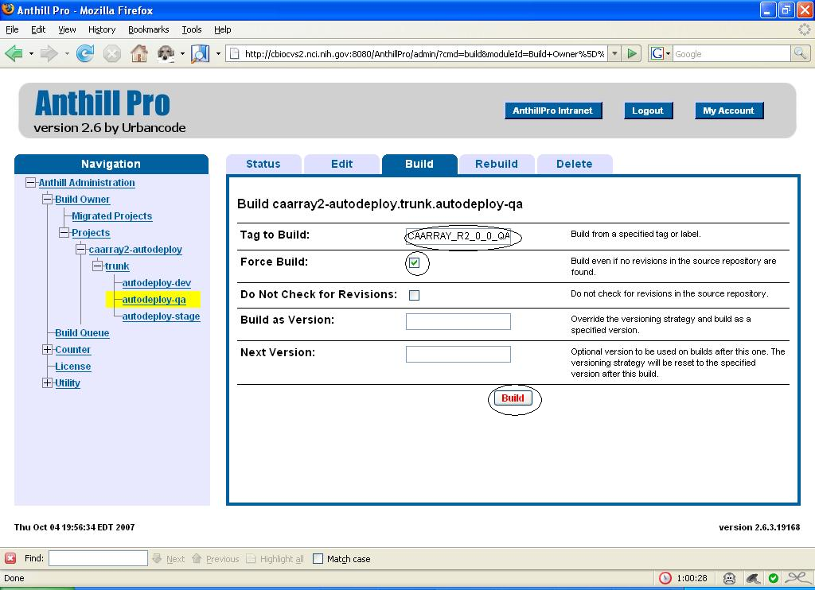

Select the Build Tab, enter the Tag to Build and Execute the Build

- Go to http://cbvapp-q1001.nci.nih.gov:19280/caarray/

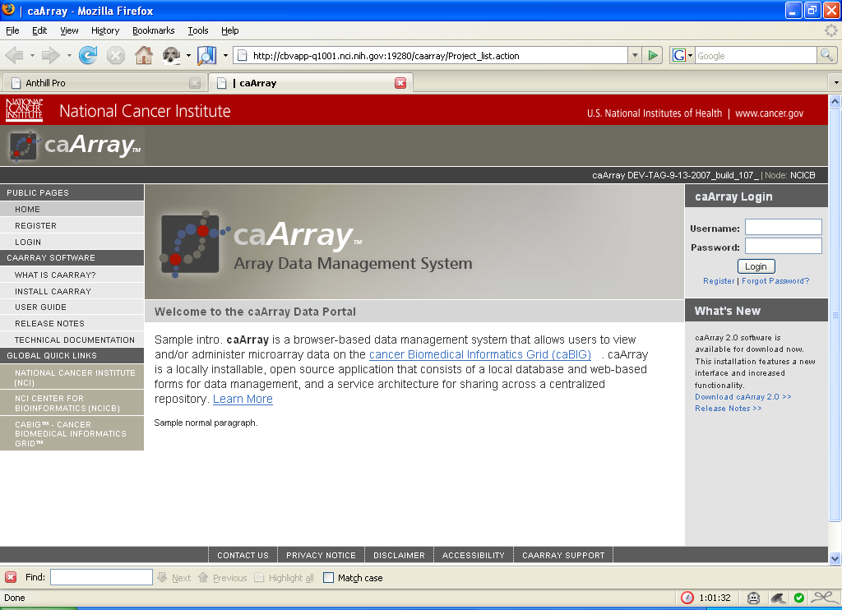

Testing the CaArray 2 application

Running Command Line Deployment

Installing SVN

Installing Java

Installing Ant

Installing Globus
- http://www.globus.org/toolkit/downloads/4.0.3/
  - Go to “Download page for ws-core-4.0.3-bin.zip”

