Automated Build and Deployment - Stage
Command Line
Last Revised: | 10/18/07
Produced By: | Paul Duvall
Version: | 0.3

Running a Local Build
The following steps describe how to run a caArray 2 build on your local workstation (pseudo-build machine)

- Install JDK 1.5.0_10
  - Download from http://java.sun.com/javase/downloads/index_jdk5.jsp
  - After installing the JDK, create a JAVA_HOME environment variable (which points to the location of your JDK installation) and add %JAVA_HOME/bin% to the front of the System PATH environment variable.
  - To test proper installation, open a new command prompt and type java –version.
- Install Apache Ant 1.7.0
  - Download from http://ant.apache.org/
  - After installing Ant, create an ANT_HOME environment variable (which points to the location of your Ant installation) and add %ANT_HOME/bin% to the front of the System PATH environment variable.
  - To test proper installation, open a new command prompt and type ant –version. Apache Ant version 1.7.0 compiled on December 13 2006 should be displayed.
- Install the Subversion command line client
  - Download from http://subversion.tigris.org/project_packages.html
  - After installing Subversion, create an SVN_HOME environment variable (which points to location of your Subversion installation) and add %SVN_HOME% to the front of the System PATH environment variable.
  - To test Subversion, open a command prompt and type svn help. A list of SVN commands should be displayed.
- Perform a check-out the project from the NCI GForge repository, e.g. from https://gforge.nci.nih.gov/svnroot/caarray2/trunk to a local working directory
    - 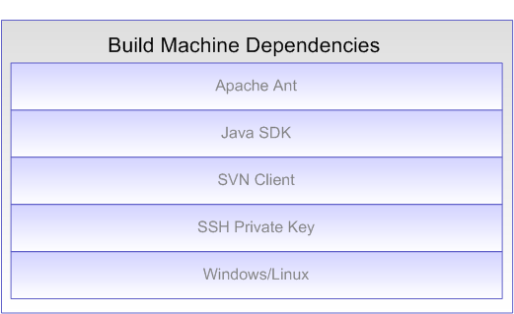

- Obtain the environment properties files (from a private Subversion repository at NCICB) and the SSH key files (id_dsa, id_dsa_qa, etc.) and modify each environment property file to point to the right key locations. For example, modify STAGE.properties file to point to the location of the SSA private key, id_dsa.
- Run the build
ant -f remote-build.xml -Denvpropertyfile=C:tmp/caarray2/software/build/DEV.properties
-Dnotest=true -Dnoglobus=true -Dsvn.tag=CAARRAY_R2_0_0_QA6 -Duse.tag=true

Dynamic build properties
The standard way to pass properties to an Ant script is through a property file. You can also pass runtime properties on the command prompt using the –D option. The following are the –D properties one can pass to the automated build and deployment script:
- envpropertyfile (required) – sets the environment property file. Has to be a fully qualified file name, e.g. c:\temp\nci\STAGE.properties
- notest – when present, all tests will be skipped (required, temporary)
- nodbintegration – when present, skips database integration
- nodeploy – when present, skips JBoss deployment
- noglobus – when present, skips Globus deployment and tests (temporary)
- nocheck – Turn off static analysis source code checks
- use.tag – use the provided tag to build. Mostly needed by QA to deploy a specific tag. Needs svn.tag to work properly.
- create.tag – tells the script that a new SVN tag will be created. Needs svn.tag to work properly.
- svn.tag – specifies the tag to be used or created

