Appendix B: Importing Data Files

caArray supports the storage of a wide variety of data files, and enables the association of those data files to biomaterials (samples) and hybridizations. Depending on the type of data, there are specific rules that govern the association of data to biomaterials and hybridizations. In addition, caArray parses certain types of data files and stores discrete values in its repository, enabling external client applications to retrieve subsets of that data for further analysis. Upon import, unparsed file types end up in the "Imported, not Parsed" state, while parsed file types end up in the "Imported" state.
This chapter describes the rules governing validation and import of all the data file types supported by caArray. It is organized by provider (vendor or software).

Affymetrix
All Affymetrix data files can be imported with or without an accompanying MAGE-TAB IDF and SDRF. If accompanied by an IDF and SDRF, the data files will be associated to biomaterials and hybridizations as specified in the SDRF. If no accompanying IDF-SDRF is present, then biomaterial-hybridization-data chains are generated according to one of the three user-selectable options as described in Chapter 6 - Section "Importing Data".
The following table summarizes the validation and import rules for Affymetrix data files.
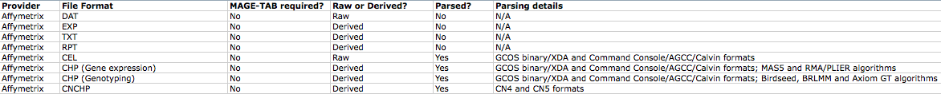
There are four Affymetrix file types that are imported without parsing:
* DAT — Data file containing raw image data (pixel intensity values).
* EXP — Data file containing information about experimental conditions and protocols.
* RPT — Report File summarizing data quality information generated from the CHP file.
* TXT - Exported file generated from the CHP file in text format.
Of the above, DAT files are considered to be raw data and can consequently appear in only the Array Data File column of an accompanying SDRF (if present). The EXP, RPT and TXT files are considered to be derived data and can consequently appear in only the Derived Array Data File column of an accompanying SDRF (if present).
caArray imports and parses three Affymetrix file types:
* CEL — Data file containing information about the intensity values of the individual probes.
The GCOS binary/XDA as well as the Command Console/AGCC/Calvin formats are supported.
* CHP — Data file containing summary information of the probe sets, including normalized intensity values.
For gene expression CHP files, the GCOS binary/XDA as well as the Command Console/AGCC/Calvin formats are supported. So are the MAS5 and RMA/PLIER algorithms.
For genotyping CHP files, the GCOS binary/XDA as well as the Command Console/AGCC/Calvin formats are supported. So are the Birdseed, BRLMM and Axiom GT algorithms.
* CNCHP — Level 2 derived data files containing copy number and (optionally) LOH data.
The CN4 (only copy number) as well as the CN5 (copy number and LOH) algorithms are supported.
Of the above, CEL files are considered to be raw data and can consequently appear in only the Array Data File column of an accompanying SDRF (if present). The CHP and CNCHP files are considered to be derived data and can consequently appear in only the Derived Array Data File column of an accompanying SDRF (if present).

Genepix
Genepix files are 2-or-more colour experiments, and an accompanying MAGE-TAB file set (IDF and SDRF) is required to ensure correct biomaterial-hybridization-data associations.
The following table summarizes the validation and import rules for Genepix data files.
There are no unparsed Genepix formats. caArray imports and parses the Genepix GPR (Genepix Results) file type version 3.0. GPR files are in Axon Text File (ATF) format, and contain general information about image acquisition and analysis, as well as the data extracted from each individual feature. GPR files are considered to be derived data and can consequently appear in only the Derived Array Data File column of an accompanying SDRF (if present).
The format is described in detail here:
http://www.moleculardevices.com/pages/software/gn_genepix_file_formats.html#gpr

Illumina
All Illumina data files can be imported with or without an accompanying MAGE-TAB IDF and SDRF. For the three parsed Illumina file types (CSV, Sample Probe profile TXT and genotyping processed data matrix TXT), the biomaterial-data association rules are a little complex due to the fact that these files contain the hybridization names within the files themselves. If these data files are imported without an accompanying MAGE-TAB IDF and SDRF, then biomaterial-hybridization chains will be auto-generated according to the hybridization names present in the data files themselves. On the other hand, if these data files are accompanied by a MAGE-TAB IDF and SDRF, hybridization names in SDRF will be checked against hybridization names within the data files - if the SDRF is missing one or more of the hybridization names in the data files, validation/import will fail.

The following table summarizes the validation and import rules for Illumina data files.
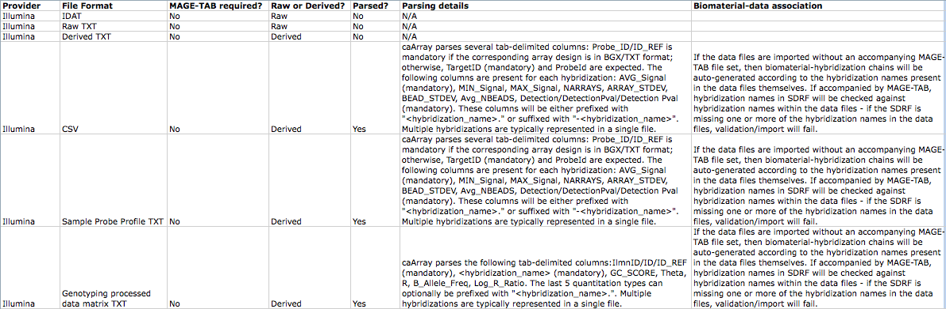
There are three Illumina file types that are imported without parsing:
* IDAT — Data file containing raw image data.
* Raw TXT - Plain text file containing raw signal data in one of a variety of formats.* Derived TXT - Plain text file containing processed signal data in one of a variety of formats that don't conform to any of the parsed file types described later in this section.
Of the above, IDAT and Raw TXT files are considered to be raw data and can consequently appear in only the Array Data File column of an accompanying SDRF (if present). The Derived TXT files are considered to be derived data and can consequently appear in only the Derived Array Data File column of an accompanying SDRF (if present).
caArray imports and parses three Illumina file types:
* CSV (gene expression) - a comma-separated-values file containing processed signal values. This was generated by older versions of BeadStudio (pre 3.0).
* Sample probe profile TXT (gene expression) - a tab-separated values file containing processed signal values. This is generated by newer versions of BeadStudio and GenomeStudio.
* Genotyping processed data matrix TXT (genotyping) - a tab-separated values file containing logratio values.
All three of the above file types are considered to be derived data and can consequently appear in only the Derived Array Data File column of an accompanying SDRF (if present). The following sub-sections describe these file formats and their parsing in detail.

CSV (gene expression)
caArray parses several comma-delimited columns. TargetID (mandatory) and ProbeId identify the probes. The following columns are present for each hybridization: AVG_Signal (mandatory), MIN_Signal, MAX_Signal, NARRAYS, ARRAY_STDEV, BEAD_STDEV, Avg_NBEADS, Detection. These columns will be suffixed with "-<hybridization_name>". Multiple hybridizations are typically represented in a single file. A snippet from an example file is shown below:
Illumina Inc. BeadStudio version 1.5.1.3,,,,,,,,,,,,,,,,,,,,,,,,,,,,,,,,,,,,,,,,,,,,,,,,,,,,,,,,,,,,,,,,,,,,,,,,,,,,
Normalization = cubic spline,,,,,,,,,,,,,,,,,,,,,,,,,,,,,,,,,,,,,,,,,,,,,,,,,,,,,,,,,,,,,,,,,,,,,,,,,,,,
Array Content = Human_WG-6.xml,,,,,,,,,,,,,,,,,,,,,,,,,,,,,,,,,,,,,,,,,,,,,,,,,,,,,,,,,,,,,,,,,,,,,,,,,,,,
Error Model = none,,,,,,,,,,,,,,,,,,,,,,,,,,,,,,,,,,,,,,,,,,,,,,,,,,,,,,,,,,,,,,,,,,,,,,,,,,,,
DateTime = 9/30/2005 6:39 PM,,,,,,,,,,,,,,,,,,,,,,,,,,,,,,,,,,,,,,,,,,,,,,,,,,,,,,,,,,,,,,,,,,,,,,,,,,,,
Local Settings = en-US,,,,,,,,,,,,,,,,,,,,,,,,,,,,,,,,,,,,,,,,,,,,,,,,,,,,,,,,,,,,,,,,,,,,,,,,,,,,
TargetID,AVG_Signal-A1,BEAD_STDEV-A1,Avg_NBEADS-A1,Detection-A1,AVG_Signal-B1,BEAD_STDEV-B1,Avg_NBEADS-B1,Detection-B1,AVG_Signal-C1,BEAD_STDEV-C1,Avg_NBEADS-C1,Detection-C1,AVG_Signal-D1,BEAD_STDEV-D1,Avg_NBEADS-D1,Detection-D1,AVG_Signal-A2,BEAD_STDEV-A2,Avg_NBEADS-A2,Detection-A2,AVG_Signal-B2,BEAD_STDEV-B2,Avg_NBEADS-B2,Detection-B2,AVG_Signal-C2,BEAD_STDEV-C2,Avg_NBEADS-C2,Detection-C2,AVG_Signal-D2,BEAD_STDEV-D2,Avg_NBEADS-D2,Detection-D2,AVG_Signal-A3,BEAD_STDEV-A3,Avg_NBEADS-A3,Detection-A3,AVG_Signal-B3,BEAD_STDEV-B3,Avg_NBEADS-B3,Detection-B3,AVG_Signal-D3,BEAD_STDEV-D3,Avg_NBEADS-D3,Detection-D3,AVG_Signal-A4,BEAD_STDEV-A4,Avg_NBEADS-A4,Detection-A4,AVG_Signal-B4,BEAD_STDEV-B4,Avg_NBEADS-B4,Detection-B4,AVG_Signal-C4,BEAD_STDEV-C4,Avg_NBEADS-C4,Detection-C4,AVG_Signal-D4,BEAD_STDEV-D4,Avg_NBEADS-D4,Detection-D4,AVG_Signal-A5,BEAD_STDEV-A5,Avg_NBEADS-A5,Detection-A5,AVG_Signal-B5,BEAD_STDEV-B5,Avg_NBEADS-B5,Detection-B5,AVG_Signal-C5,BEAD_STDEV-C5,Avg_NBEADS-C5,Detection-C5,AVG_Signal-D5,BEAD_STDEV-D5,Avg_NBEADS-D5,Detection-D5
GI_10047089-S,5.8,3.3,45,0.84179301,105.1,6.7,48,1,14.7,3.5,56,0.98681608,56.7,4,50,0.9993408,0.4,3,39,0.53460778,124.8,6.5,39,1,18.5,4.1,42,0.99406724,64.5,5.8,37,1,4.1,3.3,48,0.77982861,91.7,5.9,40,1,70.1,5.2,39,0.9993408,2.8,3.8,36,0.70731707,102,6.5,44,1,16.7,2.7,40,0.99406724,57.4,3.7,47,1,7,4,46,0.90112063,105.6,6.7,31,1,15.1,5.2,35,0.98879367,68.7,5.4,34,1

Sample probe profile TXT (gene expression)
caArray parses several tab-delimited columns: Probe_ID/ID_REF is mandatory if the corresponding array design is in BGX/TXT format; otherwise, TargetID (mandatory) and ProbeId are expected. The following columns are present for each hybridization: AVG_Signal (mandatory), MIN_Signal, MAX_Signal, NARRAYS, ARRAY_STDEV, BEAD_STDEV, Avg_NBEADS, Detection/DetectionPval/Detection Pval (mandatory). These columns will be either prefixed with "<hybridization_name>." or suffixed with "-<hybridization_name>". Multiple hybridizations are typically represented in a single file. A snippet from an example file is shown below:
Probe_Id Patient 1-Tumor.AVG_Signal Patient 1-Tumor.NARRAYS Patient 1-Tumor.ARRAY_STDEV Patient 1-Tumor.Detection Pval Patient 1-Tumor.BEAD_STDERR Patient 1-Tumor.Avg_NBEADS Patient 2-Tumor.AVG_Signal Patient 2-Tumor.NARRAYS Patient 2-Tumor.ARRAY_STDEV Patient 2-Tumor.Detection Pval Patient 2-Tumor.BEAD_STDERR Patient 2-Tumor.Avg_NBEADS
ILMN_2136495 111.1856 1 NaN 0 6.041573 36 87.39001 1 NaN 0 6.327084 33
A snippet from another example file demonstrates the second variant:
TargetID ProbeID MIN_Signal-1745080067_B AVG_Signal-1745080067_B MAX_Signal-1745080067_B NARRAYS-1745080067_B ARRAY_STDEV-1745080067_B BEAD_STDEV-1745080067_B Avg_NBEADS-1745080067_B Detection-1745080067_B MIN_Signal-1745080067_A AVG_Signal-1745080067_A MAX_Signal-1745080067_A NARRAYS-1745080067_A ARRAY_STDEV-1745080067_A BEAD_STDEV-1745080067_A Avg_NBEADS-1745080067_A Detection-1745080067_A
0610005I04 580022 164.9 164.9 164.9 1 NaN 61.030 33 0.51703 164.9 164.9 164.9 1 NaN 57.871 29 0.73723

Genotyping processed data matrix TXT (genotyping)
caArray parses the following tab-delimited columns: IlmnID/ID/ID_REF (mandatory), <hybridization_name> (mandatory), GC_SCORE, Theta, R, B_Allele_Freq, Log_R_Ratio. The last 5 quantitation types can optionally be prefixed with "<hybridization_name>.", and the <hybridization_name> column contain allele values. Multiple hybridizations are typically represented in a single file. A snippet from an example file is shown below:
IlmnID HYB1 GC_SCORE Theta R B_Allele_Freq Log_R_Ratio HYB2 GC_SCORE Theta R B_Allele_Freq Log_R_Ratio
MitoA10045G-13273284_B_R_IFB1141652022:0 AA 0.3197343 0.006295365 6.168365 0.000579326 0.4340365 AA 0.3197343 0.005859224 4.608023 9.934365E-05 0.01329622
A snippet from another example file demonstrates the second variant:
ID TCGA-06-0119-01A-08D TCGA-06-0119-01A-08D.GC_SCORE TCGA-06-0119-01A-08D.Theta TCGA-06-0119-01A-08D.R TCGA-06-0119-01A-08D.B_Allele_Freq TCGA-06-0119-01A-08D.Log_R_Ratio TCGA-06-0119-01A-08D TCGA-06-0119-01A-08D.GC_SCORE TCGA-06-0119-01A-08D.Theta TCGA-06-0119-01A-08D.R TCGA-06-0119-01A-08D.B_Allele_Freq TCGA-06-0119-01A-08D.Log_R_Ratio
MitoA10045G-13273284_B_R_IFB1141652022:0 AA 0.3197343 0.006295365 6.168365 0.000579326 0.4340365 AA 0.3197343 0.005859224 4.608023 9.934365E-05 0.01329622

Agilent
Agilent raw TXT files from aCGH and 2-colour gene expression assays must be accompanied by a MAGE-TAB IDF and SDRF in order to ensure correct biomaterial-hybridization-data associations. All other Agilent data files can be imported with or without an accompanying MAGE-TAB IDF and SDRF.
The following table summarizes the validation and import rules for Agilent data files.
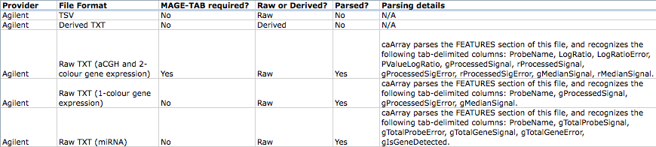
There are two Agilent file types that are imported without parsing:
* TSV
* Derived TXT - Plain text file containing processed data in one of a variety of formats that don't conform to any of the parsed file types described later in this section.
Of the above, TSV files are considered to be raw data and can consequently appear in only the Array Data File column of an accompanying SDRF (if present). The Derived TXT files can appear in only the Derived Array Data File column of an accompanying SDRF (if present).
caArray imports and parses three Agilent file types:
* Raw TXT (aCGH and 2-colour gene expression) - a tab-separated-values text file containing signal data generated by the Agilent Feature Extraction Software.
caArray parses the FEATURES section of this file, and recognizes the following tab-delimited columns: ProbeName, LogRatio, LogRatioError, PValueLogRatio, gProcessedSignal, rProcessedSignal, gProcessedSigError, rProcessedSigError, gMedianSignal, rMedianSignal.
* Raw TXT (single colour gene expression) - a tab-separated-values text file containing signal data generated by the Agilent Feature Extraction Software.
caArray parses the FEATURES section of this file, and recognizes the following tab-delimited columns: ProbeName, gProcessedSignal, gProcessedSigError, gMedianSignal.
* Raw TXT (miRNA) - a tab-separated-values text file containing signal data generated by the Agilent Feature Extraction Software.
caArray parses the FEATURES section of this file, and recognizes the following tab-delimited columns: ProbeName, gTotalProbeSignal, gTotalProbeError, gTotalGeneSignal, gTotalGeneError, gIsGeneDetected.

All three of the above file types are considered to be raw data and can consequently appear in only the Array Data File column of an accompanying SDRF (if present).

Nimblegen
All Nimblegen data files can be imported with or without an accompanying MAGE-TAB IDF and SDRF. If accompanied by an IDF and SDRF, the data files will be associated to biomaterials and hybridizations as specified in the SDRF. If no accompanying IDF-SDRF is present, then biomaterial-hybridization-data chains are generated according to one of the three user-selectable options as described in Chapter 6 - Section "Importing Data".
The following table summarizes the validation and import rules for Nimblegen data files.
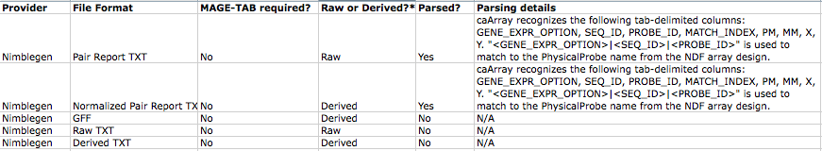
There are three Nimblegen file types that are imported without parsing:
* GFF
* Raw TXT - Plain text file containing raw data in one of a variety of formats that don't conform to any of the parsed file types described later in this section.
* Derived TXT - Plain text file containing derived/processed data in one of a variety of formats that don't conform to any of the parsed file types described later in this section.
Of the above, Raw TXT files are considered to be raw data and can consequently appear in only the Array Data File column of an accompanying SDRF (if present). The GFF and Derived TXT files can appear in only the Derived Array Data File column of an accompanying SDRF (if present).
caArray imports and parses two Nimblegen file types:
* Pair Report TXT - a tab-separated-values text file containing signal intensity information for a single channel.
caArray recognizes the following tab-delimited columns: GENE_EXPR_OPTION, SEQ_ID, PROBE_ID, MATCH_INDEX, PM, MM, X, Y. "<GENE_EXPR_OPTION>|<SEQ_ID>|<PROBE_ID>" is used to match to the PhysicalProbe name from the NDF array design.
* Normalized Pair Report TXT - a tab-separated-values text file containing normalized signal intensities output by the RMA algorithm.
caArray recognizes the following tab-delimited columns: GENE_EXPR_OPTION, SEQ_ID, PROBE_ID, MATCH_INDEX, PM, MM, X, Y. "<GENE_EXPR_OPTION>|<SEQ_ID>|<PROBE_ID>" is used to match to the PhysicalProbe name from the NDF array design.

Of the above, Pair Report TXT files are considered to be raw data and can consequently appear in only the Array Data File column of an accompanying SDRF (if present). Normalized Pair Report TXT files are considered to be derived data and can consequently appear in only the Derived Array Data File column of an accompanying SDRF (if present)).

Any Provider

Copy Number MAGE-TAB Data Matrix TXT
This is a special MAGE-TAB Data Matrix file that has copy number data in a caArray-prescribed format, and an accompanying MAGE-TAB file set (IDF and SDRF) is required. caArray expects the first header row to contain tab-delimited Hybridization REFs that refer to Hybridization Names in the corresponding SDRF. The rest of the file is expected to contain the following tab-delimited columns: Reporter REF (probe name), Chromosome, Position, Log2Ratio. A snippet from an example file is shown below:
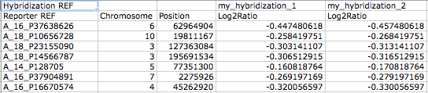

Other
The following table summarizes the validation and import rules for all other data files supported by caArray.
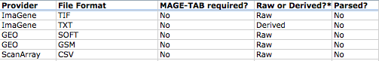
These are the file types that are imported without parsing:
* ImaGene TIF
* ImaGene TXT
* GEO SOFT
* GEO GSM
* ScanArray CSV
* MAGE-TAB Data Matrix (not the Copy Number Data Matrix format described earlier)
Of the above, ImaGene TIF, GEO SOFT, GEO GSM and ScanArray CSV files are considered to be raw data and can consequently appear in only the Array Data File column of an accompanying SDRF (if present). ImaGene TXT files are considered to be derived data and can consequently appear in only the Derived Array Data File column of an accompanying SDRF (if present). MAGE-TAB Data Matrix files can represent data from any provider, and can appear in either the Array Data Matrix File (raw) or Derived Array Data Matrix File (derived) column of an accompanying SDRF.

