Analysis Services Best Practices Whitepaper

Ted Liefeld¹, Baris Suzek², Patrick McConnell³
Claire Wolfe⁴

¹Broad Institute of MIT and Harvard
²Lombardi Comprehensive Cancer Center
³Duke Comprehensive Cancer Center
⁴National Cancer Institute

Contents
1. Contents 2
2. Introduction 3
3. Creating Analytical Services Process Overview 3
3.1. Introduction 3
3.2. Demonstration Service Background 4
3.2.1. Resources 4
3.2.2. Demonstration Service 4
3.3. Process Overview 4
3.3.1. Install caGrid 4
3.3.2. Obtain or create UML models 5
3.3.3. Obtain or create XML schemas 5
3.3.4. (optional) Obtain (if available) helper libraries 5
3.3.5. Generate Service in Introduce 6
3.3.6. Modify skeleton code to call implementation 6
3.3.7. Deploy test service 6
3.3.8. Register service metadata with ServiceLoader 6
3.4. Demonstration Service Example 7
3.4.1. Install caGrid 7
3.4.2. Obtain or create UML models 7
3.4.3. Obtain or create XML schemas 7
3.4.4. (optional) Obtain (if available) helper libraries 8
3.4.5. Generate Service in Introduce 8
3.4.6. Modify skeleton code to call implementation 13
3.4.7. Deploy test service 14
3.4.8. Register service metadata with ServiceLoader 14
4. UML Modeling Primer 14
4.1. Background 14
4.1.1. Tools for UML Modeling 14
4.1.2. Resources 15
4.2. Modeling Service-unique Input and Output Classes 15
4.3. Modeling Related Recommendations for Analytical Services 17
5. XML Schema Generation 18
5.1. Background 18
5.1.1. Resources 19
5.2. Model Generation 19
5.3 Loading the Model XSD into the GME 24
6. Implications for Reviewers 26
6.1. VCDE Reviewers 26
Appendix A. Additional entries for server-config.wsdd 28
Appendix B, GeneNeighbors ParameterListMetadata file 30
Appendix C Generating XML Schema files from Enterprise Architect 32
Appendix D Process to submit analytical service for loading to caDSR 35

Introduction
This document attempts to collect the best practices for developing analytical services on caGrid 1.1 with the aim of improving the efficiency of analytical service developers who wish to make new grid services. While these practices were developed with analytical services in mind, they are not specifically limited to this class of services and may be applicable to other classes of services such as caGrid data services.

The remainder of the document is organized as follows;

Chapter 3 provides an overview of the steps in the service development process.
Chapter 4 walks through the development an example analytical service.
Chapter 5 describes best practices for creation of service UML models.
Chapter 6 describes best practices for XML Schema (XSD) generation.
Chapter 7 reviews the implications of the process for Architecture and VCDE reviewers.
The appendices cover various details such as alternative XSD generation mechanisms, the SIW round trip procedure etc.

At the time of this writing these represent the best practices as recognized by the caBIG™ Integrative Cancer Research (ICR) Analysis Services Best Practices (ASBP) Working Group (WG) but these practices have not yet been ratified and accepted by the caBIG cross cutting workspaces (Architecture, VCDE).

Creating Analytical Services Process Overview

Introduction
The process of creating a new analysis service involves several steps and multiple interacting tools. This chapter will provide an overview the entire process from end to end. Each of the steps detailed below will include references to other documentation, in some cases other chapters in this document, in order to cover the details of each individual tool. This process does not include details of compatibility reviews, as that is outside of the scope of this document. However some pointers to required steps for compatibility reviews will be called out.

This process was documented during the development of the ASBP demonstration service. This service is described below in the background section.

The analytical service development process described below made the following assumptions;
- UML models exist for inputs and outputs
  - Ideally these are already registered in the caDSR
- caGrid 1.1 is the target deployment version.
- All development is done in Java 1.5

Demonstration Service Background

Resources
- GenePattern

http://www.genepattern.org

- Gene Neighbors Documentation

ftp://ftp.broad.mit.edu/pub/genepattern/modules/GeneNeighbors/broad.mit.edu:cancer.software.genepattern.module.analysis/00007/2/GeneNeighbors.pdf

Demonstration Service
For the purposes of having a demonstration service developed for demonstrating the process, the ASBP Working Group chose to wrap an existing GenePattern module for calculating coexpression values. This algorithm, known as GeneNeighbors within GenePattern, was chosen based on its ease of implementation, availability of existing data models, and because it had been requested by an adopter for use on caGrid.

GeneNeighbors has several input parameters including the following;
- An input dataset
- A gene accession (String) of the gene we wish to find coexpressed genes of
- The number of co-expressed genes to return
- The distance metric to use (Cosine, Euclidean, Manhattan, or Pearson)
- Optional filtering parameters
  - Floor, ceiling, minimum fold difference, minimum absolute difference

Details of the GeneNeighbors implementation are available at the GenePattern web site (see references.)

Process Overview
The process for creating an analysis service consists of the following steps;
- Install caGrid
- Obtain or create UML models
- Obtain or create XML schemas
- (optional) Obtain (if available) helper libraries
- Generate Service in Introduce
- Modify skeleton code to call implementation
- Deploy test service
- Register service metadata with ServiceLoader

Install caGrid

- caGrid web site

https://cabig.nci.nih.gov/workspaces/Architecture/caGrid/

- caGrid Wiki

http://www.cagrid.org

- caGrid User Guide

http://gforge.nci.nih.gov/frs/download.php/2386/caGrid-1-1_Users_Guide.pdf

Installation of caGrid is not unique in any way for analytical services. Follow the normal caGrid installation instructions.

Obtain or create UML models
UML Models of the inputs and outputs for the service are the first step of the process. If existing UML models exist that you can reuse (e.g. ATAT-ML, ASBP Generic Parameters Models), you can begin by downloading copies of these models from the caBIG GForge site. If you need to create new UML models for your objects, see chapter 4 of this document.

If you are unsure whether there are preexisting models that you can reuse, consult with your VCDE mentor (if a funded caBIG project) or post a question explaining the data types you wish to use as inputs/outputs to the caBIG ICR mailing list. CABIG_ICR-L@LIST.NIH.GOV

Once the UML model is complete, submit the UML Model as a domain model for loading to caDSR. Submit the servicemetadata.xml file to NCICB App Support (ncicb@pop.nci.nih.gov) as part of the analytical services submission package. Fill out part 3 (contact information) only in the submission form and zip with the XML file to create the complete submission package.

Obtain or create XML schemas
UML Models are used to ensure semantic compatibility between applications. The XML Schemas that are derived from the UML models are needed to ensure syntactic compatibility. XML schemas for re-used models are ideally retrieved from the Global Model Exchange (GME).

New models for your service that have not yet completed registration will not have XML Schemas in the GME. For these, consult chapter 5 and appendix C, for details on how to create an XML schema from a UML model.

(optional) Obtain (if available) helper libraries
Helper libraries are source code (typically java jar files) that have been created by projects using an existing model that may be useful to other projects who wish to use the same model. In some cases, these may be utilities to simplify working with the model’s objects. In others they may be necessary to ensure syntactic compatibility when a model is not fully specified and allows some interpretation. An example of the first case is the ASBP library for generic parameters. This library creates wrapper classes for the various generic parameter subclasses so that they can be used more easily. An example of the second case is the STAT-ML libraries used in the demo service (section 3.4). In this case the STAT-ML Data object maps into a string in the XML schema. Therefore it is necessary to have agreed upon mechanisms for marshalling and unmarshalling the Data object from a String to permit syntactic compatibility between projects using this model. This detail has been placed into a common java library, shared between several projects using STAT-ML.

If helper libraries exist for the models you are reusing, obtain them now from GForge or the ncicb cvs or svn repositories.

Generate Service in Introduce
Generate your new service in introduce. The basic steps are to
- Load required data types
  - From the GME if available there
  - From an XMI file generated by Enterprise Architect
  - From an XSD file
- Create operations defining input and return data types
- Add metadata for the generic parameters (if used) in the form of a ParameterMetadataList object added on the metadata tab and filling in its instantiation.
- Save the service.

Modify skeleton code to call implementation
This step will be unique for every service. In the demo below, the implementation calls some preexisting utilities to convert STAT-ML data objects into files and then calls the GenePattern gpintegration servlet to execute the analysis.

Deploy test service
Deploy the test service into your caGrid implementation using the ant build file provided by introduce.

e.g. >ant deployTomcat

Register service metadata with ServiceLoader
Submit the <my service>/etc/servicemetadata.xml file created in step 3.3.5 by introduce to NCICB Application Support (ncicb@pop.nci.nih.gov) as part of the analytical services submission package. Fill out part 3 (contact information) only in the submission form and zip with the XML file to create the complete submission package

Demonstration Service Example

Install caGrid
caGrid 1.1 was installed per the instructions at https://cabig.nci.nih.gov/workspaces/Architecture/caGrid/.

Obtain or create UML models

- ASBP Generic Parameters Model

https://gforge.nci.nih.gov/svnroot/genepattern/trunk/genepattern/cabig_ey2_2008/asbp/process_white_paper/demo_service/schema/GeneNeighbors/GenericParamSchema.xsd

- STAT-ML Model

https://gforge.nci.nih.gov/svnroot/genepattern/trunk/genepattern/cabig_ey2_2008/asbp/process_white_paper/demo_service/schema/GeneNeighbors/2.0_edu.duke.cabig.rproteomics.model.statml.xsd

For the demonstration service we did not create any new UML models. We reused two existing models to represent the data and parameters for the GeneNeighbors service. These models were STAT-ML to represent the microarray data, and the ASBP Generic parameter model to represent the parameters to this service.

Since there were no new or derived objects required, no additional UML modeling was required for the demo service. However, if you wish to receive a silver compatibility review, it would be necessary to create a model at this step defining the external interface for the service sufficient for VCDE review.

Once the UML model is complete, submit the UML Model as a domain model for loading to caDSR. Submit the servicemetadata.xml file to NCICB App Support (ncicb@pop.nci.nih.gov) as part of the analytical services submission package. Fill out part 3 (contact information) only in the submission form and zip with the XML file to create the complete submission package.

Obtain or create XML schemas
- ASBP Generic Parameters schema

http://gforge.nci.nih.gov/docman/view.php/326/10328/GenericParamSchema.xsd

- STAT-ML schema

http://gforge.nci.nih.gov/docman/view.php/326/10329/2.0_edu.duke.cabig.rproteomics.model.statml.xsd

XML schemas to match the UML models are required before we begin using Introduce to generate our schema skeleton. Details of how to generate an XML Schema from a model are available in chapter 5. The schema files used in this demonstration service are available in the resources links (above).

(optional) Obtain (if available) helper libraries
- STAT-ML Utilities jar
https://gforge.nci.nih.gov/svnroot/genepattern/trunk/genepattern/gridExtensions_y3/code/gpCaGridServer1.0/PreprocessDatasetSTATMLService/lib/statmlutil.jar

In the development of the GeneNeighbors demo service we wanted to reuse utilities written during a previous caBIG contract for converting between the STAT-ML model and GenePattern’s native file formats. A jar file containing the class org.genepattern.cabig.util.STATMLConverter was copied from the old project for reuse and to ensure that marshalling of STAT-ML objects into and out of GenePattern files was performed consistently. This jar file also included the class org.genepattern.cabig.util.IntegrationServletUtilities which we will use later in step 3.4.6.

Generate Service in Introduce
- caGrid Users Guide
http://gforge.nci.nih.gov/frs/download.php/2386/caGrid-1-1_Users_Guide.pdf

Introduce was used to generate the service skeleton.

Start introduce
cd caGrid/projects/introduce
ant introduce

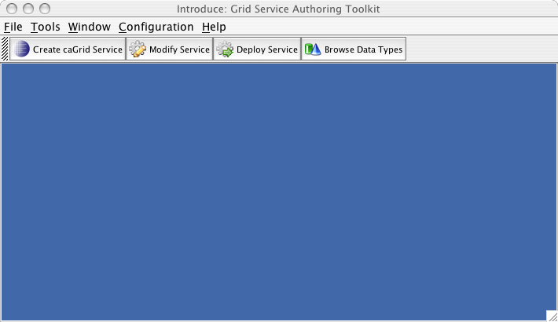
Figure 3.1: Introduce startup view.

Select “Create caGrid Service” and fill in values for directory, class package and namespace.

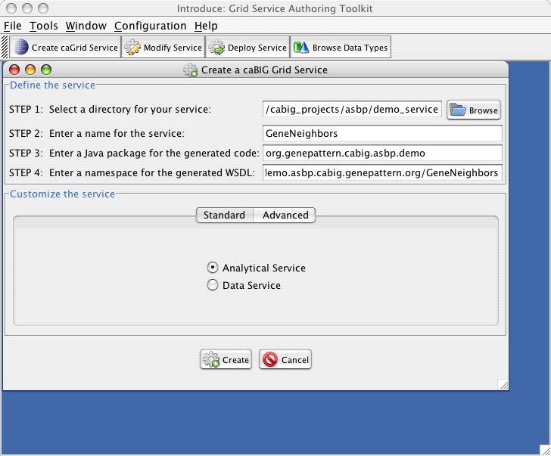
Figure 3.2: Introduce creation of a grid service.

Select “Create” to create the service skeleton.

Load the XML schemas
  - from the GME if present there
  - from the file system if not

You will need to add three collections of data types. Stat-ml, generic parameters, and generic parameter metadata.

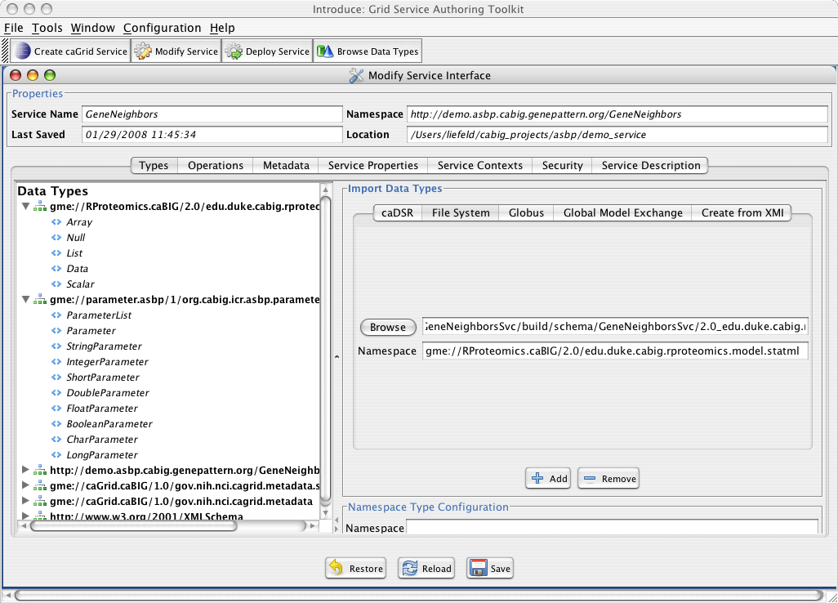
Figure 3.3: Adding datatypes to Introduce.

Define the operation for the service. It will take a ParameterList and a Data object as input and return a Data object.
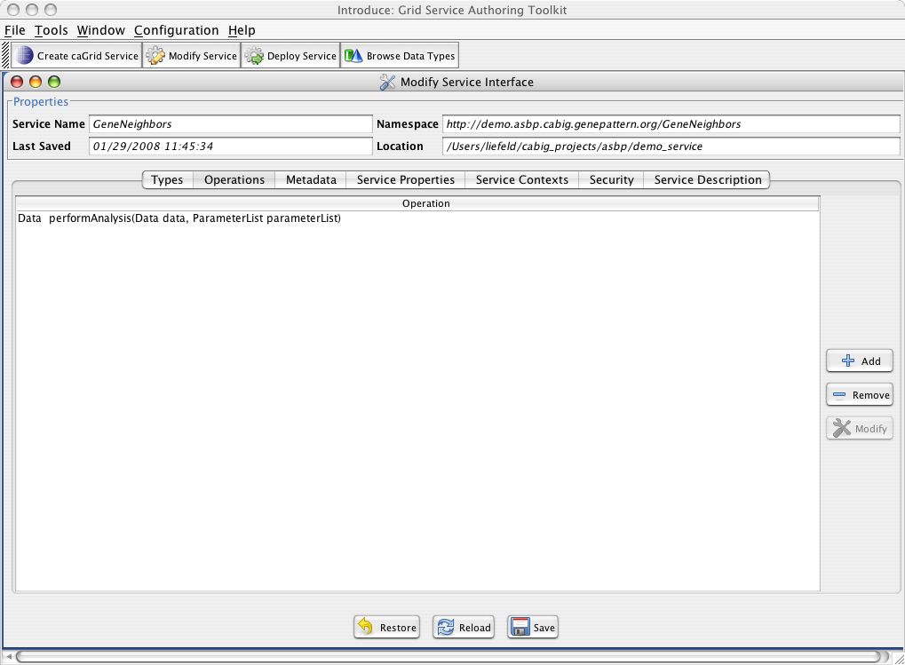
Figure 3.4: Adding operations in Introduce.

Save the service skeleton.

Now, add the parameter metadata to describe the generic parameters that your operation will be using. To begin, select the “Metadata” tab, select a ParameterListMetadata type and then select “Add”.

Check the box titled “populate from file.”
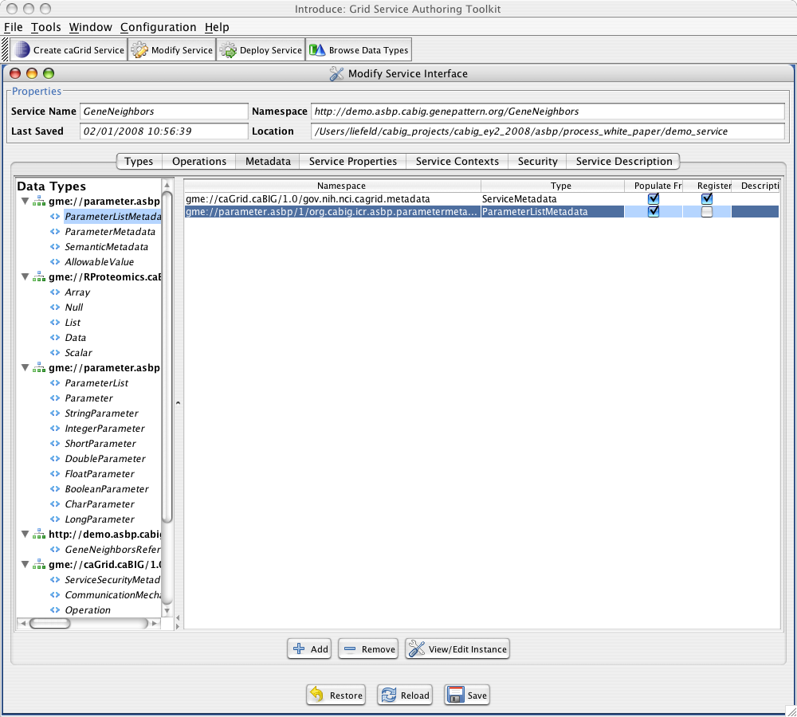
Figure 3.5: Adding Generic Parameter Metadata in Introduce.

At this time you can begin entering your parameter metadata by selecting the “view/edit instance” button. Alternately, once you have saved the service, you can edit the metadata file that will be located in the services “*/etc” directory. If you have generated your parameter list metadata from another tool, this is the easiest way to do so.
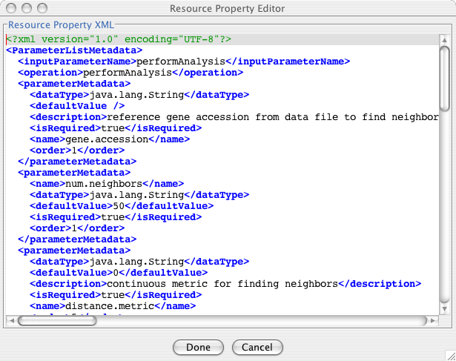

Figure 3.6: Generic Parameter Metadata XML for GeneNeighbors.

Modify skeleton code to call implementation
One element all applications using the generic parameter model will need to modify is the server-config.wsdd file. In order to allow the Parameter subclasses to be properly marshaled over the grid, they need to have type-mappings added to the server-config.wsdd file. The complete text is included in Appendix A, while one example is as follows;

<typeMapping xmlns:ns="gme://parameter.asbp/1/org.cabig.icr.asbp.parameter"
qname="ns:StringParameter"
type="java:org.cabig.icr.asbp.parameter.StringParameter"
serializer="org.apache.axis.encoding.ser.BeanSerializerFactory"
deserializer="org.apache.axis.encoding.ser.BeanDeserializerFactory"
encodingStyle=""/>
In addition, each service implementation will need to do its own custom modifications to the skeleton operations created by Introduce.

Once all modifications are complete, use the generated ant build scripts to compile and package the server.

    - ant all

Deploy test service
Deploying the test service is done using the generated ant build scripts.

    - ant deployTomcat

For production deployment, ensure that you have correctly set the caGRID instance before deploying. For this demo service, you will also need to have a GenePattern server (version 3.1) running locally on port 8020, and deploy the gpintegration.war file saved with the demo code into the GenePattern server Tomcat instance.

Register service metadata with ServiceLoader

Submit the <myservicedirectory>/etc/servicemetadata.xml file created by Introduce in step 3.4.5 to NCICB Application Support (ncicb@pop.nci.nih.gov) as part of the analytical services submission package. Also, for now, fill out part 3 (contact information) only in the submission form and zip with the XML file to create the complete submission package.

UML Modeling Primer

Background

caBIG ™ silver compatible systems (grid-enabled or not) require the use of the industry-standard modeling language, Unified Modeling Language (UML), to create domain models that describe the content of the system. Hence, as an analytical service developer, you need to create a UML model that contains classes that are unique to your service and describes their relationships. Following sections describe how to create such a model.

Tools for UML Modeling

Currently, applications (e.g. caCORE SDK) and processes that facilitate development of caBIG silver level compatible systems support UML modeling tools Enterprise Architect (EA) and ArgoUML. Though it may be possible to use other tools, some steps require exporting the UML as XMI and this particular process is non-standard across tools.
ArgoUML is an open source product and can be obtained at no cost. EA is a commercial product and requires license. caBIG-funded projects can obtain EA licenses by applying to NCICB Application Support (ncicb@pop.nci.nih.gov) .

Resources
The following external resources may be useful as examples and instructions on UML modeling:

- caCORE SDK Programmers Guide:

https://gforge.nci.nih.gov/docman/view.php/148/7346/caCORE_SDK_3.2.1_Programmers_Guide.pdf

- caBIG™ Silver Level Compatibility Checklist for Architecture Workspace Review:

https://gforge.nci.nih.gov/docman/view.php/233/8448/api_review_checklist_2.0.doc

- caBIG™ Silver Level Compatibility Checklist for Vocabulary and Common Data Elements Workspace Review:

https://gforge.nci.nih.gov/docman/view.php/233/10333/Silver-Checklist_VCDE_3.100.xls

- ArgoUML:

http://argouml.tigris.org/

- Enterprise Architect(EA):

http://www.sparxsystems.com.au/

- caCORE Software Development Kit (SDK):

https://gforge.nci.nih.gov/frs/download.php/1938/caCORE_SDK_321.zip

Modeling Service-unique Input and Output Classes

Perform the following steps to create a new model containing the input and output classes that are unique to your analytical service .

- Download caCORE SDK package and uncompress.
- caCORE SDK package includes a model project that contains Java primitive "wrapper" types for use in semantic integration. Copy this model project file “{cacoresdk_directory}\models\caCORESDKTemplate.EAP” (Figure 4.1) to your project directory (for example “c:\myproject”). (Optionally) Rename the file to reflect your project name (for example, “c:\myproject\myproject.EAP”).
- Open Enterprise Architect and select File > Open Project... from the main menu. Select the file copied in previous step to open.

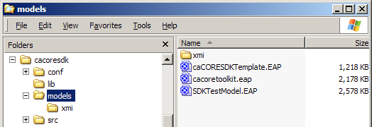
Figure 4.7: Enterprise Architect file for caCORE SDK model project

- Select View > Project Browser from the main menu bar of EA. The Project View displays.
- Click the Logical View plus sign.
- Click the Logical Model plus sign. Project view displays as shown in Figure 4.2.

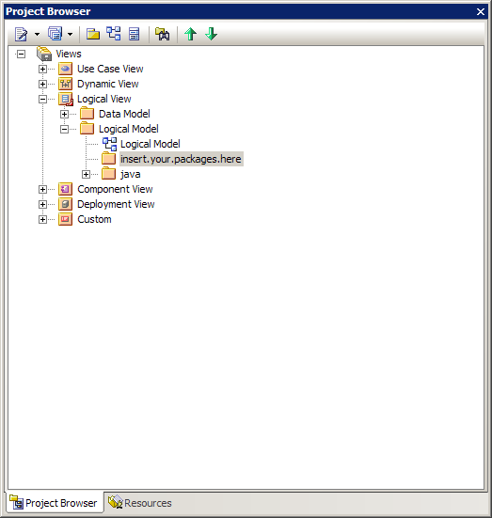
Figure 4.8: Project view for template project.

- Read the next section that provides some modeling related recommendations based on lessons learned by earlier analytical service developers. Follow the guidelines in “Chapter 5: Creating the UML Models” of the caCORE SDK Programmer’s guide to create new elements (classes) and the relationships between them. Also next section provides a tips and tricks based on lessons learned by earlier analytical service developers.

Modeling Related Recommendations for Analytical Services

Following are the tips and tricks provided by earlier analytical service developers:

- If you choose to use “Multiplicity “ for class attributes with upper bound of “many”, use “-1” instead of “*” (Figure 4.3)

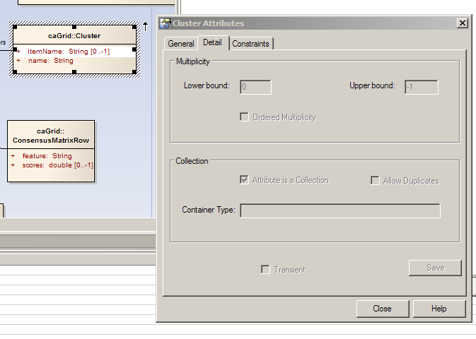
Figure 4.9: Adding multiplicity to attributes.

Alternatively, represent the attribute as a separate class and depict multiplicity using associations (Figure 4.4)
Figure 10.4: Representing multiplicity using class associations.

- You cannot reference external model files in your UML model project so your project needs to be self-contained. In other words, all the elements (classes) used in your class diagrams should be located in one project file.

- You should avoid under-specifying classes and attributes since such practices cause interoperability issues. Ideally the contents of objects instantiated from classes of you model should be processed in a uniform fashion without contacting you as a developer. For instance, defining a class attribute of “java.lang.String” type to store a 3 dimensional matrix as comma-separated element list, is not an acceptable practice for the users who are trying to use data based on your model, since there are many ways of parsing such data without your input.

- You can use Semantic Integration Workbench (SIW) option “Review Unannotated XMI File” mode to validate/check XMI representation of the UML Model exported by EA. This is an easy way to check for errors such as missing descriptions or documentation tags for classes and attributes. The details of this process can be found at “Chapter 7: Performing Semantic Integration” of the caCORE SDK Programmer’s guide.

- You should contact your Vocabulary and Common Data Elements (VCDE) mentor for guidance on modeling matrixes.

XML Schema Generation

Background
caGrid services are strongly typed, meaning that the structure of the data being passed between client and service is well defined. The data is structured in XML described by XML Schemas. In model-driven architecture (MDA), it is desirable to generate the XML Schemas directly from the UML model. This is possible using the Introduce toolkit, which leverages the caCORE SDK to generate XML Schemas directly from models defined in XMI. The following sections describe this in detail.

Resources
The following external resources may be useful as examples and instructions on XML Schema generation:

- caCORE SDK Programmers Guide

https://gforge.nci.nih.gov/docman/view.php/148/7346/caCORE_SDK_3.2.1_Programmers_Guide.pdf

- caGrid Wiki

http://www.cagrid.org

- caGrid User Guide

http://gforge.nci.nih.gov/frs/download.php/2386/caGrid-1-1_Users_Guide.pdf

- Example XMI file

https://gforge.nci.nih.gov/plugins/scmsvn/viewcvs.php/whitepaper/cabioExampleDomainModel.xmi?root=icrasbpwg&view=log

- Example EA file

https://gforge.nci.nih.gov/plugins/scmsvn/viewcvs.php/whitepaper/cacoretoolkit.eap?root=icrasbpwg&view=log

- Example Introduce-generated Grid Project

https://gforge.nci.nih.gov/plugins/scmsvn/viewcvs.php/whitepaper/ASBPSchemaGenerationService/?root=icrasbpwg

Model Generation
Follow the guidelines in the caCORE SDK user’s guide and the UML Modeling Primer chapter to create your model in Enterprise Architect (EA) (see example in Figure 5.). Generate an XMI file by selecting “Export Package to XMI” through the Project->Import/Export menu or by right-clicking on the model (Logical View) and selecting Import/Export (see Figure ). Be sure to select “Enable full EA Roundtrip” when generating XMI (see Figure ).

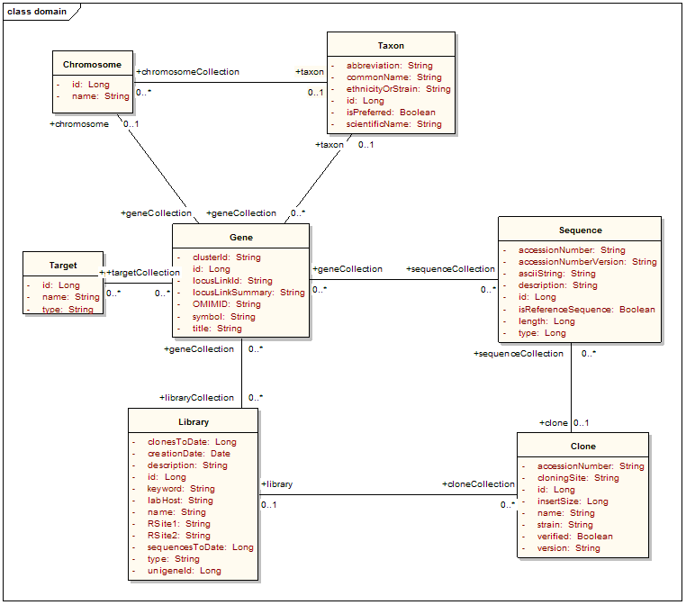
Figure 5.1 Example UML diagram from caBIO/caCORE SDK for XML Schema generation.

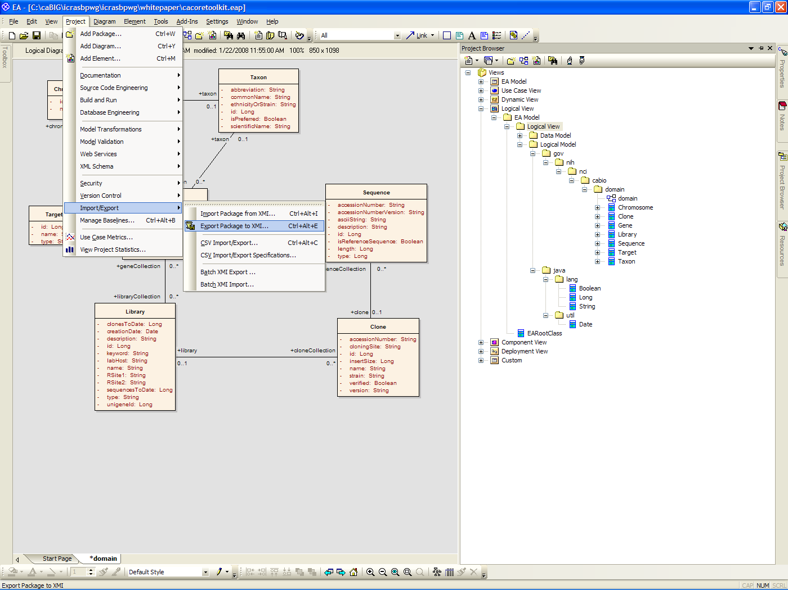
Figure 5.2 Menu to generate an XMI file from EA.

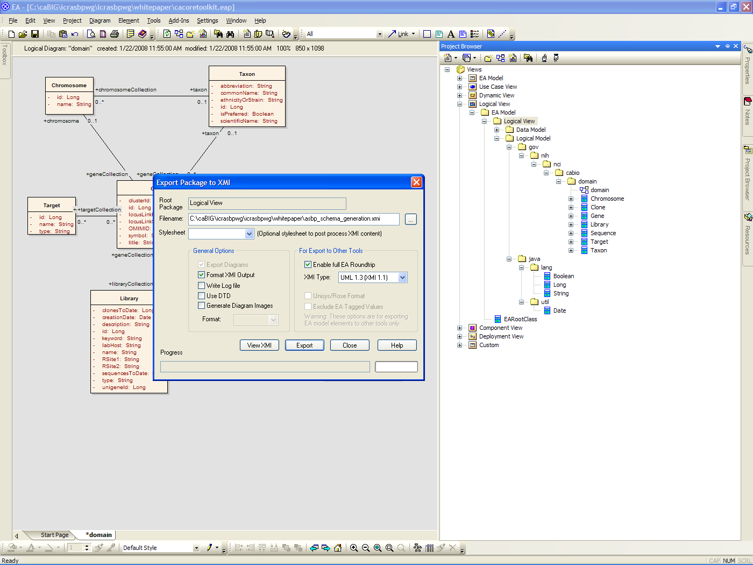
Figure 5.3 Dialog box to generate an XMI file. Be sure to select “Enable full EA Roundtrip.”

In Introduce, create your service. Then, in Types tab, select create from XMI. Enter the Model XMI File location, a regular expression for packages in the XMI file to include in the XML Schema generation, and the caDSR Context and Project Short Name (if unknown, enter another known project to be changed later) (see Figure 11). After the caCORE SDK is run, the types will show up in the Data Types list on the left-hand portion of the window (see Figure ). You can then add methods to your service skeleton with parameters and return types from the XMI (see Figure ).

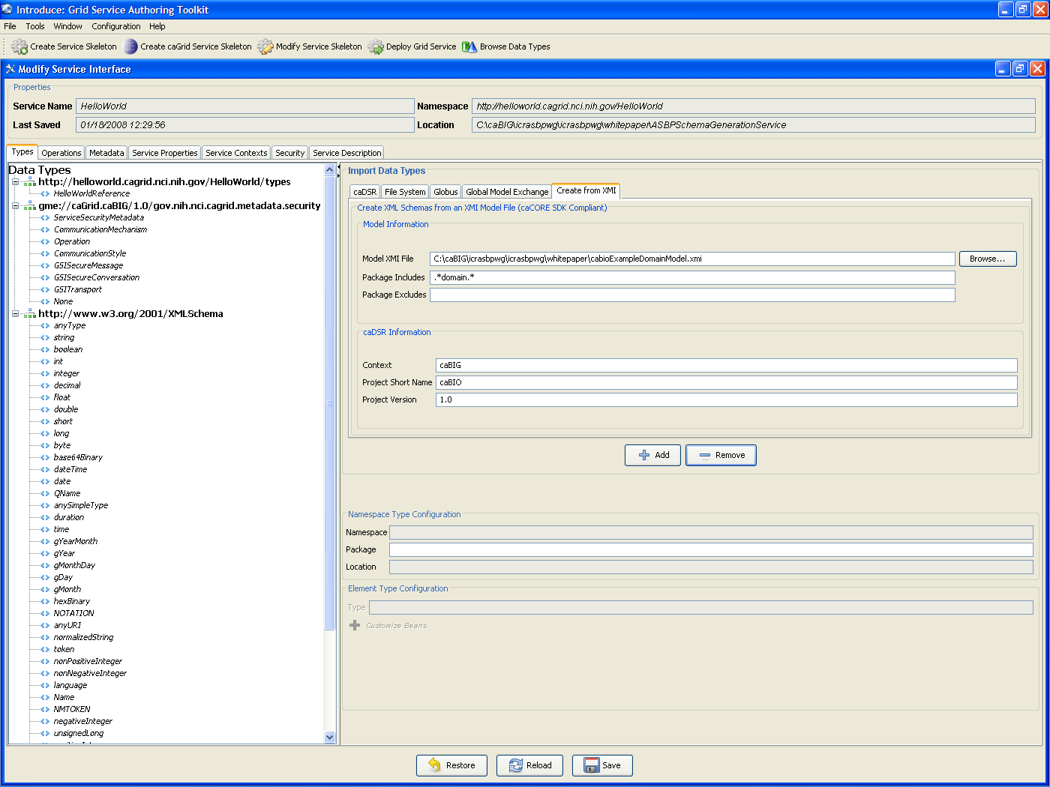
Figure 11.4 Screenshot of Introduce to add new data types from XMI.

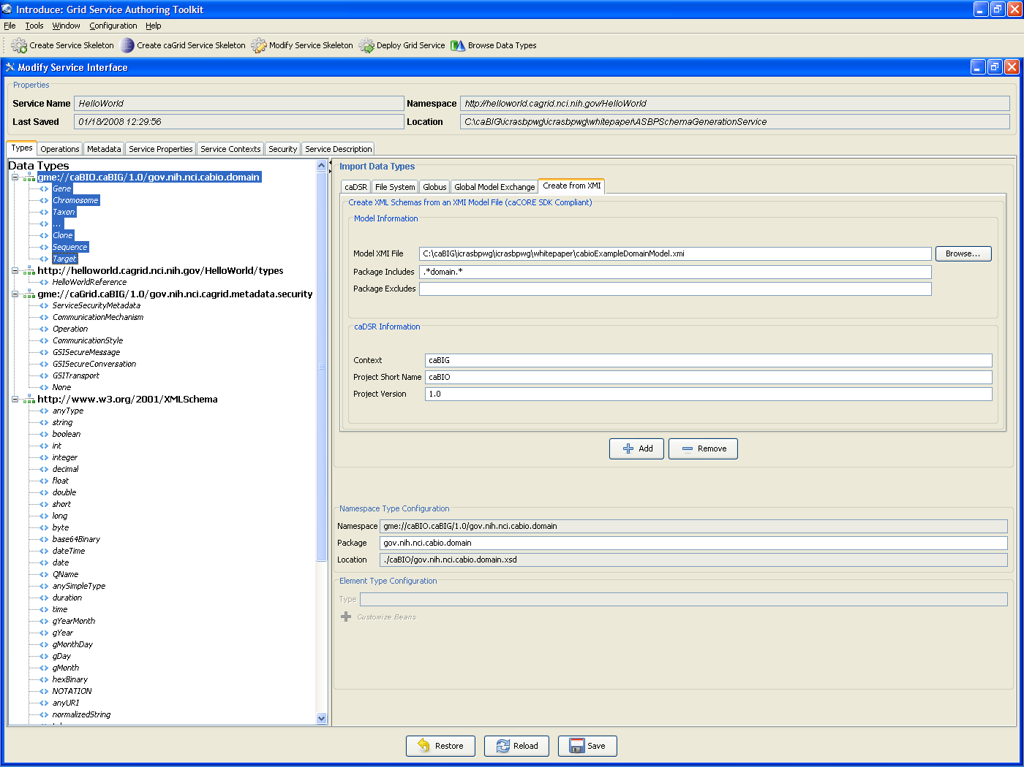
Figure 5.5 Newly created types show up in the data types list in Introduce.

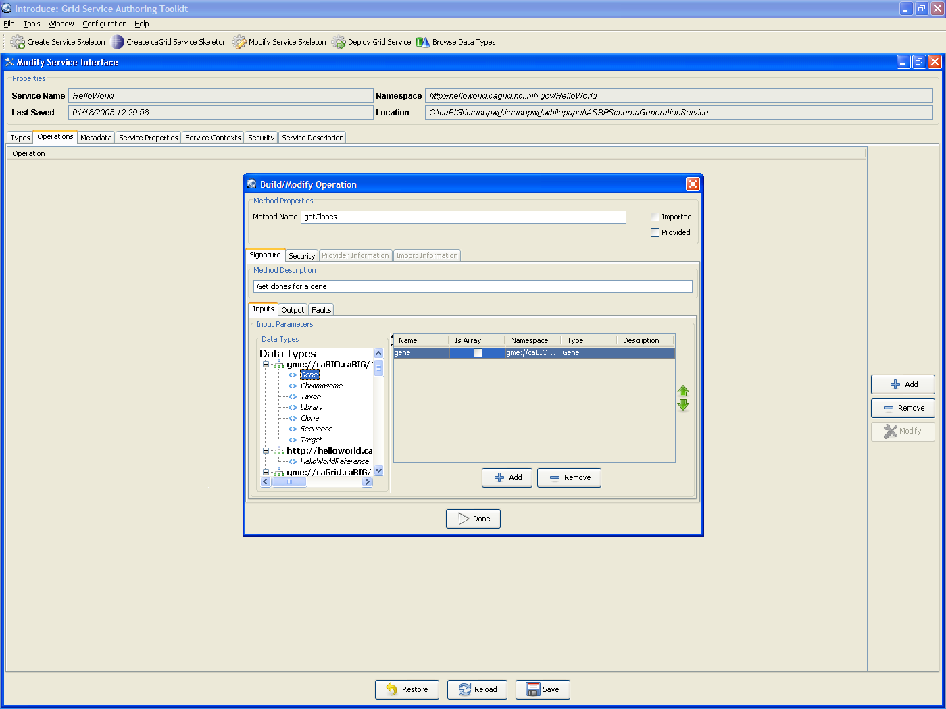
Figure 5.6 Add methods to your service skeleton with types generated from the XMI.

XML Schemas will be generated in the service skeleton under the schema directory within a subdirectory for your Project Short Name (see Figure ). The appropriate global elements, complex types, and sub-elements will be generated (see Figure ).

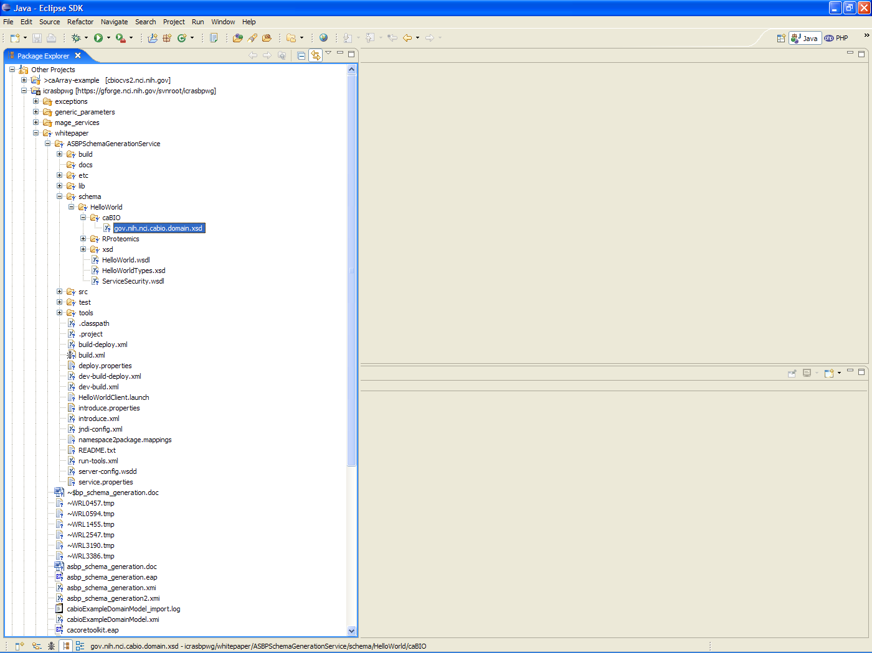
Figure 5.7 Location of XML Schemas within the Introduce-generate grid service project.

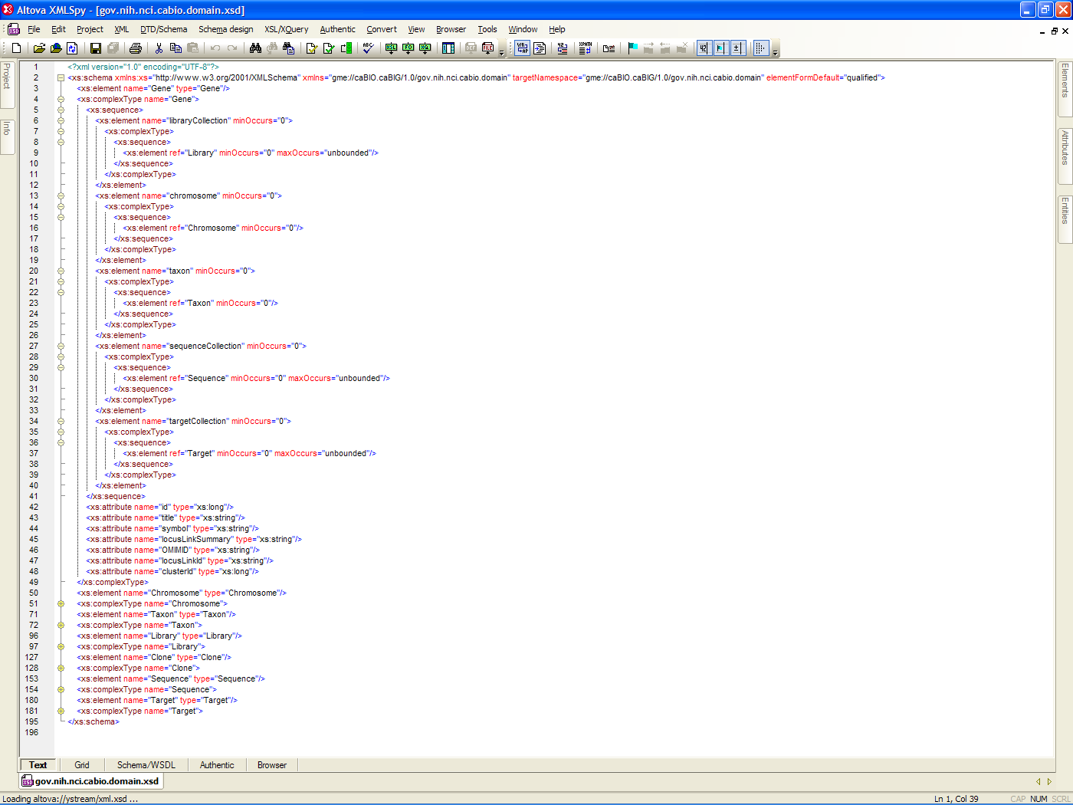
Figure 5.8 Example XML Schema generated from the caBIO/caCORE SDK example XMI.

5.3 Loading the Model XSD into the GME
The Global Model Exchange (GME) is a central service for managing and sharing XML Schemas. It should be the first place that a developer looks for reusing existing XML Schemas tied to datatypes.

GME query and upload functionality can be accessed through the Introduce toolkit by clicking on the “Browse Data Types” button at the top (see Figure 5). XML Schemas can be uploaded by clicking the Upload tab, selecting an XML Schema from the file system, and clicking upload (see Figure 5.10).
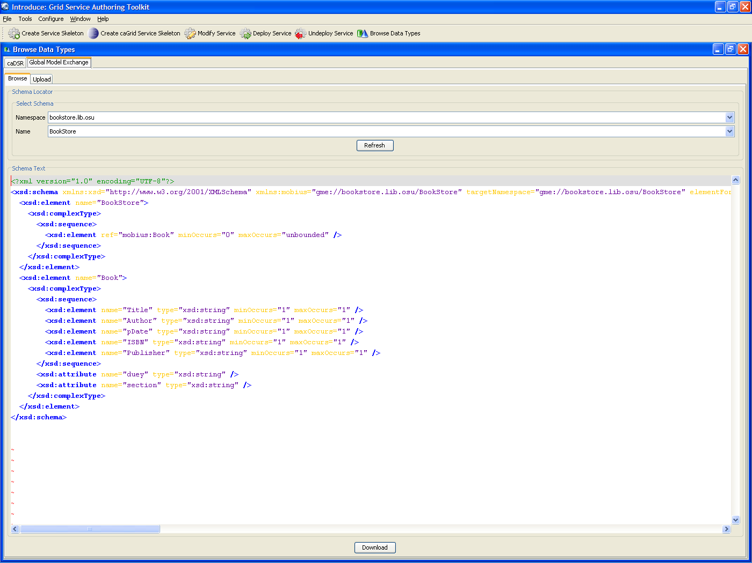
Figure 5.9 GME interface in “Browse Data Types” in Introduce.
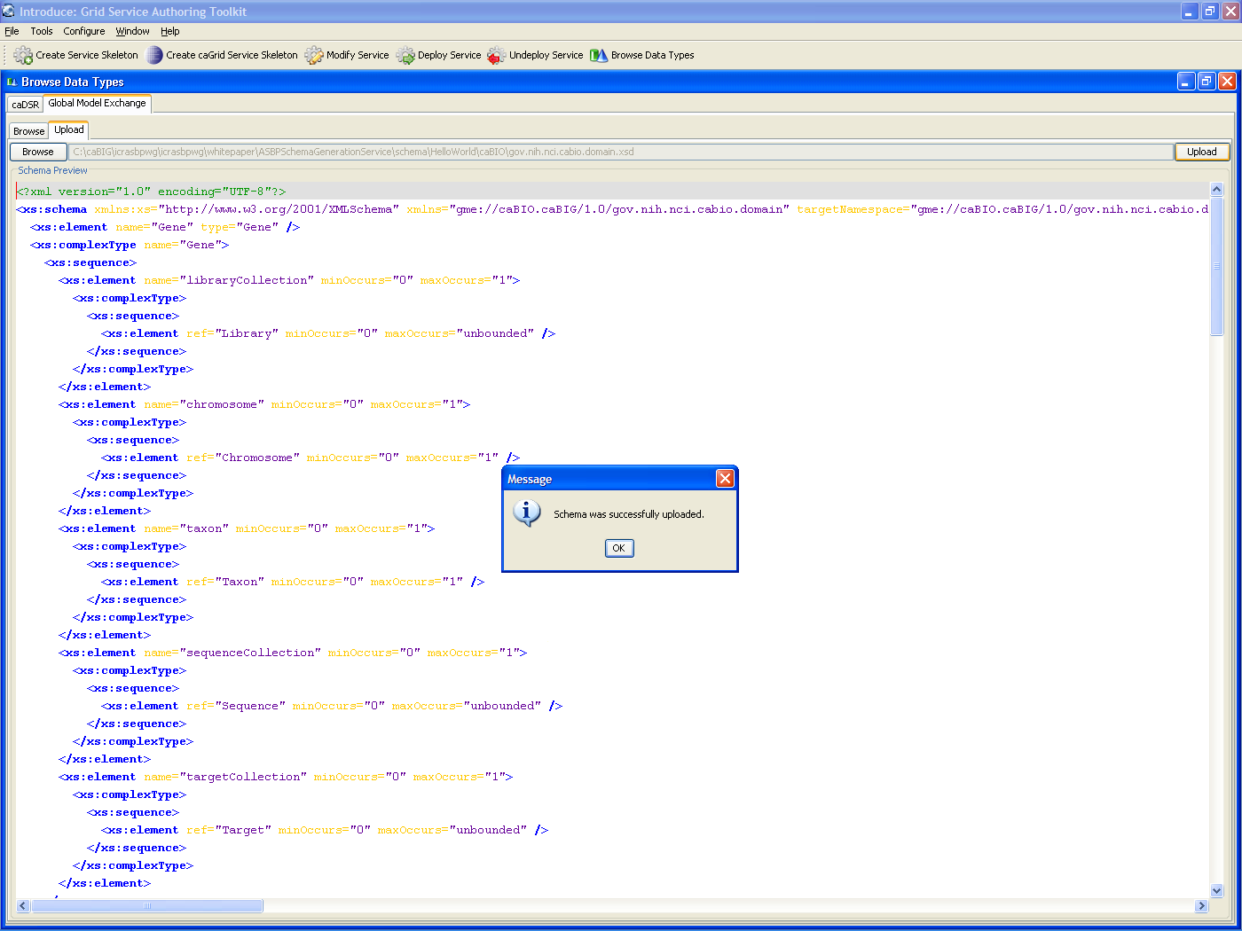
Figure 5.10 Upload example of the caBIO example XSD to the GME.

Implications for Reviewers

VCDE Reviewers
VCDE reviews will be slightly changed by the process as defined in this document. Some of the implications of this process are

  - Project UML Models will not contain reused models
  - Reused models will be referenced externally to project models
  - Interfaces in UML models will be disconnected
  - Develop tooling to consume serviceMetadata.xml

Project UML models will no longer re-import the entirety of reused models. Also, partial model reuse is discouraged as well. Therefore when a model is being reused in a caBIG project, it will reference the reused model but no longer include it. Projects reusing models will be required to provide links to or copies of reused models.

If any reused models are part of a project’s interface, then operations defined in the project’s UML model of the interface will reference the external objects by name, requiring the VCDE reviewers to load the reused models to examine the interface.

To eliminate the possibility of a mismatch between interfaces defined in the UML model, and the actual implementation of the interface in a caGrid service, we recommend developing tooling that can read serviceMetadata.ml files and present them to VCDE reviewers for review of the analysis service interfaces. For this to be effective, this will need to operate in a caGrid environment in which all of a project’s models are loaded (new and reused). This is expected to be possible in the sandbox environment following loading of new models, but prior to review of the service.

Appendix A. Additional entries for server-config.wsdd

<typeMapping xmlns:ns="gme://parameter.asbp/1/org.cabig.icr.asbp.parameter"
qname="ns:StringParameter"
type="java:org.cabig.icr.asbp.parameter.StringParameter"
serializer="org.apache.axis.encoding.ser.BeanSerializerFactory"
deserializer="org.apache.axis.encoding.ser.BeanDeserializerFactory"
encodingStyle=""/>

<typeMapping xmlns:ns="gme://parameter.asbp/1/org.cabig.icr.asbp.parameter"
qname="ns:BooleanParameter"
type="java:org.cabig.icr.asbp.parameter.BooleanParameter"
serializer="org.apache.axis.encoding.ser.BeanSerializerFactory"
deserializer="org.apache.axis.encoding.ser.BeanDeserializerFactory"
encodingStyle=""/>

<typeMapping xmlns:ns="gme://parameter.asbp/1/org.cabig.icr.asbp.parameter"
qname="ns:ShortParameter"
type="java:org.cabig.icr.asbp.parameter.ShortParameter"
serializer="org.apache.axis.encoding.ser.BeanSerializerFactory"
deserializer="org.apache.axis.encoding.ser.BeanDeserializerFactory"
encodingStyle=""/>

<typeMapping xmlns:ns="gme://parameter.asbp/1/org.cabig.icr.asbp.parameter"
qname="ns:LongParameter"
type="java:org.cabig.icr.asbp.parameter.LongParameter"
serializer="org.apache.axis.encoding.ser.BeanSerializerFactory"
deserializer="org.apache.axis.encoding.ser.BeanDeserializerFactory"
encodingStyle=""/>

<typeMapping xmlns:ns="gme://parameter.asbp/1/org.cabig.icr.asbp.parameter"
qname="ns:FloatParameter"
type="java:org.cabig.icr.asbp.parameter.FloatParameter"
serializer="org.apache.axis.encoding.ser.BeanSerializerFactory"
deserializer="org.apache.axis.encoding.ser.BeanDeserializerFactory"
encodingStyle=""/>

<typeMapping xmlns:ns="gme://parameter.asbp/1/org.cabig.icr.asbp.parameter"
qname="ns:DoubleParameter"
type="java:org.cabig.icr.asbp.parameter.DoubleParameter"
serializer="org.apache.axis.encoding.ser.BeanSerializerFactory"
deserializer="org.apache.axis.encoding.ser.BeanDeserializerFactory"
encodingStyle=""/>

<typeMapping xmlns:ns="gme://parameter.asbp/1/org.cabig.icr.asbp.parameter"
qname="ns:CharParameter"
type="java:org.cabig.icr.asbp.parameter.CharParameter"
serializer="org.apache.axis.encoding.ser.BeanSerializerFactory"
deserializer="org.apache.axis.encoding.ser.BeanDeserializerFactory"
encodingStyle=""/>

<typeMapping xmlns:ns="gme://parameter.asbp/1/org.cabig.icr.asbp.parameter"
qname="ns:IntegerParameter"
type="java:org.cabig.icr.asbp.parameter.IntegerParameter"
serializer="org.apache.axis.encoding.ser.BeanSerializerFactory"
deserializer="org.apache.axis.encoding.ser.BeanDeserializerFactory"
encodingStyle=""/>

Appendix B, GeneNeighbors ParameterListMetadata file

<?xml version="1.0" encoding="UTF-8" standalone="yes"?>
<parameterListMetadata>
<inputParameterName>performAnalysis</inputParameterName>
<operation>performAnalysis</operation>
<parameterMetadata>
<dataType>java.lang.String</dataType>
<defaultValue></defaultValue>
<description>reference gene accession from data file to find neighbors for</description>
<isRequired>true</isRequired>
<name>gene.accession</name>
<order>1</order>
</parameterMetadata>
<parameterMetadata>
<dataType>java.lang.String</dataType>
<defaultValue>0</defaultValue>
<description>continuous metric for finding neighbors</description>
<isRequired>true</isRequired>
<name>distance.metric</name>
<order>5</order>
<allowableValueCollection>
<permissableValue>3</permissableValue>
<valueMeaning>Pearson distance</valueMeaning>
</allowableValueCollection>
<allowableValueCollection>
<permissableValue>1</permissableValue>
<valueMeaning>Euclidean distance</valueMeaning>
</allowableValueCollection>
<allowableValueCollection>
<permissableValue>0</permissableValue>
<valueMeaning>Cosine distance</valueMeaning>
</allowableValueCollection>
<allowableValueCollection>
<permissableValue>2</permissableValue>
<valueMeaning>Manhattan distance</valueMeaning>
</allowableValueCollection>
</parameterMetadata>
<parameterMetadata>
<dataType>java.lang.String</dataType>
<defaultValue>no</defaultValue>
<description>if no, values below will be ignored</description>
<isRequired>true</isRequired>
<name>filter.data</name>
<order>6</order>
<allowableValueCollection>
<permissableValue>no</permissableValue>
<valueMeaning>no</valueMeaning>
</allowableValueCollection>
<allowableValueCollection>
<permissableValue>yes</permissableValue>
<valueMeaning>yes</valueMeaning>
</allowableValueCollection>
</parameterMetadata>
<parameterMetadata>
<dataType>java.lang.String</dataType>
<defaultValue>10</defaultValue>
<description>minimum threshold for data</description>
<isRequired>true</isRequired>
<name>min.threshold</name>
<order>7</order>
</parameterMetadata>
<parameterMetadata>
<dataType>java.lang.String</dataType>
<defaultValue>16000</defaultValue>
<description>maximum threshold for data</description>
<isRequired>true</isRequired>
<name>max.threshold</name>
<order>8</order>
</parameterMetadata>
<parameterMetadata>
<dataType>java.lang.String</dataType>
<defaultValue>5</defaultValue>
<description>minimum fold difference for filtering genes</description>
<isRequired>true</isRequired>
<name>min.fold.diff</name>
<order>9</order>
</parameterMetadata>
<parameterMetadata>
<dataType>java.lang.String</dataType>
<defaultValue>50</defaultValue>
<description>minimum absolute difference for filtering genes</description>
<isRequired>true</isRequired>
<name>min.abs.diff</name>
<order>10</order>
</parameterMetadata>
</parameterListMetadata>

Appendix C Generating XML Schema files from Enterprise Architect

While it is preferred that XML Schema (XSD) are reused from the GME, or failing that, that the XMI conforms to the caCore requirements and can be directly loaded into Introduce, in some cases it will be necessary to create an XSD file from Enterprise Architect. This appendix will help with the details of generating on XSD from enterprise architect.

Step one, use EA to generate the XSD file. The EA generated schema’s will then need to be modified as follows;

- Add a target namespace
- Set the target namespace prefix before all type references in the schema
- Change all type definitions of java.lang.String to xs:string.
- Qualify any other basic types (integer etc) with "xs:", lowercase type names (Integer->integer)
- Checked cardinality restrictions
- Remove minOccurs and maxOccurs tags for non-sequence elements

For example,

<?xml version="1.0" encoding="ISO-8859-1"?>
<xs:schema xmlns:xs="http://www.w3.org/2001/XMLSchema">
<xs:element name="ParameterListMetadata" type="ParameterListMetadata"/>
<xs:complexType name="ParameterListMetadata">
<xs:sequence>
<xs:element name="inputParameterName" type="String" minOccurs="1" maxOccurs="1"/>
<xs:element name="operationName" type="String" minOccurs="1" maxOccurs="1"/>
<xs:element name="parameterMetadataCollection" type="ParameterMetadata" minOccurs="1" maxOccurs="unbounded"/>
</xs:sequence>
</xs:complexType>
<xs:element name="ParameterMetadata" type="ParameterMetadata"/>
<xs:complexType name="ParameterMetadata">
<xs:sequence>
<xs:element name="cdePublicId" type="xs:long" minOccurs="0" maxOccurs="1"/>
<xs:element name="cdeVersion" type="xs:float" minOccurs="0" maxOccurs="1"/>
<xs:element name="dataType" type="String" minOccurs="1" maxOccurs="1"/>
<xs:element name="defaultValue" type="String" minOccurs="1" maxOccurs="1"/>
<xs:element name="description" type="String" minOccurs="1" maxOccurs="1"/>
<xs:element name="isRequired" type="xs:boolean" minOccurs="1" maxOccurs="1"/>
<xs:element name="name" type="String" minOccurs="1" maxOccurs="1"/>
<xs:element name="order" type="xs:int" minOccurs="0" maxOccurs="1"/>
<xs:element name="semanticMetadataCollection" type="SemanticMetadata" minOccurs="0" maxOccurs="unbounded"/>
<xs:element name="allowableValueCollection" type="AllowableValue" minOccurs="0" maxOccurs="unbounded"/>
</xs:sequence>
</xs:complexType>
<xs:element name="SemanticMetadata" type="SemanticMetadata"/>
<xs:complexType name="SemanticMetadata">
<xs:sequence>
<xs:element name="conceptCode" type="String" minOccurs="1" maxOccurs="1"/>
<xs:element name="conceptDefinition" type="String" minOccurs="1" maxOccurs="1"/>
<xs:element name="conceptName" type="String" minOccurs="1" maxOccurs="1"/>
<xs:element name="order" type="xs:int" minOccurs="0" maxOccurs="1"/>
<xs:element name="orderLevel" type="xs:int" minOccurs="0" maxOccurs="1"/>
</xs:sequence>
</xs:complexType>
<xs:element name="AllowableValue" type="AllowableValue"/>
<xs:complexType name="AllowableValue">
<xs:sequence>
<xs:element name="permissableValue" type="String" minOccurs="1" maxOccurs="1"/>
<xs:element name="valueMeaning" type="String" minOccurs="0" maxOccurs="1"/>
</xs:sequence>
</xs:complexType>
</xs:schema>

Becomes this

<?xml version="1.0" encoding="ISO-8859-1"?>
<xs:schema xmlns:xs="http://www.w3.org/2001/XMLSchema" targetNamespace="gme://parameter.asbp/1/org.cabig.icr.asbp.parametermetadata" xmlns:pm="gme://parameter.asbp/1/org.cabig.icr.asbp.parametermetadata" >
<xs:element name="ParameterListMetadata" type="pm:ParameterListMetadata"/>
<xs:complexType name="ParameterListMetadata">
<xs:sequence>
<xs:element name="inputParameterName" type="String" minOccurs="1" maxOccurs="1"/>
<xs:element name="operationName" type="String" minOccurs="1" maxOccurs="1"/>
<xs:element name="parameterMetadataCollection" type="ParameterMetadata" minOccurs="1" maxOccurs="unbounded"/>
</xs:sequence>
</xs:complexType>
<xs:element name="ParameterMetadata" type="pm:ParameterMetadata"/>
<xs:complexType name="ParameterMetadata">
<xs:sequence>
<xs:element name="cdePublicId" type="xs:long" minOccurs="0" maxOccurs="1"/>
<xs:element name="cdeVersion" type="xs:float" minOccurs="0" maxOccurs="1"/>
<xs:element name="dataType" type="xs:string" minOccurs="1" maxOccurs="1"/>
<xs:element name="defaultValue" type="xs:string" minOccurs="1" maxOccurs="1"/>
<xs:element name="description" type="xs:string" minOccurs="1" maxOccurs="1"/>
<xs:element name="isRequired" type="xs:boolean" minOccurs="1" maxOccurs="1"/>
<xs:element name="name" type="xs:string" minOccurs="1" maxOccurs="1"/>
<xs:element name="order" type="xs:int" minOccurs="0" maxOccurs="1"/>
<xs:element name="semanticMetadataCollection" type="SemanticMetadata" minOccurs="0" maxOccurs="unbounded"/>
<xs:element name="allowableValueCollection" type="AllowableValue" minOccurs="0" maxOccurs="unbounded"/>
</xs:sequence>
</xs:complexType>
<xs:element name="SemanticMetadata" type="pm:SemanticMetadata"/>
<xs:complexType name="SemanticMetadata">
<xs:sequence>
<xs:element name="conceptCode" type="xs:string" minOccurs="1" maxOccurs="1"/>
<xs:element name="conceptDefinition" type="xs:string" minOccurs="1" maxOccurs="1"/>
<xs:element name="conceptName" type="xs:string" minOccurs="1" maxOccurs="1"/>
<xs:element name="order" type="xs:int" minOccurs="0" maxOccurs="1"/>
<xs:element name="orderLevel" type="xs:int" minOccurs="0" maxOccurs="1"/>
</xs:sequence>
</xs:complexType>
<xs:element name="AllowableValue" type="pm:AllowableValue"/>
<xs:complexType name="AllowableValue">
<xs:sequence>
<xs:element name="permissableValue" type="xs:string" minOccurs="1" maxOccurs="1"/>
<xs:element name="valueMeaning" type="xs:string" minOccurs="0" maxOccurs="1"/>
</xs:sequence>
</xs:complexType>
</xs:schema>

Appendix D Process to submit analytical service for loading to caDSR

Process to submit analytical service for loading to caDSR:

- Create a UML model that contains any new input/output classes, unique to your service. NOTE: Do you also need to include input/output classes reused from other models? My understanding is NO, but we need to get that confirmed by Denise/George.
- Submit this UML Model as a domain model for loading to caDSR.
- Add your analytical service to the caGrid.
- Submit the servicemetadata.xml file created in step 3 to App Support (ncicb@pop.nci.nih.gov) as part of the analytical services submission package. Also, for now, fill out part 3 (contact information) only in the submission form and zip with the XML file to create the complete submission package.
- App Support will send the submission package on to NCICB staff to be loaded to SANDBOX via the service loader
- After service is loaded, App Support will notify the model owner to review the service in caDSR and approve
- Model owner will approve service on SANDBOX and request App Support to load on PRODUCTION.
- App Support will send on request to load service to PRODUCTION.
- After model is loaded by NCICB staff, App Support will notify model owner to approve service on PRODUCTION.
- Service is ready to be reviewed by Silver/Gold Compatibility Review committee.

