Iteration Plan
caArray 2.0 - Construction 1

Last Revised: | September 11, 2007
Produced By: | caArray Development Team
Version: | 0.2

Document Approvals
The list contains the name and contact information for the core project team and any key stakeholders who have an interest in the success of the project. An “S” identifies persons responsible for approval from the Business and Development. Sign off of the document would be required when a decision is made not to take action for defined gaps.

S | Name | Role | S | Name | Role
S | Anand Basu | NCICB Engineering Manager | S | Juli Klemm, Ph.D. | Product Manager
 | Brent Gendleman | Development Project Manager |  | Jerry Eads | NCICB Project Manager
 | Eric Tavela | Development Architect |  | Ron Keene | NCICB Independent QA
 | Don Swan | NCICB Application Support
Revision History
When you make a change to a document, you must add an entry to this Revision History table and you must manually type the Last Revised Date on the front cover.

Date | Version | Description | Revised by
8/30/07 | 0.1 | Initial Draft | Brent Gendleman
9/11/07 | 0.2 | Updated Per Review with Dev Team | Brent Gendleman
Copyrights and Trademarks
© Copyright 2007 by NCICB, caBIGTM. All rights reserved.

Table of Contents
1. Introduction 4
1.1. References 4
2. Plan 4
2.1. Iteration Schedule 4
3. Resources 6
4. Use Cases 6
4.1. Specifications to be detailed 6
4.2. Analysis to be performed 7
4.3. Software to be delivered 7
5. Evaluation Criteria 8

Introduction
This Iteration Plan describes the detailed plans for the C1 Iteration of caArray 2.0. The Iteration duration will be from September 7 to October5. In addition, while E2 can claim many successes, we were unexpectedly short staffed and had misestimated the level of effort to establish the Grid API. Therefore, there was unfinished business that needs to be delivered in this iteration in addition to what was already planned.

References
- project_management/caarray_schedule.mpp
- requirements/caarray_vision.doc
- requirements/caarray_use_case _summary.doc
- analysis_and_design/caarray_software_architecture_document.doc

Plan

Iteration Schedule
As the iteration evolves over time, updates will be made to the Microsoft Project schedule on at least a weekly basis with 1 hour reviews scheduled each Wednesday. However, in order to support evaluating how we execute against the plan, the schedule is produced below.
Discipline/Task | Duration | Start | Finish
Project Management | 21 d | 9/7/2007 | 10/5/2007
Weekly Status Meetings | 21 d | 9/7/2007 | 10/5/2007
Dev Team Iteration Plan | 1 d | 9/14/2007 | 9/14/2007
Meet with Documentation to support UC Transition | 1 d | 9/19/2007 | 9/19/2007
Meet with App Support to Validate UC's and Overall Product Releases | 1 d | 9/20/2007 | 9/20/2007
E2 Assessment/C1 Review | 0.5 d | 9/21/2007 | 9/21/2007
Plan for Next Iteration | 2 d | 10/1/2007 | 10/2/2007
Finalize Deliverables | 17 d | 9/7/2007 | 10/1/2007
Deliver C1 Plan | 4 d | 9/7/2007 | 9/12/2007
Update Risk List | 1 d | 9/20/2007 | 9/20/2007
Update Alpha and Beta Release Plan | 17 d | 9/7/2007 | 10/1/2007
August Status Report | 0.5 d | 9/17/2007 | 9/17/2007
Finalize C2 Iteration Plans | 8.5 d | 9/7/2007 | 9/19/2007
Requirements | 20 d | 9/7/2007 | 10/4/2007
Incorporate Stakeholder Feedback on Vision and Supp Spec | 16 d | 9/7/2007 | 9/28/2007
Incorporate Stakeholder Feedback on E2 Use Cases | 16 d | 9/7/2007 | 9/28/2007
Incorporate Stakeholder Feedback on UI Mockups | 10 d | 9/21/2007 | 10/4/2007
Update and Create C1 + C2 Wireframes and Mockups | 15 d | 9/7/2007 | 9/27/2007
Capture Special Requirements for SNPs | 4.17 d | 9/7/2007 | 9/13/2007
2.0 Scope Document | 1 d | 9/21/2007 | 9/21/2007
Detail C1 Use Cases | 2.5 d | 9/10/2007 | 9/12/2007
UC Update Experiment Proposal | 0.5 d | 9/10/2007 | 9/10/2007
UC Register For An Account | 1 d | 9/10/2007 | 9/11/2007
UC Manage Collaborators | 1 d | 9/11/2007 | 9/12/2007
Detail 2.x Use Cases | 9 d | 9/12/2007 | 9/25/2007
UC Manage Institutions | 1 d | 9/12/2007 | 9/13/2007
UC Organize Workspace | 5 d | 9/12/2007 | 9/19/2007
UC Approve Project | 0.5 d | 9/19/2007 | 9/19/2007
UC Assign Project | 0.5 d | 9/20/2007 | 9/20/2007
UC Search for Arrays Using Natural Text | 2 d | 9/20/2007 | 9/24/2007
UC Import Contextual Data | 1 d | 9/24/2007 | 9/25/2007
Analysis and Design | 17 d | 9/7/2007 | 10/1/2007
Use Case Design | 7 d | 9/10/2007 | 9/18/2007
Manage Experiment Permissions | 2.14 d | 9/10/2007 | 9/12/2007
Register for an Account | 1 d | 9/13/2007 | 9/13/2007
Navigate Repository | 1 d | 9/14/2007 | 9/14/2007
Search | 1 d | 9/17/2007 | 9/17/2007
Manage Collaborators | 1 d | 9/18/2007 | 9/18/2007
Manage Users | 2 d | 9/17/2007 | 9/18/2007
Finalize SubSystem Design | 4 d | 9/7/2007 | 9/12/2007
PermissionsManagementService | 3 d | 9/7/2007 | 9/11/2007
Authorization Mechanism | 1 d | 9/12/2007 | 9/12/2007
Revise and Document Grid API | 3 d | 9/7/2007 | 9/11/2007
External Review: Revised Grid API | 0.5 d | 9/24/2007 | 9/24/2007
Revise Domain Object Model w/Mentor | 3 d | 9/24/2007 | 9/27/2007
Update Software Architecture Document | 1 d | 10/1/2007 | 10/1/2007
Implementation | 15 d | 9/7/2007 | 9/27/2007
Complete Transition from JSF to Struts 2 | 5 d | 9/7/2007 | 9/13/2007
Complete Elaboration Use Cases | 15 d | 9/7/2007 | 9/27/2007
Implement UC Login | 1 d | 9/7/2007 | 9/7/2007
Implement UC Acquire Experiment Data via API | 2 d | 9/7/2007 | 9/10/2007
Implement UC Import Experiment Data | 3 d | 9/13/2007 | 9/17/2007
Implement UC Manage Project Permissions | 3 d | 9/11/2007 | 9/13/2007
Implement Validate Experiment Data | 2 d | 9/24/2007 | 9/25/2007
Integrate Stylesheet Throughout | 5 d | 9/18/2007 | 9/24/2007
Implement UC Manage Project Data Files (to support sample to file allocation) | 3 d | 9/25/2007 | 9/27/2007
Implement UC Submit Project Proposal | 3 d | 9/24/2007 | 9/26/2007
Begin C1 Use Cases | 9 d | 9/10/2007 | 9/20/2007
Manage Experiment Permissions | 5 d | 9/10/2007 | 9/14/2007
Manage Users | 2 d | 9/14/2007 | 9/17/2007
Manage Collaborators | 2 d | 9/19/2007 | 9/20/2007
Register for an Account | 2 d | 9/17/2007 | 9/18/2007
Complete Subsystem Implementation | 5 d | 9/7/2007 | 9/13/2007
PermissionsManagement | 2 d | 9/10/2007 | 9/11/2007
Object Access Authorization Mechanism | 2 d | 9/7/2007 | 9/10/2007
Remote API Grid Implementation | 5 d | 9/7/2007 | 9/13/2007
Test | 19 d | 9/10/2007 | 10/5/2007
Project Data Files Test Suite | 1 d | 9/21/2007 | 9/21/2007
Validation Test Suite | 15 d | 9/10/2007 | 9/28/2007
Update Elaboration Test Suite | 3 d | 9/28/2007 | 10/2/2007
Release QA Build C1A | 0 d | 9/21/2007 | 9/21/2007
Release QA Build C1B | 0 d | 10/5/2007 | 10/5/2007
Environment | 16.5 d | 9/10/2007 | 10/2/2007
Acquire STAGE Environment | 5 d | 9/10/2007 | 9/14/2007
Update ARC Document | 0.5 d | 9/17/2007 | 9/17/2007
Initiate DEV to QA to STAGE Deployment | 10 d | 9/17/2007 | 10/1/2007
Update Build and Deploy Plan with SCM Initiative | 1 d | 10/1/2007 | 10/2/2007
Configuration and Change Management | 20 d | 9/7/2007 | 10/4/2007
Incorporate Defect Tracking Specifics | 5 d | 9/7/2007 | 9/13/2007
Manage G-Forge Content | 20 d | 9/7/2007 | 10/4/2007
C1 Complete | 0 d | 10/5/2007 | 10/5/2007

Resources
The development team will be at partial strength with 7 individuals. They are:
Team Member | Role | Percentage on Project
Brent Gendleman | Project Manager/Requirements Analyst | 50%
Eric Tavela | Architect | 60%
Bill Mason | Developer/PM Support | 100%
Todd Parnell | Developer | 100%
Dan Kokotov | Developer | 20%
John Hedden | Developer | 100%
Matt Rehfuss | UI Designer | 80%
Rashmi Srinivasa | Developer | 0%

There are several vacations and other absences described below:
Dan Kokotov – out from September 15-October 8
Eric Tavela – out from September 1 – September 17 (MGED Conference + Vacation)
Rashmi Srinivasa – on maternity leave from August 13- October 13
In addition, Brent Gendleman will be onsite at the NCICB from between September 5 – 24

Use Cases
This section will describe at a high level what requirements, analysis and implementation will occur for C1 to be considered a success.

Specifications to be detailed
For this iteration, we will prioritize the detailing of the following use cases:
  - UC Manage Experiment Permissions
  - UC Register for an Account
  - UC Manage Collaborators
These should be done first to support analysis and design activities occurring during C1. This completes the set of 2.0 Use Cases. The entirety of all use cases that will be implemented in 2.0 will be visualized through wireframes and html mockups culminating in a style sheet to be incorporated in C1 and completed in C2.
If there is time, we will detail 2.0+ use cases highlighted above in the schedule. This is more to remind ourselves that we need to be able to move quickly into 2.1, 2.2 and ensure that the deliveries won’t be held up by a lack of clarified requirements.

Analysis to be performed
Document Data Storage and Retrieval Design
Come up with a strategy to synchronize the EA domain (e.g., logical) model, the java classes and the grid service
Strategy for building the Grid Service along with the application
Document Strategy for Performance Testing
Determine CSM 3.2 or 4.0 and document use case designs accordingly

Software to be delivered
The use cases in Blue are ones initiated in E1 or E2 and the ones in white are being introduced in C1.
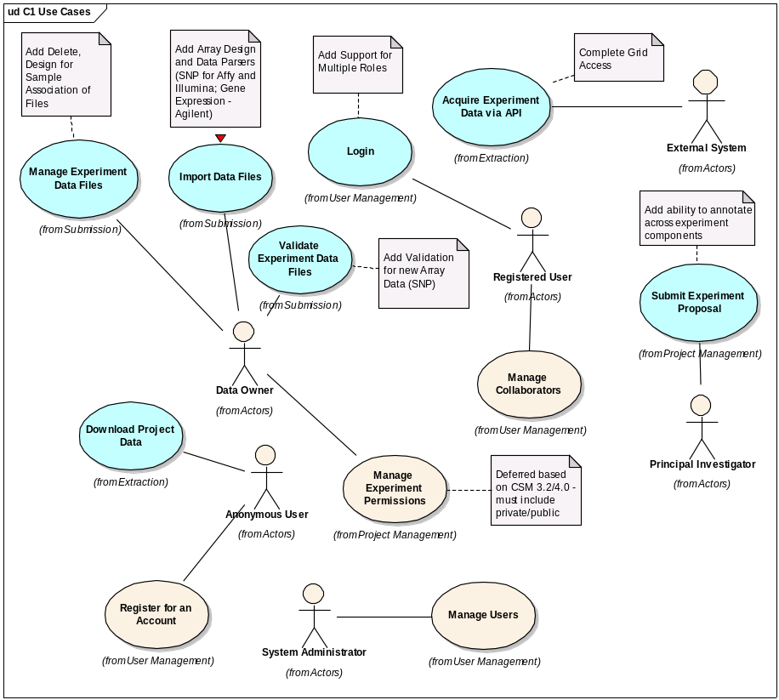
Figure 1 Use Cases for C1 Delivery

Evaluation Criteria
The primary goal of the C1 Iteration is to complete the analysis and design of selected use cases, document the Software Architecture in detail to allow us to move forward toward production, prepare for the alpha to be released in C2 and support the efficiency of the full development team that will be available in C2. The major results we need to achieve by the end of the iteration are:
- Detail the Schedule for the remainder of the release
- Complete the High Level Requirements Documentation (Vision, Use Case Summary, Supplemental Specs)
- Begin coordinating with the Documentation Team to support end user documentation and help
- Complete the Wireframes for all 2.0 UI
- Document process for Defect Tracking
- Collaborate with QA, Systems and Documentation to allow them to ramp up into the full delivery of 2.0
- Provide the ability to upload, validation, parsing and storage of SNP (Illumina and Affy) and Gene Expression (Illumina and Agilent)
- Ensure the Grid Service is available to be built along with the software
- Complete the switch from JSF to Struts 2 for the UI
- Have the Software Architecture reviewed by internal and external stakeholders with the 2.0 direction approved.
- Enable Grid accessibility to data
- Finalize the Domain Object Model for caArray to support one last revision to the API prior to Alpha Release Oct. 19
- Automate the deployment from DEV to QA to STAGE (for User Acceptance Testing)
- Tech Stack Compatibility with Bundled Tools for the December Release
- Modify the integration build will check whether the grid service and java object are synch

