Iteration Plan
caArray 2.0 - Construction 2

Last Revised: | October 6, 2007
Produced By: | caArray Development Team
Version: | 0.3

Document Approvals
The list contains the name and contact information for the core project team and any key stakeholders who have an interest in the success of the project. An “S” identifies persons responsible for approval from the Business and Development. Sign off of the document would be required when a decision is made not to take action for defined gaps.

S | Name | Role | S | Name | Role
S | Anand Basu | NCICB Engineering Manager | S | Juli Klemm, Ph.D. | Product Manager
 | Brent Gendleman | Development Project Manager | S | George Komatsoulis, Ph.D. | CBIIT IQA Manager
 | Eric Tavela | Development Architect |  | Tom Boal | NCICB Independent QA Lead
 | Don Swan | NCICB Application Support Lead
Revision History
When you make a change to a document, you must add an entry to this Revision History table and you must manually type the Last Revised Date on the front cover.

Date | Version | Description | Revised by
9/30/07 | 0.1 | Initial Draft | Brent Gendleman
10/03/07 | 0.2 | Revised to reflect C1 Status, Reorganized to support assigned responsibilities, relationship to upcoming deadlines in C2, C3, T1 | Brent Gendleman
10/7/07 | 0.3 | Revised post Scope Meeting – expect 1 more revision based on finalized scope but next 2 weeks are solid | Brent Gendleman
Copyrights and Trademarks
© Copyright 2007 by CBIIT, caBIGTM. All rights reserved.

Table of Contents
1. Introduction 4
1.1. References 4
2. Plan 4
2.1. Fundamental Tasks for Alpha 4
2.2. Iteration Schedule 5
3. Resources 7
4. Use Cases 8
4.1. Specifications to be detailed 8
4.2. Analysis to be performed 8
4.3. Implementation to be Performed 9
4.4. Test 9
4.5. Environment 10
5. Evaluation Criteria 10

Introduction
This Iteration Plan describes the detailed plans for the C2 Iteration of caArray 2.0. The Iteration duration will be from October 8 to November 2. In addition, we have been unable to make up the ground from previous iterations E2 and C1 and need to address key functional areas and have a scope discussion for the 2.0 release. Many architectural issues – including but not limited to our use of CSM 4.0, caGRID 1.1., switch from JSF to Struts2, Domain Model Changes and associated impact, build and deployment automation across tiers have been overcome. However, we are roughly a full team month behind schedule which has a cascading affect on the other teams we depend on for the software to be successful (IQA, App Support, Documentation, Senior Management, caBIG clients and mentors). Other Architectural Issues remain that will be dealt with during the first week of the iteration – primarily a thorough understanding of the architectural framework, the ability to set and reach performance metrics, and the building out of the application’s features on top of the significant plumbing established. This is our plan to come out of the hole we dug ourselves and position the project with the opportunity for momentum and confidence to be rebuilt.

References
- project_management/caarray_schedule.mpp
- requirements/caarray_vision.doc
- requirements/caarray_use_case _summary.doc
- requirements/user_interface/wireframes/
- analysis_and_design/caarray_software_architecture_document.doc
- caarray gforge: https://gforge.nci.nih.gov/projects/caarray2/ (specifically the trackers for features, use cases, supplemental, test cases and defects)

Plan

Fundamental Tasks for Alpha
There is a significant milestone on October 19 – the desired release date of the Alpha Build. The entire focus of the team will be to support getting the software into a state where the entire team feels comfortable that the release is stable and worthwhile. While covered in a bit more detail in the remainder of this document, we are highlighting it here. The following key components must be available and validated:
Use Case/Component | State | Assigned Team Member
Domain Model | Approved | Eric Tavela
Performance Benchmarks | Set and Met by Dev, Validated by IQA | Bill Mason
Acquire Experiment Data Via API | Java and Grid Validated by IQA | Todd Parnell
Login | Ability to login and logout with different roles (PI default) | John Hedden
Register | Create an account (DB or LDAP) | John Hedden with support from Scott Miller
Upload Experiment Data Files | MAGE-TAB, Gene Expression, SNP for Affy and Illumina  Multiple files (.zip file representation to come next) | John Hedden with Eric Tavela for data support
Validate Experiment Data Files | MAGE-TAB, Gene Expression, SNP for Affy and Illumina | Bill Mason with Eric Tavela for data support
Import Experiment Data Files | MAGE-TAB, Gene Expression, SNP for Affy and Illumina | Eric Tavela
Manage Experiment Data File | Change Type and Delete | Bill Mason
Submit Experiment Proposal | Minimum Annotation to support experiment identity (summary data), save as draft, submit | Dan Kokotov
Update Experiment Proposal | Edit and Submit a draft experiment | Dan Kokotov
Manage Permissions | Set public/private flag on experiment | Todd Parnell
Download Data | Retrieve data through the UI (not full UI implementation) | Todd Parnell

Iteration Schedule
As the iteration evolves over time, updates will be made to the Microsoft Project schedule twice a week (Monday and Thursday) and the notes of the meeting will be distributed to the Product and Engineering Manager. We will also have 1 hour reviews scheduled each Wednesday with the Product and Engineering Manager and weekly Status Meetings across the entire team. While the schedule will be updated, it’s represented here at the start of C2 to support evaluating how we execute against the plan.
Task | Duration | Start Date | End Date
Project Management | 20d | Mon 10/8/07 | Fri 11/2/07
Weekly Status Meetings | 20d | Mon 10/8/07 | Fri 11/2/07
Dev Team Iteration Plan | 1d | Mon 10/8/07 | Mon 10/8/07
Prepare Alpha Release Plan and Organization | 1.67d | Wed 10/17/07 | Thu 10/18/07
Organize Feedback from Alpha Testers | 3.33d | Tue 10/23/07 | Fri 10/26/07
Evolve RMP to support QA Process | 1d | Mon 10/8/07 | Mon 10/8/07
C1 Assessment | 1d | Mon 10/15/07 | Mon 10/15/07
Plan for Next Iteration | 1d | Mon 10/22/07 | Mon 10/22/07
Finalize Deliverables | 18d | Mon 10/8/07 | Wed 10/31/07
Deliver C2 Plan | 1d | Mon 10/8/07 | Mon 10/8/07
Update Beta Release Plan | 1d | Fri 10/26/07 | Fri 10/26/07
October Status Report | 1d | Wed 10/31/07 | Wed 10/31/07
Finalize C3 Iteration Plans | 1d | Mon 10/29/07 | Mon 10/29/07
Update Risk List | 1d | Tue 10/30/07 | Tue 10/30/07
Requirements | 16d | Mon 10/8/07 | Mon 10/29/07
Incorporate Stakeholder Feedback on Vision and Supp Spec | 16d | Mon 10/8/07 | Mon 10/29/07
Collaborate with Documentation Team on User Guides and Help | 16d | Mon 10/8/07 | Mon 10/29/07
Complete HTML based on Wireframe Feedback | 10d | Mon 10/8/07 | Fri 10/19/07
Collaborate with Documentation to Support Online Help, User Guides | 5d | Mon 10/22/07 | Fri 10/26/07
Analysis and Design | 15d | Fri 10/5/07 | Fri 10/26/07
Complete C1 Use Case Designs | 8d | Fri 10/5/07 | Wed 10/17/07
Manage Permissions | 2d | Fri 10/5/07 | Tue 10/9/07
Manage Collaborators | 1d | Wed 10/10/07 | Wed 10/10/07
Register | 1d | Thu 10/11/07 | Thu 10/11/07
Manage Users | 2d | Fri 10/12/07 | Mon 10/15/07
Search Repository | 1d | Tue 10/16/07 | Tue 10/16/07
Import Array Designs | 1d | Wed 10/17/07 | Wed 10/17/07
Review Updated Model with Mentors and Stakeholders | 0.5d | Tue 10/9/07 | Tue 10/9/07
Update Model Dependent Upon Mentor and Stakeholder Review | 0.5d | Tue 10/9/07 | Tue 10/9/07
Update Software Architecture Document | 1d | Fri 10/26/07 | Fri 10/26/07
Implementation | 18d | Mon 10/8/07 | Wed 10/31/07
Incorporate All Requested Changes into Domain Model | 1d | Mon 10/8/07 | Mon 10/8/07
Targeted Alpha Use Cases | 8d | Mon 10/8/07 | Wed 10/17/07
Login Use Case (lock out not included) | 1d | Mon 10/8/07 | Mon 10/8/07
Acquire Experiment Data via Java API | 0.5d | Wed 10/10/07 | Wed 10/10/07
Acquire Experiment Data via API - Grid | 2d | Wed 10/10/07 | Thu 10/11/07
Upload Experiment Data Files - Multi available not .zip presentation | 3d | Tue 10/9/07 | Thu 10/11/07
Register | 3d | Fri 10/12/07 | Tue 10/16/07
Import Experiment Data Files - MAGE-TAB, GE + SNP forAffy, Illumina | 3d | Wed 10/10/07 | Mon 10/15/07
Manage Experiment Data Files - Change Type + Delete | 2d | Wed 10/10/07 | Thu 10/11/07
Validate Experiment Data Files | 2d | Mon 10/15/07 | Wed 10/17/07
Submit Experiment Proposal - Required Annotation, Save as Draft | 5d | Mon 10/8/07 | Fri 10/12/07
Update Experiment Proposal - Update Draft + Submit | 3d | Mon 10/15/07 | Wed 10/17/07
Manage Permissions - public/private flag | 2d | Mon 10/8/07 | Tue 10/9/07
Download Data | 3d | Fri 10/12/07 | Tue 10/16/07
Start C2 UC's Not Targeted for A1 | 9d | Wed 10/17/07 | Mon 10/29/07
Manage Collaborators | 5d | Wed 10/17/07 | Tue 10/23/07
Search Repository | 8d | Thu 10/18/07 | Mon 10/29/07
Data Management | 14d | Mon 10/8/07 | Thu 10/25/07
Add Data Parsers for GenePix | 2d | Wed 10/17/07 | Fri 10/19/07
Add Data Parsers for Agilent | 2d | Fri 10/19/07 | Tue 10/23/07
Start 1.x Migration Scripts | 3d | Mon 10/8/07 | Wed 10/10/07
Plan and Acquire Initial 1.x Test Data to DEV | 2d | Wed 10/24/07 | Thu 10/25/07
Fix Defects Found in Alpha Release | 7d | Tue 10/23/07 | Wed 10/31/07
Test | 17d | Thu 10/11/07 | Fri 11/2/07
Establish Performance Benchmarks | 5d | Thu 10/11/07 | Wed 10/17/07
Create, Execute and Report on Jmeter Performance Test Cases | 10d | Wed 10/17/07 | Wed 10/31/07
Create, Execute and Report on Selenium User Interface Test Cases | 10d | Wed 10/17/07 | Tue 10/30/07
Release Build R2_0_0_QA6 | 0d | Thu 10/11/07 | Thu 10/11/07
Release Build R2_0_0_Alpha1 | 0d | Fri 10/19/07 | Fri 10/19/07
Release Build R2_0_0_QA7 | 0d | Fri 11/2/07 | Fri 11/2/07
Environment | 18d? | Mon 10/8/07 | Wed 10/31/07
Provide Command Line Support for Linux | 3d | Mon 10/8/07 | Wed 10/10/07
"Run Unit, Functional, Performance Tests in All Environments" | 18d | Mon 10/8/07 | Wed 10/31/07
Support GLOBUS in All Environments | 2d | Thu 10/11/07 | Fri 10/12/07
"Enable CruiseControl to Run Unit, Functional, Performance Tests in Dev" | 2d | Mon 10/8/07 | Tue 10/9/07
Update Build and Deploy Plan with SCM Initiative | 1d | Mon 10/8/07 | Mon 10/8/07
Begin Installer | 1d? | Mon 10/8/07 | Mon 10/8/07
Configuration and Change Management | 20d | Mon 10/8/07 | Fri 11/2/07
Manage Gforge Content | 20d | Mon 10/8/07 | Fri 11/2/07
Prioritize 2.0 Defects and UC for 2.x | 1d | Fri 11/2/07 | Fri 11/2/07
C2 Complete | 0d | Fri 11/2/07 | Fri 11/2/07

Resources
The development team will be at full strength with 7 FTEs. The team is expected to remain at this level through They are:
Team Member | Role | Percentage on Project
Brent Gendleman | Project Manager/Requirements Analyst | 80%
Bill Mason | Developer/QA Liaison | 100%
Todd Parnell | Developer/Tech Lead | 100%
Eric Tavela | Developer/Design Lead | 100%
Dan Kokotov | Developer | 100%
Scott Miller | Developer | 75%
John Hedden | Developer | 100%
Matt Rehfuss | UI Designer | 50%
Rashmi Srinivasa | Developer/Performance Tester | 30%

Vacations and other absences described below:
Rashmi Srinivasa – on maternity leave from August 13- October 22 – will work remotely for the remainder of the release life cycle
In addition, Brent Gendleman will be onsite at the NCICB from between October 10 – 19

Use Cases
This section will describe at a high level what requirements, analysis and implementation will occur for C2 to be considered a success.

Specifications to be detailed
For this iteration, all the use cases to be implemented (at least partial flows) have been written. It is expected that alterations, particularly based on feedback from the Wireframe Reviews, Internal Team Reviews (IQA, App Support, Documentation), and the application itself are received. Unaddressed Issues that are targeted for resolution in the 2.0 release must be resolved.
In C1 there was a planned activity to write 2.x use cases. Bandwidth and priority didn’t allow for that to occur and we will shoot for C3 to write those. It is expected that will be an input to the entire team for what will be next.

Analysis to be performed
Most of the analysis is complete. Some less significant use cases remain and there is a last major overhaul of the domain model that may be tweaked over the course of the iteration but must be complete by the end.
Finalize Data Storage and Retrieval Design
Document 1.6 Migration Strategies for caArray users and experiment data
Finalize use of CSM 4.0 Design
Finalize design of Search (navigate, browse, search results)
Complete Use Case Design for:
  - Register
  - Manage Users
  - Manage Collaborators
  - Import Array Design (and it’s impact to Propose and Update Experiment)

Implementation to be Performed
The use cases in Blue are ones initiated previously and the ones in yellow are being introduced in C2.
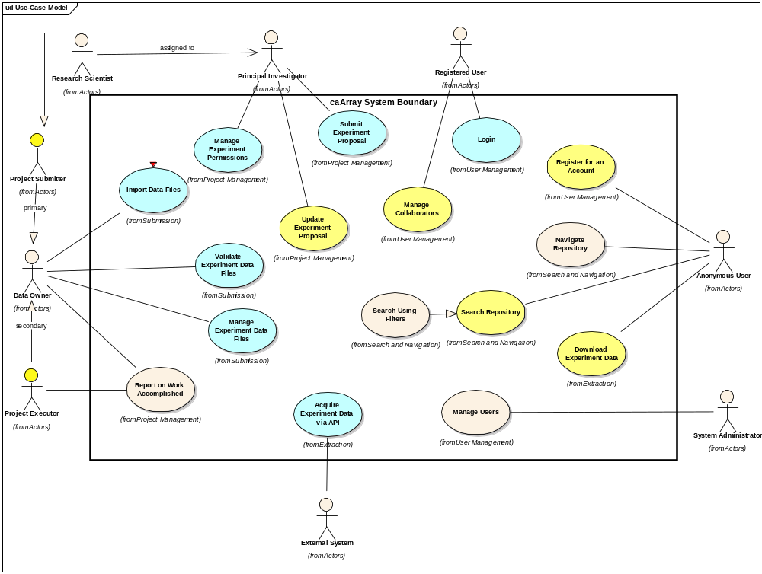
Figure 1 Use Cases for 2.0 Delivery

Test
Performance Benchmarks need to be established which will include assigning all the relevant test data, ensuring that the repository can handle the file size without impacting the build process and using a combination of Selenium and JMeter to execute the tests from a user interface and performance perspective.
Unit Tests should also be updated to reflect the new Java and Grid API.
All UI and Performance Test Cases (and their state) should be entered into the GForge Tracker: Test Cases: https://gforge.nci.nih.gov/tracker/?atid=1343&group_id=305&func=browse

Environment
Establish a distinct nightly build on the Dev Integration Machine that runs the full set of tests (unit, selenium and JMeter).
Establish an appropriately sized Stage and Production Environment
Prove the build can be deployed to Dev, QA and Stage under 2 hours and behaves consistently between the Command Line and AntHillPro.
Validate the command line build and deployment runs on Linux and Windows executing unit tests.

Evaluation Criteria
The primary goal of the C2 Iteration is complete many of the use cases that were significant from a business and architectural perspective and started in previous iterations. The architectural plumbing for most of the application is stable (with known limitations) – now we need to complete the features. Of most importance is the quality of the API and the basic features that will allow the internal and external user community to test it in Alpha form.
The major results we need to achieve by the end of the iteration are:
- Release Alpha by October 19
- Scope the release with reasonable timelines and with sufficient detail to make the finish line clear to all teams
- Detail the full schedule for completing the 2.0 delivery into GA by Dec 14 during the week of October 14.
- Complete all HTML templates for 2.0 from the Wireframes
- Finalize the Domain Object Model for caArray to support one last significant revision to the API prior to Alpha Release Oct. 19. Must be frozen by the end of the iteration.
- Complete the following Use Cases:
      - Validate Experiment Data Files (same caveat as above – add more data should not impact the execution of this use case)
      - Import Data Files
      - Acquire Experiment Data via API
      - Login
      - Register for an Account
- Incorporate all significant User Interface concepts into the appropriate use cases that are incomplete but significantly advanced:
      - Manage Experiment Data Files
        - Association of data to samples will not be complete but incorporated
      - Submit Experiment Proposal
        - UI incorporated, but field level choices will need an additional full iteration
        - Handling entity management (protocols, software, hardware) will not be available
      - Update Experiment Proposal
        - The ability to edit what is entered will be slightly behind what is available in the Submission
      - Manage Collaborators
        - UI will be present – dependent on implementation of sample entry in Submit Experiment Proposal and Import Data
      - Download Data
        - Will be available and UI incorporated
          - Integrating the association of data to the queue not likely to be finished
      - Search Repository
        - Begun – ability to bring back experiment results in tabular format
          - Additional Iteration is needed for fine tuning metadata it searches against for 2.0 - and will continue throughout the life of the product)
- Begin collaboration with Documentation team to structure the User Guide, Installation Guide and Help Files
- Ensure the Grid Service is available to be built along with the software
- Automate the deployment from DEV to QA to STAGE
- Modify the integration build will check whether the grid service and java object are synch

