Iteration Plan
caArray 2.0 - Construction 3

Last Revised: | November 2, 2007
Produced By: | caArray Development Team
Version: | 0.2

Document Approvals
The list contains the name and contact information for the core project team and any key stakeholders who have an interest in the success of the project. An “S” identifies persons responsible for approval from the Business and Development. Sign off of the document would be required when a decision is made not to take action for defined gaps.

S | Name | Role | S | Name | Role
S | Anand Basu | NCICB Engineering Manager | S | Juli Klemm, Ph.D. | Product Manager
 | Brent Gendleman | Development Project Manager | S | George Komatsoulis, Ph.D. | CBIIT IQA Manager
 | Eric Tavela | Development Architect |  | Tom Boal | NCICB Independent QA Lead
 | Don Swan | NCICB Application Support Lead
Revision History
When you make a change to a document, you must add an entry to this Revision History table and you must manually type the Last Revised Date on the front cover.

Date | Version | Description | Revised by
10/29/07 | 0.1 | Initial Draft | Brent Gendleman
11/02/07 | 0.2 | Revised with review by Todd and Bill | Brent Gendleman
Copyrights and Trademarks
© Copyright 2007 by CBIIT, caBIGTM. All rights reserved.

Table of Contents
1. Introduction 4
1.1. References 4
2. Plan 4
2.1. Tasks for External Release 4
2.2. Iteration Schedule 5
3. Resources 7
4. Use Cases 8
4.1. Specifications to be detailed 8
4.2. Analysis to be performed 8
4.3. Implementation to be Performed 9
4.4. Test 9
4.5. Environment 10
5. Evaluation Criteria 10

Introduction
This Iteration Plan describes the detailed plans for the C3 Iteration of caArray 2.0. The Iteration duration will be from November 2 to November 21. The results of the C2 Iteration were positive but incomplete. We were able to make up significant ground and narrowed the focus of the 2.0 Release by reducing Scope. The major milestone missed was the release of an Alpha version to the community. However, most of the functionality we targeted was developed – but not stable enough for delivery. The clarity of how caArray 2.0 will fit into the Life Sciences Distribution (LSD) Bundle’s environment is still being determined and will be known during the first week of C3. The result may impact the delivery of the functionality planned but we are proceeding with the idea that the change will impact timing more than functionality. We have confidence and momentum that the scope for 2.0 can be delivered by December 14th , tested sufficiently and integrated into the LSD bundle for independent validation and verification.

References
project_management/caarray_schedule.mpp
requirements/caarray_vision.doc
requirements/caarray_scope_2_0.doc
requirements/caarray_use_case _summary.doc
requirements/user_interface/wireframes/
analysis_and_design/caarray_software_architecture_document.doc
test/performance_test_plan.doc
caarray gforge: https://gforge.nci.nih.gov/projects/caarray2/ (specifically the trackers for features, use cases, supplemental, test cases and defects)

Plan

Tasks for External Release
November 21st is the target for completing the functionality necessary for an external release to select community members. The goal is to deliver the final set of functionality on that day (vs. the Friday before) so that the last iteration can be dedicated to fixing bugs and improving already available features. The following key components must be available for validation according to the 2.0 Scope:
Use Case or Component | State | Assigned Team Member
Domain Model | Annotated – ready for Submission | Eric Tavela
Acquire Experiment Data Via API | Complete with model updates | Eric Tavela, Todd Parnell
Acquire Experiment Data Via API | Java and Grid Validated for Performance and Function | Rashmi Srinivasa (java), Bill Mason (Grid)
Login | Complete (no locking) | Todd Parnell
Register | Complete | Akhil Bhaskar
Manage Experiment Data Files | Associate Files to Samples | Scott Miller
Manage Experiment Data Files | Upload Complete (display of .zip files, reusable as needed in other experiment tabs) | Scott Miller
Manage Experiment Data Files | Delete Complete (UI solution to # of files made irrelevant) | Scott Miller
Manage Experiment Data Files | Ability to change a MAGE-TAB file that ends in .txt to MAGE-TAB file | Eric Tavela
Manage Experiment Data Files | Tabs extended, Filter Available, Supplemental Added as Choice | Scott Miller
Validate Experiment Data Files | Complete – MAGE-TAB, Gene Expression and SNP, Affymetrix, Illumina, GenePix | Eric Tavela
Import Experiment Data Files | Complete – choice of automated chaining or not for valid experiment data files, Add Supplemental | Eric Tavela
Submit Experiment Proposal | Complete –tabs functional with validation, MAGE-TAB annotation displayed, conditional logic for display of appropriate array designs, controlled vocab integrated, visibility extended to users with lab roles from same organization as submitter, create id on submit | Dan Kokotov
Update Experiment Proposal | Complete – MAGE-TAB annotation that is non-editable available, editing of chain relationships available | Dan Kokotov
Manage Publications | Complete – validation, editing of Publications (independent of state) | Dan Kokotov
Manage Permissions | Complete – Incorporate Collaboration Group Access, Complete Sample Selection, Add TCGA Policy | Dan Kokotov/Todd Parnell
Manage Collaborators | Complete – Add filter for finding all users | Todd Parnell
Download Experiment Data | Complete – Add Filter, Make Download Available for Tab Integration (individual sample or hybridization) | Todd Parnell
Import Array Designs | Complete – (no filter) Display, Upload, Drop-Down Integration in Proposal, Validation Integration | Winston Cheng/Akhil Bhaskar/Eric Tavela
Navigate Repository | Partial– Browse Experiments, Counts, Location Displayed | Winston Cheng
Search Repository | Complete – Search Elements, Tabular Display (proved, not complete), Search on Home Page and All Pages in Upper Right | Winston Cheng

Iteration Schedule
As the iteration evolves, updates will be made to the Microsoft Project schedule twice a week (Monday and Thursday) and the notes of the meeting will be distributed to the Product and Engineering Manager. We will also have 1 hour reviews scheduled each Wednesday with the Product and Engineering Manager and weekly Status Meetings across the entire team each Monday. While the schedule will be updated, it’s represented here at the start of C3 to support evaluating how we execute against the plan.
Construction - Iteration 3 | 14d | Fri 11/2/07 | Wed 11/21/07
Project Management | 12d | Fri 11/2/07 | Mon 11/19/07
Weekly Status Meetings | 2.2d | Thu 11/15/07 | Mon 11/19/07
Dev Team Iteration Plan | 1d | Mon 11/5/07 | Mon 11/5/07
Prepare Alpha Release Plan | 2d | Tue 11/6/07 | Wed 11/7/07
C2 Assessment/C3 Review | 1d | Mon 11/12/07 | Mon 11/12/07
Plan for Next Iteration | 1d | Fri 11/2/07 | Fri 11/2/07
Finalize Deliverables | 7d | Fri 11/2/07 | Mon 11/12/07
Deliver C3 Plan | 3d | Fri 11/2/07 | Tue 11/6/07
Update Beta Release Plan | 1d | Wed 11/7/07 | Wed 11/7/07
Finalize T1 Iteration Plan | 2d | Thu 11/8/07 | Fri 11/9/07
Update Risk List | 1d | Mon 11/12/07 | Mon 11/12/07
Requirements | 14d | Fri 11/2/07 | Wed 11/21/07
Finalize Vision, Scope, Supplemental Spec | 2d | Fri 11/2/07 | Mon 11/5/07
Incorporate Stakeholder Feedback on C2 Use Cases | 2d | Tue 11/6/07 | Wed 11/7/07
Collaborate with Documentation to Support Online Help, User Guides | 13d | Mon 11/5/07 | Wed 11/21/07
Analysis and Design | 4d | Fri 11/2/07 | Wed 11/7/07
Revise Domain Object (Logical) Model with GeneID | 1d | Mon 11/5/07 | Mon 11/5/07
Support Analysis Services Integration as Needed | 3d | Fri 11/2/07 | Tue 11/6/07
Investigate EVS Methods for Vocabulary Retrieval | 1d | Wed 11/7/07 | Wed 11/7/07
Design Migration Strategy for 1.x Experiments | 1d | Thu 11/8/07 | Fri 11/8/07
Update Software Architecture Document | 1d | Fri 11/19/07 | Fri 11/19/07
Implementation | 14d | Fri 11/2/07 | Wed 11/21/07
Introduce and Complete C3 UC's | 13d | Fri 11/2/07 | Tue 11/20/07
Search Repository UC | 5.5d | Fri 11/2/07 | Fri 11/9/07
Navigate Repository UC | 5.5d | Fri 11/9/07 | Fri 11/16/07
Import Array Design UC | 2d | Mon 11/19/07 | Tue 11/20/07
Complete C2 UC's | 14d | Fri 11/2/07 | Wed 11/21/07
Manage Exp Data Files - Full UI (Add Filter, Associate File<->Sample, Progress Meter) | 8d | Fri 11/2/07 | Tue 11/13/07
Download Exp. Data UC (Add Filter, Enable Single Sample Download) | 2d | Fri 11/2/07 | Mon 11/5/07
Manage Experiment Permissions UC - Complete Sample Level and TCGA Policy | 3d | Fri 11/2/07 | Tue 11/9/07
Manage Publications UC (edit, delete) | 1d | Wed 11/7/07 | Wed 11/7/07
Submit Experiment Proposal (validation, draft, incorporate UCV) | 5d | Fri 11/9/07 | Thu 11/15/07
Update Experiment Proposal (validation, across states, edit entity association) | 3d | Fri 11/16/07 | Tue 11/20/07
Import Experiment Data (improve validation, add genepix, fix UI scheme for large file sets, auto-chain choice) | 4d | Fri 11/16/07 | Wed 11/21/07
Manage Collaborators | 2d | Fri 11/2/07 | Mon 11/5/07
Manage Users (ensure UPT3.2 works) | 1d | Fri 11/2/07 | Fri 11/2/07
Validate Data Files (Add Illumina, GenePix Validation, Other File Skip Validation) | 1d | Fri 11/2/07 | Fri 11/2/07
Acquire Experiment Data Via API (Convenience Queries and Response to Size Limit) | 3d | Fri 11/2/07 | Tue 11/6/07
Data Management | 9d | Fri 11/2/07 | Thu 11/14/07
Add Data Parsers for GenePix | 0.5d | Fri 11/2/07 | Fri 11/2/07
Import Experiment Data Files Gene Pix | 0.5d | Fri 11/2/07 | Fri 11/2/07
Support MAGE-TAB Import (allow for .txt to be valid) | 1d | Mon 11/5/07 | Fri 11/5/07
Annotate Model for caDSR Submission | 3d | Fri 11/9/07 | Tue 11/13/07
Create Initial 1.x Migration Scripts | 1d | Fri 11/14/07 | Mon 11/14/07
Fix Defects Found in QA7&8 | 12d | Mon 11/5/07 | Tue 11/20/07
Test | 13d | Fri 11/2/07 | Wed 11/21/07
Write, Execute and Record UI Test Cases in Selenium | 12d | Fri 11/2/07 | Mon 11/19/07
Write, Execute and Record Performance Test Cases in Jmeter | 12d | Fri 11/2/07 | Mon 11/19/07
Release QA Build C3A - Alpha 1 | 0d | Wed 11/21/07 | Wed 11/21/07
Load 1.x Data from DEV to QA to STAGE | 2d | Fri 11/2/07 | Mon 11/5/07
Environment | 8d | Mon 11/5/07 | Wed 11/14/07
Design and Create caArray 2.0 Installer | 10d | Mon 11/5/07 | Fri 11/16/07
Update Build and Deploy Plan with SCM Initiative | 1d | Tue 11/13/07 | Tue 11/13/07
Prepare Deployment to Bundle Environment | 1d | Wed 11/14/07 | Wed 11/14/07
Configuration and Change Management | 14d | Fri 11/2/07 | Wed 11/21/07
Manage Gforge Content | 14d | Fri 11/2/07 | Wed 11/21/07
Prioritize 2.0 Defects | 14d | Fri 11/2/07 | Wed 11/21/07
Prepare Download Center Material, Release Notes | 2d | Mon 11/19/07 | Tue 11/20/07
C3 Complete | 0d | Wed 11/21/07 | Wed 11/21/07

Resources
The development team is undergoing some change of personnel and roles. We will be at less than full strength planned (7 FTEs) but have compensated with a switch in team members (introducing Akhil Bhaskar and Winston Cheng from the last week of C2 taking the place of John Hedden) and increased the QA coverage by shifting Bill Mason and Rashmi Srinivas to the Role of QA. The team is expected to remain at this level through the entire Iteration. They are:
Team Member | Role | Percentage on Project
Brent Gendleman | Project Manager/Requirements Analyst | 80%
Todd Parnell | Developer/Tech Lead | 100%
Bill Mason | QA – UI | 100%
Rashmi Srinivasa | QA – Performance | 100%
Eric Tavela | Developer/Design Lead | 100%
Dan Kokotov | Developer | 100%
Scott Miller | Developer | 100%
Winston Cheng | Developer | 100%
Akhil Bhashkar | Developer | 40%
Matt Rehfuss | UI Designer | 10%

Vacations and other absences described below:
Veterans Day: November 12 (no team member taking off)
Thanksgiving: all development team members will be off on November 22 and 23rd.
Rashmi Srinivasa –will primarily work remotely for the remainder of the release life cycle
In addition, Brent Gendleman will be onsite at the NCICB from between November 6 – 21

Use Cases
This section will describe at a high level what requirements, analysis and implementation will occur for C2 to be considered a success.

Specifications to be detailed
For this iteration, all the use cases to be implemented (at least partial flows) have been written and reviewed. It is expected that alterations, particularly based on feedback from the Wireframe Reviews, Internal Team Reviews (IQA, App Support, Documentation), and the application itself will be incorporated. This is particularly important for the refinement of the User Guide and Online Help.
In C3 there was a planned activity to write 2.x use cases. Bandwidth and priority didn’t allow for that to occur and we will write them post the 2.0 Release. It is expected that will be an input to the entire team for what will be next.

Analysis to be performed
Most of the analysis is complete. There are two significant investigations left:
Document 1.6 Migration Strategies for caArray users and experiment data
Finalize the Use of Enterprise Vocabulary Service (if any) and design of the Controlled Vocabulary features
The Software Architecture Document should also be updated with Use Case Design for:
Register
Manage Users – Use of the NCI User Provisioning Tool (3.2)
Manage Collaborators
Import Array Design

Implementation to be Performed
The use cases in Blue are ones initiated previously and the ones in yellow are being introduced in C3. One caveat is that the Import Array Design currently functions but is included as part of the experiment – whereas this distinctly will support an independent import.
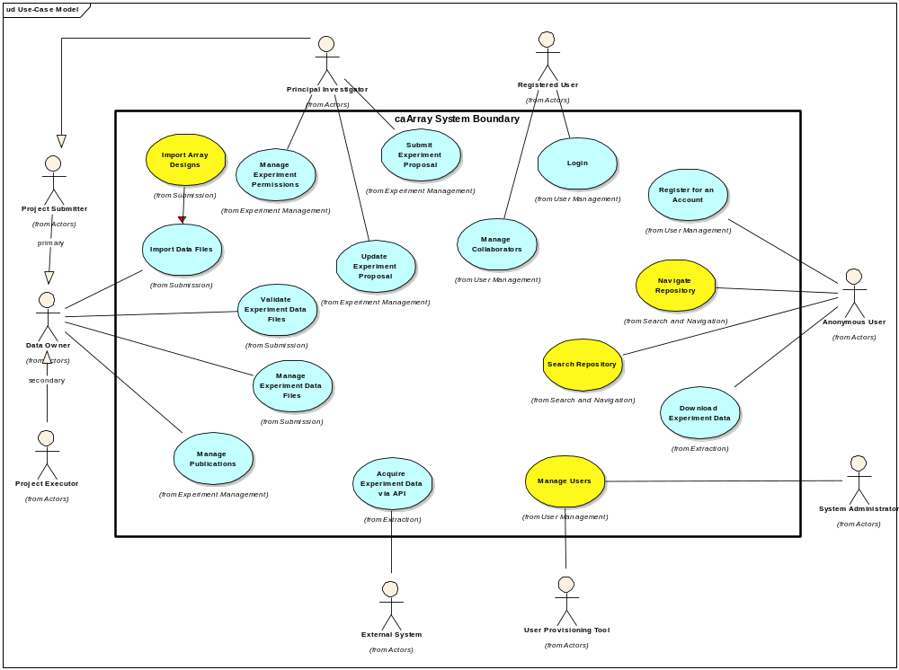
Figure 1 Use Case Diagram for 2.0

Test
This iteration is significant not only in terms of the functionality to be built upon, introduced and enhanced but in addition, two members of the development team are assuming full time Quality Assurance Roles. Bill and Rashmi will be working in concert with the development team to support the overall testing in both the Development and Independent Quality Assurance Environments. The Testing will be split into Performance testing and User Interface Testing with a heavy weight on the API, Functional and Integration tests. Unit Tests are still the responsibility of each developer and the code coverage is expected to be:
Line: 70%
Branch: 60%
This is an incremental increase from the C2 release (64%/56%) and we’d like to increase it to 80% Line/70% Branch coverage after the December 14th Release Candidate is provided.
The Performance Benchmarks have been established (and available in the Supplemental Requirements Document) and all test data (except for what’s required for unit tests) will be stored in:
ftp://caftpd.nci.nih.gov/pub/caarray_test/
Affymetrix and MAGE-TAB files are currently there, Illumina and Gene Pix data will need to be moved to that location. It is a public with anonymous access.
All UI and Performance Test Cases (and their state) should be entered into the GForge Tracker: Test Cases: https://gforge.nci.nih.gov/tracker/?atid=1343&group_id=305&func=browse
All Defects from the QA7 Release should be added to the Defect Tracker:
https://gforge.nci.nih.gov/tracker/?atid=1344&group_id=305&func=browse
Anyone may enter a defect, the Project Manager will assign them and if necessary, elevate the defect for resolution to the Product Manager. Enter defects will not garner immediate attention but all developers have 10% time allocated to the fixing of defects.

Environment
The most significant hurdle is whether the LSD Bundle Environment versions will change. We are currently in a holding pattern for whether to downgrade to MySQL 4.1 from MySQL 5.0.27 but are assured that the JBoss version will remain 4.0.5. The plan if downgrading is required is to change local developer environments, test, and then push across the tiers.
We have establish a distinct nightly build on the Development Environment and the Development Integration Machine. However, the movement toward integrating all of our tests into automated build is on hold, but highly desirable (unit, selenium and JMeter).
An installer for caArray 2 is to be delivered by the close of this iteration. While not required to be a GUI, it does need to work within the constraints of the LSD bundle and be available for external use.

Evaluation Criteria
The primary goal of the C3 Iteration is complete all functional threads. Defects, User Interface Improvements and Documentation are allowed to be in an incomplete state but the functionality for the 2.0 release must be available. There is a high dependency on the other teams (IQA, Systems, SCM, LSD Bundle) to make this effective but the focus for development is to get the functionality done.
The major results we need to achieve by the end of the iteration are:
  - Release stable enough for external adoption by friendly community members by November 21.
  - Scope the release with reasonable timelines and with sufficient detail to make the finish line clear to all teams
  - Detail the full schedule for completing the 2.0 delivery into a Release Candidate by Dec 14 and ensure the LSD timeline can be met.
  - Finalize the Domain Object Model, Produce the API, Begin the Model Annotation (with assistance from Mentors. Must be frozen by the end of the iteration.
  - Continue collaboration with Documentation team to structure the User Guide, Installation Guide, Technical Guide and Help Files
  - Ensure the Grid Service is available to be built automatically along with the software (will require automating Globus Restart)
  - Create the caArray 2.0 Installer
  - Create 1.6 Migration Scripts
  - Enable the Build and Deploy to reach Production

