Scope
caArray 2.0
Last Revised: | January 20, 2008
Produced By: | Brent Gendleman
Version: | 1.00.6

Document Approvals
The list contains the name and contact information for the core project team and any key stakeholders who have an interest in the success of the project. An “S” identifies persons responsible for approval from the stakeholder groups. Sign off of the document would be required when a decision is made not to take action for defined gaps.

S | Name | Role | S | Name | Role
S | Anand Basu | NCICB Engineering Manager | S | Juli Klemm, Ph.D. | Product Manager
 | Brent Gendleman | Development Project Manager |  | Jerry Eads | NCICB Project Manager
 | Eric Tavela | Development Architect |  | Ron Keene | NCICB Independent QA
 | Don Swan | NCICB Application Support
Revision History
When you make a change to a document, you must add an entry to this Revision History table and you must manually type the Last Revised Date on the front cover.

Date | Version | Description | Revised by
9/25/07 | 0.1 | Initial version | Brent Gendleman
9/28/07 | 0.2 | Revised Draft based on Product Manager Review | Brent Gendleman
10/2/07 | 0.3 | Additional revision to represent the actors and the use case model in a more holistic manner – still pending Product Manager Review | Brent Gendleman
10/12/07 | 0.4 | Use Case Flow Analysis | Brent Gendleman
10/23/07 | 0.5 | Use Cases Flow Analysis Completed | Brent Gendleman
11/14/07 | 0.6 | Final Draft Proposed – modifications made across the document | Brent Gendleman
1/20/08 | 1.0 | Prepared for GA Release | Brent Gendleman
Copyrights and Trademarks
© Copyright 2007 by CBIIT, caBIGTM. All rights reserved.

Table of Contents
1. Introduction 1
2. What is caArray 1
3. What’s in It 1
3.1. Array Annotation and Data Management 1
3.1.1. Experiment Workflow 1
3.1.2. Feature Set 2
3.2. Data Submission 2
3.2.1. Feature Set 2
3.3. Data Extraction 3
3.3.1. Feature Set 3
3.4. Search 4
3.4.1. Feature Set 4
3.5. Permissions 4
3.5.1. Feature Set 4
3.6. System Administration 5
3.6.1. Feature Set 5
3.7. Data Migration 5
4. Actors and Use Cases Supported 6
4.1. Annotation and Data Management 9
4.1.1. Acquire Experiment Data via API 9
4.1.2. Download Experiment Data 9
4.2. Experiment Management 10
4.2.1. Manage Experiment Permissions 10
4.2.2. Submit Experiment Proposal 10
4.2.3. Update Experiment Proposal 10
4.2.4. Report on Work Accomplished 11
4.3. Data Submission 11
4.3.1. Import Array Designs 11
4.3.2. Import Experiment Data 11
4.3.3. Manage Experiment Data Files 11
4.3.4. Validate Experiment Data Files 12
4.4. Navigation 12
4.4.1. Navigate Repository 12
4.4.2. Search Repository 13

Introduction
The purpose of this document is to provide a summary of the major features of caArray 2.0. The Vision document covers its present and future requirements but a depiction of just 2.0 in terms of features to be implemented in the first release is expressed here. The Use Case Model and Use Case Specifications detail what needs to be accomplished and the Supplemental Specifications cover non-functional and global requirements. GForge Trackers have been set up to provide at-a-glance visibility and the Requirements Management Plan details how requirements are elicited, documented and managed. This Scope document will be updated for each major (3.0, 4.0) or minor release (2.1, 2.2, 2.3, etc.).

What is caArray
caArray is an open-source, user-driven, role-based, web and programmatically accessible array data management system. caArray guides the annotation and exchange of array data using a federated model of local installations whose results are shareable across the cancer Biomedical Informatics Grid (caBIG™). Identified primarily as a data service on the Grid, caArray furthers translational cancer research through acquisition, dissemination and aggregation of semantically interoperable array data to support subsequent analysis by tools and services on and off the Grid. As array technology advances and matures, caArray will extend its logical library of assay management.

What’s in It
The 2.0 features have been prioritized based on an assessment of the product’s current functionality, direct input and validation from the user community, and the need to improve performance, usability and the ease of adding new features as our understanding of the community needs evolve. At the highest level, functionality is provided for managing experiment annotation and array data (upload, validation, import) and searching across experiments using a web browser; programmatic querying and retrieval of data over the grid or via a java API; and the management of experiment security and access.

Array Annotation and Data Management

Experiment Workflow
caArray supports a role-based workflow designed to support collaboration between PIs, Lab Administrators, Scientists and Statisticians on the definition, execution, and publication of experiments. Serving as an foundation from which discreet workflow features will be added, 2.0 will provide the definition of the experiment, submission to a PI-directed and determined set of collaborators, and providing the results. The end-to-end states of an experiment are: draft, in-progress, and public.

Feature Set
- PI Workflow – a standard set of required and optional annotation is available to anyone who is registered to the caArray installation and has the role of PI, Lab Administrator, Lab Scientist or Biostatistician.
- Save as Draft – the ability to save work in progress before submission or after a revision has been requested by the lab
- Work Queues – a personal workspace that provides structured visibility into the projects one’s directly associated with or that are public within the installation
- Conditional Workflows – the desired assay type, array provider, and level of service requested will lead the collaborators down particular paths and allow for data specific attributes to be presented. Two paths are provided –
      - full service (mirroring the typical PI/Core Lab relationship)

Data Submission
For any of the users connected to an experiment, the ability to upload, validate and import single or a set of files by zipping them together will be available. While the data is large, much of it lends itself well to compression. The workflow allows for the effort to be spread over time and in synch with the way work is performed in the lab but also offers the ability to perform bulk uploads of annotation and experiment data.

Feature Set
- Bulk Upload – once an experiment definition has been set, files can be uploaded all at once or over time regardless if they are for annotation, arrays, or supplemental to an experiment.
- Validate Files Prior to Import – validation of MAGE-TAB and Array Data by array design, number of rows and file extension before import is available for user initiation or automatically upon import
- Import Annotation Data – MAGE-TAB files – IDF, SDRF, ADRF – can be imported to support annotation automation as well as references to array data. The original file will be kept intact and available for download.
- Web-based Annotation – experimental designs, experiment factors, sources, samples, extracts, labeled extracts and hybridization annotation can all be entered over the web with a strategic mixture of restricted elements, the ability to add to existing elements and completely open but shareable controlled vocabularies
- Array File Management – Affymetrix, Illumina and Genepix files can be selectively uploaded, deleted, parsed and imported. Agilent, ImaGene, UCSF Spot and Nimblegen can have their data uploaded, deleted and imported (not parsed).
- Array Design Management –Gene Expression or SNP assays from Affymetrix, Illumina and Gene Pix can have their designs imported so that only the designs of an installation’s choice are available

Table 1- Assays supported in 2.0
Assay Type | Provider | File Type Content Available through API | File Types Available for Download
SNP | Affymetrix | .cel, .chp | .dat, .cel, .chp, .exp, .rpt, .txt
SNP | Illumina bead arrays | .csv | .idat (image), .csv (content) or .dat (bead manifest), .xml (content)
Gene Expression | Affymetrix (including Exon) | .cel, .chp | .dat, .cel, .chp, .exp, .rpt, .txt, .cab
Gene Expression | GenePix (custom) | .gpr | .gpr (data + derivable array design if no gal), .gal (array design)
Gene Expression | Illumina | .csv | .idat (image), .csv or .dat (bead manifest), .xml (content)

Data Extraction
With the significant amount of effort to get data in, caArray 2.0 will provide both user interface and API access to getting the data out. A thoroughly reviewed domain model will be available that borrows from pre-existing models (MAGE, caBIO and caTissue specifically) and is prepared for submission to caDSR to support gaining Silver Level Compliance post release. There are several consumers of the data:
- End users who want to download the files of interest from the User Interface
- End users who have significant technical ability that want to use the API to interrogate the data to extract what data they want over the Grid or through Java
- External Applications that want to either get to the raw files and/or their inner contents to support analysis
- External Applications that want to use caArray as their array data repository but have a different purpose

Feature Set
- UI Download – the ability to acquire the entire data set of an experiment or a selection of native files is available through the UI
- Grid API – the ability to acquire native files or full or partial sets of data over the Grid is available. Data content can be selected by columns of interest.
- Java API – for those who want to take advantage of java’s features or who want to by-pass the Grid, the same search and retrieval capabilities are available

Search
To support finding experiments of interest, the ability to search through the repository for public experiment data or data one is directly associated to by the owner will be available. The search mechanisms will lead to actionable results that are clear to the end user and incorporate their specific rights for the experiments found. The initial focus will be presenting the experiments of interest to the user to support getting at the annotation and array data.

Feature Set
- Browse Public Data – anonymous users will be able to access and download all available data organized by Experiments, Organism, and Assay Provider,
- Query Public Data – free text searches paired with pre-defined attributes will be consistently available in the application with one-click access
- Repository Dashboard – the ability to see what’s in the installation repository based on experiments, organisms, assay providers, array designs, hybridizations, registered organizations, and number of users

Permissions
The ability to control the public visibility of an experiment will be controlled by the Principal Investigator or their designee. The actions can be taken against an Experiment as a whole (with a cascading affect across all experiment elements) or an individual or discreet set of samples within an experiment. In addition, visibility to particular annotations for a public Human SNP experiment may be restricted by applying the policy based on the requirements of The Cancer Genome Atlas.

Feature Set
- Experiment Public/Private Actions – the ability to expose or hide the experiment
- Sample Level Access Control – the ability to expose or hide samples (annotation and data are controlled by the action of exposing or hiding)
- Creation of Collaboration Groups – the ability to create groups of an installation’s registered users to grant access to an entire experiment or a specific set of samples with read, write or no permissions

System Administration
The System Administration role will be granted to specific individuals by organizations that choose to install caArray locally and will accessing the functionality of managing users using the User Provisioning Tool 3.2.

Feature Set
- Manage Users – create, edit, disable and delete users from a specific organization or organization’s installation

Data Migration
Targeted Experiment Data that can be pulled completely from caArray 1.6 will be migrated into 2.0. The exact experiments are still to be determined. The method will be to extract annotation into MAGE-TAB and pull data files for import into caArray 2.0.

Supported Roles and Use Cases

caArray |  | Roles
 |  | Anonymous User | Principal Investigator | Lab Administrator | Lab Scientist | Biostatistician | System Administrator | External System
2.0 Use Cases | Acquire Experiment Data via API
2.0 Use Cases | Manage Experiment Data Files
2.0 Use Cases | Import Experiment Data
2.0 Use Cases | Submit Experiment Proposal
2.0 Use Cases | Download Experiment Data
2.0 Use Cases | Manage Experiment Permissions
2.0 Use Cases | Import Array Designs
2.0 Use Cases | Login
2.0 Use Cases | Manage Users
2.0 Use Cases | Navigate Repository
2.0 Use Cases | Search Repository
2.0 Use Cases | Manage Collaborators
2.0 Use Cases | Register for an Account
2.0 Use Cases | Update Experiment Proposal
2.0 Use Cases | Manage Publications
2.0 Use Cases | Validate Experiment Data Files

Figure 1 – Capability to Role Matrix
The capability to feature matrix provides a high level view of the users of the system and the features available to them (described as use cases). The use cases marked in blue indicate that the role has a direct relationship with the use case.
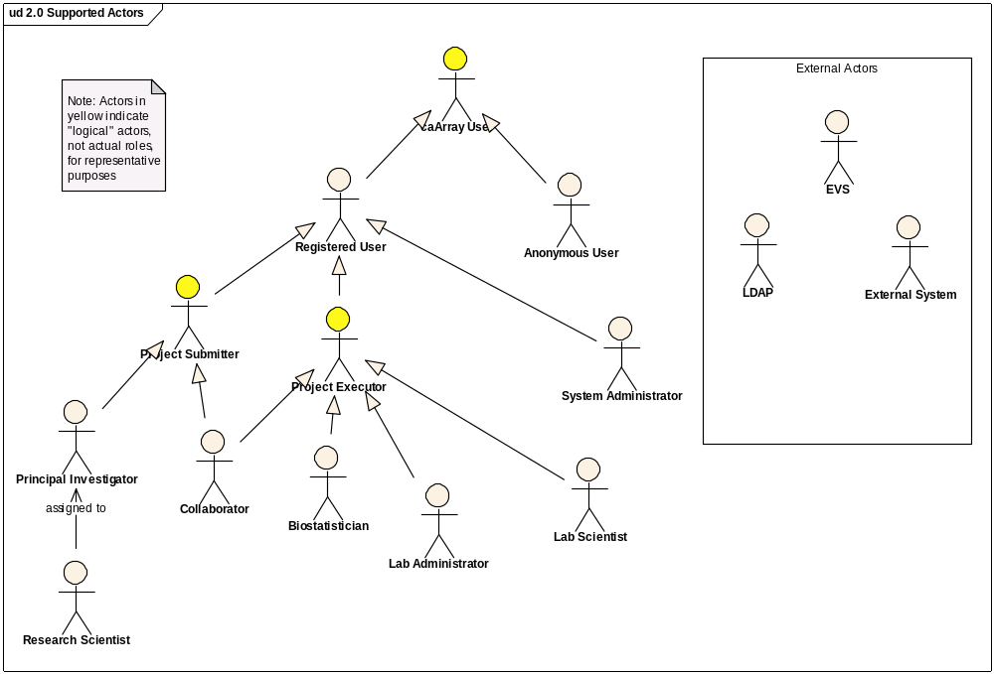
Figure 2 – Supported 2.0 Actors

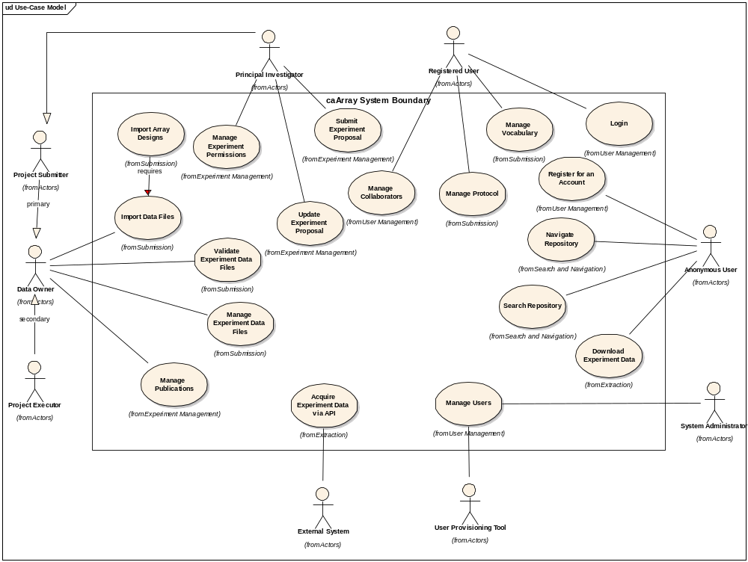
Figure 3 – 2.0 Use Cases
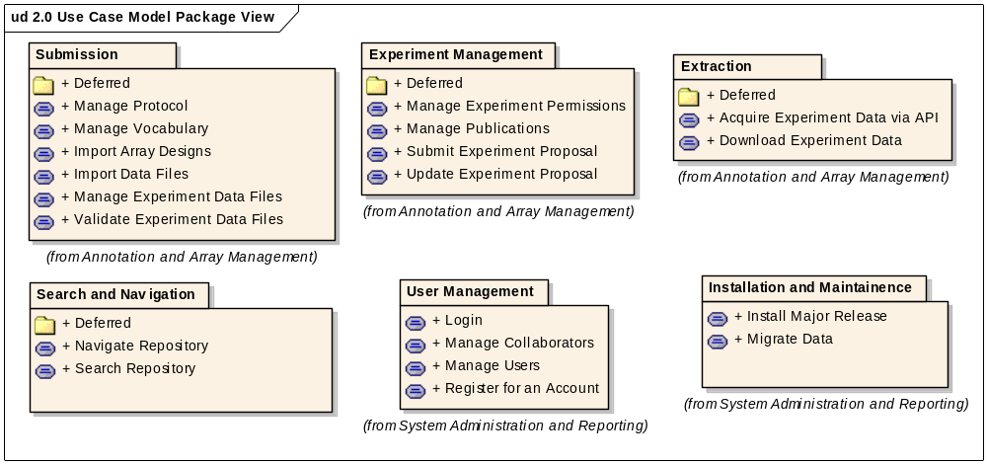
Figure 4 Use Case Model Package View for 2.0

Annotation and Data Management

Acquire Experiment Data via API
Brief Description: Initiated by an External System, this use case enables programmatic extraction of annotation and array content from caArray using an API. The use case also includes extraction of data from caArray by a grid client through a caGRID service. caBIG Analysis Services is the primary External System targeted and public and protected data should be available provided appropriate authorization is used. The use case may expand to include external systems such as GEO or Array Express or other systems that are local to the installer or NCICB that may have an interest in the data contained in caArray.
- Search for Experiments, Samples or Data Types
- Retrieve MAGE-TAB Files, Array Data as whole files
- Retrieve Specific Columns of Array Data
Expected Performance Characteristics:
- Search Requests should be returned in seconds
- Retrieval Requests should begin in seconds
- Whole Data Files should be returned in seconds or minutes (dependent on file size, number of files and network bandwidth
- Partial File Data should be returned in seconds

Download Experiment Data
Initiated by any caArray User, this use case allows for the extraction of data from any publicly available instance of caArray. No permission restrictions are required to acquire the data, either at an experiment level or individual samples within or across projects. For data that is permission protected, the same mechanism will apply but only users associated with the project will be able to perform this action. Once the data of interest is found, the user should be informed of expected download time.
Ability to select array data from a single experiment through the User Interface when finding an experiment of interest (either through the workspace, searching for it, or being sent a link to a public experiment or one that the user has rights to
- Single Array Data File can be selected
- All Array Data Files can be selected
- Subset of Array Data Files can be selected
- Data Table can be sorted and filtered by type
- MAGE-TAB file(s) can be selected – only means for Annotation to currently be downloaded from the User Interface

Experiment Management

Manage Experiment Permissions
Initiated by a Data Owner, this use case allows for the promotion of a project's visibility. This action can apply to an entire project or to specific samples within the project. The basic visibility states of the project experiment are: restricted, institutionorganization, group, public and collaborator. There is no restriction on changing an project's experiment's visibility, though it is not advisable once a publication has been published against the project.
Ability to make an experiment public
Ability to make an experiment explicitly restricted
Ability to create experiment or sample level permissions for:
- User defined collaboration groups (1->n users per group)
- Users registered with the same affiliation to an Organization (Organizational)
Ability to apply the TCGA Policy restricting annotation visibility for Human SNP Experiments
Permissions effective whether using the User Interface or API

Submit Experiment Proposal
Initiated by a Principal Investigator, this use case allows for the creation, editing and submission of annotation supporting array experiments. Several high level items will be covered including the array provider, the experiment’s design and sample annotation. A minimum set of information about an experiment must be entered prior to being allowed to submit but almost as soon as an experiment is begun it can be saved as draft to be retrieved by the Principal Investigator when desired. In addition, the PI may choose to have a research scientist complete the submission on their behalf.

PI’s can submit experiments and create Collaboration Groups to allow pre-public access and contributions
They can choose Full Service or Publish
They can enter annotation using restricted, addable or freely entered but shared values
They can upload annotation outside of what is directly provided by caArray by using MAGE-TAB but CAN’T edit those values in the UI (see Manage Data UC)

Update Experiment Proposal
Initiated by the Principal Investigator, this use case allows for editing a proposed experiment to reflect change or to simply update a proposal that is in draft status.
Changes can be made to an Experiment in Draft by the PI

Manage Publications
Initiated by a Data Owner, this use case allows for the creation, editing and deletion of publication associations to a project. Common formats for publications will be presented. Several types of publications are available: manuscripts, abstracts and posters. More than one association can be made.

Data Submission

Import Array Designs
Initiated by a Curator, this use case allows for the uploading of array designs on an as needed basis. A significant number of array designs will come pre-loaded from the CBIIT but when necessary, aNo array designs will be preloaded. This will support the flexibility for any particular institutionorganization to upload only the designs they use and reduce the overhead introduced by having to load unnecessary designs - which are often of significant size (100's of megabytes or more). may need to upload array designs that are dated (when pushing in legacy data) or be in front of the curve (prior to official support for parsing of a particular manufacturer).
Full Support for Affymetrix, Illumina and GenePix (parsers available)

Array Designs can be uploaded independent of an experiment
Array Designs must be imported prior to attempting to validate array data in an experiment

Import Experiment Data
Initiated by a Data Owner, this use case enables the import of annotation and array data from previously-uploaded files.
Import Validated Files
Import Non-Validated Files (and validate them; returning appropriate errors and warnings)
Import non-associated files (and create sources and samples based on file name and associate them automatically with the ability to change source and sample placeholder names via the UI)
Manage Experiment Data FilesInitiated by a Data Owner, this use case enables the uploading of annotation and array content collectively and independently into a caArray project and then provides the ability to validate, import and/or delete the uploaded files and records each action taken. Due to the large file size of array data and to a lesser extent – the annotation, the upload may take minutes or even hours to complete; so the ability to offer to run the upload in the background (allowing the user to perform other functions inside caArray) is desirable.Upload Files
- Single Array File
- Multiple Array Files (one at a time)
- Single MAGE-TAB File or File Set
- Zipped File of any of the above
Show Progression of Files Uploaded
View Uploaded Files
- See contents of Zipped File
Delete Files

Validate Experiment Data Files
Initiated by a Data Owner, this use case allows for the validation of file structure and content for annotation or array data, with a future intent to import the data into the project. The content validation is not to determine the accuracy of the information from a scientific viewpoint; rather it is purely to ensure that the data files loaded are sound for importing into the system. This use case will also be invoked when a Data Owner chooses to import non-validated data.
Validate a single array file, set of array files, mage-tab file set
Validate against an array design file in the system
Existence
Non-Existence
Validate Errors don’t allow file to be imported
Validation Warnings do allow file to be imported

Navigation

Navigate Repository
Initiated by a caArray User, this use case presents a tabular representation of high level meta data about the contents of the repository.
Anonymous ability to Browse Experiments, Organisms, Providers, Unique Array Designs from the home page of a single installation
Anonymous ability to see counts of the total number of hybridizations, organizations, and users
Experiment Result Sets will be organized in the following manner:
- Experiments – full result set
- Organisms – broken out by available organisms
- Providers – broken out by distinct providers
- Unique Array Designs – broken out by distinct providers which must be chosen and then the result set will be broken out by respective unique array designs

Search Repository
This is a generalized use case that describes how users will be able to locate content of caArray based on user-specified criteria. We will likely offer several forms, including friendly "iTunes-like" natural text searches that search a limited set of often-referenced values, filter-based searches on high level entities (protocols, investigator, etc.), and potentially more discrete/field-specific searches based on specific values and ranges of values (such as certain genes with a minimal intensity value, or specific probe sets, etc.). The most significant value will be not just the ability to find information but to do something with the result - download the data, directly hyperlink to additional data, easily refine the query parameters.
Search available no matter where one is in the system
Free text Search against any of these specific items

All of the below

Experiment ID

Experiment Title

Assay Provider

Array Design

Organism

Sample

Disease State
Results will be organized by experiment but broken by these elements with counts based on the search executed populating each tab (Experiments, Array Designs, Assay Provider

