Use Case Summary
caArray

Last Revised: | March 13, 2009
Produce By: | NCICB Development Team
Version: | 2.0

Document Approvals
The list contains the name for the core project team and any key stakeholders who have an interest in the success of the project. An “S” identifies persons responsible for approval from the Business and Development. Sign off of the document would be required when a decision is made not to take action for defined gaps.

S | Name | Role | S | Name | Role
S | Anand Basu | NCICB Engineering Manager | S | Juli Klemm, Ph.D. | Product Manager
 | Maki Duncan | Development Project Manager |  | Rashmi Srinivasa, Ph.D. | Requirements Analyst
 | Dan Kokotov | Development Architect |  | Leonie Misquitta, Ph.D. | Independent QA Lead
 | Don Swan | NCICB Application Support
Revision History
When you make a change to a document, you must add an entry to this Revision History table and you must manually type the Last Revised Date on the front cover.

Date | Version | Description | Revised By
4/6/2007 | 0.1 | Initial Draft | Rob Daly
5/14/2007 | 0.2 | Detailed for Review | Brent Gendleman
6/12/2007 | 0.3 | Incorporated Product Manager’s scoping of the Use Cases for the 2.0 Release | Brent Gendleman
7/10/07 | 0.4 | Updates post Use Case Analysis by Development Team | Brent Gendleman
10/9/07 | 0.5 | Updates per Scope Review | Brent Gendleman
10/12/07 | 0.6 | Updates per Scope Review | Brent Gendleman
1/24/08 | 0.7 | Finalized per 2.0 Scope | Brent Gendleman
3/13/09 | 2.0 | Major rewrite to clean up and pare down all the use cases, and to include them all in their full form within this document. | Rashmi Srinivasa

Copyrights and Trademarks
© Copyright 2007-09 by CBIIT, caBIGTM. All rights reserved.

Table of Contents
1. Introduction 1
2. Use Case Overview 1
2.1. Use Case Model 1
2.2. Actors 1
3. Experiment Management Use Cases 4
3.1. Submit Experiment Proposal 5
3.2. Update Experiment Proposal 6
3.3. Lock Experiment 8
3.4. Manage Experiment Permissions 9
4. Data Management Use Cases 10
5. User Management Use Cases 10
6. Search and Navigation Use Cases 10
7. Installation and Maintenance Use Cases 10
8. Deferred Use Cases 11
8.1. Submit Experiment Proposal to a Specific Lab 11
8.2. Approve Experiment – Medium 11
8.3. Assign Project – Medium 11
8.4. Report on Work Accomplished - Medium 11
8.5. Validate MIAME Compliance –Low 11
8.6. View MIAME Compliance –Low 11
8.7. Submit Experiment to External Repository 11
8.8. Manage Institutional Groups - High 12
8.9. Support Different Service Types 12
8.10. Manage Queries – Low 12
8.11. Manage Virtual Project – Medium 12
8.12. Organize Workspace – High 12
8.13. Search for Arrays Using Natural Text – Medium 12
8.14. Curate Ontological Entries – Low 13
8.15. Evaluate Project Annotation – Low 13
8.16. Submit New Ontological Entries to EVS – Low 13
8.17. View New Entry Vocabulary Report – Low 13
8.18. Reporting - Low 13

Introduction
This document defines all the Use Cases for caArray. The primary goal of caArray is to further translational cancer research through acquisition, dissemination and aggregation of high quality array data to support subsequent analysis. Data from expression, SNP, methylation, and protein arrays are anticipated for inclusion in caArray. Also under consideration are RNAi, CHip-chip and tissue microarray data.

Use Case Overview

Use Case Model
The use cases are categorized into Experiment Management, Data Management, Extraction, User Management and Installation and Maintenance.
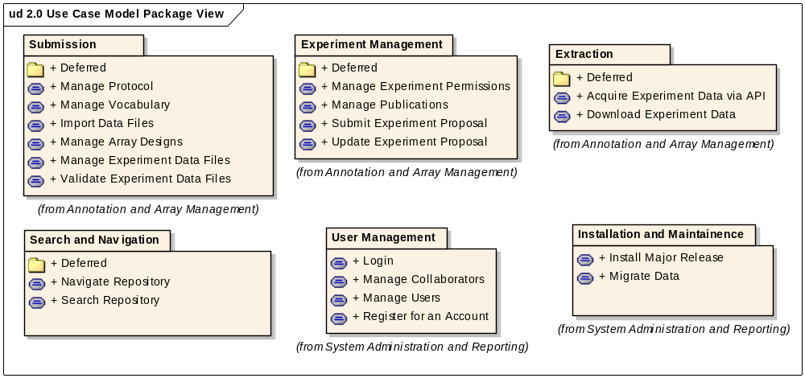

Actors
The main actors are shown in the following diagram.
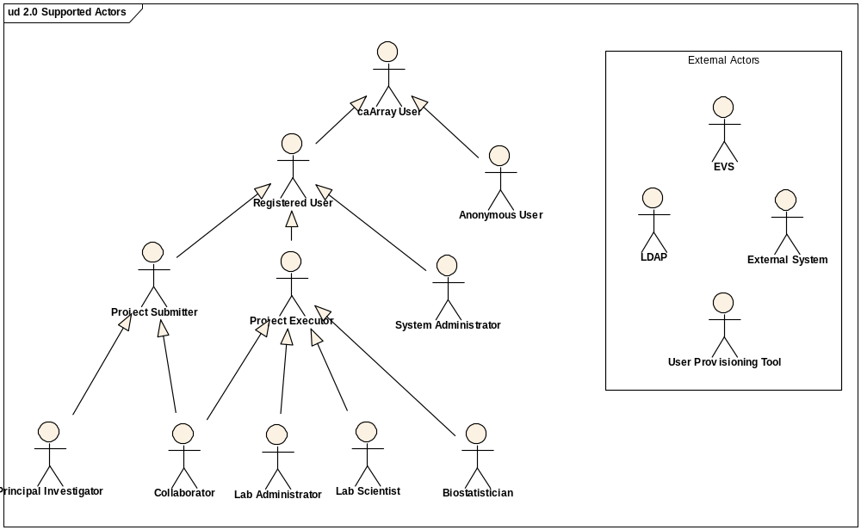

caArray User

This is anyone who directly accesses caArray, via the interactive or programmatic interfaces. Immediate descendants are Anonymous User and Registered User.Anonymous User
This is any user who visits caArray but does not get identified through a log in or other form of authentication/authorization. Another name for this actor might be "public user." This actor will have no ability to enter information into caArray.

Registered User

A registered user is known to caArray, and is allowed to enter information into caArray.Project Submitter
This user creates experiment proposals and enters information like the experimental design, desired samples and quality control information governing the samples. The Project Submitter is typically a Principal Investigator or his/her representative.

Principal Investigator
A specific form of Project Submitter, a Principal Investigator (PI) typically owns experiments.

Collaborator
One or more collaborators can be assigned by a Principal Investigator to receive a "preview" of an experiment and possibly even work on a subset of the experiment. A preview represents access to an experiment prior to its being made public by the Principal Investigator.

Research Scientist
This actor supports the PI in submitting experimental designs, sample annotation and quality control metrics used in the collection and treatment of the samples. While the PI is considered the owner of the experiment, we anticipate that the data entry activities will be performed by Research Scientists acting as Collaborators.

Project Executor
This actor represents various specific roles in the core facility, including Lab Scientist, Biostatistician, Lab Administrator and a Collaborator who is working on a subset of the experiment.

Lab Scientist
This actor is the primary handler of samples in the lab. The Lab Scientist runs the experiments, collaborates with the Biostatistician and documents activities step by step.

Biostatistician
A Biostatistician is responsible for statistical analysis of experiment data. The key actions to be performed are review of experiment designs, submission of quality control metadata, and uploading of normalized data and the annotation of the parameters used.

Lab Administrator

This actor is responsible for managing lab operations. The Lab Administrator will typically interact with the PI, assign work, and run reports on the operations of the lab.System Administrator
A system administrator is responsible for ensuring caArray operates effectively. They are responsible for managing users and groups, providing status of the quality of operation of the caArray application, and ensuring the system is backed up and recoverable, among other things.

Curator
A curator is a caArray User responsible for curating the data present in caArray. Curators have special privileges to ensure the quality (through editing, demoting, and promoting) the content of caArray.

Data Owner
A Data Owner represents a user at the research lab and the core facility, and is responsible for entering data into an experiment in caArray.

External System

A generalized Actor intended to represent those applications/systems that programmatically communicate with caArray. Examples of External Systems that interact with caArray include webGenome, geWorkbench, GenePattern and caIntegrator2.LDAP
LDAP (Lightweight Directory Access Protocol) is a software protocol for enabling anyone to locate organizations, individuals, and other resources such as files and devices in a network, whether on the public internet or on a corporate intranet.

Experiment Management Use Cases
The Experiment Management Use Cases include functionality to create an experiment, modify its annotations, lock the experiment to mark it as complete, and manage permissions for other users to view or edit the experiment and its data.

Submit Experiment Proposal
Initiated by a Data Owner, this use case allows for the creation of an experiment.

Preconditions
A Data Owner (typically a PI or the PI’s representative) has logged in.

Basic Flow
The Data Owner chooses to create a new experiment, fills in overview information about the experiment including the title, array provider, array design(s) and organism. The Data Owner saves the experiment.
The System validates the overview information, and if correct, saves the Experiment in Draft status and generates a legible experiment identifier which will be used to generate a well-known experiment URL.
If the overview information is incorrect, the System messages the Data Owner indicating the type of information required.

Post Conditions
A new experiment is in the repository in Draft status.
The System provides the Data Owner the ability to edit or delete the experiment. (See Use Case: Update Experiment Proposal.)
The System provides the Data Owner the ability to manage permissions for the experiment. (See Use Case: Manage Experiment Permissions.)

Special Requirements
All array designs used in an experiment must belong to the same provider.

Update Experiment Proposal
Initiated by a Data Owner, this use case allows for the editing of a proposed experiment to add/modify annotations associated with the experiment.

Preconditions
A Data Owner has logged into the System, and a Draft experiment exists.

Basic Flow: Edit Experiment
The Data Owner edits and saves any of the information for an experiment, including overview information, contacts, data files, publications and annotations (biomaterials, hybridizations, experimental design and experimental factors).
The System validates the overview information, and if correct, saves the modified experiment. If the overview information is incorrect, the System messages the Data Owner indicating the type of information required.

Post Conditions
The modified experiment is saved in the repository.

Alternative Flow: Delete Experiment
The Data Owner chooses to delete an experiment.
The System deletes the experiment and all associated data files from the repository. There is no ability to undo the delete.

Special Requirements

Experiment Overview
The experiment title, assay type, provider and organism can be edited. An array design can be removed from the experiment’s list only if the experiment does not have imported data files using that design.

Experiment Contacts
Contacts can be added, edited or deleted. Each contact is associated with a name, contact information and roles from the MGED ontology. One contact can be designated as the main point of contact (initially the creator of the experiment).

Experiment Data Files (See Manage Data Files Use Case)

Experiment Publications
Publications can be added, edited or deleted. Each publication is associated with a title, authors, URL, editor, pages, publisher, PubMed ID, volume, year, publication type and publication status.
Auto-population of other attributes based on PubMed ID is deferred. Ability to add talks, abstracts or references (not specific to experiment) is deferred.

Experiment Annotations
The following experiment annotations can be edited or auto-created by the System as a result of the import of data files and/or a MAGE-TAB file set.
The experimental design types, quality control types and replicate types can be edited with terms from the NCI Thesaurus or a user-specified ontology.
Experimental factors can be added, modified and deleted. Each factor is associated with a name and a category (term from the NCI Thesaurus or a user-specified ontology.
Biomaterials (Sources, Samples, Extracts and Labeled Extracts) can be added, modified and deleted. Each biomaterial is associated with a name, external identifier (e.g., specimen ID in an external biospecimen system), material type and protocol information as to how it was derived. A Source is also associated with a tissue site, cell type and disease state. Material type, tissue site, cell type, disease state and protocol type are typically from the MGED Ontology.
Hybridizations can be added, modified and deleted. Each hybridization is associated with a name and protocol information as to how it was derived.
In addition, the links between biomaterials and hybridizations can be modified. The biomaterial chain is modeled as Source – Sample – Extract – Labeled Extract – Hybridization, with a many-to-many relationship at each link.

Lock Experiment
Initiated by a Data Owner, this use case allows for the state of an experiment to be switched between Draft (open for editing) and Complete (locked from edits).

Preconditions
A Data Owner (typically a PI or the PI’s representative) has logged into the System.

Basic Flow: Lock Experiment
The Data Owner chooses to lock an existing experiment from further edits. This is typically done when the experiment proposal has been edited to add data and annotations, and the experiment is deemed ready for publication.
The System changes the state of the experiment from Draft to Complete, and makes all experiment details (data and annotations) read-only.
The System provides the Data Owner the ability to unlock the experiment.

Post Conditions
The state of the experiment has changed from Draft to Complete.
There is no direct mechanism to edit or delete the experiment.
The Data Owner retains the ability to manage permissions for the experiment.

Alternative Flow: Unlock Experiment
Once an experiment has been locked from edits, the Data Owner can choose to unlock the experiment to allow further edits.
The System reverts the state of the experiment back to Draft, and allows the Data Owner to edit or delete the experiment.

Manage Experiment Permissions
Initiated by a Data Owner, this use case allows management of access permissions for an experiment and its samples (and by implication, its data and derived extracts).

Preconditions
A Data Owner with permissions to manage the experiment’s permissions has logged in.

Basic Flow: Change Public Permissions
The Data Owner chooses to change permissions for the public (all users).
The System displays the current public permissions. Possible permissions are:

No Visibility - Applied by default on experiment creation, this removes the experiment summary from view.

Visible - Exposes experiment summary without access to annotation and data.

Read - Grants read access to the experiment as a whole.

Read Selective - Grants read access to specific samples. Each sample in the experiment is shown along with the access level (None or Read).
The Data Owner sets one of these profiles and saves. (In the case of Read Selective, the Data Owner also specifies the access level for each sample.)

Alternative Flow: Permissions for Collaboration Group
The Data Owner elects to change permissions for a collaboration group.
The System displays the current permissions for the group. These could be:

None - Applied by default, this offers no level of access beyond what the public has.

Read – (See Basic Flow for description.)

Read Selective – See Basic Flow for description.)

Read+Write - Grants read+write access to the experiment as a whole, allowing the collaborator to modify the experiment annotations and data.

Read+Write Selective - Grants read+write access to specific samples. Each sample is shown along with access level (None, Read, Read+write).
The Data Owner sets one of these profiles and saves. (In the case of Read Selective or Read+Write Selective, the Data Owner also specifies the access level for each sample.)

Post Conditions
The System modifies the experiment (and sample and data) permissions as specified.

Deferred Flow: Permissions for an Institution or Group
The Data Owner changes permissions for an institution or for a group of institutions.

Data Management Use Cases
The Data Management Use Cases

User Management Use Cases

Search and Navigation Use Cases

Installation and Maintenance Use Cases

Deferred Use Cases

Submit Experiment Proposal to a Specific Lab
There could be a choice of array labs to which to submit the experiment. The System presents a set of labs to which the experiment can be submitted. The Data Owner submits the experiment proposal to one of the labs. The System places the experiment in the chosen lab’s queue and updates the state of the experiment to “In Progress”.

Approve Experiment – Medium
Initiated by a Lab Administrator, this use case provides the ability to review a project submitted to the administrator’s core, edit it if necessary, write comments and make a decision to return it for revision, reject it or approve the project.

Assign Project – Medium
Initiated by a Lab Administrator, this use case supports the assignment of a lab scientist and a biostatistician for a particular project or reassigns the project as needed.

Report on Work Accomplished - Medium
Initiated by the Lab Scientist and at key analytical and quality control points, the Biostatistician, this use case allows them to detail what work they are doing step by step. The data entry performed will also be used by the system to inform the Principal Investigator and others interested, to see the status of work and kick-off timers for additional use cases.

Validate MIAME Compliance –Low
Initiated by a Data Owner, this use case allows for a per project or per form validation to be run and to return positive or negative reports to the user. In the case of a negative report, the area of MIAME affected and the causal elements (or lack thereof) will be presented. The report status does not affect whether the project can continue or even to be made public. However, indicators will be present in a summary view of the project and it can be used as a search criteria.

View MIAME Compliance –Low
Initiated by a caArray user, this use case allows for anyone to view whether a project in MIAME compliance or not and to investigate why it isn’t.

Submit Experiment to External Repository
Initiated by any Data Owner for a particular Institute, this use case enables the project annotation and array data to be deposited in web-based microarray repositories. Two repositories have been identified, the Gene Expression Omnibus and Array Express. The desire is to enable the system to automate this process fully, but a manual process will be required until those two systems allow for other techniques to be employed. Once a project has been submitted, the status will be indicated to all. Special Requirements, such as acquiring and inputting the Accession Number from GEO on a per sample basis will become available.

Manage Institutional Groups - High
Initiated by a System Administrator, this use case allows for the creation, editing and deletion of an Institution's groups. This typically will help organize an institution's research labs and core facilities, which will allows for organizing users among them. However, the ability to create supersets of institutions will also be available to the System Administrator.

Support Different Service Types
Supporting different types of service (in addition to the “Full Service” flow) is deferred. Specifically, Publish Service, Partial Service and Analysis Service flows are deferred. (See caArray Vision.)

Manage Queries – Low
Initiated by any Registered User, this use case allows for the saving of criteria used in searches that the user found valuable. They will be able to name the search, re-run it when they like, and change paramters. While no version control is expected (or implied) the abilty to copy a search and modiy the copy is available to the user. In addition, the ability to share a "query definition"(the name plus the parameters) with another user is envisioned.

Manage Virtual Project – Medium
Initiated by any Registered User, this use case enables the creation, editing, and deletion of virtual projects within one's workspace. A virtual project contains references to other project information, most commonly sample annotation and arrays, and supports features common to "real" projects, such as downloading data. The names must be unique per user and will be made available when reviewing other projects for taking additive actions (e.g., "send to virtual project").

Organize Workspace – High
This use case permits Registered Users to preserve references to arrays for ease of access and navigation in future sessions. The concepts of folders and subfolders will likely be very familiar to users and we intend to put as few limitations/structure as possible. A default structure of projects and samples will be made available. This is distinct from virtual projects which collects references within one project.

Search for Arrays Using Natural Text – Medium
A.K.A. "Spotlight" Search or "Horizontal" Search - caBIO TeamThis is a free text, single edit field search that quickly finds results (<10 seconds typically) though the results will be governed (e..g, never more than 150 arrays returned). It is assumed a handful of important (and indexed) fields are considered. Consider the Spotlight search Apple employs, particularly the text search of the Apple iTunes Store.... millions of items to be searched, extremely fast and governed results.MERGEFIELD Element.NameCurate Ontological Entries – LowMERGEFIELD Element.NotesInitiated by the Curator, Curate is a generalized use case to describe the act of curating caArray's submitted content.The sorts of things we anticipate requiring curation include:1) Shareable resources such as protocols and array designs and their names.2) Projects, to ensure that their annotations are meaningful and consistent.3) Proposal and promotion of ontology entries, even those that are merely referenced by caArray but are maintained by external organizations.MERGEFIELD Element.NameEvaluate Project Annotation – LowMERGEFIELD Element.NotesInitiated by a Curator, this use case allows for the review of entries made by Data Owners in the execution of a project. Similar to the spirit of copy editing a paper, the meaning can't be changed, only clarified or made consistent, in support of quality project annotation.MERGEFIELD Element.NameSubmit New Ontological Entries to EVS – LowInitiated by a Curator, this use case allows for the compilation of entries that have resulted from project activity or which are invented by the Curator and submit them to EVS. caMOD has implemented a process to support this.MERGEFIELD Element.NotesMERGEFIELD Element.NameView New Entry Vocabulary Report – LowMERGEFIELD Element.NotesInitiated by a Curator, this use case reports on new terms that have been submitted by Data Owners during the course of a project's execution. The data is made available as soon as a project has moved into the "complete' state. The report allows a curator to review any new items and to take the appropriate action (accept or edit).Reporting - LowReports and dashboard views.

