caArray 2.0

Use Case Summary
Version:
Created:
Last Update:
Print Date:
By:
Distribution:

Introduction
This document can be found in the installation directory of the application. It can be modified to reflect company logo as well as general layout. Below are some simple introductory remarks on the purpose of the document.

Purpose of Document
The Purpose of this Document is to define the Use Case for ...

This is to be a standard paragraph to layout that the Business Logic and the elements within the package which are laying out the Use Cases for the package under development. This text is definable as a template by the user and stored locally. The system Variables are filled in by EA via the RTF Document Generator.

Application Overview
Some text on the application Overview…

Define the Scope
Definition of the Scope of the application …

Context
This is to give a brief definition of the Context in which of the application will be implemented. Specifying the relationship this system will have to existing systems within the environment.

Technical Environment
This is to give a brief definition of any applications relevant to the system being implemented. There needs to be a definition of the relationship between these as well as any aspects that this system is reliant upon them.

Use Cases

- Use Case Model

Use Case Model
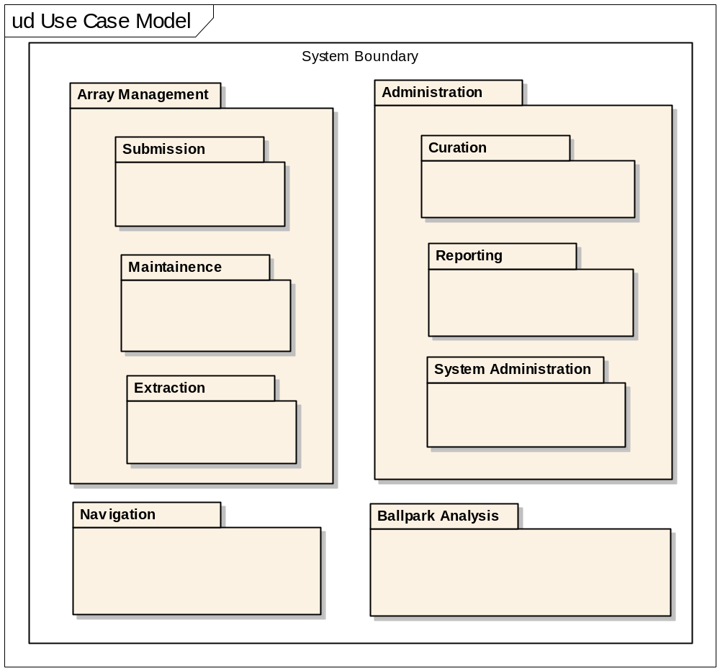
Figure:: Use Case Model

- Actors

Actors
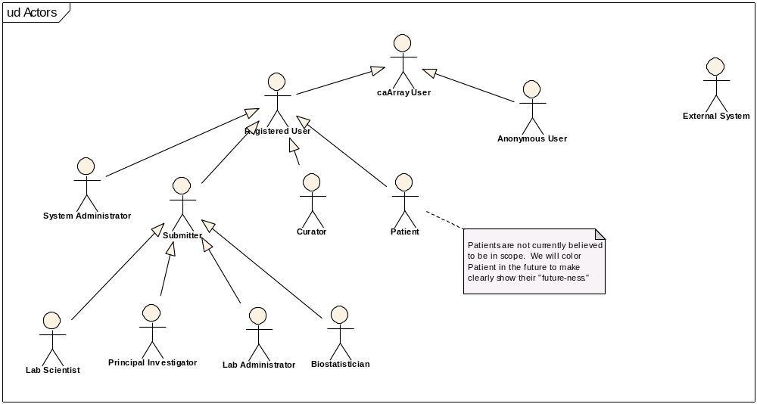
Figure:: Actors

Anonymous User
This is any user who visits caArray but does not get identified throuhg a log in or other form of authentication/authorization. Another name for this actor might be "public user."

Biostatistician

A biostatistician is a special form of submitter who is responsible for statistical analysis of experiment data.At this point, a role which may be too specific for caArray's purposes. It was offered to inspire ideas during inception, but will go away iof we do not find any specific use cases for this specific of an actor, and will be replaced by its ancestor, Submitter.

caArray User

caArray User is anyone who directly accesses caArray, via the interactive or programmatic interfaces.Immediate descendents include Registered User and Anonymous User.In the case of extraction, a caArray User has a need to extract arrays (including array data and annotaitons) for "downstream" use, such as analysis via analytic tools or importing into additional repositories.

Curator
A curator is a caArray user responsible for curating the data present in caArray. Curators have special privileges to ensure the quality (through editing, dmeoting, and promoting) the content of caArray.

External System

A generalized Actor intended to represent those applicaitons/systems that programmatically communicate with caArray. Examples of external sstems we know want to interact with caArray include WebGenome, geWorkBench, and caIntegrator.Examples of programmatic access might include an API, web service, or grid -- specific mechanisms that will be supported have not been solidified.

Lab Administrator

A lab adminsitrator is responsible for managing lab operations, typically for a specific PI.At this point, a role which may be too specific for caArray's purposes. It was offered to inspire ideas during inception, but will go away iof we do not find any specific use cases for this specific of an actor, and will be replaced by its ancestor, Submitter.

Lab Scientist

A lab scientist is a collaborator who assists a PIexecuting protocols for experiments.At this point, a role which may be too specific for caArray's purposes. It was offered to inspire ideas during inception, but will go away iof we do not find any specific use cases for this specific of an actor, and will be replaced by its ancestor, Submitter.

Patient

NOTE: We do not believe Patient will be in scope for 2.0, but we felt we should capture it for now.A Patient is any person who is the source of array data and annotations.

Principal Investigator
A specific form of Submitter, a Principal Investigator (PI) typically owns experiments and studies/projects.

Registered User

A registered user is a specific form of caArray User who is known to caArray (done so throuhg the act of registering).One must be a Registered User before one can submit to caArray.In terms of submission, a registered user can actively contrbute and maintain arrays (including array annotations and array data) to caArray. Registered users who perform submissions are typically researchers with something valuable to offer caArray, such as a Lab Scientist or Prinicpal Investigator.

Submitter
A submitter is a specific form of Register USer who will be the role most likely to make submissions of arrays, including array data and related annotations.

System Administrator
A system administrator is responsible for ensuring caArray operates effectively. They are repsonsible for managing users and groups, providing status of the quality of operation of the caArray application, and ensuring the system is backed up and recoverable, among other things.

- Administration

Administration
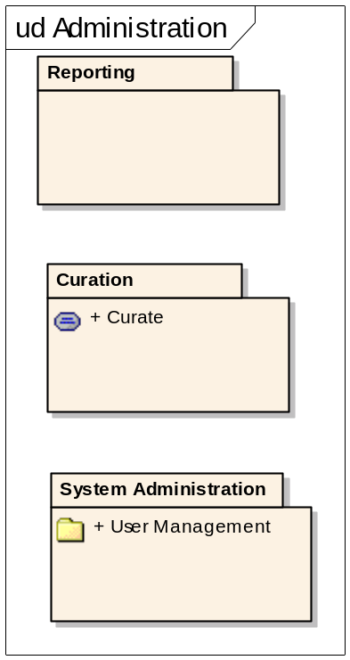
Figure:: Administration

- Curation

Curation
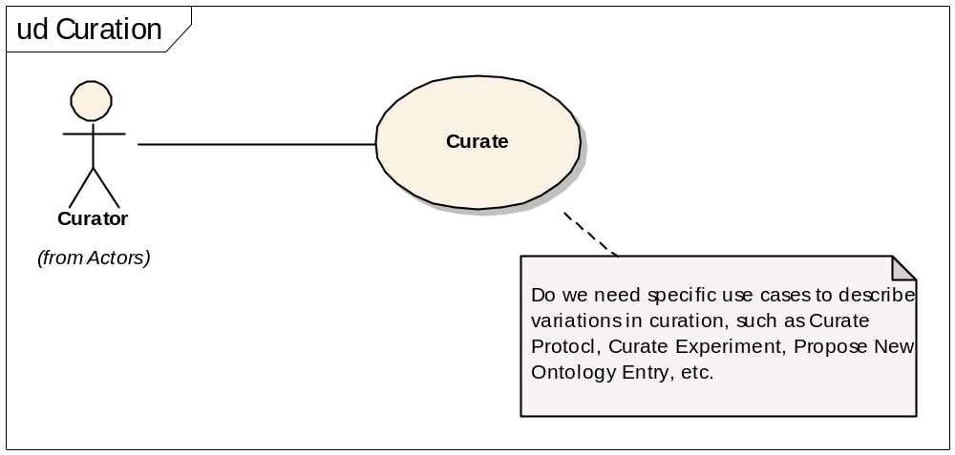
Figure:: Curation

Curate

Initiatited by the, you guessed it, Curator, Curate is a generalized use case to describe the act of curating caArray's submitted content.The sorts of things we anticipate requiring curation include:1) Shareable resources such as protocols and array designs and their names.2) Experiments, to ensure that their annotaitons are meaningful and consistent.3) Proposal and promotion of ontology entries, even those that are merely referenced by caArray but are maintained by external organizations.

- Reporting

Reporting
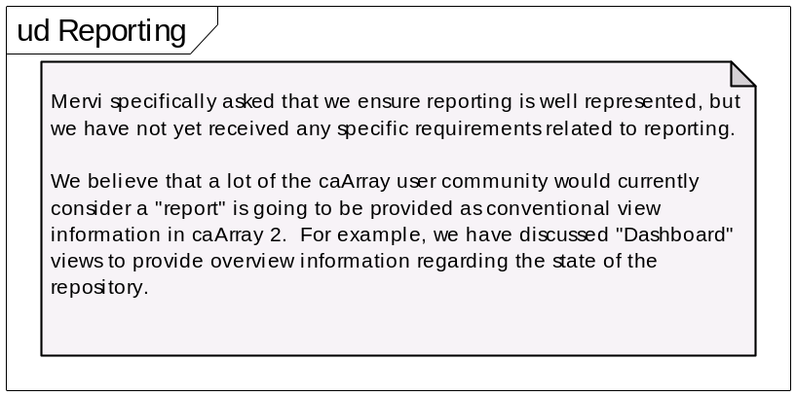
Figure:: Reporting

- System Administration

System Administration
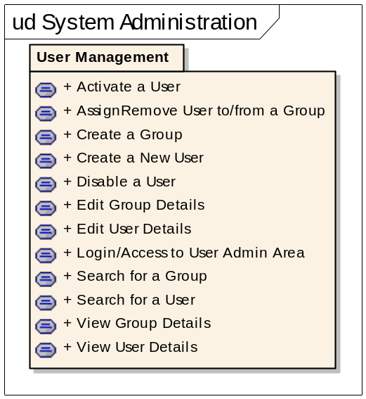
Figure:: System Administration

- User Management

User Management
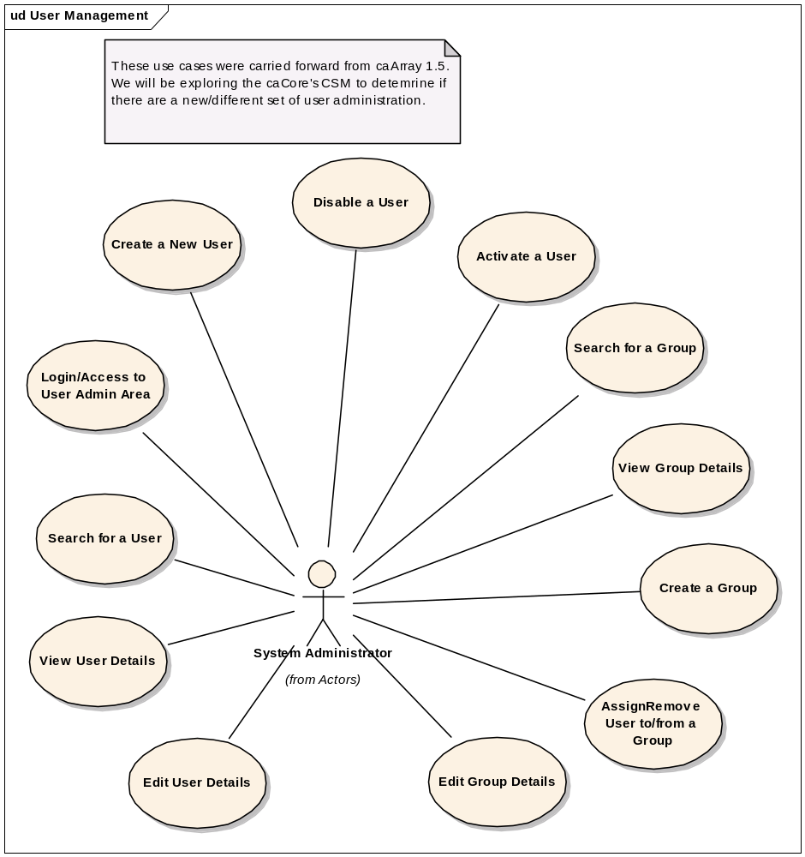
Figure:: User Management

Activate a User
An Admin user can disable an "Inactive" caArray user from the Modify User Details screen. On this screen, there will be a button Activate User next to the user status. Clicking on this button will attempt to set the End Date value a blank string (null value). On successful save of the user information, the user account will be seen as active since there is no end date specified.

AssignRemove User to/from a Group
System administrators will be able to add or remove a user to or from an existing group.

Create a Group
This functionality will allow the Admin user(s) to create a new group within the caArray application.

Create a New User
This functionality will allow the Admin user(s) to create new users for the caArray application. Note that the Password and Confirm Password fields are displayed only when the database is being used for authentication. If LDAP authentication is in use, these fields are not displayed and are, hence, not required.

Disable a User
An Admin user can disable an "Active" caArray user from the Modify User Details screen. On this screen, there will be a button Disable User next to the user status. Clicking on this button will attempt to set the End Date value to the previous day’s date. On successful save of the user information, the user account will be deemed to be inactive as the end date is set to the previous day.

Edit Group Details
This use case permits system administrators to modify particular group's information.

Edit User Details
This use case allows for modification of a User’s details.

Login/Access to User Admin Area

Only Admin users will be allowed access to the User Management area. On successful login, the application will determine "User Management" tab will be visible on the caArray home page before the "Logout" tab. Clicking on the User Management tab will redirect the logged in user to the User Management Area/Section of the application.If the logged in user is not an Admin, then the tab will not be displayed. Any attempts to navigate directly to that URL will display a page that specifies the logged-in user does not have sufficient privileges (or appropriate role) to perform this operation, with instructions on whom to contact to rectify the situation.Any changes to the user privileges (ability to view/not view the User Management area) will take effect when the caArray user logs into the application the next time.

Search for a Group

An admin user can search for groups existing in the system. The "Group Name" can be used as criteria to narrow down the groups list.

Search for a User

Once the Admin User accesses the User Management Area of the application, they can search for other caArray users. The following fields have been identified (initially) that can be used as criteria to narrow down the user list: + Login Name + First Name + Last Name + Institution + E-Mail Address

View Group Details
Once a group has been found, the logged-in Admin user can view the details of the group.

View User Details
Once a user has been found, the logged-in Admin user can view the user details by clicking on the hyperlinked User Name or Login Name fields.

- Array Management

Array Management
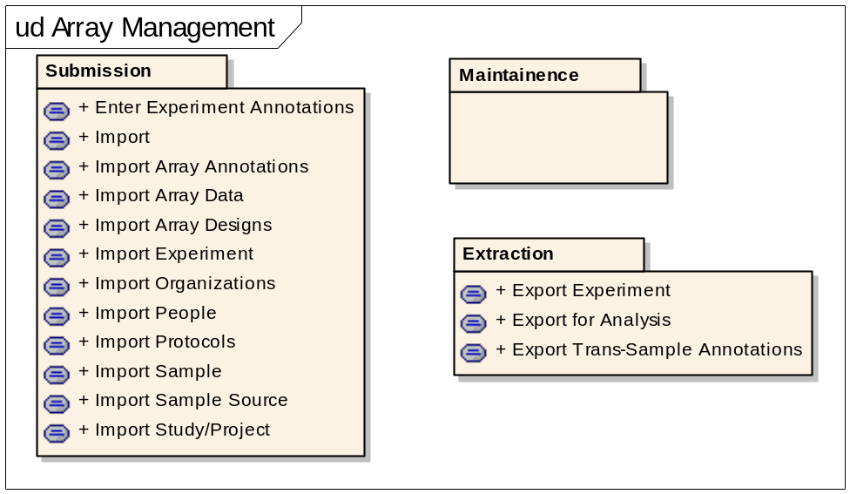
Figure:: Array Management

- Extraction

Data Extraction
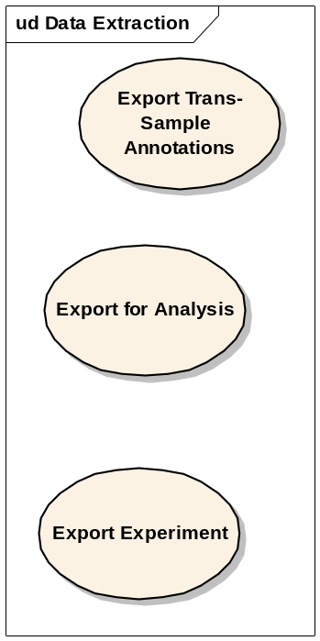
Figure:: Data Extraction

Export Experiment

Export for Analysis

Export Trans-Sample Annotations

- Maintainence

Maintainence
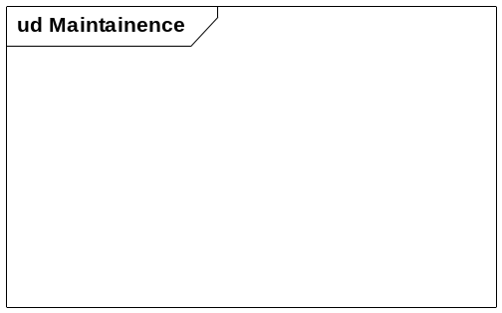
Figure:: Maintainence

- Submission

Data Submission
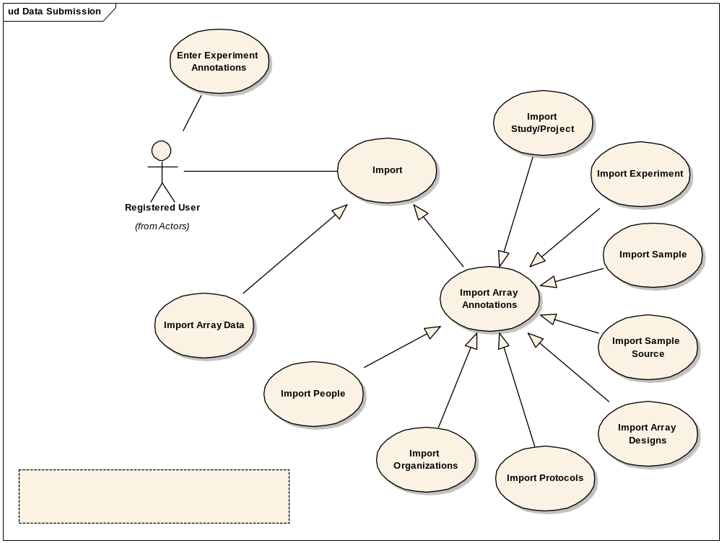
Figure:: Data Submission

Enter Experiment Annotations

Import

This is a general use case that describes how Registered Users will import content into caArray. Note that there are effectively two kinds of things imported into caArray, array data and array annotations.An essential flow of events will look something like:+ Registered User navigates to target location of interest that permits import.+ Registered User chooses import from available actions.+ System shows what is available for import given the context.+ Registered User chooses from possible choices..+ System responds with a file chooser dialog to locate file(s) to import.+ Registered User uses file chooser dialog to locate file(s).+ If possible, Registered User can select a "run in foreground" or run in background" option for impending import.+ Registered User submits.+ System performs import.+ System notifies user of completion.

Import Array Annotations
This use case permits registered users to import annotations into caArray from files on their local file system. Two file formats to be supported include MAGE-ML and MAGE-TAB.

Import Array Data
array data represents the hybridization data for gene expression and snp

Import Array Designs

Import Experiment

Import Organizations

Import People

Import Protocols

Import Sample

Import Sample Source

Import Study/Project

- Ballpark Analysis

Ballpark Analysis
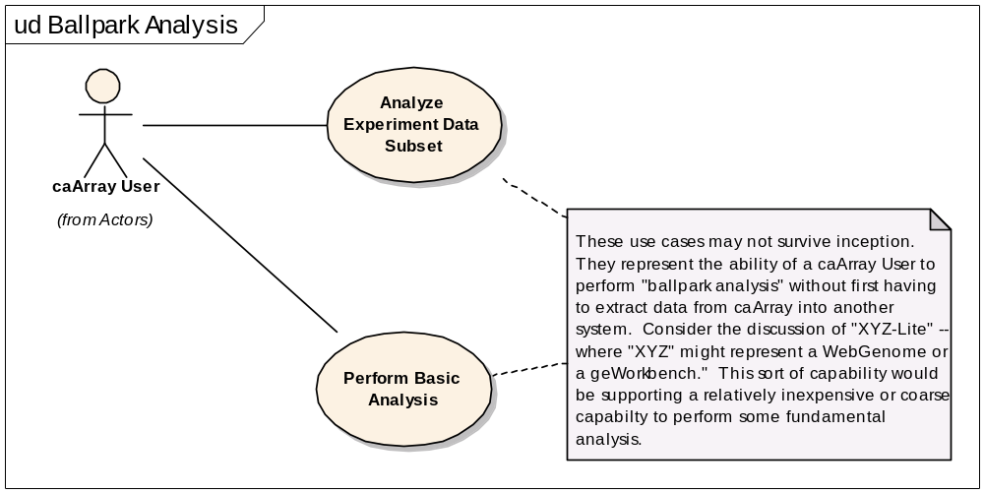
Figure:: Ballpark Analysis

Analyze Experiment Data Subset

Note: We are not certain of the valiadity of this use case. We will investigate with the known programmatic clients of caArray who would provide full-featured analytic tools (e.g,. WebGenome) to see what they say.Juli noted a concern that, without normalized data, analyzing subsets may not be valid/relevant.

Perform Basic Analysis
NOTE: Unsure of the valididty of this use case. We are not certain caArray will be responsible for local analysis of data or if this will strictly be an external function.

- Navigation

Navigation
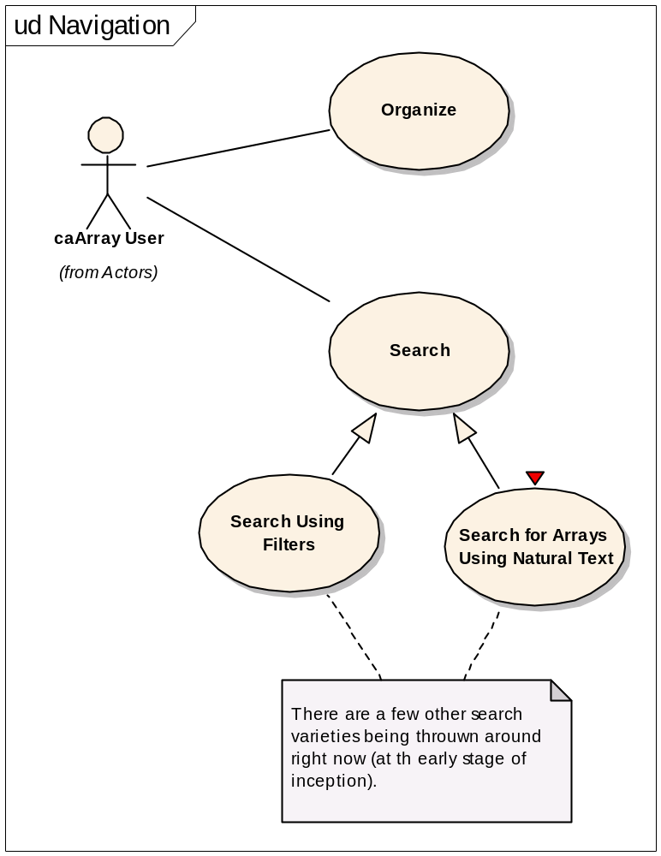
Figure:: Navigation

Organize
This use case permits Registered Users to preserve references to arrays for ease of access and navigation in future sessions. the concepts of folders and subfolders will likely be very familiar to users and we intend to put as few limitations/structure as possible.

Search
This is a generlized use case that describes how users will be able to locate content of caArray based on user-specified criteria. We will likely offer several forms, including friendly "iTunes-like" natural text searches that search a limited set of often-referenced values, as well as more discrete/field-specific searches based on specific values and ranges of values (such as certain genes with a minimal intensity value, or specific probe sets, etc.).

Search for Arrays Using Natural Text

A.K.A. "Spotlight" Search or "Horizontal" SearchThis is a free text, single edit field search that quickly finds results (<10 seconds typically) though the results will be governed (e..g, never more than 150 arrays returned). It is assumed a handful of important (and indexed) fields are considered. Consider the Spotlight search Apple employes, particulalry the text search of the Apple iTunes Store.... millions of items to be searched, extremely fast and governeed results.

Search Using Filters
This is a conventional field-based search. The filters for each entity that can be searched are driven by those entities. For example, Name or Applicable Platform might be filters for a search of and for Array Designs.

- Primary Use Cases

Primary Use Cases

Figure:: Primary Use Cases

