HowTo

- Cvs co caGrid 1.1. stream

- Cvs co cacore SDK 3.2.1

- Update caCore SDK classes based on bugs

- Rebuild the caCore SDK (based on patches)
  - Compile the source files (what ant target???)
  - Run ant package-sdk
  - Copy cacoresdk\output\example\package\cacoresdk.zip to cagrid-1-1\caGrid\projects\introduce\extensions\sdk_discovery. Rename file to “caCORE_SDK_321.zip”
- Rebuild Introduce from source
  - ant build-introduce
- Generate XMI file from EA
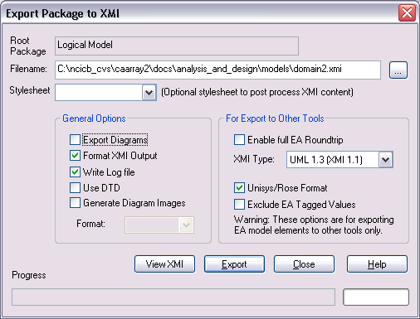

  - (need to modify the generated XSDs and caCore generated XSDs to remove the wording, “Logical Model” from the package names”
  - Modify the XMI file to find & replace “Logical Model” with “LogicalModel” (remove the space)
- Run Introduce to build a CaArraySvc (caBIG Data service)
  - cagrid-1-1\caGrid> ant introduce
  - Choose, Create caBIG service
  - Choose Data Service
  - Specify CaArraySvc as the name
    - Update folder & package names accordingly
  - Choose to generate the XSDs from an XMI file
    - Provide the .xmi file generated from EA
  - When generation complete, click Save in Introduce.
  - Scrub the generated XSDs and introduce.xml to remove any occurrences of “LogicalModel” (case-insensitive)
  - Re-load the service (click Reload button).
  - Click Save, should generate all the proper classes now w/ correct package names, etc..
- Scrub the introduce.xml file
  - Update each <SchemaElement …/> to specify className, deserializer, serializer attributes, e.g. <ns2:SchemaElement className="ArrayGroup" deserializer="gov.nih.nci.cagrid.encoding.SDKDeserializerFactory" serializer="gov.nih.nci.cagrid.encoding.SDKSerializerFactory" type="gov.nih.nci.caarray.domain.array.ArrayGroup" xsi:type="ns2:SchemaElementType"/>
  - Re-load the service w/in Introduce
- Prepare to add additional service methods (Operations tab w/in Introduce)
  - Copy the caarray-client.jar file to the CaArraySvc/ext folder
    - May need to run caarray2/software/build> ant build:caarray-client.jar
  - Modify the “dev-build.xml” file
<target name="defineExtendedClasspaths">
<path id="base.extended.classpath">
<pathelement location="./ext/caarray-client.jar"/>
</path>
…

  - Add

Notes:

