Instructions

This submission form provides information to guide you in annotating and loading your model to the caDSR. It also provides information to the Loading team when registering the model in the caDSR.

- Contacts
Fill out all the relevant information for each role. This information is planned to be entered into caDSR as the contact information for this UML model and thus become available for people who are browsing UML models using the UML Model Browser available at http://umlmodelbrowser.nci.nih.gov/umlmodelbrowser/.

- Runtime Parameters
Context is the name of the context under which your model resides. Contexts can be found in the UML Model Browser and CDE Browser trees as the nodes that are directly under the root node caDSR Contexts. Your model will be placed into a project folder in that context in the caDSR.

Folder Name: This is an optional container that groups several Classification Schemes together. Each Classification Scheme is still versioned separately (see discussion of classification schemes below). The folder is for Browser tree presentation purposes only.

Project Name: The caDSR uses Classification Scheme (CS) of type “Project” as a mechanism to group together all the parts of your UML model. This may be either a new Project name, or the name of a previously loaded Project. The Project Name, (aka CS long name), is used as the name of the node in the UML Model Browser and CDE Browser trees.

*HINT: If you do not see the project in the CDE Browser or UML Model Browser, check that the Workflow Status of the Project is set to “Released”.

Project Versions: Models are versioned at the Project (CS) level. If you wish to place several models under a given Project (CS), note that they will all be versioned at the same time. When models are versioned, contacts and GME namespace name information is carried over to the new version.

Sub-Project Name: Under the Project, you can optionally include a Sub-Project Name that is created as a Classification Scheme Item (CSI) of type “UML Package Alias.” This alias is used as a container for all packages in a Sub-Project within a Project. The caCORE Project in the caCORE context contains an example of the use of Sub-Projects. See the screen snapshot below.

Package Name: Under the Sub-Project, there will be a node corresponding to each UML package, containing all of the data elements in that package. Each Package is created as a caDSR Classification Scheme Item (CSI) of type “UML Package Name” and associated with the Project (CS). UML Package Names (CSIs) are used to keep track of all the model specific information, such as the specific classes and attributes in the model, as well as model owner supplied class and attribute names and definitions. (The CS/CSI construct for organizing metadata in the caDSR is a standard ISO 11179 metadata construct.)

*NOTE: All UML model projects are versioned at the Project level, including all packages within a model, all at the same time.

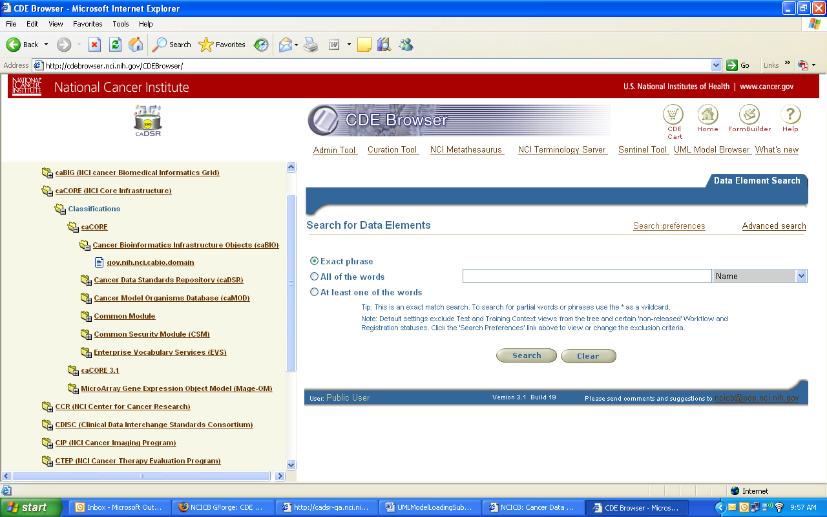
UML Project →
UML Sub-Project →
UML Package →

Example of Folders:

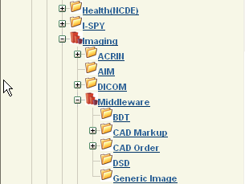
Folder
Folder
UML Projects
UML Projects

- Code Generation
Indicate whether or not you plan to use the code generator provided by the caCORE SDK to generate your API. There are different validation rules performed on the extracted XMI representation of your model if you plan to use the SDK code generator.
- Submission Package
Please create a zipped file that contains the following files from your model.

For models annotated using the SIW 3.1 process:
  - UML Model .EAP file
  - The original XMI file that was exported from the UML model
  - The Fixed XMI file produced by running the Fix XMI file in SIW
  - The CSV file produced by running the Semantic Connector (first pass) in SIW, if submitting the model to be annotated and verified by the EVS team, OR,
  - The approved (“Model Owner Verified”) Annotated XMI file, if submitting the model to be loaded to the caDSR
  - A Model documentation file (optional), such as the RTF file that can be produced from Enterprise Architect (EA)
  - The completed Submission Form

For models annotated using the SIW 3.2 process:
  - UML Model .EAP file
  - The original XMI file that was exported from the UML model
  - The First Pass XMI file produced by running the Semantic Connector in SIW, if submitting the model to be annotated and verified by the EVS team, OR,
  - The approved (“Model Owner Verified”) Annotated XMI file, if submitting the model to be loaded to the caDSR
  - A URL for Model documentation. Model documentation should be produced from Enterprise Architect (EA) in HTML format, if possible. Otherwise a similar model owner supplied document should be created. The URL is planned to be linked to your Project in the UML Model Projects GForge site, as well as in the caDSR as a Project Reference Document. This will allow end users to easily browse your model from the UML Model Browser at http://umlmodelbrowser.nci.nih.gov/umlmodelbrowser/.
  - The completed Submission Form

When complete, send the zipped file to NCICB Application Support (ncicb@pop.nci.nih.gov). Please specify the step in the process to be completed (e.g., verify concept mappings, load to sandbox, load to production).

Pre-Submission CHECKLIST

To create the model submission package to be annotated and validated by the EVS team, follow these steps.

*NOTE: These steps apply to the SIW 3.2 only. If you are submitting a model using the SIW 3.1 process, please ask NCICB Application Support (ncicb@pop.nci.nih.gov) for details.

- Export the model in default Enterprise Architect (EA) XMI format.

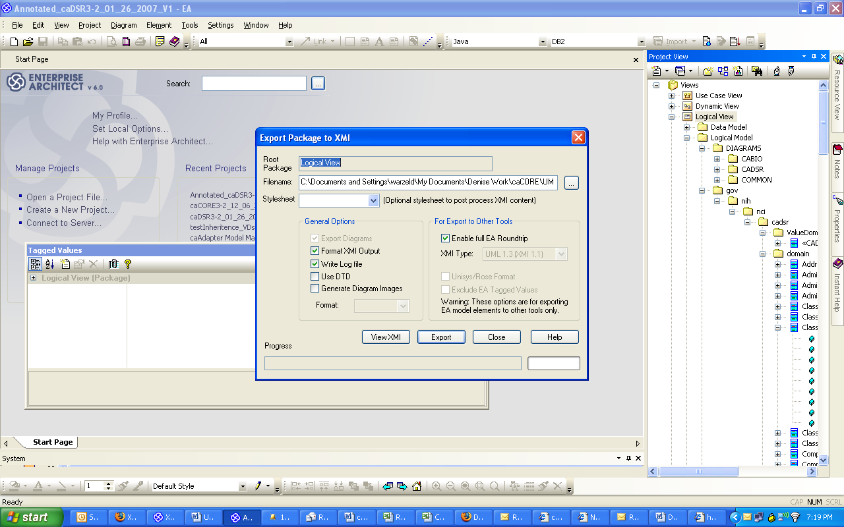

*NOTE: The dialog box may look slightly different depending on the version of EA you are using. Please use the EA default settings when exporting.

- Open the exported file in “Review un-annotated XMI File” in SIW and check the error log.
  - Look for missing documentation and description tags, invalid data types, missing Value Domain tagged values, association errors
  - Correct any errors in your UML model in EA
  - Re-export the XMI file and repeat
- Run SIW Roundtrip, if:
  - This is a new version of a model already loaded into caDSR on the production environment
  - Your model includes part of another model already loaded into caDSR on the production environment and you used the same class and attribute names

- Open the XMI file in “Review un-annotated XMI File” in SIW to review the results of the roundtrip (CDE reuse), and look for other errors (see step 2).
- Run the Semantic Connector in SIW to perform a first pass at concept annotation of classes and attributes that were not matched to CDEs in step 3.

Please fill in the following information. This information will be used to load your model to caDSR. It will also be used by the EVS and Model Loading Teams if a problem is encountered during processing.

- Curation Account and Curriculum
  - Do you have a caDSR Curator Account?
Yes
No

  - If yes, what is your account name?

  - Please indicate any caCORE courses you have completed:
- Basic Courses
- 1000: Intro to caCORE and caDSR
- 1010: Intro to ISO/IEC 11179
- 1020: Using the CDE Browser and UML Model Browser
- 1030: EVS Overview
- 1040: Creating Well-formed Metadata and Metadata Business Rules
- 1070: Curating Metadata from UML Models – three parts
- Intermediate Courses
- 2010: Using the CORE SDK
- 2020: Using the Sentinel Tool
- 2030: Using the Formbuilder
- Other, Specify:
*NOTE: For more information and to register for these courses go to http://ncicb.nci.nih.gov/NCICB/training/cadsr_training.

- Model Review Options
  - Have you reviewed your XMI file to check for basic errors such as invalid data types, missing class or attribute definitions and missing VD tagged values?
Yes
No

*NOTE: Performing this task before submitting model will speed up processing of your model.

  - Have you made any edits to the concept mappings using the SIW in the “Roundtrip” or “First Pass” XMI file?
Yes
No

  - Have you made any edits to the XMI file using any tool other than SIW?
Yes
No

If yes, please explain what tool you used and what you edited:

- Contacts
  - Model Owner
    - Name: Juli Klemm
    - Organization: NCICB
    - Email: klemmj@mail.nih.gov
    - Phone: 978-443-2431

  - Primary Point of Contact (if different from Model Owner)
    - Name: Rashmi Srinivasa
    - Organization: 5AM Solutions
    - Email: srinivra@mail.nih.gov
    - Phone: 301-443-6022

  - Secondary Point of Contact to notify when load is complete (if different from Point of Contact):
    - Name: Maki Duncan
    - Organization: 5AM Solutions
    - Email: duncanm@mail.nih.gov
    - Phone:

- Project Information
  - caDSR context into which project is to be loaded (e.g., caBIG, CTEP, CIP, NHLBI, etc.): caBIG

  - Naming and identification:
    - Project Description (brief description of the model and intended usages, e.g., “Application xyz is based on this model…”):
caArray Internal Model

    - Please fill in the following structure with the names with which you would like the project and packages to be registered. These names will be displayed in the CDE and UML Model Browser Trees:
      - >>>Folder Name (optional; use if you wish to group several Projects in the caDSR Browser tree):
caArray

      - >>>>Project Name:
caArray Internal

      - >>>>>Subproject Name(s) (optional):
caArray Internal 2.3

*NOTE: For each subproject listed, please indicate the names of the packages to be contained in that subproject. Each subproject must include at least one package.

  - Project Version
    - Version being loaded (e.g., 1.0): 2.3

*NOTE: Versions are assigned to a Project, not an individual sub-project or package.

    - Previously loaded version number (if applicable): caArray2.1

    - Do you wish to retire the previous version (if applicable)?
Yes, retire previous version
No, leave previous version released

*NOTE: Selecting “Yes” will cause the model not to display in the CDE and UML Model Browsers.

* NOTE: The default workflow status for all DECs, VDs, and CDEs will be Draft New, and should be block edited using the Curation Tool to change to “Released” once the model is reviewed, approved and released on the production environment.

  - Please list any packages in your UML model you wish to exclude from loading:

  - URL to project documentation to be linked to your project (optional):

- Miscellaneous
  - Which UML modeling tool did you use to create your UML model (product name and version)?
Enterprise Architect 6.5

  - Which SIW release did you use to annotate the XMI file?
3.1
3.2

  - Do you plan to use the caCORE SDK Code Generator to generate your APIs?
Yes
No
Have not decided

  - Do you plan to submit your model for the caBIG Silver Compatibility Review?
Yes
No
Have not decided

  - Who is funding your project (e.g., NCICB, caBIG, etc.)? NCICB

