Datatypes in the caDSR

Patrick McConnell, Scott Oster, Baris Suzek, Moses Hohman, Xin Zheng,
Tommie Curtis, Brian Davis, Arumani Manisundaram

Contents
1. Contents 1
2. State of the caDSR 1
2.1. Stakeholders 1
2.2. Current definition of datatype 2
2.3. Current caDSR datatypes 2
3. Goals 3
4. Scope: primitive datatype defined 3
5. Evaluation of current caDSR datatypes 4
6. Standards review 4
6.1. HL7 4
6.2. CORBA 5
6.3. ISO 11404 5
6.4. XML Schema 7
7. Recommendation 8
7.1. Recommended datatypes 8
7.2. Mapping existing datatypes 9
7.3. Modeling recommendations 11
7.4. Implementation 21
7.5. Adoption strategy 21
8. Process for reviewing new datatypes 22
9. Appendix 22
9.1. Descriptions of Recommended XML Schema Datatypes 22

State of the caDSR

Stakeholders
The caDSR is a large, complex system used in production environments by a number of groups throughout the NCI. The changes that are recommended in this document are fairly broad and will affect the way the caDSR is used, so it is important to enumerate the stakeholders that will be affected. The primary effect of the changes will be in how applications map their underlying types to the caDSR types. The stakeholders should have an opportunity to review the recommendations and provide feedback before any changes are made. The caBIG domain modelers have become core users of the caDSR and will likely be among the first groups affected by the recommendations. Modeling forms is one aspect of the caDSR that is not leveraged much by this group, so it will be critical to gain feedback from forms modelers. There are a number of tools and infrastructure developers that rely on the caDSR either directly or indirectly. These include the developers of the Semantic Integration Workbench (SIW), the UML Model Loader, the caCORE codebase, caCORE SDK, and the caGrid infrastructure. Finally, there are a number of curators that work hands-on with the caDSR on a daily basis. Though this document has been drafted by a small group from the VCDE workspace, feedback from the above groups has been and will continue to be incorporated wherever possible.

Current definition of datatype
caDSR is an implementation of the ISO/IEC 11179 specification. Here, datatype is defined as:

A set of distinct values, characterized by properties of those values and by operations on those values (ISO/IEC 11179-3:2003(E))

The ISO/IEC 11179 definition of a composite datatype is:

A data type that is also a class.

A Datatype class in ISO/IEC 11179 is designated by a data type name, and described by a datatype description. The datatype name is usually drawn from some external source, which is designated by a datatype scheme reference. Additional information may optionally be provided using the datatype annotation. The characteristics of these attributes and their definitions in ISO/IEC 11179 are:

- datatype_name [1..1] : String - a designation for the Datatype
- datatype_description [0..1] : String - descriptive information to further clarify the Datatype
- datatype_scheme_reference [1..1] : String - reference identifying the source of the Datatype specification
- datatype_annotation [0..1] : String - specifying information to further define the Datatype

Current caDSR datatypes
The following are the datatypes that are currently registered in the caDSR (see 7.2 for definitions):

Basic

ALPHANUMERIC, BINARY OBJECT, BOOLEAN, CHARACTER, DATE, DATE/TIME, DATETIME, NUMBER, OBJECT, SVG, TABLE, TIME

Oracle

Date Alpha DVG, Numeric Alpha DVG

Java

java.lang.Boolean, java.lang.Byte, java.lang.Character, java.lang.Double, java.lang.Float, java.lang.Integer, java.lang.Long, java.lang.Short, java.lang.String, java.lang.Void, java.lang.Integer[], java.lang.String[], java.lang.String[][]

java.util.ArrayList, java.util.Collection, java.util.Date, java.util.HashSet, java.util.Hashtable, java.util.Map, java.util.Set, java.util.Vector

java.sql.Blob, java.sql.Clob, java.sql.Timestamp

MutableTreeNode

EVS

evs.domain.Property, evs.domain.Role, evs.domain.Source, evs.domain.TreeNode.

Goals
The overall goal of this white paper is to recommend a set of standard datatypes to be used in the caDSR in order to promote interoperability between applications. This will entail an evaluation of the datatypes currently registered in the caDSR, as well as standard datatypes used by the broader software community. For those datatypes currently used in the caDSR that differ in any way from the recommended set, a migration path should be described and documented. Ultimately, all the pre-existing datatypes should be retired. Finally, to insure that the efforts of this whitepaper are maintainable, we provide a process for reviewing new datatypes before they are incorporated into the caDSR.

Scope: primitive datatype defined
We define a primitive datatype as describing the lowest form of a piece of data. The datatype itself should be at some level self-descriptive – there should be no ambiguity about what a specific primitive datatype represents. For many datatypes, this meaning can be defined even down to the structure of the bytes that represent the value. Furthermore, a primitive datatype found in the caDSR should be implementation-agnostic. The datatype itself should not be tied to any specific language, though the definition of the datatype should be sufficient to implement it in any programming language. We use these characteristics to evaluate datatypes and provide our recommendation.

Evaluation of current caDSR datatypes
In our evaluation of the current caDSR datatypes, we found that they pose a significant barrier to interoperability. The most widely used datatypes for caBIG domain modeling are the Java primitives (java.lang.*). These datatypes are specific to that programming language, and thus are not truly interoperable. Furthermore, the Java utility types (java.util.*) and SQL types (java.sql.*) pose further problems because they are complex objects that carry with them intrinsic meaning to the programming language. For example, Hashtable is a datatype with meaning that is very much implementation-dependent – Perl’s notion of a Hash is much different than Java’s notion of a Hashtable.

The basic datatypes used frequently in forms building are for the most part language-agnostic but have some similar problems as those of the Java types. For example, the SVG and TABLE datatypes are complex with varying meaning. Additionally, there are a number of overlapping types for data and time. While they are important datatypes, their actual differences are somewhat ambiguous. The semantics of the Oracle datatypes are vague and seem to overlap with the other types. The EVS types are complex types that are implementation-specific.

In the caDSR, arrays are currently handled by adding a new type that is named similarly to the component type. For example, String[] and String[][] are defined and represent 1-dimensional and 2-dimensional arrays of Strings, respectively. This solution is not scalable for all datatypes and all possible array dimensionalities.

Given this evaluation, we recommend replacing the existing datatypes registered in the caDSR with a standard set used in the broader community.

Standards review

HL7
The Health Level Seven (HL7) organization has defined a standard set of datatypes and interfaces for exchanging clinical data. The datatypes include a number of typical primitives, such as Boolean, Character String, Integer Number, and Real Number. In addition, the specification defines a number of more complex primitives, such as Person Name, Postal Address, and Parametric Probability Distribution. Finally, there are a number of collection types, such as Set, Sequence, and Bag. All of these types can be composed into complex types that make up messages. HL7 has implementations in many of the common programming languages, including Java.

HL7 primitives are language- and implementation-agnostic, though they are oriented to the health care field. In addition, a number of the common primitive types could not easily be mapped to many programming languages. For example, Integer Number has no lower or upper bound, making it very difficult to map to the integer primitive in any programming language. Furthermore, many of the primitives are fairly complex, such as Postal Address. For these reasons, we do not recommend HL7 primitives to be adopted for the caDSR.

CORBA
The Common Object Request Broker Architecture (CORBA) is a software infrastructure for enabling distributed applications. In theory, CORBA is platform-, language-, and vendor-agnostic, though in practice it can be difficult to interoperate between vendor implementations. It uses an interface definition language (IDL) to specify the interface that an object exposes, and this interface is then mapped to an implementation in a specific programming language.

IDL defines a number of primitive datatypes, including many of the types typically found in programming languages (e.g. int, float, long, short). Additionally, CORBA defines the higher-level constructs of array and data structures (similar to C structs). There are implementation mappings to most programming languages, such as Java, C, C++, and Perl. However, not all of the mappings are straightforward – for example, in Java some primitive types have a different number of bytes that the CORBA counterpart. Additionally, CORBA is not used very much in new application development. For these reasons we do not recommend CORBA as a basis of new datatypes to be defined in the caDSR.

ISO 11404
The ISO 11404 specification aims to standardize the way in which procedures are called, as well as datatypes. The goal is to alleviate the burden of needing to map service libraries to the multitude of programming languages available to developers. The expectation is that each programming language will provide a mapping to the standard datatypes. The standard defines datatypes in the following way:

A datatype is a set of distinct values, characterized by properties of those values and by operations on those values. Characterizing operations are included in this International Standard solely in order to identify the datatype.

ISO 11404 has the notion of primitive datatypes, which “are defined ab initio without reference to other datatypes”, and generated datatypes, “which are specified, and partly defined, in terms of other datatypes”. Each datatype has a “value space”, which is the collection of values for a given datatype. For example, the Scaled datatype has a value space of scaled-literal and scale-factor.

The following are the primitive datatypes defined in the specification:

- Boolean: the mathematical datatype associated with two-valued logic.
- State: a family of datatypes, each of which comprises a finite number of distinguished but unordered values.
- Enumerated: a family of datatypes, each of which comprises a finite number of distinguished values having an intrinsic order.
- Character: a family of datatypes whose value spaces are character-sets.
  - character-literal, any-character, bound-character, non-quote-character, added-character, escape-character, character-name
- Ordinal: the datatype of the ordinal numbers, as distinct from the quantifying numbers (datatype Integer). Ordinal is the infinite enumerated datatype.
  - ordinal-literal, number
- Date-and-Time: a family of datatypes whose values are points in time to various common resolutions: year, month, day, hour, minute, second, and fractions thereof.
- Integer: the mathematical datatype comprising the exact integral values.
  - integer-literal, signed-number, number
- Rational: the mathematical datatype comprising the "rational numbers".
- Scaled: a family of datatypes whose value spaces are subsets of the rational value space, each individual datatype having a fixed denominator, but the scaled datatypes possess the concept of approximate value.
  - scaled-literal, scale-factor
- Real: a family of datatypes which are computational approximations to the mathematical datatype comprising the "real numbers". Specifically, each real datatype designates a collection of mathematical real values which are known to certain applications to some finite precision and must be distinguishable to at least that precision in those applications.
  - real-literal, scale-factor
- Complex: a family of datatypes, each of which is a computational approximation to the mathematical datatype comprising the "complex numbers". Specifically, each complex datatype designates a collection of mathematical complex values which are known to certain applications to some finite precision and must be distinguishable to at least that precision in those applications.
  - complex-literal, real-part, imaginary-part
- Void: the datatype representing an object whose presence is syntactically or semantically required, but carries no information in a given instance.

The ISO 11404 standard does provide many of the features necessary for a language-agnostic datatype for the caDSR. However, there are a handful of drawbacks. The standard provides example bindings to Pascal and MUMPS, but we were unable to find any other example or real implementations of the standard. This would not only make it difficult to use, but the effectiveness of the standard has not yet been “proven”. Furthermore, some of the datatypes would likely have to be decomposed into more concrete datatypes, such as Date-and-Time being decomposed into date and time to meet caDSR use cases. Finally, many of the datatypes are defined at a very abstract level and may be difficult to implement. For example, the Real datatype is defined as having “some finite precision” that is “distinguishable to at least that precision in those applications”. For these reasons, we do not recommend adoption of ISO 11404 as the base set of datatypes for the caDSR.

XML Schema
The W3C XML Schema Datatype Specification describes a datatype system (see Figure 1) that can be used in validating the element content and the attribute values in XML documents. The datatypes in XML can be classified into three groups; ur-Type, built-in and user-derived.

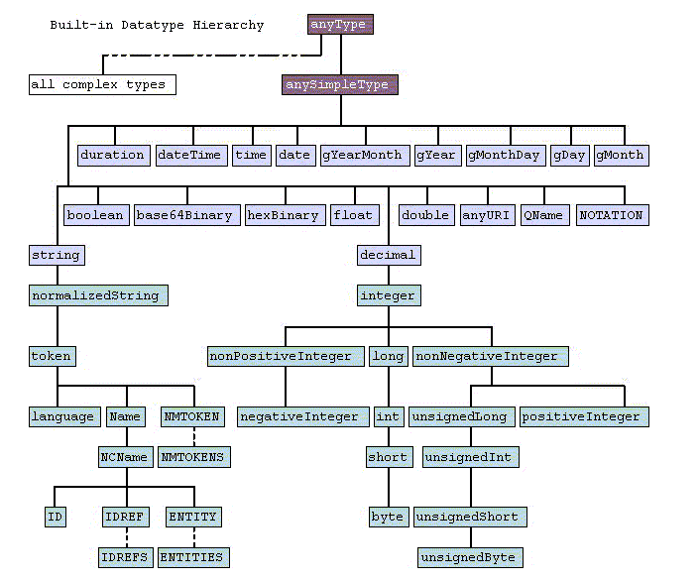
ur-Type
built-in primitive
built-in derived
Figure 1 XML Schema Built-in Datatype Hierarchy
Ur-Type datatypes are at the root of the entire type system hierarchy. Similar to java.lang.Object in Java, the types of this group are base for all built-in and user-derived types. “anyType” and “anySimpleType” are within this group.

Built-in datatypes can be classified into two groups:

- Primitive datatypes are those that are not defined in terms of other datatypes; they exist from the beginning. This group includes datatypes such as “string”, ”boolean”, ”decimal”, ”float”, ”double”, ”time”, and ”base64Binary”. The details on these datatypes can be found in Section 3.2 of W3C XML Schema Datatype Specification document.
- Derived datatypes are those derived from the built-in primitive datatypes. This group includes “normalizedString”, ”nonPositiveInteger”,”long”, ”int”, “short”, “byte”, and ”positiveInteger”. The details on these datatypes can be found in Section 3.3 of W3C XML Schema Datatype Specification document.

User-derived dataypes are those defined by individual schema designers. As described in more detail in section 4.1.2 of W3C XML Schema Datatype Specification, one can derive new datatypes 1) by restricting the value space of the base type using constraining facets; 2) by creating a list datatype whose value space consists of finite-length sequences of values of its item type; or 3) by creating a union datatype whose value space consists of the union of the value spaces of its member types. For example a user-derived datatype to represent a product code which must exactly be 8 characters long can be defined as:

<simpleType name='productCode'>
<restriction base='string'>
<length value='8' fixed='true'/>
</restriction>
</simpleType>

XML Schema datatypes will be an ideal basis for the standard datatypes to be used in the caDSR for following reasons:
- They are language agnostic.
- The standard is complete, in the sense that built-in datatypes cover majority of the primitive datatypes available in and outside caDSR. Furthermore, the datatype system provides mechanisms to derive new datatypes as needed.
- Mappings of XML Schema datatypes to virtually any programming language are available.
- The standard is widely accepted by the community and supported by World Wide Web Consortium (W3C).
- The standard is well documented.
- The standard maps well to the caGrid implementation, which uses XML for data transport and XML Schema to describe the structure of data.

Recommendation

Recommended datatypes
We recommend the following datatypes that come from the XML Schema specification (see section 9.1 for detailed descriptions):

- string
- short, int, long
- decimal, float, double
- boolean
- byte
- base64Binary
- dateTime, date, time (also see section 7.3.7)

We also recommend the following additional datatypes not found in XML Schema:

- anyClass (see section 7.3.4)
- binary (see section 7.3.5)

Mapping existing datatypes
The caDSR currently contains nearly fifty datatypes. The table below shows the mappings between datatypes currently available in the caDSR and the recommended XML Schema datatypes. The descriptions of recommended XML Schema datatypes are available in Appendix A.

caDSR Datatype | Description | XML Schema Datatype
ALPHANUMERIC | A mix of numeric and alphabetic characters | string
BINARY OBJECT | A binary large object such as a document or image. | See section 7.3.5
BOOLEAN | The mathematical datatype associated with two-valued logic. | boolean
CHARACTER | A character string of letters, symbols, and/or numbers | string
DATE | A date specifying month, day, and year | See section 7.3.7
Date Alpha DVG | Oracle Clinical datatype-contains alphanumeric and Date data (Discreet Value Groups) | string and see section 7.3.7
DATE/TIME | A date (month,day,year) and time(hours,minutes,seconds). | See section 7.3.7
DATETIME | A date (month,day,year) and time(hours,minutes,seconds). | See section 7.3.7
java.lang.Boolean | A local java datatype - TreeNode. | boolean
java.lang.Byte | Java primitive - byte-length integer. | byte
java.lang.Character | Java primitive - single character. | string
java.lang.Double | Java primitive - double-precision floating point number. | double
java.lang.Float | Java primitive - single-precision floating point number. | float
java.lang.Integer | Java primitive - Integer. | int
java.lang.Integer[] | Java datatype - array of integers. | See section 7.3.1
java.lang.Long | Java primitive - long integer. | long
java.lang.Short | Java primitive - short integer. | short
java.lang.String | Java datatype - class that represents character strings. | string
java.lang.String[] | Java datatype - array of strings. | See section 7.3.1
java.lang.String[][] | Java datatype -array of strings arrays. | See section 7.3.1
java.lang.Void | Java - reference placeholder for the Java word void. | See section 7.3.13
java.sql.Blob | Java SQL datatype - binary large object. | See section 7.3.5
java.sql.Clob | Java SQL datatype - character large object. | string
java.sql.Timestamp | Java SQL datatype - thin wrapper around java.util.Date | See section 7.3.7
java.util.ArrayList | Java datatype - represents resizable-array, List interface | See section 7.3.2
java.util.Collection | Java datatype - represents a group of objects. | See section 7.3.2
java.util.Date | Java datatype - represents a specific instant in time. | See section 7.3.7
java.util.HashSet | Java datatype - implements the set interface. | See section 7.3.2
java.util.Hashtable | Java datatype - implements hashtable mapping keys to values. | See section 7.3.2
java.util.Map | Java datatype - maps keys to single, non-duplicate values. | See section 7.3.2
java.util.Set | Java datatype - collection containing no duplicate elements. | See section 7.3.2
java.util.Vector | Java datatype - implements a growable array of objects. | See section 7.3.2
MutableTreeNote | Java datatype - general purpose node in a data tree | See section 7.3.2
NUMBER | A number that may be used in calculations | double
Numeric Alpha DVG | Oracle Clinical datatype-contains alphanumeric and numeric | string
OBJECT | Representation is an object | See section 7.3.4
String Array | An array of strings | See section 7.3.1
SVG | Scalable Vector Graphic - XML file format for 2-D graphics | string
TABLE | A complex datatype composed of data elements | See section 7.3.1
TIME | A time of day specifying hours, minutes, and (opt.) seconds | See section 7.3.7
java.lang.Object | Java datatype – generic object | See section 7.3.4

Modeling recommendations
The following sections contain recommendations for modeling specific constructs using the recommended set of primitives.

Modeling arrays
An array type modifies a primitive type by allowing more than one value to be associated with a data element. In UML, this is similar to the notion of the cardinality of an attribute. However, an array adds one more level of complexity by allowing the values to fall among a semi-arbitrary number of dimensions where each dimension can be accessed by a numeric index. For example, a one-dimensional array arranges values sequentially, which can be accessed with one numeric index, a two-dimensional array arranges values in a square table, which can be accessed with two numeric indices, and so on. It is important to note that the dimensionality of an array is a logical structure added to the values – computers generally arrange all the values in a sequential order in memory. In addition to the number of dimensions, it can also be important to represent the maximum index values in each dimension.

The recommended way to model arrays in the caDSR is to use the component datatype as the datatype of the data element. Then, the value domain should be used to address the dimensionality and any minimum or maximum index values. The method by which this is accomplished in the caDSR is not clear. One option would be to have extra fields in the value domain, such as dimensionality. This method would preclude the use of minimum and maximum index values, though that is a feature that is not strictly necessary to implement arrays.

The following is an example of mapping java.lang.Object[][][] into the caDSR:

Value Domain Long Name: AnyClass Three Dimensional Array
Value Meaning Definition: Generic value domain for a three dimensional array with UML Classes as elements.
Datatype: anyClass
Conceptual Domain: Bioinformatics
Context: caBIG
Non-enumerated

A UML model Data Element created using this Value Domain would be structured as an object class and property of:

Object Class Property AnyClass Three Dimensional Array

Modeling collections
Some models registered in the caDSR have a collection type (e.g. ArrayList, HashSet) as the datatype of an attribute. This is not acceptable because the datatype is not one of the recommended datatypes. One way to model a collection type is to create a class for the collection and add an association with cardinality greater than one. An alternate and more concise way to model it is as an array with cardinality greater than one (see Figure 2). A more difficult collection type to model is that of a Hashtable. The best way to model this is with an associated class with cardinality greater than one that has attributes for the hash key and the value (see Figure 3). Note: the diagrams below are not caCORE SDK compliant, but they do follow the guidelines for UML modeling in caBIG.

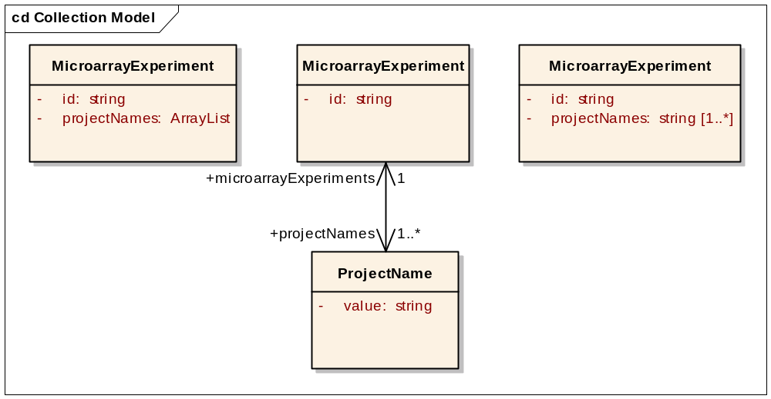
Figure 2 Example of modeling an collection type in an inappropriate way (left), as an associated class in an appropriate way (middle), or an array in an appropriate way (right).
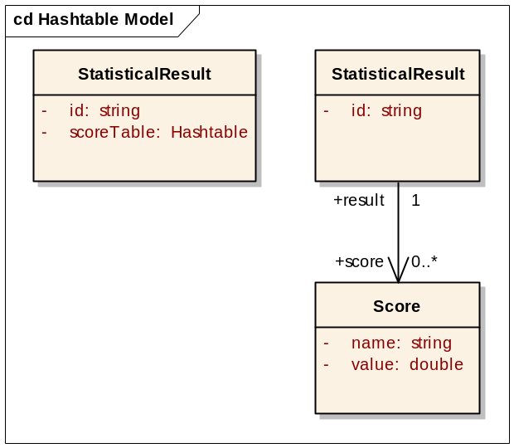
Figure 3 Example of modeling a Hashtable type in an inappropriate way (left) and as an associated class in an appropriate way (right).

Modeling complex types
If at all possible, it is desirable to describe the structure and semantics of the complex type using common data elements in the caDSR. However, it can be quite difficult to model some complex datatypes, such as an external data standard, using classes with primitive attributes. The reason for this could be that the datatype itself does not lend itself to being modeled using classes, the effort of modeling the datatype using classes is too great to undertake, or there simply is no gain semantically to model the datatype with classes. If this is the case, then it is recommended that the complex datatype be modeled as an attribute with a simple type. That attribute would store the complex data using whatever native encoding the complex datatype requires. In addition to the complex data, other attributes important for querying, identifying, and decoding the data should be included (see Figure 4). Information about the actual type of the complex type can be captured in the value domain and semantic concepts associated with the class and attribute.

The following examples demonstrate two different complex types that are modeled as the value of an attribute. SVG is a standard for encoding graphics in XML. The contents of an SVG document (encoded in the value attribute) are typically not semantically interesting. There likely are few or no use cases that dictate that the structure of the SVG document be described semantically or queried. BioPAX is a standard for encoding biological pathway information in the OWL format. The contents of the BioPAX document can be considered semantically interesting. If possible, it is desirable to encode this structure and the semantics in the caDSR. However, if this is not possible or feasible (as in the case of some BioPAX caBIG applications), it is acceptable for the OWL document to be encoded in an attribute (bioPAXValue).

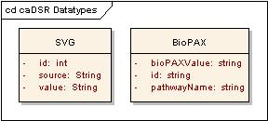
Figure 4 Examples of modeling complex types. Left: example of modeling the complex type SVG, the contents of which are not particularly semantically interesting. Right: example of modeling BioPAX, a complex datatype that is an external standard with contents that are semantically interesting..
Modeling complex types is being addressed by the External Standards Small Group of the VCDE workspace. Additional information can be found at http://gforge.nci.nih.gov/projects/extern-standard/.

Modeling generic objects
Some applications or services provide capability to process inputs or produce outputs of a type that is not known until runtime. For example, a caGrid data service returns a result object which contains a sequence of results, in which the actual result could be any Class that is exposed through the data service. It is important for every data service to share a common service interface and produce the same caDSR-registered result object, so it is not appropriate to create a model-specific result type for each data service.

The current modeling approach to handle this situation is to use java.lang.Object as an attribute datatype (see Figure 5). This has several drawbacks, which have been previously identified (such as being language-specific), but most importantly it provides a “back door” for a model to introduce data types not registered in the caDSR. That is, at runtime, a non-registered Class could be returned in the model.

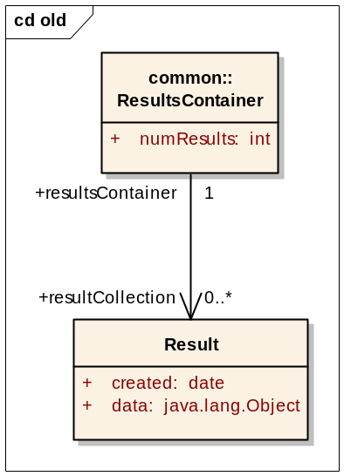
Figure 5 Example of using the object type inappropriately
The recommendation is to disallow the use of java.lang.Object (or any equivalent construct) as a datatype. To handle the use cases of generic types, there are two alternatives (one of which must be selected) detailed in the following sections. The first is to provide a new datatype with similar semantics, but without the drawbacks of java.lang.Object. The second is to disallow the use of such a datatype and require these use cases are handled through associations to a special class representing “any Class.”

The use of the generic objects, however, should only be allowed when no alternative is available. That is, it should not be used when, for instance, only a small set of objects, known at design time, are actually needed. In these cases, an aggregate or enumeration type should be created in the model. Generally, the use of generic types should only be allowed for models defined for use as middleware or when data-agnostic tools are being provided.

Datatype Approach
In this approach the generic objects are modeled using a new datatype called “anyClass” (see Figure 6). This datatype would have a new common Value Domain called “caDSR UML Class” (or equivalent), that would allow the anyClass datatype to have as values any Class registered in caDSR. As an initial implementation, the Value Domain could be non-enumerated, but ideally the caDSR would have appropriate triggers to dynamically update an Enumerated Value Domain for this purpose to list all of the Classes currently registered in caDSR as permissible values. This approach has the advantage of not requiring any implicit business rules to interpret the meaning of the datatype, as it is fully described by its corresponding Value Domain in the same way other datatypes are.

This approach also has the added benefit of being able to be specialized as needed. That is, additional, more restrictive, Enumerated Value Domains could be created as needed on a model-by-model basis. For example, a Value Domain could be restricted to allow Classes from only a given Project, Context, or any other such restriction.

The downside to this approach is our recommendations generally prohibit the use of complex types as datatypes, and in this case, the attributes using this datatype would have complex Classes as their value domain.

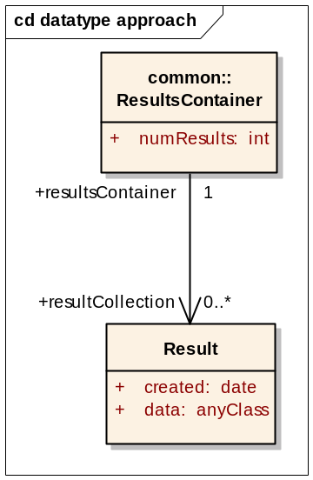
Figure 6 Example of using the anyClass data type

Class Approach
In this approach, we disallow the use of generic objects as datatypes. Instead, these use cases would be satisfied by the introduction of a “special Class” in caDSR that tools would interpret. That is, a common Object Class called “AnyClass” would be created and defined with the semantics detailed above. Models wishing to model generic types would then create associations to this attribute-less class (see Figure 7).

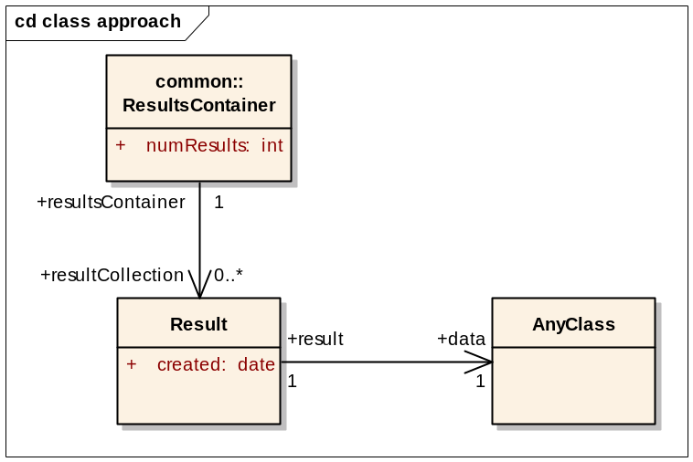
Figure 7 Example of using the AnyClass class
The downside to this approach is that it is not self-evident in the model, and tools using these models require a special interpretation of these classes. That is, when creating a language binding to such a model, an AnyClass Class should not be created, but a special generic type (e.g. java.lang.Object) should be created in the Class associated with the AnyClass. This approach may require special tooling in the caDSR and/or the SIW because classes without attributes do not generate any CDEs.

Generic objects recommendation
We recommend the datatype approach. It will be cleaner to implement in the caDSR, SIW, and applications that leverage them.

Modeling binary
One of the more complicated and problematic issues that arises in caBIG domain modeling is how to handle data that is natively represented in some binary form. For example, an image, proprietary data file, or an executable file are all potential items to be used in a domain model. It is not practical to “outlaw” these things because they are not easily represented with the current domain modeling processes. On the other hand, the use of binary data is very problematic as it, much like generic datatypes, presents a convenient “back door” to proper modeling. For example, one could easily represent lab data, captured in a spreadsheet, as a single binary data attribute, in which case the data is unusable outside its native context. However, it is very likely that this lab data could alternatively be modeled properly by a more complex model, and the data could be accessible by other systems.

To model such data, there are two basic options for datatypes that follow the philosophy of our recommendations. The first is the base64Binary type, wherein the entire binary stream is encoded using the Base64 Alphabet (i.e., a-z, A-Z, 0-9, the plus sign (+), the forward slash (/) and the equal sign (=)). The second is the creation of a new datatype “binary” that would be used to represent the data in its native binary form. In both cases, the data is maintained as opaque data, and care must be taken during model curation to ensure its use is appropriate.

- binary
  - Advantages
    - Practical from an application perspective
  - Disadvantages
    - Not cross platform (endianness, etc)
    - Need policy to determine appropriate use

- base64Binary
  - Advantages
    - Platform independent
  - Disadvantages
    - Inefficient (storage and computationally -- http://www.extreme.indiana.edu/xgws/soap_bench/)
    - Not practical for intra-application use on large data

- Both
  - Advantages
    - Practical from an application perspective
  - Disadvantages
    - Need policy to determine appropriate use/selection

The “easy” solution is to require use of base64Binary, as it meets our requirements of a data type. However, this is impractical from many application perspectives, and we need a data model that accurately reflects the intended use. In an application that works with large images, (proprietary) experiment files, or any file that is natively binary and has no alternative representation, it is not practical to enforce the use of a text-encoding of that data type.

Suggested Default Policy:
Use base64Binary, unless (all are true):
- Data Type is intractable (from a performance or storage perspective) to represent in a textual form
- Data Type is inherently binary (that is, there is no alternative representation)

Examples:
- While an extremely large text document (such as an OWL export of EVS) meets the first criteria it could be broken down to smaller components, therefore the best approach would be to create a more complex model and avoid using the base64Binary or binary datatypes.
- An image meets the second criteria as there is no general way to represent most image formats aside from their native binary form, but some small images (such as icons), are tractable to base64 encode, and therefore fail the first criteria. It is up to individual use cases, requirements, and other developmental considerations whether to use base64 binary based on data size.

Modeling null
Programming languages use null to represent the lack of a value. In UML, this is modeled as an attribute or association having a minimum cardinality of 0. We recommend that in the caDSR this is represented in the value domain as an extra field called nillable that can be either true or false. If true, then values represented by the value domain can be missing or null. This concept overlaps with the Missing Value Reason standard (http://gforge.nci.nih.gov/projects/mvr/), which seeks to define CDEs for encoding why a value is missing (null). This standard should work in concert with the recommended nillable field in the value domain.

Modeling dates and times
For models capturing dates and times, we recommend the adoption of a dateTime datatype. This datatype, based on the ISO recommendation for dates and times (ISO 8601), provides an unambiguous definition capable of capturing any point in time. The dateTime datatype is actually composed of a separate date component and time component. We recommend the adoption of these separate components as datatypes for models wishing to capture dateless times and timeless dates.

While these types can be viewed as formatted strings, we believe they are important enough and prevalent enough to warrant their own datatypes. The primary reason is that when binding to programming languages, these types warrant the use of complex date Classes as opposed to a general string representation.

XML Schema defines the following relevant datatypes:
dateTime is base. http://www.w3.org/TR/xmlschema-2/#dateTime
date is timeless dateTime. http://www.w3.org/TR/xmlschema-2/#date
time is dateless dateTime. http://www.w3.org/TR/xmlschema-2/#time

While the preceding datatypes are the most consistent with our recommendations, dates and times are very important and common place in caBIG applications. As such, there is significant prior art surrounding this issue in caBIG, and an existing recommendation is in place to adopt the HL7 date and time data types. The VCDE group has recommending adoption of these datatypes from HL7 in the recommendation: http://gforge.nci.nih.gov/frs/download.php/376/DateTime_Mar1505.zip. While these two recommendations (XML Schema and HL7) are lexically incompatible, they are both based on the same ISO specification (ISO 8601) and are therefore very similar in nature.
Given that it is expected that there will be a large scale adoption of the HL7 date time types, the most pragmatic solution for caDSR datatypes for date time is the existing HL7 types. While the VCDE recommendation enumerates several other date and time releated types (as does XML Schema), we feel that only “date,” “time,” and “datetime” should be adopted as caDSR datatypes. It can also be important to represent the individual components of dateTime in data elements, such as second, hour, day, month, year, etc. We recommend that the string datatype be used and the value domain be leveraged to further enumerate what is being represented.
For the lexical representation of these types, we recommend that the simpleType expressions of these types be adopted from HL7 version 3, which corresponds with the currently accepted data and time standards of the VCDE workspace. While there is some discussion about a complexType expression capable of representing “null” values and partial precision, we feel that use of the data types and its corresponding value domain should imply full precision. In cases where partial precision (e.g. "March 2001") is desired, we recommend the use of either an actual Class with separate attributes for the various components of the date time is used, or a string with a custom value domain be created. While this may result in the proliferation of date/time related CDEs, this is preferable to creating “special case” datatypes that are difficult to implement in programming languages.
The lexical format is: YYYYMMDDhhmmss.uuuu[+|-]ZZzz
where:
YYYY – a Year of the Gregorian Calendar
MM - a Month of the Gregorian Calendar
DD - Day
hh – hours
mm – minutes
ss – seconds
uuuu – fractional seconds
[+|-]ZZzz – time difference from the UTC

Modeling grid identifiers
With the forthcoming Grid Identifier Infrastructure, it is expected that many new models will natively make use of identifiers. It would be reasonable to introduce a new datatype for such use, but it is our recommendation that this is not necessary. As Grid Identifiers are essentially opaque string values, we feel it is sufficient to make use of the “string” datatype with a common Value Domain created to model the identifier value space.

There may also be some value in creating a common Class that models can associate to, which would contain a string attribute to hold the identifier. This common CDE could be reused across models, though it would not be strictly necessary.

Modeling Numeric Types
When storing “numeric” data, there are several options from which the modeler may choose. These include: decimal, short, int, long, float, double, byte, and boolean. The general principles that modelers should follow when selecting a datatype is to use the most “restrictive” datatype that accurately describes the data being stored (or planned to be stored in the future). This is not to say that “smaller” types should be preferred over “larger” (for example, use of short over int), but rather the most descriptive applicable type should be selected. For example, if the data consists of only whole numbers (without fractional components), then one of the integer-based datatypes (e.g., short, int, long) should be chosen over a datatype that provides superfluous precision (e.g., float, double).

Generally this is an easy decision to make, as most aforementioned data types map directly to native programming language data types that will be used. However, particular care should be taken when using the decimal datatype. The decimal datatype is the most inclusive of the numeric data types as it does not specify an upper or lower bound on the value domain of the numerals it stores. As such, there may be an urge to simply use decimal for every numeric type. While this is allowable, it should only be done if none of the other types are adequate because it will require manifestations of the model to handle arbitrarily large values with an arbitrary level of precision. The implication of this is that general programming language primitive types will not suffice and each instance will require special handling. Wherever possible, alternative numeric types should be used instead.

Value domain representation term
The value domain contains a representation term that can be leveraged to add extra information related to the use of data elements that are associated to it. For example, a value domain with the datatype string could have a representation term of java.lang.String, text, number, or name. Another example is a value domain with datatype boolean having a representation term of indicator. Each of these examples refine the value domain to an actual use in an application or form. This practice does not conflict with any of the recommendations in this document related to datatype. Thus, we recommend that this practice continue normally, with the exception that representation terms related to language-specific implementations should likely be changed to the recommended language-agnostic datatypes. Typically, representation terms that include “java” are simply replicated from the existing datatype and do not add any extra semantics to the value domain.

Forms-based data elements
The datatypes described in section 7.1 and the recommendations described in section 7.3 should be used for all data elements registered or being registered in the caDSR. This includes those that are being entered programmatically or manually for use in forms-based applications. We call this out as a special case because many of the data elements used in forms applications are manually curated. New procedures for creating forms-based data elements should be defined by another small working group. These procedures should include typical scenarios in forms development, such as data elements that previously used the CHARACTER datatype should now use the string datatype. Rules for mapping existing caDSR datatypes to the recommended set of datatypes can be found in section 7.2.

Existing commercial and legacy applications
There are a number of existing commercial and legacy applications that leverage the caDSR, such as Oracle Clinical. In these cases, it may be difficult for them to be migrated from the existing datatypes to the recommended set. Thus, we propose a phased approach whereby the commercial applications are among the last to be “required” to migrate (see section 7.5). This will allow the commercial group ample time to review the recommendation, see the benefits of the recommended common datatypes, and generate a plan for migrating its application. There is nothing to preclude the application from being migrated earlier in the overall migration scheme, but for the sake of interoperability we recommend that ultimately a deadline should be set for commercial applications to migrate to the recommended set of datatypes. This deadline could be enforced by setting a specific date that the pre-existing datatypes are retired. It should also be realistic and be determined in collaboration with the commercial group.

It is important to note that migration to a new set of datatypes defined in the caDSR involves simply changing the binding of existing datatypes in an application to those defined in the caDSR. It does not necessarily require that the application itself change the datatypes in its implementation. A thorough evaluation of these considerations should be made before any changes are implemented in individual applications.

Modeling void
Programming languages use void to indicate the lack of a type. We recommend against including any datatype in the caDSR that indicates the lack of a type because all data should be typed. Any data that is untyped would be difficult and ambiguous to interpret by applications and programming languages.

Implementation
It is currently out of the scope of this small group to define how the recommendations of this white paper be implemented. However, we do recommend that the a new group be formed or the focus of this group be shifted to investigate implementation of these recommendations.

Adoption strategy
We recommend a phased approach to adoption of the recommended datatypes:

- Early adopters
  - Early caBIG adopter
  - Early forms adopter
- caBIG applications
  - All new caBIG applications
  - All existing caBIG applications
- Forms-based applications
- Commercial applications

The timeline and details for the phased approach is outside of the scope of this white paper. However, it is obvious that a phased approach is needed, whereby applications that are easier to migrate are first and those that are more difficult to migrate are last. Difficulty relates to the development of business rules for migration, the manpower required to migrate, and the overall impact of migrating. There should be a small set of “early adopters” that vet the new datatypes and tools used to create caDSR-based metadata. It is critical that these processes be ironed as much as possible before other applications begin adoption. We see caBIG modelers as the first group that should adopt the recommended datatypes because their models are largely programmatically registered in the caDSR, and caBIG will reap the benefits of a common set of datatypes more readily. Forms-based applications should likely be the next logical group, and adoption will likely take the form of policy around new data elements and programmatic/manual migration of existing data elements. The last group to adopt the recommended datatypes should be the commercial applications because they will likely be the most difficult applications to migrate and the least likely to immediately benefit from a common set of datatypes.

Process for reviewing new datatypes
It is critical that a process for reviewing new datatypes be constructed such that the ideals and standards that are defined in this whitepaper continue to be met. If language-specific datatypes find their way back into the caDSR, then many of the tenets of interoperability and open standards will not be met. However, the definition of this process is outside the scope of this small group, though we recommend that a group be immediately formed to begin this work.

Appendix
The following sections contain supporting information.

Descriptions of Recommended XML Schema Datatypes

base64Binary
The base64Binary datatype represents Base64-encoded binary data. The value space of base64Binary is the set of finite-length sequences of binary octets. For base64Binary data the entire binary stream is encoded using the Base64 Alphabet in [RFC 2045].

The lexical forms of base64Binary values are limited to the 65 characters of the Base64 Alphabet defined in [RFC 2045], i.e., a-z, A-Z, 0-9, the plus sign (+), the forward slash (/) and the equal sign (=), together with the characters defined in XML 1.0 (Second Edition) as white space. No other characters are allowed.

Further information on this datatype can be found in Section 3.2.16 of W3C XML Schema Datatype Specification document. One further note is that base64 defines a network byte-order, which allows for interoperability between applications with different endianness.

boolean
The boolean datatype has the value space required to support the mathematical concept of binary-valued logic: {true, false}. An instance of a datatype that is defined as boolean can have the following legal literals {true, false, 1, 0}.

Further information on this datatype can be found in Section 3.2.2 of W3C XML Schema Datatype Specification document.

byte
The byte datatype represents integers with a range from -128 to +127, inclusive (8 bits).

The byte datatype has a lexical representation consisting of an optional sign followed by a finite-length sequence of decimal digits. If the sign is omitted, "+" is assumed. For example: -1, 0, 126, +100.

Further information on this datatype can be found in Section 3.3.19 of W3C XML Schema Datatype Specification document.

decimal

The decimal datatype represents a subset of the real numbers, which can be represented by decimal numerals. The value space of decimal is the set of numbers that can be obtained by multiplying an integer by a non-positive power of ten, i.e., expressible as i x 10^{-n} where i and n are integers and n ≥ 0. Precision is not reflected in this value space; the number 2.0 is not distinct from the number 2.00.
The decimal datatype has a lexical representation consisting of a finite-length sequence of decimal digits separated by a period as a decimal indicator. An optional leading sign is allowed. If the sign is omitted, "+" is assumed. Leading and trailing zeroes are optional. If the fractional part is zero, the period and following zero(es) can be omitted. For example: -1.23, 12678967.543233, +100000.00, 210.
Further information on this datatype can be found in Section 3.2.3 of W3C XML Schema Datatype Specification document.

double
The double datatype is patterned after the IEEE double-precision 64-bit floating point type [IEEE 754-1985]. The basic value space of double consists of the values m x 2e, where m is an integer whose absolute value is less than 2⁵³, and e is an integer between -1075 and 970, inclusive. In addition to the basic value space described above, the value space of double also contains the following three special values: positive and negative infinity and not-a-number (NaN).

The double datatype has a lexical representation consisting of a mantissa followed, optionally, by the character "E" or "e", followed by an exponent. The exponent must be an integer. The mantissa must be a decimal number. The representations for exponent and mantissa must follow the lexical rules for integer and decimal. If the "E" or "e" and the following exponent are omitted, an exponent value of 0 is assumed. The special values positive and negative infinity and not-a-number have lexical representations INF, -INF and NaN, respectively. Lexical representations for zero may take a positive or negative sign. For example, -1E4, 1267.43233E12, 12.78e-2, 12 , -0, 0 and INF are all legal literals for double.

Further information on this datatype can be found in Section 3.2.5 of W3C XML Schema Datatype Specification document.

float
The float datatype is patterned after the IEEE single-precision 32-bit floating point type [IEEE 754-1985]. The basic value space of float consists of the values m x 2e, where m is an integer whose absolute value is less than 2²⁴, and e is an integer between -149 and 104, inclusive. In addition to the basic value space described above, the value space of float also contains the following three special values: positive and negative infinity and not-a-number (NaN).

The float datatype has a lexical representation consisting of a mantissa followed, optionally, by the character "E" or "e", followed by an exponent. The exponent must be an integer. The mantissa must be a decimal number. The representations for exponent and mantissa must follow the lexical rules for integer and decimal. If the "E" or "e" and the following exponent are omitted, an exponent value of 0 is assumed. The special values positive and negative infinity and not-a-number have lexical representations INF, -INF and NaN, respectively. Lexical representations for zero may take a positive or negative sign. For example, -1E4, 1267.43233E12, 12.78e-2, 12 , -0, 0 and INF are all legal literals for float.

Further information on this datatype can be found in Section 3.2.5 of W3C XML Schema Datatype Specification document.

int
The int datatype represents integers with a range from -2147483648 to +2147483647, inclusive (32 bits).

The int datatype has a lexical representation consisting of an optional sign followed by a finite-length sequence of decimal digits. If the sign is omitted, "+" is assumed. For example: -1, 0, 126789675, +100000.

Further information on this datatype can be found in Section 3.3.17 of W3C XML Schema Datatype Specification document.

long
The long datatype represents integers with a range from -9223372036854775808 to 9223372036854775807, inclusive (64 bits).

The long datatype has a lexical representation consisting of an optional sign followed by a finite-length sequence of decimal digits If the sign is omitted, "+" is assumed. For example: -1, 0, 12678967543233, +100000.

Further information on this datatype can be found in Section 3.3.16 of W3C XML Schema Datatype Specification document.

short
The short datatype represents integers with a range from -32768 to 32767, inclusive (16 bits).

The short datatype has a lexical representation consisting of an optional sign followed by a finite-length sequence of decimal digits If the sign is omitted, "+" is assumed. For example: -1, 0, 12678, +10000.

Further information on this datatype can be found in Section 3.3.18 of W3C XML Schema Datatype Specification document.

string
The string datatype represents character strings in XML. The value space of string is the set of finite-length sequences of characters (as defined in [XML 1.0 (Second Edition)]) that match the Char production from [XML 1.0 (Second Edition)]. A character is an atomic unit of communication; it is not further specified except to note that every character has a corresponding Universal Character Set code point, which is an integer.

Further information on this datatype can be found in Section 3.2.1 of W3C XML Schema Datatype Specification document.

http://ncicb.nci.nih.gov/NCICB/infrastructure/cacore_overview/cadsr
http://metadata-stds.org/11179/
The list was generated by Tommie Curtis in 8/2006
http://www.hl7.org/
http://www.corba.org/
http://www.standardzworld.com/iso-11404.htm
http://www.w3.org/TR/xmlschema-2/
http://www.w3.org/TR/xmlschema-2/
http://www.w3.org/Graphics/SVG/
http://www.biopax.org/
http://www.w3.org/TR/xmlschema-2/#RFC2045
Open potential implementation of this datatype is that the value domains for CDEs utilizing this datatype be enumerated with these four values.
http://standards.ieee.org/reading/ieee/std_public/description/busarch/754-1985_desc.html
http://www.w3.org/TR/xmlschema-2/#XML

