Report on Work Accomplished
caArray
Last Revised: | October 24, 2007
Produced By: | NCICB Development
Version: | 0.3

Document Approvals
The list contains the name and contact information for the core project team and any key stakeholders who have an interest in the success of the project. An “S” identifies persons responsible for approval from the stakeholder groups. Sign off of the document would be required when a decision is made not to take action for defined gaps.

S | Name | Role | S | Name | Role
S | Anand Basu | NCICB Engineering Manager | S | Juli Klemm, Ph.D. | Product Manager
 | Brent Gendleman | Development Project Manager |  | Jerry Eads | NCICB Project Manager
 | Eric Tavela | Development Architect |  | Ron Keene | NCICB Independent QA
 | Don Swan | NCICB Application Support
Revision History
When you make a change to a document, you must add an entry to this Revision History table and you must manually type the Last Revised Date on the front cover.

Date | Version | Description | Revised by
6/18/07 | 0.1 | Initial Draft – Basic Flow | Brent Gendleman
7/05/07 | 0.2 | Flows Flushed Out – State Diagrams Included for Service Types | Brent Gendleman
10/24/07 | 0.3 | Publish Service Type added – needs scoping for 2.0 | Brent Gendleman
Copyrights and Trademarks
© Copyright 2007 by NCICB, caBIGTM. All rights reserved.

Table of Contents
1. Brief Description 1
1.1. References 1
1.2. Unaddressed Issues 1
1.2.1. Requirements Confirmation 1
2. Preconditions 1
2.1. Lab Scientist or Biostatistician is Logged In 1
2.2. An Available Experiment Exists in an Approved State (deferred) 2
2.3. The Experiment Service and Assay Types are Known 2
3. Basic Flow of Events 3
4. Alternate Flows 3
4.1. Cascading Submission 3
4.2. Discreet Submission 4
4.3. Unassigned Contributor Reports on Work 4
4.4. Partial Service Project 5
4.5. Analysis Service Project 5
5. Exception Flow 6
6. Post-conditions 6
6.1. Project State Updated 6
6.2. Publications Enabled 6
7. Special Requirements 6
7.1. Lab Scientist Checklist 6
7.2. Biostatistician Checklist 7

Brief Description
Initiated by the Lab Scientist and at key analytical and quality control points, the Biostatistician, this use case allows them to detail what work they are doing step by step. The data entry performed will also be used by the system to inform the Principal Investigator and others interested, to see the status of work and kick-off timers for additional use cases.
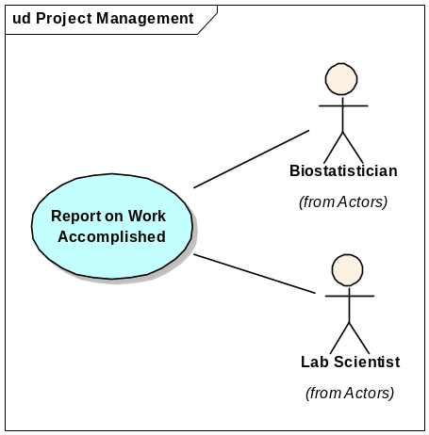

References
caArray Vision – functional requirements
caArray Supplementary Specifications – non-functional requirements
caArray Use Case Summary – actor definitions and context

Unaddressed Issues

Requirements Confirmation
The use case needs to be confirmed by the stakeholders. In particular the checklist needs validation that it won’t be impacted by array type.

Preconditions

Lab Scientist or Biostatistician is Logged In
In order to execute this use case, a registered user that has at least one of the aforementioned roles has logged in and been presented with their workspace. The Basic Flow will represent the actions for either a Lab Scientist or a Biostatistician – a Lab Contributor for ease of reading – with distinctions in their activities documented as necessary.

An Available Experiment Exists in an Approved State (deferred)
At least one experiment that has been assigned to the Research Lab or Core Facility that the Lab Contributor is associated with exists in an approved state. It is possible that the registered user’s lab or core facility is assigned a project due to a relationship with the Institution, as a collaborator, or as part of a larger group. In addition, while projects are assigned to individual contributors, other contributors within the lab can take the actions on behalf of one of their colleagues.
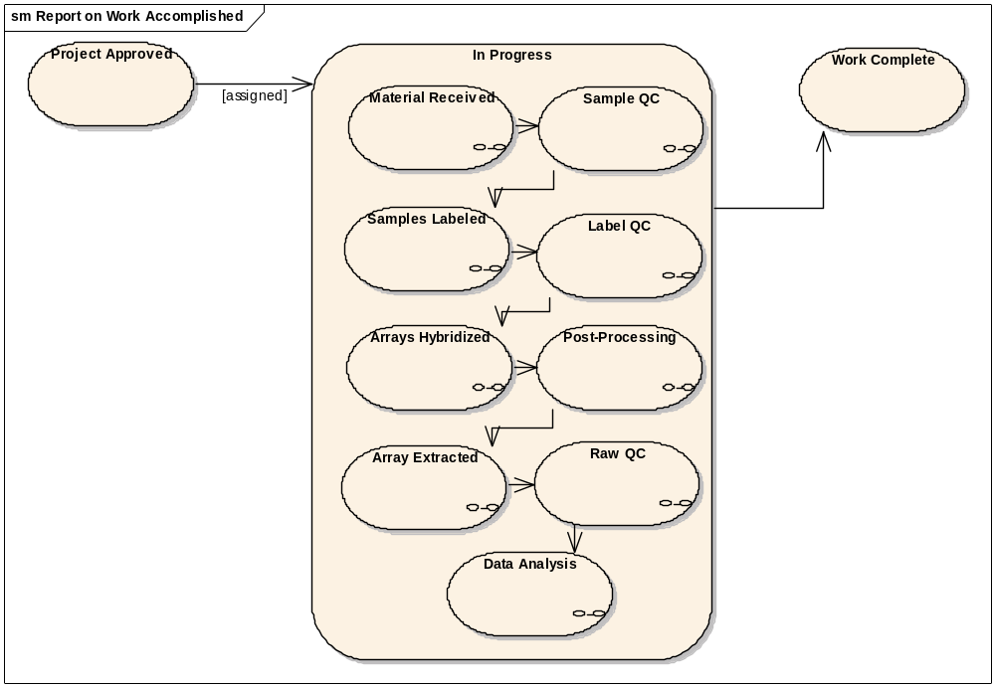
Figure 1. In Progress Sub-States

The Experiment Service and Assay Types are Known
The service type (complete, partial, analysis, publish) and the type of assay (e.g., gene expression vs. SNP) are known so that the corresponding fields and their relevancy to the checklist are displayed. It is believed that the assay type will not impact the checklist but this assumption needs to be verified.

Basic Flow of Events

The Lab Contributor chooses to open an available “full service” project in their workspace that is in the “in progress” state.

The System displays the project description including an action “Report on Work Accomplished”.

The Lab Contributor chooses the action “Report on Work Accomplished.”

The System displays summary project data:

the project name,

assigned scientist,

date last updated,

along with the Lab Scientist checklist and/or the Biostatistician checklist for reporting on work.

The Lab Contributor enters all required fields against any of the role’s reportable steps. For any step that is dependent on the number of samples a given project has, two options are presented

The ability to enter one value(s) against all checklist items (see Alt. Flow: Cascading Submission)

The ability to enter values on a per item basis (see Alt. Flow: Discreet Submission)

The Lab Contributor submits non-sample dependent values and submits.

The System validates that for each reportable step the corresponding required fields have been entered, updates the project and returns the Lab Contributor to Step 2.

Alternate Flows

Cascading Submission

From Step 5a in the Basic Flow, the Lab Contributor chooses to manage a checklist step by entering one value or set of values for a given checklist item.

The System indicates which fields are available for such an action and offers the ability to apply the entry to the number of items (such as the number of samples or the corresponding number of labeled extracts).

The Lab Contributor enters the values and selects “apply to all.”

The System applies the entered value to all and indicates to the Lab Contributor when the action is complete and returns the Lab Contributor to Step 5 in the Basic Flow.

Discreet Submission
The following flow is complicated but in essence the goal is to be able to show, for example, 50 samples in a given project and be able to indicate that 48 of the 50 passed the quality control step. In order to accomplish that, one could enter “pass” and choose to apply to “all” and then change just the two that failed and submit.

From Step 5b in the Basic Flow, the Lab Contributor chooses to manage a checklist step by entering distinct value or set of values for a given checklist item.

The System indicates which fields are available for such an action and offers the ability to view all the related items and assign values individually (such as the number of samples or the corresponding number of labeled extracts).

The Lab Contributor chooses “manage discreetly.”

The System presents the fields that can be applied with the ability to apply the value to be entered against

All

None

Or one-by-one selection

The Lab Contributor enters in the values and chooses “All”.

The System replicates the value entered and displays them next to each item in the list in an editable form.

The Lab Contributor changes any one (or none) of the entries supplied and submits.

The System applies the entered value to all and indicates to the Lab Contributor when the action is complete and returns the Lab Contributor to Step 5 in the Basic Flow.

Unassigned Contributor Reports on Work
In order to support the ability for another Lab Contributor to report on work accomplished, they can choose to “View All Projects” from their workspace that will display all accepted projects inside their Institution or Lab versus the selective default view of projects assigned to them. Once that action is taken, the Basic Flow is taken but the System records that a user other than the assigned scientist performed the work.

Partial Service Project

From Step 3 in the Basic Flow, the project selected is a Partial Service type.

The System displays a subset of the workflow beginning with Material Received but jumping to Label Quality Control and following through the remainder of the full service workflow.

Return to Step 4 in the Basic Flow.

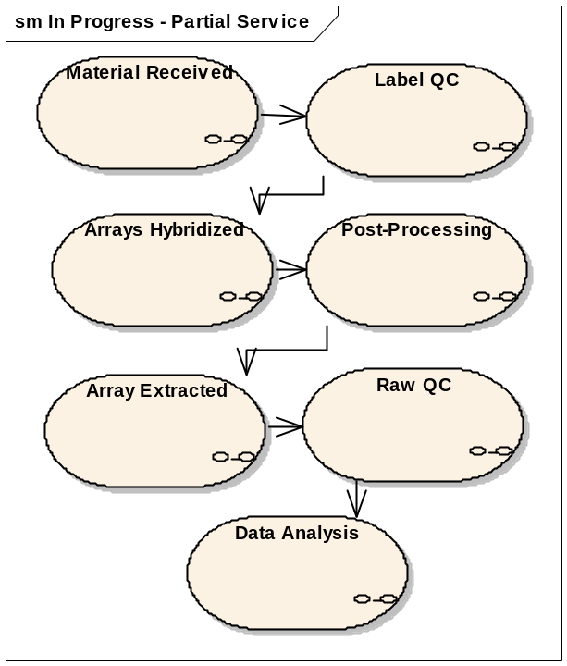

Analysis Service Project

From Step 3 in the Basic Flow, the project selected is an Analysis Service type.

The System displays a smaller subset of the workflow beginning with Material Received but skipping to Raw QC.

Return to Step 4 in the Basic Flow
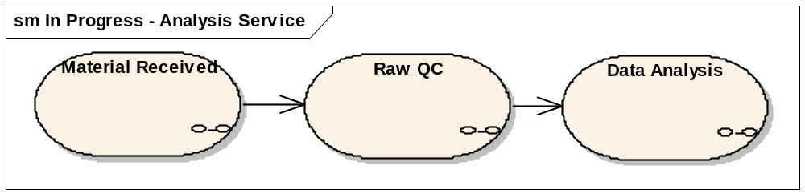

Exception Flow

No exception flows have been analyzed yet.

Post-conditions

Project State Updated
The Project State will remain “In Progress” until all steps have entries marked against it – which will cause the project to transition to “Complete”. However, each time the use case is executed by submitting work accomplished, the Step and Date (mm/dd/yyyy) will be updated.

Publications Enabled
Once a project transitions to a complete state, publications can be associated to it.

Special Requirements

Lab Scientist Checklist
The following table indicates the data that is required to be entered (or visible in some cases) by the Lab Scientist for any given project, with “All” representing checklist items available to each project type (complete, partial, analysis).
Checklist Item | Fields | Values | Required | Derived Data | Project Types
1. Material Received | Received | Yes/No | Yes | None | All
1. Material Received | Date | Calendar | Yes | None | All
1. Material Received | Notes | Text Area | No | None | All
2. Storage Location | Freezer |  | No | None | Complete
2. Storage Location | Shelf |  | No | None | Complete
2. Storage Location | Box Number |  | No | None | Complete
2. Storage Location | Notes |  | No | None | All
3. Sample Quality Control Met | Date Completed | Calendar | Yes | None | Complete
3. Sample Quality Control Met | Status | Pass/Fail | Yes | None | Complete
3. Sample Quality Control Met | Notes | Text Area | No | None | Complete
3. Sample Quality Control Met | Bio-Analyzer Results | Text Box | No | URL | Complete
4. Samples Labeled | Date Completed | Calendar | Yes | None | Complete
4. Samples Labeled | Notes | Text Area | No | None | Complete
4. Samples Labeled | RNA Extraction | Display | Yes | # out of # samples have extracts | Complete
4. Samples Labeled | RNA Amplification | Display | Yes | # out of # extracts are amplified | Complete
4. Samples Labeled | RNA Labeling | Display | Yes | # out of # extracts are labeled | Complete
5. Label QC | Date Completed | Calendar | Yes | None | Complete, Partial
5. Label QC | Status | Pass/Fail | Yes | None | Complete, Partial
5. Label QC | Notes | Text Area | No | None | Complete, Partial
5. Label QC | Bio-Analyzer Results | Text Box | No | URL | Complete, Partial
6. Arrays Hybridized | Date Completed | Calendar | Yes | No | Complete, Partial
6. Arrays Hybridized | Notes | Text Area | No | None | Complete, Partial
6. Arrays Hybridized | Hybridizations | Display | Yes | # out of # labeled extracts have been hybridizations AND # of # arrays have been hybridized | Complete, Partial
7. Post Hybridization Processing | Date Completed | Calendar | Yes | None | Complete, Partial
7. Post Hybridization Processing | Stain/Washing Protocol | List |  |  | Complete, Partial
7. Post Hybridization Processing | Notes | Text Area | No | None | Complete, Partial

Biostatistician Checklist
Checklist Item | Fields | Values | Required | Derived Data | Project Types
1. Material Received | Received | Yes/No | Yes | None | All
1. Material Received | Date | Calendar | Yes | None | All
1. Material Received | Notes | Text area | No | None | All
8. Raw Data QC | Date Completed | Calendar | Yes | None | All
8. Raw Data QC | Status | Pass/Fail | Yes | None | All
8. Raw Data QC | Data QC Protocol | Select Box | Yes | None | All
8. Raw Data QC | Data QC Results | Text Box | No | URL | All
8. Raw Data QC | Notes |  | No | None | All
9. Data Analysis | Date Completed | Calendar | Yes | None | All
9. Data Analysis | Status | Pass/Fail | Yes | None | All
9. Data Analysis | Data Normalization | Read only | Yes | Yes (# of image files) | All
9. Data Analysis | Normalization Protocol | Select Box | No | None | All
9. Data Analysis | Analysis Protocol | Select Box | No | None | All

