caArray 2.2.1 Data Portal

Title of Publication

Local Installation Guide






Center for Biomedical Informatics and Information Technology
Table of Contents

Introduction 1
caArray 2.2.1 Software and Technology Requirements 2
Java SDK Installation 3
Apache Ant Installation 3
Apache Ant Environment Variables 3
MySQL Installation and Configuration 6
Working with Properties Files 9
Downloading and Installing UPT (Optional) 10
Installing caArray 2.2.1 Application and Services 12
Downloading caArray 2.2.1 files 13
Installing a New caArray 2.2.1 13
GUI Installer Method of Installation 13
Fatal Error During GUI Installation on Linux 18
Command-Line Method of Installation 19
Upgrading caArray 2.X to 2.2.1 21
Upgrade Using the GUI Installer 22
Fatal Error During GUI Installation on Linux 25
Upgrade Using Command-Line Installer 26
Configuring JBoss 27
Configuring JBoss Servers and MySQL Server to Run as Services 28
Post-Installation Tasks 30
Using UPT to Add caArray Users 30
Appendix I: Custom Type GUI Installer Walk-Through 32
Appendix II: Default Users 37
Contacting Application Support 37

Introduction
This caArray 2.2.1 Installation Guide provides you with the instructions to install and configure a fresh caArray 2.2.1 application, or upgrade an existing 2.X application. The caArray installation installs and configures two JBoss application servers, a grid service and creates a caArray-specific schema within a pre-existing database on a preinstalled MySQL server. An upgrade of caArray converts an existing 2.X caArray application and associated grid service to version 2.2.1.

Directions are given in this document for both Linux and Windows operating systems.

NOTE   | Published caArray development documentation can be found on the caArray page of the NCICB web site: http://caarray.nci.nih.gov/

Overview of caArray Installation | The process for installing caArray includes the following tasks described in this document:  - Downloading and installing required software  - Setting environment variables  - Downloading caArray 2.2.1 distribution files  - Installing caArray:  - GUI Installer Method  - Command-Line Method  -- Editing install.properties file  - Upgrading caArray  - GUI Installer Method  - Command-Line Method  -- Editing upgrade.properties file  - Configuring JBoss servers and MySQLserver to run as a service  - Post-Installation Tasks  - Updating Help-Desk info in DB using SQL  - Using UPT to Add caArray Users

Before You Proceed | If you have a 1.x version of caArray installed, you must do a fresh installation as there is no way to upgrade a 1.x caArray installation to 2.1.1. Contact NCICB Application Support directly for 1.x data migration support:  Web: http://ncicb.nci.nih.gov/NCICB/support/caarraysupport  E-mail: ncicb@pop.nci.nih.gov  Telephone: 301-451-4384  Toll free: 888-478-4423

caArray 2.2.1 Software and Technology Requirements

Tested Environment | The caArray 2.2.1 installation has been tested on Linux Red Hat Enterprise Linux AS 4 64/32-bit (for AMD chipset) and the Windows XP/2003 environments. While the installation may work in other Linux and Windows environments, it has only been tested in these environments.

Required Software—Not Included in caArray | Many of the servers and services that make up caArray 2.2.1 are automatically installed as part of this installation. However, certain tools that you must manually install and configure are listed in Table 1. The software name, version, description, and URL hyperlinks (for download) are indicated in the table.

Prior to the caArray 2.2.1 installation, you must download and install the following tools and recommended versions in the order they are listed in Table 1. Complete the directions for installing each, as directed on the corresponding website.

Required Software Name  Version | Description
Java 2 Platform Standard Edition 5.0 Update 10 (J2SE 5.0)  http://java.sun.com/products/archive/j2se/5.0_10/.  Be sure to download the correct Java SDK for your operating environment. For example, for Linux AMD 64, you would download jdk-1_5_0_10-linux-amd64-rpm.bin. For Windows, you might download jdk-1_5_0_10-windows-i586-p.exe. | The J2SE Development Kit (JDK) supports creating J2SE applications.
Apache Ant, 1.7.0  https://gforge.nci.nih.gov/svnroot/lsd/trunk/tools/apache-ant-1.7.0-bin.zip | Apache Ant is a Java-based build tool.
MySQL, 5.0.27  http://downloads.mysql.com/archives.php?p=mysql-5.0&v=5.0.27 | MySQL is an open-source database software application.
Table 1 Required Software

IMPORTANT | As you install each application, record the installation directory path, and the hostname of your MySQL DB server, and the DB admin username/password, if you are going to install UPT.

Java SDK Installation
When you install the Java SDK, you will be prompted to select the installation directory. Record the path, as this directory will be used when you set the environment variables.

Apache Ant Installation

- Unzip the Apache Ant distribution files using a command line unzip tool or a zip utility, such as WinZip.

- After extracting the zip, you must set the environment variables, described in the following section, so that Ant is available in the system PATH.

Apache Ant Environment Variables

NOTE | The purpose of setting operating system environment variables is so that the Java SDK and Ant build tool are available to run from anywhere in the system.

Linux
To set the environmental variables in Linux, follow these steps:

NOTE | The JAVA_HOME, ANT_HOME and PATH environment variables are set in /etc/profile. You may need to create the variables, or modify them if they already exist.

Step | Action
1 | As the root user, enter the following in the /etc/profile file. A PATH variable should already be created in this file, so be sure to define the JAVA_HOME and ANT_HOME export before the PATH export. Replace <some_path> with the correct path fragment for Java and Ant installations.  export JAVA_HOME=<some_path>/jdk1.5.0_10  export ANT_HOME=<some_path>/apache-ant-1.7.0  export PATH=$JAVA_HOME/bin:$ANT_HOME/bin:$PATH
2 | Log out and log back in so that the system recognizes your changes.

Verifying the Environment Variables in Linux
To verify that environment variables have been set correctly, follow these steps:

Step | Action
1 | From the command line, enter:  echo $JAVA_HOME  echo $ANT_HOME  Both of these commands should return the location where you installed these tools.
2 | To verify your Java SDK installation, enter java –version from a command prompt. You should see java version "1.5.0_10".
3 | To verify your Ant installation, enter: ant –version from a command prompt. You should see: Apache Ant version 1.7.0 compiled on December 13 2006.

Windows
To set the environmental variables in Windows, follow these steps:

NOTE | The JAVA_HOME, ANT_HOME and PATH environment variables are set in the Systems Properties.

Step | Action
1 | In Windows, select Control Panel, then select the Systems application. In the Systems window, select the Advanced tab.
2 | On the Advanced tab, click the Environment Variables button. To add a new system variable, select the New button.  - In the Variable name text box, enter JAVA_HOME.  - In the Variable value text box, enter the location of your Java installation.
3 | Click the New button again.  - In the Variable name text box, enter ANT_HOME.  - In the Variable value text box, enter the location of your Ant installation.
4 | Select the PATH system environment variable, and select the Edit button. This opens the Edit System Variable dialog box, displayed here as an example.  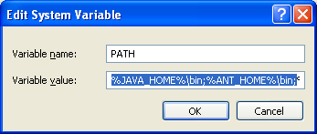
5 | In the Variable value text box, prepend the following text in front of the text that already exists in the Variable Value field.  %JAVA_HOME%\bin;%ANT_HOME%\bin;  Click OK.

Verifying the Environment Variables in Windows
To verify the environment variables have been set correctly, follow these steps:

Step | Action
1 | From the command line, enter:  echo %JAVA_HOME%  echo %ANT_HOME%  Both of these commands should return the location where you installed these tools.
2 | To verify your Java SDK installation, enter java –version from a command prompt. You should see java version "1.5.0_10".
3 | To verify your Ant installation, enter ant –version from a command prompt.  You should see: Apache Ant version 1.7.0 compiled on December 13 2006.

NOTES | Environment variables for caArray and, optionally, UPT are modified and set in those sections of this document: Installing a New caArray 2.2.1 on page 13 and Downloading and Installing UPT (Optional)  on page 9.

MySQL Installation and Configuration
A MySQL 5.0.27 server must be downloaded, installed and running in order for the caArray installation to work successfully.

To download and install MySQL, follow the steps outlined on the MySQL website: http://downloads.mysql.com/archives.php?p=mysql-5.0&v=5.0.27

TIP | You should consult the following three links to successfully set up secure and well-performing MySQL servers, in preparation for installing caArray:  - MySQL Security Guide - http://dev.mysql.com/doc/refman/5.0/en/security-guidelines.html  - Performance –  - General performance tuning - http://dev.mysql.com/books/hpmysql-excerpts/ch06.html  - InnoDB engine performance tuning - http://dev.mysql.com/doc/refman/5.0/en/innodb-tuning.html

MORE TIPS | - Record the MySQL root username/password chosen during the MySQL installation process, as you will need to use this as your database.system.user/ database.system.password later in the UPT installation process, should you choose to install UPT.  - Note the MySQL port chosen during the MySQL installation process, as you will need to use this as your database.port later in both the caArray and UPT (if installing UPT) installation processes.

Once installed, you must configure My-SQL for caArray.

Linux
Configure MySQL in Linux using the following steps:

Step | Action
1 | Lowercase Table Names in MySQL  Edit the /etc/init.d/mysqld (or mysql) file as follows:  - Locate the start() section and modify the mysqld_safe command (do not include the ellipses):  /usr/bin/mysqld_safe --lower_case_table_names=1 ...  - Restart the MySQL service for the changes to take effect:  Restart /etc/init.d/mysqld
2 | Modify the MySQL parameters  Open the /etc/my.cnf and add the following text.  [mysqldump]  max_allowed_packet=64M  [mysqld]  max_allowed_packet=64M  [mysql]  max_allowed_packet=64M  Note: If the file is not present, you will need to create it. To do so, open a text editor such as Notepad. Add the above text, name and save the file.

Windows
Configure MySQL in Windows using the following step:

Step | Action
1 | Modify the MySQL parameters  - Locate the [MySQL installation directory]/my.ini file. Open the file in a text editor such as Notepad and add the following text:  [mysqldump]  max_allowed_packet=64M  [mysqld]  max_allowed_packet=64M  [mysql]  max_allowed_packet=64M  Note: If the file is not present, you will need to create it. To do so, enter the above text in a text editor such as NotePad.  - Save the amended or new my.ini file in the <MySQL installation directory>.  - Restart the MySQL Windows service for the changes to take effect. To do so, select Settings > Control Panel. Select Administrative Tools > Services.. Scroll down to MySQL. Right click and select Restart.

Working with Properties Files

About Properties
An important component of command-line installation of either caArray or UPT, is configuring properties files.
Prior to initiating a command-line installation, property variables must be modified. Note the following points about changing or entering variables.

Paths in Properties Files
NOTE | The paths in the .properties files should use forward slashes. For example, you would use application.base.path=C:/apps/caarray-app, not application.base.path=C:\apps\caarray-app. If you use backslashes, you will experience undesirable results.

Spaces in Path Property Values
NOTE | You should not specify paths with spaces included as property values. In Windows, note that the C:\Documents and Settings\<username> path contains spaces and should not be used, or anything similar. If you are using Windows, use a path such as C:/apps/caarray. Spaces are fine for property values which do not represent a path.

More About Property Values
NOTES | - In each *.properties file,, any property value marked with uppercase REPLACE_* must be manually updated with the appropriate value.  - In each *.properties file, any property value marked with lowercase replace_* may be optionally updated with the appropriate value.  - If there is reference to a database.system.user for your MySQL server, you can determine which users have full privileges to create and manage other databases, by executing show grants from a MySQL prompt to determine the correct level of privileges.

Downloading and Installing UPT (Optional)
If you do not already have a User Provisioning Tool (UPT) installed, and you wish to manage user accounts for your caArray application, you must install UPT.

Overview of UPT | UPT is used to provision users in the caArray application. Each application installs with its own Common Security Module (CSM) schema that has sample/default users and a role/permissions structure. To add additional users you must provision the caArray application in the UPT. Then you can assign users to caArray. Below is the general flow for UPT as it relates to caArray, but for more complete documentation of UPT see this document: https://gforge.nci.nih.gov/frs/download.php/2634/UPT_User_Guide.pdf.

NOTE | Verify that default port values defined in install.properties files are not in use on your system by running netstat –a from the command line. The installers run pre-installation checks and fail the installation if ports the installer must use are in use. If the ports are in use prior to installation, you will need to stop any processes that are running.

To download and install the UPT 3.2 files, follow these steps:

Step | Action
1 | The installation file for UPT 3.2 is over 30MB.  From the https://gforge.nci.nih.gov/frs/?group_id=305 directory in GForge, download the upt_distribution_[version].zip file.  Remember the download location as you will be using this file to run the installation in the steps that follow.
2 | From the directory where you downloaded the upt_distribution_[version].zip_Downloading_UPT_files file, unzip the files, using one of these two methods:  - Open a command prompt and use it to extract this file to a temporary location. For example, you may enter a command such as unzip -q upt_distribution_[version].zip. (You must have a ZIP tool installed.) This location will be referred to as the <upt_installer_directory> henceforth. Example: C:\UPT_installer.  - Use WinZip or a similar utility to unzip the files.
3 | Open the <upt_installer_directory>/upt/install.properties file and modify the values for your environment and save the file. (See Working with Properties Files on page 9.) At a minimum, you will need to modify the values in the following table:  Note: Descriptions for UPT properties are included in this document, but descriptions for caArray properties are outlined in the wiki, referenced later in this document.
Environment Variable | Description
upt.home | The location where you want to install UPT.  Example: In Windows, it could be C:/apps/upt. Linux users can use ${user.home}/apps/upt or any other folder to which you have write permissions.  Important: The upt.home directory must be different than <upt_installer_directory> or the installation will fail.
database.server | This value must correspond to the domain name of machine that hosts the MySQL server. You may need to consult your system administrator for this information.
database.port | This value must correspond to the port for the database.server. 3306 is the default port, but check with your database administrator to be certain.
database.name | Choose a name for the UPT MySQL database.
database.user | Choose a username to access database.name. This can be any valid name that you choose, but it must be different than database.system.user.
database.password | Choose a password to access database.name for the username identified in database.user.This must be different from the database.system.password.

 | Note: You shouldn’t need to modify the other defaults values as we have chosen unique ports to reduce the risk of other applications using the same values. However, be sure to check the install.properties to verify that the ports in this file are not being used by other applications, otherwise you will experience problems.
4 | From the command line, navigate to <upt_installer_directory>/upt (Example:cd C:\UPT_installer\upt), and type ant. This runs the installation.
5 | To verify the UPT installation, go to: http://<jboss.server.hostname>.<jboss.server.port>/upt (example; http://upt.nci.nih.gov/upt/. Refer to the install.properties for the correct values. See note below.)
6 | After successfully installing UPT, make a backup of <upt_installer_directory>/upt/install.properties in another directory for future reference.

Installing caArray 2.2.1 Application and Services
To newly install the caArray 2.2.1 application and services, follow the steps in this section:
- Downloading caArray 2.2.1 files on page 13
- Installing a New caArray on page 13
  - GUI Installer Method on page 13
  - Command-Line Method on page 18
- Configuring JBoss on page 28
  - Configuring JBoss Servers and MySQL Server to Run as Services on page 28
- Post-Installation Tasks on page 30
  - Using UPT to Add caArray Users on page 30

BEFORE YOU BEGIN | - Important: There must already be a pre-existing MySQL DB and connection username/password for caArray to install into; caArray does not create its own DB.  - If you have installed a previous version of caArray 2.X, you must follow the upgrade procedures described in Upgrading caArray 2.X to on page 21 to migrate to caArray 2.2.

Downloading caArray 2.2.1 files
To download the caArray 2.2.1 files, follow this step:

Step | Action
1 | The installation files for caArray 2.2.1 are each 200-300MB. All of the files can be downloaded from the caArray distribution folder here: https://gforge.nci.nih.gov/frs/?group_id=305.  - For a new command-line installer, download the caarray_install_2_2_0.zip file (around 200 MB).  - For a command-line upgrade installer, download the caarray_upgrade_2_2_0.zip file (about 90 MB)..  - For a GUI installer that you can use to do a fresh caArray 2.2.1 installation, download the caarray_gui_distribution_2_2_0.jar file (about 300 MB).  Remember the download location, as you will be using this file to run the installation in the steps that follow.

Server Components in caArray 2.2 | These server components are installed and configured as part of the caArray 2.2.1 installation. You do not need to do anything further to download or install these components.  - JBoss 4.0.4 (hosts the caArray grid service)  - JBoss 4.0.5 (hosts the caArray application)

Installing a New caArray 2.2.1

You can perform a new installation of caArray v.2.2.1 using either of these two methods:
- A GUI Installation wizard. Instructions for this method begin on this page
- A command-line installation. For instructions, see page 18.

GUI Installer Method of Installation

For detailed information on all of the GUI installer fields, refer to the documentation at this location: https://wiki.nci.nih.gov/x/LRKy.

For performing an installation using the GUI Installer, follow these steps:

Step | Action
1 | Open a command prompt in the directory where you downloaded the caarray_gui_distribution_2_2_1.jar. Enter this command to Invoke the GUI installer : java –jar caarray_gui_distribution_2_2_1.jar.
2 | The Installation Wizard opens to prompt you through the installation process. Click Next to proceed through the pages of the wizard, beginning with progressing past the Welcome page.  Note: All screens are not shown in the steps in this section. Follow the instructions in the wizard, referring back to these steps, as appropriate.
3 | Review the release notes.
4 | You must accept the license agreement.
5 | Select Install installation type. For a new installation, select Install.
6 | Navigate to the directory where you would like to install caArray 2.2.  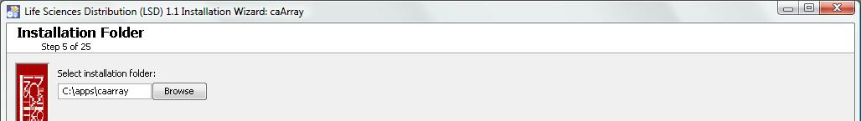  If the folder does not yet exist, click OK in the dialog box to indicate that you want the folder to be created.
7 | Choose the type of installation you prefer Typical or Custom.  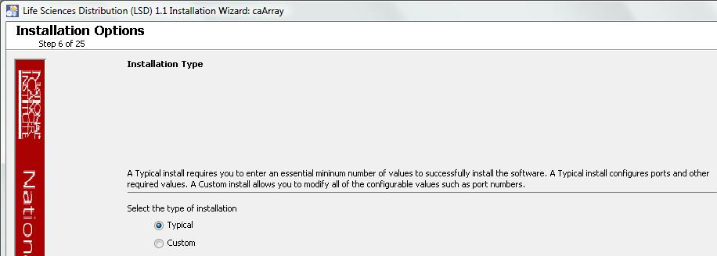
  NOTE | The Custom installation allows more detailed configuration options. If you choose to do a Custom installation type, go directly to the walk-through presented in the Appendix I: Custom Type GUI Installer Walk-Through on page 32. Do not proceed further with this section which describes the remaining steps for the Typical installation type.
8 | Specify the admin account password for the JBoss servers to be installed (caArray and grid service). The username is “admin” and is not currently configurable. The admin account is needed to login to the JBoss JMX console or admin console, or to shutdown a JBoss server from the command line.  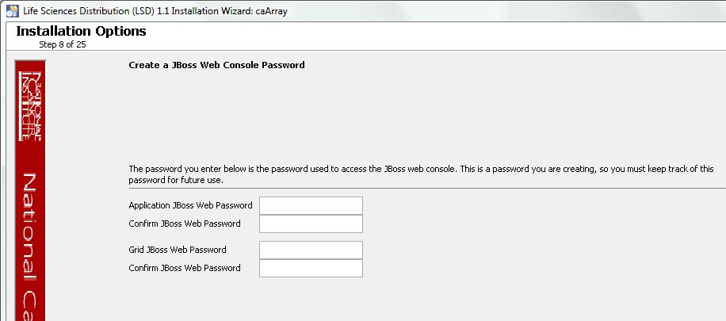  If you do not specify passwords, or if one of the passwords does not match its confirmation field, you will see error messages.
9 | Specify the research center and technical point-of-contact information needed for grid service registration.  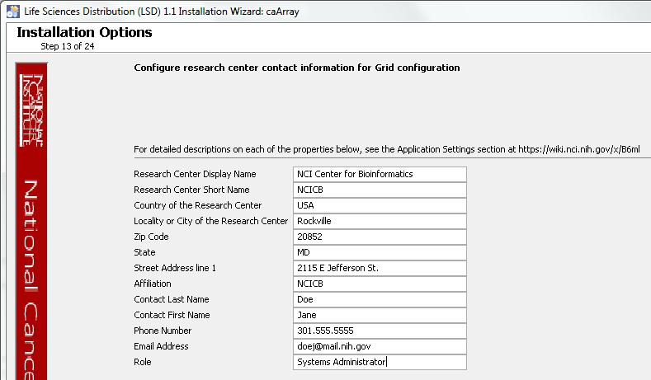  An error message displays if you did not enter all of the required information.
10 | Specify the database connection information, including the name of the pre-existing database where the caArray schema will be installed, and the pre-existing user which will be used by caArray to connect to its database.  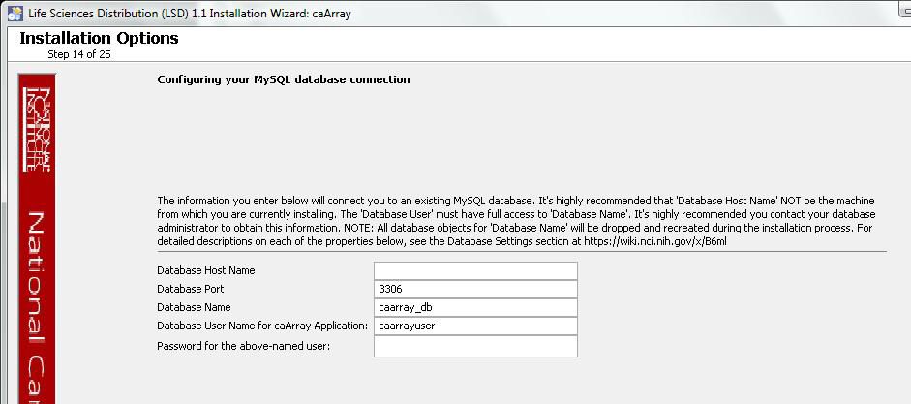  Error messages inform you if the following occurs:  - If the specified database host cannot be reached, or the field is blank.  - If the database admin user’s credentials are incorrect.  - If the specified database does not already exist, or the caArray DB user’s credentials are wrong.
11 | Specify the grid service index URL, an externally-visible hostname or IP address which the index service can use to communicate with the grid service, and optionally, the UPT user management URL.  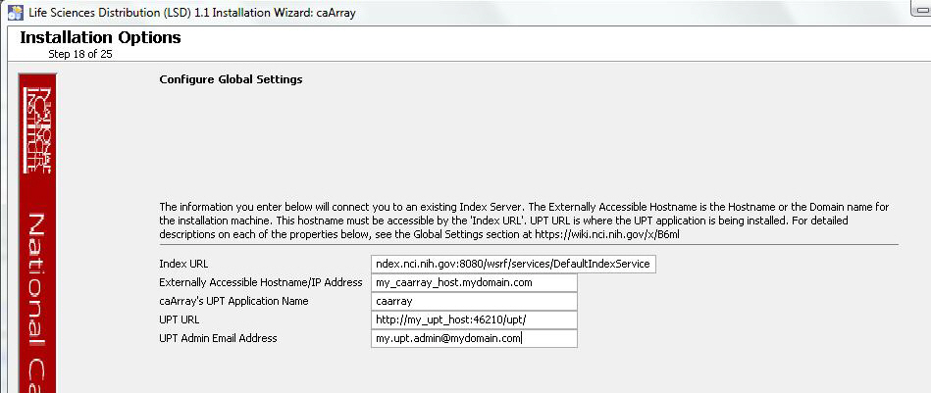  If the index service cannot be reached at the specified URL, an error message displays, informing you to check your firewall or the proxy setting.
12 | Specify the SMTP mail server connection information so that caArray can send emails from users with new account requests.  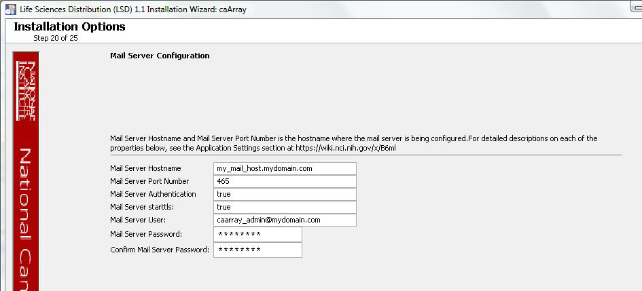
13 | Review the summary of the information you have entered.  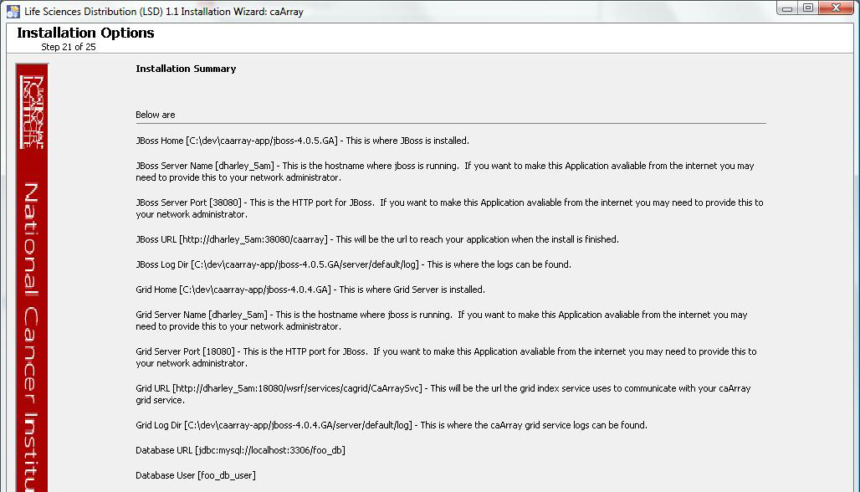
14 | On the next two pages, review the selected install type and the installation destination.  After you click Next from reviewing the installation destination, the installer runs. The installation wizard displays the installation progress and completion.
15 | When you are informed that the process is finished, click Done on the lower right corner of the wizard to close the installer.
16 | To verify caArray installation, open your web browser to http://<jboss.server.hostname>.<jboss.server.port>/caarray (example; https://array.nci.nih.gov/caarray/. If needed, you can refer to the <user home>/.installer-csarray/caarray_installer/install.properties file for the correct values. Enter caarrayadmin as the user and caArray2! as the password.
17 | After successfully installing caArray, make a backup of the <user home>/.installer-csarray/caarray_installer/install.properties file in a different directory for future reference.

Fatal Error During GUI Installation on Linux
IMPORTANT | If you are installing on Linux, it is likely that you will see this error at the end of the GUI installer execution:  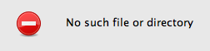  Then, after dismissing the error dialogue, the installer will crash and you will see this exception on the command line where you executed the java command to launch the GUI installer:  java.io.IOException: No such file or directory  at java.io.UnixFileSystem.createFileExclusively(Native Method)  at java.io.File.createNewFile(File.java:850)  at com.izforge.izpack.installer.UnpackerBase.writeInstallationInformation(UnpackerBase.java:891)  at com.izforge.izpack.installer.Unpacker.run(Unpacker.java:482)  at java.lang.Thread.run(Thread.java:613)  Even though the GUI installer crashes unexpectedly, the actual installation of caArray is complete, and you should be able to access the application. Verify application availability as discussed in step 17 above, and then go ahead and use caArray as usual.

Command-Line Method of Installation

Overview of caArray 2.2.1 Command-Line Installer Properties Files | When you do a command-line installation of caArray 2.2.1 for the first time, you will work with the properties file included in the caarray_distribution_2_2_1.zip. The file is: install.properties.  If you are command-line upgrading from a previous version of caArray 2.X, you will work with the upgrade.properties file included in the caarray_upgrade_2_2_1.zip. For more information about upgrading caArray, see Upgrade Using Command-Line Installer on page 26.

caArray Port Usage
NOTE | Verify that default port values defined in install.properties files are not in use on your system by running netstat –a from the command line. If the ports are in use prior to installation, you will likely experience problems with your installation.

JBoss Errors During Installation
NOTE | You may receive an error such as Exception in thread "main" java.lang.NoClassDefFoundError: org/jboss/Shutdown. This should not be a problem, as the installer attempts to remove previously installed servers to prevent problems during the installation. If this is your first time installing caArray, you may receive and disregard this error message.

Command-line Installation Steps
To install a new instance of caArray 2.2.1 using the command-line, follow these steps:

Step | Action
 | Refer to the command-line installation instructions found here: https://wiki.nci.nih.gov/x/MxKy .
1 | From the directory where you downloaded the caarray_distribution_2_2_1.zip from Downloading caArray 2.2.1 files on page 13, unzip the files, using one of these two methods:  - Open a command prompt and use it to extract this file to a temporary location. For example, you may enter a command such as unzip -q caarray_distribution_2_2_1.zip (you must have a ZIP tool installed). This location will be referred to as the <installer_directory> henceforth.  - Use WinZip or a similar utility to unzip the files to a temporary location. This location will be referred to as the <installer_directory> henceforth.  Example: <installer directory> = C:\caarray_221_installer
2 | Note: Setting the property values is an important step in the install process. Before you complete steps 2 & 3, review Working with Properties Files on page 9.  Open the <installer_directory>/install.properties file, modify the values for your environment and save the file. For the latest details about configuring the properties for your environment, refer to this wiki page: https://wiki.nci.nih.gov/x/LRKy
3 | Record the property values you have set.  Note: You shouldn’t need to modify the other default values as we have chosen unique ports to reduce the risk of other applications using the same values. However, be sure to verify that the ports in this file are not being used by other applications.
4 | From the command line, navigate to <installer_directory>/(Example:cd C:\caarray_221_installer), and type ant. This initiates the installation process. The anticipated duration is anywhere from 1-15 minutes, depending on your system’s speed, power and memory.  The installer installs the caArray schema in the specified pre-existing database on your MySQL server, and installs, configures, and starts two JBoss servers, one for the caArray application, and one for the grid service.
5 | To verify caArray installation, open your web browser to http://<jboss.server.hostname>.<jboss.server.port>/caarray (example; https://array.nci.nih.gov/caarray/. Refer to the <installer_directory>/install.properties file for the correct values. Enter caarrayadmin as the user and caArray2! as the password.
6 | After successfully installing caArray, make a backup of the <installer_directory>/install.properties file in a different directory for future reference.

Upgrading caArray 2.X to 2.2.1
This section describes how to upgrade your product from caArray 2.X to caArray 2.2.
The instructions in this section apply only if you have already installed a caArray version 2.X.

You can perform an upgrade installation of caArray v.2.2.1 using either of these two methods:
- A GUI Installation wizard. Instructions for this method begin on page 22.
- A command-line installation. For instructions, see page 26.

Before You Begin | - Important: Backup the 2.X database. You need to create a reliable copy of your entire caArray database—the DDL and DML.  - Important: Backup the current installation of caArray and artifacts from the original installation, such as properties files.

If you are performing a new installation, go directly to the installation of version 2.2, Installing caArray 2.2.1 Application and Services, on page 12.

caArray 2.X Users Upgrading to caArray 2.2 | The directions in this section presume that you have a valid and functioning caArray 2.X. That assumes that Java SDK, Apache Ant and MySQL have all been successfully uploaded and installed, as described on pages 3 - 8 in this document.

Overview of Properties Files | When you installed the previous version of caArray 2.X, you configured the install.properties file. To complete the upgrade to caArray 2.2, you must use some of the values from the original install.properties to configure values in the upgrade installer wizard GUI, or the upgrade.properties file if you are doing a command-line method of upgrade.  See the steps below for more information.

Upgrade Using the GUI Installer

For detailed information on all of the GUI installer fields, refer to the documentation at this location: https://wiki.nci.nih.gov/x/MBKy.

To perform an upgrade to caArray 2.2.1 using the GUI Installation Wizard, follow these steps:

Step | Action
1 | Open a command prompt in the directory where you downloaded the caarray_gui_distribution_2_2_1.jar and invoke the GUI installer like this: java –jar caarray_gui_distribution_2_2_1.jar.
2 | The Installation Wizard opens to facilitate the installation process. Click Next to proceed through the pages of the wizard, beginning with progressing past the Welcome page.
3 | Review the release notes.
4 | You must accept the license agreement to continue.
5 | Select the Upgrade installation type.
6 | Configure the JBoss Server-related upgrade settings.  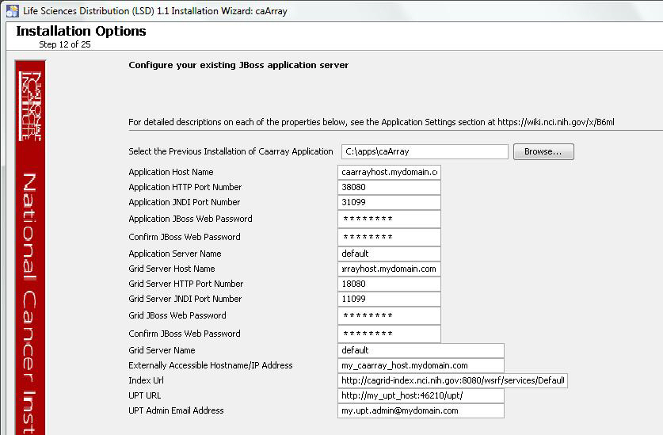  If the path pointing to the caArray installation to be upgraded is incorrect, an error message appears.
7 | Specify a research center and technical point-of-contact information needed for grid service registration.  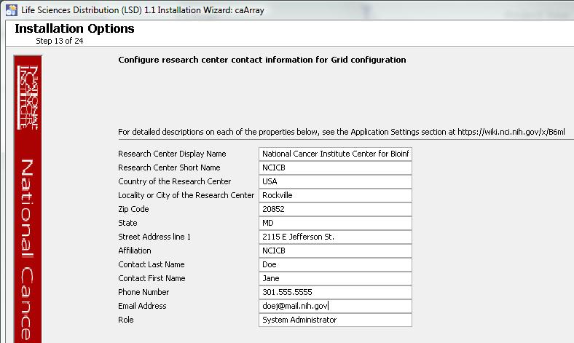  If you do not specify all of the required fields, an error message appears.
8 | Set your duplicate hybridization behavior preference:  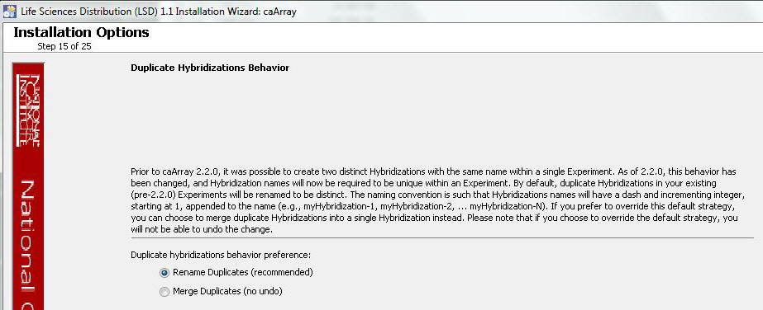
9 | Specify the authentication type that caArray is using. If you choose LDAP, configure the LDAP information.  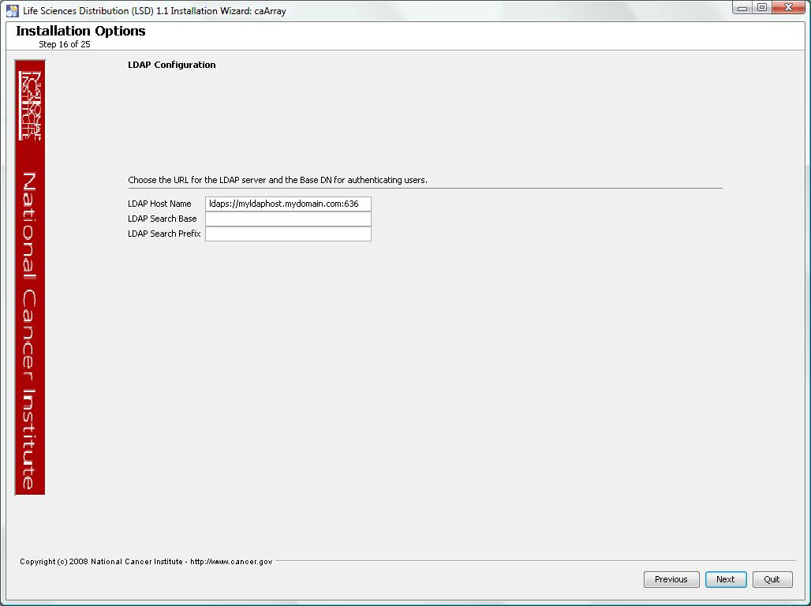
10 | Review the summary of gathered information.  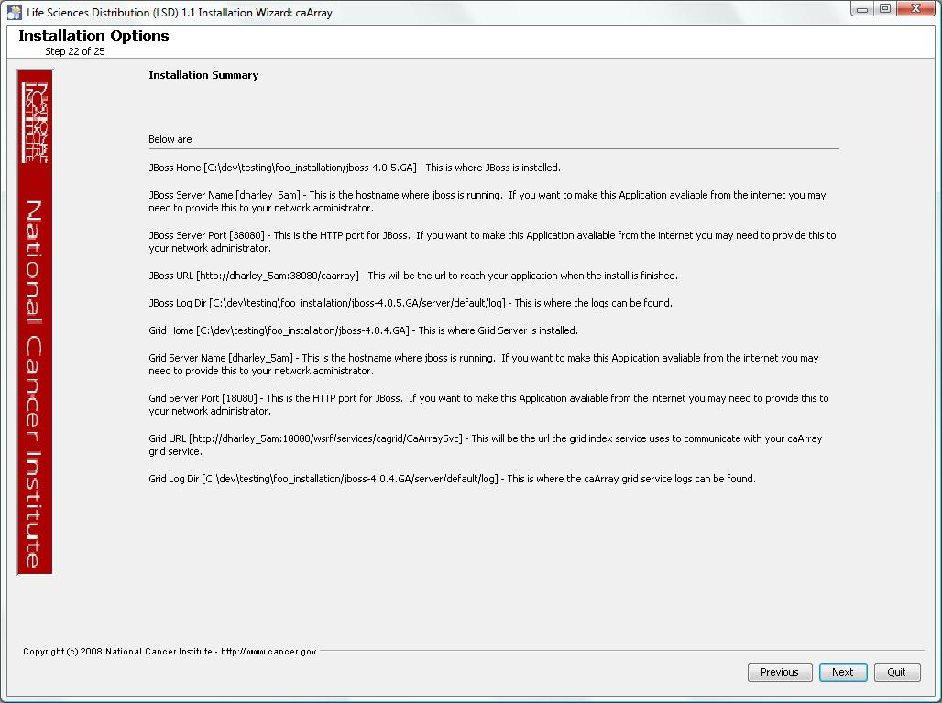
2  11 | Click Next to proceed through the next two pages. Review the selected upgrade installation type and the upgrade destination.
12 | After you click Next from reviewing the installation destination, the installer runs. The installation wizard displays the installation progress and completion.  When you are informed that the process is finished, click Done in the lower right corner to close the installation wizard.
13 | To verify caArray installation, open your web browser to http://<jboss.server.hostname>.<jboss.server.port>/caarray (example: https://array.nci.nih.gov/caarray) and enter caarrayadmin as the user and caArray2! as the password. Refer to the original install.properties for the correct jboss.server.hostname and jboss.server.port values.

IMPORTANT | For optimal performance, you must modify your JBoss 4.0.5 configuration to increase the amount of available memory for the caArray application. Directions for doing this in Windows are in the following step 1.

Fatal Error During GUI Installation on Linux
IMPORTANT | If you are installing on Linux, it is likely that you will see this error at the end of the GUI installer execution:  Then, after dismissing the error dialogue, the installer will crash and you will see this exception on the command line where you executed the java command to launch the GUI installer:  java.io.IOException: No such file or directory  at java.io.UnixFileSystem.createFileExclusively(Native Method)  at java.io.File.createNewFile(File.java:850)  at com.izforge.izpack.installer.UnpackerBase.writeInstallationInformation(UnpackerBase.java:891)  at com.izforge.izpack.installer.Unpacker.run(Unpacker.java:482)  at java.lang.Thread.run(Thread.java:613)  Even though the GUI installer crashes unexpectedly, the actual installation of caArray is complete, and you should be able to access the application. Verify application availability as discussed in step 13 above, and then go ahead and use caArray as usual.

Upgrade Using Command-Line Installer

To perform an upgrade to caArray 2.2.1 using the command-line, follow these steps.

Step | Action
1 | From the directory where you downloaded the upgrade zip file, extract the files, using one of these two methods:  - Open a command prompt and use it to extract this file to a temporary location. For example, you may enter a command such as unzip -q caarray_upgrade_2_2_1.zip. (You must have a ZIP tool installed).  Note: It is recommended that you use a new directory for the unzipped files, rather than the one you used to unzip the installer for the previous version(s) of caArray. This location will be referred to as the <upgrade_installer_directory> henceforth.  - Use WinZip or a similar utility to unzip the files to a temporary location. This location will be referred to as the <upgrade_installer directory> henceforth  Example <upgrade_installer directory> = C:\caarray221_upgrade_installer
2 | Edit the default properties in the <upgrade_installer_directory>/upgrade.properties file. Before doing so, review the Working with Properties Files section on page 9.  To do so, open both properties files, the one you configured originally when you installed the previous version of caarray_2.X. (<install properties file>)and the <upgrade_installer_directory>/upgrade.properties file.  For the latest details about configuring the properties for your updated environment, refer to this wiki page: https://wiki.nci.nih.gov/x/MBKy  Note: The upgrade.properties file does not have as many attributes, so you will not need to transfer all values you sent in the previous installation file.
3 | Record these property values.  Note: You shouldn’t need to modify the other default values as we have chosen unique ports to reduce the risk of other applications using the same values. However, be sure to check the *.properties to verify that the ports in this file are not being used by other applications.
6  5 | From the command line, navigate to <upgrade_installer_directory>/ (Example:cd C:\caarray220_upgrade_installer), and type ant. This initiates the upgrade process. The anticipated duration is anywhere 1-15 minutes depending on your system’s speed, power and memory.  The installer upgrades your existing caArray database on your MySQL server, starts your existing JBoss servers and starts up the grid service for the caArray application.  Notes regarding upgrade:  When the installer detects that a database exists, it warns you to back it up, which you were instructed to do earlier in this process. Press Y to proceed.
6  6 | To verify caArray installation, open your web browser to http://<jboss.server.hostname>.<jboss.server.port>/caarray (example: https://array.nci.nih.gov/caarray) and enter caarrayadmin as the user and caArray2! as the password. Refer to the original install.properties for the correct jboss.server.hostname and jboss.server.port values.

Configuring JBoss

NOTE | For optimal performance, you must modify your JBoss 4.0.5 configuration to increase the amount of available memory for the caArray application. Directions for doing this in Windows are in the following step 1.

To configure JBoss in Windows, follow these steps:

Step | Action
1 | Add the following entry to the JBoss run.bat file which is located will be located at <application_root_directory>/jboss-4.0.5.GA/bin/run.bat. Add the text right after the line ”rem Add -server to the JVM options, if supported”.  -server -Xms2048m -Xmx2048m -XX:ThreadStackSize=128 -XX:SurvivorRatio=10 -XX:PermSize=128m -XX:MaxPermSize=128m -Dsun.rmi.dgc.client.gcInterval=3600000 -Dsun.rmi.dgc.server.gcInterval=3600000 -Djava.awt.headless=true  Warning: Be careful when copying and pasting from this document, whether PDF or MS Word. No spaces must come before and after the columns. A safe way to ensure that the text has no unwanted space and unwanted characters is to copy the text into a blank NotePad first. Correct the spacing, then copy and paste back into the run.bat file.
2 | Restart your JBoss 4.0.5 server for the changes to take effect. The method of doing this may depend on the start/stop/restart scripts you created after the installation. Most commonly, you can execute shutdown.bat and then run.bat under $JBOSS_HOME/bin. Refer to the publicly available JBoss user’s guide at www.jboss.org for more information.

JBoss memory is configured through the jboss.java.opts property in caarray2-install.properties.

Configuring JBoss Servers and MySQL Server to Run as Services

NOTE | MySQL, and the two JBoss servers that make up caArray, and the JBoss server optionally installed for UPT, must run continually as services. The instructions in this section cover all of these scenarios. For a caArray 2.2.1 deployment, there are at least three servers, and if UPT is installed, four servers:  - JBoss 4.0.4 for UPT (optional)  - JBoss 4.0.4 (for Grid services)  - JBoss 4.0.5 (for caArray application)  - MySQL 5.0.27

Running JBoss as a Service

NOTE | The default caArray installation runs JBoss as a command line process using the user currently logged on. Therefore, when you log out as this user, JBoss will no longer be available for caArray. For that reason, it is recommended that you configure your JBoss servers to run as a Linux or Windows service. The instructions are contained in this section.

To run JBoss as a service, follow these steps:

Step | Action
1 | Linux  See http://wiki.jboss.org/wiki/Wiki.jsp?page=StartJBossOnBootWithLinux.
2 | Windows  To run an existing JBoss command line installation as a service, follow the directions for creating a user-defined service at http://support.microsoft.com/kb/137890/EN-US/  Note: You need to have access to the Windows Resource Kit.

Running MySQL as a Service

NOTE | It is assumed that your MySQL server was installed as a service. If it was not, follow these recommendations for installing this server as a service.

To run MySQL as a service, follow these steps:

Step | Action
1 | Linux  See http://www.redhat.com/docs/manuals/enterprise/RHEL-AS-2.1-Manual/cluster-manager/s1-service-mysql.html.
2 | Windows  When installing MySQL server on Windows, choose the option to run MySQL as a Windows service.

Post-Installation Tasks

Using UPT to Add caArray Users

To use the UPT, follow these steps:

Step | Action
1 | Install UPT. For more information, see page 9.
2 | Launch a browser and access UPT via http://<jboss.server.hostname>:<jboss.server.port>/upt (from install.properties).
3 | Login to UPT, using the following profile:  - Login ID=superadmin  - Password=changeme  - Application Name=csmupt
4 | Select the User tab at the top of the page, and click Create a New User.
5 | Enter Login Name, User First Name, User Last Name, User Password, User Password Confirm. Click Add.
6 | On the Application tab at the top of the screen, click Create a New Application.
7 | Enter the following parameters:  - Application Name=caArray  - Application Description=<Application Description>  - Application Declarative Flag=Yes  - Application Active Flag=Yes  - Application Database URL=jdbc:mysql://${database.server}:${database.port}/${caarray.database.name}  - Application Database User Name=${caarray.database.user}  - Application Database User Password=  ${caarray.database.password}  - Application Database Confirm Password=  ${caarray.database.password}  - Application Database Dialect=org.hibernate.dialect.MySQLDialect  - Application Database Driver=${com.mysql.jdbc.Driver}
8 | Click on Add > Associated Admins. then click on Assign Admin.
9 | Highlight the user you want to be admin of the application, and click Assign Admin.
10 | Logout of UPT.
11 | Login to UPT at http://<jboss.server.hostname>:<jboss.server.port>/upt (from install.properties). Use the following login profile:  - Login ID=<User created above>  - Password=<Password for User created above>  - Application Name=caArray
12 | Add users to the caArray application like you did above.
13 | Click Logout.

Appendix I: Custom Type GUI Installer Walk-Through
The Custom type GUI installer process walk-through begins on the panel immediately following the panel where you specified the Custom type install (page 14).

To continue with the Custom installation, follow these steps:

1 | Configure caArray JBoss server on the next two pages of the installation wizard. The screen shots show example values. The port values which are specified are the defaults and can be used unless you want to reconfigure the values because of values already in use.  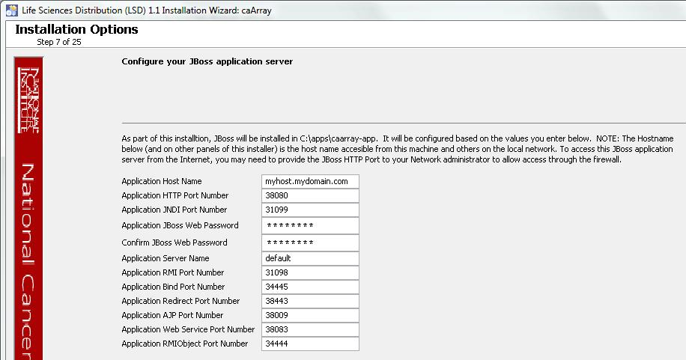
2 | 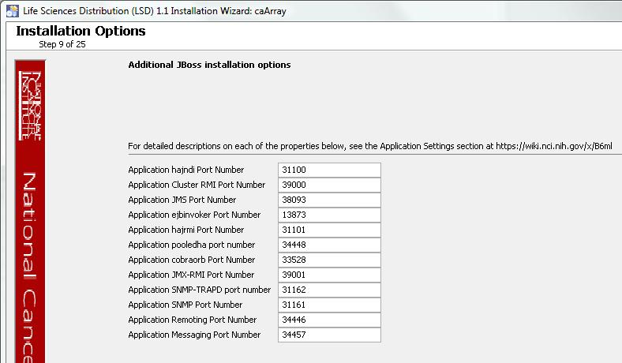
3 | Configure grid service JBoss server on the next two pages of the installation wizard. The screen shots show example values.  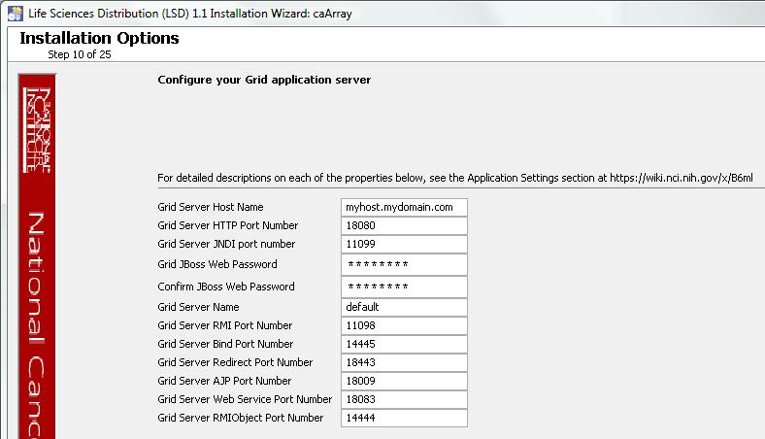
4 | 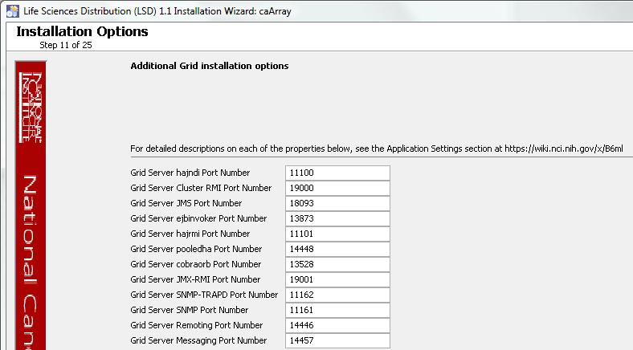
5 | Specify the research center and technical point-of-contact info needed for grid service registration.  An error message opens informing you of required fields you may have missed.
6 | Specify the database connection information, including the name of the pre-existing database where the caArray schema will be installed, and the pre-existing user to be used by caArray to connect to its database.  Error messages inform you if the following occurs:  - If the specified database host cannot be reached, or the field is blank.  - If the database admin user’s credentials are incorrect.  - If the specified database does not already exist, or the caArray DB user’s credentials are wrong.
7 | Specify the authentication type that caArray should use. If LDAP is chosen, configure LDAP info.
8 | Specify the grid service index URL, an externally-visible hostname or IP address which the index service can use to communicate with the grid service, and optionally, the UPT user management URL.  If the grid index service cannot be reached at the specified URL, an error message appears.
9 | Configure the database connection pool settings.  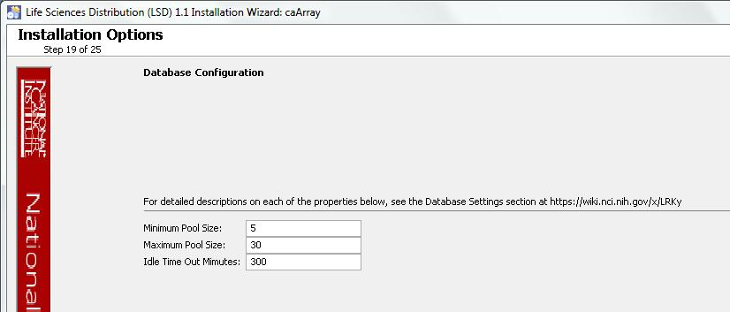
10 | Specify SMTP mail server connection info so that caArray can send emails from users with new account requests.
11 | Review the summary of the information you entered.
12 | Review the selected install type and the installation destination.  After you click Next from reviewing the installation destination, the installer runs. The installation wizard displays the installation progress and completion.
13 | When you are informed that the process is finished, click Done in the lower right corner of the wizard to close the installer.
14 | To verify caArray installation, open your web browser to http://<jboss.server.hostname>.<jboss.server.port>/caarray (example; https://array.nci.nih.gov/caarray/. Refer to the <user home>/.installer-csarray/caarray_installer/install.properties file for the correct values. Enter caarrayadmin as the user and caArray2! as the password.
15 | After successfully installing caArray, make a backup of the <user home>/.installer-caarray/caarray_installer/install.properties file in a different directory for future reference.

Appendix II: Default Users
The following users are provided by default by the caArray installer. The password for all is caArray2!.

- caarrayadmin
- caarrayuser
- researchscientist
- labadministrator
- labscientist
- biostatistician
- systemadministrator - This is the only user who will have access to the Manage Users functionality in caArray.
- collaborator

Contacting Application Support
NCICB Application Support | http://ncicb.nci.nih.gov/NCICB/support  Telephone: 301-451-4384  Toll free: 888-478-4423

