On-site interview with the NCI-60 Drug Profiling Project group
Location: Fort Detrick, Frederick, MD
February 14, 2008

Attendees:

Anne Monks, SAIC
Curtis Hose, SAIC
Bruce Crise, SAIC
Xiaolin
Nick, Core Genotyping Facility (CGF)
Juli Klemm, NCI
Brent Gendleman, 5AM
Rashmi Srinivasa, 5AM
Robert (Bob) Clifford, NCI

- PIs and Labs:
  - Anne and Curtis are the Principal Investigators.
  - Bruce, Xiaolin and Nick are from the LMT lab and they run the arrays. They’re the “Chip” lab.
  - The LMT lab will capture the data and pass it on to an Analysis lab.
- Samples and Cell Lines:
  - They have 60 cell lines and they are currently testing 1 drug.
  - 3 dosage levels (0, Low and High) are being tested at 4 time lines (0, 2, 6 and 24 hours). Except that there are no Low and High doses for the 0 time line.
  - This makes 600 samples (60 cell lines x 1 drug x 10 dose-time combinations).
- Plates:
  - Each cell-line-time-line combination goes on 1 plate, plus there is a growth plate (no drug) and growth inhibitor plate (no drug). This makes 6 plates x 60 cell lines = 360 plates.
  - They are considering storing this information in caLIMS so that it can be communicated from Anne’s lab to the LMT lab.
  - Bob is exploring ways to organize all this information so that it is easy and intuitive to navigate.
- Process followed by the labs:
  - Figure 1 shows the overall process followed by the labs.
  - Anne’s lab does minimal QC to determine whether to go ahead or re-do. This decision is based on the RIN numbers obtained for each of the 600 samples. A RIN number of 8 or above is usually acceptable; anything below must be reviewed by a human.
  - If 95% of the samples pass QC, and if the most commonly-used cell-lines are in the group that pass QC, then Anne’s lab makes a “GO” decision. Otherwise it’s a “NO-GO” and they have to re-do the process.
  - Anne would like to capture information about this iterative process.
  - Anne would also like the interaction between her lab and LMT to be smoother, but does not know yet how software could be of help in this respect.
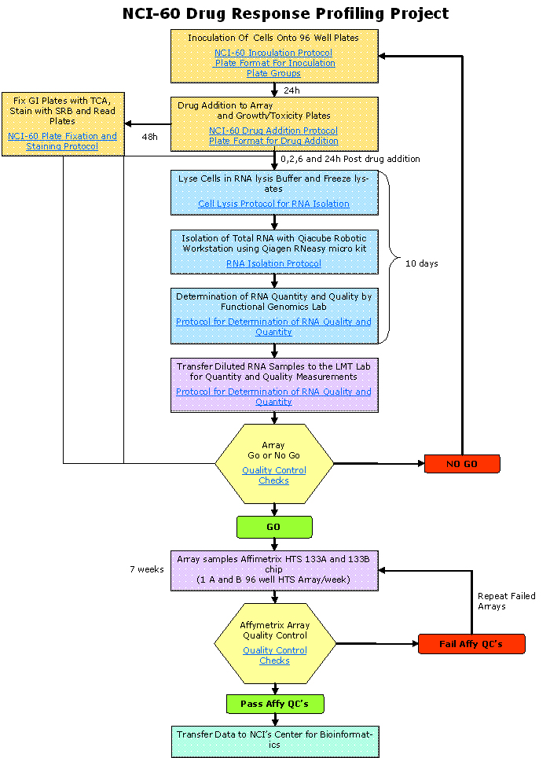
Figure 1: Flowchart of Process followed by the NCI-60 Drug Profiling Project
  - The LMT lab runs full QC, labels, runs QC, runs the chip, and then does a chip QC.
- Importing the array data into caArray:
  - It was recommended to Anne and the LMT lab that they follow a convention when talking about the 600 samples. <drug>_<cell-line>_<time>_<dose> was agreed on as an intuitive naming scheme.
  - By carrying the above naming convention all the way through their process, the data files (CEL, CHP etc.) that are generated will have the right names.
  - When these data files are imported into caArray, caArray will automatically generate the appropriate names for the samples, extracts, labeled extracts and hybridizations automatically created for each data file set.
  - Curtis et al reported that they would prefer to use a spreadsheet format in order to import the data into caArray and caLIMS.
  - Juli agreed that we would provide a simplified MAGE-TAB template for them to use to submit their data. (This format would take away some of the complexity of MAGE-TAB elements by eliminating Term Source REFs, for example.)
- More data issues:
  - The LMT lab will generate .CEL, .CHP, .EXP and .TXT files and would like to store these.
  - They will also generate a large volume of .DAT files. There will be 98 .DAT files per well, 96 wells per plate and 360 plates for each drug experiment. Since this is a huge volume of images which are not required to be parsed in any way, it was agreed that these would be archived somewhere instead of storing in the caArray database. caArray would provide a pointer for users to be able to get to the .DAT files.
  - Xiaolin indicated that they would like some guidance with making sure that their data is MIAME-compliant before they publish their data.
- Anne drew the following table to explain how they think about their data:
Sample | Location (Well) | Location (Tube) | Location on QC plate | Location on array plate | QC (RIN#) | Quantity | Cell growth | Growth inhibitor
1 |  |  |  |  |  | 2.8µM | Y | Y
2 |  |  |  |  |  |  | Y | Y
… |  |  |  |  |  |  | N | Y
600 |  |  |  |  |  |  | Y | Y

- Action Items:
  - Bob is looking into how to organize the information in 360 plates in caLIMS.
  - Juli(?) will provide a simplified MAGE-TAB spreadsheet template that Curtis/LMT can use to submit their data.

