National Cancer Institute   
Center for Bioinformatics   
(CBIIT)

Project Management Plan

caArray and caIntegrator

|  |  |
| --- | --- |
|  |  |
| Produced By: | 5AM Solutions, Inc. |
| Version: | 1.2 |

Revision History

|  |  |  |  |
| --- | --- | --- | --- |
| Date | Version | Description | Revised by |
| 07/21/2011 | 1.0 | Initial Draft. | Rashmi Srinivasa |
| 10/12/2011 | 1.1 | Updated personnel roster | Rashmi Srinivasa |
| 12/6/2011 | 1.2 | Updated personnel roster | Rashmi Srinivasa |
|  |  |  |  |
|  |  |  |  |
|  |  |  |  |
|  |  |  |  |

Copyrights and Trademarks

© Copyright 2011-2012 by CBIIT, caBIGTM. All rights reserved.

Table of Contents

1. Executive Summary 1

1.1. Purpose 1

1.2. Scope 1

2. Approach 1

2.1. Project Management 1

2.2. Process 3

2.3. Deliverables 3

2.4. Key Stakeholders Directly Supporting the Project 4

2.5. Team Personnel / Org chart 4

2.6. Resource Management 4

2.7. Risk Management 4

2.8. Budget and Cost Management 5

2.9. Communication Plan 5

3. Roadmap, Scope and Milestones 6

# Executive Summary

## Purpose

This is a project management plan for the caArray and caIntegrator projects. caArray is a software tool to support the management of microarray data and associated experiment and sample annotations. caIntegrator is a tool that allows researchers to set up custom web portals that bring together heterogeneous clinical, medical imaging and microarray data.

This document lays out the approach that 5AM Solutions has chosen to take in managing the two projects. Detailed project plans for individual releases are available in the NCI subversion repository, and fine-grained iteration plans for the individual milestones are available in the NCI Jira tracker.

## Scope

caArray is a software tool to support the management of microarray data and associated experiment and sample annotations. It consists of a web-based user interface as well as both caGrid and Enterprise Java Bean-based programmatic interfaces. The system is intended for installation at institutions requiring local management and control of their microarray data; in addition, NCI CBIIT hosts an instance of the system for public use. Users may upload sample annotations and files using forms provided through the graphical user interface; alternatively, they may bulk upload data that has been formatted as MAGE-TAB. All details of the project are available:

1. on the wiki: <https://wiki.nci.nih.gov/x/cCIhAQ>
2. in subversion: <https://ncisvn.nci.nih.gov/svn/caarray2/>
3. on Gforge: <https://gforge.nci.nih.gov/projects/caarray2/>

caIntegrator is a tool that allows researchers to set up custom web portals that bring together heterogeneous clinical, medical imaging and microarray data stored in caArray. The tool provides a graphical user interface to allow a study author to “point” to data of interest in systems on the grid and to then bring that data (or pointers to it, in the case of images) into the data warehouse. Once this information is in the caIntegrator environment, end user scientists can then run advanced queries, perform correlative outcomes analysis using Kaplan-Meier plots, and access analysis and visualization tools on and off the grid. All details of the project are available:

1. on the wiki: <https://wiki.nci.nih.gov/x/9YMOAQ>
2. in subversion: [https://ncisvn.nci.nih.gov/svn/caintegrator2](https://ncisvn.nci.nih.gov/svn/caintegrator2" \t "_new)
3. on Gforge: <http://gforge.nci.nih.gov/projects/caintegrator2/>

# Approach

## Project Management

We plan releases, iterations and milestones at various levels:

1. A coarse-grained release plan which describes the entire project in phases, including a backlog of client-prioritized items. This is maintained in an Excel spreadsheet and/or a Microsoft Project plan. The caArray release plan is available here: <https://ncisvn.nci.nih.gov/svn/caarray2/trunk/docs/project_management/> and the caIntegrator project plan is available here: <https://ncisvn.nci.nih.gov/svn/caintegrator2/trunk/docs/project_management/>.
2. A series of fine-grained Iteration Plans, which are fleshed out at the start of each iteration. An Iteration Plan defines and tracks the detailed tasks planned in that iteration. These are maintained in the Jira tracker for caArray: <https://tracker.nci.nih.gov/browse/ARRAY> and the Jira tracker for caIntegrator: <https://tracker.nci.nih.gov/browse/INTEGRATOR>. (See Figures 1 and 2.)

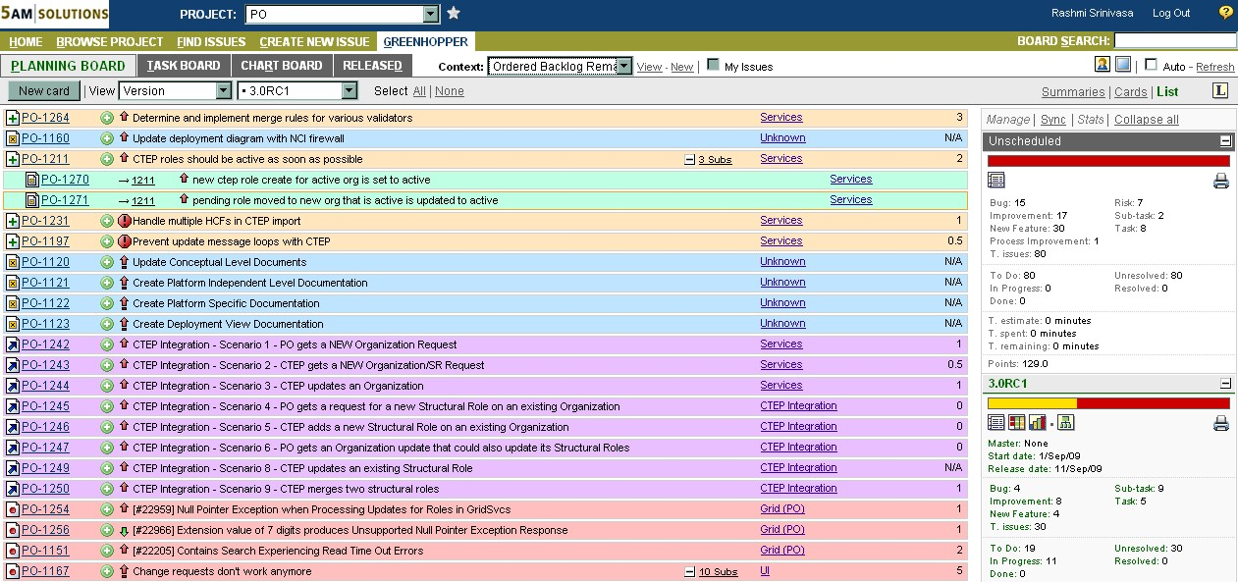

Figure 1: Backlog on Planning Board

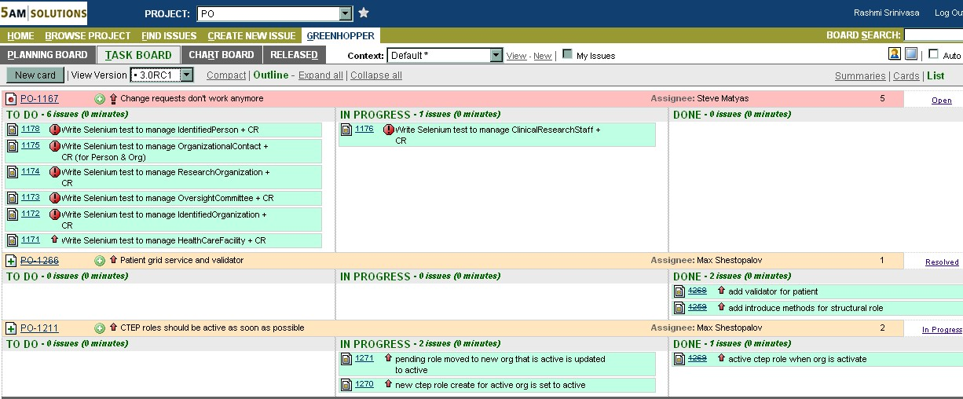

Figure 2: Iteration Task Board

## Process

Our software development process is called the Glassbox™ process, and can be characterized as an iterative, agile process organized into the Phases defined by the Rational Unified Process. (See Figure 3: Glassbox Process.) Through continuous integration and testing, we can be confident that the software works.

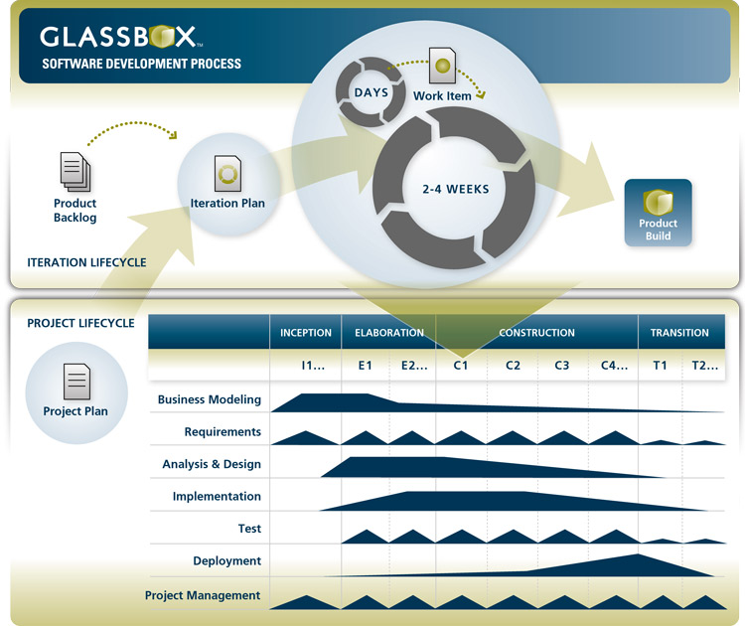

Figure 3: Glassbox Process

For these projects, we have chosen 2-week iterations. At the end of every iteration, we deliver complete and deployable software to the independent QA team to test. We also use this end-of-iteration meeting to review how the iteration went and to make any adjustments needed to improve productivity.

The team has daily scrums to monitor progress, and the scrums are attended by the developers, analysts, project manager and QA personnel. In addition, the team has an iteration planning meeting once in 2 weeks.

The iteration planning meetings, iteration retrospectives and daily scrums are run as separate meetings for the caArray and caIntegrator projects. The two project teams meet regularly, typically once in 2 weeks, to review shared goals and milestones.

## Deliverables

The 5AM Project Manager provides formal status reports to the SAIC-F COTR every month, reporting on progress made so far, future directions planned, current risks, delivery schedule and budget. Risks are continuously monitored and mitigation strategies planned.

All the project deliverables are made available on the ncisvn subversion repository, and the links are sent to SAIC-F. The deliverables are also linked to off the project wiki pages.

Finally, deliverables are uploaded to the Gforge projects at release milestones. Links to the subversion repositories, wiki pages and Gforge projects are above in section 1.2.

## Key Stakeholders Directly Supporting the Project

|  |  |  |
| --- | --- | --- |
| **Role** | **People** | **Organization** |
| Project Officers | Juli Klemm - caArray  Mervi Heiskanen – caIntegrator  JJ Pan – Engineering  Robert Shirley - Engineering | NCI CBIIT |
| Contracting Office Technical Representative (COTR) | Jeff Aaronson | SAIC-F |
| 5AM Contract Specialist | Susan Mason | 5AM Solutions, Inc. |

## Team Personnel / Org chart

|  |  |  |
| --- | --- | --- |
| **Role** | **People** | **Responsibilities** |
| Software Engineering -Architecture and Development | Todd Parnell - caArray  JP Marple - caIntegrator  Krishna Kanchinadam – caArray  Max Shestopalov - caIntegrator | Write the software; coordinate with other teams to build and deploy releases; plan and review iterations. Write architecture specifications; ensure that product conforms to enterprise architecture framework/requirements. |
| Subject Matter Expertise and Requirements Analysis | Will Fitzhugh (15%)  Andy Evans (15%) | Provide subject matter expertise and help with requirements elicitation and analysis. |
| Project Management - caIntegrator | Shine Jacob (50%) | Manage the project schedule and scope. |
| Project Management, Requirements Analysis and Data Modeling - caArray | Rashmi Srinivasa (50%) | Manage the project schedule, scope, resources and budget. Provide monthly status reports and other deliverables to the client. Communicate with stakeholders, document and manage requirements, manage data model. |

## Resource Management

All proposed resource additions and changes will be sent to the SAIC-F COTR for approval. The SAIC-F COTR is responsible for clearing the resource changes with the NCI Project Officers. The 5AM Project Manager will be responsible for the actual procurement and assignment of resources to the project.

## Risk Management

Risks will be identified throughout the course of the project, and communicated to the COTR. Risks in all categories – technical, schedule, resources, budget, environment, external dependencies – will be considered. Communication of risks will be done explicitly at the status meetings with SAIC-F. The risk matrix will also be available in the NCI subversion repository, captured in monthly status reports, and linked off the project wiki page. The current statuses of all caArray risks are available here: <https://ncisvn.nci.nih.gov/svn/caarray2/trunk/docs/project_management/>. All caIntegrator risks are available here: <https://ncisvn.nci.nih.gov/svn/caintegrator2/trunk/docs/project_management/>.

## Budget and Cost Management

The 5AM Project Manager provides monthly financial reports to the SAIC-F COTR. The 5AM Project Manager (Delivery Manager) works closely with the 5AM Chief Operations Officer on a bi-weekly basis to review budget actuals and projections. 5AM uses the Netsuite time tracking tool to capture all labor hours worked by an employee. These hours are captured by project and task / labor category. Hours are submitted weekly and are approved by the Delivery Manager as well as the COO. These hours are then captured and reported to the client through a monthly status report as well as a monthly invoice.

## Communication Plan

| **Communication Audience** | **Purpose** | **Communication Method** | **Occurrence** | **Participants** |
| --- | --- | --- | --- | --- |
| Users, API partners | Requirements gathering and review | Teleconferences, face-to-face meetings, questionnaires, surveys. | As needed | Requirements Analyst, Project Manager, Tech Lead |
| COTR | Project status updates | Email communication, Phone call | Monthly | Project Manager |
| Project Officer, full project team (QA, Systems team, tech writer) | Project status updates | Face-to-face meeting and teleconference | Biweekly | Full project team including Project Officer |
| Users, API partners | Provide updates to the ICR-WS group | Teleconference | Monthly | Users, Project Manager, Project Officer |
| Users, API partners | Release Notices | Gforge, MAT-KC forums, ListServs | Concurrent with release cycle | Users |

# Roadmap, Scope and Milestones

The latest Roadmap, Scope and Milestones are available on the caArray and caIntegrator wiki pages. See section 1.2 for links to the wiki.