

Project Charter

caBench-to-Bedside

Version 1

July 31, 2006

Table of Contents
Table of Contents 2
Sign Off Sheet (Key Stakeholders Only) 4
Document Overview 5
Change Record 5
Reviewers 5
Introduction 6
Purpose of Document 6
Audience 6
Related Documents 6
Terms and Definitions 6
Background and Rationale 7
Background 7
Workflows and Use Cases 9
Business Justification 10
Project Description 12
Project Overview 12
Related Projects 13
Project Assumptions 13
System Challenges 13
Project Constraints 14
Technical Constraints 14
Critical Success Factors 14
Project Resource Allocation 14
Risks and Risk Management 15
In Scope/Out of Scope Functions 16
Purpose of This Section 16
In Scope/Out of Scope Functions 16
Phase 0: September 06 – Pre-prototype 16
Phase 1: November 06 - Prototype 16
Phase 2: January 07 - Annual meeting 17
Phase 3: April 07 – Feature complete, Beta release 17
Phase 4: June 07 – Final release 17
Future Phase Functions 17
Project Impact on Business Areas and Processes Error! Bookmark not defined.
System Requirements 18
Requirements Matrix 18
Project Activities and Milestones 20

Sign Off Sheet (Key Stakeholders Only)
PROJECT ACCEPTANCE: By signing this Project Charter, you are accepting the initial direction of the common security Project.

__________________________________________________________ DATE: ___/___/___

__________________________________________________________ DATE: ___/___/___

__________________________________________________________ DATE: ___/___/___

__________________________________________________________ DATE: ___/___/___

__________________________________________________________ DATE: ___/___/___

__________________________________________________________ DATE: ___/___/___

Document Overview

Change Record
Date | Author(s) | Document  Version | Change Reference (Major Changes)
July 31, 2006 | Srikanth Adiga and Rakesh Nagarajan | 1.0
August 6, 2006 | Srikanth Adiga | 1.1 | Updated after review meeting with Avinash Shanbhag

Reviewers
Name | Position | Document  Version | Date  Reviewed

Introduction

Purpose of Document
The purpose of this document is to describe the vision and scope of the caBench-to-Bedside (caB2B) version 1.0 release. At the high level, the document outlines the following:
- A brief introduction to the project statement and how caB2B helps in solving the problem
- Timeline and details of the iterations of the software development lifecycle
- Risks and dependencies of the project
- High level requirements and deliverables
This is also a working document used to facilitate communication between the National Cancer Institute Center for Bioinformatics (NCICB) management and the development teams to ensure that the project goals, scope, and stakeholders are all well defined prior to project execution.

Audience
NCICB management

Related Documents
caB2B Project Proposal submitted by Washington University

Terms and Definitions
caFunctionExpress (caFE) | A gene annotations data warehouse
caTissue Core | Biospecimen inventory and tracking system
Clinical Annotation Engine (CAE) | Source of clinical data associated with biospecimens
caTIES | Free text information extractor for surgical pathology reports
caTissue | Integrated suite of caTissue Core, CAE and caTIES
caArray | A microarray database and microarray data analysis and visualization tools
GoMiner | A resource for biological interpretation of genomic and proteomic data
GeneConnect | A mapping service that will facilitate interoperability by interlinking approved genomic identifiers

Background and Rationale

Background
It is becoming increasingly apparent that a majority of cancers are the product of multi-step processes which each involve the complex interplay of a multitude of genes acting at different levels of the genetic program. Indeed, it is clear that genome-wide detection of genetic alterations, transcriptional profiles, and protein compositions is required to describe the complex pathophysiology of these multi-factorial diseases comprehensively. Fortunately, in the post-human genome sequencing era, there are a number of experimental methodologies that facilitate the genome-wide detection of genetic alterations, transcriptional profiles, and protein compositions of normal and diseased tissues. There is great potential in microarray analysis as evidenced by the recent explosion of publications using the technique to monitor genome-wide expression and to correlate the expression changes to biological processes or to disease states. It is clear that robust expression markers, which are predictive of clinical outcome, and genes, which are targets for therapy, may only be obtained through integration of expression data with mining techniques, clustering algorithms, and gene annotation data.

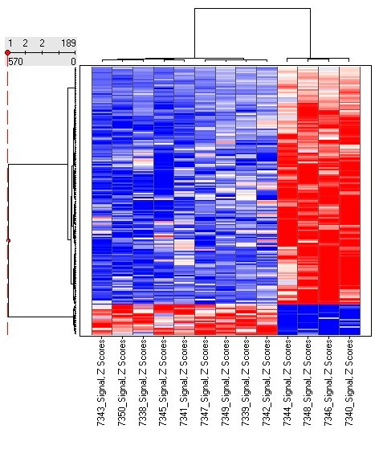
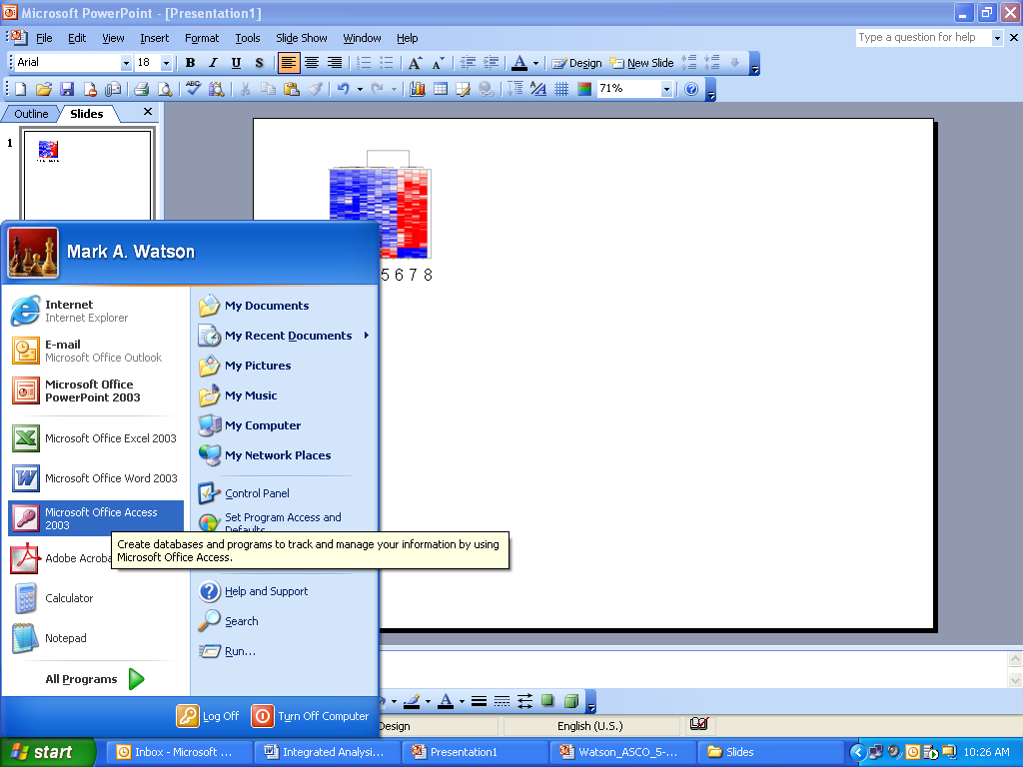

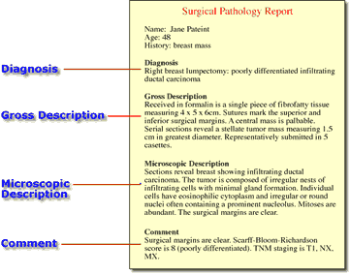
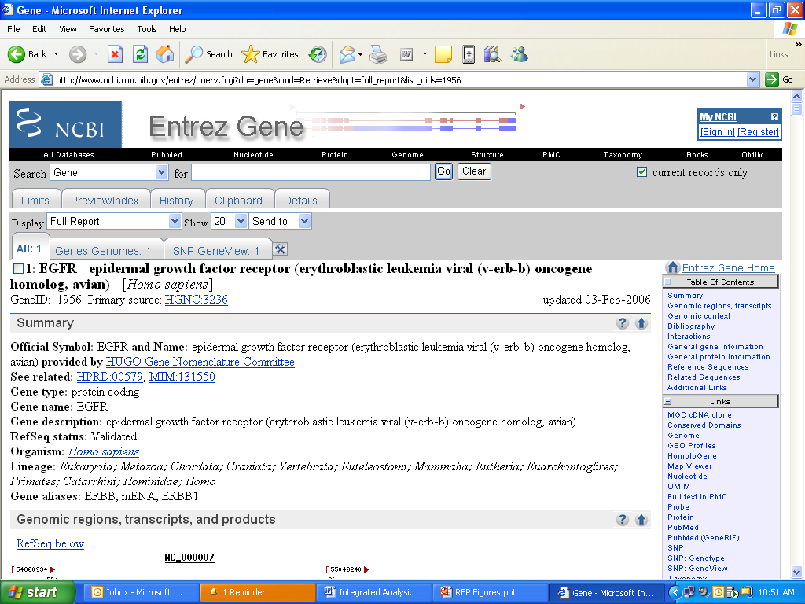

Given these challenges, most end-users (physicians and scientists) find the task of performing such integrated in-silico experiments and analyses daunting in the functional genomic era, since considerable computing power and expertise are required. This is exemplified by the variety of disparate data sources and formats, different software applications, and varied output formats that exist today (Error: Reference source not found). This problem is most apparent in cancer where cancer centers frequently conduct similar clinical trials or participate in multi-institutional studies. Thus, a flexible framework is required that will handle such complexities and allow the translational researcher to focus on the results of analyses. Such an application will need to address several major issues in the areas of data management, storage, analysis, and visualization before seamless integration of these data sets into complex workflows is possible.
1 2 3 4 5 6 7 8
?
Analytical Tools
Clinical (Pathology) Text Reports
RDMS Clinical Data Store
Study Database and Patient/Specimen Key
Microarray Data Referenced by Chip ID
Gene Annotation Web Services
Figure 1: A major roadblock to performing translational and analytical research: disparate data sources need to be integrated into a single view for data mining.

Integrated analysis of this data will increase the power and will result in more robust prognostic/diagnostic markers and targets against which therapeutic intervention may be designed. To directly address this need, the National Cancer Institute has recently started the cancer Biomedical Informatics Grid (caBIG™, https://cabig.nci.nih.gov) initiative to create a “network or grid connecting individuals and institutions to enable the sharing of data and tools, creating a World Wide Web of cancer research.”

Although caBIG™ is developing separate applications that will facilitate individual steps involved in microarray analysis and that are useful to bioinformaticians, there is no single application that leverages these tools in a user-friendly graphical interface. Such a tool, which is essential for the ultimate end-user, the physician-scientist, will serve as a powerful means to identify previously underappreciated pathways for potential new targeted therapeutics against devastating biological diseases such as cancer. Therefore, we propose to develop caBench-to-Bedside (caB2B), which will use the caGrid infrastructure and be capable of performing the following (Figure 1):

- Query any available caTissue Core installation for biospecimens that match a set of criteria and have available microarray data. These queries could include clinical data and information extracted from pathology reports.
- Acquire microarray data from any available caArray data source.
- Filter and normalize this data from tools available in the Function Express (FE) Client and GenePattern (e.g., filter probes absent across all genes, z-score normalize, log normalize).
- Analyze filtered and normalized data using tools available in the FE Client, GenePattern, geWorkBench, BioConductor, etc. (e.g., hierarchical clustering, k-means clustering, self-organizing maps).
- Acquire gene annotation data available in caFE and GoMiner (e.g., participation in biological processes and pathways, interaction data, literature-based networks).
- Integrate data sets using standard caBIG™ common data elements (CDEs) and the genomic identifier mapping service, GeneConnect.
- Create complex workflows using these available data and analytical services.

caB2B
caTissue Core
EAM
caArray
Gene Pattern
caFE
GoMiner
FE Client
GeneConnect

Figure 1: The caBench-to-Bedside (caB2B) Client will integrate several caBIG applications and provide a unified interface for investigators. The caB2B will provide access to clinicopathology tools, microarray data stores and analysis algorithms, probeset and gene annotations, and a genomic identifier translation service.

The seamless, integrated analyses of research data sets will empower the translational scientist to address the difficulties of studying tumorigenesis, and as such, this software suite will be an important contribution to the general cancer research community. caB2B will facilitate cancer research in multiple ways. First, it will provide investigators with the ability to query tissue banks at multiple cancer centers, enabling studies to focus on very specific tumor subtypes and to target less common tumors by pooling biospecimen resources, and thereby attenuating the problem of small sample sizes. Second, it will give investigators the ability to perform novel in silico experiments using microarray data sets that have already been collected. These capabilities will facilitate the process of identifying genes that are up- or down-regulated in specific cancers, and allow investigators to view that data in the context of biological pathways. By identifying genes important to the development and treatment of cancer, investigators will gain further understanding into the complex system of cancer biology. Ultimately, this will lead to the more effective identification of novel drug targets and improve treatment strategies.

Workflows and Use Cases
Given the magnitude and complexity of genome-wide profiling data sets, most end-user physician-scientists find the task of analyzing and extracting meaningful results from them quite daunting. Simple analysis workflows and a core set of visualization windows would facilitate this task and would thus be invaluable for the analyses performed by the modern day physician-scientist. Accordingly, we will create workflows using the Business Process Execution Language (BPEL) or other caBIGTM Architecture Workflow SIG recommended languages to orchestrate individual analysis applications which will be wrapped as web services. Open source workflow technologies will be examined for utilization in caB2B. These workflows may then be used to analyze microarray and clinicopathology data sets using analytical services available on the grid.

Examples of use cases that could be supported by caB2B are described below.
Searching for biospecimens at other institutions
  - Find high quality RNA biospecimens (A₂₆₀/A₂₈₀ ratio >= 1.8) from prostate adenocarcinomas and age-matched normals (100 biospecimens each) that have associated microarray data
  - Find high quality RNA biospecimens (A₂₆₀/A₂₈₀ ratio >= 1.8) from prostate adenocarcinomas and age-matched prostatic intraepithelial neoplasias (100 biospecimens each) that have associated microarray data
  - Find high quality RNA biospecimens (A₂₆₀/A₂₈₀ ratio >= 1.8) from prostate adenocarcinomas, Gleason grade 6-9 and evidence of perineural invasion, and age-matched normals (100 biospecimens each) that have associated microarray data
  - Find high quality RNA biospecimens (A₂₆₀/A₂₈₀ ratio >= 1.8) from primary prostate adenocarcinomas and corresponding metastases from the same patient (100 biospecimens each) that have associated microarray data

Analyzing microarray data sets with multiple applications
- Querying for RNA derived from a set of frozen primary breast tumors and surrounding nonmalignant breast tissue that have both been subject to microarray experiments.
- Use the FE Client to log-normalize a microarray data set, then use GenePattern's non-negative matrix factorization routines to analyze the data. Similarly, the data could be normalized with the FE Client z-score normalization routine and analyzed using GenePattern's principle component analysis method.
- Use the SAM analysis method in the FE Client to analyze microarray data and identify a set of interesting genes, then use GenePattern's GeneNeighbors routine to identify genes whose expression profiles are similar to the genes in that set.
- Following microarray analysis and the identification of a set of interesting genes, caFE can be used to obtain a gene identifier for and other information about the relevant probesets. GeneConnect can be used to translate the gene identifiers to a set that can be used to query GoMiner and obtain gene annotation data.

Integration of molecular data sets with clinicopathology information
- Visualize the PSA level, Gleason grade, recurrence status, tumor size, etc. of tumors after hierarchical clustering a set of 200 prostate tumors to see if tumors segregate according to any of these clinicopathology parameters.
- Identify 400 prostate tumors that are between Gleason grade 6-9 or from 10-12 and use 200 samples to train an SVM. Test the other 200 samples to determine if they can be differentiated using this SVM.

Business Justification
The cancer Biomedical Informatics Grid, or caBIG, is a voluntary network or grid connecting individuals and institutions to enable the sharing of data and tools, creating a World Wide Web of cancer research (https://cabig.nci.nih.gov). The goal is to speed the delivery of innovative approaches for the prevention and treatment of cancer. The approach is to leverage existing technologies for the standardization of data representation and semantics coupled with common data integration architecture.

The goal of caBench-to-Bedside will be to demonstrate the usefulness of caGrid infrastructure as a platform to perform scientifically challenging investigations involving integration of data and analytical services from diverse research communities. The caB2B project will enable individual users to work on common platforms to access caGrid resources in real time from common data and analytical services. The client will have various configurations that support end users in the cancer biomedical research community. Finally, although only microarray data sets are targeted for analysis initially, the design and infrastructure will seamlessly allow for co-analyses and visualization of virtually any data set as such data and analytical services come on line (e.g. proteomics data repository, protein database searching service, SNP analytical services, array comparative genomic hybridization [aCGH] services, non-expression microarray repository services, etc.)

This application will ensure that all end users can access caGrid and serve as a platform for further development and innovation in the caBIG community.

Project Description

Project Overview
To facilitate large-scale scientific studies and to satisfy the workflows mentioned in Section Workflows and Use Cases, we propose to develop a highly interactive rich client application to integrate the following applications:

Application | Type of  Service | Status of  Grid enablement
GenePattern | Analytical | In Progress
GoMiner | Data | In progress
GeneConnect | Data | Apart of v1.0 due Nov 2006
caTissue | Data | Apart of integrated suite due Mar 2007
caArray | Data | Sep 2006
caFE | Data | Yes
Function Express Client | Analytical | As part of caB2B
BioConductor | Analytical | In progress

Our vision is to build a highly extensible and innovative application that demonstrates the real power of the caGrid. It will leverage existing caCORE and caGrid infrastructure, and allow investigators to design and build workflows involving multiple biomedical domains and disparate data sets.

As part of the caB2B project, we propose the following goals:
- Extend caTissue, caFE models in order to contain extensions to caArray model
- Use the grid infrastructure to develop a highly extensible and secure UML model-based query interface
- Create a fully integrated user interface with rich visualization capabilities
- Ability to define workflows and jobs wherein any sequence and instances of goals 3 and 4 can be performed

The caB2B client will be developed on top of our existing product Function Express Client (Windows based).

Error: Reference source not found illustrates how data from different sources could be integrated into a single, common view.

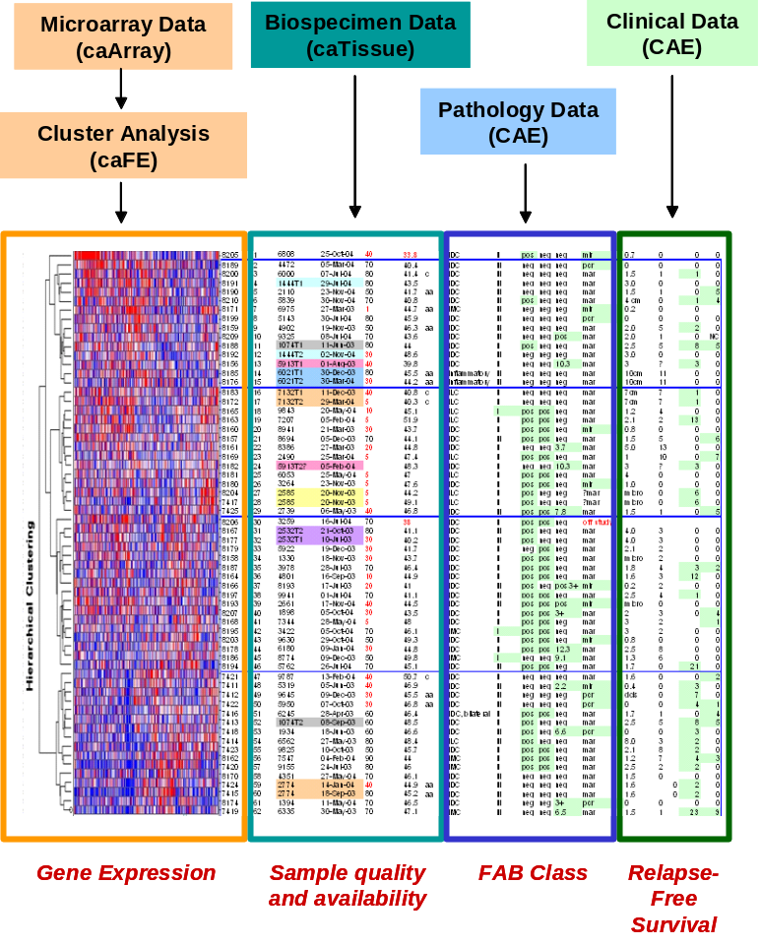
Figure 3: An example of how data from multiple, disparate data sources could be integrated into a single view.

Related Projects

Project Assumptions
caGrid v1.0 release: An important assumption of the caB2B project is availability of a stable caGrid 1.0 infrastructure.
Necessary data and analytical services will be caGrid 1.0 enabled: caB2B depends on many applications being grid enabled using caGrid 1.0. They include caArray, GenePattern, BioConductor, caTissue, GeneConnect, caFunctionExpress, and GoMiner. Amongst these, caTissue, GeneConnect and caFunctionExpress are developed by Washington University, and we will be grid enabling them as part of caB2B or their respective project deliverables.

System Challenges
- A sophisticated search engine which can query single instance of a service, multiple instances of a service and perform distributed queries over multiple services.
- End-user friendly user interface
- Performance of the application such that it can be used in production
- Ability to create workflows

Project Constraints
The project will be executed under the following constraints:
- Scope defined in the project charter (this document), use cases and requirements document, and change request approved by the change management board.

Technical Constraints
- caGrid v1.0:
  - We are constrained by the features and limitations of caGrid 1.0.
  - Ability of the development team to quickly understand the architecture of the caGrid 1.0.
- Java v1.5 based thick client
- Java Swing based application
- Active BPEL for workflow
- Operating Systems to be certified: Windows XP, Mac 10x, Linux Red Hat
- Databases to be certified: MySQL v5.0 (for local database)

Critical Success Factors
The following are critical success factors for the project:
- Identifying key users and stakeholders
- The necessary resources, personnel and equipment, are available as required.
  - Most importantly, this includes future users of the system, who must be readily available for defining system requirements
- Participants (full-time and part-time) attend meetings as required and adhere to deadlines and schedules
- Development team’s ability to quickly understand and use caGrid v1.0 Beta release.
- Stability of caGrid v1.0 Beta release
- All participants have a clear and common understanding of project goals, objectives, timelines, deliverables, and so forth
- Detailed planning and close tracking of project progress
- Accurate requirements gathering
- Adherence to established scope and avoidance of scope creep

Project Resource Allocation
Adequate resources should be allocated to the team with the right mix of domain experts, end users, software architects, senior developers and QA personnel.

The team consists of:

Domain experts:
- Dr. Rakesh Nagarajan
- Dr. Mark Watson
- Dr. Robert Freimuth

End users:
- Dr. Jason Gustin
- Dr. Burr Fontaine
- Dr. Jackie Payton
- Dr. Mukesh Sharma

Technical Architect
- Srikanth Adiga

Team leads
- Munesh Gupta (caGrid Infrastructure)
- Mahesh Iyer (caB2B client application)
- Pratibha Naikade (Lead Reviewer)

Risks and Risk Management
caGrid 1.0 Risks:
- caB2B is one of the first applications that will utilize all the components of the caGrid infrastructure. Therefore, the success of caB2B has significant dependency on the success of caGrid 1.0 release.
- caGrid v1.0 Beta release’s stability
- The development team’s ability to quickly understand all the components of caGrid v1.0.
- Lack of cooperation from the caGrid development team
Mitigation Plan:
- We will be closely interacting with the caGrid v1.0 development team. The development team will be responsible for helping the team with issues, providing workarounds and fixes for critical bugs.
- Any issues like lack of cooperation from the caGrid development team will be escalated to the NCICB caGrid leadership.

Performance
- Since the performance of caGrid query engine is not yet thoroughly tested, it could result in poor performance of caB2B.
Mitigation Plan:
- caB2B development team will closely interact with the caGrid development team to identify any bottlenecks in the system.
- The local database architecture of caB2B enables users to cache all the data locally and thereby not have to query the grid repeatedly.

In Scope/Out of Scope Functions

Purpose of This Section
The purpose of this section is to clearly outline different phases of the project and high level scope for every phase.

In Scope/Out of Scope Functions
The following diagram describes the different phases of the project and the delivery timeline.

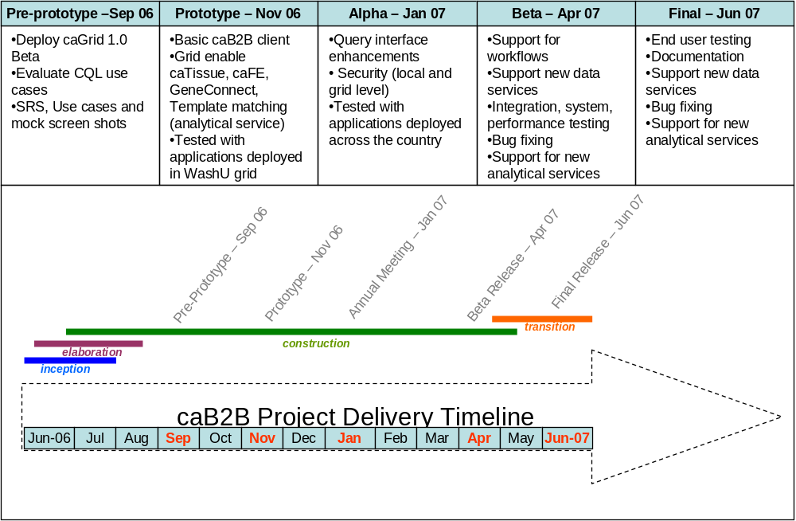

Phase 0: September 06 – Pre-prototype
The focus of this phase is to define the scope (requirements and use cases) and design the system along with doing some initial prototyping of important use cases to ensure that the grid components satisfy those use cases.
- Deploy caGrid 1.0 locally in Washington University and Persistent Systems
- Prepare CQL queries for all the important caB2B use cases and review them for support in caGrid 1.0
- Extend caTissue Core and caFE model and submit for UML loading to the caDSR team
- Document use cases, requirements and mock screenshots
- End user face-to-face meeting to discuss use case and requirements
- Finalize design and architecture

Phase 1: November 06 - Prototype
The focus of this phase is to build a workable infrastructure which includes grid enabling important data services and at least one analytical service, and building the caB2B client which can utilize these services. Importantly, the testing for this phase will be done on caGrid 1.0 deployed locally at Washington University.
Enabling applications on caGrid 1.0
- caTissue data service with extended model to link to caArray
- caFE data service with extended model to link to caArray
- Template matching analytical service
caB2B Application
- Viewers to view results of template matching algorithm
- Basic query interface:
  - Ability to discover data services
  - Ability to query single service at a time
- Create, edit, delete experiment
- Local database caching
- Tested on a locally deployed caGrid 1.0 at Washington University

Phase 2: January 07 - Annual meeting
The focus of this phase is to extend the phase one deliverable to support complex queries like distributed queries and support for additional analytical services. In addition, this phase will be tested for services deployed anywhere on the grid (i.e. not just the services deployed at Washington University).
- Query interface enhancements
  - Ability to query any data service
  - Ability to execute the same query on multiple instances of the same application
- Add support for any new relevant analytical service and viewers for them
- Tested on caGrid 1.0 services installed on multiple sites nodes (geographically distributed caGrid)
- Security

Phase 3: April 07 – Feature complete, Beta release
- Workflow
  - User interface to create workflows
  - Use caGrid 1.0 workflow infrastructure
- Ability to perform distributed queries across applications
- Add support for any new relevant analytical service and viewers for them

Phase 4: June 07 – Final release
- Add support for any new relevant analytical service and viewers for them
- End user face to face meeting
- Integration testing
- Final release

Future Phase Functions
- Support for additional functional genomic and proteomic data sets as they are available on the caGrid
- Proteomics data repository, analytical services, and database searching services
- SNP/aCGH data repository and analytical services

System Requirements

Requirements Matrix
Below is a composite list of all requirements and the phase in which each requirement is intended to be implemented.

Number | Requirement Description | Phase
1 | UML modeling
1.1 | Extend caTissue Core UML model to include EAM | 1
1.2 | Extend caFunctionExpress UML model to connect to caArray | 1
1.3 | Prepare UML model for template matching analytical service | 1
2 | Enabling applications on caGrid v1.0
2.1 | caTissue IBPS | 1
2.2 | caFunctionExpress | 1
2.3 | Template matching analytical service | 1
3 | caB2B Client
3.1 | Create, edit, delete Experiment | 1
3.2 | Local database | 1
3.3 | Basic query interface (no distributed query) | 1
3.4 | Ability to discover services | 1
3.5 | Security | 1
3.6 | Distributed queries | 2
3.7 | User interface to define workflows | 3
3.8 | Ability to execute workflows | 3
3.9 | Viewers for other analytical service  (Will be developed in multiple phases based on order of analytical services being enabled on caGrid 1.0) | 1,2,3

Project Activities and Milestones
Item # | Description | Deliverable(s) | Deliverable format
 | MS Project Plan – Detailed project plan identifying the project milestones | Project plan | Microsoft Project Plan
 | Project Charter document describing the vision and scope of the project | Project Charter | Microsoft Word
 | Draft use cases and requirements document | Use cases and requirements | Microsoft Word
 | Final use cases and requirements document | Use cases and requirements | Microsoft Word
 | Draft design document | Design | Microsoft Word
 | Final design document | Design | Microsoft Word
 | Pre-Prototype release consisting of caTissue and caFE extensions and CQL prototype of caB2B use cases | UML model, CQL queries | EA file and text files
 | Prototype release | Refer to section “In Scope/Out of Scope Functions” | Code
 | Annual meeting release | Refer to section “In Scope/Out of Scope Functions” | Code
 | Beta release | Refer to section “In Scope/Out of Scope Functions” | Code
 | Final release | Refer to section “In Scope/Out of Scope Functions” | Code
 | End user guide | System integrated help file | Help file
 | Deployment guide |  | Microsoft Word/PDF

