caBench-to-Bedside v2.1
End User Manual

Document Change History
Version Number | Date | Contributor | Description
V1.0 | July 12, 2007 | Washington University/Persistent Systems | Reviewed
V2.0 | June 9, 2008 | Washington University/Persistent Systems | Reviewed
V2.1 | December 4, 2008 | Washington University/Persistent Systems | Reviewed
V2.1 | December 23, 2008 | Washington University/Persistent Systems | Reviewed by Documentation and Training workspace



This is a U.S. Government work. December 24, 2008

Development Teams
Development | End User Manual | Program Management
Chandrakant Talele¹ | Chandrakant Talele¹ | Dr. Rakesh Nagarajan²
Srinath Krishnamurthy¹ | Srinath Krishnamurthy¹ | Srikanth Adiga¹
Jasbir Sachdeva¹ | Srikanth Adiga¹
Chetan Patil¹ | Madhumita Shrikhande¹
Hrishikesh Rajpathak¹ | Madhurima Bhattacharjee¹
Lalit Chand¹ | Pooja Arora¹
Atul Jawale¹ | Mukesh Sharma²
Rajesh Vyas¹ | Jahangheer Shaik²
Gaurav Mehta¹
¹Persistent Systems Limited | ²Washington University

Contacts and Support
Training contact | cab2b@bmi.wustl.edu
Customer support contact | cab2b@bmi.wustl.edu

Copyright and License Information

Copyright Notice Copyright 2008 School of Medicine, Washington University in St. Louis (“caBIG® Participant”). ca Bench-to-Bedside was created with NCI funding and is part of the caBIG® initiative. The software subject to this notice and license includes both human readable source code form and machine readable, binary, object code form (the “caBIG® Software”).
This caBIG® Software License (the “License”) is between caBIG® Participant and You. “You (or “Your”) shall mean a person or an entity, and all other entities that control, are controlled by, or are under common control with the entity. “Control” for purposes of this definition means (i) the direct or indirect power to cause the direction or management of such entity, whether by contract or otherwise, or (ii) ownership of fifty percent (50%) or more of the outstanding shares, or (iii) beneficial ownership of such entity.
License Provided that You agree to the conditions described below, caBIG® Participant grants you a non-exclusive, worldwide, perpetual, fully-paid-up, no-charge, irrevocable, transferable and royalty-free right and license in its rights in the caBIG® Software, including any copyright or patent rights therein, to (i) use, install, disclose, access, operate, execute, reproduce, copy, modify, translate, market, publicly display, publicly perform, and prepare derivative works of the caBIG® Software in any manner and for any purpose, and to have or permit others to do so; (ii) make, have made, use, practice, sell, and offer for sale, import, and/or otherwise dispose of caBIG® Software (or portions thereof); (iii) distribute and have distributed to and by third parties the caBIG® Software and any modifications and derivative works thereof; and (iv) sublicense the foregoing rights set out in (i), (ii) and (iii) to third parties, including the right to license such rights to further third parties. For sake of clarity, and not by way of limitation, caBIG® Participant shall have no right of accounting or right of payment from You or Your sublicensees for the rights granted under this License. This License is granted at no charge to You. Your downloading, copying, modifying, displaying, distributing or use of caBIG® Software constitutes acceptance of all of the terms and conditions of this Agreement. If you do not agree to such terms and conditions, you have no right to download, copy, modify, display, distribute or use the caBIG® Software.
- Your redistributions of the source code for the caBIG® Software must retain the above copyright notice, this list of conditions and the disclaimer and limitation of liability of Article 6 below. Your redistributions in object code form must reproduce the above copyright notice, this list of conditions and the disclaimer of Article 6 in the documentation and/or other materials provided with the distribution, if any.
- Your end-user documentation included with the redistribution, if any, must include the following acknowledgment: “This product includes software developed by School of Medicine, Washington University in St. Louis.” If You do not include such end-user documentation, You shall include this acknowledgment in the caBIG® Software itself, wherever such third-party acknowledgments normally appear.
- You may not use the names “School of Medicine, Washington University in St. Louis”, “The National Cancer Institute”, “NCI”, “Cancer Bioinformatics Grid” or “caBIG®” to endorse or promote products derived from this caBIG® Software. This License does not authorize You to use any trademarks, service marks, trade names, logos or product names of either caBIG® Participant, NCI or caBIG®, except as required to comply with the terms of this License.
- For sake of clarity, and not by way of limitation, You may incorporate this caBIG® Software into Your proprietary programs and into any third party proprietary programs. However, if You incorporate the caBIG® Software into third party proprietary programs, You agree that You are solely responsible for obtaining any permission from such third parties required to incorporate the caBIG® Software into such third party proprietary programs and for informing Your sublicensees, including without limitation Your end-users, of their obligation to secure any required permissions from such third parties before incorporating the caBIG® Software into such third party proprietary software programs. In the event that You fail to obtain such permissions, You agree to indemnify caBIG® Participant for any claims against caBIG® Participant by such third parties, except to the extent prohibited by law, resulting from Your failure to obtain such permissions.
- For sake of clarity, and not by way of limitation, You may add Your own copyright statement to Your modifications and to the derivative works, and You may provide additional or different license terms and conditions in Your sublicenses of modifications of the caBIG® Software, or any derivative works of the caBIG® Software as a whole, provided Your use, reproduction, and distribution of the Work otherwise complies with the conditions stated in this License.
- THIS caBIG® SOFTWARE IS PROVIDED "AS IS" AND ANY EXPRESSED OR IMPLIED WARRANTIES (INCLUDING, BUT NOT LIMITED TO, THE IMPLIED WARRANTIES OF MERCHANTABILITY, NON-INFRINGEMENT AND FITNESS FOR A PARTICULAR PURPOSE) ARE DISCLAIMED. IN NO EVENT SHALL THE SCHOOL OF MEDICINE, WASHINGTON UNIVERSITY IN ST. LOUIS OR ITS AFFILIATES BE LIABLE FOR ANY DIRECT, INDIRECT, INCIDENTAL, SPECIAL, EXEMPLARY, OR CONSEQUENTIAL DAMAGES (INCLUDING, BUT NOT LIMITED TO, PROCUREMENT OF SUBSTITUTE GOODS OR SERVICES; LOSS OF USE, DATA, OR PROFITS; OR BUSINESS INTERRUPTION) HOWEVER CAUSED AND ON ANY THEORY OF LIABILITY, WHETHER IN CONTRACT, STRICT LIABILITY, OR TORT (INCLUDING NEGLIGENCE OR OTHERWISE) ARISING IN ANY WAY OUT OF THE USE OF THIS caBIG® SOFTWARE, EVEN IF ADVISED OF THE POSSIBILITY OF SUCH DAMAGE.

Contents
About This Guide 1
Purpose 1
Typical User 1
Topics Covered 1
Text Conventions Used 2
Chapter 1 Introduction 3
Conducting Research using caB2B 3
Getting started with caB2B 4
Understanding Categories and Limits 4
What is a Category? 4
Why do we need categories? 5
What is a Limit? 5
What is a Query? 5
Starting the Application 5
Links on Home Page 8
Popular Categories 9
Overriding admin defined service instances 10
Chapter 2 Searching Data 13
Search data – The Query Wizard 13
Choose Search Category 14
Advanced Search 15
Define Limit 16
Limit Set – Diagrammatic View 18
DAG Operations 19
Connecting the Limits 20
The Information Panel 23
Reset, Previous and Next Buttons 24
Define Search Results View 24
The Next, Previous, Save Query and Configure Service Instances Buttons 25
Configuring Service Instances while querying 26
DCQL Viewer 27
View Search Results 28
Record Details 29
The Next, Previous and Save Query Buttons 34
Group Results by Service URL 34
Save Query 36
Why to Save Query? 36
How to Save Query? 37
Executing a Saved Query 39
Viewing and Saving Data List 41
Operations on the Data List 43
Chapter 3 Experiments 45
What are Experiments and Projects? 45
Creating an Experiment 46
Viewing the Existing Experiments 47
Opening an Experiment 48
Working with an Experiment 49
The Operations panel 49
Visualization panel 50
Filtering Data 50
Custom Data Category 53
Analyzing Data 55
Visualizing Data 58
Appendix A Examples of category search 62
Text-based Search - For category name information 62
Text-based Search - For category and attribute name and description 63
Concept Code Based Search - For category name information 64
Concept code based search - For attribute name information 65
Appendix B Define Limit: Operators and Values 67
Appendix C Record Details View 69
Administrator defined categories 69
Appendix D Types of Filters 71
Using the Range Filter 71
Using the Pattern Filter 72
Using the Enumerated Values Filter 72
Index 73

About This Guide
This section introduces you to caBench-to-Bedside 2.1. Topics in this section include
- Purpose
- Typical User
- A typical user of the caB2B application would be a translational research scientist. The term translational research means research which typically begins at “the bench” with basic research — in which scientists study disease at a molecular or cellular level — then progress to the clinical level, or the patient's “bedside.” As this application supports the research at the bench as well as at the bedside, scientists would be the typical users.
- Text Conventions Used

Purpose
This manual provides the details of how to use cancer Bench-to-Bedside (caB2B) application to search data sets of interest, create an experiment from data sets, analyze data, and visualize data.
All the chapters in this user’s manual begin with an introductory statement and are followed by a list of topics included in that chapter.

Typical User
A typical user of the caB2B application would be a translational research scientist. The term translational research means research which typically begins at “the bench” with basic research — in which scientists study disease at a molecular or cellular level — then progress to the clinical level, or the patient's “bedside.” As this application supports the research at the bench as well as at the bedside, scientists would be the typical users.

Topics Covered
- Chapter 1: Introduction explains the scope and function of caB2B
- Chapter 2: Searching Data describes process of retrieving data by building metadata based queries
- Chapter 3: Experiments explains how to create and use virtual experiments using the searched data
- Appendix A: Examples of category search
- Appendix B: Define Limit: Operators and Values
- Appendix C: Record Details View
- Appendix D: Types of Filters

Text Conventions Used
This section lists the conventions that are used in this guide. The various typefaces represent interface components, keyboard shortcuts, toolbar buttons, dialog box options, and text that you type.
Convention | Description | Example
Bold | Highlights names of option buttons, check boxes, drop-down menus, menu commands, command buttons, or icons. | Click Search.
Underlined Blue Text | Indicates a Web or e-mail address. | http://domain.com
text in Small Caps | Indicates a keyboard shortcut. | Press Enter.
text in Small Caps + text in Small Caps | Indicates keys that are pressed simultaneously. | Press Shift + Ctrl.
Italics | Highlights references to other documents, sections, figures, and tables. | See Figure 4.5.
Italic boldface monospace type | Represents text that you type. | In the New Subset text box, enter Proprietary Proteins.
Note: | Highlights information of particular importance. | Note: This concept is used throughout this document.
{ } | Surrounds replaceable items. | Replace {last name, first name} with the Principal Investigator’s name.

Introduction
This chapter explains the scope and function of the cancer Bench to Bedside (caB2B) application. It helps you understand how to use caB2B to satisfy diverse biomedical research needs.
This chapter contains the following topics:
- Conducting Research using caB2B
- Getting started with caB2B
- Understanding Categories and Limits
- Starting the Application

Conducting Research using caB2B
The National Cancer Institute cancer Biomedical Informatics Grid® (NCI caBIG®) project creates a common, extensible informatics platform that integrates diverse data types and supports interoperable analytic tools. caBIG® is developing separate applications that will facilitate individual steps involved in micro-array analysis. These applications are also useful to bioinformaticians.
caGrid is the infrastructure for caBIG that helps integrate these applications. caGrid can be used to perform investigation involving data integration and analytical services from diverse research communities.
caBench-to-Bedside (caB2B) is an application that leverages these tools in a user-friendly graphical user interface (GUI). caB2B can be used by the physician scientist to perform operations such as:
- Query any caGrid data service to obtain data
The data service can be a single data service, multiple data services, or a combination of the two services using semantically interoperable Common Data Elements (CDEs).
For example, caB2B allows investigators to query tissue banks at multiple cancer centers, design studies that focus on very specific tumor subtypes and to target less common tumors by pooling bio-specimen resources. This alleviates the problem of small sample size in a study.
- Collect data and create experiments
caB2B also enables investigators to perform novel in silico experiments using microarray data that have been archived. These capabilities facilitate identifying genes that are up or down regulated in specific cancers with respect to normals and enable investigators to view the data in the context of biological pathways. Investigators gain further understanding of the complex system of cancer biology by identifying genes that are important to the development and treatment of cancer. These capabilities may lead to effective identification of novel drug targets and improved treatment strategies.
- Perform analyses by using various grid-enabled analytical services.
caB2B enables individual users to work on common platforms to access caGrid resources in real time from common data and analytical services.
- Visualize analysis results by using charts and dendrograms.

Getting started with caB2B
caB2B provides a platform to bring the laboratory research to the clinical level. caB2B enables information to be shared along with the continuum from the scientific bench to the clinical bedside and back. The tool helps in querying various caGrid enabled services. For example, it is possible to query for all the up-regulated and down-regulated genes of a malignant tissue sample by using the services available in caB2B. Thus, caB2B helps bridge the gap between the bench and the bedside.caB2B consist of a caB2B client and a caB2B administrative(admin) module, the admin module can be used to configure caB2B client where the administrator can load models from caDSR, configure service URL’s create customized categories, create intermodel joins and curate the paths.
- To configure caB2B refer to admin module user guide.
- To start caB2B admin module, refer to caB2B admin installation guide.
- To start caB2B client, refer to the caB2B Installation Guide.
- To search for data sets, refer to “Search data – The Query Wizard”.
- To design experiments, refer to “Experiments”.

Understanding Categories and Limits

What is a Category?
A category is a collection of searchable attributes. You can use a category to search, view, and add data to experiments. Every domain object in an application is, trivially, a category. For example, Participant is a domain object from caTissue Core application.
Examples:
The Participant category consists of the following attributes:
- Identifier
- First Name
- Last Name
- Gender
- Race
The Gene Annotation category consists of the following attributes:
- Entrez Gene ID
- Gene Symbol
- Gene Name
- GenBank Accession Number
- Taxonomy ID
- Chromosome

Why do we need categories?
Categories are designed to help you to easily locate all the data elements needed for your search.
 | Categories are created by the administrator.  Your administrator can create new categories based on your requirements. If there are queries that you perform regularly, discuss them with your administrator.

What is a Limit?
A limit is a condition (or criterion or predicate or condition) on a category. It is the smallest unit of a query. For example, female participants

What is a Query?
The collection of limits is a query. For example, female participants who have DNA specimens collected from their breast. This query has two limits: female participants, DNA specimens from breast. There are two categories involved in this query: Participant and Specimen.
Your administrator can create a new category that contains relevant data elements from Specimens and Participants. This enables entering all the limits in a single category.

Starting the Application
For details on installing and starting the caB2B client, refer to the Client Installation chapter of the Installation Manual.
When caB2B application is launched, you see the caB2B Login page as shown in Figure 1.1.
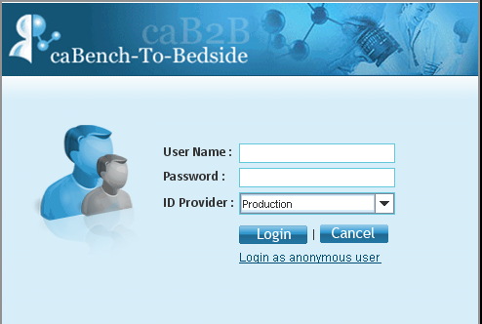
Figure 1.1 caB2B Login Page
To access the caB2B client, the user must either be a valid caGrid user or can be an anonymous user. Currently, all the training grid users and the production grid users having a Dorian Identity Provider are supported. To access the caB2B application, the following steps must be followed:
- Type the User Name and Password.
- Select an ID Provider from the dropdown.
- Click Login to start the application.
If the user provided credentials are authentic, access is granted to the application else access to the application is denied and an error message is displayed as shown in Figure 1.2.
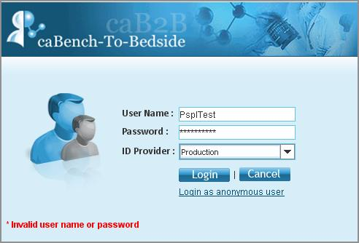
Figure 1.2 Login Error
The error details can be seen in the error log file present in the {user.home}, which on a windows machine means C:\Documents and Settings\User_name.

The user can also log in as an anonymous user; in this case the user won’t be asked for any of the credentials and would be logged into the application. While using anonymous user login the user can access only the public data not the secured data which essentially requires caGrid credentials. It means that the user would not be able to see data from any of the secured service like caTissue.

The anonymous user’s data would not be secured. It can be accessed by any user who logs in using the anonymous users link.

When the user is authenticated and the caB2B application is launched, you see the caB2B Home page as shown in Figure 1.3.
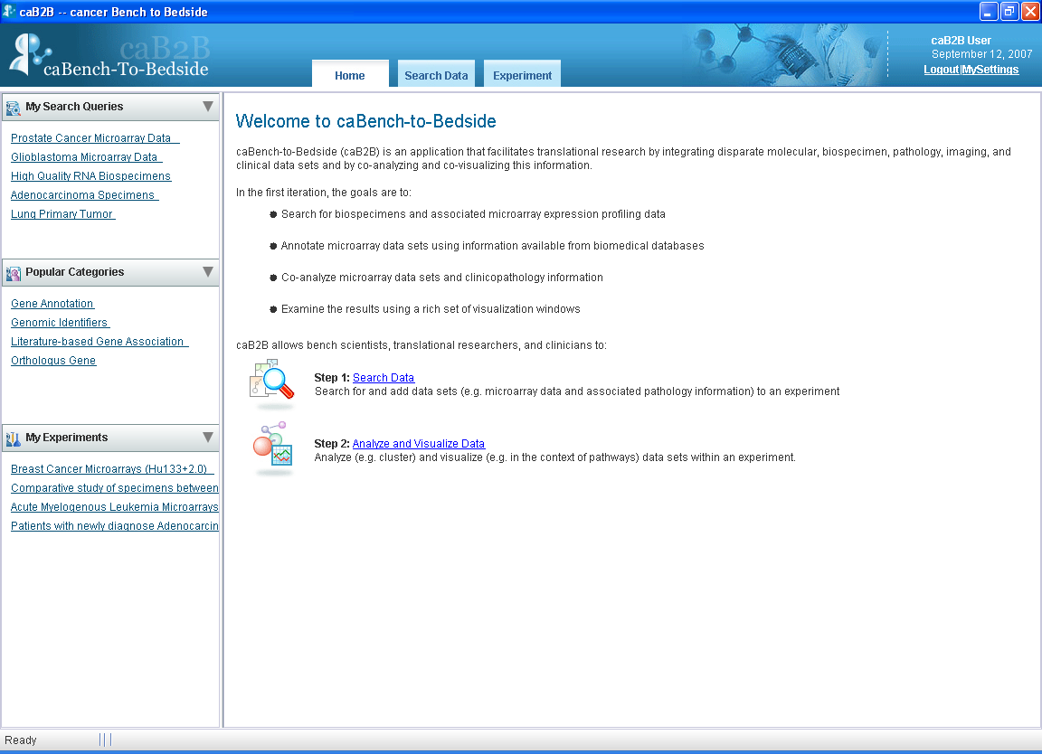
Figure 1.3 caB2B Homepage

Links on Home Page
caB2B client’s Home Page provides a quick access to various features available in caB2B. It contains a link to the following features:
- My Search Queries – User gets a quick access to all of the user’s saved queries. The queries can be executed and modified from the homepage link itself and only the user who has saved the query can access them. The queries saved by the other users are not visible.
- Popular Categories – This panel shows the five most popular categories. Popular categories are the classes that have been queried maximum number of times by the users.
- My Experiments – This panel shows the five most recently created experiments by the user and not the experiments created by other users. User can click on these links to quickly navigate to the users experiments.
- Search Data – This link opens the query wizard which can be used for executing queries and creating experiments.
- Analyze and Visualize data – This link helps the user to analyze and visualize the data.
- My Settings – This link provides the user with an option to override the admin defined service instance settings. Every user can customize the application to suit his needs. User can change the admin defined service instances to define the service instances that the user wants to query.
- Logout – This link helps the user to log out of caB2B.

As mentioned in the Conducting Research using caB2B section, a caB2B end user typically performs the following steps:
- Execute queries to obtain the dataset(s) of interest. Details of this step are provided in the “Searching Data” chapter.
- Analyze and visualize the data. Details of this step are provided in the “Experiments” chapter.

Popular Categories
Popular categories are the categories/classes that are queried the maximum number of times by a user. Popular categories are useful for the users to know which classes are being used by other users. A user can also directly navigate to the query page without searching for the class.
The popularity for a class is increased when a user queries that particular class. When user queries admin defined category then the popularity of the classes composing that category is also increased along with the category. For example, if a user queries for a class gene then its popularity would increase by one. Similarly, if there is an admin defined category genomic identifiers consisting of gene, messengerRNA and protein then the popularity of the category genomic identifier and individual classes would be increased by count of one.

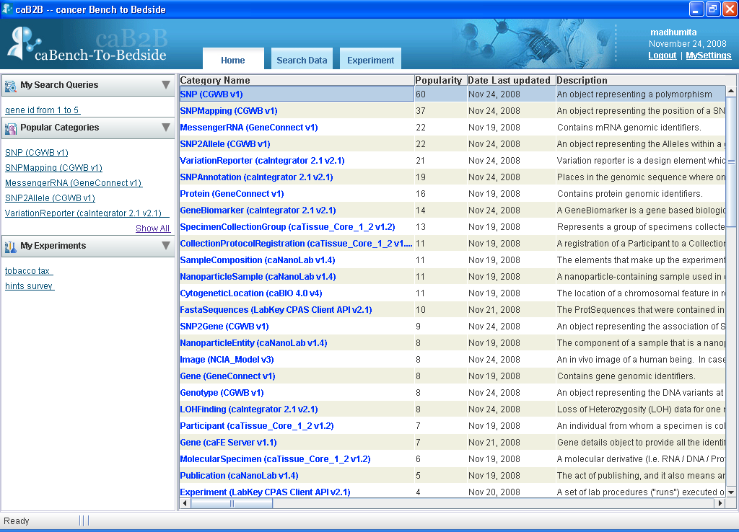

Figure 1.4 Popular categories

Overriding admin defined service instances
Service instances for a model that are queried through the client are initially configured by Administrator. The user might not be interested in querying all the instances for a particular model. He might be interested in only a few of the instances. This way a user can remove the instances that the admin has already configured and customize the client to suit his own needs. Overriding admin defined instances mean that the user can change the instances defined by the admin to define services of his interest. User gets an option here to add or remove the service instances defined by the administrator.

Steps for overriding a service URL:
- Click on My Settings link on the Home Page of caB2B

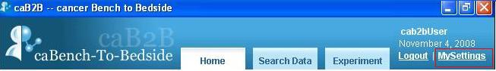 My settings link
Figure 1.5. My Settings

- The My Settings window displays the various models that have been loaded into the application.
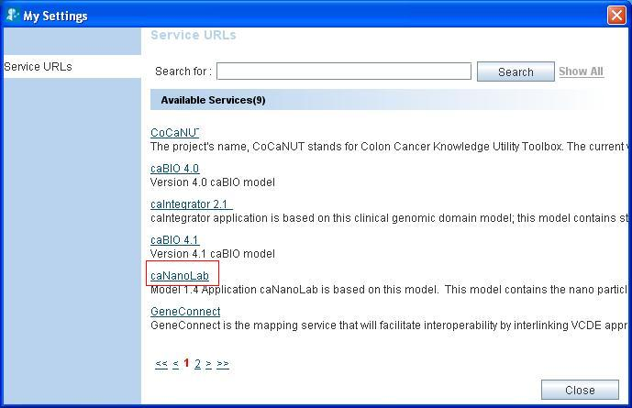
Figure 1.6. My Settings Page
- Click on a particular model name to display the list of services, example caNanoLab (refer to Figure 1.6).
- Select/Deselect the instances to override the admin defined instances.
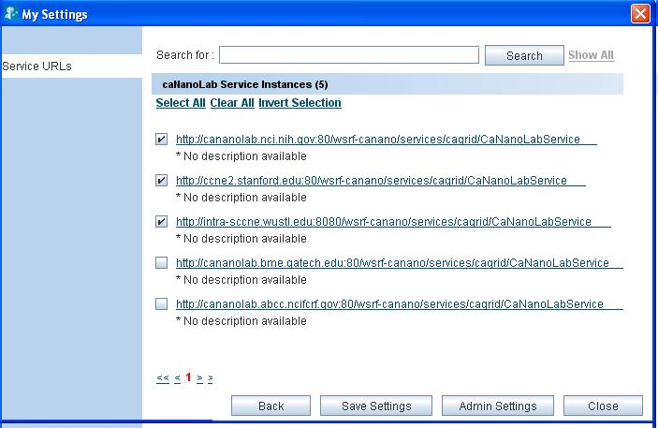
Figure 1.7. Service instances for the selected model
- Click Save settings(refer to figure 1.7)
- To restore admin defined instances click Admin Settings.

Services can also be configured from the search wizard. A user might want to retrieve data from a specific instance for a particular query, but not want to apply these settings for all the queries. In such a case configuring the service instances during the query would be helpful (steps defined in the section).

Searching Data
This chapter describes how caB2B can be used to fetch data from available caGrid data services like caArray, GeneConnect, caFE, caTissue etc.
The chapter is broadly divided into the following subtopics:
- Search data – The Query Wizard
- Choose Search Category
- Define Limit(s)
- Define Search Results View
- View Search Results
- Save Query
- Viewing and Saving Data List

Search data – The Query Wizard
This section details the steps required to obtain data. Click the Search Data tab on the Home page to display the Search data for Experiment wizard. The wizard begins at the Choose Search Category tab. (See Figure 2.8. Begin search for data ).
The wizard guides you through the following steps
Step one | Step two | Step three | Step four | Step five
Choose Search Category | Add Limits | Choose an Output Category  (Save Query) | View Search Results  (Save Query) | View Data List

To search data:
- Choose Search Category: Search for Category to apply limits.
- Add Limits: Add limits on the selected Category
- Choose Output Category (Optional): Select the output format (that is, define the results view). User can also save the query in this step
- View Search Results: View the results view in a Google-like search results page and add data to the data list (or shopping cart). User can also save the query in this step
- View Data List: View the data that you have added in the data list and create an Experiment.

Choose Search Category
This step helps you to search for the category on which you want to define the limits. For example, if you have a query with limits on participants, you can use this feature to first find the Participant category.
To find the categories, do the following:
- Type the search string in the text box (near the top of the screen). Gene, gender, participant, RNA, experiment are examples of search strings.
- Click Search or press Enter.
- Categories that match the entered string are displayed as hyperlinks along with a short description.
- Once a Category of your choice is found, click the desired search result to proceed to the next step.
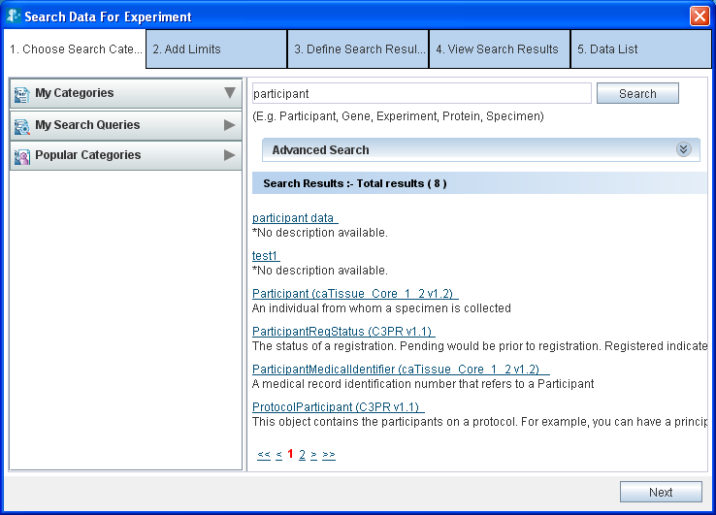
Figure 2.8. Begin search for data
More on searching:
- The search performed is partial and is not case-sensitive. Hence, the search for terms such as participant, PART or PARTICIPANT returns the same results.
- If a category description is long, you can view the complete description as a tool-tip by positioning the mouse over that description.
- If the number of matching categories is large, the system displays the results in multiple pages. Click the page numbers at the bottom to navigate through different pages.
- You can separate the multiple search terms by spaces or tabs. The system searches for each term individually and displays a collective set of matching categories. For example, if you enter the search string Participant Gene, the categories that match either Participant, Gene, or both will be found.

Advanced Search
Expanding the Advanced Search box displays the advanced options that help you refine the category search. The Figure 2.9 depicts the default selection of the various options
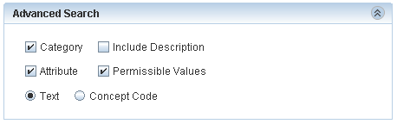
Figure 2.9. Advanced Search
If the system returns too many results for a Category search, you may use the Advanced Search to narrow your search.

Table 2.1 Advanced Search Options (Checkboxes and radio buttons)
Option | Description
Check Boxes
Category | Includes the category names in the search.
Attribute | Attribute (also known as data element) is the lowest unit of the searchable items. A category contains many attributes.  Select this check box to include the individual attribute names in the search.  For example: Select attribute and search for gender. You will find the category Participant since it contains an attribute by name Gender.
Permissible value | Some attributes contain a fixed set of values. For example, Gender can be Male, Female or Unspecified. Organ can be heart, lung, breast, and so on.  This fixed set is known as Permissible Values.  Select this check-box to include the permissible values in the search. For example, if you select the permissible value as Male the system displays the Participant category since it contains an attribute Gender which contains a permissible value Male gender.
Include Description | Includes the description text in the search.  Note: Include Description check-box is enabled only for a text based search when you select the Category check box, the Attribute check box, or both.
Option Buttons
Text | The system matches the search string that you type with the name of the category, its attributes, or the permissible values based on the text.  This is simple, most commonly used and the default way of searching for a category.
Concept Code | The system treats the search string as an Enterprise Vocabulary Services (EVS) concept code and matches it with the concept code of the category, its attributes, or the permissible values thereby showing the matching categories.  More details on the concept code can be found at http://nciterms.nci.nih.gov/NCIBrowser/Dictionary.do by connecting to NCI_Thesaurus and http://ncimeta.nci.nih.gov/MetaServlet/

Additional refinements that may be made with these options are illustrated in the Appendix A: Examples of category search

Define Limit
A limit is a condition (or criterion or predicate) on a category and multiple limits together form a query. Table 2.2 outlines two example queries and the limits added to them.
Table 2.2
Example | Category | Limit
Get the details about all the African male participants | Participant | Gender equals Male  Race equals African
Biospecimens from prostate adenocarcinoma | Specimen Characteristics | Tissue Site equals prostate
Biospecimens from prostate adenocarcinoma | Specimen Collection Group | Clinical diagnosis equals adenocarcinoma

Screen for define limit is shown below. It has 3 parts,
- Category search is present on the left hand part. It is explained in section choose search category
- Define Limit present at right hand side top is explained in section Steps for defining a limit
- Limit set present at right hand-side bottom is explained in section Limit Set – Diagrammatic View
.
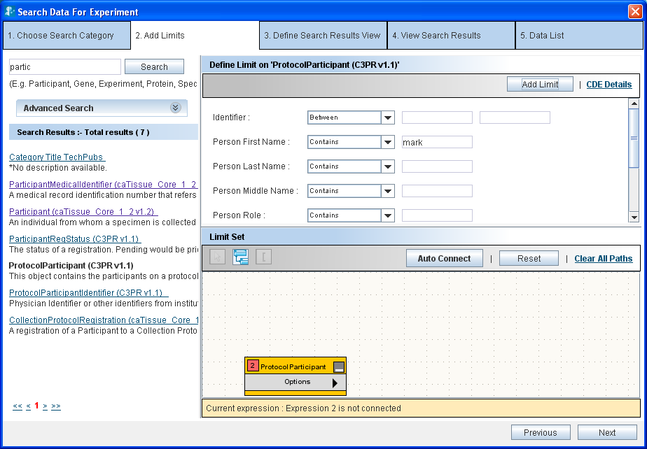
Figure 2.10. Define Limit

Steps for defining a limit
Perform the following steps to define a limit:
- Choose an operator from the list of operators adjacent to the attribute you wish to constrain.
- Specify the constraining values.
For detailed explanation of various operators and how to specify values, refer to Appendix 2: Define Limit: Operators and Values.

Example:
Single constraint – Show all male participants
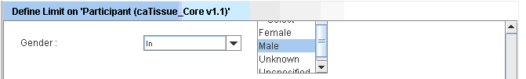
Figure 2.11. Male participants
Example:
Multiple constraints within one limit: male participants who are alive. Multiple conditions can be defined on an attribute by pressing Ctrl key while selecting different options: Specimens which are either Serum or Plasma.

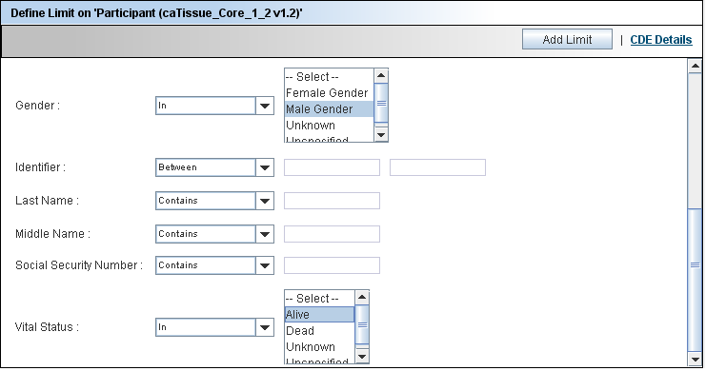
Figure 2.12. Male participants who are alive
WARNING! | Ensure that you click Add Limit at the top of the Define Limits screen before proceeding. In case you do not click Add Limit, the constraints that you have specified are not saved.

Limit Set – Diagrammatic View
Once the limits have been set on the category, clicking on the Add Limit button adds the category in the form of a yellow rectangle (also called a node) into the Limit Set Panel. The Limit Set panel consists of the DiAGrammatic view (DAG view) panel. DAG view is like a canvas where all the categories on which limits have been added appear in the form of nodes (Figure 1.3). Whenever a new limit is added, the system adds a yellow rectangle that represents the limit being added to the DAG view. As you continue to add limits, the system adds corresponding rectangles to the DAG view.
These rectangles in the DAG view provide a graphical view of all the limits that have been added.
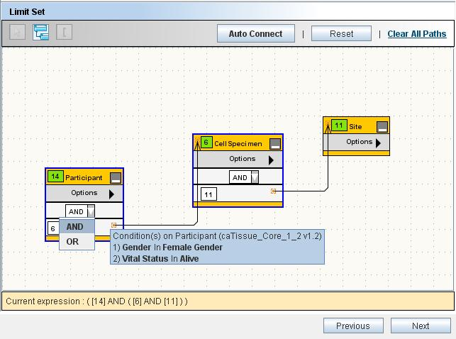
Figure 2.13. Limit Set Panel

DAG Operations
You can perform the following operations within the DAG view.
Table 2.3
View details of the limit | Position your mouse over a node to view the details of that limit.  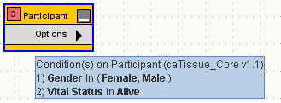
Edit the limit | Click Edit Limits from the Options menu of the node whose limits you wish to edit. Alternatively, double click the title of the node.  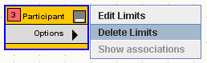  This opens the limit in the Define Limit panel in edit mode. Edit the constraints in the Define Limit panel, and click Edit Limit.
Delete the limit | Select the nodes that you wish to delete and press Delete.  Alternatively, you can delete a single node by selecting Delete Limits from the Options menu of the node as shown above.

Connecting the Limits
You must connect all the limits before proceeding to the next step.
When multiple limits are specified, you need to connect these limits to form an expression. Two limits may be connected by using either the AND or the OR operator. Following is an example of how the DAG looks when the limits are connected.

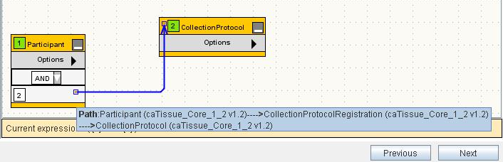
Figure 2.14 Connected Nodes
If there are only two limits in the query, you have to connect only those two rectangles
To connect the limits, you need to specify the following:
- The path to be taken in connecting the nodes
- The logical operator (AND, OR) in the dropdown box in a node
The rest of this section focuses on various ways in which you can specify the path(s)

What is a Path?
A path tells the system how two categories are to be connected. A path is a way to travel from one category to another. There could be multiple ways to connect two categories and the results of the query differ based on the path chosen.
For example, consider the two categories Specimen and Site (from the caTissue Core application). A Specimen is associated with the Site category in two ways: 1) Site where the specimen was collected 2) Site where the specimen is stored.
That means there are two paths between Specimen and Site: 1) Through Specimen Collection Group for the collection site.2) Through Storage Container
Query example 1: Show all the available specimens collected in Barnes Jewish Hospital. In this query, as you are specifically interested in a particular collection site, you should choose the path through Specimen Collection Group.
Query example 2: Show all the available specimens stored in Barnes Jewish Hospital. In this query, as you are specifically interested in a particular storage site, you must choose the path through Storage Container.
Therefore it is important to choose the right path for your query.

Connecting Limits
Click Auto Connect. The system automatically connects to all the boxes based on the settings provided by your administrator.
However, the administrator might not have configured the path between all the categories. In such cases, you can manually connect the limits as described below.
Example query: For all the male participants, show all the available specimens collected in Barnes Jewish Hospital.
- After adding three limits on the Participant, Specimen and Site the DAG view looks as shown in the figure below:
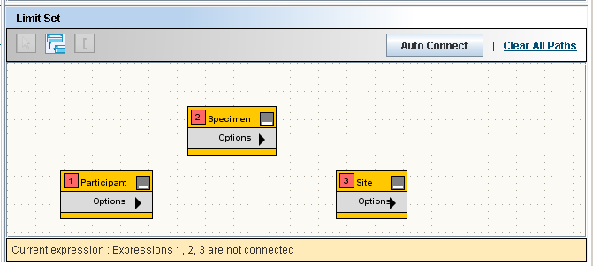
Figure 2.15. Limit Set
- Click the Participant and the Specimen rectangles to select them.
- Click Connect Limits to connect the two nodes. The resulting DAG view is shown in Figure.2.9.
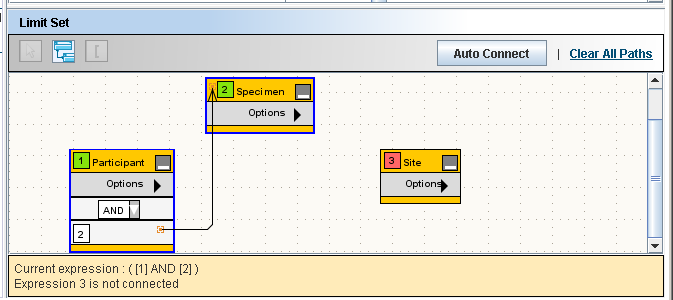
Figure 2.16. Limit Set with Two Connected Limits
Note: There is only one path between Participant and Specimen, therefore the system automatically connects it. Default operator is AND, it can be changed to OR using operator dropdown.
- Select the Specimen and Site rectangles and click Connect Limits.
- Since there are more than one path between Specimen and Site, the system cannot connect the limits on its own. So it displays the Ambiguity Resolver window. The Ambiguity Resolver window is shown in Figure 2.17. Path Ambiguity Resolver
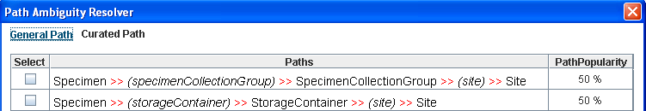
Figure 2.17. Path Ambiguity Resolver
- Select the first path to find out the collection site.
- Once the path(s) is determined, the system creates a connection between the two nodes (see figure below). You can position the mouse over the connection to view the path(s) that you chose.
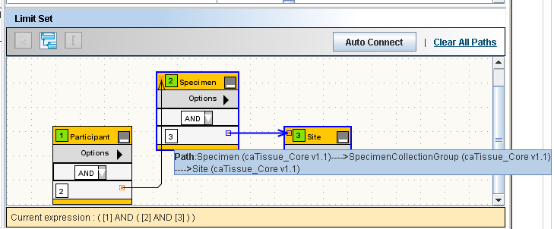
Figure 2.18. Limit Set with Three Connected Limits
- Specify the operator (AND or OR) using the dropdown box in the node. For above query the operator will be AND
- Click Next.

Deleting a Connection
You can delete a connection by clicking the connection arrow between the two nodes and pressing the Delete key.

The Information Panel
The Information panel is located at the bottom of the Limit Set panel.
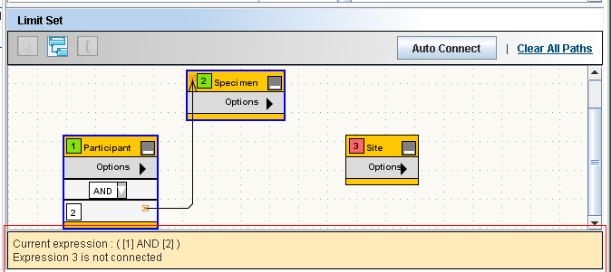
Figure 2.19. The Information Panel
The Information panel provides the following information:
- The expression formed as a result of how the limits are connected.
- Limits that not yet connected to any other limit
- To execute the query, there should not be any unconnected rectangles.

Reset, Previous and Next Buttons
These buttons are located on the right hand bottom of the screen, see Figure 2.13. Limit Set Panel.
- The Reset button clears all the specified limits.
- The Previous button takes you to Choose Search Category step of the wizard.
- The Next button takes you to the Choose Output Category step of the wizard. A valid query allows you to proceed to the next step. If the query is invalid, an appropriate error message is displayed.

Define Search Results View
After specifying the limits, user proceeds to choose the category for the data. For example, “show all the participants who had biospecimens collected from their breast”. Participant is the category that you want to view, based on a limit on the specimens.
The Define Search Results View tab allows you to select the category to be shown in the output of the query. It is also called as output category for the query.
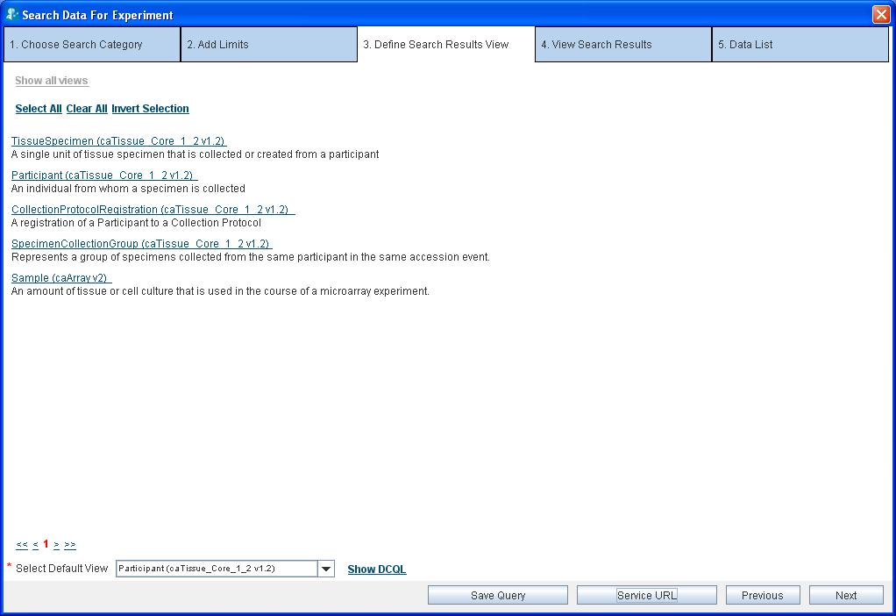
Choose the Default view here
Figure 2.20. Define Search Result View.
All the categories with specified limits are shown in the Select Default View dropdown box at the bottom of the screen as shown in Figure 2.20. From the Select Default View dropdown box, select the category whose data you wish to obtain.

Ignore the other contents of this screen such as the check boxes and hyperlinked categories. Those are intended to allow you to fetch data for multiple related categories in one go. However, this feature is not supported in this release of caB2B.

The Next, Previous, Save Query and Configure Service Instances Buttons
- To edit the limits, click Previous and go to the Define Limit step
- Click Next to execute the query that you have created
- Click Save Query (refer to Error: Reference source not found) to save the query.
- Click Configure Service Instances to define the service instances to be queried.

WARNING! | On clicking the Next button, the system executes the query and fetches the data from appropriate data services over the caGrid.  This step could be time-consuming. It may take few minutes to couple of hours based on the network speed and complexity of the query.

Configuring Service Instances while querying
A query fetches data from all the service instances that have been configured by the user under my settings. There might be a case when the user wants information from just one of the instances for a particular query. For some other query user might need some different instance. In such a case, it would be helpful if the user is provided an option to choose the instance from which the data must be fetched during the process of querying.

Depending on the query the number of service instances to be configured differs. To select the instances for a query with two models follow the steps given below:

If the query includes classes from two or more models then the steps to be followed are:
- Click service URL button on the query page.

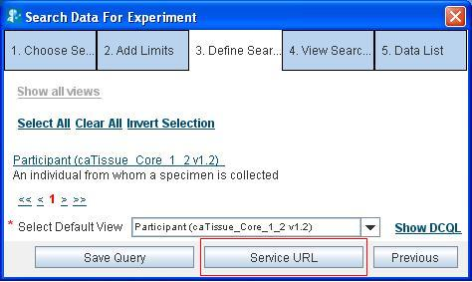
Figure 2.21 Service URL button on the query page.

- Click the model name for which instance is to be configured.
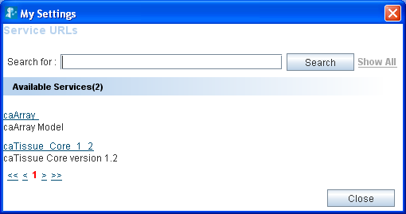
Figure 2.22 showing all the models available in the query
- Check the services to be configured.

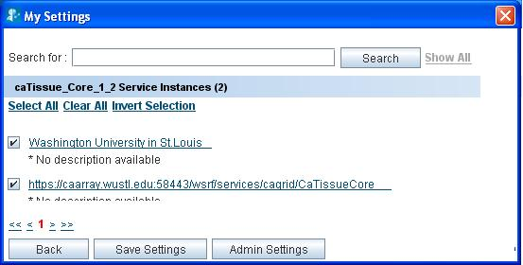
Figure 2.23Service URL selection

- Click Save (refer to Figure 2.23)

If there is just a single model, then user just have to define the service instances for one model.

DCQL Viewer
DCQL is the query language used by caGrid Data Services to express queries against a data source using an object oriented language. It is the query language used by the grid to retrieve data from various data services. It is defined in the form of XML schemas. A user who is new to caGrid can view the DCQL and learn from the DCQL to use the query language.
To view the DCQL on the Define Search Results view tab click on the Show DCQL link. The pop-up window shows the DCQL executed for the query.
The DCQL query can also be exported by clicking on the Export on DCQL pop up window.

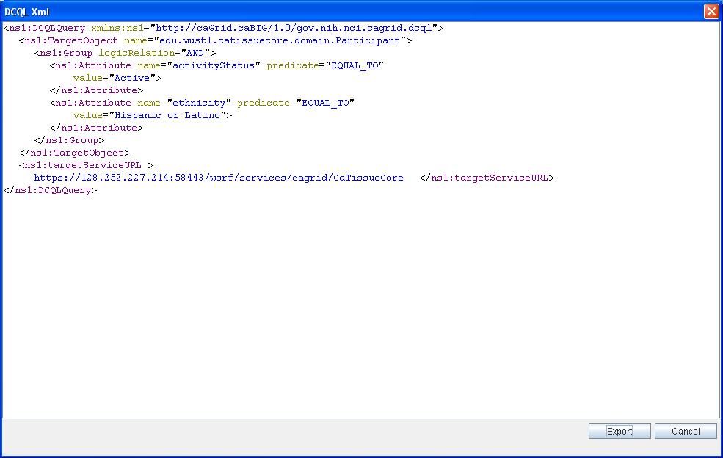
Figure 2.24 DCQL query

View Search Results
The View Search Results tab displays the results obtained by executing the query defined in the previous steps. The concept of viewing results in caB2B is similar to viewing results after a Google search. The following are the similarities:
- caB2B returns a set of records that match your limits.
- Some details of the record are displayed along with the record.
- Click on one of the records to view more details.
- Records provide additional information, for example, from Participants you can see the Collection Protocol in which they registered. This is similar to Google where, after you click one of the hyperlinks, you can traverse into other web pages by clicking the hyperlinks within that page.
- As in Google, the results are divided into multiple pages for easy navigation.
If you find any data of interest, you can add it to the Data List.
The following image displays a typical results view. The View Search Results tab displays the records that match the limits and also the data that you have already added to the data list.
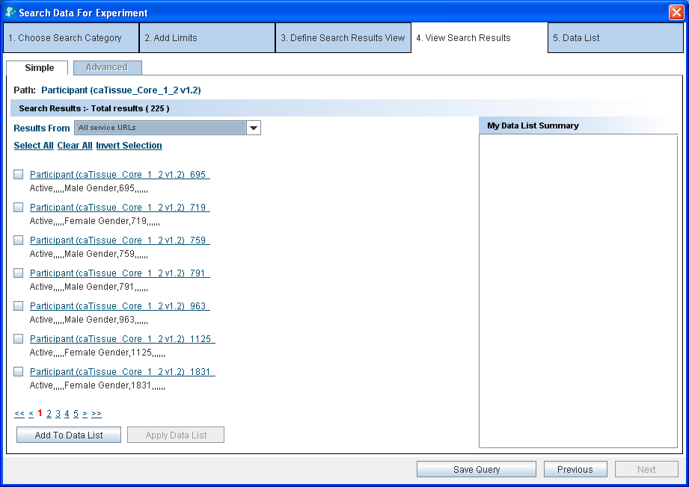
Figure 2.25. View Search Results

Record Details
Click on the hyperlink of a record on the View Search Results to take you to the Record Details page. Here you can view the values of all the attributes of the category.
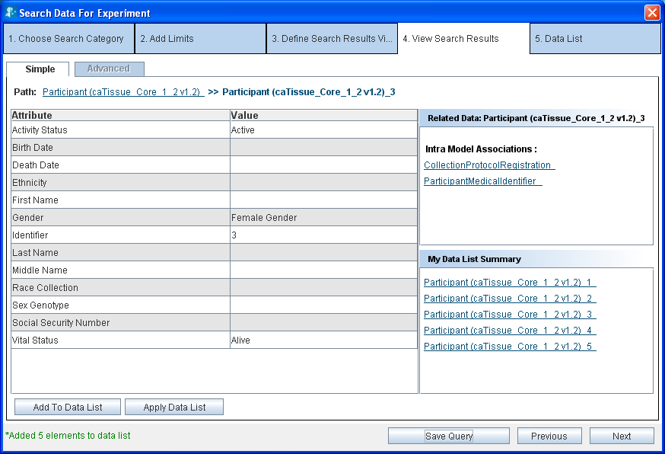
Figure 2.26. Results’ Details
A view of the Results Details page is shown in Figure 2. 14 and shows the following sections:
- Value of all the data elements in the record
- Links to related data
- Summary of the records that you have already added to the data list

Related Data
As shown in Figure 2.14 above, the Related Data box on the right displays the categories that are related to the current category. Click on any of the categories to display records for that category. For example, if you are currently viewing records of Participant (caTissue), the following categories are shown in the related data box:
- Collection Protocol Registration (caTissue)
- Participant Medical Identifier(caTissue)
If you now click Collection Protocol Registration, you would see the Collection Protocol Registrations related to the Participant you are currently viewing.

Breadcrumbs
Breadcrumbs or a breadcrumb trail is a navigation technique used in user interfaces. Its purpose is to give users a way to keep track of their location within programs or documents. (definition from Wikipedia entry)
As you traverse the results view, breadcrumbs are displayed at the top of the page. For example, if you are viewing a molecular specimen record related to a participant, you would see the path as
Participant >> participant_1125 >> collection protocol registration >> specimen collection group >> molecular specimen
This means that you originally queried for participant. Then you fetched related molecular specimen for participant_1125 via collection protocol registration and specimen collection group.
Click any of the links in the breadcrumbs to navigate back to the corresponding page. For example, you can click participant in the above path to go back to the page where you were shown the list of participants.

Adding data to the Data List
A data list is like a shopping cart which enables you to add interesting data to the shopping cart as you traverse through the results. You can add data to the data list in two ways:
- Click Add to Data List
- Click Apply Data List
As you add the data to the data list, they are reflected in the My Data List Summary box on the right hand side.

Add to Data List
Select the record that you want to add to the data list and click Add to Data List. You can either add one record at a time or add multiple records by selecting the checkboxes placed along with the record summary.

Using Apply Data List
Once you obtain the related data for a particular record, Apply Data List allows you to fetch similar related data for several other records easily. We outline an example of this approach below.
A typical user query might do the following:
- Fetch the data for the Participant category.
- Fetch related data from the category molecular specimen for a record of participant, for example, participant_1125.
- Add the molecular specimen record to the data list.
The resulting data list is shown in Figure 2.15 (below).
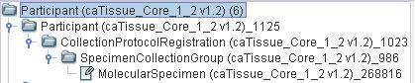
Figure 2.27. Data List
If you wish to obtain the specimen data for other participant records, you have to fetch related specimen for one participant record at a time. The Apply Data List functionality allows you to fetch the specimen for several participant records in a single operation. To do this, perform the following steps:
- Fetch the data for the Participant category.
- Fetch the related data from the category Specimen for a record of Participant, for example, Participant_1125
- Add the Specimen record to the data list.
- From the View Results screen for the Participant records, (see Figure 2.25. View Search Results) select Participant records for which you want the related Specimen records.
- Click Apply Data List, it will fetch Specimen for all selected Participant records.
- A message is displayed in the status bar when the operation is complete. Click Next to see the data list. . Figure. 2.16 show the resulting data list.
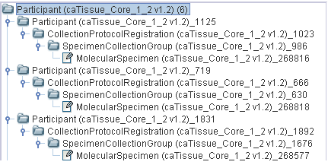
Figure 2.28. Result of Apply Data List to participants with id 1125,719,1831

How Apply Data List functionality works
To understand this functionality better, consider a slightly more complicated data list below:
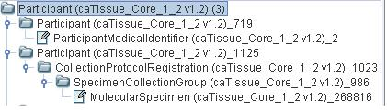
Figure 2.29. Example 3- Data List
Example 3:
The following records have been added to the data list
- For participant_1125, related collection protocol registration,specimen collection goup,molecular specimen and tissue specimen records are present.
- For participant_719, related participantMedicalIdentifier is present.
- For participant_1831, there is no other related data.
Now, Apply Data List to the participants with id 1125,719,1831
. The resulting data list is shown in Figure 2.30.
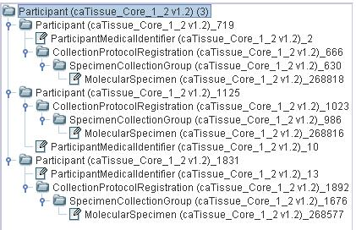
Figure 2.30. Example 3- Apply Data List

As seen in Figure 2.30, the following related new data has been fetched:
- For participant _719, the system fetches collection protocol registration,
- specimen collection group and molecular specimen (as participant_1125 had collection protocol registration, specimen collection group and molecular specimen).
- For participant_1125, the system fetches participant medical identifier, as this were the related data for participant_719.
- For participant_1831, the system fetches all of participant medical identifier, collection protocol registration, specimen collection group and molecular specimen. As a result, each participant contains the related data for of participant medical identifier, collection protocol registration, specimen collection group and molecular specimen.
Thus, the Apply Data List operation results in a homogenous structure in the data list. The system fetches related data for all the other records such as the related data present for one record.

The Next, Previous and Save Query Buttons
- Click Next to view the contents of the data list. It will take you to Data List tab.
- Click Previous to go back to Choose Search Category, which is Define Search Result View tab.
- Click Save Query will pop up a window to save the query. This is explained in detail in section below.

Group Results by Service URL
- Click on the results from service URL drop down in the View Search Results tab.
- It shows the number of results per service URL used in the query.
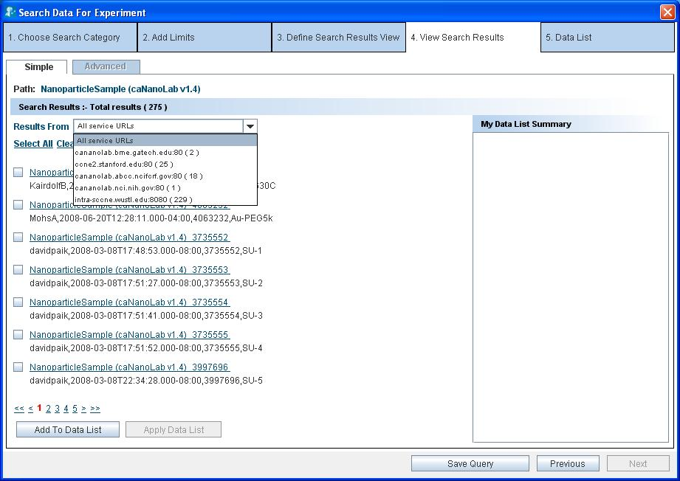
CaNanolab service instance at Washington University
Figure 2.31 results group by service URL.
- Click on any one of the service URL in the drop down to see the results from that particular service URL .
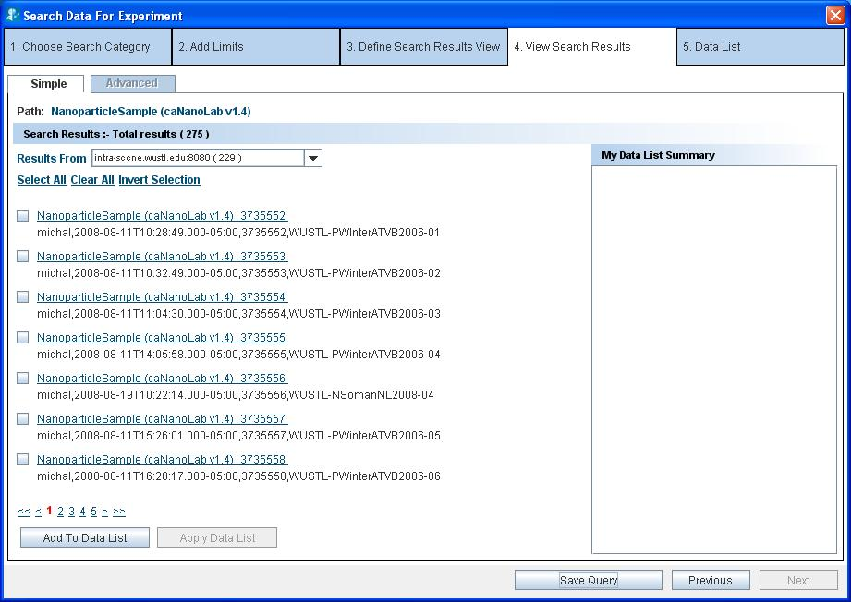
Results from selected service instance
Figure 2.32 results from the selected service URL instance
- User can then proceed with related data and saving the data list for the particular required service instance rather than all the service instances.

Save Query
This option is used to save the user executed query. It saves all the conditions on the various classes as defined in the query.

Why to Save Query?
When the user saves the executed query, he can simply view the result of the query by executing already saved query. This saves considerable amount of time as the user does not have to form the query again. The saved query can also be parameterized by choosing to save conditions on attributes which form the parameters (described further below). The user can execute a saved query with or without changing the conditions defined in the saved query.

Advantages of Save Query can be listed as follows:
- Saving complex queries with multiple nodes
- Availability of saved queries to all the users to aid the users who might not know how to query
- Setting up parameterized queries that allow a user to use the same query for a variety of conditions on a single attribute
- Queries can be saved in two ways:
- Non-parameterized: No parameters have been defined while saving the query. It means that the saved query cannot be modified at the time of execution. The conditions defined on attributes while querying cannot be changed during execution of the saved query.
- Parameterized: Parameters, that is, certain attributes are saved while saving the query. For example, during the execution of the query, the condition on the attributes can be changed to generate a new query.

How to Save Query?
Once the user has formed the query, that is, added certain categories and connected them via the available paths, the query can be saved. After forming the query, user navigates to the Define Search Results View tab and then to the View Search Results tab, both these tabs provide the option to save a query. The Save Condition button at the bottom of both these tabs can be used to save the query.

How to save a non-parameterized query?
- Click Save Condition (as shown in Figure 2.20. Define Search Result View.).
- Enter the Title and Description for the query to be saved, in the save query panel (see the figure below).
- To save the query, click Save.

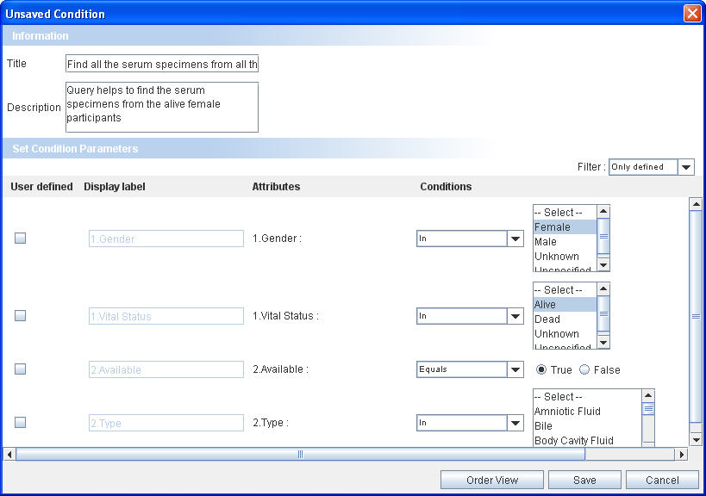
Title
Description
Figure 2.33. Save Query Panel-Non Parameterized Query

How to save a parameterized query?
- Click Save Condition (as shown in Figure 2.20. Define Search Result View.).
- Enter the Title and Description for the query to be saved, in the save query panel (see the figure below).
- Select the User Defined Check Box for the attribute you wish to select different values for in the future.
- Select the order of attributes in the Save Query Panel by changing it by Order View button.
- Use Filter option to define condition on any of the attribute of the category other than the attributes against which the conditions were initially defined.
- Click Save to save the query.
Click Cancel to exit without saving the query.

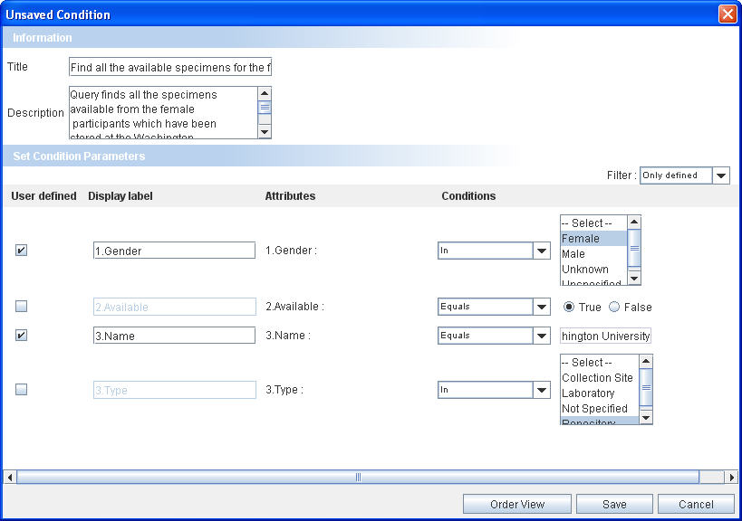
Figure 2.34. Save Query Panel-Parameterized Query

Executing a Saved Query
All the saved queries are visible in the Home Page in the My Search Queries stack box in the left hand side panel. To execute any query, click on the query to view the results.
To execute a saved query, perform the following steps:
- Click on the title of the query to be executed
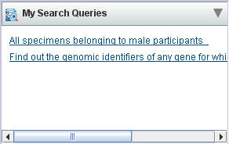
Figure 2.35. Saved Query Stack box
The Saved Query Panel opens.
- For non-parameterized queries, click Show Results on the execute query panel
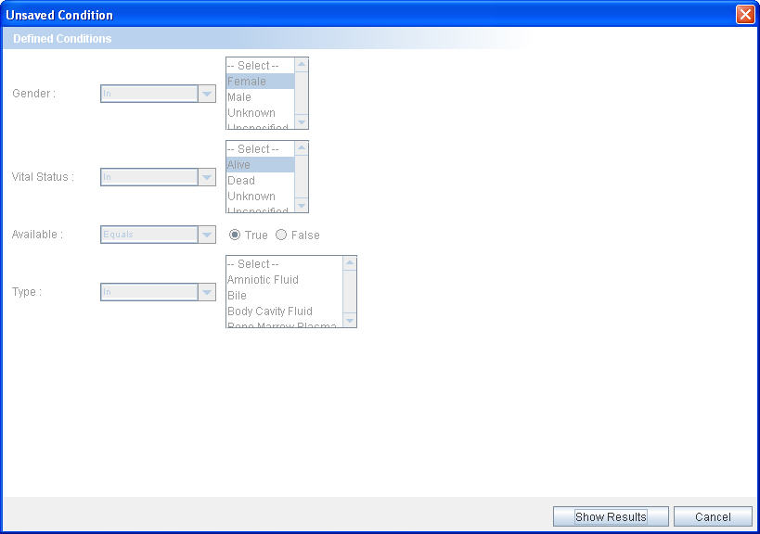
Click to execute

Figure 2.36. Execute Query Panel- Non Parameterized Query
- For parameterized queries,
- Change the conditions in the parameterized attributes
- Click Show Results to view the results
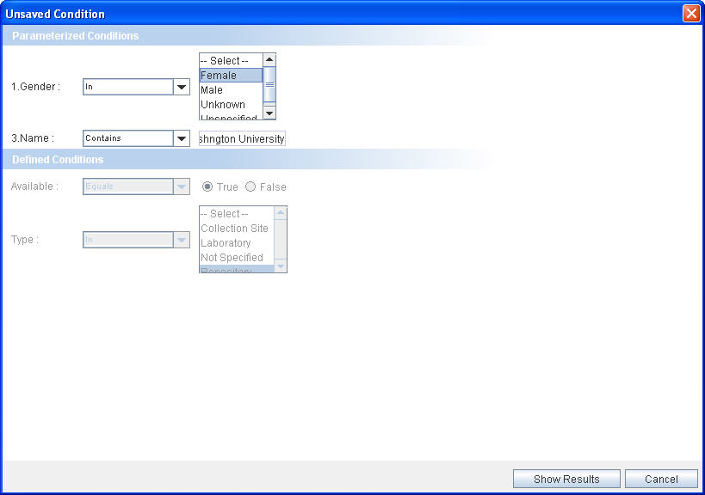
Click to execute

Figure 2.37. Execute Query Panel-Parameterized Query

The save query option provides an easy alternative way of executing the queries without actually forming the query again. The parameterized query allows changing the conditions on attributes thereby allowing flexibility to the saved queries.

Viewing and Saving Data List
After adding the records of interest to the data list, you can get the consolidated view of the data list that shows all the records added to the list in a hierarchical tree fashion. These include all the records as well as the details of a particular record. You can also export the data list into a Comma Separated Value (CSV) file or create an Experiment by using the contents of the data list.

The following figure shows the data list tab:
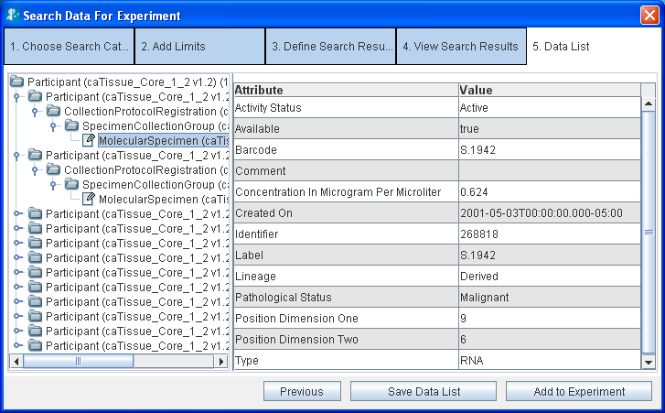
Figure 2.38. Data List

The left-hand side pane shows all the records that you have added to the data list in a tree format. Each node in the tree represents either a category or a record of a category.
- For a node representing a category:
- The number of records for that category is shown in parentheses. For example Gene (3) means that you have added 3 records for the Gene category.
- Clicking on the node updates the right hand side panel to show a spread sheet containing the records of that category (see figure above) with the columns depicting the attributes and the rows are depicting the records (Figure 2.29. Example 3- Data List).
- For a node representing a record
- The unique identifier for that record is displayed. For example, Gene_1 represents the record with identifier 1.
- Click the node updates on the right hand side pane to show the details of that record.
The right hand side panel shows the record details. The details shown in the panel depends on the record chosen in the left hand side panel.
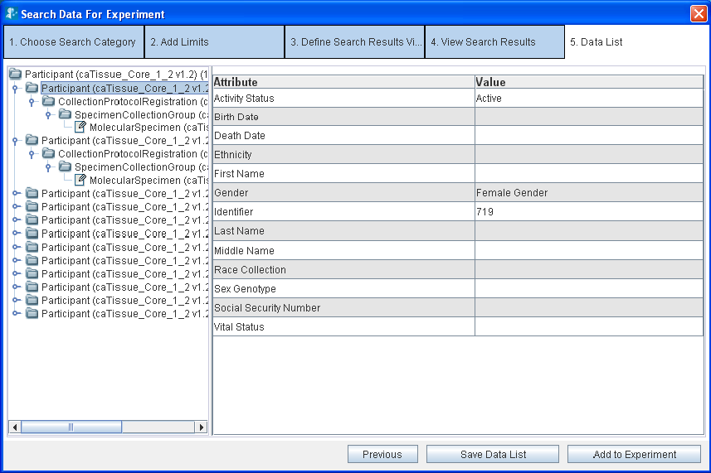
Figure 2.39. Record Details for a single record in Data List

Operations on the Data List
You can perform the following operations on the data list:
- Save the data list – Click Save Data List.
- Export the data list into a CSV file – Click Export.(see Figure 2.38. Data List)
- Add the data list to an Experiment – Click Add To Experiment (see Chapter 3 for additional information).

To save the data list:
- Click Save Data List.
- Type the title and description for the data list.
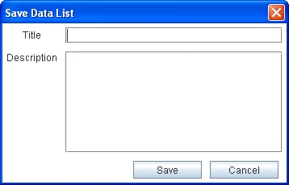
Figure 2.40. Save Data List Panel
- Click Save. The system displays a message in the status bar indicating that the data list is saved. The data list gets saved in the database.

Experiments
After you search and add some data of interest to the data list, you can create an experiment using that data. This chapter explains the various operations that you can perform on the data sets collected.
This chapter covers the following topics:
- What are Experiments and Projects?
- Creating an Experiment
- Viewing the Existing Experiments
- Working with an Experiment
- Filtering Data
- Analyzing Data

What are Experiments and Projects?
An experiment is defined as collection of data. After an experiment is created, you can perform the following:
- Perform various analyses on the data using the grid-enabled analytical services
- Visualize analysis results using various viewers such as bar charts and scattered plots.
- Create new data sets by applying filters on the existing datasets

A project is a collection of experiments. A project can contain many experiments or other sub-projects. The grouping of experiments into projects helps you to manage multiple experiments easily.
Example of an experiment
Aim: Find micro-array data for non-malignant brain tissue. Perform Comparative Marker Selection (CMS) on this data to determine the expression values that are most closely correlated with a class template. View the correlation among the expression values as a scattered plot.
You need to perform the following steps using caB2B
Step no. | Description | Related Section
1 | Search for micro array data | Search data – The Query Wizard
2 | Create experiment with this data | Creating an Experiment
3 | Open the experiment you have created | Opening an Experiment
4 | Filter the data further if desired | Filtering Data
5 | Save the filtered data | How to save filtered data
6 | Perform CMS analysis on selected data | Analyzing Data
7 | Plot analysis result as a scattered plot | Visualizing Data

Creating an Experiment
To create an experiment, you need to have a saved data list with the required data. See Viewing and Saving Data List for more details.
After you have saved the data list, do the following to create an experiment:
- Click Add to Experiment (Figure 2.27. Data List). This opens the Create New Experiment window.
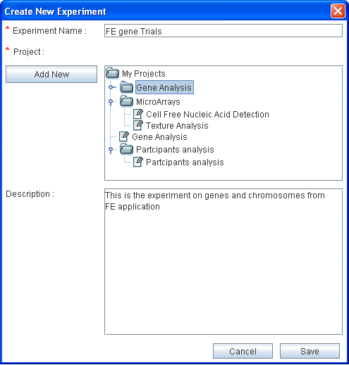
Figure 3.41. Create New Experiment
- Give an appropriate name to the experiment.
- Select the project in which you wish to create this experiment (see note below).
- Provide a description for the experiment.
- Click Save.

You can now close the Search Data wizard to return to the Home page and to open the experiment.
Similarly, user can search for gene, RNA, protein and save the experiment. Further the features of experiment are explained by taking an example of gene and related intramodel associations.

- To create a new project, perform the following:
- Select the parent project under which you wish to create a new project
- Click Add New. This adds a new sub project under the selected project with the default name– New Project.
- To rename the new project
- Select the project.
- Press F2.
- Type the desired name.
- Press Enter.

Viewing the Existing Experiments

On the caB2B Home page, click the Experiment tab. This opens the My Experiments page.
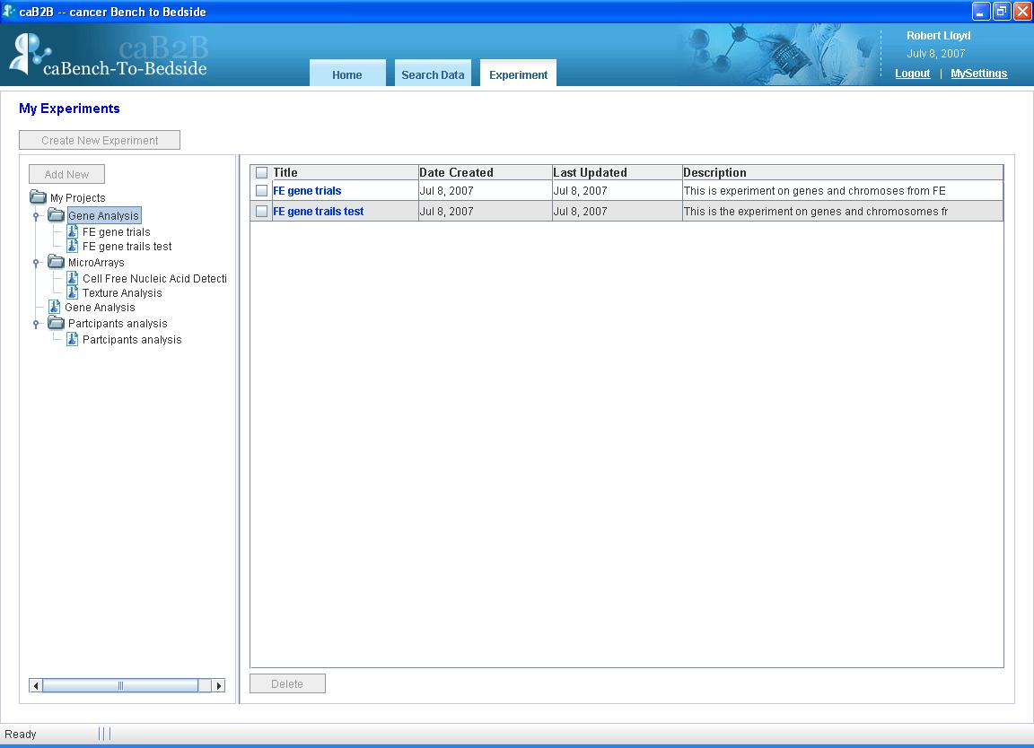
Figure 3.42. My Experiments
You can see all the projects and experiments that you created in the left panel.
When you select a project in the left hand side panel, the system displays a list of experiments in the project in right hand side panel.

Opening an Experiment
To open an experiment, go to the My Experiments page and click on the experiment title seen in the right panel (see Figure 3.42. My Experiments).
When an experiment is opened, you see the Experiment Details page. The experiment details page shows the data categories added to experiment. It gives the user an option to modify the experiment by adding a new column, adding new data, exporting data etc. All these options are also available on the right click menu.
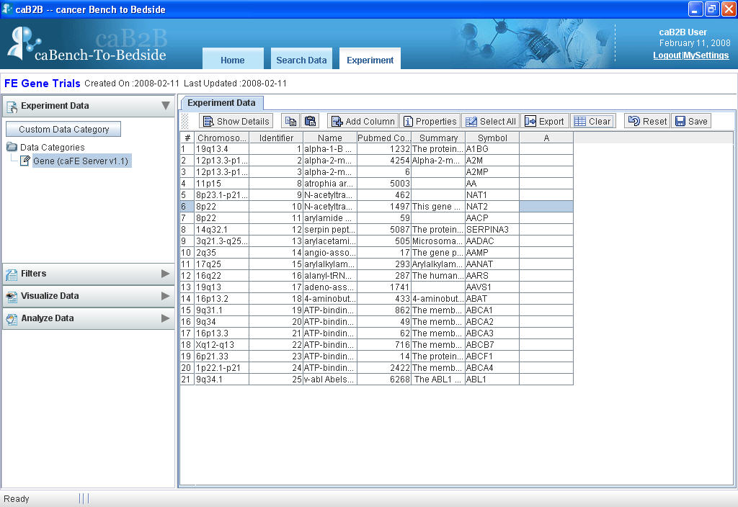
Figure 3.43.Experiment Details
The various options provided by the spreadsheet on the experiment details page are listed in the table below:
Button | Description
 | Shows details of the particular record.
 | Copies data of the selected cells.
 | Pastes the data to the specified cells.
 | Adds a new column to the spreadsheet.
 | Shows the properties of the spreadsheet, like which attributes are visible, what filter is applied.
 | Selects all the records.
 | Exports data to a .csv file.
 | Clears the user added data from the selected cell.
 | Undo’s all the changes and shows the original data.
 | Creates a data category.

Working with an Experiment
The Experiment Details page consists of the following sections:
- The Operations panel on the left hand side
- The Visualization panel on the right hand side

The Operations panel
The Operations panel encompasses the following collapsible boxes.
Table 3.3. Operations on the Experiment Page
UI Elements | Description
 | Displays a list of all the data categories present in the experiment. See How to save filtered data in this chapter for more information.
 | Shows all the filters that are currently applied to the data of the selected data-category. See Filtering Data in this chapter for more details.
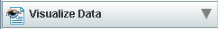 | Shows the visualization options available for the selected data-category. See Visualizing Data in this chapter for more details.
 | Shows the links to call analytical services that are applicable to the selected data-category. See Analyzing Data in this chapter for more details.

Visualization panel
This is the right hand side panel on the Experiment Details page (see Figure 3.43.Experiment Details). This panel can contain several pages at a time (see figure below). You can switch between the pages by clicking on the tabs at the top of this panel.
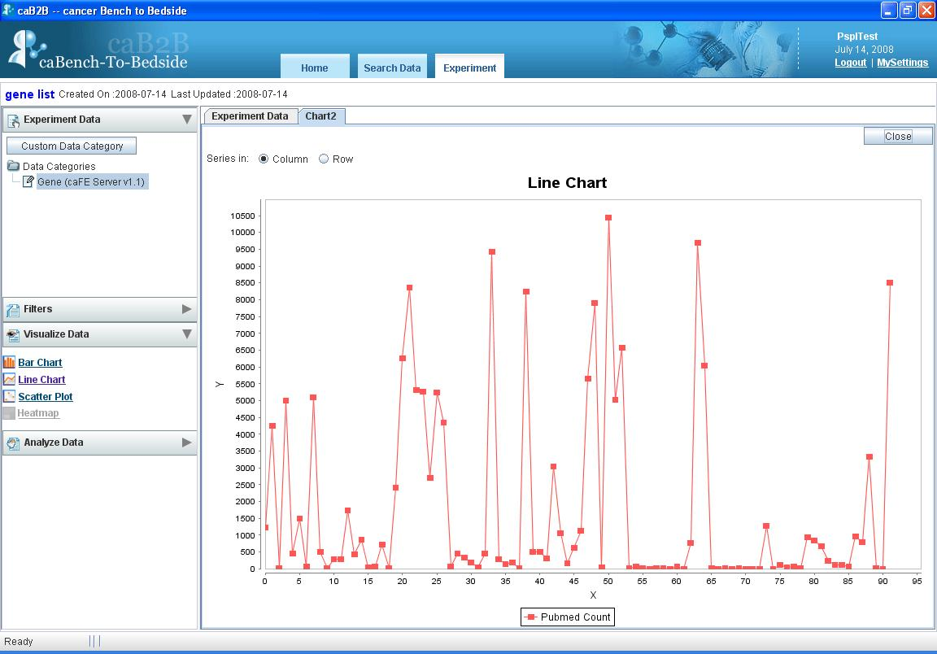
Figure 3.44. Visualization Panel
The visualization panel is updated based on the operations you perform in the operations panel. For example,
Operations pane | What happens in Visualization pane
Click a data-category in the Select Data Category box | The Experiment Data tab is updated to show the records of that data category
Choose a visualization from the Visualize Data panel | A new tab is created to display the desired visualization

Filtering Data
The purpose of creating experiments is to perform analysis on the data. To aid the analysis, caB2B provides features to filter the data so that you can zero in on the data of interest.
After filtering the data, you can save the filtered data as a data-category. For example, if you have created an experiment with all female Participants, you can now create different data categories based on age less than 50, age between 50 and 65 and age greater than 65.

How to filter data
- Select the column whose data is to be filtered, select the filter from the Filter stack box, (located in the left hand side panel)
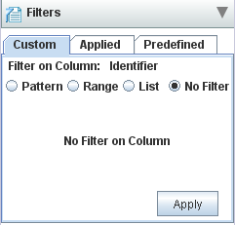
Figure 3.45: Filter Stack box
- System displays appropriate filter controls.
- Choose one of the available filters and specify the conditions that the data must satisfy (see Appendix D: Types of Filters).
- Click Apply.
- The data in the Experiment Data tab is updated to show the filtered data.
- The filter that you have applied is also shown in the Applied tab of the Filter stack box in the panel on the left hand side.
You can now save the filtered data as a new data-category (more information about this is provided below) and use it to perform analyses or visualization.
You can filter on multiple columns by successively applying filters on those columns. For example, to obtain female participants between age 30 and 40
- Apply the filter “Gender = female”.
- Then apply the filter “age between 30 and 40”.
For details of the various filter controls and how to use them, see. Appendix D: Types of Filters.

How to edit a filter
- Choose the column whose filter you wish to edit.
An appropriate filter control is shown in the Filter stack box with the values that you previously entered.
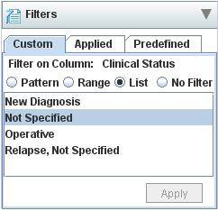
Figure 3.46. Edit Filter
- Specify desired values of the filter (see Appendix D: Types of Filters).
- The data in the Experiment Data tab is updated to show data based on the new filter.
- The filter criteria shown in the Applied tab of Filter stack box as shown in Figure 3.46 in the operations panel is also updated.

How to remove a filter
- Choose the column whose filter you wish to remove.
- An appropriate filter control is shown with the values previously entered.
- Select the No Filter option.
- Click Apply.
- The data in the Experiment Data tab is updated to show data after removing the filter.
- The filter is also removed from Applied tab the Filter Data stack box in the operations panel.

How to save filtered data
Once you apply filters to a data set, save the filtered data as a data category. You can create as many data-categories as required. The data-categories can be further used for data analysis.
To do this,
- Click Save (located in the toolbar of the right hand side panel of the experiment details page Figure 3.43.Experiment Details).
- The Save as Data category panel is displayed.
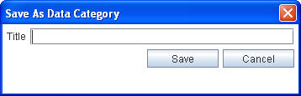
Figure 3.47.Save Data Category Panel
- In the Title field, type the title of the new data-category.
- Click Save.
The new data-category will appear under Custom Data Categories section in Experiment Data box of the operations pane.

Custom Data Category
Data Category is used to define a class which is a subset of other classes. In an experiment there are various data categories, like participant, specimen etc. Typically, user wants to use data from various categories, to create a new category. This new category shows the information which makes sense to the end user, Custom Data Category (CDC), is a way to bring data from various categories under a single category. For example, end user wants to see the specimen details and participant information in a single view. For this he can create a CDC with the desired attributes from the participant and the specimen class and create a third category.

How to create CDC
- Click Custom Data Category (located at the top of the Experiment Data box on the left hand side panel of the experiment page).
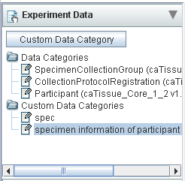
Figure 3.48. Custom Data Category
The Create Custom Data Category Panel is displayed (Figure 3.8 below).
- In the Custom Data Category Title field, type the title of the new custom data-category.
- In the Data List field, select the data list to create the category.
- In the Categories field, select the category to be customized.
- Select attributes from Available Attributes to be present in CDC.
- Click Add/Add All to add to Selected Attributes.
- Select attributes from the Selected Attributes and click Remove/Remove All button to remove the attributes from CDC.
- Click Save.
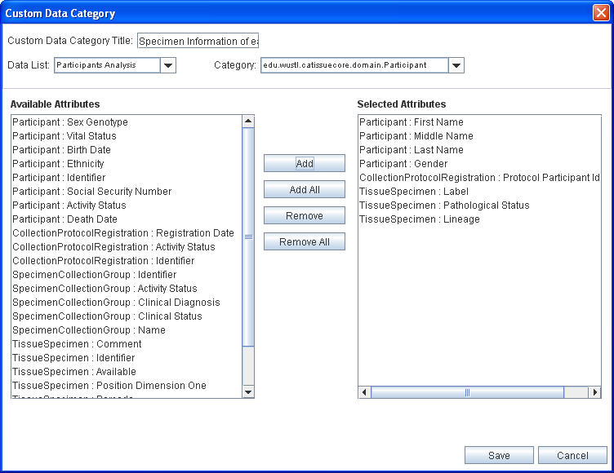
Figure 3.49. Custom Data Category Panel
The CDC created appears under Custom Data Categories section in Select Data Category box of the operations panel as shown below.
Saved Custom Data Category
Figure 3.50. Saved Custom Data Category

Analyzing Data
After you searched for the data of interest and created experiments from it, you can analyze that data. To do this, you can use various available analytical services. Typically they accept data, perform analyses on it and return the result. You can also pass configuration parameters along with the data to the analytical services.

When you are viewing the data, the services that can operate on that data are shown in the Analyze Data box. In the current version one analytical service Comparative Marker Selection, from gene pattern is available.

How to analyze data?
- Select the data category from Select Data Category box, for example Bioassay.
- In the Analyze Data box, click on the link to call the service, for example Comparative Marker Selection link.
- It will open a popup that accepts configuration parameters for the service. Figure 3.51. Configuration parameters for CMS.
- Enter the Title for this analysis and the values for various parameters
- Click Finish to submit this analysis.
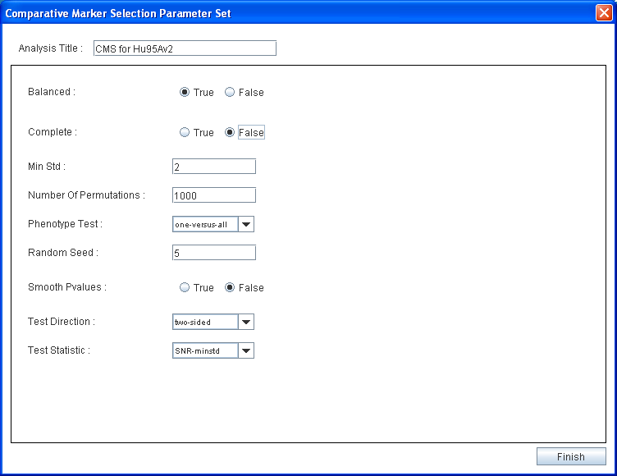
Figure 3.51. Configuration parameters for CMS

You can see the new Analysis tab added in the right hand side panel. It contains following fields
Field | Description
Data Category | The data category on which you performed the analysis.
Analysis Title | The title you provided for the analysis. It is a link to the result of the analysis.
Date | The date on which you performed the analysis.
Status | Indicated whether analysis is completed or pending.

You can view the result on completed analysis by clicking the link in Analysis Title field.
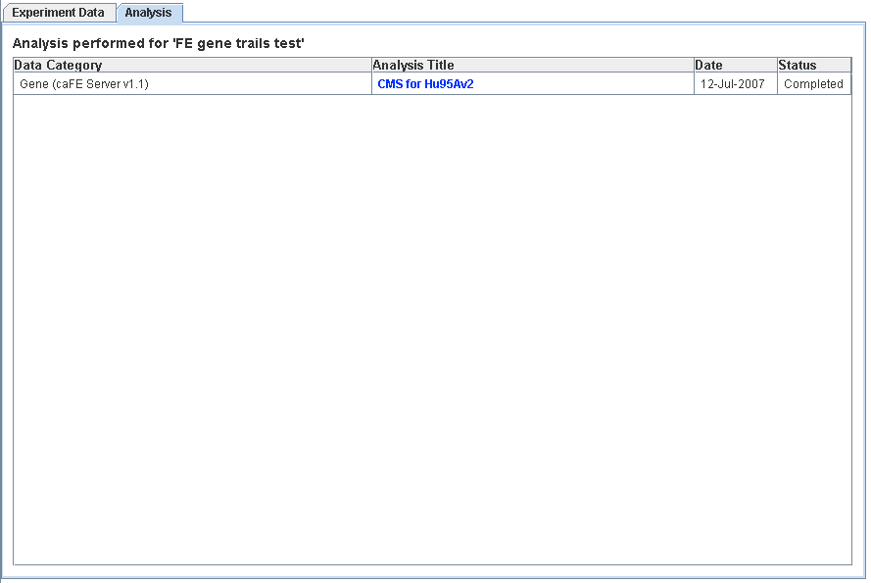
Figure 3.52. List of analysis performed for the experiment

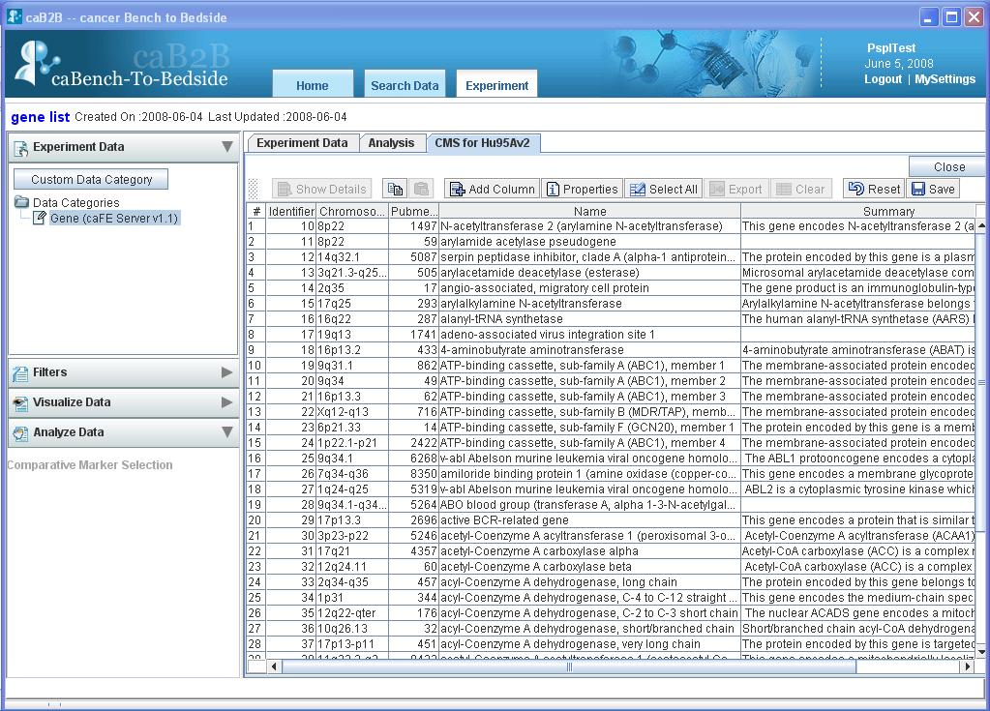
Figure 3.53. Result of CMS Analysis

Visualizing Data
You can visualize the data in the experiment by using various graphical components such as charts and scatter plots. These options provide a graphical summary of the data allowing comparison, variation and co-relational analysis of the data.
Some terms used:
Data series: Related data points plotted in a chart that originate from data rows or data columns. Each data series in a chart has a unique color or pattern. This is represented by a Legend. You can plot one or more data series in a chart.
Legend: A small color box that identifies each series in the chart.
The current version of caB2B supports following visualization options in Visualize Data box.
Visualize option | Description
 | This is a chart with rectangular bars of lengths proportional to the data value it represents.
 | This is a chart with a line joining the points that represents data value
 | A scatter plot will show a linear or non-linear relationship between the variables (column selected). It also helps in finding outliers in the data.
Table 3.4.Types of charts supported

How to plot data series
- Select the data that you want to plot from Experiment tab.
- Click on the link for type of the chart you wanted from the Visualize Data Stack Box, for example
- It will open the chart in a new tab in right hand side panel.
- By default data series are from columns on the Experiment Data tab. This can be changed by toggling the radio buttons in the upper left corner of the chart area.

Following screen shots represents the various charts for PubMed count for few Genes from FE server.

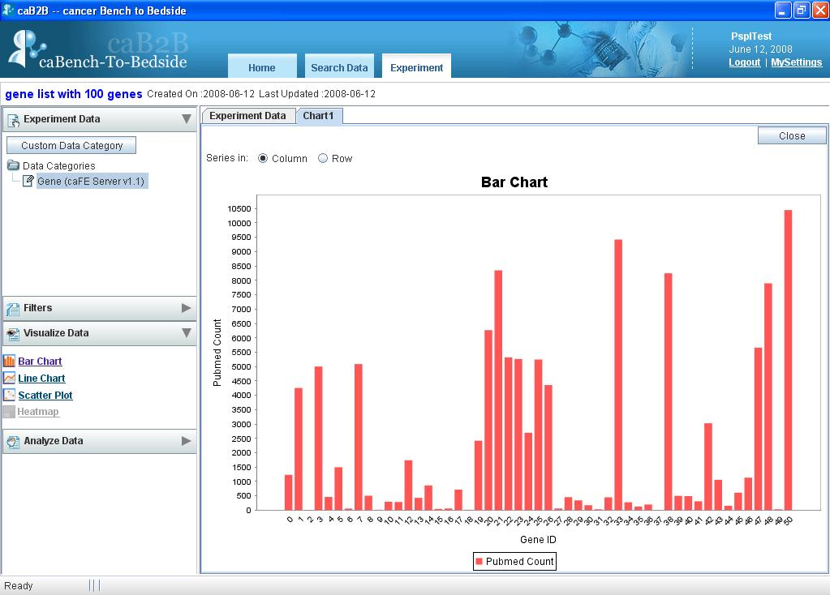
Figure 3.54. Bar chart example

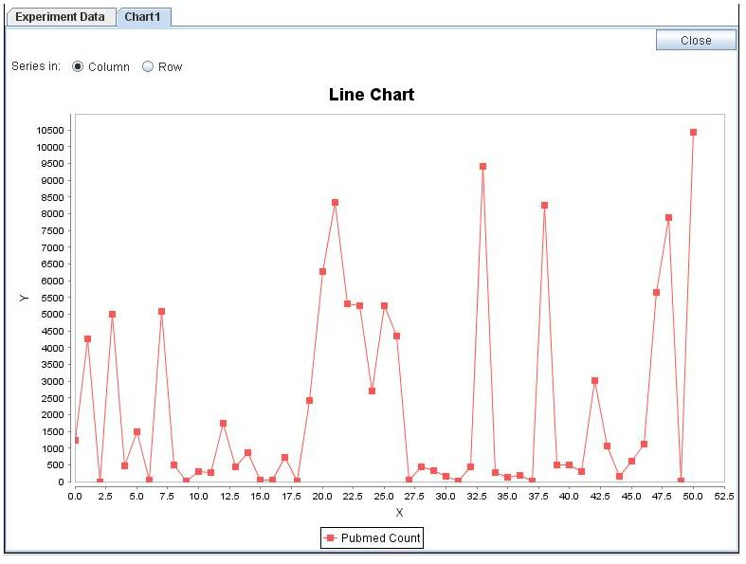
Figure 3.55. Line chart example
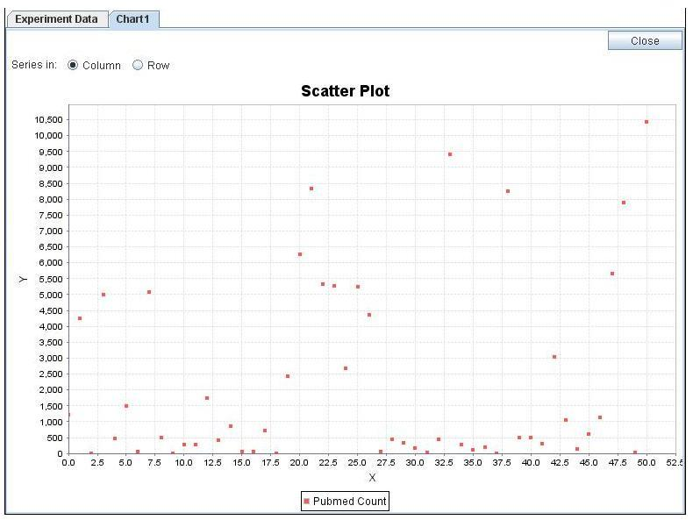
Figure 3.56. Scatter Plot example

How to change data series from rows to columns and vice versa?
You can configure whether data series are from rows or columns by selecting appropriate Series In options.
- To have the data columns to represent the data series, select option.
- To have the data rows to represent the data series, select option.

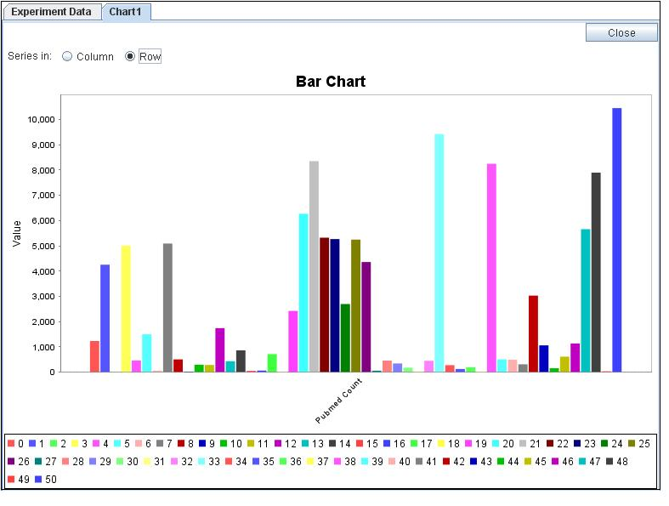
Figure 3.57. Bar chart with data series from rows
You can change the type of the chart that you are currently viewing by selecting required chart link from Visualize Data box.
You can create multiple charts for the data.
The name of the tab added for each chart is “chart” followed by a unique number for that chart. For example chart1, chart2, etc.

Examples of category search
This appendix provides examples of the advanced search strategies that are possible in caB2B, while searching for categories.

Text-based Search - For category name information
To search categories having “gene” in their name do the following:
- In the Search box, type gene.
- Expand the Advanced Search box
- Select the Category check box.
- Click Text.
- Click Search.

The results of this search are as shown below. All the categories shown below have gene in their names.
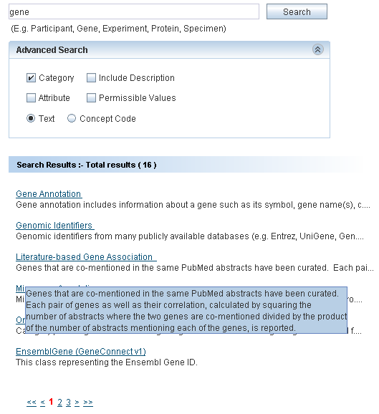
Figure A.1. Search Result of Example 1

Text-based Search - For category and attribute name and description
To search the categories having “Protein” in their name or description or to search the attributes having “Protein” in their name or description, you need to do following:
- In the Search box, type Protein
- Open Advanced Search box.
- Select the Category check box.
- Select the Attribute check box.
- Select the Include Description check box.
- The Text option button is selected by default.
- Click Search.

The result of this search is as shown in the screenshot below.
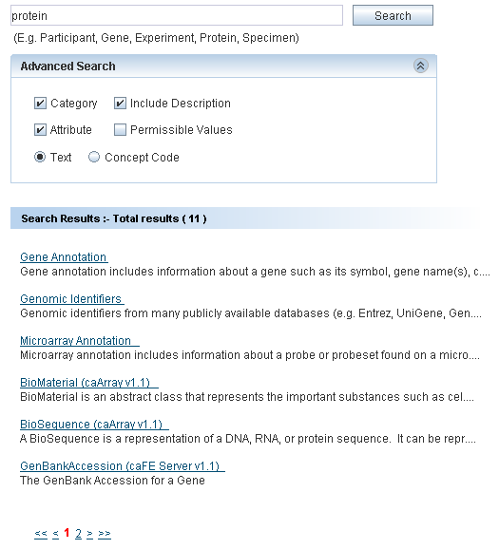
Figure A.2. Search Result of Example 2

Concept Code Based Search - For category name information
To search categories having concept code “c29867”:
- In the Search box, type c29867.
- Open the advanced search box.
- Select the Category check box.
- Select the Concept Code option button.
- Click Search.
The result of this search is as shown in the screenshot below.
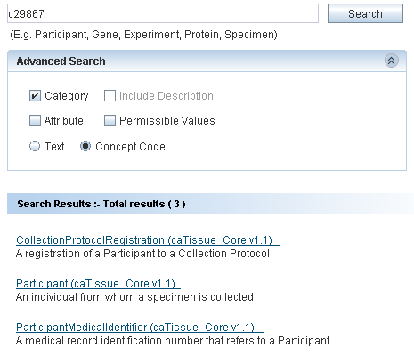
Figure A.3. Search Result of Example 3

Concept code based search - For attribute name information
To search categories whose attribute has concept code “C42614”:
- In the Search box, type C42614.
- Select the Attribute check box.
- Select the Concept Code option button.
- Click Search.

The result of this search is as shown in the screenshot below.
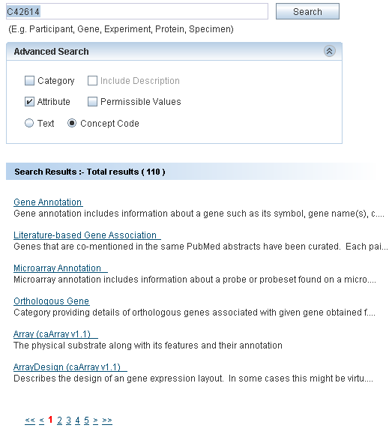
Figure A.4. Search Result of Example 4

Define Limit: Operators and Values
This appendix explains the various operators and how to specify values while defining limits on a category.

The following table explains the different operators and provides examples as to how values are to be specified.

Operator | Data types for which applicable | Sample condition | Expected Results
Equals | Numeric  Date  String | Name equals “John” | Returns only John and not john.
Not equals | Numeric  Date  String | Identifier not equals 32 | Returns all records except those having identifier = 32
Less than | Numeric  Date | Participant’s birth date less than 2000/1/1 | Returns all Participants born before January 1st, 2000
Less than or equal | Numeric  Date | Signal value less than or equals to 0.5 | Returns all records for which signal value is not more than 0.5
Greater than | Numeric  Date | Cell count is greater than 10000 | Returns all records with Cell count > 10000
Greater than or equals | Numeric  Date | Specimen’s collection-date greater than or equal to 2005/5/1 | Returns all specimens collected on or after May 1st, 2005
Between | Numeric  Date | Patient’s admission date between 2000/1/1 and 2000/12/31 | Returns all Patients admitted in the year 2000
Is null | Numeric  String  Date | Patient’s contact number is null | Returns all patients who do not have any contact number
Is not null | Numeric  Date | Participant’ middle name is not null | Returns all Participants for whom middle name is specified
In | Numeric  String  Enumerated | - Signal value in 0.1,0.5,0.7,  - Name in “John”, ”john” | - Returns all records whose signal value is 0.1 or 0.5 or 0.7  - Returns both John and john.
Not in | Numeric  String  Enumerated | Participant’s gender not in male, unspecified | Returns all participants whose gender is either not specified or gender is not male.
Starts with | String | Participant’s first name starts with Jo | Returns all participants whose first name starts with Jo like John, Jona.  Does not return the participant with name Scott, Henry, Jen
Ends with | String | Participant’s last name ends with n | Returns all participants whose last name ends with n like John, Jon, and Jen. Does not return participant with name Scott, Henry
Contains | String | Participant’s first name contains ann | Returns all participants whose first name is Joanna, Anna, and Johanna. Does not return participant with name Jen, Denny

- For attributes with enumerated values and Boolean attributes, clear a value by clicking on the value with the CTRL key pressed.
- If you use the In operator for a non-enumerated attribute, you can specify multiple values as follows:
- Multiple values should be separated using a comma. For example, to specify the constraint Identifier IN 2, 4, 5, 7, you should type the value as 2,4,5,7.
- If a value itself contains a comma, you can enclose the value in double quotes. For example, to specify the constraint Name IN “Einstein, Albert”, “Newton, Isaac” the value that you should enter is “Einstein, Albert”, “Newton, Isaac”.
- For attributes that requires a date value, you can click the icon to launch a date selector. You can also type a date string directly in the text box. The format of this string must be YYYY/MM/DD. A valid date string becomes green whereas an invalid date string turns red. An invalid date string will be ignored.

Record Details View

The details of a record usually consist of the values of the attributes of the category. See Figure 2.26. Results’ Details for an example.
This section provides examples of special categories that result in a slightly different view of the record’s details.

Administrator defined categories
These categories are built by manually grouping relevant attributes from one or more existing categories.
For each record of such a category the following information is shown:
  - Values of the attributes in a table
  - Related information as a tree. The leaf nodes of this tree are attributes; you can see the values of those in the value column.
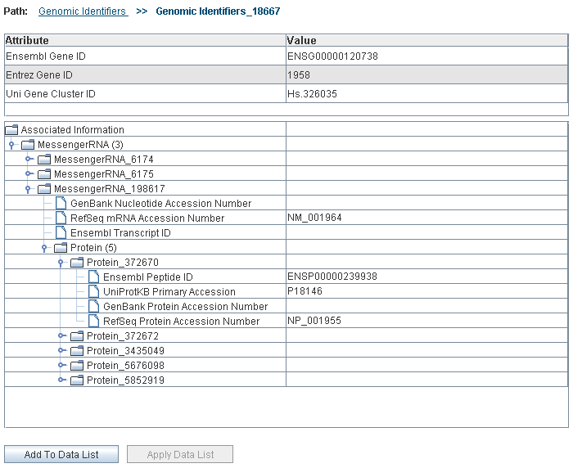
Figure C.1. One record of an administrator defined category (Genomic Identifiers)

Types of Filters
A filter control is shown when you choose to filter the data of a data-category (see How to filter data).
The type of filter control upon the column based on which you wish to filter data.
Table D.1: Column Type and Applicable Filter
Data type of the column | Applicable filter
Numeric | Range filter
Text | Pattern filter
Column with permissible values | Enumerated filter
Boolean | Enumerated filter

Using the Range Filter
The system shows a Range Filter if the column selected as a basis for the filter has numeric values. It allows you to select the desired minimum and maximum values of the column.
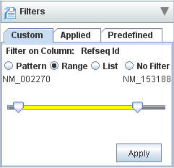
Figure D.1. Set Filter for Range

There are two sliders, the left slider and the right slider. The value denoted by each slider is shown at the two ends.
- Position the left slider to the minimum value desired.
- Position the right slider to the maximum value desired.
- Click Apply to apply the filter.

Using the Pattern Filter
The system shows a Pattern Filter if the column selected as a basis for the filter has text values. It allows you to specify a pattern that the values of that column should satisfy.
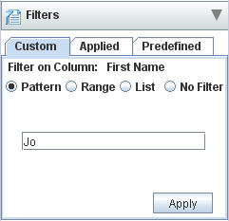
Figure D.2. Pattern Filter
In the Enter Pattern field, type the desired pattern and click Apply.

Using the Enumerated Values Filter
The system shows an Enumerated Values Filter if the column selected as a basis for the filter has a set of permissible values. It allows you to specify the values that the column should satisfy.
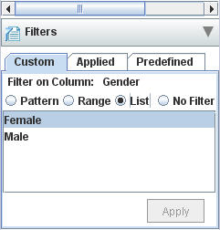
Figure D.3. Enumerated Values Filter for the column gender
Select the desired permissible values and click Apply.

Index

Administrator defined category, 69
Advanced search, 15
Ambiguity resolver, 22
Analyze Data, 45, 49, 55
Apply Data List, 31
Breadcrumbs, 31
caB2B, 3
caBench-to-Bedside. See caB2B
Categories, 4
CDC, 53
Concept code, 16
Creating Experiments, 45, 46
Custom Data Category
creating, 53
definition, 53
Data
analyzing, 45, 49, 55
filtering, 45, 49, 50
visualizing, 46, 49, 58
Data List, 13, 41, 46
Saving, 43
Define Search Results View, 13, 24
Editing filters, 51
Executing saved query, 39
Experiment Details page, 48
Operations panel, 49
Visualization panel, 50
Experiments
creating, 45, 46
definition, 45
example, 45
opening, 45, 48
viewing, 47
Filters
editing, 51
enumerated value, 72
pattern, 72
range, 71
removing, 52
saving, 45, 49, 52
types, 71
Limits
connecting, 20
DAG, 18
defining, 13, 16, 19, 25
definition, 5
deleting, 20
editing, 19
information panel, 23
Login, 3, 5
My Data List Summary, 31, 38
Opening Experiments, 45, 48
Path, 21
Plotting data series, 59
Projects, 45
Query
definition, 5
executing, 39
saving, 13, 36
Query Wizard, 13, 45
Related data, 30
Removing filters, 52
Save query
advantages, 36
executing, 39
non-parameterized, 37
Search categories, 62
Spreadsheet view, 48
View Search Results, 13, 28
Viewing Experiments, 47
Vizualise data, 46, 49, 58
Vizualize data
bar chart, 58, 59
line chart, 58, 60
scatter plot, 58, 60

