caBench-To-Bedside

User Manual
Version 1.0

[Insert approval date of document]

Revision History
Date | Version | Description
22nd February 2007 | 1.0 | Draft document

TABLE OF CONTENTS
Chapter 1 Introduction 3
Purpose 3
Overview 3
Pre-requests and installation guidelines 4
Chapter 2 GUI overview 5
Chapter 3 Search Data Workflow 6
Search Meta-Data 6
Add limits 12
Visualize and redefine the query 15
Define the view 19
View Search Results 20
Select and Add to data list 23

Introduction

Purpose
This document is intended to provide assistance to the caB2B user for understanding the functionalities supported by caB2B application. This documents covers following aspects of the application:
- Brief overview of the application
- Pre-requests and installation guidelines
- Features supported
- Steps to execute different functionalities

Overview
The NCI caBIG™ project is creating a common, extensible informatics platform that integrates diverse data types and supports interoperable analytic tools. Although caBIG™ is developing separate applications that will facilitate individual steps involved in microarray analysis and that are useful to bioinformaticians, there is no single application that leverages these tools in a user-friendly graphical interface. Such a tool, which is essential for the ultimate end-user, the physician-scientist, will serve as a powerful means to identify previously underappreciated pathways for potential new targeted therapeutics against devastating biological diseases such as cancer.
The caBench-to-Bedside (caB2B) project is intended to facilitate cancer research in multiple ways. First, it will provide investigators with the ability to query tissue banks at multiple cancer centers, enabling studies to focus on very specific tumor subtypes and to target less common tumors by pooling biospecimen resources, and thereby attenuating the problem of small sample sizes. Second, it will give investigators the ability to perform novel in silico experiments using microarray data sets that have already been collected. These capabilities will facilitate the process of identifying genes that are up- or down-regulated in specific cancers, and allow investigators to view that data in the context of biological pathways. By identifying genes important to the development and treatment of cancer, investigators will gain further understanding into the complex system of cancer biology. Ultimately, this will lead to the more effective identification of novel drug targets and improve treatment strategies.

One of the other very important goals of this project is to demonstrate the usefulness of caGrid infrastructure as a platform to perform scientifically challenging investigations involving integration of data and analytical services from diverse research communities. The caGrid client will enable individual users to work on common platforms to access caGrid resources in real time from common data and analytical services. The client will have various configurations that support end users in the cancer biomedical research community.

Thus caBench-to-Bedside (caB2B) is graphical user interface based application which allows user to
- Query any caGrid data service (single data service or multiple data services or joining the two using semantic interoperable CDEs) in order to fetch data of interest.
- Collect data of interest and create experiments
- Perform different kinds of analyses using different grid enabled analytical services
- Visualize analysis results using different viewers like charts, dendrograms.

NOTE: Current version of caB2B application has implemented step 1: Querying different caGrid services functionality only.

Pre-requests and installation guidelines
The caB2B application consists of two components:
- caB2B server : Administrator should configure this component. This component loads the required metadata information for different data services.
- caB2B Client : The graphical user interface which the end-user will be using for querying and analysis. The client should be configured to query caB2B server instance.

Please refer to the installation guide for detailed information.

GUI overview
The caB2B application’s graphical user allows user to search for different data sets like search for specimen details in caTissue Core data service or microarray annotation details in caFE data service or allows user to analyze and visualize data sets within experiments.

The Figure 1 shows the home page of the application. This page summarizes the goal of the application and provides navigation link for searching data.

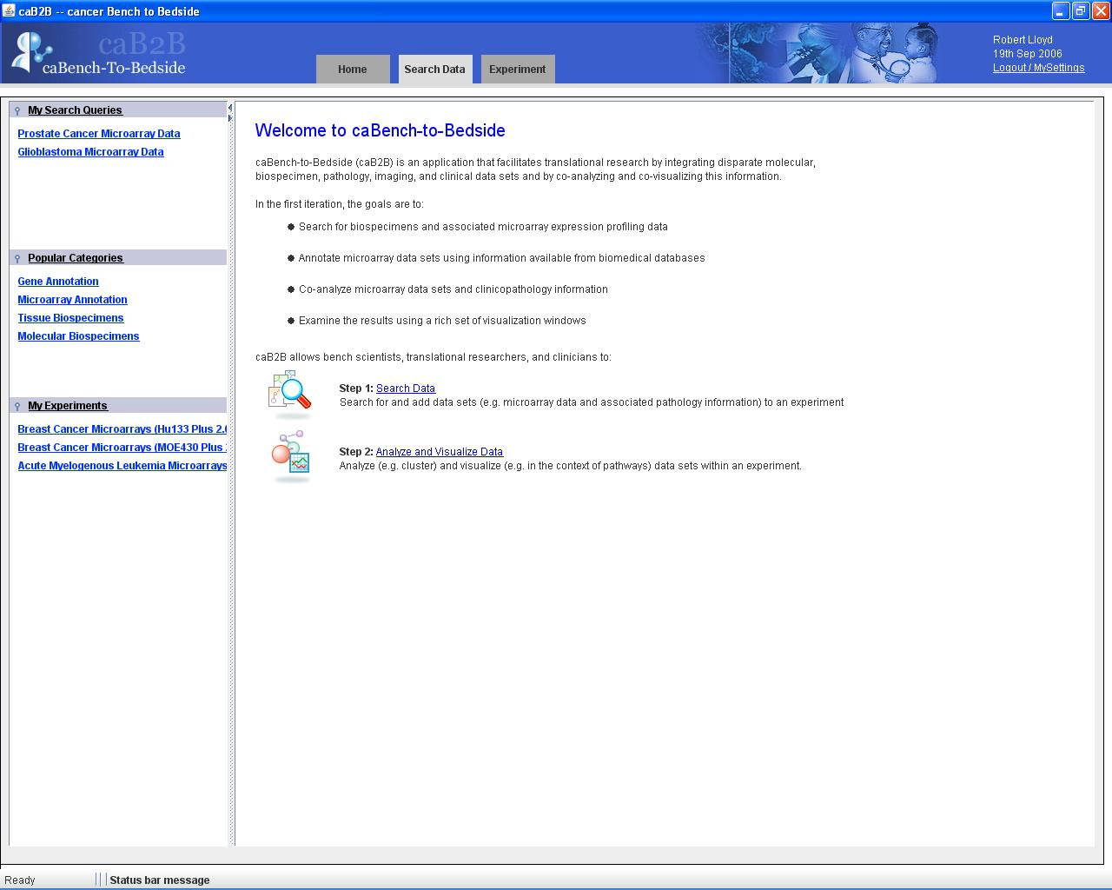
Figure 1: Home page of caB2B application

Search Data Workflow

The search data functionality provides user interface to search for the metadata of the data set user is interested in like user may want to search for specific microarray annotation details or specimen details. Once user knows what he is looking for and searches for the same (example – microarray data), then the user can form a query using visual query interface and get the dataset associated with specified query as a result of the query execution.

Following are the steps which would enable the user to understand the workflow of the caB2B functionality. Each of these steps is described in detail later in this chapter.

Step # | Purpose
Step #1 | Search for the metadata for which user want to get data set
Step #2 | Add constraints to the meta data elements
Step #3 | Visualize and redefine the query
Step #4 | Define the view
Step #5 | View Search Results
Step #6 | Select and add to data list

Search Meta-Data
This step allows user to search for the metadata and get details for it. This search returns all the metadata elements like gene, specimen matching to the user specified search criteria. The search is performed in all the caGrid applications loaded into the caB2B server.

How to get search Meta-Data option?
In caB2B application,
- Click at the ‘Search Data’ link on the home page.
- The system opens ‘Search Data’ dialog with ’Choose Search Category’ tab active. This tab is the one which allows user to search for the meta-data of interest.

The diagram below shows this dialog with different options of searching meta-data.
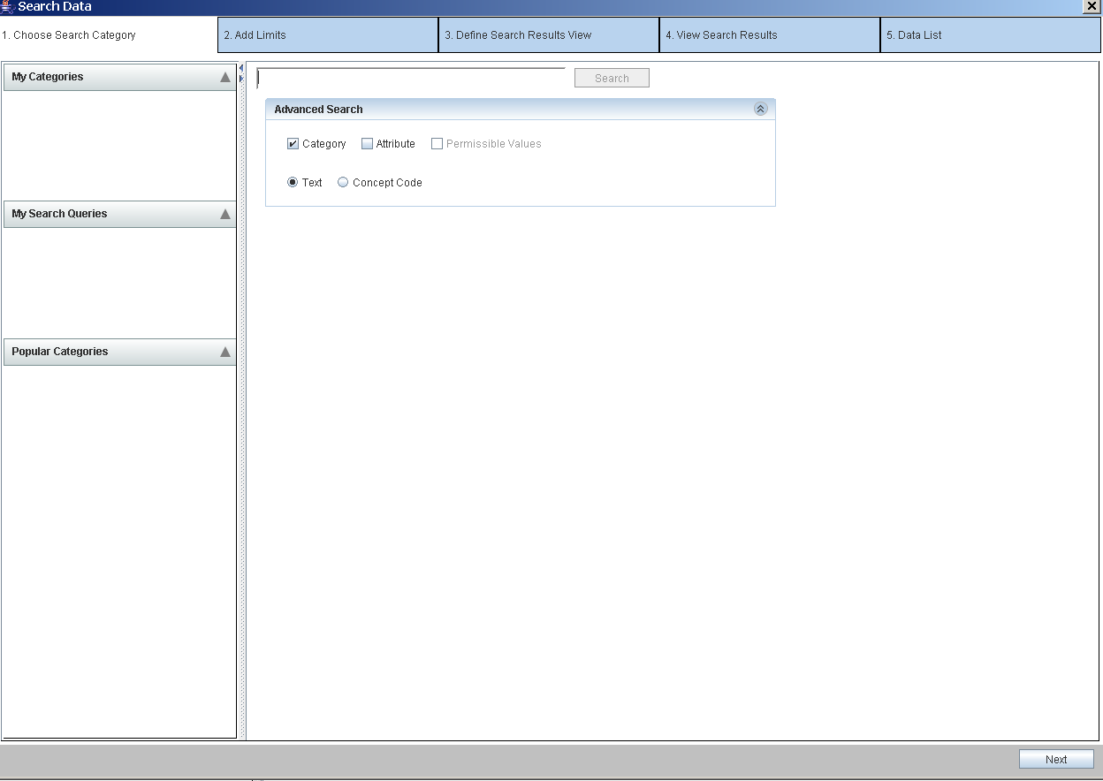

The details of different options on this page are as below:
- The ’Choose Search Category’ tab is the first step to find data sets of interest. It allows the user to search metadata term of interest.
- The advance search option pane on this page allows the user to search for any combination of followings:
  - category name
  - attribute name
  - permissible values
- The term to search can be either a plain text or a concept code depending upon the radio button option selected in ‘Advanced Search’ option pane
- The category is a collection of attributes from one or more classes from the same or different caGrid applications like caTissue, caArray, GeneConnect.
- A category will have either subcategories or attributes from classes but cannot have both.
- In ‘Advance Search’ pane if the ‘Text’ radio button is selected:
  - Search is performed on the category name, description, attribute name, description or the permissible value text depending upon the check-box selection in ‘Advance Search’ pane’.
  - Example 1: Suppose ‘Clinical diagnosis’ is the search string specified and ‘Category’ checkbox is checked along with ‘Text’ radio button selected and then search button is clicked. This will search system only for category name and category description. The result of this search is as shown in below image.

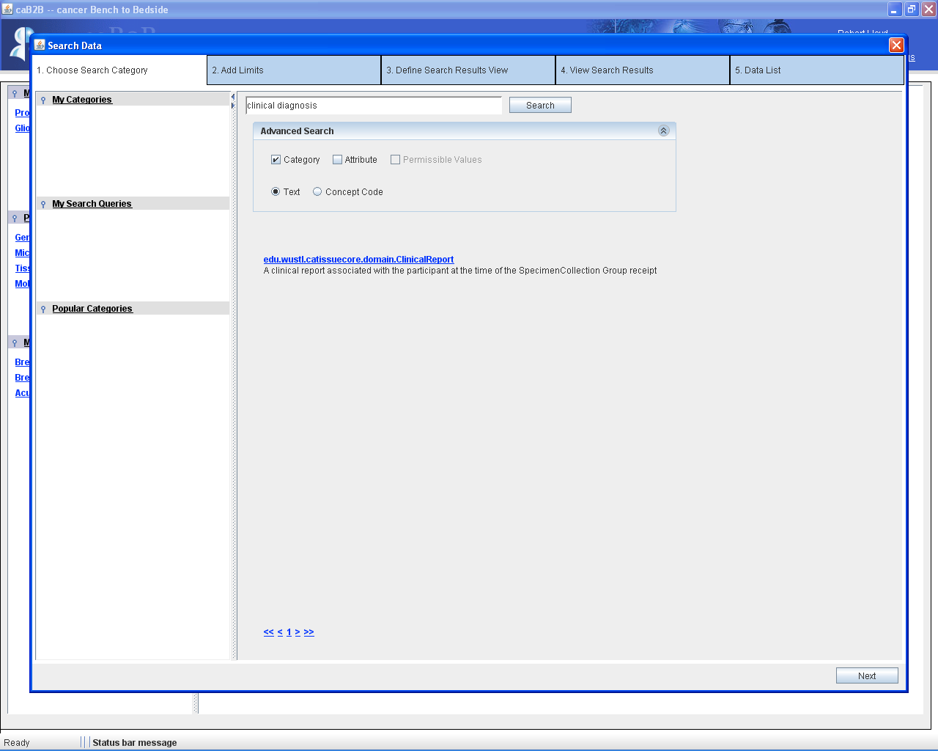
1) Enter ‘Clinical Diagnosis’
2) ‘Category’ is checked & ‘Text radio button is selected’
3) Click on ‘Search’
2) ‘Category’ is checked & ‘Text’ radio button is selected’
1) Enter ‘Clinical Diagnosis’
3) Click on ‘Search’
Figure 2.1 Choose Search Category Dialog

  - Example 2: Suppose ’Clinical diagnosis’ is the search string specified and ‘Category’ checkbox is checked, ‘Attribute’ checkbox is checked along with ‘Text’ radio button selected and now search button is clicked. This will search system for category name and category description as well as attribute name and attribute description. The result of this search is as shown in below image.

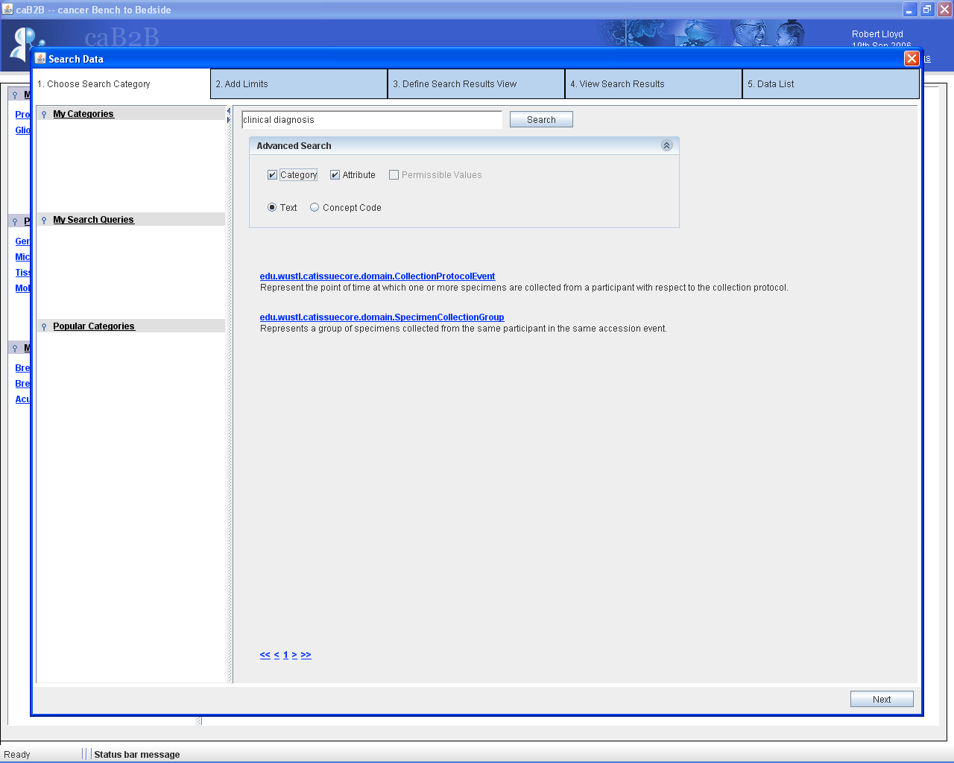
1) Enter “clinical diagnosis”
“Text” radio button is by default selected
3) “Category” & “Attribute” check boxes are checked
4) Click on “Search”
Figure 2.2 Choose Search Category Dialog

- In ‘Advance Search’ pane if the ’Concept Code’ radio button is selected:
- Search is performed in for the concept codes of category name, attribute name and permissible values depending upon the check-box selection in ‘Advance Search’ pane’.
- Suppose ’C16977‘ is the entered search string and ‘Category’ checkbox is checked along with ‘Concept Code’ radio button selected and then search button is clicked. This will search system only for concept codes of category name. The result of this search is as shown in below image.

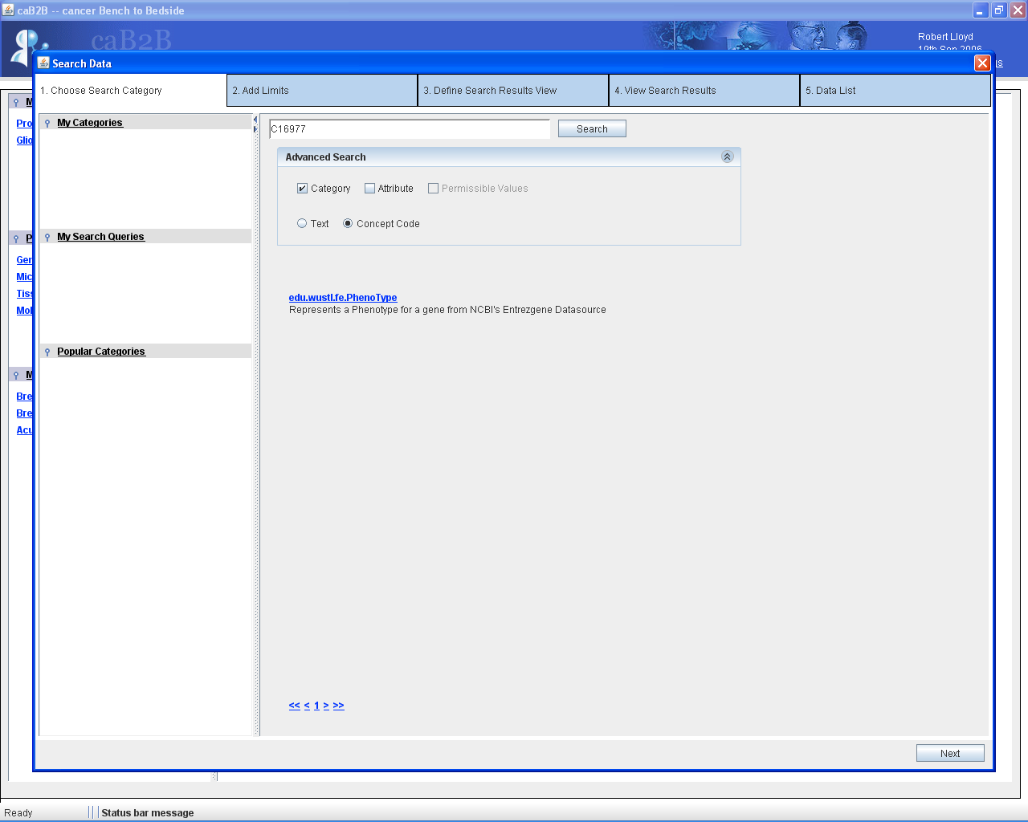
1) Enter ‘C16977’
2) ‘Category’ check box is checked
3) ‘Concept Code’ radio button is selected
4) Click on ‘Search’
Figure 2.3 Choose Search Category Dialog

- Suppose ’C16977‘ is the entered search string and ‘Category’ checkbox is checked, ‘Attribute’ checkbox is checked along with ‘Concept Code’ radio button selected and now search button is clicked. This will search system for concept codes of category name, attribute name. The result of this search is as shown in below image.
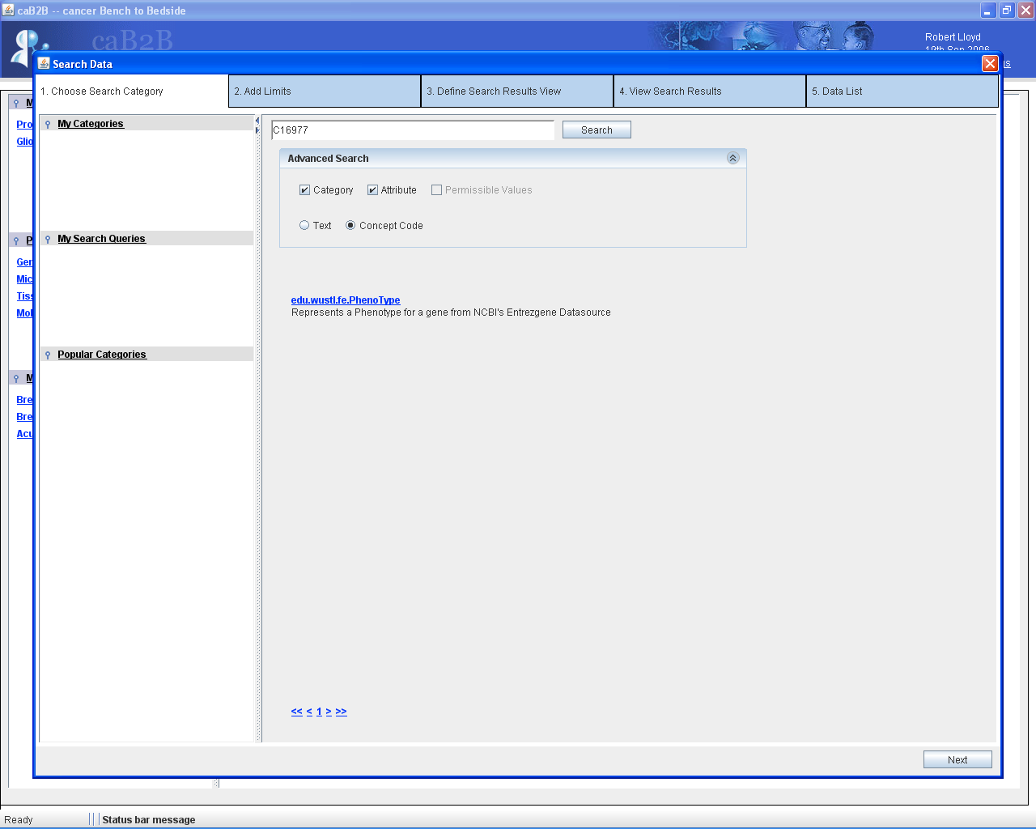
2) “Category” & “Attribute” check boxes are checked
1) Enter “C16977”
3) “Concept Code” radio button is selected
4) Click on “Search”
Figure 2.4 Choose Search Category Dialog

Thus, to search meta-data

- Enter the search item in the search field.
- Choose either ’Text‘or ’Concept Code‘ radio button.
- Check the check box corresponding to ’Category‘ and/or ’Attribute‘ and/or ‘Permissible Values’.
- Click on the ‘Search’ button.
- The System returns set of results in the browser like view. Every matched result is a hyperlink and contains description associated with it.
- Taking mouse over any description text will show the detailed description of the associated with corresponding element as tooltip.
- If the result set returned is huge, then the results are shown in multiple pages. The user can navigate to different pages by
  - Clicking page numbers at the bottom
  - Moving mouse wheel back and forth.
- Click on desired result element.
- System navigates to the ‘Add Limits’ tab.

NOTE: Search performed is partial and case insensitive. Hence search for terms like ‘Gene’, ‘gene’, ‘GENE’ will return same results for same set of options.

NOTE: The search term containing spaces / tabs is broken into multiple search terms taking space / tab as a separator and these separated search terms are search individually and then results are returned.

Add limits
This step allows user to specify constraints on the selected categories.
- In the ’Add Limits‘ tab, a set of attributes with their corresponding list of operators is displayed.
- The number of attributes and the attribute names are specific for any given category.
- Each attribute has a set of operators associated with it.
For example:
      - For an attribute of numeric data type:
The table elucidates the names of the operators along with the number of edit boxes associated with each of these operators:

No. | Operator | Number of edit boxes
1 | Equals | 1
2 | Not Equals | 1
3 | Less Than | 1
4 | Less Than or Equals | 1
5 | Greater Than | 1
6 | Greater Than or Equals | 1
7 | Between | 2
8 | Is Null | 0
9 | Is Not Null | 0
10 | In | 1
11 | Not In | 1

      - For an attribute of date data type:
The table elucidates the names of the operators along with the number of edit boxes associated with each of these operators:

No. | Operator | Number of edit boxes
1 | Equals | 1
2 | Not Equals | 1
3 | Less Than | 1
4 | Less Than or Equals | 1
5 | Greater Than | 1
6 | Greater Than or Equals | 1
7 | Between | 2
8 | Is Null | 0
9 | Is Not Null | 0

      - For an attribute of a string data type:
The table elucidates the names of the operators along with the number of edit boxes associated with each of these operators:

No | Operator | Number of edit boxes
1 | Starts with | 1
2 | Ends with | 1
3 | Contains | 1
4 | Equals | 1
5 | Not Equals | 1
6 | Is Null | 0
7 | Is Not Null | 0

      - For an attribute which is enumerated (number or string), the list of operators is:
      - In
      - Not In
Corresponding to the attribute of enumerated data type, a multi select list box containing the permissible values of the attribute is provided so that the user can select permissible values of his/her choice.

      - For an attribute of Boolean data type, the list of operators is
        - Equals
        - Not Equals
Corresponding to the attribute of Boolean data type, two radio buttons, one for ‘True’ and other for ‘False’ are provided.

Note:
- The single edit allows the user to enter input of his choice.
- Two edit boxes allows the user to enter a range constaint like age between 30 to 40.
- The ‘In’ operator values should be comma separated and “” is used as text qualifier.

- If the attribute set is huge then the user can view all the attributes by:
- Using vertical scroll bar.
- Moving mouse wheel back and forth.
- Select appropriate operator and enter a condition in the edit box, if required.
- Click on ‘Add Limit’.

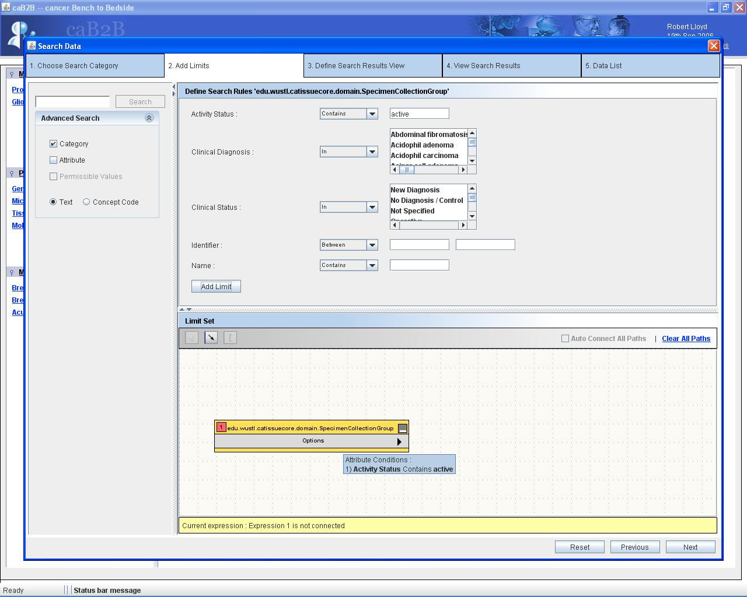
1) Enter a rule
2)Click on “Add Limit”
“Add Limits” tab
3) Rule gets added in the Dag view
Figure 3.1: Adding a limit
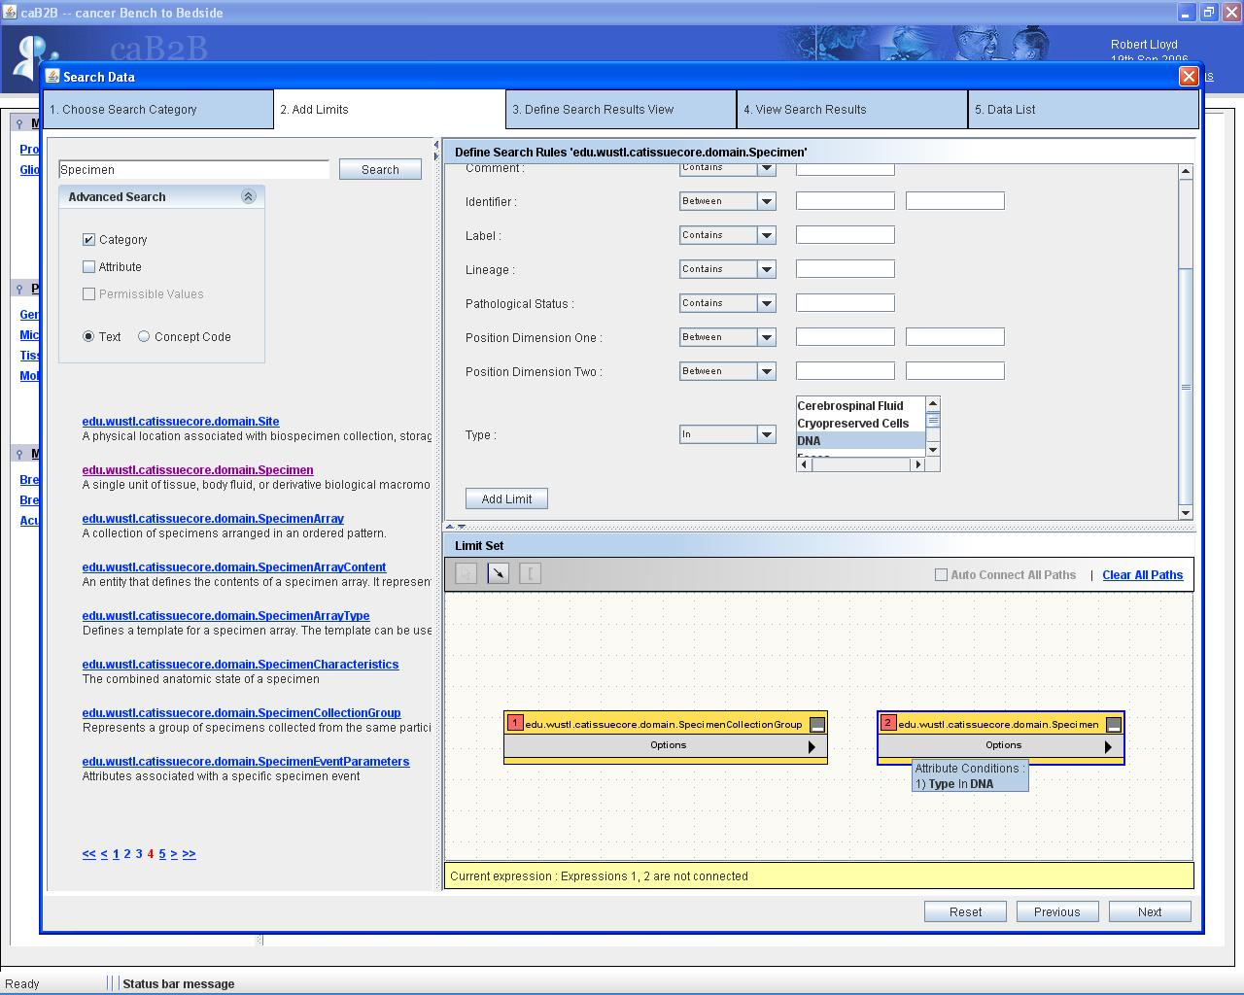
1) Enter “Specimen”
2) Enter a rule
3) Click on “Add Limit”
4) Rule gets added in the DAG view
Figure 3.2: Adding another limit

Visualize and redefine the query
This step allows the user to link added rule and form a query
- Once the user adds a limit on the attribute, then that particular category, to which this attribute belongs, gets registered in the diagrammatic (DAG) view i.e. a rectangle containing the name of the category gets added in the DAG view.
- The attribute condition gets displayed when the user places the cursor on the category in the DAG view.
- The category that got registered in the DAG view can be removed from the DAG view by clicking on the rectangle corresponding to this category and then hitting Delete button of the keyboard or selecting ‘Delete Limit’ menu item of Options menu button of the selected category rectangle.
- More than one category can be added in the D view. New search can be done in the ‘Add Limits’ tab itself. For this, the ‘Advanced Search’ panel is provided on the left hand side.
- The categories added can be linked in order for a query. The two categories from DAG are connected if path is available between selected categories.
- For this, press shift plus the two categories which the user wants to connect and then click on the ‘Arrow tool’ () button.
- If more than one path is available for connecting the two categories then an ‘Ambiguity resolver’ page pops up (Figure 6).
- Select one or more paths from the ‘Ambiguity resolver’ to connect the two categories.
- The two constraints should be connected via appropriate logical operator i.e. AND/OR.
For example:
Suppose the user has added two constraints:
  - 1st constraint: The value of ‘Activity Status’ attribute of ‘Specimen Collection Group’ category is ‘active’.
  - 2nd constraint: The value of ‘Type’ attribute of ‘Specimen’ category is ‘DNA’.

Now, if a ‘AND’ logical operator is used to connect the two constraints, then the query would essentially mean that get all the Specimen Collection Groups which have activity status as active and the type of specimen under this specimen collection Group is of type DNA.
Else if, a ‘OR’ logical operator is used to connect the two constraints, then the query would essentially mean that get all the Specimen Collection Groups which have activity status as active or the type of the specimen under this specimen collection Group is of type DNA.
- The path which the user has selected to connect the two categories gets displayed once the user places the cursor on the link connecting two categories.
- The category along with its associated links gets deleted once the user deletes the category.
- If the user wishes to edit the constraint that has been added in the DAG view then:
  - Click on Options menu button in the rectangle corresponding to the category whose constraint has to be edited
  - Select ‘Edit Limits’ menu item.
  - The user can now edit the query.
  - Note: The ‘Add Limit’ button changes to ‘Edit Limit’ button.
  - Click on ‘Edit Limit’ button.
  - The edited constraint can be viewed in the DAG view by placing the cursor on that particular rectangle.
- All the paths get cleared once the user clicks on ‘Clear All Paths’.
- Clicking on ‘Previous’, the system navigates to ‘Choose Search Category’ tab.
- Clicking on ‘Next’, the system navigates to ‘Define Search Results View’ tab.

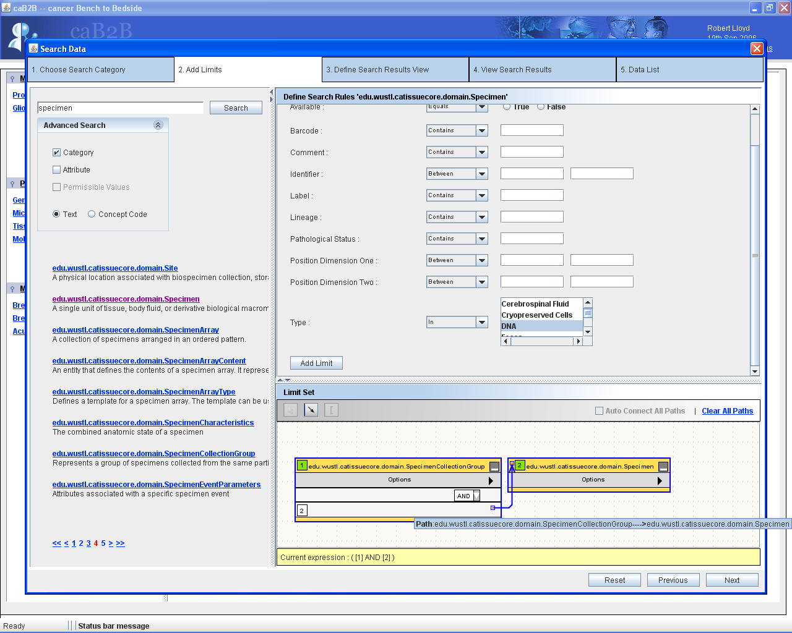
1) Connect the constraints
2) Click on ‘Next’
Figure 5: Connecting the two constraints

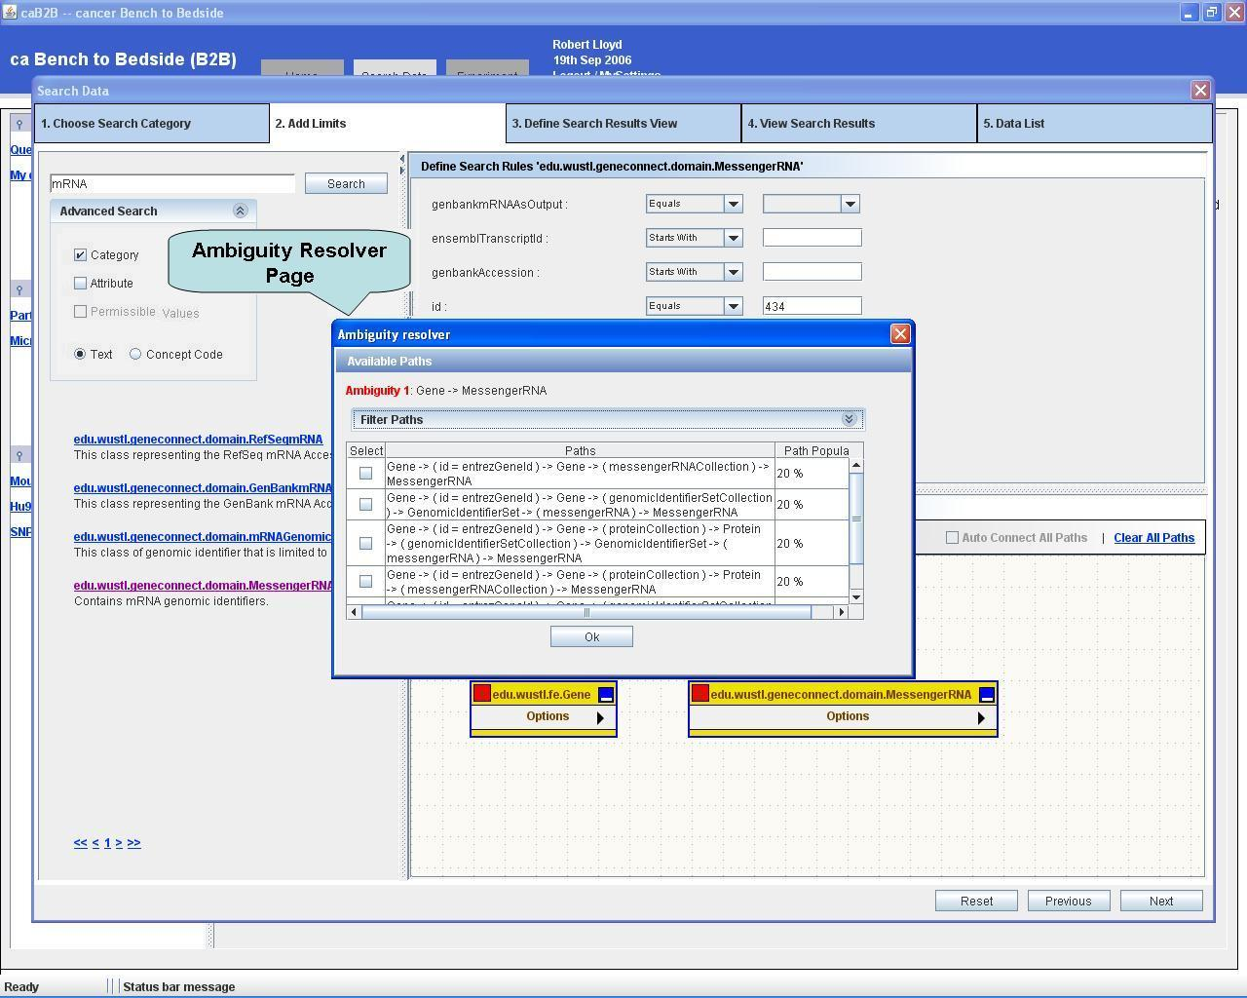
Figure 6: Ambiguity resolver page

Define the view
This step allows the user to select the output category for the query. The query constructed using
DAG view will be executed to get selected output category as a result.
- In this step, the categories on which the constraints were imposed are displayed along with their description.
- Taking mouse over any description text will show the detailed description of the associated element a as tooltip text.
- If the numbers of categories are huge, then the categories are shown in multiple pages. The user can navigate to different pages by
  - Clicking page numbers at the bottom
  - Moving mouse wheel back and forth.
- ‘Select All’ option will select all the categories from across all the pages.
- ‘Clear All’ option will deselect all the categories that were previously selected.
- ‘Invert Selection’ will select the categories which were previously not selected and also deselect the categories which were previously selected.
- Clicking on ‘Previous’, the system navigates to the ‘Add Limits’ tab.
- Clicking on ‘Next’, the system navigates to the ‘View Search Results’ tab.

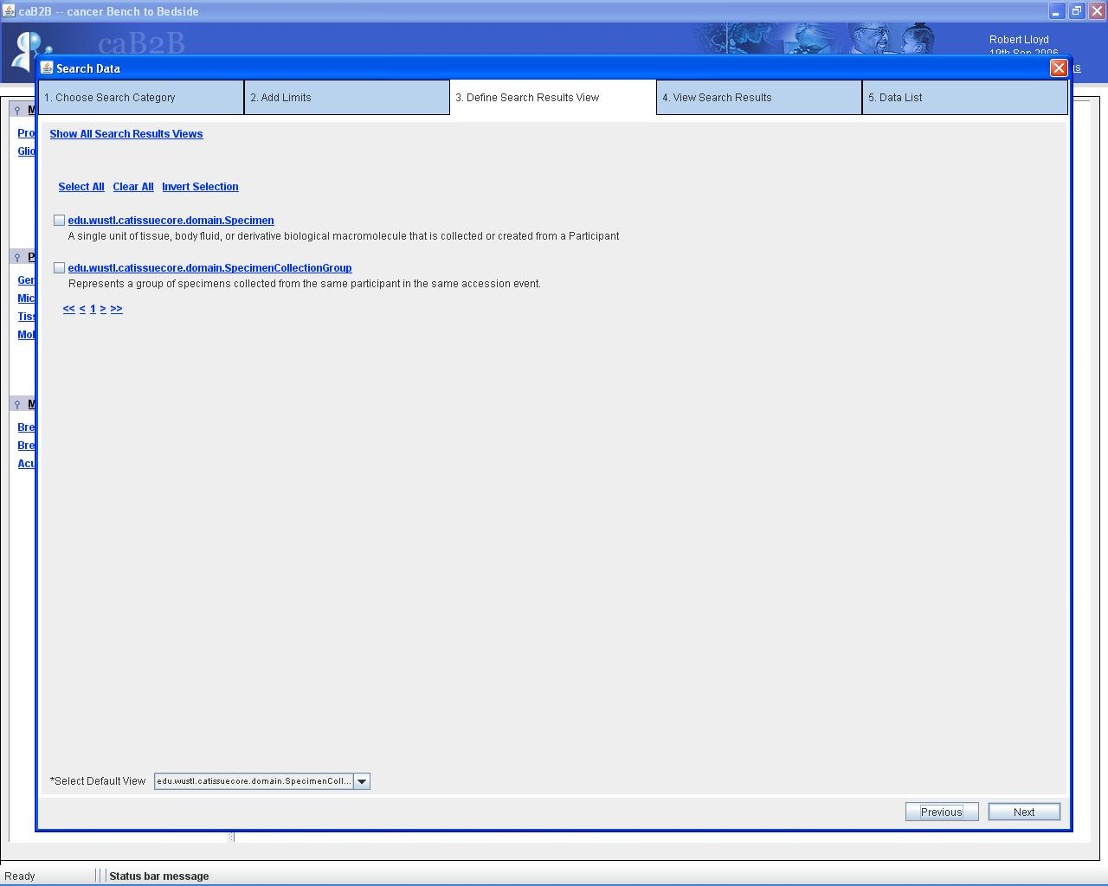
“Define Search Results View” tab
Click on “Next”
Figure 7: ‘Define Search Results View’ Tab

View Search Results
This step executes the query constructed by user in earlier step and shows results in a browser like view.
- In this step, all those output category elements which have satisfied the constraints imposed in the earlier steps displayed.

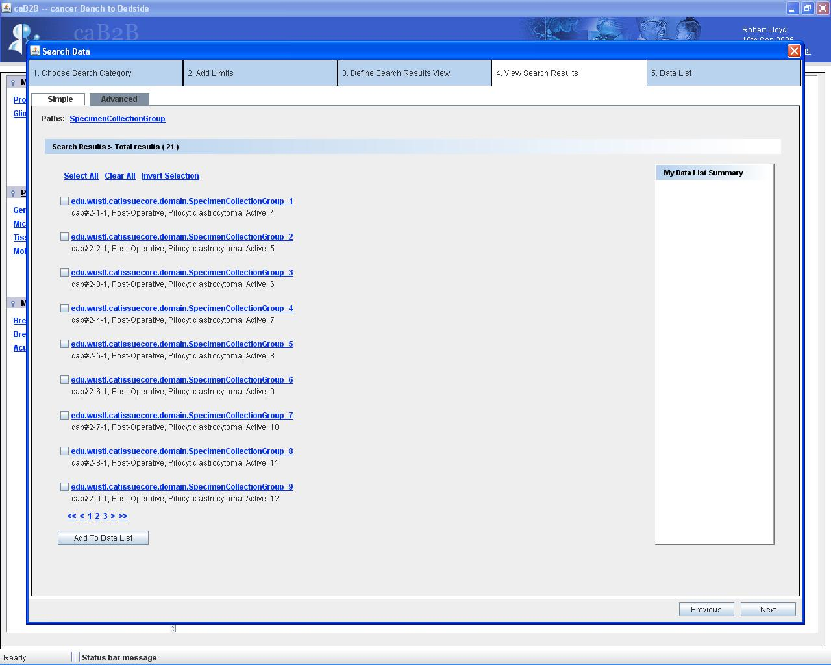
“View Search Results” tab
1) Click on “SpecimenCollectionGroup 5”
Figure 8: ‘View Search Results’ tab

- Clicking on any hyperlink element, the system shows up a page which has description of that clicked element i.e. attributes along with their values.
- If the result set is huge then the results are shown in multiple pages. The user can navigate to different pages by
  - Clicking page numbers at the bottom
  - Moving mouse wheel back and forth.
- Adjacent to the element's description is the ‘Related Data’ panel, which contains categories which are related to this element.
For example: The ‘Related Data’ categories for the category ‘Specimen Collection Group’ are ‘Specimen’ and ‘Collection Protocol Registration’.
- Clicking on any category from the ‘Related Data’ panel, the system show up a page which contains elements of selected ‘Related Data’ category which belongs to the parent category from where ‘Related Data’ link is clicked.
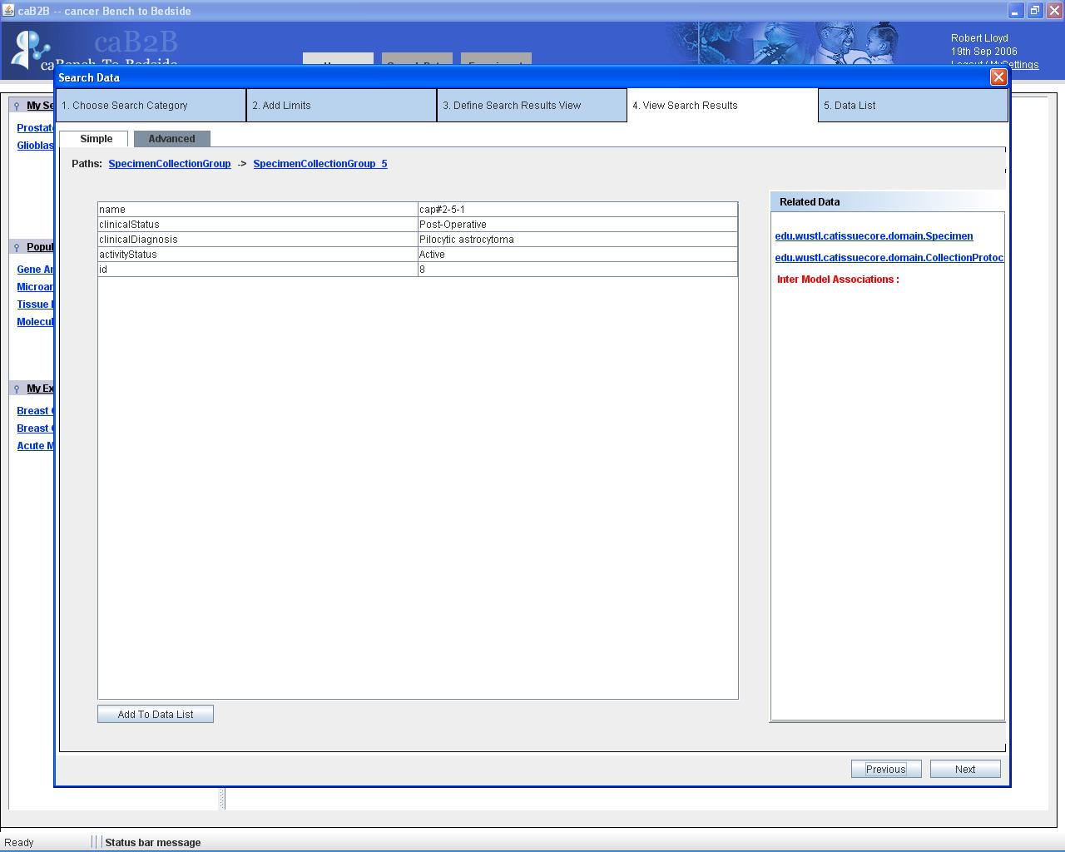
1) Click on ‘CollectionProtocolRegistration’
Figure 9: ‘Related Data’ panel

- Clicking on any hyperlink element, system shows up a page which has description (i.e. attributes with their values) of that element.
- As the user navigates through all these different elements and categories, a path map, ‘Paths’ is shown, at every step, which contains the user traversed path.
For example:
From Figure 11:
Paths: SpecimenCollectionGroup -> SpecimenCollectionGroup 5 -> CollectionProtocolRegistration -> CollectionProtocolRegistration 1

NOTE:All these categories/objects are hyperlinks.

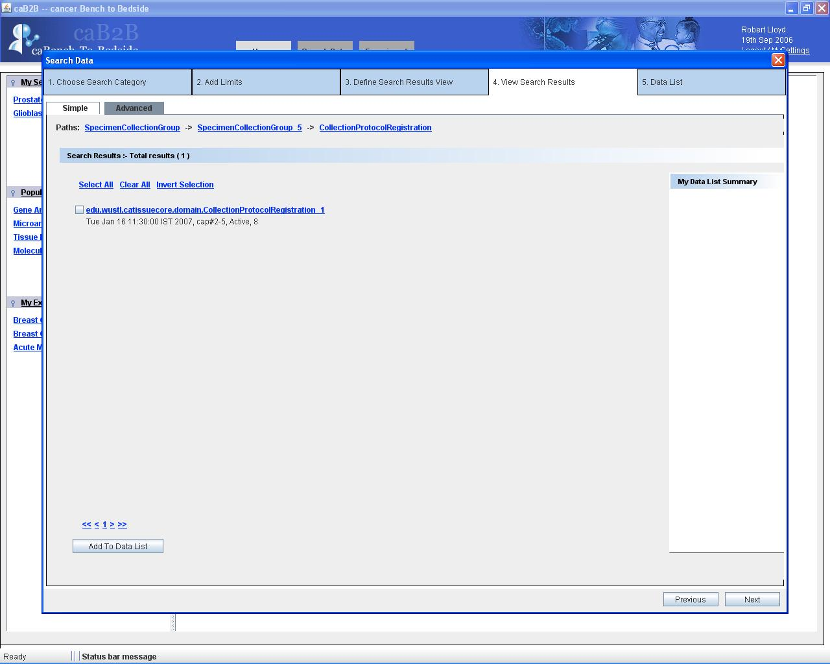
Click on ‘CollectionProtocolRegistration 1’
Path map
Figure 10: Path Map

- Clicking on any of the links in the path map then the system navigates to the corresponding page.
- ‘My Data List Summary’ panel contains links of the data items that are added to the data list. The section ‘Select and Add to Data List’, described further in this manual, tells how the user can add data items to the ‘Data List’.
- Clicking on ‘Previous’, the system navigates to the ‘Define Search Results View’ tab.
- Clicking on ‘Next’, the system navigates to the ‘Data List’ tab.

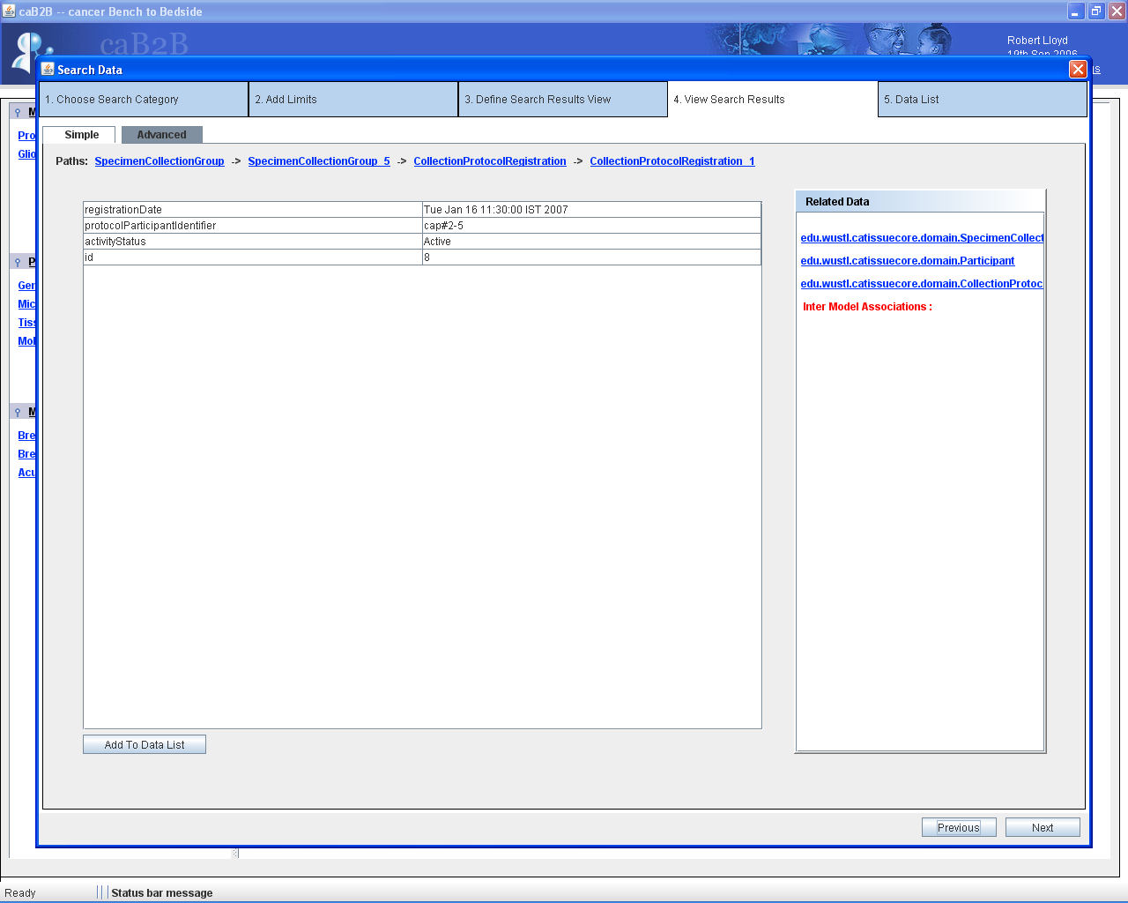
Path map
Click on “SpecimenCollectionGroup”
Figure 11: Traversal to different data elements with the help of Path Map.

Select and Add to data list
- The user has the option of adding all or selected result elements to the ‘Data List’ for further use.
- For selecting all result elements:
- In the ‘View Search Results’ tab, click on ‘Select All’.
- Click on ‘Add To Data List’.
- Click on ‘Next’.
- System navigates to ‘Data List’ tab.
- All the elements across different pages get displayed in the ‘Data List’ tab.
- Selecting few result elements from different pages:
  - In the ‘View Search Results’ tab, select few elements from disparate pages.
  - Click on ‘Add To Data List’.
  - Click on ‘Next’.
  - System navigates to the ‘Data List’ tab.
  - Only those elements, which are checked by the user in the ‘View Search Results’ tab, get displayed in the ‘Data List’ tab.
- In the ‘View Search Results’ tab, ‘Clear All’ option will deselect all the elements that were previously selected.
- In the ‘View Search Results’ tab, ‘Invert Selection’ will select the elements which were previously not selected and also deselect the elements which were previously selected.
- In the ‘Data List’ tab, clicking on any element shows description of that element.
- In the ‘Data List’ tab tree hierarchy of the element which has been added in the ‘View Search Results’ tab can be viewed. Example of tree hierarchy is shown in Figure 14.
- Clicking on ‘Previous’, the system navigates to the ‘View Search Results’ tab.
- Clicking on ‘Next’, a ‘Reset’ button pops up.
- Clicking on ‘Reset’, the system shows ‘Search Dialog’ (as shown in Figure 1.1) in the ‘Data List’ tab.

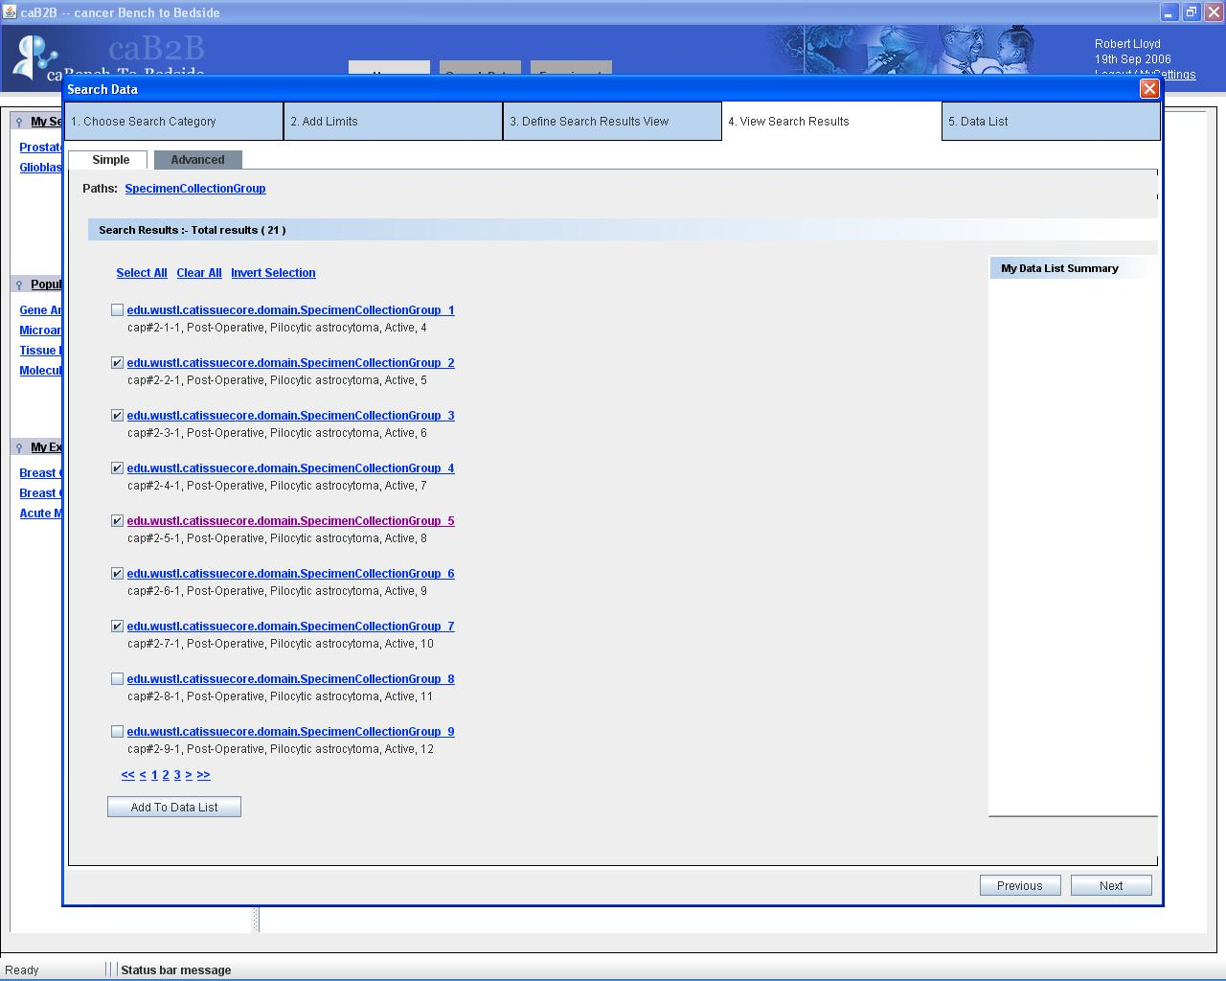
1) Select few objects
2) Click on ‘Add To Data List’
3) Click on ‘Next’
Figure 12: ‘Add To Data List’ functionality
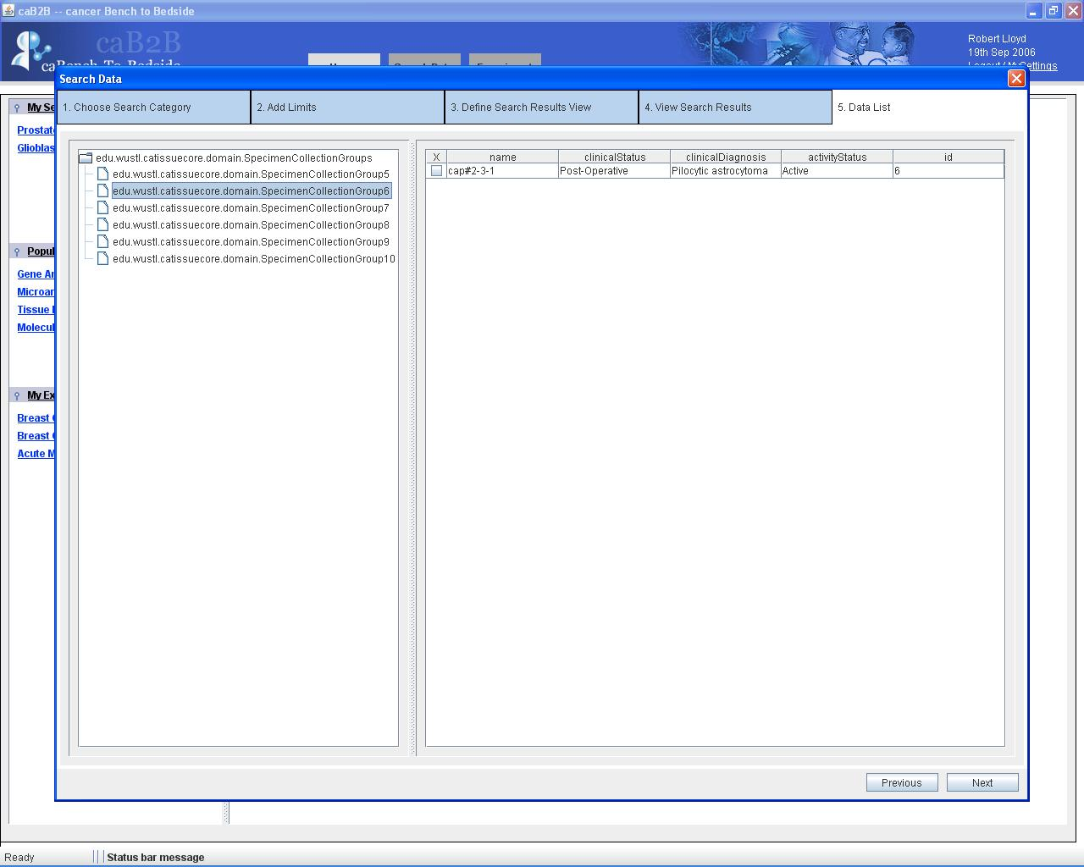
‘Data List’ tab
Figure 13: ‘Data List’ tab

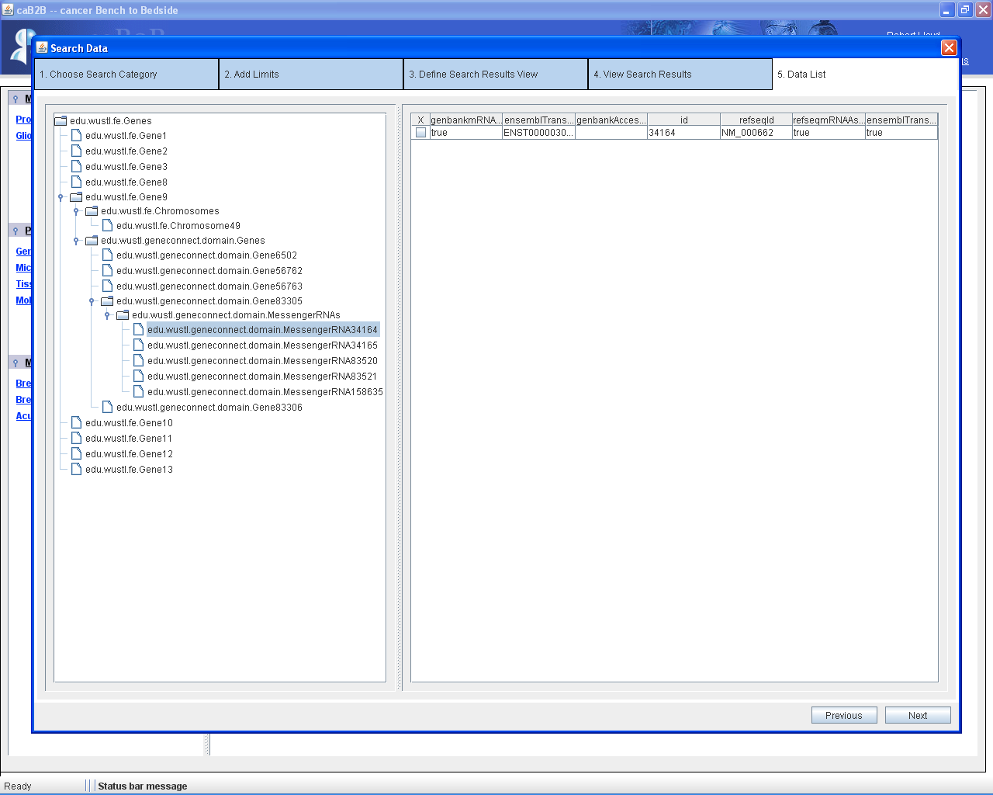
Tree hierarchy
Figure 14: Example of tree hierarchy

