caBench-to-Bedside 1.0
User’s Manual

Document Change History
Version Number | Date | Contributor | Description
V1.0 | July 12, 2007 | Washington University/Persistent Systems | Reviewed


Updated 20 July 2007
Teams
Development | User’s Manual | Program Management
Chandrakant Talele¹ | Rahul Ner¹ | Dr. Rakesh Nagarajan²
Srinath Krishnamurthy¹ | Srinath Krishnamurthy¹ | Srikanth Adiga¹
Rahul Ner¹ | Chandrakant Talele¹
Deepak Shingan¹ | Srikanth Adiga¹
Chetan Patil¹ | Raji Joshi¹
Hrishikesh Rajpathak¹ | Mukesh Sharma²
¹Persistent Systems Limited | ²Washington University

Contacts and Support
Training contact | help@mga.wustl.edu
Customer support contact | help@mga.wustl.edu

Table of Contents

Chapter 1 Introduction 1
In this chapter 1
Introduction to caB2B 1
Getting started with caB2B 2
Overview of the Manual 2
Organization of the User Manual 3
Document Text Conventions 3
Introduction to Category and Limits 4
The Home page 6
Chapter 2 Searching Data 7
In this chapter 7
Search data – The Query Wizard 7
Choose Search Category 8
Define Limit 11
Limit Set – Diagrammatic View 12
Define Search Results View 19
View Search Results 20
Save Query 27
Viewing and Saving Data List 31
Chapter 3 Experiments 35
In this Chapter 35
What are Experiments and Projects? 35
Creating an Experiment 36
Viewing the Existing Experiments 38
Opening an Experiment 38
Working with an Experiment 40
Custom Data Category 43
Analyzing Data 45
Visualizing Data 48
Appendix 1 - Examples of category search 52
Appendix 2 - Define Limit: Operators and Values 57
Appendix 3 - Record Details View 59
Administrator defined categories 59
Appendix 4 - Types of Filters 61

Introduction

In this chapter
This chapter explains the scope and function of the cancer Bench to Bedside (caB2B) application. It helps you understand how to use caB2B to satisfy diverse biomedical research needs. It contains the following sections:
- Introduction to caB2B
- Getting started with caB2B
- Overview of the manual
- Organization of the manual
- Document text conventions
- Introduction to Category and Limits
- Overview of Home Page

Introduction to caB2B
The National Cancer Institute cancer Biomedical Informatics GridTM (NCI caBIG™) project creates a common, extensible informatics platform that integrates diverse data types and supports interoperable analytic tools. caBIG™ is developing separate applications that will facilitate individual steps involved in micro-array analysis. These applications are also useful to bio-informaticians.
caGrid is the infrastructure for caBIG that helps integrate these applications. caGrid can be used to perform investigations involving data integration and analytical services from diverse research communities.

caBench-to-Bedside (caB2B) is an application that leverages these tools in a user-friendly graphical user interface (GUI). caB2B can be used by the physician scientist to perform operations such as:
- Query any caGrid data service to obtain data.
The data service can be a single data service, multiple data services, or a combination of the two services using semantically interoperable Common Data Elements (CDEs).
For example, caB2B allows investigators to query tissue banks at multiple cancer centers, design studies that focus on very specific tumor subtypes and to target less common tumors by pooling bio-specimen resources. This alleviates the problem of small sample size in a study.
- Collect data and create experiments.
caB2B also enables investigators to perform novel in silico experiments using micro-array data that have been archived. These capabilities facilitate the process of identifying genes that are up-regulated or down-regulated in specific cancers and enable investigators to view data in the context of biological pathways. Investigators gain further understanding of the complex system of cancer biology by identifying genes important to the development and treatment of cancer. These capabilities could lead to more effective identification of novel drug targets, and improved treatment strategies.
- Perform various analyses by using various grid-enabled analytical services.
caB2B enables individual users to work on common platforms to access caGrid resources in real time from common data and analytical services.
- Visualize analysis results using charts and dendrograms.

Getting started with caB2B
caB2B provides a platform to bring the laboratory research to clinical level. caB2B enables information to be shared along the continuum from the scientific bench to the clinical bedside and back. The tool helps in querying the various caGrid enabled services, for example, it is possible to query for all the up-regulated and down-regulated genes of a malignant tissue sample, using the services available in caB2B. Thus, caB2B helps bridge the gap between the bench and the bedside.
- To start caB2B client, refer to the Installation Guide.
- To search for data sets refer to “Search data – The Query Wizard”.
- To design experiments, refer to “Experiments”.

Overview of the Manual
This manual provides the details of how to use caB2B application to
- Search data sets of interests
- Create an experiment from data sets
- Analyze data
- Visualize data
All the chapters in this user’s manual begin with an introductory statement and are followed by a list of topics included in that chapter.

Organization of the User Manual
Following table summarizes the chapters in this manual.
Chapter in caB2B | Chapter Contents

Document Text Conventions
2. Searching Data | General overview  Searching categories  Adding limits  Defining output  Viewing the results  Saving Query  Saving data
3. Experiments | Creating Experiments  Analyzing data  Visualizing data
6. Appendix 1 | Examples of category search
7. Appendix 2 | Operators in Defining limit
8. Appendix 3 | Details of the various records
9. Appendix 4 | Various filters
Following table illustrates documentation conventions represented in this manual.
Convention | Description | Example

Introduction to Category and Limits
 | Indicates information of particular interest
 | Indicates that you should be particularly aware of the information provided. | CAUTION  It deletes permanently.
Administrator can create a new category.
CAUTION

What is a Category?
A category is a collection of searchable attributes. You can use a category to search, view, and add data to experiments. Every domain object in an application is, trivially, a category. For example, Participant is a domain object from caTissue Core application.
Examples:
Participant is a category consisting of attributes like
- Identifier
- First Name
- Last Name
- Gender
- Race
Gene Annotation is a category consisting of attributes like
- Entrez Gene ID
- Gene Symbol
- Gene Name
- GenBank Accession Number
- Taxonomy ID
- Chromosome

Why do we need categories?
Categories are designed to help you to easily locate all the data elements needed for your search.
Categories are created by the administrator.
Your administrator can create new categories based on your requirements. If there are queries that you perform regularly, discuss them with your administrator.

What is a Limit?
A limit is a condition (or criterion or predicate or condition) on a category. It is the smallest unit of a query. For example, female participants

What is a query?
The collection of limits is a query. For example, female participants who have DNA specimens collected from their breast. This query has two limits: female participants, DNA specimens from breast. There are two categories involved in this query: Participant and Specimen.
Your administrator can create a new category that contains relevant data elements from Specimens and Participants. That way you can enter all the limits in a single category.

The Home page
For details on installing and starting the caB2B client, refer to the Client Installation chapter of the Installation Manual.
When the caB2B application is launched, you see the caB2B Home page as shown below.
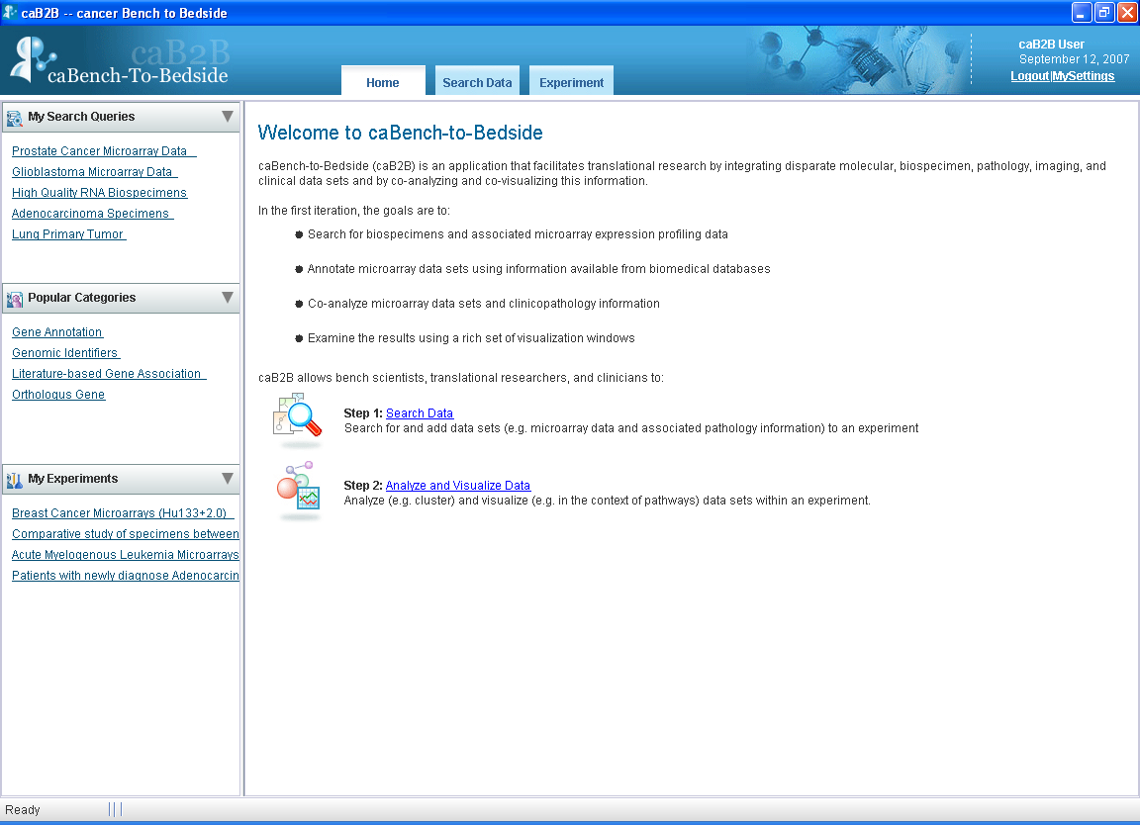
Figure 1: caB2B Home page

As mentioned in the Introduction section, a caB2B end user would typically perform the following steps:
- Perform queries to obtain the data set of interest. Details of this step are provided in the chapter, Searching Data.
- Analyze and visualize data. Details of this step are provided in the Experiment chapter.

Searching Data

In this chapter
This chapter describes details of how to search data using caB2B in the following sections:
- Search data
- Choose Search Category
- Define Limit
- Define Search Results View

- Save Query

Search data – The Query Wizard
This section provides details of the steps that are required to obtain data. Click the Search Data link on the Home page to open the Search data for Experiment wizard. This opens the Choose Search Category tab. (see Figure 2: Choose Search Category Tab).
The wizard guides you through the following steps:
Choose Search Category
Add Limits
Choose Output Category
View Search Results
STEP ONE
STEP TWO
STEP THREE
STEP FOUR
STEP SIX
STEP FIVE
Save Query
View Data List

The steps used to search data are:
- Choose Search Category: Search for Category to apply limits.
- Add Limits: Add limits on the selected Category
- Choose Output Category (Optional): Select the output format (i.e. define the results view)
- View Search Results: View the results view in a Google-like search results page and add data to the data list (or shopping cart).
- Save query: Saves the query to be executed later
- View Data List: View the data you have added in the data list and create Experiment.

Choose Search Category
This step helps you search for the category on which you have limits. For example, if you have a query with limits on participants, you can use this feature to first find the Participant category.
To find the categories, do the following:
Type the search string in the text box. Gene, gender, RNA, experiment are examples of search strings.
Click the Search button or press ENTER.
Categories that match the string you entered are displayed as hyperlinks along with a short description.
Once you find a Category of your choice, click the Category to proceed to the next step.

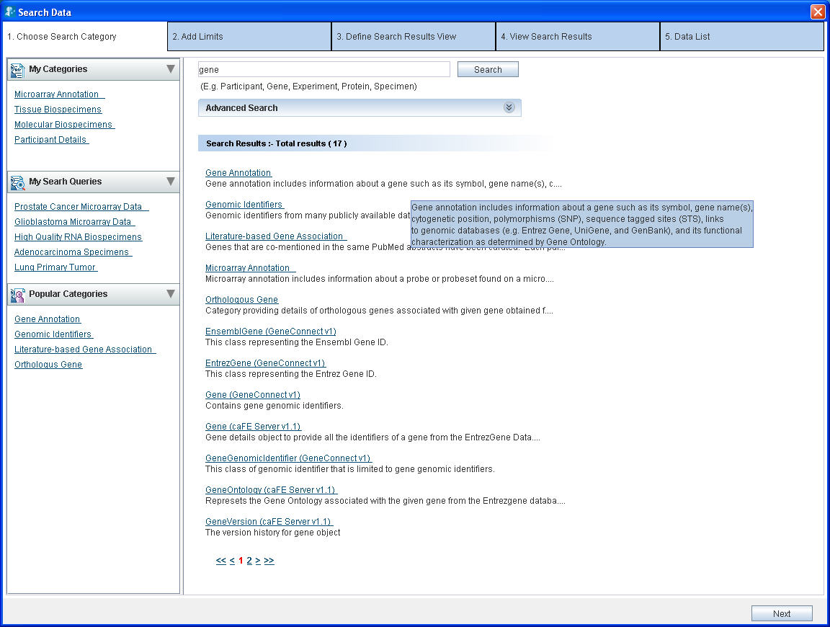
Figure 2: Choose Search Category Tab
More on searching:
- The search performed is partial and is not case-sensitive. Hence the search for terms such as Gene, gen or GENE returns the same results.
- If a category’s description is long, you can view the complete description as a tool-tip by positioning the mouse over that description.
- If the number of matching categories is large, the system displays the results in multiple pages. Click the page numbers at the bottom to navigate to different pages.
- You can separate the multiple search terms using spaces or tabs. The system searches for each term individually and displays a collective set of matching categories. For example, if you enter the search string Participant Gene, you will find the categories that match either Participant, Gene, or both.

Advanced Search (*)
Expanding the Advanced Search box displays the advanced options that help you refine the category search. The following is the default selection of the various options:
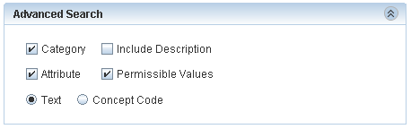
Figure 3: Advanced search
If the system returns too many results for your Category search, you can use the Advanced Search to narrow your search.
Table 3
Option | Description
Check Boxes
Category | Includes the category names in the search.
Attribute | Attribute (also known as data element) is the lowest unit of the searchable items. A category contains many attributes.  Select this check box to include the individual attribute names in the search.  For example: select attribute and search for gender. You will find the category Participant since it contains an attribute by name Gender.
Permissible value | Some attributes contain a fixed set of values. For example, Gender can be Male, Female or Unspecified. Organ can be heart, lung, breast, and so on.  This fixed set is known as Permissible Values.  Select this check-box to include the permissible values in the search. So if you select the permissible value as Male the system displays the Participant category since it contains an attribute Gender which contains a permissible value Male gender.
Include Description | Includes the description text in the search.  Note: Include Description check-box will be enabled only for a text based search when you select the Category check box, the Attribute check box, or both.
Option Buttons
Text | The system matches the search string that you type with the name of the category, its attributes, or the permissible values based on the text.  This is the simple, most commonly used and the default way of searching a category.
Concept Code | The system treats the search string that you type as an Enterprise Vocabulary Services (EVS) concept code. The system matches this concept code with the concept code of the category, its attributes, or the permissible values. The results contain matching categories. More details in concept code can be found on http://nciterms.nci.nih.gov/NCIBrowser/SearchConcept.do and http://ncimeta.nci.nih.gov/MetaServlet/

Additional refinements that you can make with these options are illustrated in the Appendix 1 - Examples of category search.

Define Limit
A limit is a condition (or criterion or predicate) on a category and multiple limits together form a query. The following table outlines two example queries and the limits added to them.
Table 4
Example | Category | Limits
Get the details about all the African male participants | Participant | Gender In Male  Race equals African
Biospecimens from prostate adenocarcinoma | Specimen Characteristics | Tissue Site equals prostate
Biospecimens from prostate adenocarcinoma | Specimen Collection Group | Clinical diagnosis equals adenocarcinoma

Steps for defining a limit
Perform the following steps to define a limit:
- Choose an operator from the list of operators adjacent to the attribute you wish to constrain.
- Specify the constraining values.

For a detailed explanation of the various operators and how to specify values, refer to Appendix 2: Appendix 2 - Define Limit: Operators and Values.

Example:
Single constraint – Show all male participants
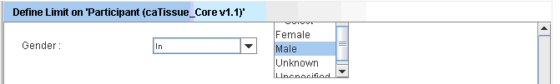
Figure 4: Male participants

Example:
Multiple constraints within one limit: male participants who are alive. Multiple conditions can be defined on an attribute by pressing CTRL key while selecting the options: Specimens which are either Serum or Plasma.
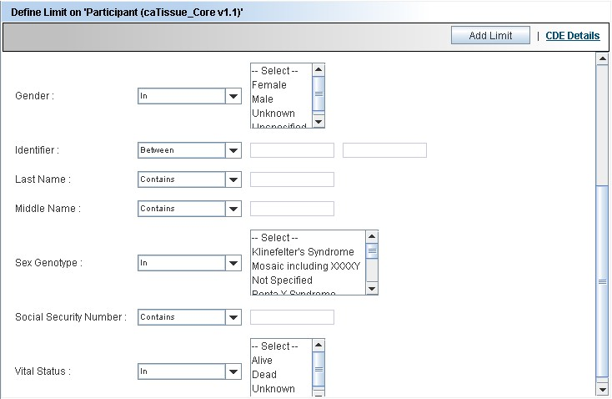
Figure 5: Male participants who are alive
CAUTION
Do not forget to click the Add Limit button at the bottom of the Define Limits screen before proceeding. If you forget to click this button, the constraints that you specify will not be saved.

Limit Set – Diagrammatic View
Once the limits have been set on the category clicking on the Add Limit button adds the category in form of a yellow rectangle also called as node into the Limit Set Panel. The Limit Set panel consists of the DiAGrammatic view (DAG view) panel. DAG view is like a canvas where all the categories on which limits have been added appear in the form of nodes (Figure 6). Whenever you add a new limit, the system adds a yellow rectangle to the DAG view. This rectangle represents the limit you added. As you continue to add limits, the system adds corresponding rectangles to the DAG view.
These rectangles in the DAG view give you a graphical view of all the limits that have been added.

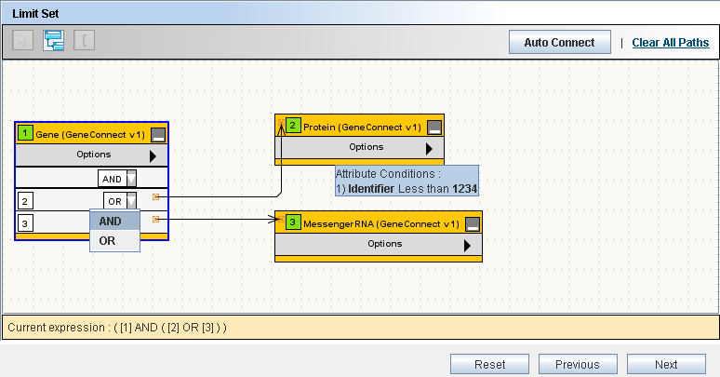
Figure 6 : Limit Set Panel

DAG Operations
You can perform the following operations within the DAG view:
Table 5
View details of the limit | Position your mouse over a node to view the details of that limit.  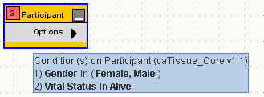
Edit the limit | Click Edit Limits from the Options menu of the node whose limits you wish to edit. Alternatively, double click the title of the node.  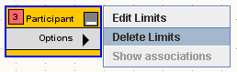  This opens the limit in the Define Limit Error: Reference source not foundpanel in the edit mode. Edit the constraints in the Define Limit panel, and click the Edit Limit button.
Delete the limit | Select the nodes that you wish to delete and press DELETE.  Alternatively, you can delete a single node by selecting Delete Limits from the Options menu of the node as shown above.

Connecting the Limits
You must connect all the limits before proceeding to the next step.
When you specify multiple limits, you need to connect these limits to form an expression. You can connect two limits using either the AND or the OR operator. The following is an example of how the DAG looks when the limits are connected.

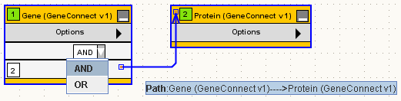
Figure 7: Connected Nodes
If there are only two limits in the query, you have to connect only those two rectangles
To connect the limits, you need to specify the following:
- The path to be taken in connecting the nodes
- The logical operator (AND, OR) in the dropdown box in a node
The rest of this section focuses on various ways in which you can specify the path(s).

What is a Path?
A path tells the system how two categories are to be connected. A path is a way to travel from one category to another. There could be multiple ways to connect two categories and the results of the query will differ based on the path you choose.
For example, consider the two categories Specimen and Site (from the caTissue Core application). A Specimen is associated with the Site category in two ways: 1) Site where the specimen was collected 2) Site where the specimen is stored.
That means there are two paths between Specimen and Site: 1) through Storage Container 2) through Specimen Collection Group for the collection site.
Query example 1: Show all the available specimens collected in Barnes Jewish Hospital. In this query, as you are specifically interested in a particular collection site, you should choose the path through Specimen Collection Group.
Query example 2: Show all the available specimens stored in Barnes Jewish Hospital. In this query, as you are specifically interested in a particular storage site, you must choose the path through Storage Container.
Therefore it is important to choose the right path for your query.

Connecting Limits
Click the Auto Connect button. The system will automatically connect all the boxes based on the settings done by your administrator.
However, the administrator might not have configured the path between all the categories. In such cases, you can manually connect the limits as described below.
Example query: For all the male participants, show all the available specimens collected in Barnes Jewish Hospital.
- After adding the three limits on Participant, Specimen and Site the DAG view will look like the figure below.
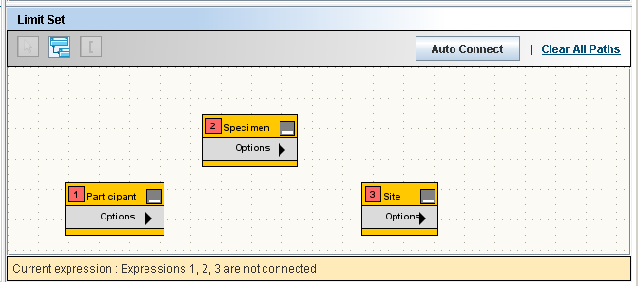
Figure 8: Limit Set
- Click the Participant and the Specimen rectangles to select them.
- Click the Connect Limits icon to connect the two nodes. The resulting DAG view is shown in Fig.9 below.
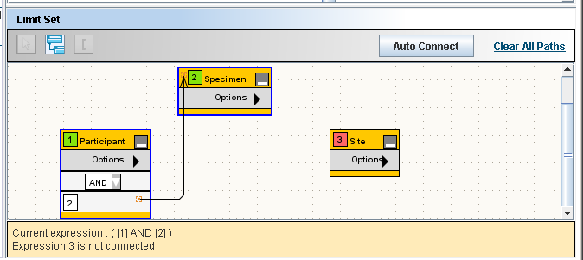
Figure 9: Limit Set with Two Connected Limits

Note: There is only one path between Participant and Specimen, therefore the system automatically connects it.
- Select the Specimen and Site rectangles and click the Connect Limits icon.

- Since there are more than one path between Specimen and Site, the system cannot connect the limits on its own. So it displays the Ambiguity Resolver window. The Ambiguity Resolver window is shown inFig.10 below:

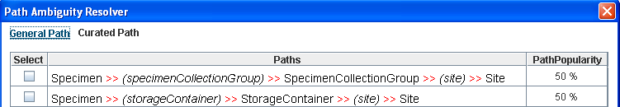
Figure 10: Path Ambiguity Resolver

The Ambiguity Resolver now shows two paths between Specimen and Site: 1) through Specimen Collection Group for the collection site 2) through Storage Container.
- Select the first path to find out the collection site.
- Once the path(s) are determined, the system creates a connection between the two nodes (see figure below). You can position the mouse over the connection to view the path(s) that you chose.
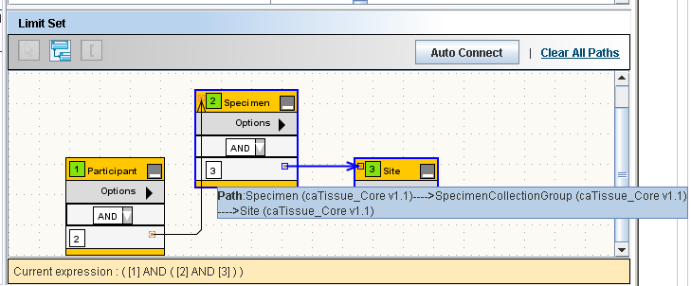
Figure 11: Limit Set with Three Connected Limits

- Specify the operator (AND or OR) using the dropdown box in the node.
- Click the Next button to go to the next step.

Deleting a Connection
You can delete a connection by clicking the connection which is the arrow between the two nodes and pressing the DELETE key.

The Information Panel
The Information panel is located at the bottom of the Limit Set panel.
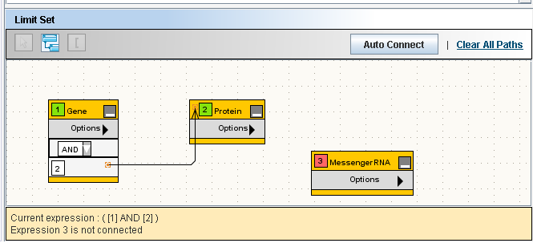
Information Panel
Figure 12: The Information Panel

The Information panel provides the following information:
- The expression formed as a result of the way you have connected the limits
- Limits that not yet connected to any other limit
- To execute the query, there should not be any unconnected rectangles.

Reset, Previous and Next Buttons
These buttons are located at the right hand bottom of the screen (see Figure 6).
- The Reset button clears all the limits that you have specified.
- The Previous button takes you to Choose Search Category step of the wizard.
- The Next button takes you to the Choose Output Category step of the wizard. A valid query allows you to proceed to the next step. If the query is invalid, an appropriate error message is displayed.

Define Search Results View
After specifying the limits, user proceeds to choose the category for the data. For example, “show all the participants who had biospecimens collected from their breast”. Participant is the category that you want to view, based on a limit on the specimens.
The Define Search Results View tab enables you to select the output category for the query.
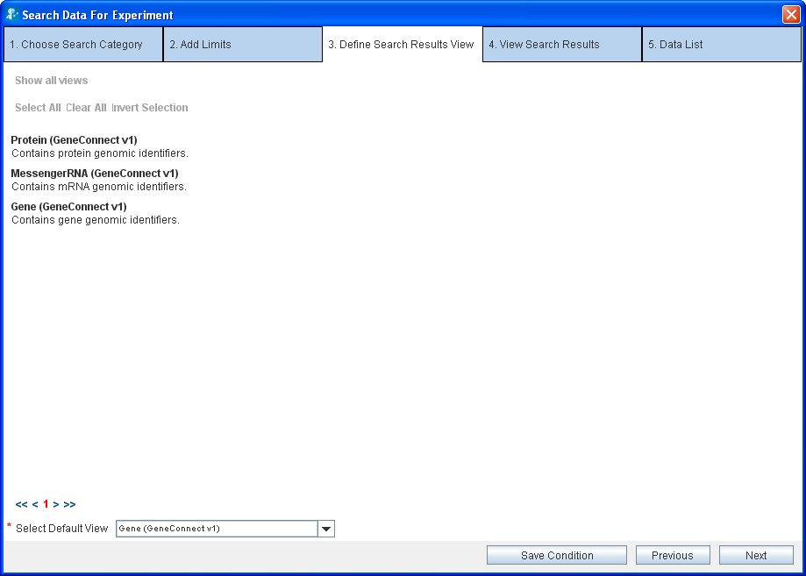
Choose the Default view here
Figure 13: Define Search Result View.

All the categories with specified limits are shown in the Select Default View dropdown box at the bottom of the screen. From the Select Default View dropdown box, select the category whose data you wish to obtain.

Ignore the other contents of this screen such as the check boxes and hyperlinked categories. Those are intended to allow you to fetch data for multiple related categories in one go. However, this feature is not supported in this release of caB2B.

The Next and Previous Buttons
- To edit the limits, click the Previous button and go to the Define Limit step.
- Click the Next button to execute the query that you have created.
CAUTION

On clicking the Next button, the system will execute the query and fetch the data from appropriate data services over the caGrid.
This step could be time-consuming based on the network speed and the complexity of the query.

View Search Results
The View Search Results tab displays the results obtained by executing the query you had defined in the previous steps. The concept of viewing results in caB2B is similar to viewing results after a Google search. The similarities are as follows:
- caB2B returns a set of records that match your limits.
- Some details of the record are displayed along with the record.
- You can click on one of the records to view more details.
- There you can view additional associated information for the record you are viewing. For example, from Participants you can see the Collection Protocol in which they registered. This is similar to Google where, after you click one of the hyperlinks, you can traverse into the other web pages by clicking the hyperlinks within that page.
- As in Google, the results are divided into multiple pages for easy navigation.
- If you find any data of your interest, you can add it to the Data List.

The following image displays a typical results view. The View Search Results tab displays the records that match the limits and also the data that you have already added to the data list.
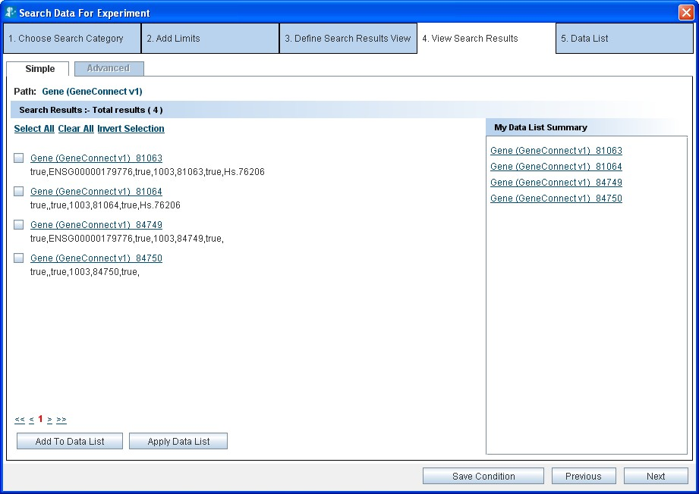
Data List
Summary
Figure 14: View Search Results

Record Details
Click on the hyperlink of a record on the View Search Results to take you to the Record Details page. Here you can view the values of all the attributes of the category.
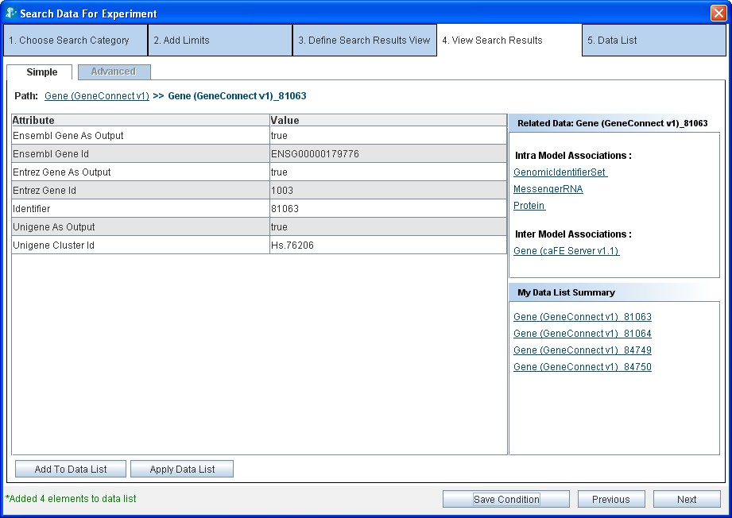
Related Data
Figure 15: Results’ Details
A view of the Results Details page is shown in Figure 15 (above) and shows the following sections:
- Value of all the data elements in the record
- Links to related data
- Summary of the records that you have already added to the data list

Related Data
In Figure 15 above, the Related Data box on the right displays the categories that are related to the current category. Click on any of the categories to display records for that category. For example, if you are currently viewing records of Gene (GeneConnect), the following categories are shown in the related data box:
- GenomicIdentifierSet (GeneConnect)
- Protein (GeneConnect)
- MessengerRNA (GeneConnect)
- Gene (caFE Server)
If you now click Protein, you would see the Proteins related to the Gene you are currently viewing.

Breadcrumbs

Definition of Breadcrumbs – Wikipedia
Breadcrumbs or breadcrumb trails are a navigation technique used in user interfaces. Its purpose is to give users a way to keep track of their location within programs or documents.
As you traverse the results view, breadcrumbs are displayed at the top of the page. For example, if you are viewing a Protein record related to a Gene, you would see the path as
Gene >> Gene _1 >> Protein >> Protein_5
This means that you originally queried for Gene. Then you fetched related proteins for Gene_1. From the proteins obtained, you are currently viewing details of Protein_5.
Click any of the links in the breadcrumbs to navigate back to the corresponding page. For example, you can click Gene in the above path to go back to the page where you were shown the list of Genes.

Adding data to the Data List
A data list is like a shopping cart. As you traverse through the results and find some interesting data you can add it to the shopping cart.
You can add data to the data list in two ways:
- Click the Add to Data List button
- Click the Apply to Data List button

As you add the data to the data list, they are reflected in the My Data List Summary box on the right hand side.

Add to Data List
Select the record that you want to add to the data list and click the Add to Data List button. You can either add one record at a time or add multiple records by selecting the checkboxes placed along with the record summary.

Using Apply Data List

Why use Apply Data List
In the Results Details page in Figure 15: Results’ Detailsthe following sections are shown:
- Value of all the data elements in the record
- Links to related data: you can obtain data for categories related to a particular category.
- Summary of the records that you have already added to the data list

A typical user query might do the following:
- Fetch the data for the Gene category.
- Fetch the related data from the category Chromosome for a record of Gene, for example, Gene_1.
- Add the Chromosome record to the data list.
The resulting data list is shown in Fig. 16 (below).

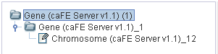
Figure 16: Data List

If you wish to obtain the Chromosome data for some more Gene records you have to fetch the related Chromosome for each Gene record one at a time. The Apply Data List functionality allows you to fetch the Chromosome for several Gene records in a single operation. To do this perform the following steps:
- Fetch the data for the Gene category.
- Fetch the related data from the category Chromosome for a record of Gene, for example, Gene_1.
- Add the Chromosome record to the data list.
- From the View Results screen for the Gene records, (see Figure 14: View Search Results) select Gene records for which you want the related Chromosome records.
- Click the Apply Data List button.
- A message is displayed in the status bar when the operation is complete. Click Next to see the data list. . Fig. 17 shows the resulting data list.
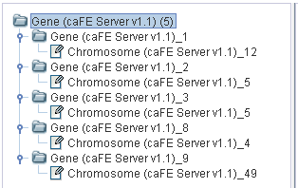
Figure 17: Result of Apply Data List to genes with id 2, 3, 8, 9

Thus, once you obtain the related data for a particular record, Apply Data List allows you to fetch similar related data for several other records easily.

How the Apply Data List functionality works
To understand this functionality better, consider a slightly more complicated data list below:

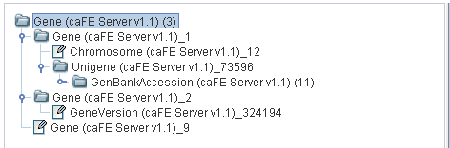
Figure 18: Example 3- Data List

Example 3
The following records have been added to the data list
- For Gene_1, related Chromosome, Unigene, and GenBankAccession records are present.
- For Gene_2, related GeneVersion is present.
- For Gene_9, there is no other related data.

Now, Apply Data List to the genes Gene_1, Gene_2 and Gene_9. The resulting data list is shown below:
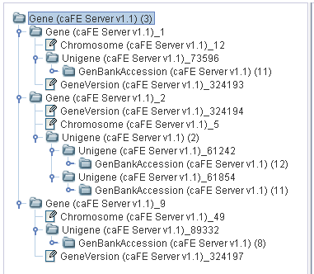
Figure 19: Example 3- Apply Data List
As seen from above figure, following new related data has been fetched:
- For Gene_1, the system fetches GeneVersion (as Gene_2 had GeneVersion).
- For Gene_2, the system fetches Chromosome, Unigene, and GenBankAccession, as these were the related data for Gene_1.
- For Gene_9, the system fetches all of GeneVersion, Chromosome, Unigene, and GenBankAccession.
As a result, each gene contains the related data for GeneVersion, Chromosome, Unigene, and GenBankAccession.
Thus, the Apply Data List operation results in a homogenous structure in the data list. The system fetches related data for all the other records like the related data present for one record.

The Next, Previous and Save Condition Buttons
- Click Next to view the contents of the data list.
- Click Previous to go back to Choose Search Category tab.
- Click Save Condition to save the query.

Save Query
This option is used to save the query which the user has just performed.

Why to Save Query?
When the user saves the query that he/she has performed then one can simply view the result of the query by choosing to execute the saved query. This considerably saves time as the user does not have to form the query again to get to the results. Saved query can also be parameterized, i.e., he can choose to save conditions on attributes which form the parameters. The user can execute a saved a query by changing or not changing conditions defined in the saved query. Advantages of Save Query can be listed as follows:
- Saving complex queries with multiple nodes.
- Availability of saved queries to all the users, where some users might not know how to query.
- Setting up parameterized queries which allow user to use the same query for a variety of conditions on a single attribute.
Queries can be saved in two ways:
- Non-parameterized: No parameters have been defined while saving the query. It means that the saved query cannot be modified at the time of execution. The conditions defined on attributes while querying cannot be changed while execution of the saved query.
- Parameterized: Parameters, i.e., certain attributes are saved while saving the query, so that while executing the query the condition on the attributes can be changed to generate a new query. Thus, a query has certain parameters that can be changed while execution of the query.

How to Save Query?
Once the user has formed the query, i.e., the user has added certain categories and connected them via the available paths, the query can be saved. After forming the query, user navigates to the define search results view tab and then to the view search results tab, both these tabs provide the option to save a query. The save condition button at the bottom of both these tabs can be used to save the query.
The process of saving a non-parameterized query involves the following steps:
- Make a query by adding nodes in the DAG and define the paths between them (as defined in Error: Reference source not found).
- Click the Save Condition button (as shown in Error: Reference source not found).
- Enter the Title and Description for the query to be saved, in the save query panel (see the figure below).
- Save the query by clicking on Save.

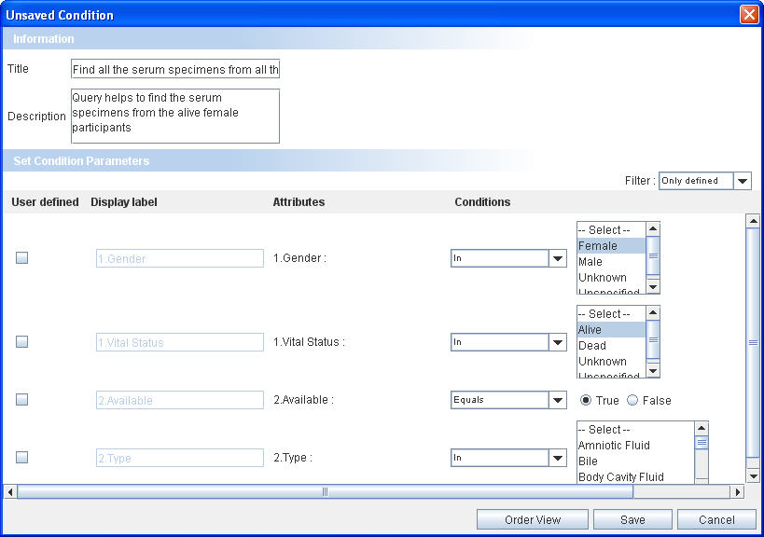
Figure 20: Save Query Panel-Non Parameterized Query
Order attributes in view

The process of saving a parameterized query involves the following steps:
- Make a query by adding nodes in the DAG and define the paths between them (as defined in Error: Reference source not found).
- Click the Save Condition button (as shown in Error: Reference source not found).
- Enter the Title and Description for the query to be saved, in the save query panel (see the figure below).
- Select the Check Box for the attribute which has to be saved.
- Select the order of attributes in the Save Query Panel by changing it by Order View button.
- Use Filter option to define condition on any of the attribute of the category.
- Click Save to save the query.
- Click Cancel to exit without saving the query.

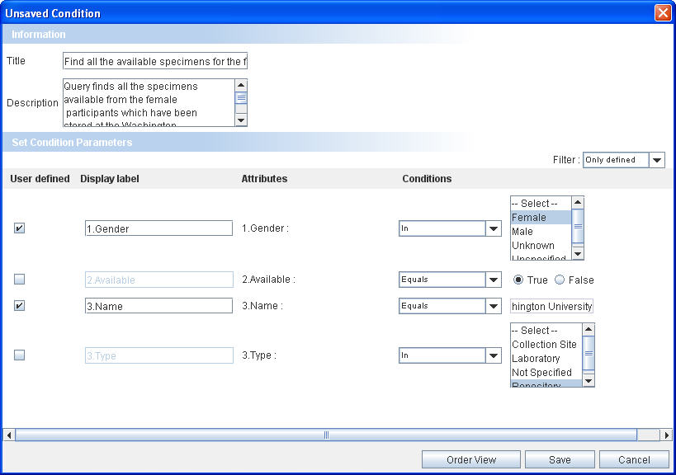
Title
Description
Filter for attributes
Parameters
Figure 21: Save Query Panel-Parameterized Query

Executing a Saved Query
All the saved queries are visible in the Home Page in the My Search Queries stack box in the left hand side panel. To execute any query simply click on the query to view the results. Given below are the steps to execute any of the saved queries:
- Click on the title of the query to be executed.
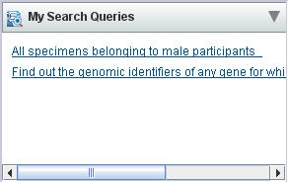
Figure 22: Saved Query Stack box

- The Saved Query Panel opens.
- For non-parameterized queries, click Show Results button on the execute query panel.

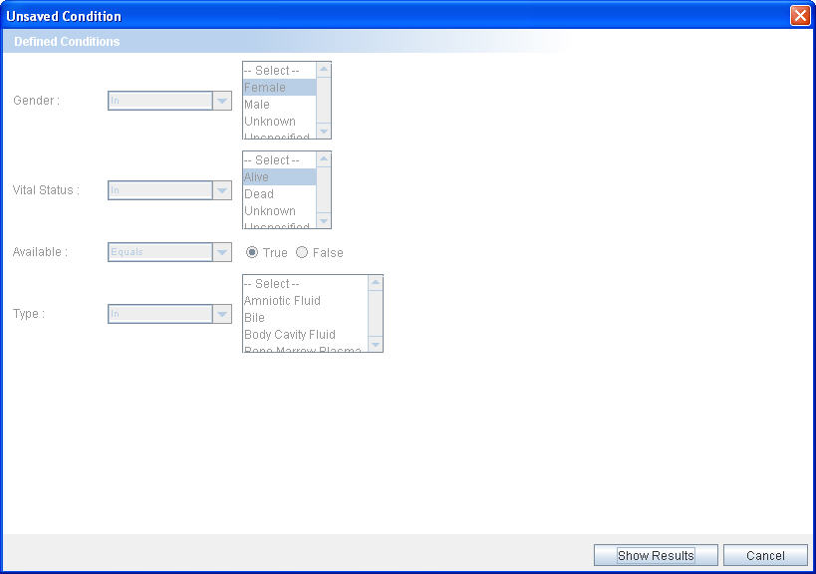
Click to execute

Figure 23: Execute Query Panel- Non Parameterized Query

- For parameterized queries,
- Change the conditions in the parameterized attributes.
Click to execute

- Click on Show Results button to view the results.

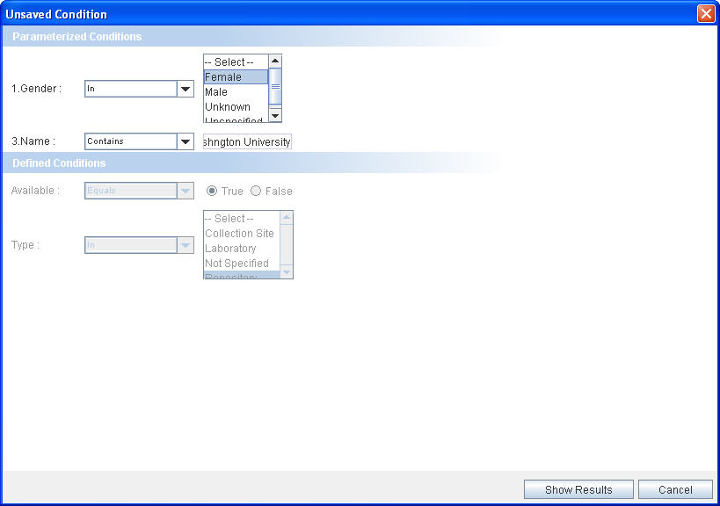
Click to execute

Figure 24: Execute Query Panel-Parameterized Query
The save query option gives us an easy alternative way of executing the queries without actually going and forming the query again. The parameterized query allows us to change the conditions on attributes thereby giving flexibility to the saved queries.

Viewing and Saving Data List
After adding the records of your interest to the data list, you can get the consolidated view of the data list showing all the records added to the list in a hierarchical tree fashion which shows all the records as well as the details of a particular record. You can also export the data list into a Comma Separated Value (CSV) file or create an Experiment using the contents of the data list.

The following figure shows the data list tab:
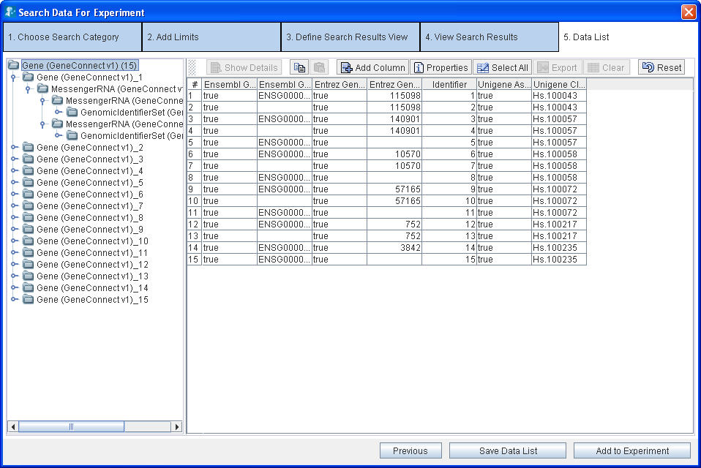
Figure 25: Data List
The left-hand side pane shows all the records that you have added to the data list in a tree format. Each node in the tree represents either a category or a record of a category.
- For a node representing a category:
  - The number of records for that category is shown in parentheses. For example Gene (3) means that you have added 3 records for the Gene category.
  - Clicking on the node updates the right hand side pane to show a spread sheet containing the records of that category (see figure above).
- For a node representing a record
  - The unique identifier for that record is displayed. For example, Gene_1 represents the record with identifier 1.
  - Click the node updates on the right hand side pane to show the details of that record.
The right hand side panel shows the record details. The details shown in the panel depends on the record chosen in the left hand side panel.
- For a node representing a category:
  - The right hand side panel shows all the records in a spread sheet format, with the columns depicting the attributes and the rows the records (Figure 20).

- For a node representing a record
  - Details of that particular record are shown in the right hand side panel (Figure 22).
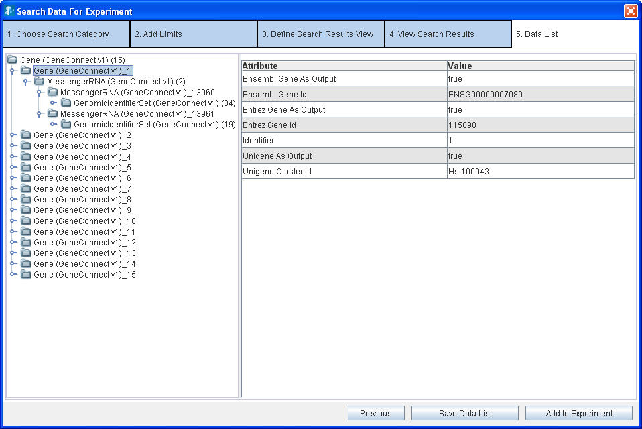
Record Details
Figure 26: Record Details for a single record in Data List

Operations on the Data List
You can do the following operations on the data list:
- Save the data list – Click the Save Data List button.
- Export the data list into a CSV file – Click the Export button.
- Add the data list to an Experiment – Click the Add To Experiment button.

To save the data list:
- Click the Save Data List button.
- Type the title and description for the data list.
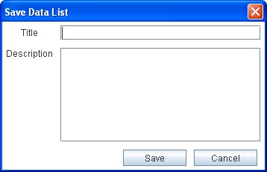
Figure 27: Save Data List Panel
- Click the Save button. The system displays a message in the status bar indicating that the data list is saved. The data list gets saved in the database.

Experiments

In this Chapter
After you search and add some data of interest to the data list, you can create an experiment using that data. This chapter explains the various operations that you can perform on the data sets that you collected.
The following sections are described in this chapter:
- What are Experiments and Projects?
- Creating an Experiment
- Viewing the Existing Experiments
Working with an Experiment
- Analyzing Data

What are Experiments and Projects?
An experiment is a collection of data. After you create an experiment, you can perform the following:
- Perform various analyses on the data using the grid-enabled analytical services
- Visualize the analysis results using various viewers such as bar charts and scattered plots.
- Create new data sets by applying filters on the existing datasets

A project is a collection of experiments. A project can contain many Experiments or other sub-projects. The grouping of experiments into projects helps you manage the multiple experiments easily.
Example of an experiment
Aim: Find out the micro-array data for a nonmalignant brain tissue. Perform Comparative Marker Selection (CMS) on this data to determine the expression values that are most closely correlated with a class template. View the correlation among the expression values as a scattered plot.
You need to perform the following steps using caB2B:

Step no. | Description | Related Section
1 | Search for micro array data | Search data – The Query Wizard
2 | Create experiment with this data | Creating an Experiment
3 | Open the experiment you have created | Opening an Experiment
4 | Filter the data further if desired
5 | Save the filtered data | How to save filtered data?
6 | Perform CMS analysis on selected data | Analyzing Data
7 | Plot analysis result as a scattered plot | Visualizing Data

Creating an Experiment
To create an experiment, you need to have a saved data list with the required data. See Viewing and Saving Data List for details on how to do this.
After you have saved the data list, do the following to create an experiment:
- Click the Add to Experiment button (Figure 25: Data List). This opens the Create New Experiment window.

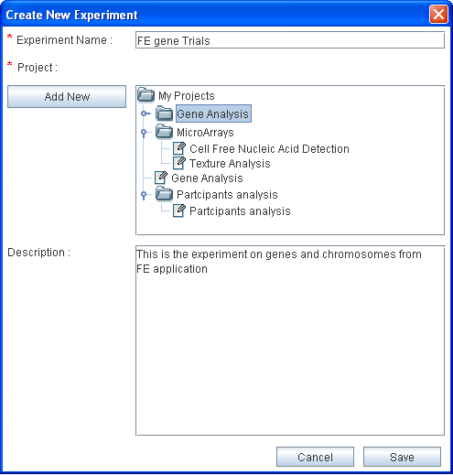
Figure 28: Create New Experiment

- Give an appropriate name to the experiment.
- Select the project in which you wish to create this experiment (see note below).
- Provide a description of the experiment.
- Click Save.

You can now close the Search Data wizard to return to the Home page and open the experiment.
To create a new project, perform the following:
Select the parent project under which you wish to create the new project
Click the Add New button. This adds a new sub project under the selected project with the default name– New Project.
To rename the new project
Select the project.
Press F2.
Type the desired name.
Press ENTER.

Viewing the Existing Experiments

On the caB2B Home page, click the Experiment tab. This opens the My Experiments page.

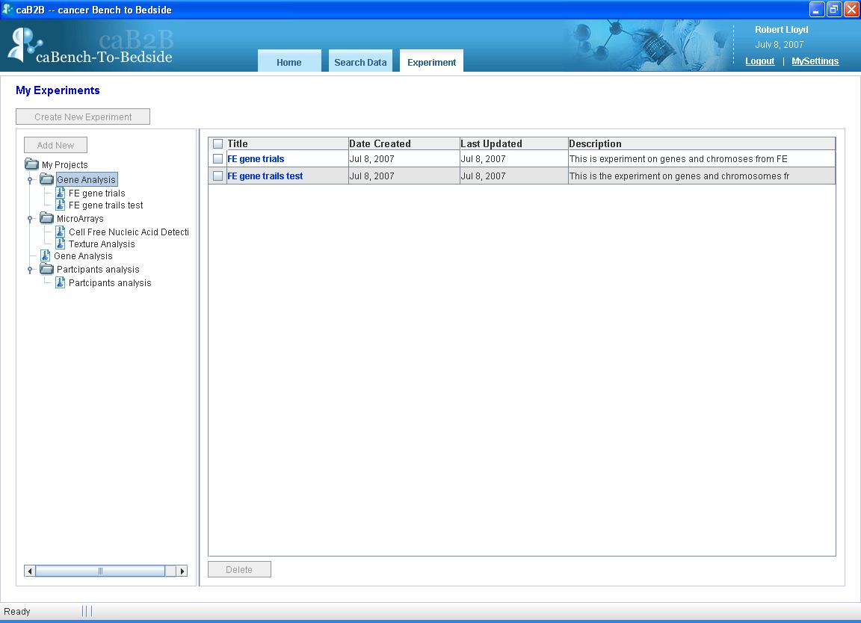
Figure 29: My Experiments
You can see all the projects and experiments that you created in the left panel.
When you select a project in the left hand side pane, the system displays a list of the experiments in the project in right hand side panel.

Opening an Experiment
To open an experiment, go to the My Experiments page and click on the experiment title seen in the right panel (see Figure 29: My Experiments).
When you open an experiment, you see the Experiment Details page. The experiment details page gives user an option to modify the experiment by adding a new column, adding new data, exporting data etc. All these options are also available on the right click menu.

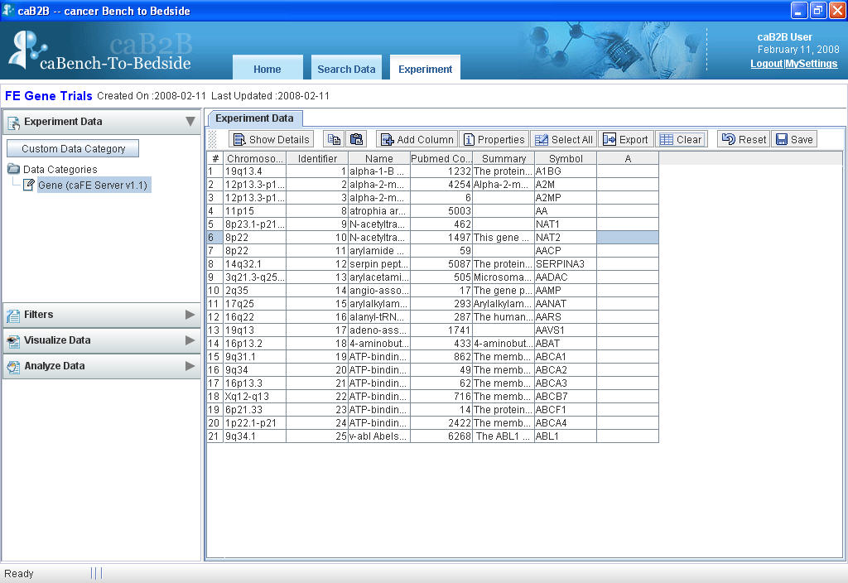
Toolbar
User Added Column
Figure 30: Experiment Details
The various options provided by the spreadsheet present in the experiment details page are listed in the table below:
UI Elements | Description
 | Shows details of the particular selected record.
 | Adds a new column to the spreadsheet.
 | Shows the properties of the spreadsheet, like which attributes are visible, what filter is applied.
 | Selects all the records.
 | Exports data to a .csv file.
 | Undo’s all the changes and shows the original data.
 | Clears the user added data from the selected cell.
 | Creates a data category.
 | Copies data of the selected cells.
 | Pastes the data to the specified cells.

Working with an Experiment
The Experiment Details page consists of the following sections:
- The Operations panel on the left hand side
- The Visualization panel on the right hand side

The Operations panel
The Operations panel contains the following collapsible boxes.

Table 1: Operations on the Experiment Page
UI Elements | Description
 | Displays a list of all the data categories present in the experiment. See How to save filtered data?
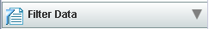 | Shows all the filters that are currently applied to the data of the selected data-category. See for details.
 | Shows the links to call analytical services that are applicable to the selected data-category. See Analyzing Data for details.
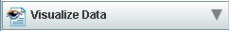 | Shows the visualization options available for the selected data-category. See Visualizing Data for details.

Visualization panel
This is the right hand side panel on the Experiment Details page (see Figure 30: Experiment Details). This panel can contain several pages at a time (see figure below). You can switch between the pages by clicking on the tabs at the top of this panel.

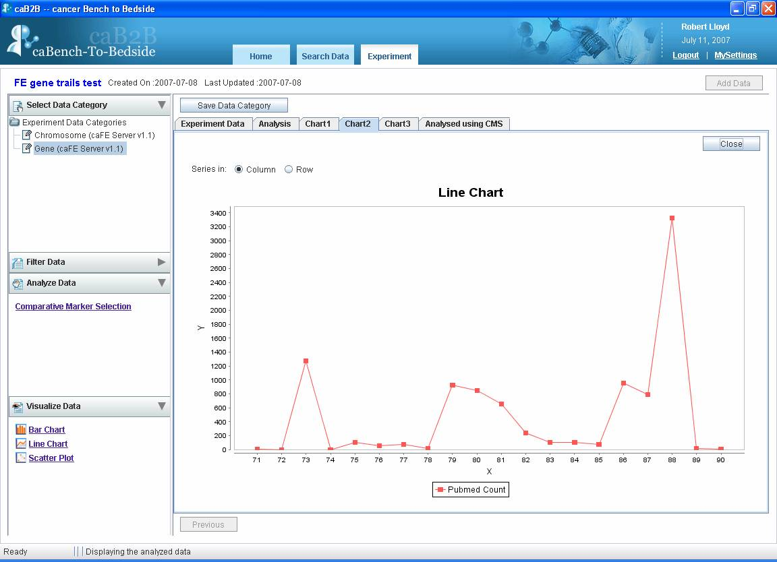
Figure 31: Visualization Pane

The visualization pane is updated based on the operations you do in the operations pane. For example,
Operations pane | What happens in Visualization pane
Click a data-category in the Select Data Category box | The Experiment Data tab is updated to show the records of that data-category
Choose a visualization from the Visualize Data pane | A new tab is created to display the desired visualization

Filtering Data
The purpose of creating experiments is to perform analysis of the data. To aid the analysis, caB2B provides features to filter the data so that you can zero in on the data of your interest.
After you filter the data, you can save the filtered data as a data-category. For example, if you have created an experiment with all female Participants, you can now create different data categories based on age less than 50, age between 50 and 65 and age greater than 65.

How to filter data?
- Select the column whose data is to be filtered, select the filter from the Filter stack box, (located in the left hand side panel)
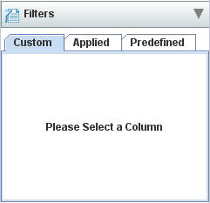
Figure 32: Filter Stack box

- System displays appropriate filter controls.
- Choose one of the available filters and specify the conditions that the data must satisfy (see Types of filter).
- Click on Apply.
- The data in the Experiment Data tab is updated to show the filtered data.
- The filter that you have applied is also shown in the Applied Tab of the Filter stack box in the panel on the left hand side.
You can now save the filtered data as a new data-category and use it to perform analyses or visualization.
You can filter on multiple columns by successively applying filters on those columns. For example, to obtain female participants between age 30 and 40
Apply the filter “Gender = female”.
Then apply the filter “age between 30 and 40”.
For details of the various filter controls and how to use them, see Appendix 4: Types of Filters.

How to edit a filter?
- Choose the column whose filter you wish to edit.
- An appropriate filter control is shown with the values that you previously entered.
- Specify desired values of the filter (see Appendix 4 - Types of Filters).
- The data in the Experiment Data tab is updated to show data based on the new filter.
- The filter criteria shown in the Applied tab of Filter stack box in the operations panel is also updated.

How to remove a filter?
- Choose the column whose filter you wish to remove.
- An appropriate filter control is shown with the values that you previously entered.
- Choose the No Filter option.
- Click on Apply.
- The data in the Experiment Data tab is updated to show data on removing the filter.
- The filter is also removed from Applied tab the Filter data stack box in the operations panel.

How to save filtered data?
Once you apply filters to a data set, you can save the filtered data as a data-category. You can create as many data-categories are you want. The data-categories can be further used for data analysis.
Once you have obtained filtered data, you might wish to save it as a new data-category.
To do this,
- Click the Save button (located in the toolbar of the right hand side panel of the experiment details page Figure 25).
- The Save as Data category panel is displayed.
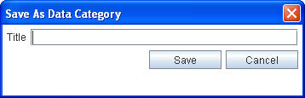
Figure 33: Save Data Category Panel
- In the Title field, type the title of the new data-category.
- Click Save.
The new data-category will appear under Custom Data Categories section in Select Data Category box of the operations pane.

Custom Data Category
Data Category is used to define a class which is a subset of other classes. In an experiment there are various data categories. Typically, user wants to use data from various categories. Ideally data from different categories is not available as a single set, thus, Custom Data Category (CDC henceforth), is a way to bring data from various categories under a single category.

How to create CDC?
- Click on the Custom Data Category button (located at the top of the Experiment stack box on the left hand side panel of the experiment page).
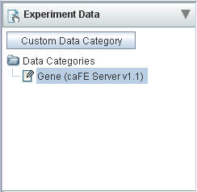
Figure 34: Custom Data Category
- The Create Custom Data Category Panel is displayed (Figure below).
- In the Title field, type the title of the new custom data-category.
- In the Data List field, select the data list to create the category.
- In the Categories field, select the category to be customized.
- Select attributes from Available Attributes to be present in CDC.
- Click on Add button to add to Selected Attributes.
- Select attributes from the Selected Attributes and click on Remove button to delete from CDC.
- Click Save.
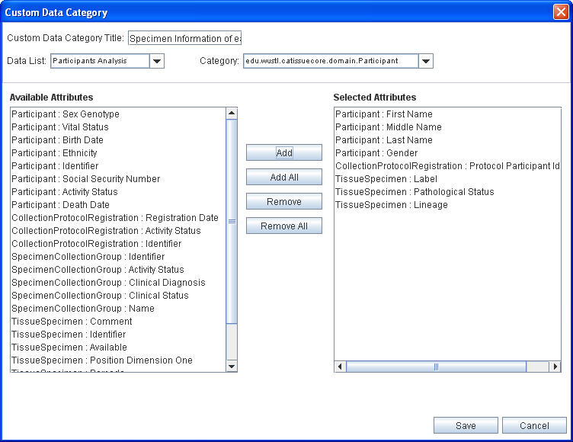
Figure 35: Custom Data Category Panel
The CDC created will appear under Custom Data Categories section in Select Data Category box of the operations panel.

Analyzing Data
After you searched the data of interest and created experiments from it, you can analyze that data. To do this you can use various analytical services that are available. Typically they accept data, perform analyses on it and return the result. You can also pass configuration parameters along with the data to the analytical services.

When you are viewing the data, the services that can operate on that data are shown in the Analyze Data box. In the current version one analytical service Comparative Marker Selection, from gene pattern is available.

How to analyze data?
- Select the data category from Select Data Category box, for example Bioassay.
- In the Analyze Data box, click on the link to call the service, for example Comparative Marker Selection link.
- It will open a popup that accepts configuration parameters for the service. Figure 36: Configuration parameters for CMS.
- Enter the Title for this analysis and values for the various parameters
- Click the Finish button to submit this analysis.

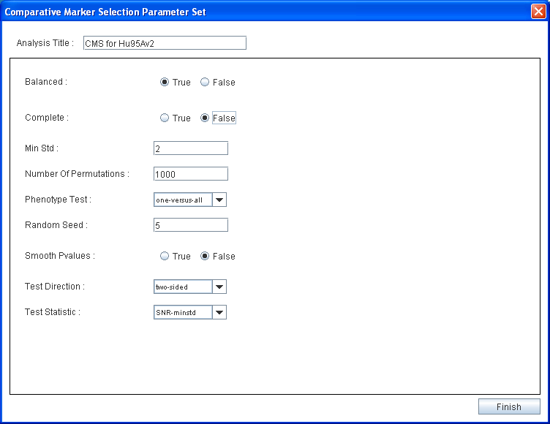
Figure 36: Configuration parameters for CMS

You can see the new Analysis tab added in the right hand side panel. It contains following fields:
Field | Description
Data Category | The data category on which you performed the analysis.
Analysis Title | The title you provided for the analysis. It is a link to the result of the analysis.
Date | The date on which you performed the analysis.
Status | Indicated whether analysis is completed or pending.

You can view the result on completed analysis by clicking the link in Analysis Title field.

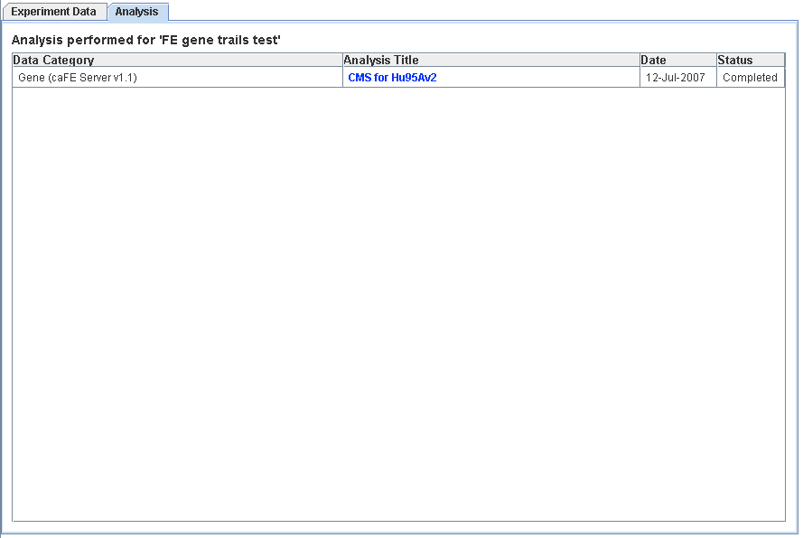
Figure 37: List of analysis performed for the experiment

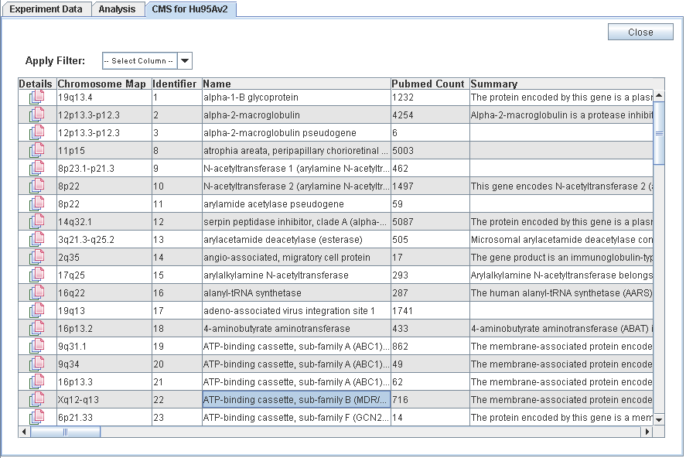
Figure 38: Result of CMS Analysis

Visualizing Data
You can visualize the data in the experiment using various graphical components like charts and scatter plots. These options provide a graphical summary of the data allowing comparison, variation and co-relational analysis of the data.
Some Terms that are used:
Data series: Related data points that are plotted in a chart and originate from data rows or data columns. Each data series in a chart has a unique color or pattern. This is represented by a Legend. You can plot one or more data series in a chart.
Legend: A small color box that identifies each series in the chart.

The current version of caB2B supports following visualization options in Visualize Data box:

Visualize option | Description
 | This is a chart with rectangular bars of lengths proportional to the data value it represents.
 | This is a chart with a line joining the points that represents data value
 | A scatter plot will show a linear or non-linear relationship between the variables (column selected). It also helps in finding odd-mans in the data.
Table 2: Types of charts supported

How to plot data series?
- Select the data that you want to plot from Experiment tab.
- Click on the link for type of the chart you wanted from the Visualize Data Stack Box, for example
- It will open the chart in a new tab in right hand side panel.
- By default data series are from columns on the Experiment Data tab.

Following screen shots represents the various charts for pubmed count for few Genes from FE server.
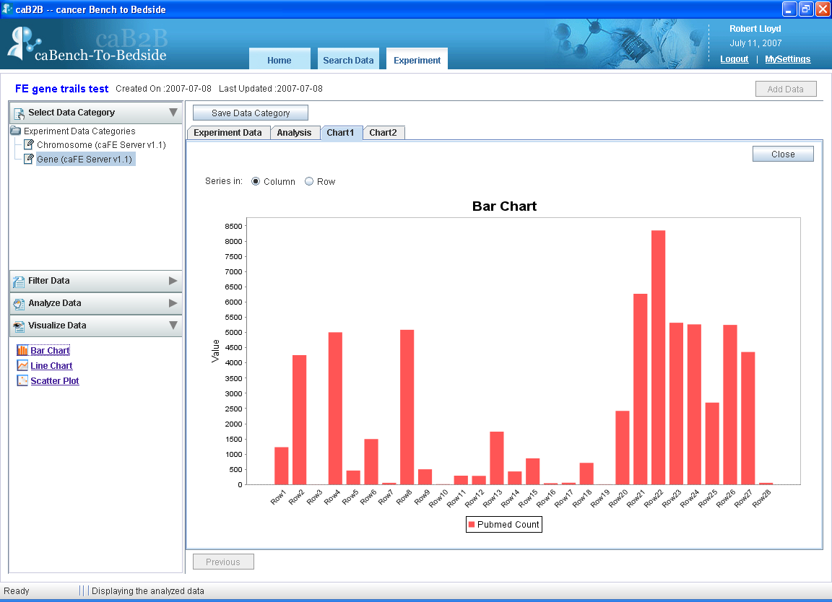
Figure 39: Bar chart example
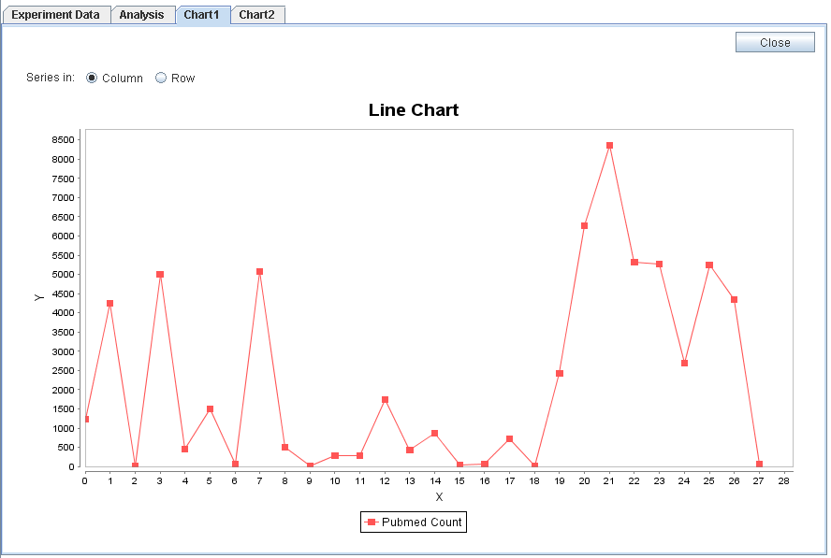
Figure 40: Line chart example

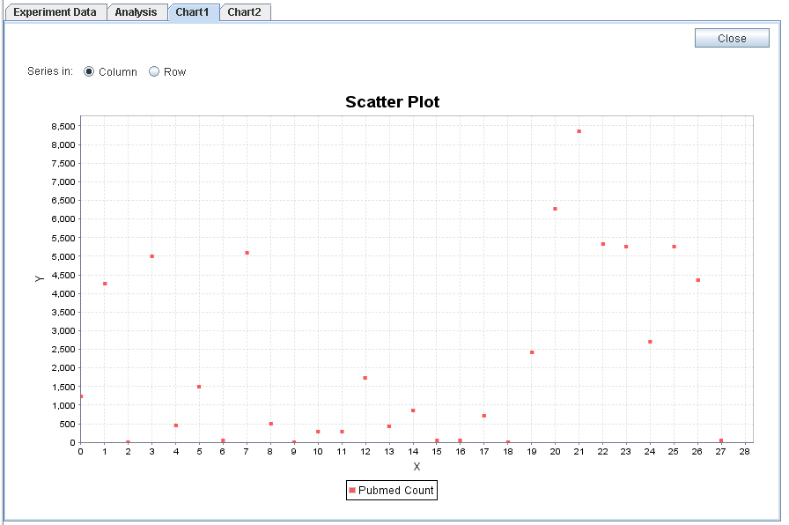
Figure 41: Scatter Plot example

How to change data series from rows to column and vice versa?
You can configure whether data series are from rows or columns by selecting appropriate Series In options.
- To have the data columns to represent the data series, select option.
- To have the data rows to represent the data series, select option.

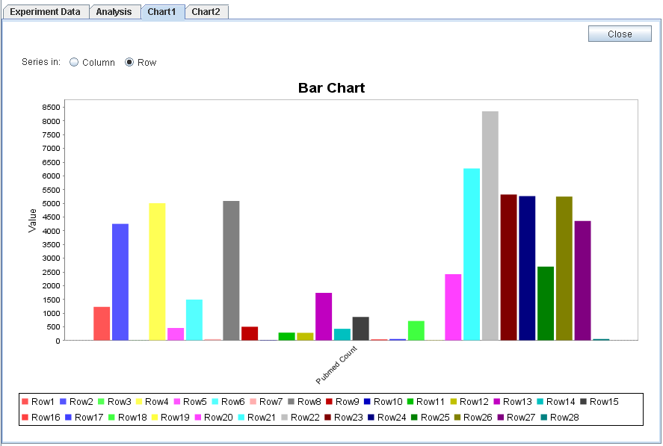
Figure 42: Bar chart with data series from rows

You can change the type of the chart you are currently viewing by selecting required chart link from Visualize Data box.
You can create multiple charts for the data.
The name of the tab added for each chart is “chart” followed by a unique number for that chart. For example chart1, chart2 and so on.

Appendix 1 - Examples of category search
This appendix provides examples of the advanced search strategies that are possible in caB2B, while searching for categories.

Text-based Search - For category name information
To search categories having gene in their name, first expand the Advanced Search box, then you need to do following:
- In the Search box, type gene.
- Select the Category check box.
- Click the Text option button.
- Click the Search button.

The results of this search are as shown below. All the categories shown below have gene in their names.

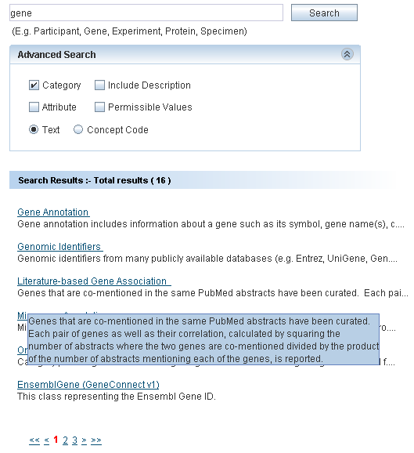
Figure 43: Search Result of Example 1

Text-based Search - For category and attribute name and description
To search the categories having Protein in their name or description or to search the attributes having Protein in their name or description, you need to do following:
- In the Search box, type Protein
- Select the Category check box.
- Select the Attribute check box.
- Select the Include Description check box.
- The Text option button is selected by default.
- Click the Search button.

The result of this search is as shown in the screenshot below.

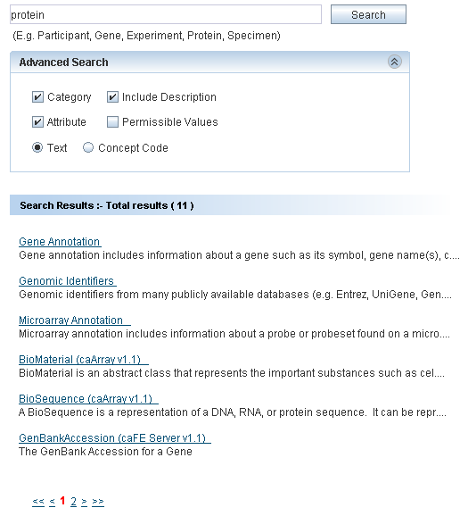
Figure 44: Search Result of Example 2

Concept Code Based Search - For category name information
To search categories having concept code c29867:
- In the Search box, type c29867.
- Select the Category check box.
- Select the Concept Code option button.
- Click the Search button.
The result of this search is as shown in the screenshot below.

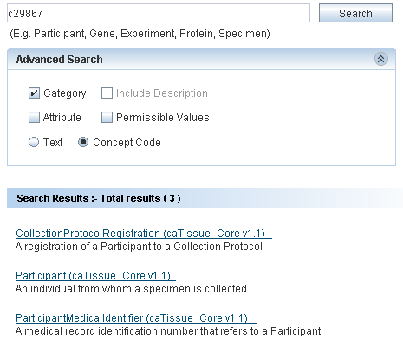
Figure 45: Search Result of Example 3

Concept code based search - For attribute name information
To search categories whose attribute has concept code C42614
- In the Search box, type C42614.
- Select the Attribute check box.
- Select the Concept Code option button.
- Click the Search button.

The result of this search is as shown in the screenshot below.

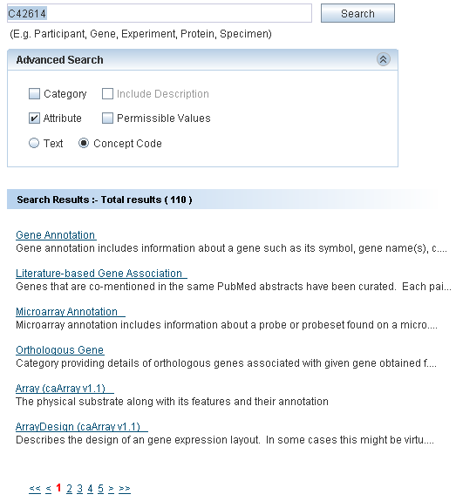
Figure 46: Search Result of Example 4

Appendix 2 - Define Limit: Operators and Values
This appendix explains the various operators and how to specify values while defining limits on a category.

The following table explains the different operators and provides examples as to how values are to be specified.
Table 3
Operator | Data types for which applicable | Sample condition | Expected Results
Equals | Numeric  Date  String | Name equals “John” | Returns only John and not john.
Not equals | Numeric  Date  String | Identifier not  equals 32 | Returns all records except those having identifier = 32
Less than | Numeric  Date | Participant’s birth date less than 2000/1/1 | Returns all Participants born before January 1st, 2000
Less than or equal | Numeric  Date | Signal value less than or equals to 0.5 | Returns all records for which signal value is not more than 0.5
Greater than | Numeric  Date | Cell count is greater than 10000 | Returns all records with Cell count > 10000
Greater than or equals | Numeric  Date | Specimen’s collection-date greater than or equal to 2005/5/1 | Returns all specimens collected on or after May 1st, 2005
Between | Numeric  Date | Patient’s admission date between 2000/1/1 and 2000/12/31 | Returns all Patients admitted in the year 2000
Is null | Numeric  String  Date | Patient’s contact number is null | Returns all patients who do not have any contact number
Is not null | Numeric  Date | Participant’ middle name is not null | Returns all Participants for whom middle name is specified
In | Numeric  String Enumerated | - Signal value in 0.1,0.5,0.7,  - Name in “John”, ”john” | - Returns all records whose signal value is 0.1 or 0.5 or 0.7  - Returns both John and john.
Not in | Numeric  String Enumerated | Participant’s gender not in male, unspecified | Returns all participants whose gender is either not specified or gender is not male.
Starts with | String | Participant’s first name starts with Jo | Returns all participants whose first name starts with Jo like John, Jona.  Does not return the participant with name Scott, Henry, Jen
Ends with | String | Participant’s last name ends with n | Returns all participants whose last name ends with n like John, Jon, Jen. Does not return participant with name Scott, Henry
Contains | String | Participant’s first name contains ann | Returns all participants whose first name is Joanna, Anna, and Johanna. Does not return participant with name Jen, Denny
- For attributes with enumerated values and Boolean attributes, clear a value by clicking on the value with the CTRL key pressed.
- If you use the In operator for a non-enumerated attribute, you can specify multiple values as follows:
  - Multiple values should be separated using a comma. For example, to specify the constraint Identifier IN 2, 4, 5, 7, you should type the value as 2,4,5,7.
- If a value itself contains a comma, you can enclose the value in double quotes. For example, to specify the constraint Name IN “Einstein, Albert”, “Newton, Isaac” the value that you should enter is “Einstein, Albert”, “Newton, Isaac”.
- For attributes that requires a date value, you can click the icon to launch a date selector. You can also type a date string directly in the text box. The format of this string must be YYYY/MM/DD. A valid date string becomes green whereas an invalid date string turns red. An invalid date string will be ignored.

Appendix 3 - Record Details View
The details of a record usually consist of the values of the attributes of the category. See Figure 15: Results’ Details for an example.
This section provides examples of special categories that result in a slightly different view of the record’s details.

Administrator defined categories

These categories are built by grouping relevant attributes from one or more existing categories.
For each record of such a category the following information is shown:
Values of the attributes in a table
Related information as a tree. The leaf nodes of this tree are attributes; you can see the values of those in the value column.

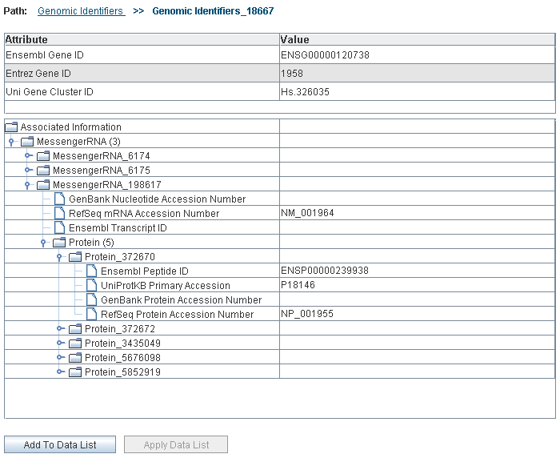
Figure 47: One record of an administrator defined category (Genomic Identifiers)

Appendix 4 - Types of Filters
A filter control is shown when you choose to filter the data of a data-category (see How to filter data).
The type of filter control upon the column based on which you wish to filter data.
Table 4: Column Type and Applicable Filter
Data type of the column | Applicable filter
Numeric | Range filter
Text | Pattern filter
Column with permissible values | Enumerated filter
Boolean | Enumerated filter

Using the Range Filter
The system shows a Range Filter if the column selected as a basis for the filter has numeric values. It allows you to select the desired minimum and maximum values of the column.
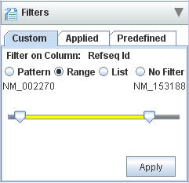
Figure 48: Set Filter for Range

There are two sliders, the left slider and the right slider. The value denoted by each slider is shown at the two ends.
- Position the left slider at the minimum value desired.
- Position the right slider at the maximum value desired.
- Click Ok to apply the filter.

Using the Pattern Filter
The system shows a Pattern Filter if the column selected as a basis for the filter has text values. It allows you to specify a pattern that the values of that column should satisfy.
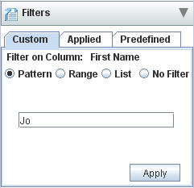
Figure 49: Pattern Filter
In the Enter Pattern field, type the desired pattern and click Ok.

Using the Enumerated Values Filter
The system shows an Enumerated Values Filter if the column selected as a basis for the filter has a set of permissible values. It allows you to specify the values that the column should satisfy.
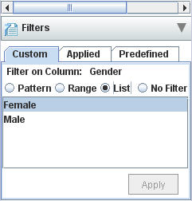
Figure 50: Enumerated Values Filter for the column gender

Select the desired permissible values and click OK

