Adopting caBIG Standards for caBIO

Adopting caBIG Standards for caBIO 1
Overview 1
Standards 1
Project Website 1
Support for caBIG Standards in caBIO 1
mRNAs in CaBIO 2
New objects to support the caBIG Standards 2
Proposed Model 3
Prototyping 4
Statistics 4
Issues 4

Overview
This document outlines the proposed changes to caBIO to support the caBIG Standards

Standards
CaBIG Standards are designed to facilitate the use of unique identifiers to identify a biological entity such as Gene, Protein, etc.

Project Website
https://cabig.nci.nih.gov/workspaces/VCDE/Data_Standards/

Support for caBIG Standards in caBIO

Gene: A caBIG-compatible Gene can be uniquely identified using any of the following identifiers
Entrez Gene Id
RefSeq Gene Id
Unigene Cluster Id
Ensembl Gene Id

A caBIO Gene is populated with data from Unigene. It stores details of a gene such as its symbol, etc and can be identified using the Unigene Cluster Id.
Of the 195911 Unigene clusters in caBIO, 3903 Unigene Clusters map to multiple genes.

Entrez Gene Ids are available for 59789 Genes in DatabaseCrossReference.

31707 genes associated with Affymetrix RNA Arrays are also cross-referenced through Ensembl Ids in DatabaseCrossReference.

Protein: A caBIG compatible Protein can be uniquely identified using any of the following identifiers:
Uniprot Accession Number
RefSeq Protein Id
Ensembl Peptide Id

All 31288 caBIO Protein can be uniquely identified using a Uniprot Accession Number. RefSeq Protein Accession Numbers are available for 15776 caBIO Proteins in DatabaseCrossReference.

NucleicAcidSequence: Genbank sequences associated with a caBIO Gene are available through NucleicAcidSequence and are uniquely identified using Genbank Accession Numbers or RefSeq Accession Numbers.

Approximately 55,000 out of 10 million sequence identifiers in NucleicAcidSequence are in RefSeq format.

mRNAs in CaBIO

caBIO currently exposes chromosomal start and stop locations for approximately 170,000 Genbank Mrna sequences from UCSC at http://hgdownload.cse.ucsc.edu/goldenPath/hg18/database/all_mrna_txt.gz

This data is used to populate PhysicalLocation with the start and stop of an EST/mRNA along the genome and is currently available in ZSTG_HUMAN_MRNA and ZSTG_MOUSE_MRNA.

New objects to support the caBIG Standards

mRNA: A new object that captures a Gene-Transcript. It can contain details such as the accession number, associated chromosome, etc. and can be linked with the associated sequence in NucleicAcidSequence and relevant genes. It could be linked with the current Transcript and/or Exon Object if required. The current Transcript object models those used in Affymetrix microarray probesets. Every mRNA in the proposed object would be identified using a Genbank Accession Number.

Proposed Model
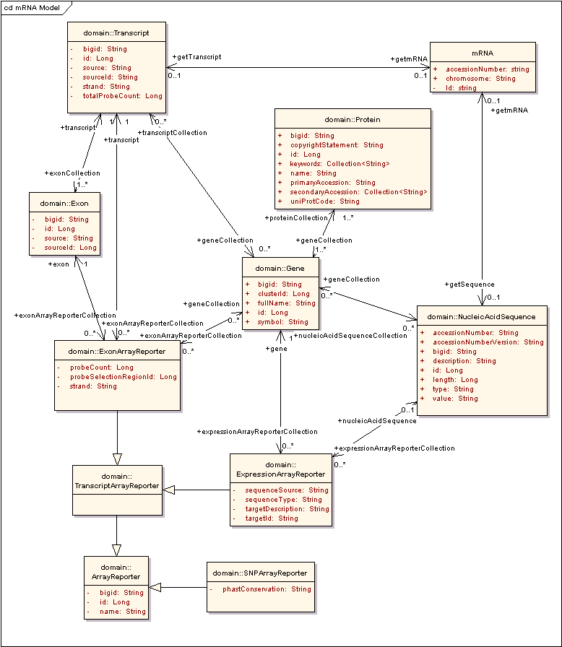

Prototyping

ZSTG_MRNA_UNIGENE is a prototype of the proposed model in the caBIO database and associates a Human/Mouse mRNA with the relevant Genes, NucleicAcidSequences and Chromosomes. It provides the Gene Symbol and Unigene Cluster Id for each Mrna.

Statistics
The prototype exposes 341,445 mRNAs of which 148960 are mRNAs from humans while the others are mouse mRNAs.
These are associated with 336907 unique NucleicAcidSequences and are linked with 64503 unique caBIO Genes (Unigene clusters)

There are 3381 mRNA records for which multiple alignment results are provided by UCSC leading to 3381 duplicates in the prototype above.

Issues
No mappings to Gene or NucleicAcidSequence are available for around 30,000 mRNAs from UCSC-provided data to caBIO Genes. This is due to these sequences not being used by Unigene for creating gene clusters.

