Implementation Specification
for
Array Annotation API in caBIO

Release 4.1

Last Updated: March 12, 2008

Owner: caBIO Team
Email: klemmj@mail.nih.gov

National Cancer Institute Center for BioInformatics
6116 Executive Blvd.
Rockville, MD 20852



1 Document Purpose 3
2 Implementation Overview 4
2.1 Team Members 4
2.2 Description 4
2.3 Scope 4
2.3.1 Feature Requests 4
2.4 Use Cases 5
2.5 Architecture 12
2.5.1 Current Model 12
2.5.2 Model Changes 13
2.6 Data 16
2.6.1 New Arrays 16
2.6.2 Reporter Locations 16
2.6.3 HUGO Gene Symbols 16
2.6.4 Physical Location Assembly 16
2.6.5 Gene Location Feature Type 17
2.6.6 Microarray Naming 17
2.7 Assumptions 17
2.8 Dependencies 17
2.9 Issues 17
2.10 Third Party Tools 18
3 Implementation Contents 19
3.1 Server 19
3.1.1 Algorithms 19
3.1.2 Batch Processes 19
3.1.3 APIs 19
3.1.4 Error Handling 22
3.1.5 Database Changes 22
3.2 Client 22
3.2.1 JSP/HTML 22
3.2.2 Servlet 22
3.2.3 Error Handling 22
3.3 Security Issues 22
3.4 Performance 22
3.5 Internationalization 23
3.6 Installation / Packaging 23
3.7 Migration 23
3.8 Documentation Considerations 23
4 Unit Testing 24
4.1 Test Guidelines 24
4.2 Test Cases 24
5 Data Exemplars 25
DOCUMENT CONTROL 27
DOCUMENT APPROVAL 28

Document Purpose
This document provides design and implementation details that support additional use cases for microarray annotations in caBIO. The use cases come from the caIntegrator project, which makes heavy use of microarray and gene annotations.

Implementation Overview

Team Members

Role | Name
Director of Engineering | Avinash Shanbhag²
Internationalization Lead | N/A
Product Manager | Juli Klemm²
Project Manager | Sharon Gaheen¹
Test Lead | Ye Wu¹
Tech Lead | Jim Sun¹
Documentation Lead
Development Team | Konrad Rokicki¹  Lalitha Viswanath¹  Hong Dang³
¹ Science Applications International Corporation (SAIC)
² National Cancer Institute Center for Bioinformatics (NCICB)
³ Alpha-Gamma Technologies, Inc.
Table 1: Team Members

Description
In this version of caBIO we will analyze caIntegrator’s array annotation needs and modify caBIO to provide the necessary data at an acceptable performance level.

The caIntegrator framework is used for a number of applications, with various annotation requirements.

Application | Array Name | Available in caBIO?
TCGA | Affymetrix Exon 1.0 ST | Yes
TCGA | Affymetrix 500K SNP Array | Yes
TCGA | Agilent 44K Array | Yes
TCGA | Agilent 8x15k miRNA data | No
TCGA | Agilent Human Genome CGH 244K (in the future) | Yes
CGEMS | Illumina 550K Array | Yes
Rembrandt | Affymetrix U133 Plus 2.0 Array | Yes
Rembrandt | Affymetrix 100K Array | Yes
caIntegrator-EAGLE | Affymetrix U133A | Yes
caIntegrator-EAGLE | Affymetrix U133A 2.0 | Yes
I-SPY | custom CDNA | No
I-SPY | Agilent 44K Array | Yes

Scope
The scope of this document includes all changes and additions to the model and API related to supporting array annotations for caIntegrator.

Feature Requests
GF9414 Provide support for additional array annotations
Implement support for additional caIntegrator use cases supporting array annotations.

Use Cases
The use cases are modeled on the data needs of caIntegrator’s AnnotationHandler classes.

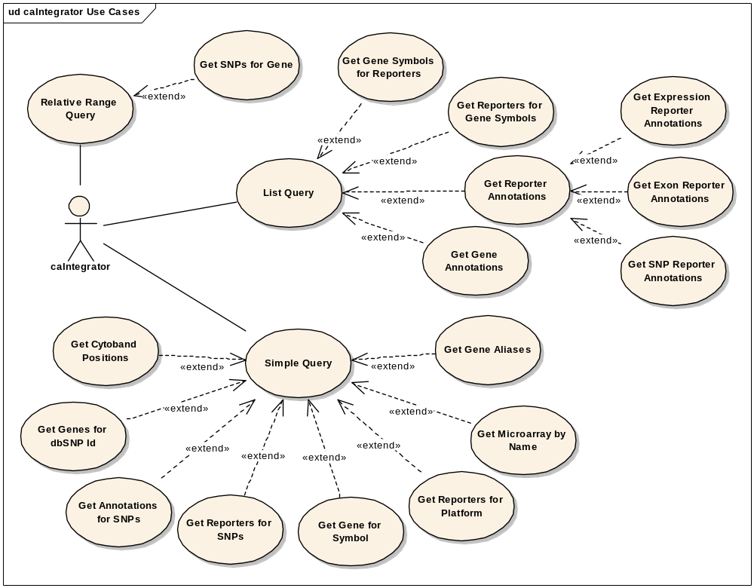
Figure 1: Use Case Diagram

Use Case Name | Get Gene Symbols for Reporters
Use Case ID | 1.1
Primary Actor | caIntegrator
Brief Description | Given an array platform and a list of array reporter names, return a mapping of the reporters to HUGO gene symbols.
Trigger | API call
Pre-conditions | - The client has a valid CaBioApplicationService  - The client has a String “arrayPlatform” with the name of the array  - The client has a Collection<String> “reporterIds” of reporter names
Flow of Events | - The client calls the caBIO convenience method:  Map<String, Collection<String>> results =  getGenesForReporters(arrayPlatform, reporterIds)
Post Conditions | Success Condition: The user obtains a result object  Error Conditions:  EC1: System Error during Request Processing  EC2: “Array Platform type cannot be null”  EC3: “Reporter list must not be empty”
Alternative Flow | Alternate Condition:  AC1: No result is found
Related Use Cases | Get Reporters for Gene Symbols
Issues/Notes | Corresponds to this AnnotationManager method in caIntegrator:  Map<GeneBiomarker, Collection<GeneBiomarker>>  getGenesForReporters(AnnotationCriteria annotationCriteria)

Use Case Name | Get Reporters for Gene Symbols
Use Case ID | 1.2
Primary Actor | caIntegrator
Brief Description | Given an array platform and a list of HUGO gene symbols, return a mapping of gene symbols to reporter names.
Trigger | API call
Pre-conditions | - The client has a valid CaBioApplicationService  - The client has a String “arrayPlatform” with the name of the array  - The client has a Collection<String> “geneSymbols” of HUGO gene symbols
Flow of Events | - The client calls the caBIO convenience method:  Map<String, Collection<String>> results =  getReportersForGenes(arrayPlatform, geneSymbols);
Post Conditions | Success Condition: The user obtains a result object  Error Conditions:  EC1: System Error during Request Processing  EC2: “Array Platform type cannot be null”  EC3: “Reporter list must not be empty”
Alternative Flow | Alternate Condition:  AC1: No result is found
Related Use Cases | Get Gene Symbols for Reporters
Issues/Notes | Corresponds to this AnnotationManager method in caIntegrator:  Map<GeneBiomarker, Collection<GeneExprReporter>>  getReportersForGenes(AnnotationCriteria annotationCriteria)

Use Case Name | Get Reporters for Platform
Use Case ID | 1.3
Primary Actor | caIntegrator
Brief Description | Given an array platform, return all of its reporter names
Trigger | API call
Pre-conditions | - The client has a valid CaBioApplicationService  - The client has a String “arrayPlatform” with the name of the array
Flow of Events | - The client calls the caBIO convenience method:  Collection<ArrayReporter> results = getReportersForPlatform(arrayPlatform);
Post Conditions | Success Condition: The user obtains a result object  Error Conditions:  EC1: System Error during Request Processing  EC2: “Microarray with name %s not found.”
Alternative Flow | Alternate Condition:  AC1: No result is found
Related Use Cases
Issues/Notes | Corresponds to this AnnotationManager method in caIntegrator:  Collection<GeneExprReporter> getReportersForPlatform(  AnnotationCriteria annotationCriteria)

Use Case Name | Get Expression Reporter Annotations
Use Case ID | 1.4
Primary Actor | caIntegrator
Brief Description | Given an array platform and a list of array reporter names, return a list of ExpressionArrayReporters with loaded associations which provide the following annotations:  - Reporter name  - Reporter chromosome  - Reporter cytoband  - Reporter start/end physical location  - HUGO Gene symbol
Trigger | API call
Pre-conditions | - The client has a valid CaBioApplicationService  - The client has a String “arrayPlatform” with the name of the array  - The client has a Collection<String> “reporterIds” of reporter names
Flow of Events | - The client calls the caBIO convenience method:  Collection<ExpressionArrayReporter> results =  getExpressionReporterAnnotations(arrayPlatform, reporterIds);
Post Conditions | Success Condition: The user obtains a result object  Error Conditions:  EC1: System Error during Request Processing  EC2: “Array Platform type cannot be null”  EC3: “Reporter list must not be empty”
Alternative Flow | Alternate Condition:  AC1: No result is found
Related Use Cases
Issues/Notes | Corresponds to this AnnotationManager method in caIntegrator:  Collection<GeneExprReporter> getReporterAnnotations(  AnnotationCriteria annotationCriteria)

Use Case Name | Get Exon Reporter Annotations
Use Case ID | 1.5
Primary Actor | caIntegrator
Brief Description | Given an array platform and a list of array reporter names, return a list of ExpressionArrayReporters with loaded associations which provide the following annotations:  - Reporter name  - Reporter chromosome  - Reporter cytoband  - Reporter start/end physical location  - HUGO Gene symbol
Trigger | API call
Pre-conditions | - The client has a valid CaBioApplicationService  - The client has a String “arrayPlatform” with the name of the array  - The client has a Collection<String> “reporterIds” of reporter names
Flow of Events | - The client calls the caBIO convenience method:  Collection<ExpressionArrayReporter> results =  getExpressionReporterAnnotations(arrayPlatform, reporterIds);
Post Conditions | Success Condition: The user obtains a result object  Error Conditions:  EC1: System Error during Request Processing  EC2: “Array Platform type cannot be null”  EC3: “Reporter list must not be empty”
Alternative Flow | Alternate Condition:  AC1: No result is found
Related Use Cases
Issues/Notes | Corresponds to this AnnotationManager method in caIntegrator:  Collection<GeneExprReporter> getReporterAnnotations(  AnnotationCriteria annotationCriteria)

Use Case Name | Get SNP Reporter Annotations
Use Case ID | 1.6
Primary Actor | caIntegrator
Brief Description | Given an array platform and a list of array reporter names, return a list of ExpressionArrayReporters with loaded associations which provide the following annotations:  - Reporter name  - Reporter chromosome  - Reporter cytoband  - Reporter start/end physical location  - dbSNP id
Trigger | API call
Pre-conditions | - The client has a valid CaBioApplicationService  - The client has a String “arrayPlatform” with the name of the array  - The client has a Collection<String> “reporterIds” of reporter names
Flow of Events | - The client calls the caBIO convenience method:  Collection<SNPArrayReporter> results =  getSNPReporterAnnotations(arrayPlatform, reporterIds);
Post Conditions | Success Condition: The user obtains a result object  Error Conditions:  EC1: System Error during Request Processing  EC2: “Array Platform type cannot be null”  EC3: “Reporter list must not be empty”
Alternative Flow | Alternate Condition:  AC1: No result is found
Related Use Cases
Issues/Notes

Use Case Name | Get Gene Annotations
Use Case ID | 1.7
Primary Actor | caIntegrator
Brief Description | Given a list of HUGO gene symbols, return a list of Genes with loaded annotations which provide the following annotations:  - Entrez Gene Id  - Chromosome  - Cytoband  The following associations must be lazy loaded because of their relatively high cardinality:  - GO terms (average ~8 per gene)  - Pathway names (average ~3.2 per gene)
Trigger | API call
Pre-conditions | - The client has a valid CaBioApplicationService  - The client has a Collection<String> “geneSymbols” of HUGO gene symbols
Flow of Events | - The client calls the caBIO convenience method:  Collection<Gene> results = getGeneAnnotations(geneSymbols);
Post Conditions | Success Condition: The user obtains a result object  Error Conditions:  EC1: System Error during Request Processing  EC2: “Gene symbol list must not be empty”
Alternative Flow | Alternate Condition:  AC1: No result is found
Related Use Cases
Issues/Notes | Corresponds to this AnnotationManager method in caIntegrator:  Collection<GeneBiomarker> getGeneAnnotations(  AnnotationCriteria annotationCriteria)

Use Case Name | Get Cytoband Positions
Use Case ID | 1.8
Primary Actor | caIntegrator
Brief Description | Given a chromosome, and start/end cytoband, return the physical location range of the cytobands.
Trigger | API call
Pre-conditions | - The client has a valid CaBioApplicationService  - The client has a String “chromosomeNumber”, the name of a chromosome
Flow of Events | - The client calls the caBIO convenience method:  Collection<CytobandPhysicalLocation> results =  getCytobandPositions(chromosomeNumber);
Post Conditions | Success Condition: The user obtains a result object  Error Conditions:  EC1: System Error during Request Processing
Alternative Flow | Alternate Condition:  AC1: No result is found
Related Use Cases
Issues/Notes | Corresponds to this AnnotationManager method in caIntegrator:  List<CytobandPosition> getCytobandPositions(  String chromosome, String startCytoband, String endCytoband

Use Case Name | Get Microarray by Name
Use Case ID | 1.9
Primary Actor | caIntegrator
Brief Description | Given the name of a microarray platform, return the appropriate Microarray object.
Trigger | API call
Pre-conditions | - The client has a valid CaBioApplicationService  - The client has a String “arrayPlatform” with the name of the array
Flow of Events | - The client calls the caBIO convenience method:  Microarray microarray = getMicroarray(arrayPlatform);
Post Conditions | Success Condition: The user obtains a result object  Error Conditions:  EC1: System Error during Request Processing
Alternative Flow | Alternate Condition:  AC1: No result is found
Related Use Cases
Issues/Notes

Use Case Name | Get Genes for Symbol
Use Case ID | 1.10
Primary Actor | caIntegrator
Brief Description | Given a HUGO gene symbol, retrieve the caBIO Genes with that symbol. There may be more than one since Gene is a Unigene-centric object.
Trigger | API call
Pre-conditions | - The client has a valid CaBioApplicationService  - The client has a String “geneSymbol”, a HUGO gene symbol
Flow of Events | - The client calls the caBIO convenience method:  Gene gene = getGeneForSymbol(geneSymbol);
Post Conditions | Success Condition: The user obtains a result object  Error Conditions:  EC1: System Error during Request Processing
Alternative Flow | Alternate Condition:  AC1: No result is found
Related Use Cases
Issues/Notes | Corresponds to this AnnotationManager method in caIntegrator:  GeneBiomarker getGeneForSymbol(String geneId)

Use Case Name | Get Gene Aliases
Use Case ID | 1.11
Primary Actor | caIntegrator
Brief Description | Given a HUGO gene symbol, return all the gene’s aliases.
Trigger | API call
Pre-conditions | - The client has a valid CaBioApplicationService  - The client has a String “geneSymbol”, a HUGO gene symbol
Flow of Events | - The client calls the caBIO convenience method:  Collection<GeneAlias> aliases = getAliasesForGene(geneSymbols);
Post Conditions | Success Condition: The user obtains a result object  Error Conditions:  EC1: System Error during Request Processing
Alternative Flow | Alternate Condition:  AC1: No result is found
Related Use Cases
Issues/Notes | Corresponds to this AnnotationManager method in caIntegrator:  List<GeneAlias> getGeneAliasForSymbol(String symbol)

Use Case Name | Get Reporters for SNPs
Use Case ID | 1.12
Primary Actor | caIntegrator
Brief Description | Given an array platform and a list of dbSNP Ids, return a mapping of the dbSNP Ids to Lists of reporter names.
Trigger | API call
Pre-conditions | - The client has a valid CaBioApplicationService  - The client has a String “arrayPlatform” with the name of the array  - The client has a List<String> “dbsnpids” of dbSNP rs ids
Flow of Events | - The client calls the caBIO convenience method:  HashMap<String, Collection<String>> results =  getReportersForSnps (arrayPlatform, dbsnpids);
Post Conditions | Success Condition: The user obtains a result object  Error Conditions:  EC1: System Error during Request Processing  EC2: “Array Platform type cannot be null”  EC3: “SNP list must not be empty”
Alternative Flow | Alternate Condition:  AC1: No result is found
Related Use Cases
Issues/Notes | Corresponds to this AnnotationManager method in caIntegrator:  List<VariationReporter> getReportersForDbSnpId(String dbSnpId)

Use Case Name | Get Annotations for SNPs
Use Case ID | 1.13
Primary Actor | caIntegrator
Brief Description | Given a list of db SNP ids, return the corresponding SNPs with preloaded associations which provide the following annotations:  - chromosome  - physical location  - cytoband
Trigger | API call
Pre-conditions | - The client has a valid CaBioApplicationService  - The client has a List<String> “dbsnpids” of dbSNP rs ids
Flow of Events | - The client calls the caBIO convenience method:  List<SNP> result = getSNPAnnotations(dbsnpids);
Post Conditions | Success Condition: The user obtains a result object  Error Conditions:  EC1: System Error during Request Processing  EC2: “Array Platform type cannot be null”  EC3: “SNP list must not be empty”
Alternative Flow | Alternate Condition:  AC1: No result is found
Related Use Cases
Issues/Notes | Corresponds to this AnnotationManager method in caIntegrator:  List<SNPAnnotation> getSnpAnnotationsForSymbol(String symbol)

Use Case Name | Get Genes for dbSNP Id
Use Case ID | 1.14
Primary Actor | caIntegrator
Brief Description | Given a dbSNP Id, return all the associated genes according to manufacturer array annotations (via GeneRelativeLocation).
Trigger | API call
Pre-conditions | - The client has a valid CaBioApplicationService  - The client has a String “dbsnpid”, the rs id of a dbSNP
Flow of Events | - The client calls the caBIO convenience method:  Collection<Gene> results = getGenesForDbSnpId(dbsnpid);
Post Conditions | Success Condition: The user obtains a result object  Error Conditions:  EC1: System Error during Request Processing
Alternative Flow | Alternate Condition:  AC1: No result is found
Related Use Cases
Issues/Notes

Use Case Name | Get SNPs for Gene
Use Case ID | 1.15
Primary Actor | caIntegrator
Brief Description | Given a HUGO gene symbol and range parameters, return all SNPs in the range kbUpstream to kbDownstream of each exon (CDS) of the gene. By default, both Genes and SNPs will be located on the reference assembly. Other assemblies (e.g. Celera) can be used if specified as a parameter.
Trigger | API call
Pre-conditions | - The client has a valid CaBioApplicationService  - The client has a Long “kbUpstream” with the distance to search upstream  - The client has a Long “kbDownstream” with the distance to search downstream  - The client has a String “geneSymbol”, a HUGO gene symbol
Flow of Events | - The client calls the caBIO convenience method:  Collection<SNPPhysicalLocation> results =  getSnpsNearGene(geneSymbol, kbUpstream, kbDownstream);
Post Conditions | Success Condition: The user obtains a result object  Error Conditions:  EC1: System Error during Request Processing  EC2: “No gene found for symbol %s”
Alternative Flow | Alternate Condition:  AC1: No result is found
Related Use Cases
Issues/Notes | Corresponds to this AnnotationManager method in caIntegrator:  List<SNPAnnotation> getSnpAnnotationsForGene(  String geneId, Long kbUpstream, Long kbDownstream)

Architecture

Current Model

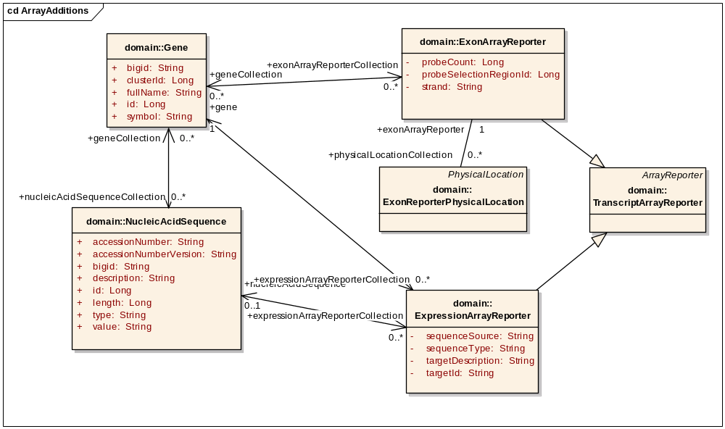
Figure 2: caBIO Array Model in 4.0
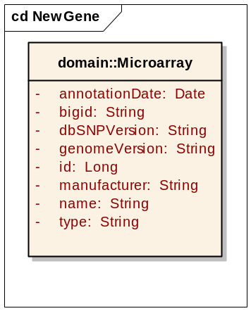
Figure 3: caBIO Microarray in 4.0

Model Changes

Several data which are not in caBIO are needed by the use cases defined above. In order to add these data, the following model changes will be made:

1) Replace ExonReporterPhysicalLocation with ArrayReporterPhysicalLocation

Most array manufacturers provide locations or alignments for their reporters. Currently, caBIO only contains such locations for ExonArrayReporters. This change would generify this for all arrays (including SNPArrayReporters) by adding a new class ArrayReporterPhysicalLocation and then an association from the ArrayReporter class. This will help satisfy the Get Reporter Annotations use case.

2) Add ArrayReporterCytogeneticLocation

Many array manufacturers provide the cytoband on which their reporter is located. Adding this class, with the association to ArrayReporter will allow us to add these cytobands wherever available. This will help satisfy the Get Reporter Annotations use case.

3) Add hugoSymbol attribute to Gene

The HUGO gene symbol is central to caIntegrator’s gene representation and must be added to caBIO to support most of the use cases.

4) Add assembly attributes to PhysicalLocation

PhysicalLocations are specific to a genome assembly. Exposing this information will help users decide which location is right for their purposes.

5) Add featureType attribute to GenePhysicalLocation

The “Gene” locations in caBIO may refer to different parts of the gene, such as exons. Exposing this information helps users find the full Gene location.

6) Add description and LSID attributes to Microarray

The Microarray’s name attribute shall be repopulated so a new attribute called description will hold a human-readable description of each microarray (Figure 5). A new LSID attribute will provide a reference to caArray, if the array is available there. For values, see the Data section.

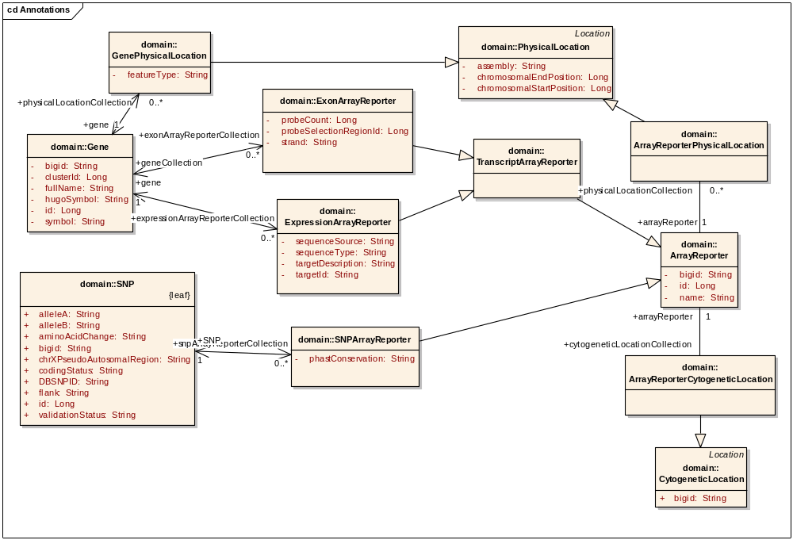
Figure 4: caBIO Array Model in 4.1

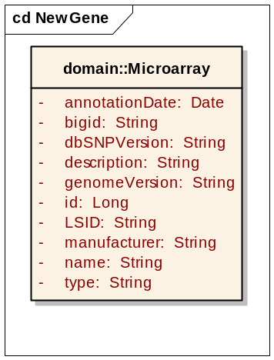
Figure 5: caBIO Microarray in 4.1
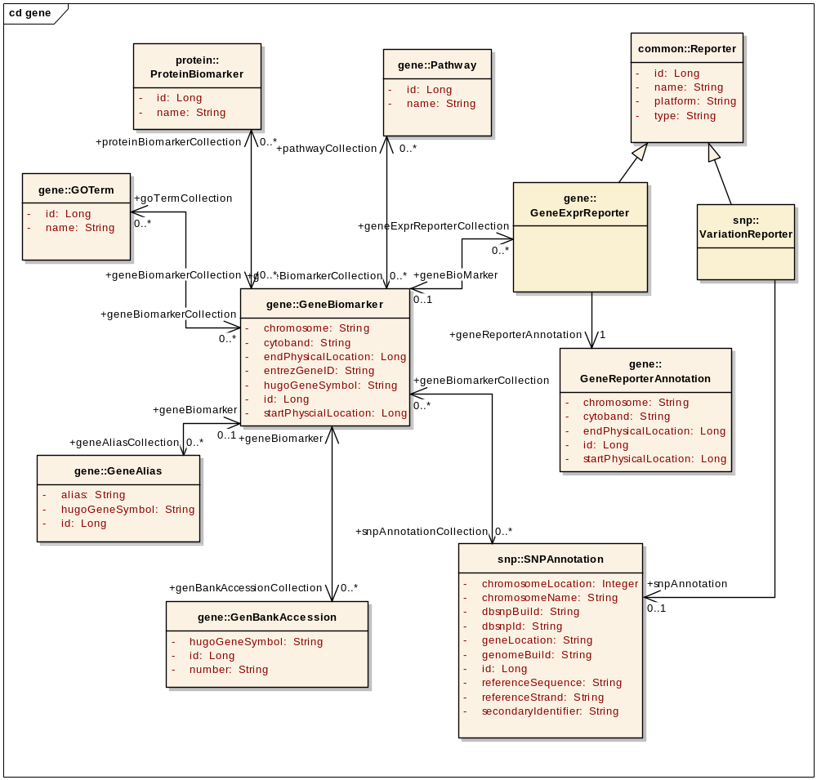
Figure 6: caIntegrator Array Model

Data
Additional data will be pulled from existing data sources, and some new data sources will be added to caBIO.

New Arrays
Affymetrix Human Genome U133 A and A 2.0 Arrays
The annotation format for these arrays is identical to the U133 Plus 2.0 array, so the same load scripts may be used.

Reporter Locations
The manufacturer locations (physical and cytologic) for array reporters will be pulled from each manufacturer-provided annotation file as follows.

Affymetrix Human Genome U133 Plus 2.0 Array
Affymetrix Human Genome U133A Array
Affymetrix Human Genome U133A 2.0 Array
Category | Attribute | Mapping
Location | Alignments | ExpressionReporter→ArrayReporterPhysicalLocation
Location | Chromosomal Location | ExpressionReporter→ArrayReporterCytogeneticLocation

Agilent 44K Array
Category | Attribute | Mapping (+++ indicates existing data source)
Location | GenomicCoordinates | ExpressionReporter→ArrayReporterPhysicalLocation
Location | Cytoband | ExpressionReporter→ArrayReporterCytogeneticLocation

Affymetrix 500K and 100K Arrays
Category | Attribute | Mapping
Location | Chromosome | SNPReporter→ArrayReporterPhysicalLocation→Chromosome
Location | Physical Position | SNPReporter→ArrayReporterPhysicalLocation
Location | Cytoband | SNPReporter→ArrayReporterCytogeneticLocation

Illumina 550K Array
Category | Attribute | Mapping
Location | Chromosome | SNPReporter→ArrayReporterPhysicalLocation
Location | Coordinate | SNPReporter→ArrayReporterPhysicalLocation

Agilent Human Genome CGH 244K
Category | Attribute | Mapping
Location | TargetID | ExpressionReporter→ArrayReporterPhysicalLocation

Affymetrix Exon 1.0 ST (Currently exists as ExonReporterPhysicalLocation)
Category | Attribute | Mapping
Location | seqname | SNPReporter→ArrayReporterPhysicalLocation→Chromosome
Location | start | SNPReporter→ArrayReporterPhysicalLocation
Location | stop | SNPReporter→ArrayReporterPhysicalLocation

HUGO Gene Symbols
HUGO symbols shall be loaded from the HGNC database into the Gene.hugoSymbol attribute.

Physical Location Assembly
Gene and Marker Locations
The raw data for these locations, loaded from NCBI’s MapView, contains a field called GROUP_LABEL, which can be taken directly as the value of the assembly attribute.

Reporter Locations
For HGU133, the assembly will be extracted from chromosome information if available. Otherwise, the assembly will be assumed as “reference”.

Other Locations
All other physical locations will have null values for assembly, for the time being. In the future, the assembly usage will need be analyzed on a case-by-case basis.

Gene Location Feature Type
The gene locations loaded from NCBI’s MapView contain locations for various gene “features” such as exons and pseudo genes. The FEATURE_TYPE field in the raw data shall be exposed in the new featureType attribute.

Microarray Naming
The name and description attributes in Microarray shall be repopulated as follows:

manufacturer | name | description
Affymetrix | HG-U133_Plus_2 | Human Genome U133 Plus 2.0 Array
Affymetrix | HT_HG-U133A | Human Genome U133A Array
Affymetrix | HG-U133A_2 | Human Genome U133A 2.0 Array
Affymetrix | HuEx-1_0-st-v2 | Human Exon 1.0 ST Array
Affymetrix | Mapping250K_Nsp | Human Mapping 250K Nsp Array
Affymetrix | Mapping250K_Sty | Human Mapping 250K Sty Array
Affymetrix | Mapping50K_Hind240 | Human Mapping 50K Array Hind 240
Affymetrix | Mapping50K_Xba240 | Human Mapping 50K Array Xba 240
Agilent | 014850_D | Human Genome, Whole
Agilent | 014693_D | Human Genome CGH 244A
Illumina | HumanHap550Kv3 | HumanHap550 Genotyping BeadChip

The LSID attribute shall be populated as follows:

manufacturer | name | LSID
Affymetrix | HG-U133_Plus_2 | URN:LSID:Affymetrix.com:PhysicalArrayDesign:HG-U133_Plus_2
Affymetrix | HT_HG-U133A | URN:LSID:Affymetrix.com:PhysicalArrayDesign:HT_HG-U133A
Affymetrix | HG-U133A_2 | URN:LSID:Affymetrix.com:PhysicalArrayDesign:HG-U133A_2
Affymetrix | Mapping250K_Nsp | URN:LSID:Affymetrix.com:PhysicalArrayDesign:Mapping250K_Nsp
Affymetrix | Mapping250K_Sty | URN:LSID:Affymetrix.com:PhysicalArrayDesign:Mapping250K_Sty

Other LSID values shall be added to caBIO as they are added to caArray.

Assumptions
This implementation assumes that the Gene mapping made by caBIO is sufficient for caIntegrator’s purposes. In particular, caBIO Genes are mapped to reporters by using the Unigene id given in the array annotation, or the symbol if the Unigene id is not present.

Dependencies
The caBIO system is dependent on the caCORE SDK, version 4.0 or higher.

Issues
There are no known issues at this time.

Third Party Tools
The API will use the caCORE SDK. See the current SDK technology stack for a complete listing.

Implementation Contents

Server
The caBIO server will run in the standard JBoss configuration. This implementation affects only the modeling and database, not the server configuration.

Algorithms
Get SNPs for Gene
This use case requires the finding of SNPs around every exon of a given gene. As such, the range query API cannot be used, since it queries for SNPs in the entire gene range (introns included). Furthermore, the SNPs must be found in the same assembly as the gene. The algorithm proceeds as follows:
- Find all genes with the given HUGO symbol and taxon.
- Get all the genes’ CDS physical locations in the reference assembly. The chromosome of each physical location must match the gene’s chromosome.
- Combine all the resultant physical locations in a set of non-overlapping ranges on the genome.
- Query for SNPs in the range set, on the same genome as the gene.

Batch Processes
None expected.

APIs
The interface defining the new convenience methods:

package gov.nih.nci.cabio.annotations;

public interface ArrayAnnotationService {

/**
* Given an array and list of reporter names, return a mapping of those
* reporter names to HUGO gene symbols.
* @param arrayPlatform Microarray name
* @param reporterIds List of reporters on the specified microarray
* @return mapping of reporter names to lists of gene symbols
* @throws ApplicationException system error
*/
public abstract Map<String, Collection<String>> getGenesForReporters(
String arrayPlatform, Collection<String> reporterIds)
throws ApplicationException;

/**
* Given an array and a list of HUGO gene symbols, return a mapping of
* those gene symbols to reporters on the specified array.
* @param arrayPlatform Microarray name
* @param geneSymbols list of HUGO gene symbols
* @return mapping of genes to lists of reporters
* @throws ApplicationException system error
*/
public abstract Map<String, Collection<String>> getReportersForGenes(
String arrayPlatform, Collection<String> geneSymbols)
throws ApplicationException;

/**
* Returns all ArrayReporters on a given array platform.
* @param arrayPlatform name of Microarray
* @return collection of ArrayReporter objects
* @throws ApplicationException system error
*/
public abstract Collection<ArrayReporter> getReportersForPlatform(
String arrayPlatform) throws ApplicationException;

/**
* Given an array and list of reporter names, return the
* ExpressionArrayReporter objects corresponding to the reporter names,
* populated with the following annotations:
* <ul>
* <li>gene
* <li>physicalLocationCollection.chromosome
* <li>cytogeneticLocationCollection
* <li>cytogeneticLocationCollection.cytoband
* </ul>
* @param arrayPlatform expression microarray name
* @param reporterIds list of reporter names
* @return list of prepopulated array reporters
* @throws ApplicationException system error
*/
public abstract Collection<ExpressionArrayReporter>
getExpressionReporterAnnotations(String arrayPlatform,
Collection<String> reporterIds) throws ApplicationException;

/**
* Given an array and list of reporter names, return the
* ExonArrayReporter objects corresponding to the reporter names,
* populated with the following annotations:
* <ul>
* <li>geneCollection
* <li>physicalLocationCollection
* <li>physicalLocationCollection.chromosome
* <li>cytogeneticLocationCollection
* <li>cytogeneticLocationCollection.cytoband
* </ul>
* @param arrayPlatform exon microarray name
* @param reporterIds list of reporter names
* @return list of prepopulated array reporters
* @throws ApplicationException system error
*/
public abstract Collection<ExonArrayReporter>
getExonReporterAnnotations(String arrayPlatform,
Collection<String> reporterIds) throws ApplicationException;

/**
* Given an array and list of reporter names, return the
* SNPArrayReporter objects corresponding to the reporter names,
* populated with the following annotations:
* <ul>
* <li>SNP
* <li>physicalLocationCollection
* <li>physicalLocationCollection.chromosome
* <li>cytogeneticLocationCollection
* <li>cytogeneticLocationCollection.cytoband
* </ul>
* @param arrayPlatform SNP microarray name
* @param reporterIds list of reporter names
* @return list of prepopulated array reporters
* @throws ApplicationException system error
*/
public abstract Collection<SNPArrayReporter>
getSNPReporterAnnotations(String arrayPlatform,
Collection<String> reporterIds) throws ApplicationException;

/**
* Returns a collection of the requested genes, populated with the
* following annotations:
* <ul>
* <li>cytogeneticLocationCollection
* <li>cytogeneticLocationCollection.startCytoband
* <li>databaseCrossReferenceCollection
* <li>chromosome
* </ul>
* @param geneSymbols list of HUGO gene symbols
* @return collection of Genes prepopulated with associated annotations
* @throws ApplicationException system error
*/
public abstract Collection<Gene> getGeneAnnotations(
Collection<String> geneSymbols) throws ApplicationException;

/**
* Returns all the cytobands on the specified chromosome.
* @param chromosomeNumber the number of the chromosome
* @return list of cytoband physical locations
* @throws ApplicationException system error
*/
public abstract List<CytobandPhysicalLocation> getCytobandPositions(
String chromosomeNumber) throws ApplicationException;

/**
* Returns the Microarray with the given name.
* @param platformName Microarray name
* @return Microarray of interest
* @throws ApplicationException system error
*/
public abstract Microarray getMicroarray(String platformName)
throws ApplicationException;

/**
* Returns the genes with the given HUGO symbol.
* @param symbol HUGO gene symbol
* @return The Genes of interest
* @throws ApplicationException system error
*/
public abstract Collection<Gene> getGenesForSymbol(String hugoSymbol)
throws ApplicationException;

/**
* Returns the aliases associated with the given gene sumbol.
* @param symbol HUGO gene symbol
* @return collection of GeneAlias objects
* @throws ApplicationException system error
*/
public abstract Collection<GeneAlias> getAliasesForGene(String symbol)
throws ApplicationException;

/**
* Returns all reporter names for the specified SNP on the given array.
* @param arrayPlatform Microarray name
* @param dbSnpId dbSNP Id
* @return Collection of reporter names
* @throws ApplicationException system error
*/
public abstract HashMap<String, Collection<String>> getReportersForSnps(
String arrayPlatform, List<String> dbSnpId) throws ApplicationException;

/**
* Returns the specified SNP preloaded with annotations.
* The associations which are preloaded:
* <ul>
* <li>physicalLocationCollection
* <li>physicalLocationCollection.chromosome
* <li>cytogeneticLocationCollection
* <li>cytogeneticLocationCollection.startCytoband
* </ul>
* @param arrayPlatform Microarray name
* @param dbSnpIds list of dbSNP Ids
* @return SNP objects preloaded with associations
* @throws ApplicationException system error
*/
public abstract Collection<SNP> getSNPAnnotations(List<String> dbSnpIds)
throws ApplicationException;

/**
* Returns the genes associated with the given dBSNP id by array
* annotations (relative locations).
* @param dbSnpId dbSNP Id
* @return Collection of HUGO gene symbols
* @throws ApplicationException system error
*/
public abstract Collection<Gene> getGenesForDbSnpId(String dbSnpId)
throws ApplicationException;

/**
* Returns all the SNPs within the specified range of the given gene on
* the specified assembly.
* @param symbol HUGO gene symbol
* @param kbUpstream distance upstream
* @param kbDownstream distance downstream
* @param assembly genome assembly for SNP and Gene locations
* @return List of SNPs
* @throws ApplicationException system error
*/
public abstract Collection<SNP> getSnpsNearGene(
String symbol, Long kbUpstream, Long kbDownstream, String assembly)
throws ApplicationException;

/**
* Returns all the SNPs within the specified range of the given gene, on
* the reference assembly.
* @param symbol HUGO gene symbol
* @param kbUpstream distance upstream
* @param kbDownstream distance downstream
* @return List of SNPs
* @throws ApplicationException system error
*/
public abstract Collection<SNP> getSnpsNearGene(
String symbol, Long kbUpstream, Long kbDownstream)
throws ApplicationException;
}

The implementation of this API will take a Taxon abbreviation in the constructor to allow for use of the APIs with various species. The default species shall be Human.

Error Handling
The new convenience methods will throw IllegalArgumentException in the event of an invalid argument. The methods will throw ApplicationException when something goes wrong with the query.

Database Changes
The database changes shall support the modeling and data changes described above. In particular:

The LOCATION_CH.EXON_REPORTER_ID column shall be renamed to ARRAY_REPORTER_ID and loaded with data for other arrays.

A new column GENE_TV.HUGO_SYMBOL shall be populated with the HUGO data.

A new column LOCATION_CH.FEATURE_TYPE shall be populated with MapView data.

A new column LOCATION_CH.ASSEMBLY shall be populated with MapView data.

Client
The standard SDK generated client will be used for this implementation

JSP/HTML
The standard SDK generated JSP/HTML interface will be used for this implementation

Servlet
The standard SDK generated Servlet will be used for this implementation

Error Handling
The standard SDK Error Handling will be used. See the SDK Exception handling documentation for more information.

Security Issues
The location data is publicly available and does not require any security.

Performance
The performance of this API shall be comparable to the existing caIntegrator annotation APIs.

For further details about performance and the latest benchmarks, please refer to the caBIO_4.1_Annotation_API_performance.xls spreadsheet in CVS.

Internationalization
Not applicable.

Installation / Packaging
The design assumes the standard caBIO installation and packaging.

Migration
Not applicable.

Documentation Considerations
- This design document
- Updated caBIO Technical Guide
- SDK 4.0 Developer’s Guide
- Hibernate v3 Reference Documentation

Unit Testing

Test Guidelines
Unit tests for the Java API are part of the cabioapi repository, and are run as part of the daily build.

Test Cases
Each method in the new API shall be tested with several exemplars.

Data Exemplars

Affymetrix Human Genome U133 Plus 2.0 Array

Probe Set ID | 1007_s_at | 1552622_s_at | 1431_at
Alignments | chr6:30964144-30975910 (+) // 95.63 // p21.33 /// chr6_cox_hap1:2304770-2316538 (+) // 95.56 // /// chr6_qbl_hap2:2103099-2114867 (+) // 95.45 // | chr7:44019089-44025288 (-) // 45.02 // p13 ///  chr7:101993922-102000124 (-) // 45.32 // q22.1 ///  chr7:102093569-102099335 (-) // 41.38 // q22.1 /// chr7:101901389-101906354 (-) // 37.88 // q22.1 | chr10:135190889-135202458 (+) // 99.87 // q26.3
Chromosomal Location | chr6p21.3 | chr7q11.22 /// chr7q11.23 | chr10q24.3-qter

Agilent 44K Array

ProbeID | A_23_P253586 | A_24_P505981 | A_23_P136135
GenomicCoordinates | chr21:36586364-36587509 | chrX:149832761-149832901 | chr11:67586031-67578067
Cytoband | hs|21q22.12 | hs|Xq28 | hs|11q13.2

Affymetrix 500K and 100K Arrays

Probe Set ID | SNP_A-1756690 | SNP_A-1644257 | SNP_A-1677427
Chromosome | 16 | 14 | 1
Physical Position | 7666758 | 50985012 | 168090969
Cytoband | p13.2 | q22.1 | q24.2

Illumina 550K Array

SNP | rs1000000 | rs10000770 | rs10001608
Chromosome | 12 | 4 | 4
Coordinate | 125456933 | 143833712 | 88656734

Agilent Human Genome CGH 244K

ProbeID | A_14_P112718 | A_14_P121179 | A_16_P02942782
TargetID | chr1:000604268-000604327 | chr1:001536308-001536363 | chr14:072147737-072147796

NCBI Gene Physical Locations

FEATURE_TYPE contains the following distinct values:

Value | Count
CDS | 968478
UTR | 283498
GENE | 123749
RNA | 123653
PSEUDO | 22954

GROUP_LABEL contains the following distinct values:

Value | Count
Celera | 715862
reference | 403939
C57BL/6J | 357156
CRA_TCAGchr7v2 | 19395
129/SvJ | 5675
129/Sv | 4094
129/SvEvTac | 3590
c6_COX | 3171
c6_QBL | 2937
NOD | 2458
unknown | 1924
c5_H2 | 749
129S7/SvEv | 387
129/Ola | 208
BALB/c | 199
C3H | 137
Cast/Ei | 111
129 | 74
SJL/J | 64
AKR/J | 62
A/J | 35
B6/CBAF1J | 32
Spret/Ei | 26
DR53 | 24
129/J | 18
c22_H2 | 5

DOCUMENT CONTROL
Change History
Content changes to this document from the previous to the current level are indicated by revision bars (|) unless a complete rewrite is indicated.

Table 2 – Implementation Specification Document Change Log
Version/Date | Approved By | Change Description and Explanation | D - Draft  A - For Review/ Approval  R - Re-Approval, Plan of Record Change
02/08/2008 | Konrad Rokicki | Initial revision | D
02/24/2008 | Konrad Rokicki | Updated use cases, added API | A
02/26/2008 | Konrad Rokicki | Revised after design review. | A
03/03/2008 | Konrad Rokicki | Added revised microarray naming and assembly information for locations. | A
Note: If this document has been inspected, please indicate the inspection date that each version is based on in the “Change Description and Explanation” area. Entries in this log must be maintained for at least 3 years.

DOCUMENT APPROVAL
Approvers List
The individuals listed in this section constitute the approvers list for the Integration Test Plan document. Formal approval must be received from all approvers prior to the initiation of the next steps in the process.

Title | Name
Project Manager | Name
Development Manager | Name

Reviewers List
The individuals listed in this section constitute the reviewers list for the Master Test Plan document. Formal approval is not required from the reviewers, however, it is desirable to have all reviewers review and comment on the document. Reviewers may choose to concentrate on reviewing only those sections that are in their area of responsibility, rather than the entire document.

Title | Name
Solutions Manager | Name
Project Manager | Name
Test Manager | Name
Test Engineer | Name
Development Manager | Name
Technical Writer | Name
Client Support Analyst | Name
Internationalization Lead | Name
DBA | Name
Developer | Name
Developer | Name

END OF DOCUMENT

