Implementation Specification
for
Gene and Marker modeling in caBIO

Release 4.1

Last Updated: January 23, 2008

Owner: caBIO Team
Email: klemmj@mail.nih.gov

National Cancer Institute Center for BioInformatics
6116 Executive Blvd.
Rockville, MD 20852



1 Document Purpose 3
2 Implementation Overview 4
2.1 Team Members 4
2.2 Description 4
2.3 Scope 4
2.4 Use Cases 4
2.4.1 Find all the Genes in an Ontology subtree 5
2.4.2 Get Homologous Gene 5
2.4.3 Find Markers contained in a Gene 6
2.4.4 Find genomic features near a Marker 6
2.5 Architecture 7
2.5.1 Existing Domain Model 7
2.5.2 Modified Domain Model 10
2.6 Data 11
2.7 Assumptions 12
2.8 Dependencies 12
2.9 Issues 12
2.10 Third Party Tools 12
3 Implementation Contents 13
3.1 Server 13
3.1.1 Algorithms 13
3.1.2 Batch Processes 13
3.1.3 APIs 13
3.1.4 Error Handling 13
3.1.5 Database Changes 13
3.2 Client 13
3.2.1 JSP/HTML 13
3.2.2 Servlet 14
3.2.3 Error Handling 14
3.3 Security Issues 14
3.4 Performance 14
3.5 Internationalization 14
3.6 Installation / Packaging 14
3.7 Migration 14
3.8 Documentation Considerations 14
4 Unit Testing 15
4.1 Test Guidelines 15
4.2 Test Cases 15
5 Data Exemplars 16
DOCUMENT CONTROL 17
DOCUMENT APPROVAL 18

Document Purpose
This document provides design and implementation details that various defects and feature requests related to the Gene model in caBIO. This document describes the required caBIO domain object modeling and new data sources.

Implementation Overview

Team Members

Role | Name
Director of Engineering | Avinash Shanbhag²
Internationalization Lead | N/A
Product Manager | Juli Klemm²
Project Manager | Sharon Gaheen¹
Test Lead | Ye Wu¹
Tech Lead | Jim Sun¹
Documentation Lead
Development Team | Konrad Rokicki¹  Lalitha Viswanath¹  Hong Dang³
¹ Science Applications International Corporation (SAIC)
² National Cancer Institute Center for Bioinformatics (NCICB)
³ Alpha-Gamma Technologies, Inc.
Table 1: Team Members

Description
There are several defects concerning the current Gene model, and Gene-related objects, which will be addressed in version 4.1 of caBIO.

Scope
The scope of this document includes the following defects:

GForge # | Defect Description | Resolution
GF8148 | No location-based Gene/SNP link | Satisfied by Range Query API
GF9264 | Incorrect relationship among Library, Histopathology, Gene | Data loading change
GF7769 | Aggregate gene ontology associations from children ontologies | Data loading change
GF7767 | Missing comparable Gene in HomologousAssociation | Modeling change
GF9770 | Add Gene - Marker association | Data loading and modeling change
GF11269 | Add PhysicalLocation data for Markers | Data loading and modeling change
GF11438 | Add UniSTS data source | Data loading and modeling change

Use Cases
The use cases described here are from the system perspective.

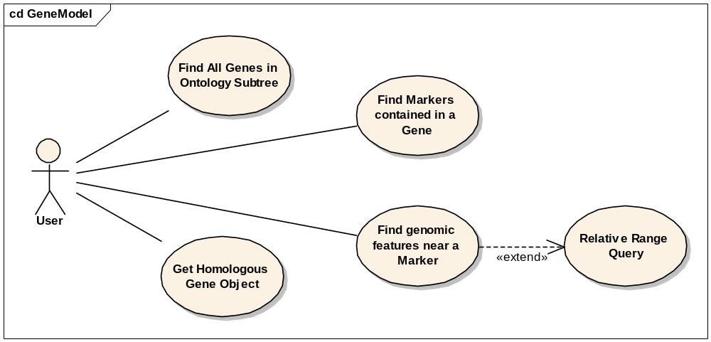
Figure 1: Use Case Diagram

Find all the Genes in an Ontology subtree

Use Case Name | Find All Genes in Ontology Subtree
Use Case ID | 1.1
Primary Actor | Public
Brief Description | Allows users to easily retrieve all the genes in a particular subtree of the Gene Ontology, without walking the tree
Trigger | The user is interested in a Gene Ontology
Pre-conditions | - The user navigates to the caBIO Home Page and clicks “Continue”  - The user finds a GeneOntology object of interest
Flow of Events | - The user clicks getGeneCollection()  - A list of Genes appears, where each Gene is associated with an ontology node that is descendant from the node of interest
Post Conditions | Success Condition: The user successfully searches the database and obtains the list  Error Conditions:  EC1: System Error during Request Processing
Alternative Flow | Alternate Condition:  AC2: No result is found  1. “Results: Zero records found” message is displayed
Related Use Cases | This is similar to the current getGeneCollection() use case for GeneOntology, except that the GeneOntology of interest can be a non-leaf (intermediate) node.
Issues/Notes | - The user can also execute the same search using the Java API or Web Service

Get Homologous Gene

Use Case Name | Get Homologous Gene Object
Use Case ID | 1.2
Primary Actor | Public
Brief Description | Allows users to easily navigate to a homologous Gene, from a Gene of interest
Trigger | The user is interested in Gene homologies
Pre-conditions | - The user navigates to the caBIO Home Page and clicks “Continue”  - The user finds a Gene of interest
Flow of Events | - The user clicks getHomologousAssociation()  - The user is presented with a list of homologous gene matches, with similarity percentages  - The user clicks getHomologousGene() to retrieve the related Gene
Post Conditions | Success Condition: The user successfully searches the database and obtains the list  Error Conditions:  EC1: System Error during Request Processing
Alternative Flow | Alternate Condition:  AC2: No result is found  1. “Results: Zero records found” message is displayed
Related Use Cases
Issues/Notes | - The user can also execute the same search using the Java API or Web Service.

Find Markers contained in a Gene

Use Case Name | Find Markers contained in a Gene
Use Case ID | 1.3
Primary Actor | Public
Brief Description | Allows users to navigate directly from a Gene to the Markers within it
Trigger | The user is interested in finding Markers for a certain Gene
Pre-conditions | - The user navigates to the caBIO Home Page and clicks “Continue”  - The user finds a Gene of interest
Flow of Events | - The user clicks getMarkerCollection()  - The user is presented with a list of Markers in the Gene
Post Conditions | Success Condition: The user successfully searches the database and obtains the list  Error Conditions:  EC1: System Error during Request Processing
Alternative Flow | Alternate Condition:  AC2: No result is found  1. “Results: Zero records found” message is displayed
Related Use Cases
Issues/Notes | - The user can also execute the same search using the Java API or Web Service.

Find genomic features near a Marker

Use Case Name | Find genomic features near a Marker
Use Case ID | 1.4
Primary Actor | Public
Brief Description | Allows users to perform range queries around a Marker
Trigger | The user is interested in using Markers to locate other genomic features
Pre-conditions | - The user navigates to the caBIO Home Page and clicks “Continue”
Flow of Events | - The user selects the GridIdRangeQuery object  - The user pastes in a valid Grid Id of the Marker of interest into the bigid field  - The user optionally provides search parameters, such as how far to search upstream/downstream, and whether or not to include features partially within the range  - The user clicks the submit button to initiate the search  - A list of PhysicalLocations in the specified range appears  The user can navigate to the feature described by each PhysicalLocation by clicking its association link
Post Conditions | Success Condition: The user successfully searches the database and obtains the list  Error Conditions:  EC1: System Error during Request Processing
Alternative Flow | Alternate Condition:  AC2: No result is found  1. “Results: Zero records found” message is displayed
Related Use Cases | Relative Range Query
Issues/Notes | - The user can also execute the same search using the Java API or Web Service.

Architecture

Existing Domain Model

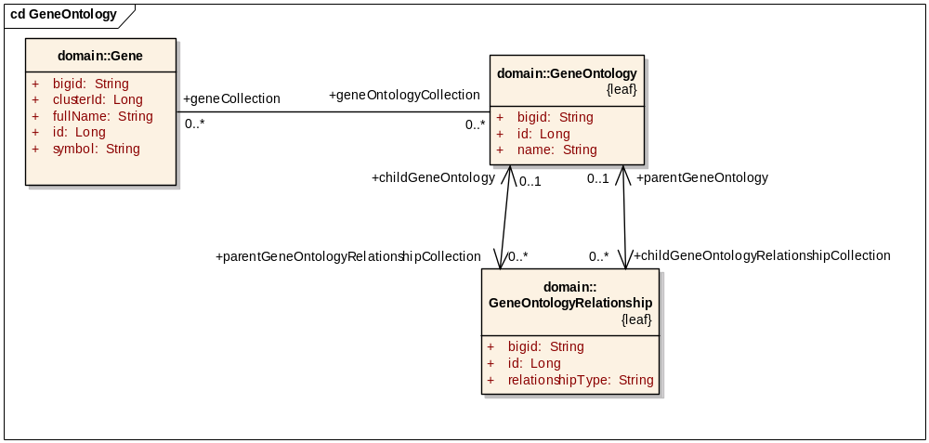
Figure 2: Current Gene Ontology Model
The GO model (Figure 2) is presented here for completeness, although no model changes are planned. New data shall be loaded into this model as per the Database Changes section (3.1.5).

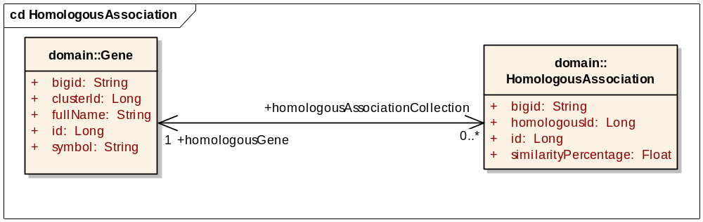
Figure 3: Current Homologous Gene model
The Homology model (Figure 3) provides a homologous gene as an attribute called homologousId, which contains the internal caBIO id of the homologous Gene. There is also a confusing association called homologousGene that actually points back to the same gene the user has come from (in the typical use case). To actually retrieve the homologous gene, the user is forced to take the homologousId and manually search for the gene, by its internal Gene.id (which is subject to change between loads, and thus should not be exposed in the model).

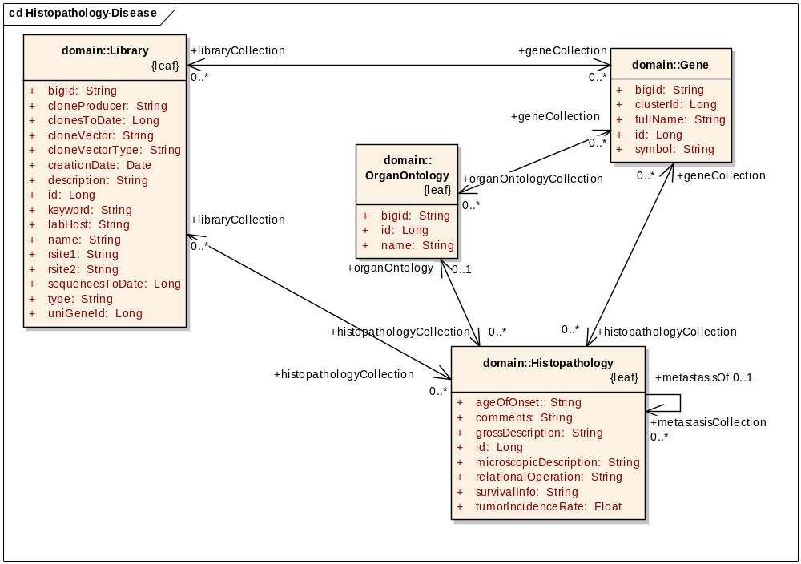
Figure 4: Current Histopathology Model
The Histopathology model (Figure 4) is presented here for completeness, although no model changes are planned.

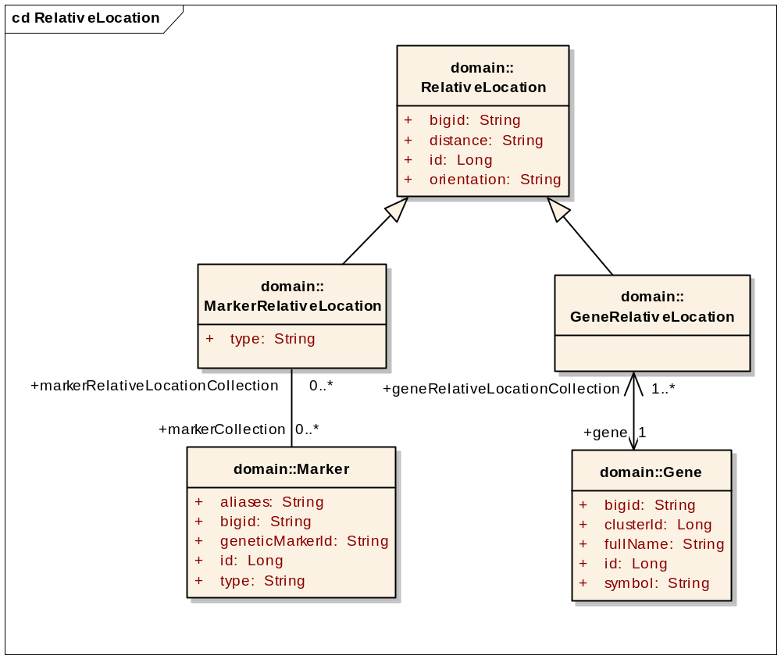
Figure 5: Current RelativeLocation model, including Marker

The current data in Marker is structured according to how it is used by microarray annotations that it comes from. Currently that means the Microsatellite and Genetic Map annotations from the Affymetrix HuMapping arrays. There are several shortcomings to this approach which make it difficult to implement a Gene-Marker association:
- The Marker.markerId is not unique. A given markerId may have separate Marker records when used as a microsatellite, in the deCODE genetic map, and so forth. This means that we will have redundant Gene-Marker associations (a Marker may be listed several times for a particular Gene).
- The data is very incomplete. For example, Figure 6 shows the 30 most referenced STS markers in the Human Unigene data file. For example, the most referenced marker is D11S2921, referenced in 1939 Unigene entries. None of these top 30 markers are in the caBIO Marker object.
- The reverse is also true. A Marker may have many aliases (GenBank, UniSTS, EMBL, etc) but caBIO only lists a single name and a single id as provided by the microarray annotations. The name is sparsely populated, and the markerId does not come from a single source, thus making lookups hard to do, even for the markers which are present.

As a result of these issues, attempting to bring in a Gene-Marker association without revamping Marker itself would not add much value to caBIO, since the number of Gene-Marker associations populated would be very small. These issues also affect the Marker PhysicalLocation implementation, to a lesser degree.

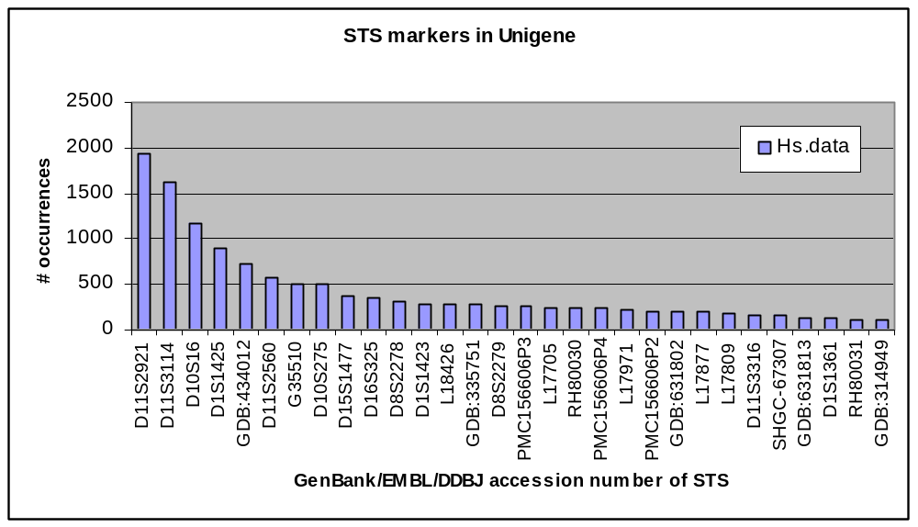
Figure 6: Top 30 marker references in Unigene Hs.data file

Modified Domain Model
To support the Get Homologous Gene use case, the model will be modified with an additional one-way association (Figure 7). The current association will be renamed to “gene” so that the user still has the option of going back to the original Gene of interest (for example, if they are handed a HomologousAssociation object). The new association will be called homologousGene, and it will replace the homologousId attribute, which will be deprecated in 4.1, and removed in the next version of caBIO.

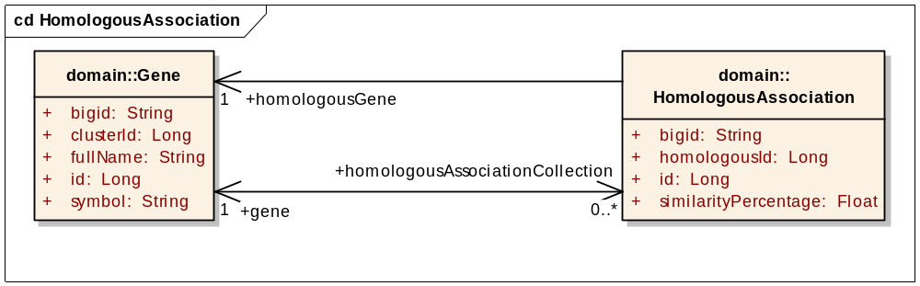
Figure 7: Proposed Homologous Gene model

To support the Find Markers contained in a Gene and Find genomic features near a Marker uses cases, the marker model shall be modified in several ways so that it becomes analogous to the Gene model (Figure 8). To accommodate the UniSTS data, the Marker.aliases attribute shall be deprecated, and a MarkerAlias object will be added with multiple aliases per marker. This is parallel to the Gene-GeneAlias association. Furthermore, to satisfy the two new Marker use cases, an association between Gene and Marker shall be added, and another association to a new object called MarkerPhysicalLocation, parallel to GenePhysicalLocation.
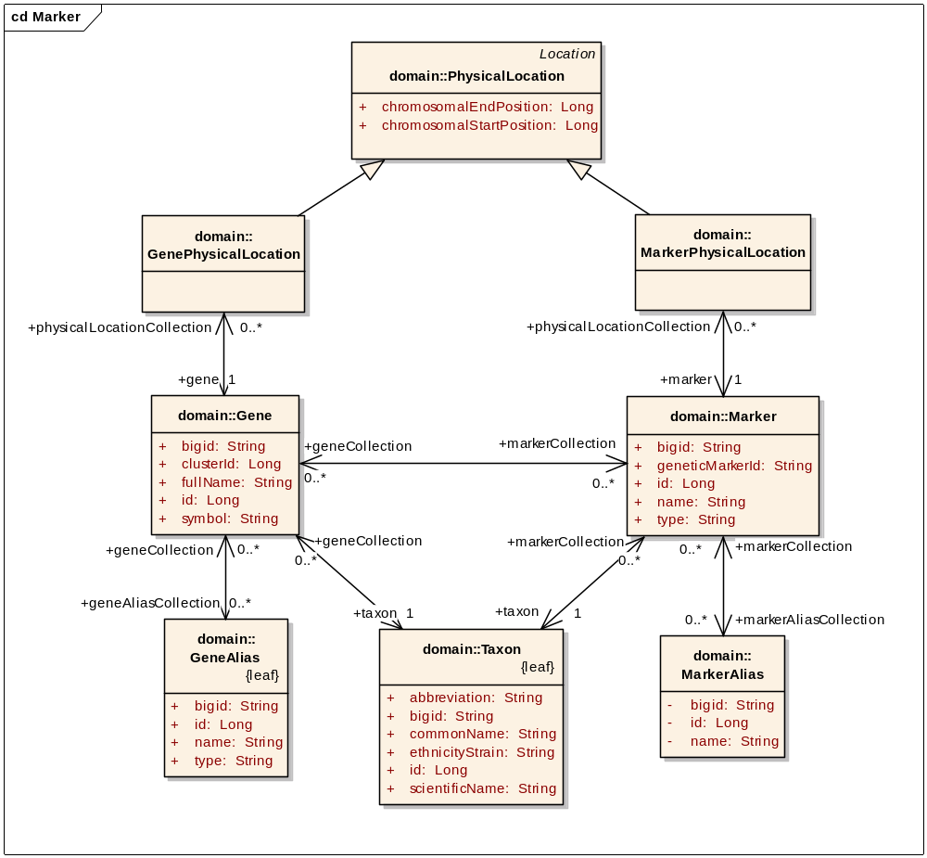
Figure 8: Proposed Marker Model

Data
Before adding any new defect-specific data, the Marker shall first be remodeled as a UniSTS-based entity. The following data changes will be made:
- Marker.markerId will now store UniSTS id
- Marker.name will now store UniSTS name
- Marker.type will be either “UniSTS” or “TSC” in the case of SLM1 markers
- Marker will be linked to Taxon so that non-human (i.e. mouse) markers can be loaded
- A new class called MarkerAlias, with attribute MarkerAlias.name will be added for storing aliases for each UniSTS marker.
- Microsatellite/Genetic Map data loading will be rewritten to link to Marker instead of populating it. This can be done by searching MarkerAliases for a match.
Since Marker is currently assumed to be human, it has no Taxon discriminator. A new association will be made to Taxon, mirroring the Gene model.

Next, the Gene-Marker association will be added, by linking on UniSTS ids. To support the Gene-Marker association, additional data shall be parsed from the Unigene data files (see Data Exemplars section on page 16). These files are already part of the caBIO load process, but the STS section is not being parsed.

To support the Marker-PhysicalLocation association, additional alignment data for UniSTS markers will be loaded. This data will come from MapView, the same source as the Gene locations come from:
- ftp://ftp.ncbi.nih.gov/genomes/MapView/Homo_sapiens/sequence/current/initial_release/seq_sts.md.gz
- ftp://ftp.ncbi.nih.gov/genomes/MapView/Mus_musculus/sequence/current/initial_release/seq_sts.md.gz

Assumptions
- The association between Marker and Gene must be many-to-many because a marker may appear in many Genes and a Gene can obviously have many markers (per Unigene data file).
- The association between Marker and MarkerAlias must be many-to-many because a marker may have many aliases and an alias can be used by several UniSTS markers (for example, both UniSTS:76320 and UniSTS:6414 have name “D1S468” and alias “AFM280we5”).
- Defect GF9264 can be fixed by fixing and running the load scripts for the Histopathology model.

Dependencies
The caBIO system is dependent on the caCORE SDK, version 4.0 or higher.

Issues
There are no known issues at this time.

Third Party Tools
The API will use the caCORE SDK. See the current SDK technology stack for a complete listing.

Implementation Contents

Server
The caBIO server will run in the standard JBoss configuration. This implementation affects only the modeling and database, not the server configuration.

Algorithms
See APIs section below.

Batch Processes
None expected.

APIs
Not applicable.

Error Handling
The standard SDK Error Handling will be used. See the SDK Exception handling documentation for more information.

Database Changes
To support the Find Genes in Ontology Subtree use case, the database load scripts will be modified to populate associations to Genes for all intermediate GO nodes in the GO_ONTOLOGY table. That is, for each non-leaf node in the GO tree, its geneCollection will be the union of all of its children’s geneCollections.

As per the Data section, the load scripts shall be modified to load UniSTS data into the MARKER, MARKER_ALIAS and MARKER_MARKER_ALIAS tables. A new column TAXON_ID shall be added to MARKER and populated with the correct foreign keys.

To support the Find Markers Contained in a Gene use case, the load scripts will be modified to extract STS data from the Unigene data files already being processed, and load it into a newly created GENE_MARKER correlation table.

To support the Find genomic features near a Marker use case, the load script will be modified to download Marker physical locations from UCSC, and populate them into the NEW_LOCATION_TV_BK table, with DISCRIMINATOR set to “MarkerPhysicalLocation”.

Finally, there is defect GF926, which does not represent a specific use case, but rather data integrity. Starting with a Library, taking its first Histopathology, then the first OrganOntology, you obtain a Gene. But that Gene’s Library Collection does not contain the original Library. The same situation happens if you omit the OrganOntology step and go straight from Histopathology to Gene. This issue seems to be caused because Histopathology is not updated during the regular data refresh. The data loading scripts shall be revisited to update the data and fix this defect.

Client
The standard SDK generated client will be used for this implementation

JSP/HTML
The standard SDK generated JSP/HTML interface will be used for this implementation

Servlet
The standard SDK generated Servlet will be used for this implementation

Error Handling
The standard SDK Error Handling will be used. See the SDK Exception handling documentation for more information.

Security Issues
The location data is publicly available and does not require any security.

Performance
The performance of the system, after the changes herein are completed, shall be at least equal to the previous version.

Internationalization
Not applicable.

Installation / Packaging
The design assumes the standard caBIO installation and packaging.

Migration
Users currently accessing the Marker object may need to change their business logic, since the object semantics have changed. Users currently accessing HomologousAssociation will need to simplify their business logic by calling the getHomologousGene() association instead of using getHomologousId() and then looking up that Gene.

Documentation Considerations
- This design document
- Updated caBIO Technical Guide
- SDK 4.0 Developer’s Guide
- Hibernate v3 Reference Documentation

Unit Testing

Test Guidelines
Unit tests for the Java API are part of the cabioapi repository, and are run as part of the daily build.

Test Cases
Each defect resolution will be tested.

Data Exemplars
Example entry from Unigene data file (Hs.data), showing STS marker associations. Every marker has a UniSTS id included.

ID Hs.2
TITLE N-acetyltransferase 2 (arylamine N-acetyltransferase)
GENE NAT2
CYTOBAND 8p22
GENE_ID 10
LOCUSLINK 10
HOMOL YES
EXPRESS bone| connective tissue| intestine| liver| liver tumor| normal| soft tissue/muscle tissue tumor| adult
RESTR_EXPR adult
CHROMOSOME 8
STS ACC=PMC310725P3 UNISTS=272646
STS ACC=WIAF-2120 UNISTS=44576
STS ACC=G59899 UNISTS=137181
STS ACC=G06461 UNISTS=17088
STS ACC=GDB:310612 UNISTS=156422
STS ACC=GDB:310613 UNISTS=156423
STS ACC=GDB:187676 UNISTS=155563

DOCUMENT CONTROL
Change History
Content changes to this document from the previous to the current level are indicated by revision bars (|) unless a complete rewrite is indicated.

Table 2 – Implementation Specification Document Change Log
Version/Date | Approved By | Change Description and Explanation | D - Draft  A - For Review/ Approval  R - Re-Approval, Plan of Record Change
12/31/2007 | Konrad Rokicki | Initial revision | D
01/02/2008 | Konrad Rokicki | Revised after team discussion. | D
01/07/2008 | Konrad Rokicki | Added full Marker model and revised several sections. Document is ready for approval. | A
01/23/2008 | Konrad Rokicki | Added Taxon/Marker association. | A
Note: If this document has been inspected, please indicate the inspection date that each version is based on in the “Change Description and Explanation” area. Entries in this log must be maintained for at least 3 years.

DOCUMENT APPROVAL
Approvers List
The individuals listed in this section constitute the approvers list for the Integration Test Plan document. Formal approval must be received from all approvers prior to the initiation of the next steps in the process.

Title | Name
Project Manager | Name
Development Manager | Name

Reviewers List
The individuals listed in this section constitute the reviewers list for the Master Test Plan document. Formal approval is not required from the reviewers, however, it is desirable to have all reviewers review and comment on the document. Reviewers may choose to concentrate on reviewing only those sections that are in their area of responsibility, rather than the entire document.

Title | Name
Solutions Manager | Name
Project Manager | Name
Test Manager | Name
Test Engineer | Name
Development Manager | Name
Technical Writer | Name
Client Support Analyst | Name
Internationalization Lead | Name
DBA | Name
Developer | Name
Developer | Name

END OF DOCUMENT

See caBIO_4.1_Location_modeling.doc
Mostly UniSTS. It will still need to contain TSC SNPs as well, for use by the SLM1 genetic map.

