Implementation Specification
for
Genomic Locations in caBIO

Release 4.1

Last Updated: January 16, 2008

Owner: caBIO Team
Email: klemmj@mail.nih.gov

National Cancer Institute Center for BioInformatics
6116 Executive Blvd.
Rockville, MD 20852



1 Document Purpose 3
2 Implementation Overview 4
2.1 Team Members 4
2.2 Description 4
2.3 Scope 4
2.3.1 Feature Requests 4
2.3.2 Defects 4
2.4 Use Cases 5
2.4.1 Relative Range Query 5
2.4.2 Absolute Range Query 6
2.4.3 Typed Relative Range Query 6
2.4.4 Typed Absolute Range Query 7
2.4.5 Physical Location to Cytoband 7
2.5 Architecture 8
2.5.1 Existing Domain Model 8
2.5.2 Modified Domain Model 11
2.6 Data 14
2.7 Assumptions 14
2.8 Dependencies 14
2.9 Issues 14
2.10 Third Party Tools 14
3 Implementation Contents 15
3.1 Server 15
3.1.1 Algorithms 15
3.1.2 Batch Processes 15
3.1.3 APIs 15
3.1.4 Error Handling 17
3.1.5 Database Changes 17
3.2 Client 18
3.2.1 JSP/HTML 18
3.2.2 Servlet 18
3.2.3 Error Handling 18
3.3 Security Issues 18
3.4 Performance 18
3.5 Internationalization 18
3.6 Installation / Packaging 18
3.7 Migration 18
3.8 Documentation Considerations 18
4 Unit Testing 19
4.1 Test Guidelines 19
4.2 Test Cases 19
5 Data Exemplars 20
TBD 20
DOCUMENT CONTROL 21
DOCUMENT APPROVAL 22

Document Purpose
This document provides design and implementation details that support additional use cases for genomic locations in caBIO. The new use cases primarily involve range queries, that is, querying for genomic features in a certain range on a chromosome. This document describes the required caBIO domain object modeling and API changes.

Implementation Overview

Team Members

Role | Name
Director of Engineering | Avinash Shanbhag²
Internationalization Lead | N/A
Product Manager | Juli Klemm²
Project Manager | Sharon Gaheen¹
Test Lead | Ye Wu¹
Tech Lead | Jim Sun¹
Documentation Lead
Development Team | Konrad Rokicki¹  Lalitha Viswanath¹  Hong Dang³
¹ Science Applications International Corporation (SAIC)
² National Cancer Institute Center for Bioinformatics (NCICB)
³ Alpha-Gamma Technologies, Inc.
Table 1: Team Members

Description
In this version of caBIO we revisit the current location model for both physical and cytogenetic locations. It should be easy for users to achieve the range query use cases described in the caBIO 4.1 Location Use Cases document.

Scope
The scope of this document includes all the use cases defined for locations in 4.1. In addition, the following feature requests and defects are addressed.

Feature Requests
GF8666 Populate CytogeneticLocation.endCytoband
The endCytoband attribute shall be populated with the ending cytoband where available, and it will be set to the startCytoband otherwise. It should never be null.

GF8925 Remodel "location" related objects
The concerns raised in this defect will be addressed by GF8666 above and the Range Query API.

GF8237 Missing link between PhysicalLocation and Cytoband
This defect is addressed by the Range Query API.

Defects

GF9474 Switch to "table per class hierarchy" inheritance mapping
Partially satisfied here (for the location hierarchy only).

GF9098 Create materialized views for superclass tables
No longer necessary, if GF9474 is implemented.

GF9419 Unable to get Chromosome from CytogeneticLocation object
Data shall be more fully populated. In general, the CHROMOSOME_ID column will never be null for any location.

GF10889 Create link from Cytoband to its Chromosome
A new association shall be created between Cytoband and Chromosome and populated with data formerly in CytogeneticLocation. That data will be removed, as it does not map to any specific subclass of CytogeneticLocation (that is, it does not locate a feature to a cytoband).

Use Cases
For domain-level use cases, refer to the caBIO 4.1 Location Use Cases document. The use cases described here are from the system perspective, and greatly generalized.

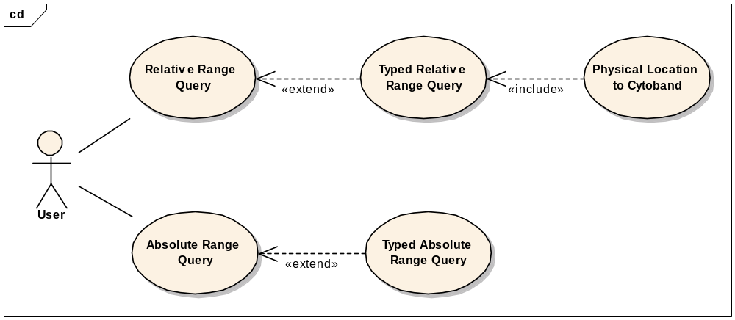
Figure 1: Use Case Diagram

Relative Range Query

Use Case Name | Relative Range Query
Use Case ID | 1.1
Primary Actor | Public
Brief Description | Allows users to find features near/within/upstream/downstream of a particular feature on the genome, regardless of feature data source.
Trigger | The user has a genomic feature of interest, and they want to search for other nearby features.
Pre-conditions | - The user navigates to the caBIO Home Page and clicks “Continue”
Flow of Events | - The user selects the GridIdRangeQuery object  - The user pastes in a valid Grid Id of the feature of interest into the bigid field  - The user optionally provides search parameters, such as how far to search upstream/downstream, and whether or not to include features partially within the range  - The user clicks the submit button to initiate the search  - A list of PhysicalLocations in the specified range appears  - The user can navigate to the feature described by each PhysicalLocation by clicking its association link
Post Conditions | Success Condition: The user successfully searches the database and obtains the list  Error Conditions:  EC1: System Error during Request Processing  EC2: Specified Grid Id does not exist  EC3: Specified Grid Id does not identify a valid genomic feature
Alternative Flow | Alternate Condition:  AC2: No result is found  1. “No results found” message is displayed
Related Use Cases | Typed Relative Range Query, Physical Location to Cytoband
Issues/Notes | - The user can also execute the same search using the Java API or Web Service

Absolute Range Query

Use Case Name | Absolute Range Query
Use Case ID | 1.2
Primary Actor | Public
Brief Description | Allows users to find features in a specific nucleotide range, on a specific chromosome.
Trigger | The user has calculated the physical positions they are interested in on the genome, and wants to query for all features in that range.
Pre-conditions | - The user navigates to the caBIO Home Page and clicks “Continue”
Flow of Events | - The user selects the AbsoluteRangeQuery object  - The user provides search parameters, including the caBIO id of the chromosome of interest, and the start/stop locations of the range to search.  - The user optionally specifies that they would like to include features partially within the specified range  - The user clicks the submit button to initiate the search  - A list of PhysicalLocations in the specified range appears  - The user can navigate to the feature described by each PhysicalLocation by clicking its association link
Post Conditions | Success Condition: The user successfully searches the database and obtains the list  Error Conditions:  EC1: System Error during Request Processing  EC2: Specified chromosome id does not exist
Alternative Flow | Alternate Condition:  AC2: No result is found  1. “No results found” message is displayed
Related Use Cases | Typed Absolute Range Query
Issues/Notes | - The user can also execute the same search using the Java API or Web Service. In those cases, they can provide the Chromosome object, rather than using the caBIO id.

Typed Relative Range Query

Use Case Name | Typed Relative Range Query
Use Case ID | 1.3
Primary Actor | Public
Brief Description | This use case is identical to the Relative Range Query, except that the user is only interested in features of a specific type (e.g. SNPs).
Trigger | The user has a genomic feature of interest, and they want to search for other nearby features of a given type.
Pre-conditions | See Relative Range Query
Flow of Events | - The user selects the GridIdRangeQuery object  - The user pastes in a valid Grid Id of the feature of interest into the bigid field  - The user optionally provides search parameters, such as how far to search upstream/downstream, and whether or not to include features partially within the range  - The user sets the Search Object to their type of interest (e.g. SNPPhysicalLocation)  - The user clicks the submit button to initiate the search  - A list of Search Objects (e.g. SNPPhysicalLocations) in the specified range appears  - The user can navigate to the feature described by each Search Object by clicking its association link (e.g. getSNP())
Post Conditions | See Relative Range Query
Alternative Flow | See Relative Range Query
Related Use Cases | See Relative Range Query
Issues/Notes | See Relative Range Query

Typed Absolute Range Query

Use Case Name | Typed Absolute Range Query
Use Case ID | 1.4
Primary Actor | Public
Brief Description | This use case is identical to the Absolute Range Query, except that the user is only interested in features of a specific type (e.g. Genes).
Trigger | The user has calculated the physical positions they are interested in on the genome, and wants to query for features of a given type, in that range.
Pre-conditions | See Absolute Range Query
Flow of Events | - The user selects the AbsoluteRangeQuery object  - The user provides search parameters, including the caBIO id of the chromosome of interest, and the start/stop locations of the range to search.  - The user optionally specifies that they would like to include features partially within the specified range  - The user sets the Search Object to their type of interest (e.g. GenePhysicalLocation)  - The user clicks the submit button to initiate the search  - A list of Search Objects in the specified range appears  - The user can navigate to the feature described by each Search Object by clicking its association link (e.g. getGene())
Post Conditions | See Absolute Range Query
Alternative Flow | See Absolute Range Query
Related Use Cases | See Absolute Range Query
Issues/Notes | See Absolute Range Query

Physical Location to Cytoband

Use Case Name | Physical Location to Cytoband
Use Case ID | 1.5
Primary Actor | Public
Brief Description | Given an object that might not have a CytogeneticLocation, the user can still locate the Cytoband that object resides on
Trigger | The user wants to know what Cytoband an object resides on
Pre-conditions | - The user navigates to the caBIO Home Page and clicks “Continue”  - The user has a Grid Id of the object or physical location
Flow of Events | - The user enters the Typed Relative Range Query use case  - The user specifies the Grid Id and sets Search Object to CytobandPhysicalLocation  - The user completes the Typed Relative Range Query use case  - The result list contains only the cytoband of the specified object
Post Conditions | See Typed Absolute Range Query
Alternative Flow | See Typed Absolute Range Query
Related Use Cases | See Typed Absolute Range Query
Issues/Notes | See Typed Absolute Range Query

Architecture
The location modeling implementation will use the standard SDK generated system. Additional API methods will be provided in order to satisfy location use cases that involve range queries.

If we define a genomic feature as any object with a location on the genome, then there are 6 such objects in the 4.0 caBIO domain model:

Object Name | Physical Location  Data Available? | Cytogenetic Location  Data Available?
NucleicAcidSequence | yes | no
Gene | yes | yes
SNP | yes | yes
Transcript | yes | no
ExonArrayReporter | yes | no
Genetic Marker | yes | no
Cytoband | yes | -

A feature can be located on the genome with one of two scales: physical (nucleotide range) and cytogenetic (cytoband). In each case, the chromosome is indicated, along with a start/end pair within that chromosome. The physical location is simply the start/end nucleotide range of a feature, on a chromosome. The cytoband is a coarser measurement of location, and has a physical location itself. Therefore, locating an object on a specific cytoband can be thought of as locating it to a specific nucleotide range.

The various use cases boil down to two query types:

- Given a genomic feature, retrieve the physical location and/or cytogenetic location of that object.
- Given a physical range on the genome, return all genomic features in that range.

It should be noted that these use cases are both possible with the 4.0 version of caBIO API. However, the second use case (range query) is difficult to execute and requires advanced knowledge of the data model and caCORE SDK. In addition, the current model is not strongly typed and is not consistent in its use of associations. Remodeling gives us a chance to correct these defects.

The second use case can be broken down into several specific use cases such as searching for all SNPs “near” a Gene. This is addressed in the API design.

Existing Domain Model
The current domain model for locations consists of an abstract Location class with two subclasses, PhysicalLocation and Cytogenetic Location. Figure 2 shows the PhysicalLocation class and all of its associations. Note that some classes are associated directly with PhysicalLocation, while others point to the Location superclass. The CytogeneticLocation model (shown in Figure 3) has the same association inconsistency.

In both cases, a single Location object only provides a location for a single genomic feature. Therefore, there is no reason for it to have empty associations to all the other possible genomic features. For example, a Gene’s associated PhysicalLocation object has a null nucleicAcidSequence, null SNP and so forth. This makes the model more cumbersome to use, because given a random PhysicalLocation object, the user must check its associations until they find the one which is not null. Only then will they know what the Location is actually locating.

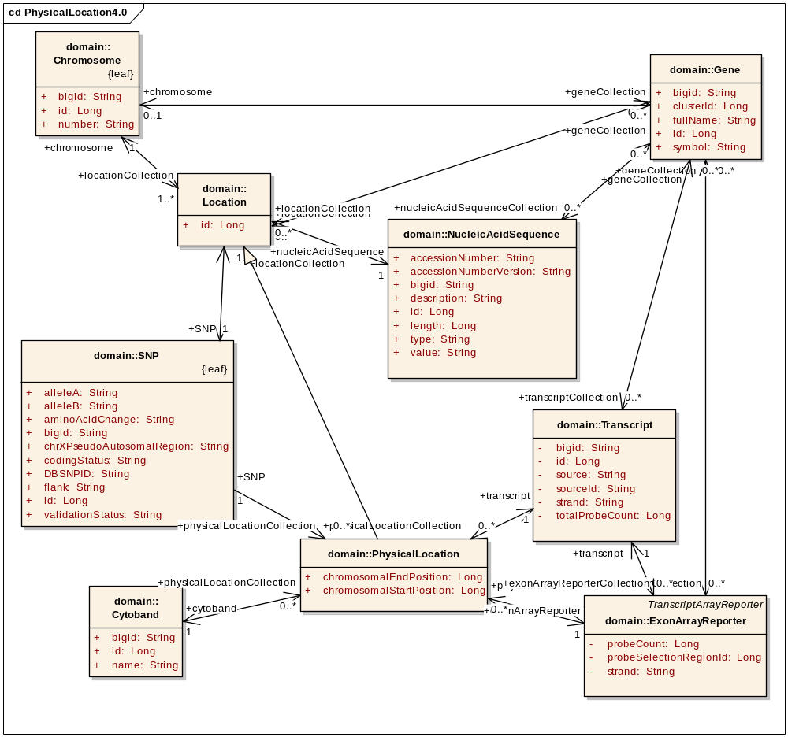
Figure 2: Physical Locations in caBIO 4.0

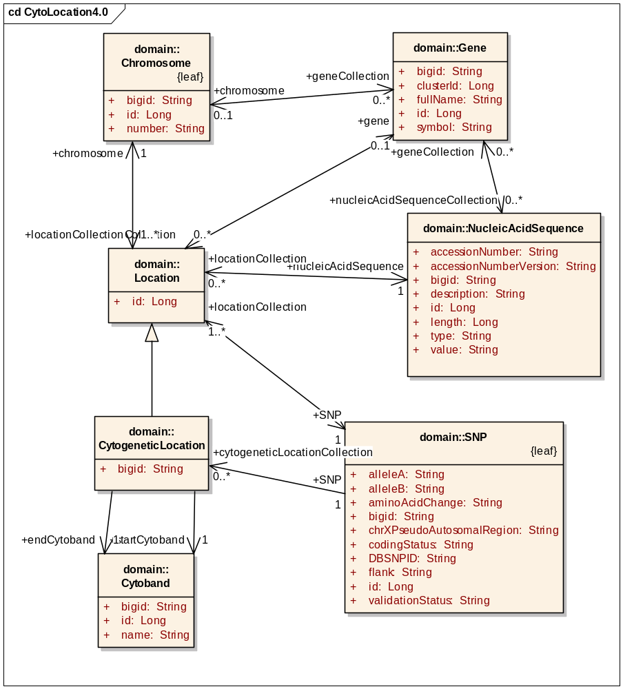
Figure 3: Cytogenetic Locations in caBIO 4.0

Modified Domain Model
The new location models are shown in Figure 4 and Figure 5. The main changes are:

- A subclass of PhysicalLocation for each feature that supports physical locations.
- A subclass of CytogeneticLocation for each feature that supports cytogenetic locations.
- Each object is linked to its location subclasses, instead of to one of the super classes.

There are several benefits to these modeling changes. When a user is holding a Location object, they know immediately (by the object’s actual class) what kind of object the Location is locating. This is important for supporting range queries, because such a query might return a collection of locations for various features. For example, it might return a GenePhysicalLocation and 2 SNPPhysicalLocations. Now the user knows to call getGene() and getSNP() because those are the only feature methods available on each object, respectively.

Also, in the 4.0 model it wasn’t clear if caBIO actually provided cytogenetic location data for an object such as NucleicAcidSequence. The object provides a getLocationCollection() method which could in theory return cytogenetic locations as well as physical locations. However, it never does in practice, since caBIO does not have that data. With the 4.1 model, users will know that if a class has a getPhysicalLocation() method, it most likely has a physical location. If it has a getCytogeneticLocation() method then there is likely to be a cytogenetic location (exceptions would be made for unavailable data in certain instances, but not on a per-class basis as is currently the case).

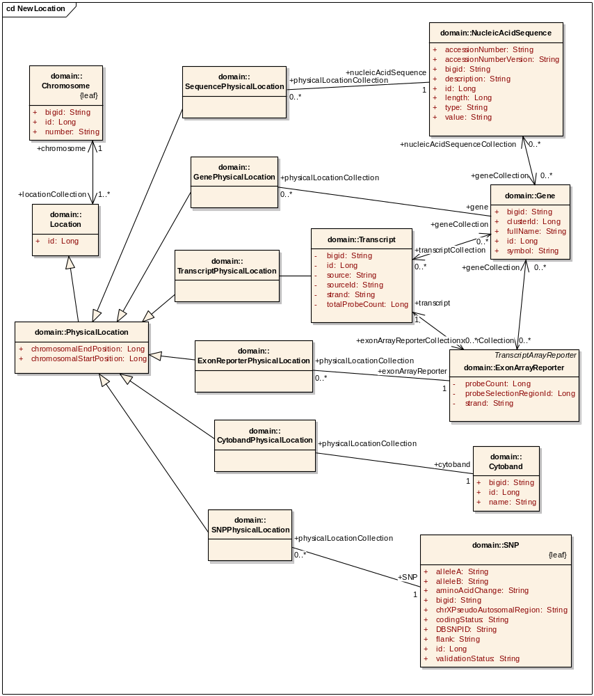
Figure 4: Physical Locations in caBIO 4.1

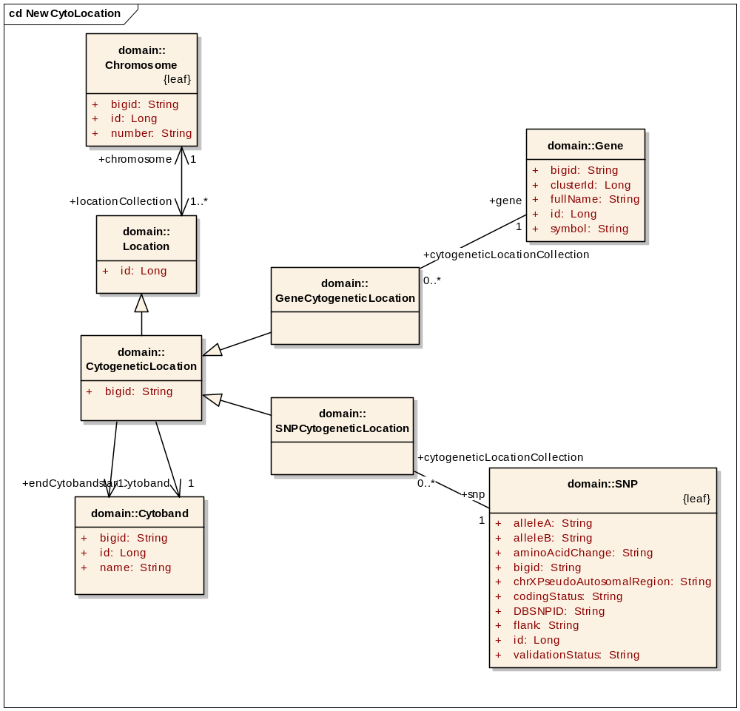
Figure 5: Cytogenetic Locations in caBIO 4.1

Data
The system currently obtains the physical location for SNPs from NCBI’s dbSNP, which will be available through SNPPhysicalLocation in the modified model. Physical Locations for ESTs, mRNAs and Cytobands from UCSC Genome Sequencing Center will be exposed in SequencePhysicalLocation and CytobandPhysicalLocation respectively. PhysicalLocation of transcripts and exon reporters in Affymetrix probesets will be available in TranscriptPhysicalLocation. New data required to support GenePhysicalLocation would be obtained from http://www.ncbi.nlm.nih.gov/mapview/ as it uses the reference assembly from NCBI.

Assumptions
- The SDK will correctly support table-per-class-hierarchy mapping
- The PhysicalLocation class provides locations for all objects in the same units of measure
- The Genome Assembly used by caBIO stays consistent for all objects

In the past, class hierarchies have been kept to a minimum in caBIO because of the way the SDK mapped them onto the underlying database. The current strategy is called table-per-subclass, and involves joining to all of the sub-classes and super-classes of a given class when querying on that class. For this new modeling to be successful, with its very large location class hierarchy, we assume that we can use a new feature of the SDK 4.0 to generate efficient table-per-class-hierarchy mappings which do not need joins. Because of this, Location queries should actually become faster in 4.1, despite enabling a richer set of functionality.

The second assumption is vital for range querying because queries across different objects which are not normalized to the same representation on the genome would be meaningless. We assume the universal reference scale for the location of these genomic features is an integer specifying the base-pair position or the physical position of the feature on the chromosome in a one-based numbering system. Thus, all genomic features and their relative locations to each other can be localized by their coordinates on the chromosomal reference scale.

Finally, we assume the genome assembly used to load the various objects in caBIO is always consistent across all the objects. This is necessary for the same reason as the second assumption – for location ranges to be meaningful relative to one another.

Dependencies
The caBIO system is dependent on the caCORE SDK, version 4.0 or higher.

Issues
There are no known issues at this time.

Third Party Tools
The API will use the caCORE SDK. See the current SDK technology stack for a complete listing.

Implementation Contents

Server
The caBIO server will run in the standard JBoss configuration. This implementation affects only the modeling and database, not the server configuration.

Algorithms
See APIs section below.

Batch Processes
None expected.

APIs
The current APIs require the use of custom HQL (Hibernate Query Language) or Criteria objects in order to perform range queries (return objects where an attribute is greater than or less than a given value). The APIs proposed here will enable users to perform location range queries easily, from any interface published by caBIO.

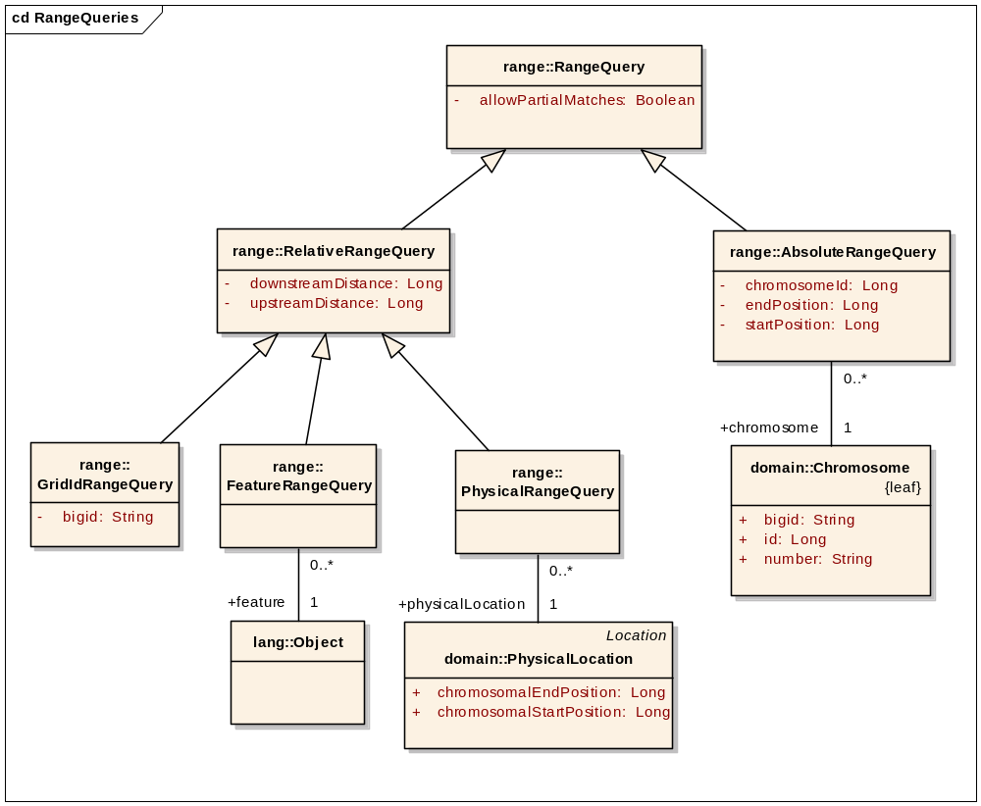
Figure 6: Range Query API
The search API domain model shown in Figure 6 allows users to search location ranges from the Java API, as well as the web interface. At a high level, the API defines Relative and Absolute range queries, with the AbsoluteRangeQuery simply being a range on a Chromosome. Web interface users will be able to specify the chromosome id to use this object, in lieu of providing a Chromosome object.

The RelativeRangeQuery is defined relative to an existing genomic feature or location. The search range can be adjusted in either direction with the downstreamDistance and upstreamDistance attributes (Figure 7).

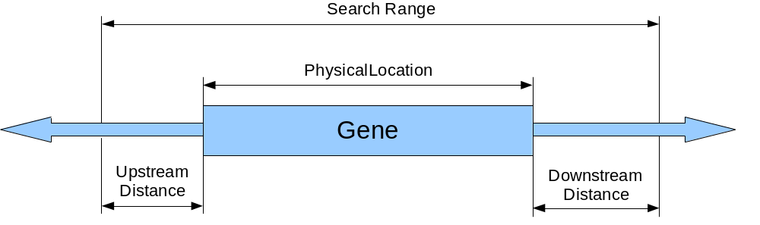
Figure 7: Search location range relative to a Gene
The object which the search can be defined relative to can be a PhysicalLocation or any object with a PhysicalLocation (that is, a genomic feature). This leads to the two subclasses PhysicalRangeQuery and FeatureRangeQuery. Again, since web interface users cannot provide linked objects, they will be able to conduct either query by passing the Grid Id of the Feature or PhysicalLocation in a GridIdRangeQuery.

Finally, every type of search can allow “partial matches”, that is returning features that only partially fall into the search range. For example, in Figure 8, the Gene is entirely within the search region, so it would be returned in any case. The sequence and reporter lie partially outside the search range, and so would only be returned if allowPartialMatches was set to true.

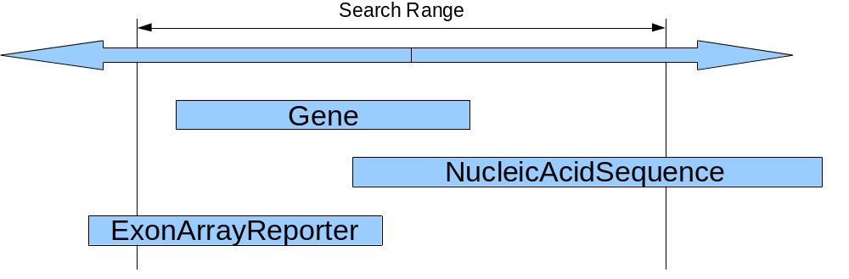
Figure 8: Partial Matches

From the Java API perspective, the standard SDK query methods are used to make the actual queries. The user can optionally pass a target class, or get all PhysicalLocations by default. For example, to find all SNPs within 10kb upstream of the EST T66952, the user could write:

GridIdRangeQuery query = new GridIdRangeQuery();
query.setBigId("hdl://2500.1.PMEUQUCCL5/64D6WTEC42");
query.setUpstreamDistance(new Long(10000));
query.setDownstreamDistance(new Long(0));
query.setAllowPartialMatches(false);

CaBioApplicationService as = (CaBioApplicationService)appService;
List<SNPPhysicalLocation> results = as.search(
SNPPhysicalLocation.class, query);

for(SNPPhysicalLocation location : results) {
SNP snp = ((SNPPhysicalLocation)location).getSNP();
System.out.println(snp.getDBSNPID());
}

To find all entities which overlap the first 1000 positions on a chromosome, the user could write:

AbsoluteRangeQuery query = new AbsoluteRangeQuery();
query.setChrmosome(chromosome);
query.setStart(new Long(1));
query.setEnd(new Long(1000));
query.setAllowPartialMatches(true);

CaBioApplicationService as = (CaBioApplicationService)appService;
List<PhysicalLocation> results = as.search(query);

for(PhysicalLocation location : results) {
System.out.println(location.getChromosomalStartPosition());
}

Error Handling
The methods which take an Object parameter as a feature will throw a standard IllegalArgumentException if the object given is not a supported genomic feature (i.e. does not have a physical location).

All methods in CaBioApplicationService throw the checked exception ApplicationException if there is an application-specific issue such as not being able to connect to the database.

Database Changes
As discussed in the Assumptions section, the new location modeling is predicated upon a table-per-class-hierarchy mapping at the ORM and database levels. On the database side, the subclass tables will be created as normal to allow for backwards compatibility. However, a new materialized view will be created for the entire location hierarchy, with class discriminator columns are required by the SDK and Hibernate.

The combined view will have one extra column called DISCRIMINATOR to indicate the class of each instance. The data in this column should be the class name such as “SNPCytogeneticLocation” or “GeneCytogeneticLocation”.

These discriminator columns will be mapped to objects in the EA model as per the SDK 4.0 Developer’s Guide.

Client
The standard SDK generated client will be used for this implementation

JSP/HTML
The standard SDK generated JSP/HTML interface will be used for this implementation

Servlet
The standard SDK generated Servlet will be used for this implementation

Error Handling
The standard SDK Error Handling will be used. See the SDK Exception handling documentation for more information.

Security Issues
The location data is publicly available and does not require any security.

Performance
The performance of the system, after the changes herein are completed, shall be at least equal to the previous version.

Internationalization
Not applicable.

Installation / Packaging
The design assumes the standard caBIO installation and packaging.

Migration
Since certain associations have changed, users may need to adjust their method calls. For example, users currently using

snp.getLocationCollection()

will need to change their code to use the more specific

snp.getPhysicalLocationCollection()

because SNP no longer has a direct association with Location. With regards to the Java API, such model changes always result in compile time errors, and are thus very easy to spot and fix. Users of the web services API will get run time errors, so the release notes should alert them to the need for changes.

Documentation Considerations
- This design document
- The caBIO 4.1 Location User Cases
- Updated caBIO Technical Guide
- SDK 4.0 Developer’s Guide
- Hibernate v3 Reference Documentation

Unit Testing

Test Guidelines
Unit tests for the Java API are part of the cabioapi repository, and are run as part of the daily build.

Test Cases
Each method in the new API shall be tested with several exemplars.

Data Exemplars

TBD

DOCUMENT CONTROL
Change History
Content changes to this document from the previous to the current level are indicated by revision bars (|) unless a complete rewrite is indicated.

Table 2 – Implementation Specification Document Change Log
Version/Date | Approved By | Change Description and Explanation | D - Draft  A - For Review/ Approval  R - Re-Approval, Plan of Record Change
11/16/2007 | Konrad Rokicki | Initial revision | D
11/27/2007 | Konrad Rokicki | Added section 2.5 from Lalitha. Revised API to allow for web interface queries. | D
12/02/2007 | Konrad Rokicki | Added Use Cases. | D
1211/2007 | Konrad Rokicki | Updated defects, added assumption about genome assembly. | A
Note: If this document has been inspected, please indicate the inspection date that each version is based on in the “Change Description and Explanation” area. Entries in this log must be maintained for at least 3 years.

DOCUMENT APPROVAL
Approvers List
The individuals listed in this section constitute the approvers list for the Integration Test Plan document. Formal approval must be received from all approvers prior to the initiation of the next steps in the process.

Title | Name
Project Manager | Name
Development Manager | Name

Reviewers List
The individuals listed in this section constitute the reviewers list for the Master Test Plan document. Formal approval is not required from the reviewers, however, it is desirable to have all reviewers review and comment on the document. Reviewers may choose to concentrate on reviewing only those sections that are in their area of responsibility, rather than the entire document.

Title | Name
Solutions Manager | Name
Project Manager | Name
Test Manager | Name
Test Engineer | Name
Development Manager | Name
Technical Writer | Name
Client Support Analyst | Name
Internationalization Lead | Name
DBA | Name
Developer | Name
Developer | Name

END OF DOCUMENT

