Implementation Specification
for
Modeling and implementation of Cancer Gene Index data in caBIO

Version 1
Release 4.1

Last Updated: February 15, 2008

Owner: caBIO Team
Email: klemmj@mail.nih.gov

National Cancer Institute Center for BioInformatics
6116 Executive Blvd.
Rockville, MD 20852



1 Document Purpose 4
2 Implementation Overview 5
2.1 Team Members 5
2.2 Description 5
2.3 Scope 5
2.3.1 GForge Feature Requests 5
2.3.2 Gforge Bugs 5
2.4 Use Cases 6
2.4.1 Gene-Disease Association 6
2.4.2 Gene-DrugCompound Association 7
2.4.3 Rational Drug Design 8
2.4.4 Agent-Disease Association 9
2.5 Architecture 10
2.5.1 Existing Domain Model 10
2.5.2 Extended Domain Model (Model 1) 12
2.5.3 Database Model 1 14
2.5.4 Proposed table-per-class hierarchy extension to final model 17
2.6 Data 19
2.6.1 CGDC’s Gene-Disease Data 19
2.6.2 CGDC’s Gene-Drug Data 20
2.6.3 Proposed Data Curation 21
2.6.4 Data in Agent and DiseaseOntology objects and overlap with CGDC 22
2.6.4.1 Overlap with existing caBIO Agent Object 23
2.6.4.2 Overlap with existing caBIO DiseaseOntology object 24
2.6.5 Model of other caBIO Objects associated with Agent and DiseaseOntology 25
2.7 Data Loading Script Modifications 27
2.7.1 Gene-Drug Data 27
2.7.2 Gene-Disease Data 27
2.8 Assumptions 27
2.9 Dependencies 27
2.10 Issues 27
2.11 Third Party Tools 27
3 Implementation Contents 28
3.1 Server 28
3.1.1 Algorithms 28
3.1.2 Batch Processes 28
3.1.3 APIs 28
3.1.4 Error Handling 28
3.1.5 Database Changes 28
3.2 Client 28
3.2.1 JSP/HTML 28
3.2.2 Servlet 28
3.2.3 Error Handling 28
3.3 Security Issues 28
3.4 Performance 28
3.5 Internationalization 29
3.6 Installation / Packaging 29
3.7 Migration 29
3.8 Documentation Considerations 29
4 Unit Testing 30
4.1 Test Guidelines 30
4.2 Test Cases 30
5 Data Exemplars 31
5.1.1 Gene-Disease Data 31
5.1.2 Gene-Drug Data 32
6 Appendix 33
6.1.1 Alternate Conceptual Model 33
6.1.2 Alternate Database Model 34
6.1.3 Modeling the CGDC Dataset using Target object 35
6.1.4 Data 36
6.1.4.1 CGDC’s Gene-Disease Data in Alternate Model 36
6.1.4.2 CGDC’s Gene-Drug Data in Alternate Model 38
6.1.5 Outline of CGDC Data Parsing in caBIO 39
DOCUMENT CONTROL 42
DOCUMENT APPROVAL 43

Document Purpose
This document provides design and implementation details that support and exposes the data from the Cancer Gene Index Curation project via the caBIO API. The data will be obtained from NCICB’s Cancer Gene Index Dataset portal at http://ncicb.nci.nih.gov/NCICB/projects/cgdcp. This document describes the required caBIO domain object modeling, data source information, data load and required scripts and data licensing issues for modeling this data.

Implementation Overview

Team Members

Role | Name
Director of Engineering | Avinash Shanbhag
Internationalization Lead | N/A
Product Manager | Juli Klemm
Test Lead | Ye Wu
Tech Lead | Jim Sun
Documentation Lead | Wendy Erikson
Consultant | Hong Dang
Development Team | Konrad Rokicki  Lalitha Viswanath
Table 1: Team Members

Description
Cancer Gene Index Curation Project is an NCICB-sponsored project that provides a database of genes implicated in various cancers along with details of their interactions with different therapeutic agents or drug compounds. This dataset was compiled by mining relevant biomedical literature from PubMed and annotating the results. The project involves a mixture of automatic text mining, semi-automatic verification, and manual validation/scoring of results. The scientific publication postulating the association serves as the ‘evidence’. Appropriate evidence-codes and identifiers from the NCI Thesaurus are assigned to the evidence, the disease ontology and therapeutic agents mentioned in the publication.

caBIO’s focus on providing a unified view of biological entities from a wide variety of public databanks can be leveraged to enhance the information available through the Cancer Gene Data Curation Project.

Scope
This section addresses functionality that will be implemented to support the Cancer Gene Index dataset and expose the same through the caBIO API.

GForge Feature Requests
GF Item | Description
GF9200 | Add Cancer Gene Index Data to caBIO. This is a dataset generated through an NCICB contract with Sophic Alliance/Biomax. Data set is described and is available at http://ncicb.nci.nih.gov/NCICB/projects/cgdcp

Gforge Bugs
Not Applicable

Use Cases

Gene-Disease Association

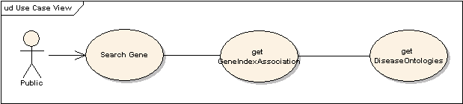

Use Case Name | Gene-Disease Association
Use Case ID | 2.1
Primary Actor | Public
Brief Description | The Gene-Disease Association use case allows users to search for diseases associated with a gene. The results of high throughput data analysis, such microarray, are often lists of genes that exhibit certain behavior of interests to the biologist, who wants to know whether any of these genes are associated with known diseases in the literature.
Workflow | - Query for caBIO Gene object by commonly used IDs, such as HUGO symbol, or Genbank accession.  - Get GeneIndexAssociations to diseases and report disease term, roles, literature evidence code, and supporting sentences.  - Filter the results by role, or evidence code
Trigger | The user searches for a Gene
Pre-conditions | - The user navigates to the caBIO Home Page and clicks “Continue”
Flow of Events | - The user selects the Gene object  - The user provides a valid Gene Id into the id field  - The user clicks the submit button to initiate the search  - A list of Genes appear  - The user can navigate to associations made by GCDC by clicking on the link, getGeneIndexAssociation.  - On the next page, the user clicks on getDiseaseOntology to get the diseases associated with a Gene
Post Conditions | Success Condition: The user successfully searches the database and obtains a list of all diseases associated with a Gene  Alternate Condition:  AC2: No result is found  Error Conditions:  EC1: System Error during Request Processing  EC2: Specified Gene does not exist  EC3: Specified Association does not identify a valid disease
Alternative Flow | Alternate Condition:  AC2: No result is found  - “No results found” message is displayed
Related Use Cases | Gene-DrugCompound Associations, Rational Drug Design, Agent-Disease Association
Issues/Notes | 1. The user can also execute the same search using the Java API or Web Service

Gene-DrugCompound Association

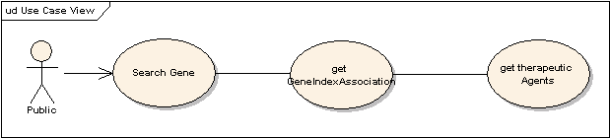

Use Case Name | Browse Gene-DrugCompound Association
Use Case ID | 2.2
Primary Actor | Public
Brief Description | Given a gene, find associations to compounds. Once we know that certain genes are associated with certain cancers (diseases), we’d like to know if there are any compounds reported in the literature, that could be potential candidates for therapy.
Workflow | - Query for caBIO Gene object by commonly used IDs, such as HUGO symbol, or Genbank accession.  - Get GeneIndexAssociations to compounds and report compound term, roles, literature evidence code, and supporting sentences.  - Filter the results by role, or evidence code.
Trigger | The user searches for a Gene to find associated DrugCompounds
Pre-conditions | - The user navigates to the caBIO Home Page and clicks “Continue”
Flow of Events | - The user selects the Gene object  - The user provides a valid Gene Id of the feature of interest into the id field  - The user clicks the submit button to initiate the search  - A list of Genes appear  - The user can navigate to associations made by CGDC by clicking on the link, getGeneIndexAssociation.  - On the next page, the user clicks on getAgents to get the associated drug compounds
Post Conditions | Success Condition: The user successfully searches the database and obtains a list of all drug compounds associated with a Gene  Alternate Condition:  AC2: No result is found  Error Conditions:  EC1: System Error during Request Processing  EC2: Specified Gene does not exist  EC3: Specified Association does not identify a valid Agent
Alternative Flow | Alternate Condition:  AC2: No result is found  - “No results found” message is displayed
Related Use Cases | Browse Gene-Disease association, Rational Drug Design
Issues/Notes | The user can also execute the same search using the Java API or Web Service

Rational Drug Design

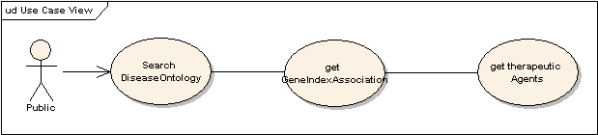

Use Case Name | Rational Drug Design
Use Case ID | 2.3
Primary Actor | Public
Brief Description | The Rational Drug Design Use case allows users to find drug compounds for clinical trials through a disease term (cancer diagnosis).
Workflow | - Start from a disease term, or disease of interest by search e.g. NCI thesaurus through EVS.  - Get GeneIndexAssociations to genes.  - From genes, get GeneIndexAssociations to compounds; report disease, genes, compounds with roles and evidences (Use case 2).  - Filter the results by gene role, compound role, gene evidence, compound evidence.
Trigger | The user desires to search for DiseaseOntologies
Pre-conditions | The user navigates to the caBIO Home Page and clicks “Continue”
Flow of Events | - Click on DiseaseOntology  - Search for a disease term by term or by NCI Thesaurus Id  - Get GeneIndexAssociations by clicking on getGeneIndexAssociation.  - Click on getAgent to get associated therapeutic Agent
Post Conditions | Success Condition: The user successfully searches the database and obtains a list of all available drug compounds associated with the disease  Alternate Condition:  AC2: No result is found  Error Conditions:  EC1: System Error during Request Processing  EC2: Specified DiseaseOntology does not exist  EC3: Specified DiseaseOntology is not associated with any therapeutic Agent
Alternative Flow | Alternate Condition:  AC2: No result is found  1. “No results found” message is displayed
Related Use Cases | Gene-DrugCompound Association, Gene-Disease Association, Agent-Disease Association
Issues/Notes | The user can also execute the same search using the Java API or Web Service

Agent-Disease Association

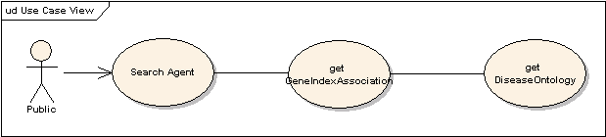

Use Case Name | Browse Agent-Disease Association
Use Case ID | 2.4
Primary Actor | Public
Brief Description | Given a compound, find all diseases through associated genes. Historically, compounds used in treatment of certain cancer may have been developed through high-throughput screening. Given the knowledge gained from studying interactions between compound and genes, what other cancers may be treated by the same compound?
Workflow | - Start from a compound (agent) of interest, such as known treatment to a particular cancer.  - Get GeneIndexAssociations to genes.  - From gene, get GeneIndexAssociations to diseases; report compound, gene, disease with roles and evidences (Use case 1).  - Filter the results by gene role, compound role, gene evidence, compound evidence.
Trigger | The user desires to search for publicly available genes
Pre-conditions | - The user navigates to the caBIO Home Page and clicks “Continue”
Flow of Events | - Click on Agent  - Search for a therapeutic Agent by name or by NSC Number  - Get GeneIndexAssociations by clicking on getGeneIndexAssociation.  - Click on getDiseaseOntology to get associated DiseaseOntologies
Post Conditions | Success Condition: The user successfully searches the database and obtains a list of all publicly available diseases associated with the therapeutic Agent  Alternate Condition:  AC2: No result is found  Error Conditions:  EC1: System Error during Request Processing  EC2: Specified Agent does not exist  EC3: Specified Association does not identify a valid disease
Alternative Flow | Alternate Condition:  AC2: No result is found  1. “No results found” message is displayed
Related Use Cases | Gene-DrugCompound Association, Gene-Disease Association, Rational Drug Design
Issues/Notes | The user can also execute the same search using the Java API or Web Service

Architecture
The Cancer Gene Index Data modeling implementation will use the standard SDK generated system. The following sections describe the relevant portions of the current caBIO 4.0 model and elaborate on the recommended upgrades to model NCICB’s Cancer Gene Index Data.

Existing Domain Model

The follow objects from the current caBIO domain model are relevant to the modeling this data in caBIO.
Figure 1 describes the current caBIO model that associates these objects.

caBIO Domain Object
GeneAlias | An alternative name for a gene; provides descriptive information about the gene (as it is known by this alias), as well as access to the primary Gene it refers to.
Agent | An object representing a therapeutic agent (drug, intervention therapy) used in a clinical trial protocol. It provides the NSC Number, name and source of the agent apart from the appropriate concept from the NCI Thesaurus.  An Agent provides access to the associated protocols used in clinical trials and associated genes targeted by that agent in the clinical trials (Targets) through the getClinicalTrialProtocolCollection and getTargetCollection functionalities.
Gene | Gene objects are the effective portal to most of the genomic information provided by the caBIO data services; It provides access to the associated proteins, gene-targets, diseases, histopathologies, ontologies, pathways, aliases, clones and sequence data through their respective objects such as Histopathology, DiseaseOntology, OrganOntology, Pathway, GeneAlias, Clone and NucleicAcidSequence respectively.  The location of the gene on the chromosome is available through the Location object.  This object gets populated with data pertaining to human and mouse genes from NCBI’s Unigene’s repository. Gene Ids from NCBI’s OMIM Databank, Ensembl, and Enzyme Commission are available through DatabaseCrossReference.
Taxon | An object representing the various names (scientific, common, abbreviated, etc.) for human and mouse genomes. It can be used to retrieve the associated Genes, Chromosomes, Pathways if any, Proteins, or Tissues.
DiseaseOntology | An object representing various oncological disease ontologies. It provides access to the clinical trials associated with these diseases (ClinicalTrialProtocol) and also the associated histopathological (Histopathology).
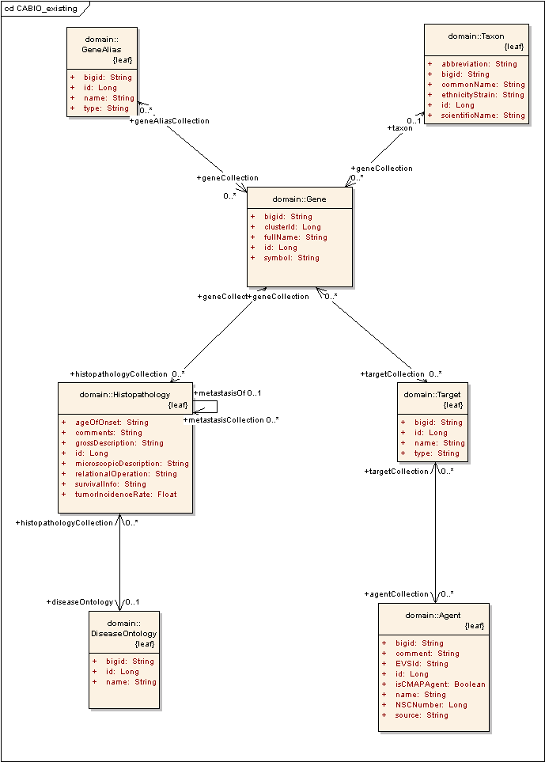
Figure 1Current caBIO Model

Extended Domain Model (Model 1)

The extended model adds supports for new objects to model the ‘evidence’, ‘evidencecode’ and the association between a Gene and a DiseaseOntology or therapeutic Agent. It also extends the current objects as applicable to accommodate the new data.

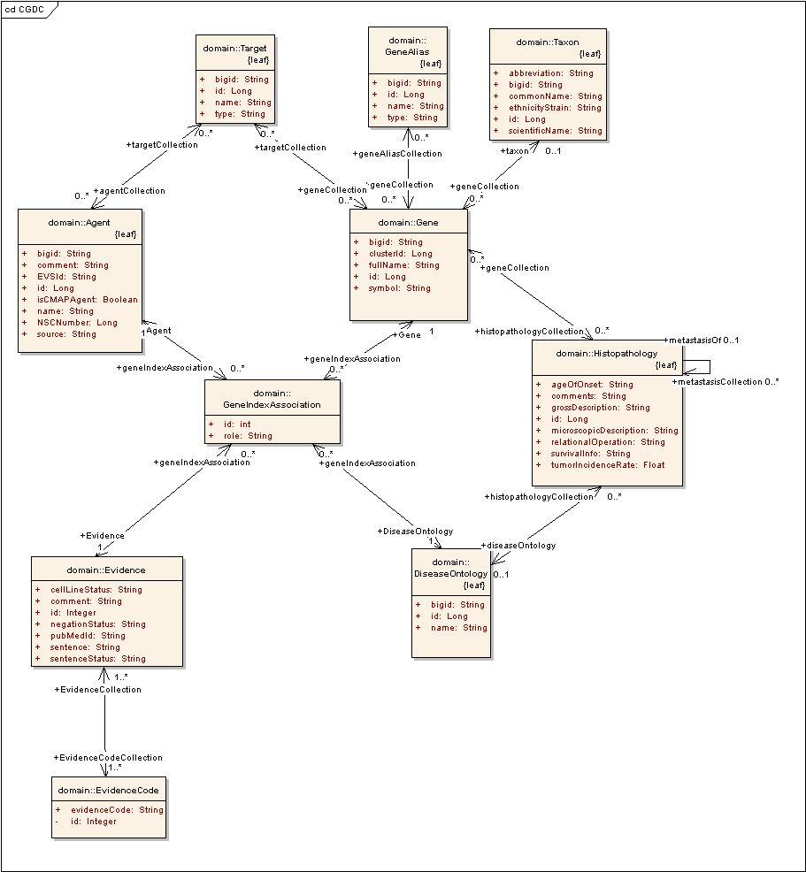
Figure 2 Proposed Model for Cancer Gene Index Modeling

Evidence

This class models the publication from PubMed that serves as an Evidence supporting the association between a caBIO Gene and a DiseaseOntology or an Agent. Based on the publication, an Evidence can be associated with multiple EvidenceCodes.

Attribute | Description
pubMedId | Id for indexing into PubMed database for relevant publication that serves as Evidence
Sentence | Sentence from PubMed publication
Comment | Comments included during curation
cellLineStatus | Yes/No indicating usage in cellLines
negationStatus | Language Processing concept defining status of association
sentenceStatus | Status aiding curation.

EvidenceCode

A class that models the different types of EvidenceCodes associated with an Evidence, based on the data in the publication.

Attribute | Description
evidenceCode | NCI Thesaurus based evidence code determining the type of evidence in the publication (experimental, theoretical, etc)

GeneIndexAssociation

This object associates a Gene with a DiseaseOntology or an Agent, on the basis of an Evidence and a role as described below.

Attribute | Description
role | NCI Thesaurus-based role indicating nature of association between Gene and Agent/DiseaseOntology on the basis of Evidence

GeneAlias

This object is available in the current caBIO 4.0 model and would get populated with additional data from the CGDC dataset. The gene aliases in CGDC dataset are obtained from HuGO and the type below will be indicated as such.
Attribute | Description
Name | Name of alias
Type | Source of gene alias

Agent

This object is available in the current caBIO 4.0 model and will be populated with additional agent data from CGDC.

Attribute | Description
Name | Name of Agent
NSCNumber | Corresponding Identifier from NSC Database
Source | Source of Agent
EVSId | Corresponding Id from NCI Thesaurus
isCMAPAgent | Indication of whether this agent is processed by CMAP
Comment | Additional comments regarding the Agent

DiseaseOntology

This object is available in the current caBIO 4.0 model and will be populated with additional data from CGDC dataset. A new attribute, EVSId is added to accommodate the NCI Thesaurus Id, if available for disease ontologies from the CGDC dataset

Attributes | Description
EVSId | Identifier from NCI Thesaurus
Name | Name of Disease Ontology

An association between Agent and DiseaseOntology would be added to support Rational Drug Design.

Database Model 1

The database design corresponding to the above model is as shown below.
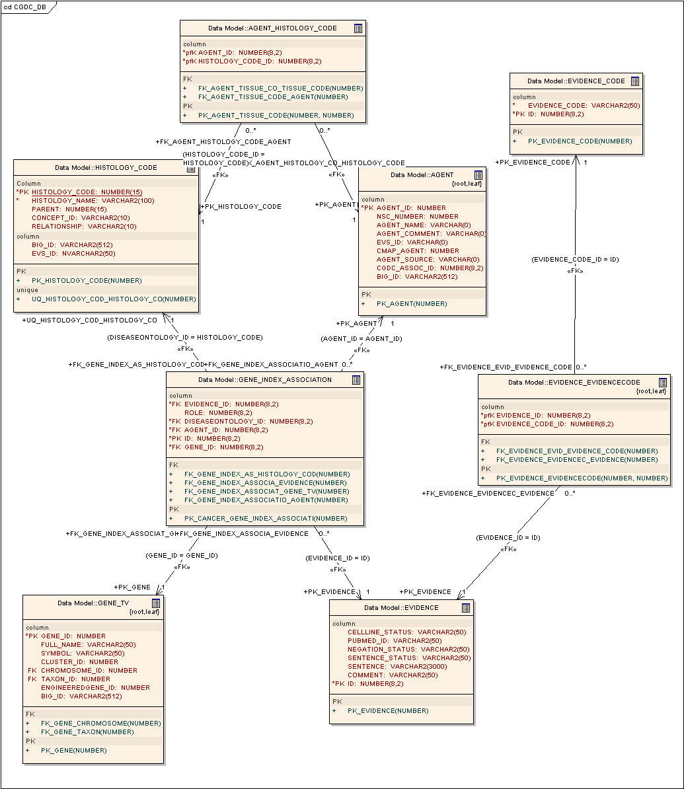
Figure 3 Database Model for CGDC Modeling

The database table layout is as given below:

Object | Table | Structure
Agent | AGENT
  ID | Primary Key | Unique Identifier
  DRUG | Not Null | Therapeutic Agent
  EVS_ID | Not Null | Identifier into NCI Thesaurus
DiseaseOntology | HISTOLOGY_CODE
  ID | Primary Key | Unique Identifier
  DISEASEONTOLOGY | Not Null | Cancer Terms
  EVS_ID | Not Null | Identifier into NCI Thesaurus
Evidence | EVIDENCE_CGID
  ID | Primary Key | Unique Identifier
  STATEMENT | Not Null | Evidence Statement
  PUBMEDID | Not Null | PubMed Id
  CELLLINEINDICATOR |  | Used in Cell Lines
  NEGATIONINDICATOR |  | Language Processing Concept
  SENTENCESTATUSFLAG |  | Status of curation
EvidenceCode | EVIDENCECODE_CGID
  ID | Primary Key | Unique Identifier
  EVIDENCECODE | Not Null | Evidence Code
Gene <-> GeneAlias association | GENE_GENEALIAS_CGID
  GENE_ID | Primary Key | CaBIO Gene Identifier
  ALIAS | Primary Key | Alternate name for Gene
GeneIndexAssociation | CGID
  GENE_ID | Primary Key | CaBIO Gene Identifier
  ROLE | Not NULL | Role
  AGENT_ID | Primary Key | CaBIO Agent Identifier
  DISEASEONTOLOGY_ID | Primary Key | CaBIO DiseaseOntology Identifier

Proposed table-per-class hierarchy extension to final model
In either of the proposed models, a Target or a GeneIndexAssociation always retrieves associations with both Agents and DiseaseOntologies. Given that a Gene is associated either with an Agent OR a DiseaseOntology, never both, the model could be adapted to conform to a table-per-class hierarchy to retrieve only the relevant associations and avoid retrieving empty associations.

This can be implemented by adding two abstract subclasses of Target/GeneIndexAssociation, namely AgentAssociation and DiseaseAssociation. Agent and DiseaseOntology would be the respective subclasses of these classes, as shown below. The rest of the model would remain unchanged.

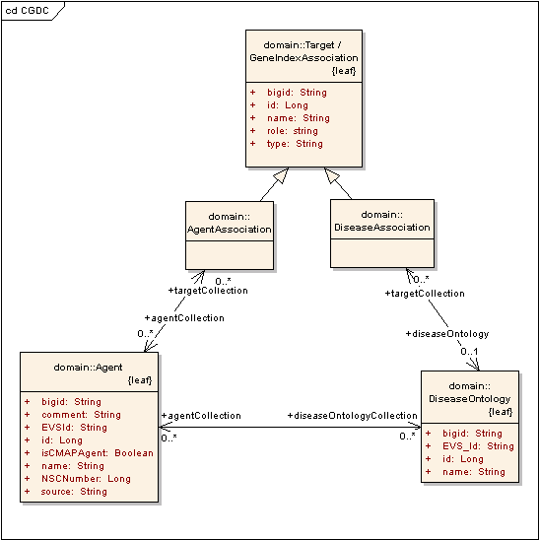

The advantage of this extension is that given a Target or a GeneIndexAssociation object, the user can knows whether it is an AgentAssociation or a DiseaseAssociation and can retrieve only the populated associations.

This change would be implemented in the database by the inclusion of a column DISCRIMINATOR to the TARGET or GENE_INDEX_ASSOCIATION object whose possible values would be “AgentAssociation” or “DiseaseAssociation”, depending on the data.

Data
Based on the above model, the tables below summarize the data available from the CGDC dataset and their proposed association to caBIO.

CGDC’s Gene-Disease Data

Category | CGDC | Using new object, GeneIndexAssociation in CABIO (Model 1)
 | <GeneEntry>
 | <HUGOGeneSymbol>a2m</HUGOGeneSymbol> | Used to obtain Gene.Id
GeneAlias | <GeneAliasCollection> | GeneAlias.type = HUGO/CGDC
 | <GeneAlias>a2m</GeneAlias> | GeneAlias.name
 | <GeneAlias>alpha-2-macroglobulin</GeneAlias> | GeneAlias.name
 | <GeneAlias>alpha-2-macroglobulinprecursor</GeneAlias> | GeneAlias.name
 | </GeneAliasCollection>
Gene | <SequenceIdentificationCollection>
 | <HgncID>7</HgncID>
 | <LocusLinkID>2</LocusLinkID> | Used to obtain GeneIndexAssociation.GeneId from DatabaseCrossReference
 | <GenbankAccession></GenbankAccession>
 | <RefSeqID>NM_000014</RefSeqID> | Used to obtain GeneIndexAssociation.GeneId from DatabaseCrossReference
 | <UniProtID>P01023</UniProtID> | Uniprot.PrimaryAccessionNumber
 | </SequenceIdentificationCollection>
 | <GeneStatusFlag>finished</GeneStatusFlag>
 | <Sentence>
 | <GeneData>
 | <MatchedGeneTerm>alpha-2 macroglobulin</MatchedGeneTerm>
 | <NCIGeneConceptCode>C4567</NCIGeneConceptCode>
 | </GeneData>
DiseaseOntology | <DiseaseData>
 | <MatchedDiseaseTerm>tumor</MatchedDiseaseTerm> | DiseaseOntology.name
 | <NCIDiseaseConceptCode>C3262</NCIDiseaseConceptCode> | DiseaseOntology.EVSId
 | </DiseaseData>
 | <Statement>Several &amp;apos;genes&amp;apos; were &amp;quot;underexpressed&amp;quot; by at least 50% in both tumor types such as c-fos, decorin, alpha-2-macroglobulin, platelet endothelial cell adhesion molecule 1,EGR1,fibronectin.</Statement> | Evidence.Sentence
Evidence | <PubMedID>11948124</PubMedID> | Evidence.PubMedId
 | <Organism>Human</Organism>
 | <NegationIndicator>no</NegationIndicator> | Evidence.Negation
 | <CellineIndicator>no</CellineIndicator> | Evidence.cellLine
 | <Comments></Comments> | Evidence.comment
EvidenceCode | <EvidenceCode>EV-EXP-IEP</EvidenceCode> | EvidenceCode.evidenceCode
 | <EvidenceCode>EV-EXP-TAS</EvidenceCode> | EvidenceCode.evidenceCode
 | <Roles>
GeneIndexAssociation | <PrimaryNCIRoleCode>Gene_Has_Expression_Measurement</PrimaryNCIRoleCode> | GeneIndexAssociation.Role
 | <OtherRole>Gene_Expression_Downregulated_in_Disease</OtherRole> | GeneIndexAssociation.Role
 | </Roles>
 | SentenceStatusFlag>finished</SentenceStatusFlag> | EvidenceCode.sentenceStatus
 | </Sentence>
 | </GeneEntry>

CGDC’s Gene-Drug Data

Category | CGDC | Using new object, GeneIndexAssociation in CABIO
 | <GeneEntry>
 | <HUGOGeneSymbol>a2m</HUGOGeneSymbol> | Used to obtain Gene.Id
GeneAlias | <GeneAliasCollection> | GeneAlias.type = HUGO/CGDC
 | <GeneAlias>myeov</GeneAlias> | GeneAlias.name
 | <GeneAlias>myeloma overexpressed gene </GeneAlias> | GeneAlias.name
 | <GeneAlias>positivemultiple myelomas)</GeneAlias> | GeneAlias.name
 | </GeneAliasCollection>
Gene | <SequenceIdentificationCollection>
 | <HgncID>7563</HgncID>
 | <LocusLinkID>26759</LocusLinkID> | Used to obtain GeneIndexAssociation.GeneId from DatabaseCrossReference
 | <GenbankAccession></GenbankAccession>
 | <RefSeqID>NM_138768</RefSeqID> | Used to obtain GeneIndexAssociation.GeneId from DatabaseCrossReference
 | <UniProtID>Q96EZ4</UniProtID> | Uniprot.PrimaryAccessionNumber
 | </SequenceIdentificationCollection>
 | <GeneStatusFlag>finished</GeneStatusFlag>
 | <Sentence>
 | <GeneData>
 | <MatchedGeneTerm>alpha-2 macroglobulin</MatchedGeneTerm>
 | <NCIGeneConceptCode></NCIGeneConceptCode>
 | </GeneData>
Agent | <DrugData>
 | <MatchedDrugTerm>5-aza-2-deoxycytidine</MatchedDrugTerm> | Agent.name
 | <NCIDrugConceptCode>C981</NCIDrugConceptCode> | Agent.EVSId
 | </DrugData>
 | <Statement>Treatment with the demethylating agent 5-aza-2\-deoxycytidine restored MYEOV ex  pression in a subset of cell lines exhibiting DNA amplification without high MYEOV expression, suggesting  that MYEOV is transcriptionally silenced by a DNA methylation mechanism in most of the latter cell lines.</Statement> | Evidence.Sentence
Evidence | <PubMedID>12202983</PubMedID> | Evidence.PubMedId
 | <Organism>Human</Organism>
 | <NegationIndicator>no</NegationIndicator> | Evidence.Negation
 | <CellineIndicator>CELL_LINE</CellineIndicator> | Evidence.cellLine
 | <Comments></Comments> | Evidence.comment
EvidenceCode | <EvidenceCode>EV-EXP-IEP</EvidenceCode> | EvidenceCode.evidenceCode
 | <EvidenceCode>EV-EXP-TAS</EvidenceCode> | EvidenceCode.evidenceCode
 | <Roles>
GeneIndexAssociation | <PrimaryNCIRoleCode>Chemical_or_Drug_Affects_Cell_Type_or_Tissue</PrimaryNCIRoleCo  de> | GeneIndexAssociation.Role
 | <OtherRole>Chemical_or_Drug_Affects_Gene_Expression</OtherRole> | GeneIndexAssociation.Role
 | </Roles>
 | SentenceStatusFlag>finished</SentenceStatusFlag> | EvidenceCode.sentenceStatus
 | </Sentence>
 | </GeneEntry>

Proposed Data Curation
Currently only records which correspond to a Mouse or a Human Gene are extracted from the dataset.
However the CGDC Data may be further curated as follows
- Removal of records with Role “not_assigned”
- Removal of records containing Evidence.comment = “dog/rabbit/etc”

Data in Agent and DiseaseOntology objects and overlap with CGDC
Object | Number of records from CGDC | Notes
Agent | 3259 | All agents in the CGDC Dataset have an associated NCI Thesaurus Id  The NCI Thesaurus Ids are not unique to a given drug-term with 787 of them being assigned to multiple agents  Examples: ‘ansamycin’ and ‘ansamycin antibiotics’ are assigned Id C1003,  ‘Ampligen’ and ‘Antogen’ have Id C1001,  ‘Bestatin’ and ‘ubenimex’ have Id C1015
DiseaseOntology | 6870 | 2751records have no NCI Thesaurus Id  Examples which DON’T have an NCI Id in the dataset but have one assigned in the NCI Thesaurus are ‘malt lymphoma’ (C5498), ‘Fibrosis’ (C3044), ‘Synovitis’ (C50766).  Examples which do not have an Id in the CGDC and in NCI Thesaurus are abdominal cancer, abdominal tumor, abelson meurine leukemia, metastasis  828 NCI Thesaurus Ids are assigned to multiple histopathological terms.  Examples of records with same NCI Thesaurus Id: ‘b16 melanoma’ and ‘melanomas’ have Id C16317,  ‘calgb’ and ‘cancer and leukemia grp b’ have Id C25442;  ‘colloid carcinoma(s)’, ‘mucinous adenocarcinoma(s)’ and ‘mucinous carcinoma(s, mc)’ have Id C26712

Overlap with existing caBIO Agent Object
The current Agent object has 164,169 agents with 558 of them having a name. Of this 558, 332 of them are available in the NCI Thesaurus and 211 of the 558 are exposed through the Cancer Gene Index Data as well.

Only 50% of this set of overlapping agents (101 agents) share the same EVS Id (NCI Thesaurus Id) in both datasets.
(caBIO and CGDC)

The EVS 4.0 Client was used to try and find matching NCI Codes from the latest version of EVS for the missing 226 Agents on the basis of Agent Name.

We found matches for 126 of these agents
Examples for which no match was found are
(+)-Catechin
17-AAG
2-CHLORO-2-DEOXYADENOSINE (2-CDA)
3'-azidothymidine 5'-[p-methoxyphenyl methoxyalaninyl phosphate] (Compound 003)CAS 149560-32-7,
3d98c1b69c0f906f-a109667ae05ba1bb
4-HC
5-FLUOROURACIL
5a5935fbef7919a2-e5ab49c051f77e25
9-AMINOCAMPTOTHECIN
ABCDEFG
AD-32
ALL-TRANS RETINOIC ACID
Arsenic Trioxide
Ascorbic Acid
BB94
BISANTRENE HCL
CA-4P
CAI
CARBOPLATIN
CCNU
CEA vaccines
Carnosol
DAUNOMYCIN
DEOXYCOFORMYCIN
DFMO
DIBROMODULCITOL
DMSO
DOLASTATIN-10
Dexamethasone, etc

There are approximately 163,000 Agents in caBIO, identified only by their NCCSC database identifier (NSC Numbers).

Subsequent investigations to find additional information on these Agents, reveal that NCCSC has folded into CTEP, which in turn provides a list of Agents, keyed off NSC Numbers, that is updated daily at http://ctep.cancer.gov/guidelines/codes.html#agent.

This list contains only ~1600 agents.
No other publicly available datasets contain any NCCSC numbers. Using the EVS API to search for Agents using the NSC Numbers retrieves only the same set of 1600 agents.
Given that the largest value for Agent.ID in caBIO is of the order of 6100,566 despite there being 164,000 records in the table, indications are that possibly
      - the NSC Numbers were folded into one another over time
      - Some, but not all of these redundant entries were deleted from caBIO’s Agent objects, resulting in the current set of 164,000 records

Overlap with existing caBIO DiseaseOntology object
The current DiseaseOntology object (HISTOLOGY_CODE) has 116 records of which 47 records are common with the Cancer Gene Index Dataset.
None of these records have EVS Ids. Using the latest version of EVS, we found matches for 88 of them in the NCI Thesaurus.

Examples for which there are no matching NCI Ids are
acute myelogenous leukemia
adenoma
basal
benign hyperplasia
borderline
bronchioloalveolar carcinoma
characterized histology
chondrosarcoma
clear cell
embryonal carcinoma
fibrothecoma
oligodendroglioma
peripheral neuroectodermal tumor
pleomorphic adenoma
preneoplasia
schwannoma
small cell
spindle cell
teratocarcinoma
ulcerative colitis
uncharacterized histology

Model of other caBIO Objects associated with Agent and DiseaseOntology

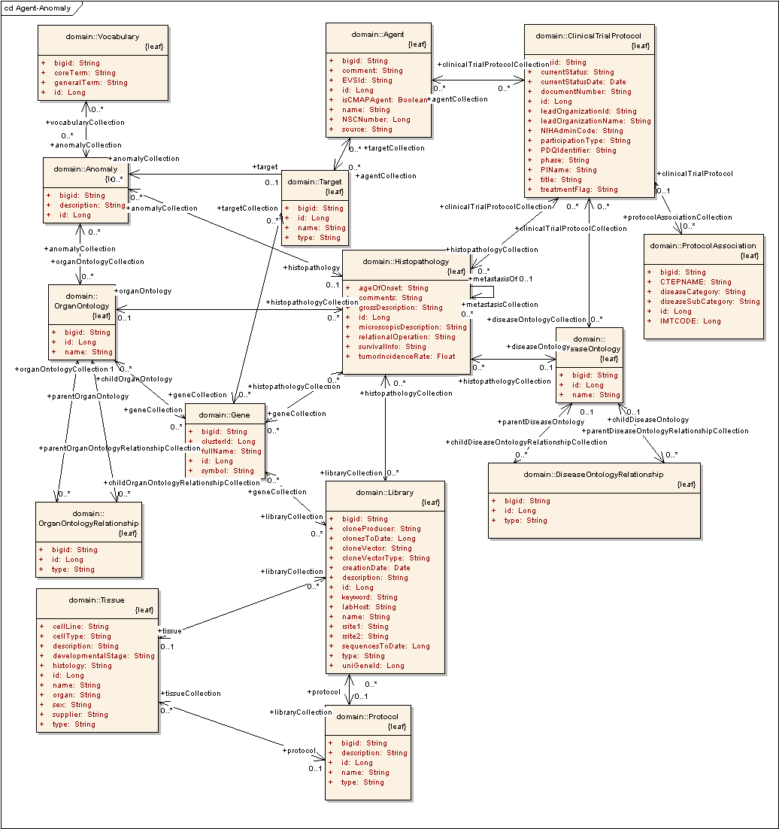

Data Loading Script Modifications

The data load scripts will be executed from the cbiows502.nci.nih.gov/28aBIO/cabiodb/28aBIO* directory.

Gene-Drug Data
- Data Source:
  - Index:ftp://ftp1.nci.nih.gov/pub/cacore/Cancer%20Gene%20Data%20Curation/Cancer_Gene_DB_p22.xml
- caBIO Parse Script: TBD
- caBIO Load Script: TBD

Gene-Disease Data
- Data Source:
  - Index:ftp://ftp1.nci.nih.gov/pub/cacore/Cancer%20Gene%20Data%20Curation/Cancer_Gene_DB_p21.xml
- caBIO Parse Script: TBD
- caBIO Load Script: TBD

Assumptions
The design assumes the data is in the same format as the current caBIO db structures.

Dependencies
caCORE SDK 4.0

The load scripts require Perl and PL/SQL.

The current load scripts must be run on cbiows502.

Issues
No know issues at this time.

Third Party Tools
The API will use the SDK. See the current SDK technology stack for a complete listing.

Implementation Contents

Server
The caBIO server will run in the standard Jboss configuration. This implementation affects only the modeling and database, not the server configuration.

Algorithms
N/A

Batch Processes
None expected

APIs
The standard caBIO domain model.

Error Handling
The standard SDK Error Handling will be used. See the SDK Exception handling documentation for more information.

Database Changes
All database changes are described above.

Client
The standard SDK generated client will be used for this implementation

JSP/HTML
The standard SDK generated JSP/HTML interface will be used for this implementation

Servlet
The standard SDK generated Servlet will be used for this implementation

Error Handling
The standard SDK Error Handling will be used. See the SDK Exception handling documentation for more information

Security Issues
The array metadata is open and does not require any security.

Performance
These changes are not expected to impact performance of loading in any significant way.

Internationalization
Not applicable

Installation / Packaging
The design assumes the standard caCORE installation and packaging.

Migration
N/A

Documentation Considerations
- This design document
- Update caBIO data dictionary
- Update caCORE Technical Guide

Unit Testing

Test Guidelines
Unit tests for the Java API are part of the cacoresystem repository, and are run as part of the daily build.

Test Cases
Test cases are available for each of the array types, and test the associated objects on each type. In particular:
Test Name | Coverage
testEvidence | EvidenceCode, GeneIndexAssociation
testEvidenceCode | Evidence
testGeneIndexAssociation | Gene, Evidence, DiseaseOntology, Agent
testAgent | DiseaseOntology, GeneIndexAssociation
TestDiseaseOntology | Agent, CancerGeneIndexAssocation

Data Exemplars

Gene-Disease Data

<!DOCTYPE GeneEntryCollection SYSTEM “deliverable.dtd”>
<GeneEntryCollection>
<GeneEntry>
<HUGOGeneSymbol>a2m</HUGOGeneSymbol>
<GeneAliasCollection>
<GeneAlias>a2m</GeneAlias>
<GeneAlias>alpha-2-macroglobulin</GeneAlias>
<GeneAlias>alpha-2-macroglobulin precursor</GeneAlias>
</GeneAliasCollection>
<SequenceIdentificationCollection>
<HgncID>7</HgncID>
<LocusLinkID>2</LocusLinkID>
<GenbankAccession></GenbankAccession>
<RefSeqID>NM_000014</RefSeqID>
<UniProtID>P01023</UniProtID>
</SequenceIdentificationCollection>
<GeneStatusFlag>finished</GeneStatusFlag>
<Sentence>
<GeneData>
<MatchedGeneTerm>alpha-2-macroglobulin</MatchedGeneTerm>
<NCIGeneConceptCode></NCIGeneConceptCode>
</GeneData>
<DiseaseData>
<MatchedDiseaseTerm>tumor</MatchedDiseaseTerm>
<NCIDiseaseConceptCode>C3262</NCIDiseaseConceptCode>
</DiseaseData>
<Statement>Several &amp;apos;genes&amp;apos; were &amp;quot;underexpressed&amp;quot; by at least 50% in both tumor types such as c-fos, decorin, alpha-2-macroglobulin, platelet endothelial cell adhesion molecule 1, EGR1, and fibronectin.</Statement>
<PubMedID>11948124</PubMedID>
<Organism>Human</Organism>
<NegationIndicator>no</NegationIndicator>
<CellineIndicator>no</CellineIndicator>
<Comments></Comments>
<EvidenceCode>EV-EXP-IEP</EvidenceCode>
<Roles>
<PrimaryNCIRoleCode>Gene_Has_Expression_Measurement</PrimaryNCIRoleCode>
<OtherRole>Gene_Expression_Downregulated_in_Disease</OtherRole>
</Roles>
<SentenceStatusFlag>finished</SentenceStatusFlag>
</Sentence>
</GeneEntry>

Gene-Drug Data

<GeneEntry>
<HUGOGeneSymbol>myeov</HUGOGeneSymbol>
<GeneAliasCollection>
<GeneAlias>myeov</GeneAlias>
<GeneAlias>myeloma overexpressed gene (in a subset of t(11</GeneAlias>
<GeneAlias>myeloma overexpressed</GeneAlias>
<GeneAlias>ocim</GeneAlias>
<GeneAlias>14) positive multiple myelomas)</GeneAlias>
</GeneAliasCollection>
<SequenceIdentificationCollection>
<HgncID>7563</HgncID>
<LocusLinkID>26579</LocusLinkID>
<GenbankAccession></GenbankAccession>
<RefSeqID>NM_138768</RefSeqID>
<UniProtID>Q96EZ4</UniProtID>
</SequenceIdentificationCollection>
<GeneStatusFlag>finished</GeneStatusFlag>
<Sentence>
<GeneData>
<MatchedGeneTerm>myeov</MatchedGeneTerm>
<NCIGeneConceptCode></NCIGeneConceptCode>
</GeneData>
<DrugData>
<DrugTerm>5-aza-2-deoxycytidine</DrugTerm>
<NCIDrugConceptCode>C981</NCIDrugConceptCode>
</DrugData>
<Statement>Treatment with the demethylating agent 5-aza-2\-deoxycytidine restored MYEOV expression in a subset of cell lines exhibiting DNA amplification without high MYEOV expression, suggesting that MYEOV is transcriptionally silenced by a DNA methylation mechanism in most of the latter cell lines.</Statement>
<PubMedID>12202983</PubMedID>
<Organism>Human</Organism>
<NegationIndicator>no</NegationIndicator>
<CellineIndicator>no</CellineIndicator>
<Comments>CELL_LINE</Comments>
<EvidenceCode>EV-EXP-IEP</EvidenceCode>
<Roles>
<PrimaryNCIRoleCode>Chemical_or_Drug_Affects_Cell_Type_or_Tissue</PrimaryNCIRoleCode>
<OtherRole>Chemical_or_Drug_Affects_Gene_Expression</OtherRole>
</Roles>
<SentenceStatusFlag>finished</SentenceStatusFlag>
</Sentence>
</GeneEntry>

Appendix

Alternate Conceptual Model
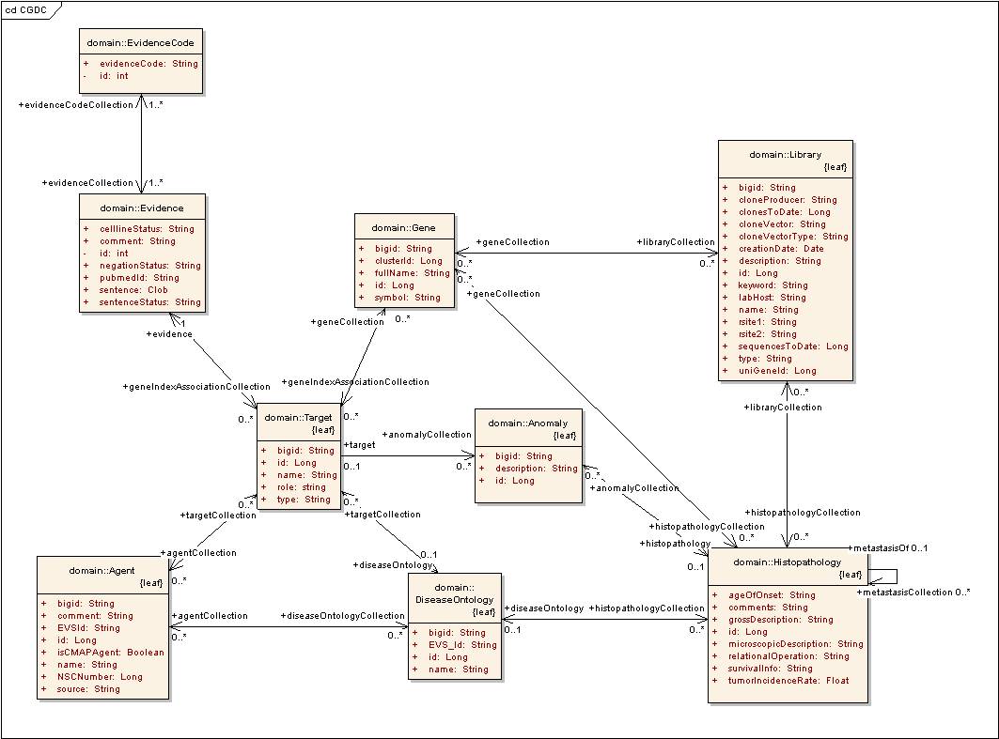

The existing Target Object could be re-used instead of adding a new GeneIndexAssociation object.

The Target object presently contains 86 gene targets along with their Locus Link Ids and Gene Symbols.

Alternate Database Model
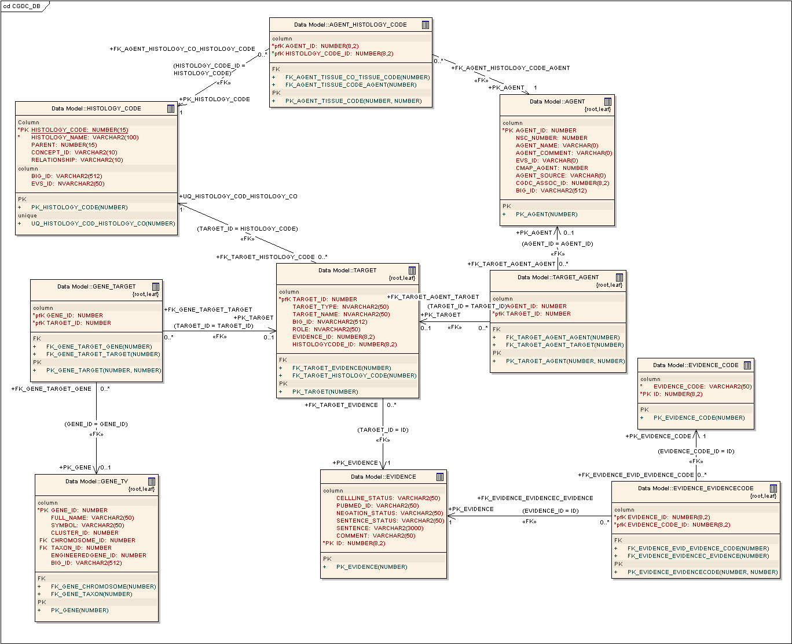

The database table layout is as given below:

Object | Table | Structure
Agent, DiseaseOntology, Evidence, EvidenceCode | Refer above | Refer above
Target | TARGET
  TARGET_ID | Primary Key | Unique Identifier
  TARGET_NAME |  | Gene Symbol
  TARGET_TYPE |  | Gene/Protein Target
  ROLE |  | Role from CGDC dataset
  EVIDENCE_ID |  | Associated Evidence
  HISTOLOGYCODE_ID |  | Associated DiseaseOntology
Gene <-> Target association | GENE_TARGET
  GENE_ID | Primary Key | Gene
  TARGET_ID | Primary Key | Target
Gene <-> Agent association | TARGET_AGENT
  TARGET_ID | Primary Key | Target
  AGENT_ID | Primary Key | Agent

Modeling the CGDC Dataset using Target object
- A new attribute, role would be added to Target and would model the role of the Genes as available in the CGDC dataset
- Symbol and locus link id for genes curated by the CGDC would be available through Target and Gene objects.
- A new association with DiseaseOntology would be added to model the CGDC data
- Existing many-to-many association with Gene and Agents would be updated with associations from the CGDC data
- Evidence would be available only for Targets associated with the CGDC dataset
- The existing association with Anomaly would remain unchanged and be valid only for the 86 targets currently in Target object.

Using New object, GeneIndexAssociation | Re-using Target
Object targeted to model the role of the Agent or Gene on Disease as per the CGDC Dataset | Object models generic drug-targets associated with Agents and Anomaly
No redundancy | Following redundancies are introduced  - Gene’s symbol and locus link Id are available through Target  - Many-to-many association between Target and Gene, and between Target and Agent (CGDC data supports a one-to-many association between them)
Incomplete data  - Agent.name (for existing agents)  - Agent.EVS Id (where not available)  - DiseaseOntology.EVS Id (where not available) | Incomplete data  - Agent.name (for existing agents)  - Agent.EVS Id (where not available)  - Diseasentology.EVS Id (where not available)  - Target – Evidence association unavailable for 86 existing targets  - Target – Anomaly association unavailable for all genes populated from CGDC data

Model 1 is designed to model literature-based associations of Genes with Agents and is extensible to other such associations as well.
Model 2 is designed to accommodate experimentally-determined associations between Targets and Agents.

Model 1 (adding object GeneFunctionAssociation)
1. Models the results of literature-mining of an association between a Gene and an Agent/Disease
2. Captures the associated Evidence/Publication information and the semantics of data being modeled
3. Extensible to other Function-Associations obtained through text-mining across the model. Evidence is a generic object designed to accommodate all literature-based evidence for associating any two objects, not just Genes.
4. Non-redundant, streamlined representation of data.

Alternate Model (Re-using Target)
1. Target models the interaction of gene targets with therapeutic agents on the basis of experimental evidence as observed in Histopathological data. The associated anomalies observed are modeled in Anomaly.
2. It is designed to model experimentally determined associations and is best suited for the same.
3. It cannot be extended to capture other generic literature-mining associations between various objects across the model.

It is advisable to use Model 1 to model literature-based associations only while using Target and associated objects (Model 2) to model experimentally-determined associations only and look for ways to associate the two models. (Example: Link Target with Evidence)
Modeling on the basis of the nature of evidence (literature/experimental) as above, allows us to extend either model in parallel, while looking for ways to interlink them as appropriate.

Data

CGDC’s Gene-Disease Data in Alternate Model

Category | CGDC | Using existing Target Object in CABIO (Model 2)
 | <GeneEntry>
 | <HUGOGeneSymbol>a2m</HUGOGeneSymbol> | Used to obtain Gene.Id
GeneAlias | <GeneAliasCollection> | GeneAlias.type = HUGO/CGDC
 | <GeneAlias>a2m</GeneAlias> | GeneAlias.name
 | <GeneAlias>alpha-2-macroglobulin</GeneAlias> | GeneAlias.name
 | <GeneAlias>alpha-2-macroglobulinprecursor</GeneAlias> | GeneAlias.name
 | </GeneAliasCollection>
Gene | <SequenceIdentificationCollection>
 | <HgncID>7</HgncID>
 | <LocusLinkID>2</LocusLinkID> | Used to obtain Target.name, Target.Locus_id and populate association between Target and Gene with corresponding Gene.Id and Target.Id
 | <GenbankAccession></GenbankAccession>
 | <RefSeqID>NM_000014</RefSeqID> | Used to obtain Target.name, Target.Locus_id and populate association between Target and Gene with corresponding Gene.Id and Target.Id
 | <UniProtID>P01023</UniProtID>
 | </SequenceIdentificationCollection>
 | <GeneStatusFlag>finished</GeneStatusFlag>
 | <Sentence>
 | <GeneData>
 | <MatchedGeneTerm>alpha-2 macroglobulin</MatchedGeneTerm>
 | <NCIGeneConceptCode>C4567</NCIGeneConceptCode>
 | </GeneData>
DiseaseOntology | <DiseaseData>
 | <MatchedDiseaseTerm>tumor</MatchedDiseaseTerm> | DiseaseOntology.name
 | <NCIDiseaseConceptCode>C3262</NCIDiseaseConceptCode> | DiseaseOntology.EVSId
 | </DiseaseData>
 | <Statement>Several &amp;apos;genes&amp;apos; were &amp;quot;underexpressed&amp;quot; by at least 50% in both tumor types such as c-fos, decorin, alpha-2-macroglobulin, platelet endothelial cell adhesion molecule 1,EGR1,fibronectin.</Statement> | Evidence.Sentence
Evidence | <PubMedID>11948124</PubMedID> | Evidence.PubMedId
 | <Organism>Human</Organism>
 | <NegationIndicator>no</NegationIndicator> | Evidence.Negation
 | <CellineIndicator>no</CellineIndicator> | Evidence.cellLine
 | <Comments></Comments> | Evidence.comment
EvidenceCode | <EvidenceCode>EV-EXP-IEP</EvidenceCode> | EvidenceCode.evidenceCode
 | <EvidenceCode>EV-EXP-TAS</EvidenceCode> | EvidenceCode.evidenceCode
 | <Roles>
GeneIndexAssociation | <PrimaryNCIRoleCode>Gene_Has_Expression_Measurement</PrimaryNCIRoleCode> | Target.Role
 | <OtherRole>Gene_Expression_Downregulated_in_Disease</OtherRole> | Target.Role
 | </Roles>
 | SentenceStatusFlag>finished</SentenceStatusFlag> | EvidenceCode.sentenceStatus
 | </Sentence>
 | </GeneEntry>

CGDC’s Gene-Drug Data in Alternate Model

Category | CGDC | Using existing object, Target in caBIO
 | <GeneEntry>
 | <HUGOGeneSymbol>a2m</HUGOGeneSymbol> | Used to obtain Gene.Id
GeneAlias | <GeneAliasCollection> | GeneAlias.type = HUGO/CGDC
 | <GeneAlias>myeov</GeneAlias> | GeneAlias.name
 | <GeneAlias>myeloma overexpressed gene </GeneAlias> | GeneAlias.name
 | <GeneAlias>positivemultiple myelomas)</GeneAlias> | GeneAlias.name
 | </GeneAliasCollection>
Gene | <SequenceIdentificationCollection>
 | <HgncID>7563</HgncID>
 | <LocusLinkID>26759</LocusLinkID> | Used to obtain Target.name, Target.Locus_id and populate association between Target and Gene with corresponding Gene.Id and Target.Id
 | <GenbankAccession></GenbankAccession>
 | <RefSeqID>NM_138768</RefSeqID> | Used to obtain Target.name, Target.Locus_id and populate association between Target and Gene with corresponding Gene.Id and Target.Id
 | <UniProtID>Q96EZ4</UniProtID> | Uniprot.PrimaryAccessionNumber
 | </SequenceIdentificationCollection>
 | <GeneStatusFlag>finished</GeneStatusFlag>
 | <Sentence>
 | <GeneData>
 | <MatchedGeneTerm>alpha-2 macroglobulin</MatchedGeneTerm>
 | <NCIGeneConceptCode></NCIGeneConceptCode>
 | </GeneData>
Agent | <DrugData>
 | <MatchedDrugTerm>5-aza-2-deoxycytidine</MatchedDrugTerm> | Used to populate Agent.name and obtain Agent.Id to populate association between Target and Agent
 | <NCIDrugConceptCode>C981</NCIDrugConceptCode> | Used to populate Agent.EVSId and obtain Agent.Id to populate association between Target and Agent
 | </DrugData>
 | <Statement>Treatment with the demethylating agent 5-aza-2\-deoxycytidine restored MYEOV ex  pression in a subset of cell lines exhibiting DNA amplification without high MYEOV expression, suggesting  that MYEOV is transcriptionally silenced by a DNA methylation mechanism in most of the latter cell lines.</Statement> | Evidence.Sentence
Evidence | <PubMedID>12202983</PubMedID> | Evidence.PubMedId
 | <Organism>Human</Organism>
 | <NegationIndicator>no</NegationIndicator> | Evidence.Negation
 | <CellineIndicator>CELL_LINE</CellineIndicator> | Evidence.cellLine
 | <Comments></Comments> | Evidence.comment
EvidenceCode | <EvidenceCode>EV-EXP-IEP</EvidenceCode> | EvidenceCode.evidenceCode
 | <EvidenceCode>EV-EXP-TAS</EvidenceCode> | EvidenceCode.evidenceCode
 | <Roles>
GeneIndexAssociation | <PrimaryNCIRoleCode>Chemical_or_Drug_Affects_Cell_Type_or_Tissue</PrimaryNCIRoleCo  de> | Target.Role
 | <OtherRole>Chemical_or_Drug_Affects_Gene_Expression</OtherRole> | Target.Role
 | </Roles>
 | SentenceStatusFlag>finished</SentenceStatusFlag> | EvidenceCode.sentenceStatus
 | </Sentence>
 | </GeneEntry>

Outline of CGDC Data Parsing in caBIO
- Remove footer from NCI_all_compound.xml and header from NCI_all_disease.xml
- Add contents of NCI_all_diseases.xml file to NCI_all_compounds.xml file (sh combine_all_new.sh). This prevents extraction of duplicate EvidenceCodes from two different files.
- Remove trailing whitespaces (in front of the tags) in this combined xml file to allow usage of Perl Library XML::Parser::Expat to parse XML documents (xmCorrecter.pl)
  - This script modifies XML document of form
    - <tag1>
<tag2>
<tag3>
</tag3>
</tag2>
<tag1>
into
<tag1>
<tag2>
<tag3>
</tag3>
</tag2>
</tag1> and stores output in wellFormedMerged.xml)
- Remove all control characters with perl -pi -e 's/[^ -~]//g' wellFormedMerged.xml
- Parse the cleaned xml file as below (xmlParser.pl) (after Gene, NucleicAcidSequence, Gene2Unigene, Gene2Accession are loaded during refresh)
  - Prior to reading data from XML file, extract hashes from caBIO for
    - All GeneSymbol-caBIOGeneId associations (Will be replaced with HugoGeneSymbol-caBIOGeneId lookup, once HUGO Symbols are exposed in caBIO)
    - LocusLink-caBIOGeneId associations
    - AccessionNumber-caBIOGeneId associations
  - Try to retrieve gene-Id using any of the above fields from raw data
  - If and only if caBIOGeneId can be retrieved in Step b), do the following on encountering respective tags
    - Write out Evidence in the form EvidenceId | PubMedId | Sentence | status-fields, etc
    - Write out EvidenceCode in the form EvidenceCodeId | EvidenceCode
    - Write out Evidence-EvidenceCode association
    - If tag is <DrugData>,Write out Agent in the form AgentId | AgentName | EVSId (note that we synchronize with existing caBIO Agent data later in Steps j) and further)
    - If tag is <DiseaseData> Write out Disease in the form DiseaseId | DiseaseName | EVSId (note that we synchronize with existing caBIO Disease data later in Steps j) and further)
    - On encountering <Role> tags, if step iv) was executed
      - Write out GeneId-EvidenceId-AgentId-Role (AgentAssociation)
    - Else if Step v) was encountered
      - Write out GeneId-EvidenceId-DiseaseId-Role (DiseaseOntologyAssociation)
  - Complete data extraction
  - Load Evidence and EvidenceCode into respective objects, EVIDENCE and EVIDENCE_CODE in database
  - Load Agent data into zstg_agent_cgid (temp table not supporting the model)
  - Load Disease into zstg_disease_cgid (temp table not supporting the model)
  - Load Agent association into zstg_gene_agent_evidence_cgid (temp table not supporting the model)
  - Load Disease association into zstg_gene_disease_evidence_cgid (temp table not supporting the model)
  - Merge from table in step f) to Agent object (AGENT table) (i.e. add only new records from CGDC)
  - Merge from table in step g) to DiseaseOntology (TISSUE_CODE) object (i.e. add only new records from CGDC)
  - Load from tables in Step h) and Step i) into GeneFunctionAssociation (GENE_FUNCTION_ASSOCIATION) table, but use updated AGENT and DiseaseOntology (TISSUE_CODE) tables to get mapping to caBIO Agent and DiseaseOntology object). Load discriminator as AgentAssociation or DiseaseOntologyAssociation to support table-per-class-hierarchy feature of SDK and distinguish between the two kinds of GeneFunctionAssociations.
  - Results of earlier attempts to retrieve EVS Ids using Agent names and retrieve Agent Names using NSC Numbers, for incomplete records in Agent are already loaded into AGENT table.

All the above scripts are in CVS under load/scripts/parse/cgdc (for the parsers) and load/scripts/sql_loader/cgdc for the data load

DOCUMENT CONTROL
Change History
Content changes to this document from the previous to the current level are indicated by revision bars (|) unless a complete rewrite is indicated.

Table 2 – Implémentation Spécification Document Change Log
Version/Date | Approved By | Change Description and Explanation | D – Draft  A – For Review/ Approval  R – Re-Approval, Plan of Record Change
12/13/2007 | Lalitha Viswanath | Complete rewrite to support full metadata load. | D
Note: If this document has been inspected, please indicate the inspection date that each version is based on in the “Change Description and Explanation” area. Entries in this log must be maintained for at least 3 years.

DOCUMENT APPROVAL
Approvers List
The individuals listed in this section constitute the approvers list for the Integration Test Plan document. Formal approval must be received from all approvers prior to the initiation of the next steps in the process.

Title | Name
Project Manager | Name
Development Manager | Name

Reviewers List
The individuals listed in this section constitute the reviewers list for the Master Test Plan document. Formal approval is not required from the reviewers, however, it is desirable to have all reviewers review and comment on the document. Reviewers may choose to concentrate on reviewing only those sections that are in their area of responsibility, rather than the entire document.

Title | Name
Solutions Manager | Name
Project Manager | Name
Test Manager | Name
Test Engineer | Name
Development Manager | Name
Technical Writer | Name
Client Support Analyst | Name
Internationalization Lead | Name
DBA | Name
Developer | Name
Developer | Name

END OF DOCUMENT

