Implementation Specification
for
Python API for caBIO

Release 0.1

Last Updated: June 26, 2008

Owner: caBIO Team
Email: klemmj@mail.nih.gov

National Cancer Institute Center for BioInformatics
6116 Executive Blvd.
Rockville, MD 20852



1 Document Purpose 3
2 Implementation Overview 4
2.1 Team Members 4
2.2 Description 4
2.3 Scope 4
2.4 Use Cases 4
2.5 Architecture 6
2.6 Data 6
2.7 Assumptions 6
2.8 Dependencies 6
2.9 Issues 7
2.10 Third Party Tools 7
3 Implementation Contents 8
3.1 Server 8
3.1.1 Algorithms 8
3.1.2 Batch Processes 8
3.1.3 APIs 8
3.1.4 Error Handling 8
3.1.5 Database Changes 8
3.2 Client 8
3.2.1 JSP/HTML 9
3.2.2 Servlet 9
3.2.3 Error Handling 9
3.3 Security Issues 9
3.4 Performance 9
3.5 Internationalization 9
3.6 Installation / Packaging 9
3.7 Migration 9
3.8 Documentation Considerations 9
4 Unit Testing 10
4.1 Test Guidelines 10
4.2 Test Cases 10
5 Data Exemplars 11
DOCUMENT CONTROL 12
DOCUMENT APPROVAL 13

Document Purpose
This document provides design and implementation details for the Python API to caBIO. It can be used as a starting point for caBIO APIs in other scripting languages.

Implementation Overview

Team Members

Role | Name
Director of Engineering | Avinash Shanbhag²
Internationalization Lead | N/A
Product Manager | Juli Klemm²
Project Manager | Sharon Gaheen¹
Test Lead | Ye Wu¹
Tech Lead | Jim Sun¹
Documentation Lead
Development Team | Konrad Rokicki¹  Lalitha Viswanath¹  Hong Dang³
¹ Science Applications International Corporation (SAIC)
² National Cancer Institute Center for Bioinformatics (NCICB)
³ Alpha-Gamma Technologies, Inc.
Table 1: Team Members

Description
Python is a dynamic, object oriented languages comparable to Java and Perl. It is a cross-platform language especially suitable for scripting and rapid prototyping. Python has extensive standard libraries, and a large open source user community. Largely because of the latter point, it has very strong support for scientific computing and research.

Currently, Python is gaining momentum in the bioinformatics field. Although it hasn’t reached the ubiquity of Perl, it is still a valuable tool when interacting with existing Python-based applications. In the case of caBIO, the Python interactive shell can also provide for easy and efficient exploration of the caBIO domain model.

Scope
The scope of this document includes design and implementation details related to Python access of caBIO. The scope includes only the SDK web service to caBIO, not the grid service. PerInstructions for connecting to the grid service from Python exist here: http://www.cagrid.org/wiki/CaGrid:How-To:DevelopPythonClients.

Use Cases
The basic query use cases are the same as for any system using caBIO web services. All query types that are currently supported by the web service will be available via Python. In addition, the Python API will make it easy to follow associations on domain objects.

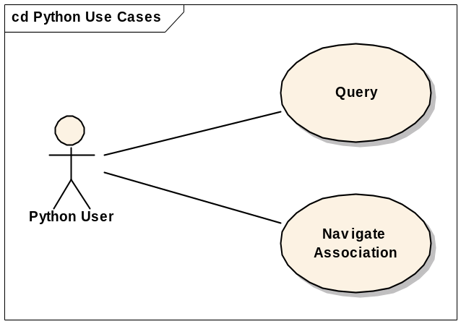
Figure 1: Use Case Diagram

Use Case Name | Query
Use Case ID | 1.1
Primary Actor | Python User
Brief Description | The Python user shall be able to perform any web service query on caBIO.
Trigger | API call
Pre-conditions | - The user has installed Python API and prerequisites
Flow of Events | - The user creates a CaBioApplicationService instance  - The user creates a criteria object by instantiating domain objects and setting their properties  - The user calls the desires method on the CaBioApplicationService, passing in any necessary parameters directly to the method  - The user receives results as the return value of the method
Post Conditions | Success Condition: The user obtains a result object  Error Conditions:  EC1: Local error (i.e. invalid parameters)  EC2: Network error  EC3: Remote error on the server side
Alternative Flow | Alternate Condition:  AC1: No result is found
Related Use Cases
Issues/Notes | Supports the following methods:  getVersion  getRecordsPerQuery  getMaximumRecordsPerQuery  getTotalNumberOfRecords  queryObject  query  getAssociation  exist  getDataObject  The following methods will not be supported in the initial alpha release:  search

Use Case Name | Navigate Association
Use Case ID | 1.2
Primary Actor | Python User
Brief Description | Once the Python user obtains a domain object from the API, they will be able to retrieve associations by accessing the roleName of the association directly on the object, without building a getAssociation query manually.
Trigger | API call
Pre-conditions | - The client has a valid domain object, retrieved by a query
Flow of Events | - The client requests the roleName of the association as an attribute on the domain object. For example, for a gene’s taxon, the user would request “gene.taxon”
Post Conditions | Success Condition: The user obtains the associated object(s)  Error Conditions:  EC1: Local error (i.e. invalid parameters)  EC2: Network error  EC3: Remote error on the server side
Alternative Flow | Alternate Condition:  AC1: No result is found
Related Use Cases
Issues/Notes

Architecture
The Python API shall use the standard caBIO web service. On the client side, the API shall be built on top of a wsdl2py-generated API, which itself sits on top of the ZSI library. These 3rd party libraries are explained in section 2.10.

The API sends SOAP messages to the caBIO web service end-point and receives responses back via HTTP.

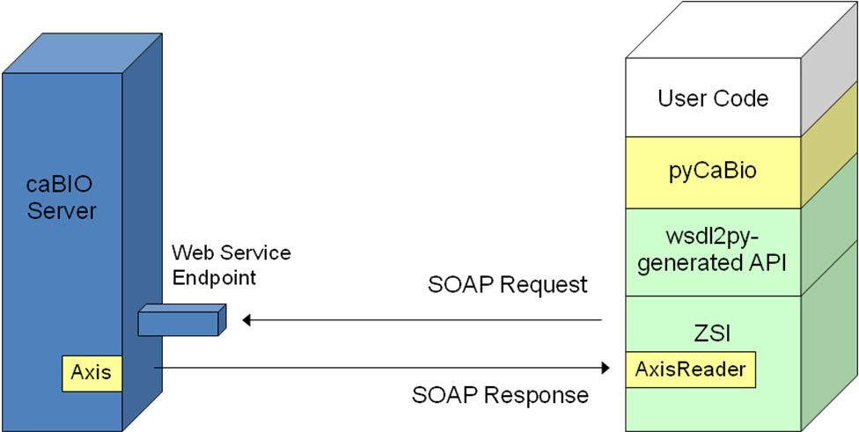
Figure 2: caBIO Python API Architecture

Responses will be sanitized by a compatibility layer called AxisReader before being passed to ZSI for parsing. This compatibility layer fixes the following:
- Change name of all nodes which are children of a result that is an array to “item”.
- Replace xsi:type of embedded arrays from soapenc:Array to ws:ArrayOf_xsd_anyType

Data
Not applicable.

Assumptions
None stated.

Dependencies
The API depends on ZSI 2.1_b1 and Python 1.5.

Issues
Issues with this API are generally found between the server side (Axis) and client side (ZSI) SOAP libraries. Most issues are resolved by the AxisReader compatibility layer.

Known issues:
- The API does not currently handle sending arrays of objects. Receiving arrays is unaffected.

Third Party Tools
The API will use the ZSI (Zolera SOAP Infrastructure, http://pywebsvcs.sourceforge.net/zsi.html) library for baseline API generation and SOAP processing. The ZSI library contains a utility called wsdl2py which will be used to generate an initial API from the caBIO WSDL. A custom proxy API will be generated on top of this wsdl2py API in order to provide the desired API. Proxy domain objects will wrap the ZSI objects. When a query is made, the proxies will be unwrapped to provide the original ZSI objects to ZSI for serialization. When results come back, they will be wrapped in proxies before being handed off to the user.

Implementation Contents

Server
This implementation affects only the client side, not the server configuration.

Algorithms
Not applicable.

Batch Processes
Not applicable.

APIs
The standard web service APIs shall be used.

Error Handling
The new convenience methods will throw IllegalArgumentException in the event of an invalid argument. The methods will throw ApplicationException when something goes wrong with the query.

Database Changes
Not applicable.

Client
The client API distribution shall be called “pyCaBio” according to Python naming conventions. The distribution will consist one a single query interface class and domain objects. The API shall be located across two packages:
- cabig – contains utilities useful across all SDK-generated projects, such as the AxisReader
- cabio – contains caBIO specific APIs

Query Interface

The query interface will be named CaBioApplicationService after the Java API, and will contain all of the methods that are defined by the caBIO WSDL at the time of API generation. This class will take 2 optional keyword parameters during construction time:
- url – This parameter allows the user to specify an alternate WS end point (by default the URL of the caBIO production server will be used)
- debug – If True, the API will print the raw SOAP messages to the STDERR stream.

Domain Objects

The domain objects shall be named according to their Java class names, by removing the initial gov.nih.nci packages. In other words, the package of containing the domain objects shall be as follows:

Java Package | Python Package/Module
gov.nih.nci.cabio.domain | cabio. domain
gov.nih.nci.cabio.common.domain | cabio.common.domain
gov.nih.nci.cabio.common.provenance.domain | cabio.common .provenance.domain

Attributes on the domain objects shall be exposed as simple attributes in Python. In other words, if a class Gene has an attribute symbol, then the Python proxy will be Gene.symbol, with normal value assignment and retrieval. Associations will be similarly represented, with the role name serving as the attribute name.
In addition to the usual attributes and associations, domain class proxies will always contain a className attribute containing the fully qualified Java class name of the class. For example, Gene.className will contain “gov.nih.nci.cabio.domain.Gene”. This can be used whenever the API requires a class name input.

Association Caching

The Python API will cache associations it has previously retrieved. For example, if the user references gene.taxon then that taxon will be stored in a cache on that gene proxy until the gene goes out of scope or the cache is cleared. The cache will be clearable by deleting the attribute in question, i.e. “del gene.taxon”.

JSP/HTML
Not applicable.

Servlet
Not applicable.

Error Handling
All web service errors shall be reported to the user wrapped in ZSI exceptions. Other errors will be handled according to Python standards.

Security Issues
Not applicable since the interface is through the web service.

Performance
The performance of this API is limited by the performance of the web service. The API itself shall add very little processing overhead.

Internationalization
Not applicable.

Installation / Packaging
The installation shall be handled by setuptools (http://peak.telecommunity.com/DevCenter/setuptools), which is rapidly becomes the standard for Python library packaging. The user needs only to download the package and type “python setup.py install” and all the prerequisites will be downloaded an installed, followed by installation of the pycabio package itself.

Migration
Not applicable.

Documentation Considerations
- This design document
- Updated caBIO Technical Guide
- SDK 4.0 Developer’s Guide
- ZSI Documentation

Unit Testing

Test Guidelines
Unit tests for the Python API are part of the pycabio distribution, and are run as part of the build.

Test Cases
Each method in the new API shall be tested.

Data Exemplars

Not applicable.
DOCUMENT CONTROL
Change History
Content changes to this document from the previous to the current level are indicated by revision bars (|) unless a complete rewrite is indicated.

Table 2 – Implementation Specification Document Change Log
Version/Date | Approved By | Change Description and Explanation | D - Draft  A - For Review/ Approval  R - Re-Approval, Plan of Record Change
06/20/2008 | Konrad Rokicki | Initial revision | D
Note: If this document has been inspected, please indicate the inspection date that each version is based on in the “Change Description and Explanation” area. Entries in this log must be maintained for at least 3 years.

DOCUMENT APPROVAL
Approvers List
The individuals listed in this section constitute the approvers list for the Integration Test Plan document. Formal approval must be received from all approvers prior to the initiation of the next steps in the process.

Title | Name
Project Manager | Name
Development Manager | Name

Reviewers List
The individuals listed in this section constitute the reviewers list for the Master Test Plan document. Formal approval is not required from the reviewers, however, it is desirable to have all reviewers review and comment on the document. Reviewers may choose to concentrate on reviewing only those sections that are in their area of responsibility, rather than the entire document.

Title | Name
Solutions Manager | Name
Project Manager | Name
Test Manager | Name
Test Engineer | Name
Development Manager | Name
Technical Writer | Name
Client Support Analyst | Name
Internationalization Lead | Name
DBA | Name
Developer | Name
Developer | Name

END OF DOCUMENT

This is a known Axis bug: https://issues.apache.org/jira/browse/AXIS-2250
http://mail.python.org/pipermail/python-dev/2006-April/063964.html

