Implementation Specification
for
caBIO Portlets in the caGrid Portal

Release 4.2

Last Updated: September 12, 2008

Owner: caBIO Team
Email: klemmj@mail.nih.gov

National Cancer Institute Center for BioInformatics
2115 Jefferson Ave. East
Rockville, MD 20852



1 Document Purpose 4
2 Implementation Overview 5
2.1 Team Members 5
2.2 Description 5
2.3 Scope 5
2.4 Use Cases 5
2.4.1 Simple Query 6
2.4.2 Canned Query 7
2.4.3 Advanced Query 7
2.4.4 Create Report 8
2.4.5 Manage Template 8
2.5 Architecture 9
2.5.1 Simple Search 10
2.5.2 Canned query 12
2.5.3 Advanced Query 13
2.5.4 Viewing Results 14
2.6 Data 15
2.7 Assumptions 16
2.8 Dependencies 16
2.9 Issues 16
2.10 Third Party Tools 16
3 Implementation Contents 17
3.1 Server 17
3.1.1 Algorithms 17
3.1.2 Batch Processes 17
3.1.3 APIs 17
3.1.4 Error Handling 17
3.1.5 Database Changes 17
3.2 Client 17
3.2.1 JSP/HTML 17
3.2.2 Servlet 17
3.2.3 Error Handling 17
3.3 Security Issues 17
3.4 Performance 17
3.5 Internationalization 17
3.6 Installation / Packaging 18
3.7 Migration 18
3.8 Documentation Considerations 18
4 Unit Testing 19
4.1 Test Guidelines 19
4.2 Test Cases 19
5 Data Exemplars 20
TBD 20
APPENDIX A: UI Options considered 21
5.1 Option 1, Flymine 21
5.1.1 Flymine.org Architecture overview 21
5.1.2 Execute query 21
5.2 Option 2, BioMart 22
5.3 Option 3, Custom using the caCORE SDK 22
5.4 Option 4, Custom Portlet using the caGrid Portal 23
DOCUMENT CONTROL 24
DOCUMENT APPROVAL 25

Document Purpose
This document provides design and implementation details for a user friendly interface that allows scientific researchers to easily browse the caBIO cancer data information through portlets inside the caGrid Portal. The functionality of the portlets extends to FreestyleLM Search, canned queries, and an advanced query builder. This document also describes the use cases for these user interfaces.

Implementation Overview

Team Members

Role | Name
Director of Engineering | Avinash Shanbhag²
Internationalization Lead | N/A
Product Manager | Juli Klemm²
Project Manager | Sharon Gaheen¹
Test Lead | Ye Wu¹
Tech Lead | Jim Sun¹
Documentation Lead
Development Team | Konrad Rokicki¹  Lalitha Viswanath¹  Hong Dang³
¹ Science Applications International Corporation (SAIC)
² National Cancer Institute Center for Bioinformatics (NCICB)
³ Alpha-Gamma Technologies, Inc.
Table 1: Team Members

Description
In this version of caBIO we will provide a new user friendly web interface for scientists to browse the caBIO database information.

Scope
The scope of this document includes all the system use cases, design and implementation specification for the new user interfaces.

Use Cases
The following diagram illustrates all the use cases for the new use interface including queries.

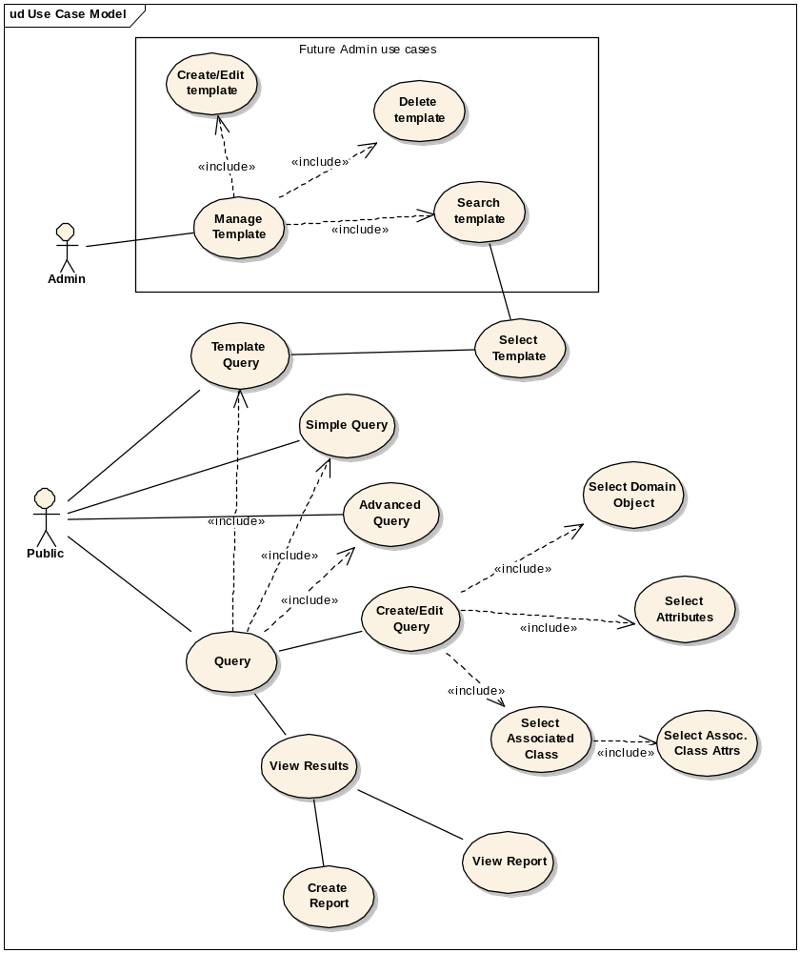
Figure 1: Use Case Diagram

Simple Query

Use Case Name | Simple Query
Use Case ID | 1.1
Primary Actor | Public
Brief Description | Allows users to perform Google-like FreestyleLM search.
Trigger | The user enters the keyword or multiple keywords to search for.
Pre-conditions | - The user navigates to the caBIO Home Page and clicks “Simple Search” tab.
Flow of Events | - The user enters the keyword(s) into the input box  - The user selects other options such as FullText search or Hibernate Search.  - The user clicks the submit button to initiate the search  - A list of domain objects returned containing the keywords user entered. The results are organized by domain object class name.  - The user can navigate to the results he is interested in.
Post Conditions | Success Condition: The user successfully searches the database and obtains the list  Error Conditions:  EC1: System Error during Request Processing  EC2: Specified Keyword(s) does not exist
Alternative Flow | Alternate Condition:  AC2: No result is found  1. “No results found” message is displayed
Related Use Cases | NA
Issues/Notes | - The user can also execute the same search using the Java API or Web Service

Canned Query

Use Case Name | Canned Query
Use Case ID | 1.2
Primary Actor | Public
Brief Description | Allows users to perform canned queries based on templates.
Trigger | The user has selected a canned query, entered the necessary information such as gene keyword and clicked on “Search” button.
Pre-conditions | - The user navigates to the caBIO Home Page and clicks “Canned Query” tab
Flow of Events | - The user selects a canned search template  - The user provides search parameters such as upstream and downstream information to search in case of Range Query template.  - The user clicks the submit button to initiate the search  - A list of matched domain objects is returned sorted by the specified columns.  - The user can navigate to the domain object and see more details.
Post Conditions | Success Condition: The user successfully searches the database and obtains the list  Error Conditions:  EC1: System Error during Request Processing  EC2: The object with specified criteria does not exist
Alternative Flow | Alternate Condition:  AC2: No result is found  1. “No results found” message is displayed
Related Use Cases | NA
Issues/Notes | - The user can also execute the same search using the Java API or Web Service.

Advanced Query

Use Case Name | Advanced Query
Use Case ID | 1.3
Primary Actor | Public
Brief Description | This use case is to allow the user to build query with custom search criteria and filters.
Trigger | The user has selected a canned query, entered the necessary information such as gene keyword and clicked on “Search” button.
Pre-conditions | The user navigates to the caBIO home page and clicks on “Advanced Query” tab.
Flow of Events | - The user selects the domain object type to search for.  - The user continues to build the search criteria by selecting the attributes to be returned.  - The user optionally provides search parameters, such as how far to search upstream/downstream, and whether or not to include features partially within the range  - The user selects any interested associated classes and its attributes  - The user clicks the submit button to initiate the search  - A list of Search Objects (e.g. SNPPhysicalLocations) is returned.  - The user can navigate to the search result and examine the details
Post Conditions | See Canned Query
Alternative Flow | See Canned Query
Related Use Cases | See Canned Query
Issues/Notes | See Canned Query

Create Report

Use Case Name | Create Report
Use Case ID | 1.4
Primary Actor | Public
Brief Description | This use case is to allow the user to generate the reports based on the search results returned.
Trigger | The user selected the report style such as what columns and report format, and submitted “Generate Report” request.
Pre-conditions | The user has performed a query using Simple, Canned or Advanced Query Interface and a list of results are returned.
Flow of Events | - The user selects the columns to be displayed in the report.  - The user selects the report export formats such as “PDF” or “CSV” ( comma separated view).  - The user clicks the submit button to initiate the report  - A report with specified format and style appears for download.  - The user can select to save it to hard drive or cancel it.
Post Conditions | A printer friendly report is generated for the user to save or print.
Alternative Flow | NA
Related Use Cases | NA
Issues/Notes | NA

Manage Template

Use Case Name | Manage Template
Use Case ID | 1.5
Primary Actor | Public
Brief Description | This is for future use only and will not be available in this release.
Trigger | The admin logs into the system and select the configuration for templates
Pre-conditions | - NA
Flow of Events | NA
Post Conditions | NA
Alternative Flow | NA
Related Use Cases | NA
Issues/Notes | NA

Architecture
The new user interface will be constructed as a series of portlets running inside the caGrid Portal (Figure 2). The portlets will be able to communicate with caBIO through its remote Java API, on the portal server side. In cases where Ajax is necessary, the REST API will be used through a proxy in order to avoid duplicating existing caBIO functionality inside the caGrid Portal.

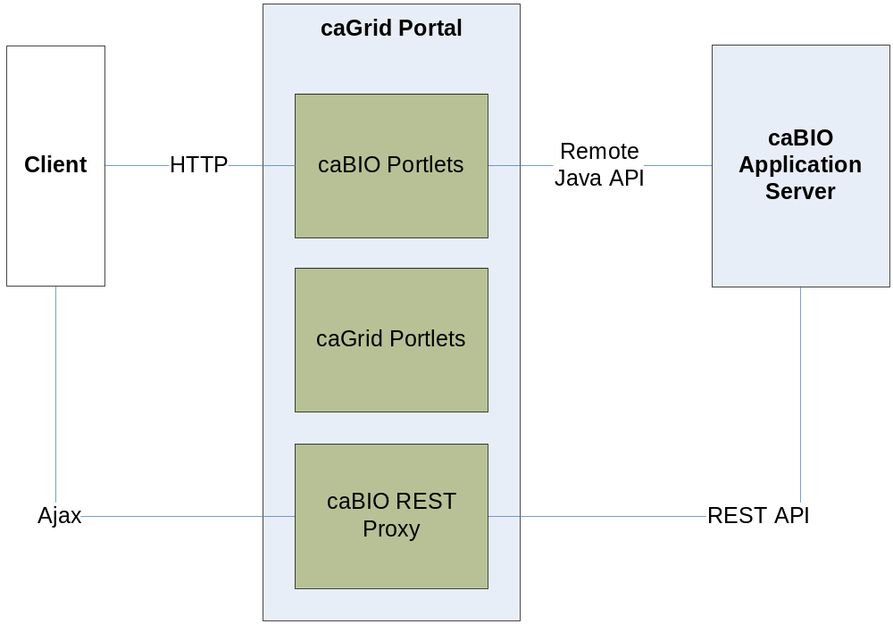
Figure 2: Portlet Architecture

Initially, there will be three main caBIO portlets, corresponding to three different search user cases: simple, canned and advanced. For now, all three portlets will be grouped together into a single monolithic portlet with tabs to separate the different functionality sets. In the future, additional portlets may be added.

Simple Search
The simple search is based on the existing FreestyleLM search to allow the user to search by simply entering one or more keywords (Figure 3). The simple search will display results in a “Google-like” manner. Formatting will be applied to each result, based on the object type, to show a relevant title and description and class for each result. Pagination will allow the user to retrieve further results. All functionality in the Simple Search portlet will be implemented using Ajax, and thus will use the caBIO REST API.

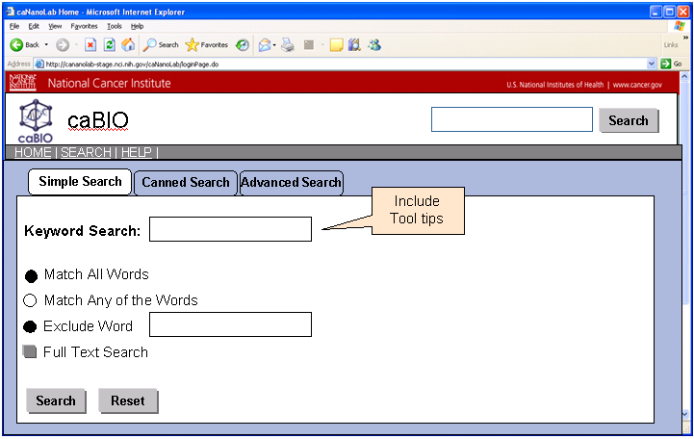

Figure 3: Wire Frame Design for Simple Query in caBIO 4.2

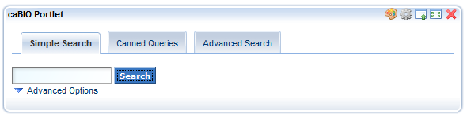
Figure 4: Simple Search

The simple search portlet will be displayed as a tab in the caBIO portlet (Figure 4). The color scheme will use the caGrid Portal defaults.

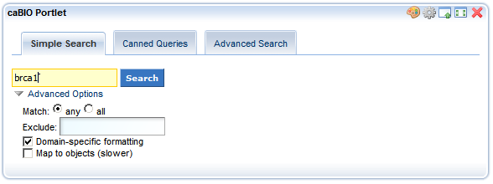
Figure 5: Simple Search Advanced Options

The advanced options (Figure 5) will be collapsible and initially closed. Upon opening, the advanced options will allow the user to match on all or any of the words in the input textbox. An additional textbox will be provided for word exclusions. Additional options may be provided for enable “hibernate search” and “domain-specific formatting”.

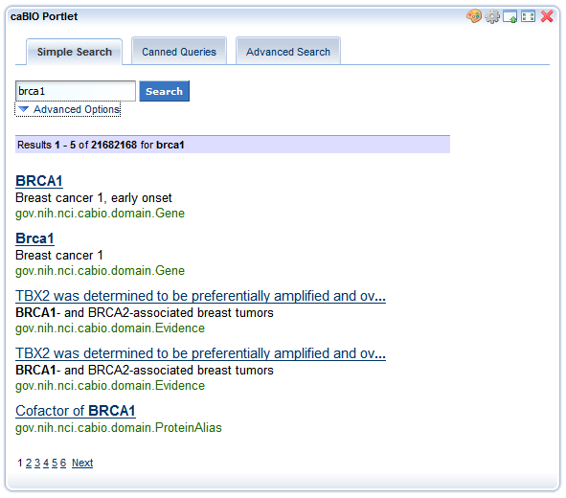
Figure 6: Simple Search Results

The simple search results will be displayed below the simple search form (Figure 6). A Google-like formatting will be applied to search results with the following UI elements:
- Header with search string, total number of results and indication of which results are currently displayed.
- Each result has a title, description and class.
- Titles and descriptions have max lengths which, when reached, truncate the text with ellipses (…).
- Search terms are highlighted in bold in the results.
- Pagination available at the end of result set.

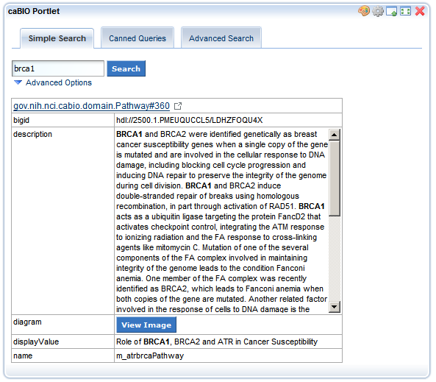
Figure 7: Simple Search Object Details

When the user clicks on any result in the simple search result list, they will be presented with a detail screen with the entire object of interest (Figure 7). On this screen, all attributes will be shown in full, with scroll bars for larger text attributes. Search terms will remain highlighted in bold. A link at the top of the screen will allow the user to open the object on the native caBIO home page.

In Firefox, pathway diagrams will be viewable by clicking “View Image”. In other browser, the literal SVG XML code will be displayed as text, due to browser limitations.

Canned query
The canned query will provide the user with pre-configured searches categorized by functionality.

- Range Query
- Microarray Annotations
- Genomic Annotations
- Pathways
- Cancer Gene Index

The search categories will be presented as a radio button list (Figure 8). When the user selects one of the categories, the search options will dynamically appear below. For each category, the first selection dropdown will list all the canned queries. Once the user selects a query, they will be presented with further inputs, based on the query type.

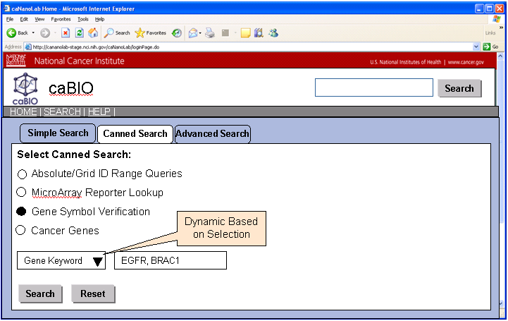
Figure 8: Canned Queries in caBIO 4.2

The individual canned queries, with their inputs, are specified below.

Range Queries

Absolute Range Query

- Taxon (drop down list)
- Chromosome Number (drop down list, populated based on taxon)
- Start (integer input field)
- End (integer input field)
- Result class filter (multi-select list with genomic feature class names, default to all)

Grid Id Range Query

- Grid Id of a genomic feature
- Left range (integer input field with default value)
- Right range (integer input field with default value)
- Result class filter (multi-select list with genomic feature class names)

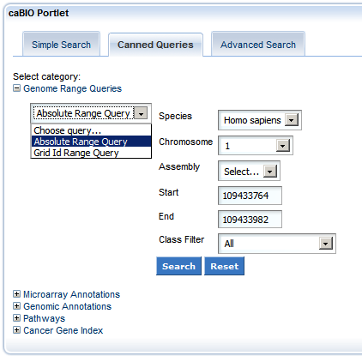
Figure 9: Absolute Range Query Form

Microarray Annotations

Reporter Lookup By Gene

- Gene symbol or HUGO symbol (string input field)

Reporter Lookup By SNP

- dbSNP Id (string input field)

Reporter Lookup By Name

- Microarray name (drop down list)
- Reporter name (string input field)

Genomic Annotations

Gene Lookup

- Gene symbol or HUGO symbol (string input field)

Pathways

By Name

- Pathway name (string input field)

By Gene

- Gene symbol or HUGO symbol (string input field)

Cancer Gene Index

Disease to Gene

- Disease name or EVS concept code (string input field)

Agent to Gene

- Agent name or EVS concept code (string input field)

Gene to Diseases and Agents

- Gene symbol or HUGO symbol (string input field)

Result Formatting

The results view for canned search will show the collapsible form used to do the search (Figure 10). The results will be segregated by object class and formatted in a table view with columns determined by the class of each result (enumerated below). Each result will contain a link back to caBIO. Pagination will show the first 50 results and then allow the user to view additional pages of results.

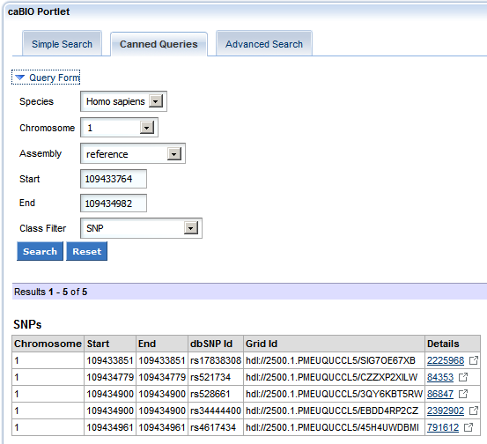
Figure 10: Results of Absolute Range Query

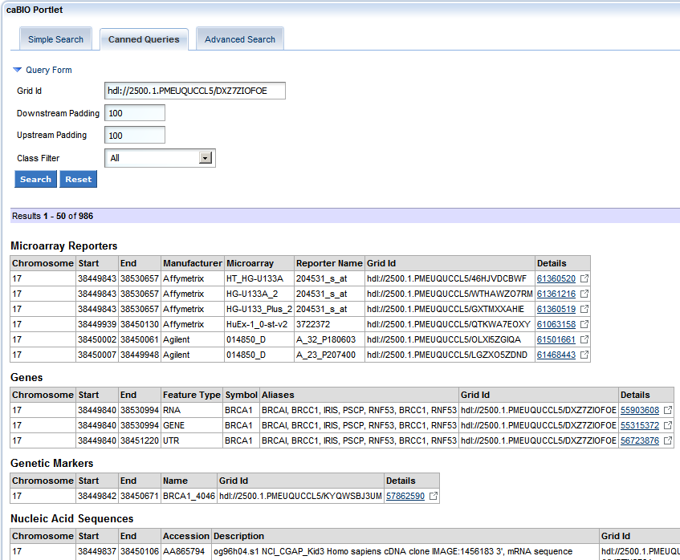
Figure 11: Results of Grid Range Query

Genes

Gene
- Gene name
- Cluster Id
- Physical location
- Cytogenetic Location
- Gene aliases
- Database cross references
- Grid Id

Array Reporters

ExpressionArrayReporters
- Reporter name
- Gene name
- Physical location
- Cytogenetic location
- Grid Id

SNPArrayReporter
- Reporter name
- dbSNP Id
- Physical location
- Cytogenetic location
- Grid Id

ExonArrayReporter
- Reporter name
- Physical location
- Strand
- Genes
- Grid Id

Pathways

Pathway
- Pathway name
- Description
- Genes
- Participants
- Diagram
- Grid Id

Diseases

DiseaseOntology
- Name
- EVS Id
- Grid Id

Agents

Agent
- Name
- EVS Id
- NSC Number
- Grid Id

Advanced Query
Advanced query is a very powerful tool which will allow the user to build custom queries by selecting custom target class, associated classes, custom attributes or columns to be searched for and specified what columns to be displayed. The following diagram shows a potential screen.

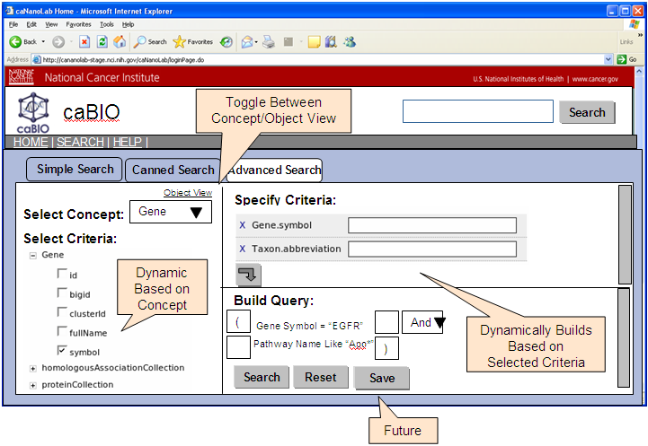
Figure 12: Advanced Query Builder

Viewing Results
In each portlet, the search results will be displayed below the query interface by default. If the user adds the “caBIO Search Results” portlet, all results will be added to this portlet instead. Here is a mockup screen for the potential result view.

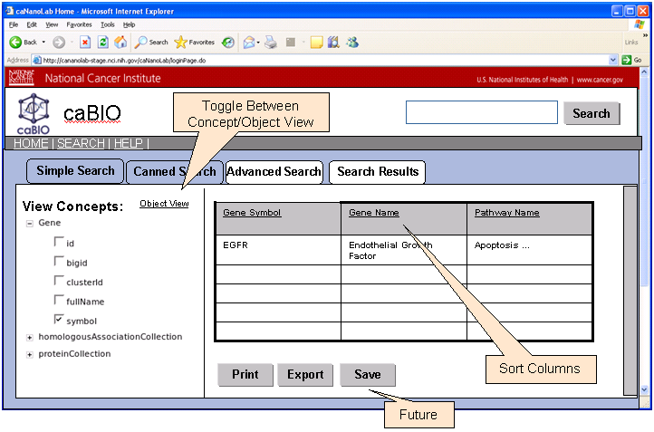
Figure 13 Search Result View

Ideally, all the search results should show the search results with same kind of look-and-feel. To that end, all the components should share the same search result view as illustrated below. Simple Search will require a slightly different presentation due to the nature of the results, but the look-and-feel will be close to other result views.

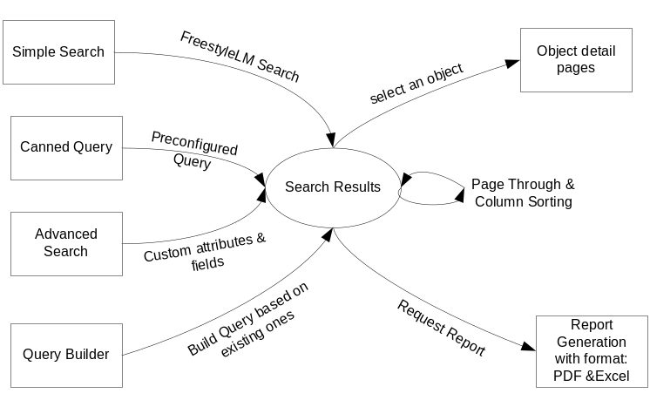

Figure 14 caBIO UI Page flows

Data
No new data will be added for this user interface implementation.

Assumptions
TBD

Dependencies
The caBIO system is dependent on the caCORE SDK, version 4.0 or higher.

Issues
There are no known issues at this time.

Third Party Tools
The API will use the caCORE SDK. See the current SDK technology stack for a complete listing.

Implementation Contents

Server
The caBIO server will run in the standard JBoss configuration and it will be deployed just like the existing caBIO 4.1 Application. The portlets will be deployed to the caGrid Portal production server.

Algorithms
N/A

Batch Processes
None expected.

APIs
No API changes

Error Handling
The new user interface will handle the error messages in a consistent and user friendly way. Since there are no Java API changes to the existing model, the error handling at API level is same as before.

Database Changes
No database change for the user interface

Client
The standard SDK generated client will be used for this implementation

JSP/HTML
The standard SDK generated JSP/HTML interface will be used for this implementation

Servlet
The standard SDK generated Servlet will be used for this implementation

Error Handling
The standard SDK Error Handling will be used. See the SDK Exception handling documentation for more information.

Security Issues
The location data is publicly available and does not require any security.

Performance
The performance of the system, after the UI changes herein are completed, shall at least equal to the previous version since there is no Java API changes. With AJAX additional on the UI, it may even improve the user response time.

Internationalization
N/A

Installation / Packaging
The design assumes the standard caBIO installation and packaging.

Migration
N/A

Documentation Considerations
- This design document
- Flymine.org design document
- caBIO 4.1 Technical Guide
- SDK 4.0 Developer’s Guide
- BioGopher design documents
- Rembrandt design documents
- BioMart design architecture
- Liferay Portal documentation
  - http://www.liferay.com/web/guest/documentation/4_4/development
- caGrid Portal documentation
  - http://www.cagrid.org/wiki/Portal:2.0:Installation_Guide
- Ajax/Portlet Best Practices
  - http://developers.sun.com/portalserver/reference/techart/ajax-portlets.html

Unit Testing

Test Guidelines
N/A

Test Cases
N/A

Data Exemplars

TBD

APPENDIX A: UI Options considered

Option 1, Flymine
- Approach
  - Leverage FlyMine software for building queries, applying templates, and generating spreadsheets
  - Replace middle-tier with SDK generated APIs
  - Customize the UI based on the NCI CBIIT usability standards
- Pros
  - Reduced implementation time on the UI due to code re-use
  - Provides Java APIs
- Cons
  - Requires additional implementation time replacing the middle-tier
  - The user interface requires customization
  - Intermine uses Struts 1.0 and tiles 1.x and no Hibernates. But caCORE SDK uses Struts 2.0 and Hibernate. Very difficult to integrate them.

Flymine.org Architecture overview

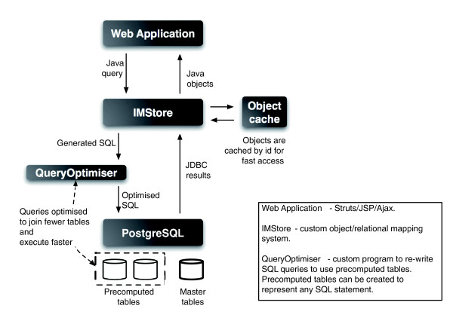

Execute query

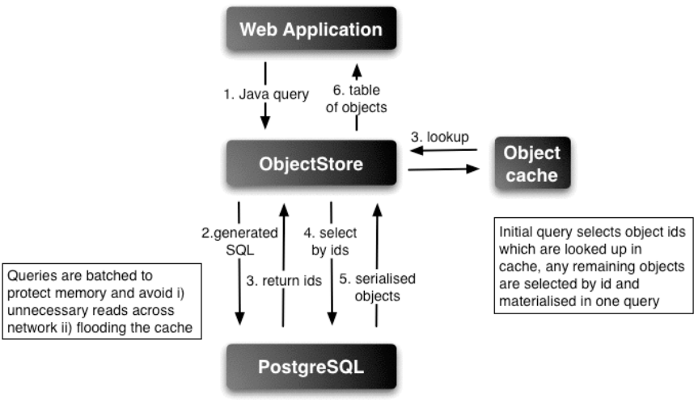

Option 2, BioMart
BioMart is a query based data management system developed by the European Bioinformatics Institute (EBI) and Cold Spring Harbor Laboratory (CSHL); Use of BioMart involves the conversion of one or more data sources into data marts; BioMart provides facilities to build advanced web based queries of data marts converted from data sources; BioMart was implemented using the Perl programming language but provides programmatic access via Perl, Java, or web services

- Approach
  - Use BioMart “out-of-the-box”
    - Use the BioMart MartBuilder to create a caBIO Data Mart
    - Create and configure caBIO Datasets
    - Customize the UI via the BioMart MartEditor
- Pros
  - Powerful query facilities
  - Performance efficient due to data warehousing approach
  - Would require little customization due to the approach
- Cons
  - Would not integrate well with the caCORE SDK
    - Perl Based
    - Operates on the data model – not object model
  - UI powerful but not user friendly
  - Would require additional maintenance of a caBIO Data Mart
    - The Data Mart would be a data warehouse containing all of the data in the existing caBIO database dimensioned for efficient data mining

Option 3, Custom using the caCORE SDK
- Approach
  - Build custom software solution re-using the caBIO query and search API which is based on caCORE SDK.
- Pros
  - Designed to work with the caCORE SDK
  - Fully customized solution
  - caCORE SDK is already using Struts 2.0 for current generated UI.
- Cons
  - Increased implementation time for certain UI.

Option 4, Custom Portlet using the caGrid Portal
- Approach
  - Build portlets in the caGrid portal
- Pros
  - Integrated caGrid environment
  - Possible future interaction with other caGrid portlets
  - Fully customized solution
- Cons
  - Additional point of failure
  - Less control over redeployments

DOCUMENT CONTROL
Change History
Content changes to this document from the previous to the current level are indicated by revision bars (|) unless a complete rewrite is indicated.

Table 2 – Implementation Specification Document Change Log
Version/Date | Approved By | Change Description and Explanation | D - Draft  A - For Review/ Approval  R - Re-Approval, Plan of Record Change
06/10/2008 | Jim Sun | Initial revision | D
07/28/2008 | Konrad Rokicki | Revised for Portlet implementation | D
08/08/2008 | Konrad Rokicki | Updated with implementation screenshots | A
Note: If this document has been inspected, please indicate the inspection date that each version is based on in the “Change Description and Explanation” area. Entries in this log must be maintained for at least 3 years.

DOCUMENT APPROVAL
Approvers List
The individuals listed in this section constitute the approvers list for the Integration Test Plan document. Formal approval must be received from all approvers prior to the initiation of the next steps in the process.

Title | Name
Project Manager | Name
Development Manager | Name

Reviewers List
The individuals listed in this section constitute the reviewers list for the Master Test Plan document. Formal approval is not required from the reviewers, however, it is desirable to have all reviewers review and comment on the document. Reviewers may choose to concentrate on reviewing only those sections that are in their area of responsibility, rather than the entire document.

Title | Name
Solutions Manager | Name
Project Manager | Name
Test Manager | Name
Test Engineer | Name
Development Manager | Name
Technical Writer | Name
Client Support Analyst | Name
Internationalization Lead | Name
DBA | Name
Developer | Name
Developer | Name

END OF DOCUMENT

ArrayReporter, Cytoband, Gene, Marker, NucleicAcidSequence, SNP, Transcript

