Implementation Specification
for
Improvements to Array Annotations in caBIO

Release 4.3

Last Updated: April 9, 2009

Owner: caBIO Team
Email: klemmj@mail.nih.gov

National Cancer Institute Center for BioInformatics
2115 Jefferson Ave. East
Rockville, MD 20852



1 Document Purpose 3
2 Implementation Overview 4
2.1 Team Members 4
2.2 Description 4
2.3 Scope 4
2.4 User Stories 4
2.5 Architecture 4
2.6 Model 5
2.7 Data 5
2.8 Assumptions 5
2.9 Dependencies 5
2.10 Issues 5
2.11 Third Party Tools 5
3 Implementation Contents 6
3.1 Server 6
3.1.1 Algorithms 6
3.1.2 Batch Processes 6
3.1.3 APIs 6
3.1.4 Error Handling 6
3.1.5 Database Changes 6
3.2 Client 6
3.2.1 JSP/HTML 6
3.2.2 Servlet 6
3.2.3 Error Handling 6
3.3 Security Issues 6
3.4 Performance 6
3.5 Internationalization 6
3.6 Installation / Packaging 7
3.7 Migration 7
3.8 Documentation Considerations 7
4 Unit Testing 8
4.1 Test Guidelines 8
4.2 Test Cases 8
5 Data Exemplars 9
DOCUMENT CONTROL 10
DOCUMENT APPROVAL 11

Document Purpose
This document describes improvements to the array annotations in caBIO in anticipation of caIntegrator 2 use after the 4.3 release.

Implementation Overview

Team Members

Role | Name
Director of Engineering | Avinash Shanbhag²
Internationalization Lead | N/A
Product Manager | Juli Klemm²
Project Manager | Sharon Gaheen¹
Test Lead | Ye Wu¹
Tech Lead | Jim Sun¹
Documentation Lead
Development Team | Konrad Rokicki¹  Lalitha Viswanath¹
¹ Science Applications International Corporation (SAIC)
² National Cancer Institute Center for Bioinformatics (NCICB)
Table 1: Team Members

Description

Scope
The scope of this document includes user stories, design and implementation specification for any improvements to the array annotations in the 4.3 release.

User Stories

U-060 | GF 18808 | Array Annotation Versioning
As a caIntegrator 2 developer, I want to know what version of annotations are loaded into caBIO for each microarray, so that I can update my application when the version changes.
Acceptance Criteria:
- Microarrays have an “annotationVersion” attribute which is populated with relevant data.

Architecture
The caBIO architecture is not impacted by this data feature.

Model
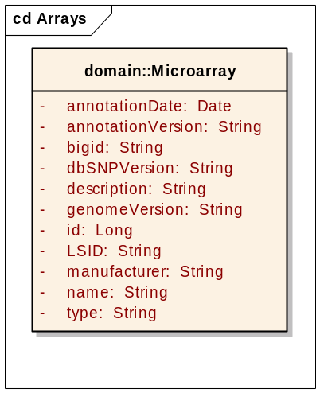
Figure 1: Addition of “annotationVersion” attribute to the Microarray class
A single String attribute will be added to the Microarray class in order to expose the version of the annotations.

Data
Affymetrix versions each of their files with a “NetAffx” version number, which is incremented each time the file is updated. Affymetrix provides annotation files with the following naming format:

Filename | Array Name | NetAffx version | Human Genome version | Suffix | File Type
HuEx-1_0-st-v2.na28.hg18.probeset.csv | HuEx-1_0-st-v2 | na28 | hg18 | probeset | csv
HG_U95A.na28.annot.csv | HG_U95A | na28 |  | Annot | csv

Based on the filenames, we will extract the NetAffx version number and place it in the Microarray.annotationVersion attribute.

Agilent and Illumina arrays do not carry version numbers, and their annotation files are rarely updated, so they are not part of this implementation. The annotationVersion will be null for non-Affy microarrays.

Assumptions
We assume that Affy will remain consistent with their file format. Since they have dozens of files following this format, it seems unlikely that it would change.

Dependencies
N/A

Issues
None at this time.

Third Party Tools
N/A

Implementation Contents

Server
N/A

Algorithms
N/A

Batch Processes
The new scripts for data ETL (extraction, transformation and load) of the array annotations will be integrated into the data refresh process.

APIs
The new data will be available through all of the caBIO APIs.

Error Handling
The standard SDK Error Handling will be used. See the SDK Exception handling documentation for more information.

Database Changes
One new column called ANNOTATION_VERSION shall be added to the MICROARRAY table.

Client
N/A

JSP/HTML
N/A

Servlet
N/A

Error Handling
The standard SDK Error Handling will be used. See the SDK Exception handling documentation for more information.

Security Issues
N/A

Performance
N/A

Internationalization
N/A

Installation / Packaging
The design assumes the standard caBIO installation and packaging.

Migration
N/A

Documentation Considerations
- This design document
- caBIO 4.3 Technical Guide
- SDK 4.1 Developer’s Guide

Unit Testing

Test Guidelines
TBD

Test Cases
TBD

Data Exemplars

DOCUMENT CONTROL
Change History
Content changes to this document from the previous to the current level are indicated by revision bars (|) unless a complete rewrite is indicated.

Table 2 – Implementation Specification Document Change Log
Version/Date | Approved By | Change Description and Explanation | D - Draft  A - For Review/ Approval  R - Re-Approval, Plan of Record Change
04/09/2009 | Konrad Rokicki | Initial revision | D
Note: If this document has been inspected, please indicate the inspection date that each version is based on in the “Change Description and Explanation” area. Entries in this log must be maintained for at least 3 years.

DOCUMENT APPROVAL
Approvers List
The individuals listed in this section constitute the approvers list for the Integration Test Plan document. Formal approval must be received from all approvers prior to the initiation of the next steps in the process.

Title | Name
Project Manager | Name
Development Manager | Name

Reviewers List
The individuals listed in this section constitute the reviewers list for the Master Test Plan document. Formal approval is not required from the reviewers, however, it is desirable to have all reviewers review and comment on the document. Reviewers may choose to concentrate on reviewing only those sections that are in their area of responsibility, rather than the entire document.

Title | Name
Solutions Manager | Name
Project Manager | Name
Test Manager | Name
Test Engineer | Name
Development Manager | Name
Technical Writer | Name
Client Support Analyst | Name
Internationalization Lead | Name
DBA | Name
Developer | Name
Developer | Name

END OF DOCUMENT

