Implementation Specification
for
FreestyleLM Suggest

Release 4.3

Last Updated: February 9, 2009

Owner: caBIO Team
Email: klemmj@mail.nih.gov

National Cancer Institute Center for BioInformatics
2115 Jefferson Ave. East
Rockville, MD 20852



1 Document Purpose 3
2 Implementation Overview 4
2.1 Team Members 4
2.2 Description 4
2.3 Scope 5
2.4 Use Cases 5
2.4.1 Display Suggestion 5
2.4.2 Select Suggestion 6
2.5 Architecture 6
2.6 Data 7
2.6.1 Loading 8
2.7 Assumptions 9
2.8 Dependencies 9
2.9 Issues 9
2.10 Third Party Tools 9
3 Implementation Contents 10
3.1 Server 10
3.1.1 Algorithms 10
3.1.2 Batch Processes 10
3.1.3 APIs 10
3.1.4 Error Handling 10
3.1.5 Database Changes 10
3.2 Client 11
3.2.1 JSP/HTML 11
3.2.2 Servlet 11
3.2.3 Error Handling 11
3.3 Security Issues 11
3.4 Performance 11
3.5 Internationalization 11
3.6 Installation / Packaging 11
3.7 Migration 11
3.8 Documentation Considerations 11
4 Unit Testing 13
4.1 Test Guidelines 13
4.2 Test Cases 13
5 Data Exemplars 14
TBD 14
DOCUMENT CONTROL 15
DOCUMENT APPROVAL 16

Document Purpose
This document describes the design and implementation for a user friendly interface extension which provides suggestions for search query terms as the user types. The functionality naturally extends the FreestyleLM Search in a way similar to Google Suggest™. This document describes inclusion of the FreestyleLM Suggest feature in both the caBIO Home Page and the caBIO Portlet.

Implementation Overview

Team Members

Role | Name
Director of Engineering | Avinash Shanbhag²
Internationalization Lead | N/A
Product Manager | Juli Klemm²
Project Manager | Sharon Gaheen¹
Test Lead | Ye Wu¹
Tech Lead | Jim Sun¹
Documentation Lead
Development Team | Konrad Rokicki¹  Lalitha Viswanath¹
¹ Science Applications International Corporation (SAIC)
² National Cancer Institute Center for Bioinformatics (NCICB)
Table 1: Team Members

Description
In a free-text search, the user may not know the best search terms to describe what they are looking for. For this, and other reasons such as spelling assistance, some search engines feature an auto-complete function which provides suggestions as the user types. Google Suggest now provides this for Google’s search (Error: Reference source not found).

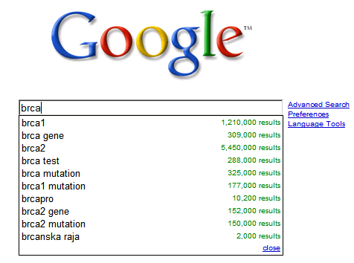
Figure 1: Screenshot of Google Suggest results for the letters “bcra”

The FreestyleLM functionality in caBIO is “Google-like” in the sense that it searches for one text string across the entire caBIO database. It differs from other types of caBIO interfaces in that prior knowledge of the model or APIs is not required. FreestyleLM is available through the caBIO Portlet (“Simple Search”) and through the caBIO Home Page. Since both implementations would benefit from an auto-completion feature for suggesting search terms, and because doing so maintains consistency across products, this design takes proliferation of the auto-completion feature into consideration.

Scope
The scope of this document includes all the system use cases, design and implementation specification for the new user interfaces.

Use Cases
The following diagram illustrates all the system-level use cases for the new user interface component.

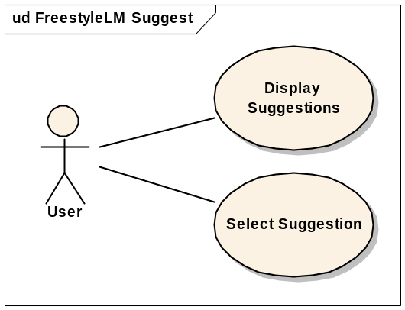
Figure 2: Use Case Diagram

Display Suggestion

Use Case Name | Display Suggestions
Use Case ID | 1.1
Primary Actor | Public
Brief Description | Displays a list of relevant suggestion as the user types.
Trigger | The user enters or deletes a character while in the search text box.
Pre-conditions | - The user navigates to the caBIO Home Page and changes focus to the FreestyleLM text box.  OR  - The user navigates to the FreestyleLM search page and changes focus to the search text box.  OR  - The user navigates to the caBIO Portlet and changes focus to the Simple Search text box.
Flow of Events | - The user enters or deletes a character in the search box.  - A number of suggestions are displayed below the search box.  - Each suggestion in the list has occurrences of the current search value highlighted.  - The list updates as the user types.
Post Conditions | Success Condition: The user makes a change and gets a new list of suggestions.  Error Conditions:  No errors are reported to the user. All systems errors are logged in the server log.
Alternative Flow | Alternate Condition:  AC2: No result is found  1. No suggestions are displayed.
Related Use Cases | NA
Issues/Notes | - The default behavior of the browser is overridden. For example, some browsers display a suggestion list consisting of a history of previous queries. This list will no longer be displayed when typing in a search box powered by FreestyleLM Suggest.

Select Suggestion

Use Case Name | Select Suggestion
Use Case ID | 1.2
Primary Actor | Public
Brief Description | Allows the user to select one of the suggestions displayed by the Display Suggestions use case.
Trigger | The user has entered a string into the search box which resulted in suggestions. A list of suggestions is displayed.
Pre-conditions | - See Display Suggestions
Flow of Events | - The user scrolls through the list by using the up/down arrow keys  - The user hits TAB to select the currently highlighted suggestion.  - The suggestion is moved to the search box.  OR  - The user clicks on a suggestion.  - The suggestion is moved to the search box.
Post Conditions | Success Condition: The user selects a suggestion and it is populated in the search box.  Error Conditions:  EC1: System Error during Request Processing
Alternative Flow | NA
Related Use Cases | Display Suggestions
Issues/Notes

Architecture
The auto-complete function will be implemented using an Ajax approach (Figure 3). On the client side, the text entry field will be monitored for user keystrokes. When a key is hit, an asynchronous query will be sent to the server side with the text currently in the entry field. An Ajax auto-completion library (i.e. jquery.suggest) will be used on the client-side to provide features such as caching (see Performance, section 3.4) and event handling.

In the case of the caBIO Portlet, a proxy will be used to redirect the Ajax request to the caBIO server. This is similar to the approach already taken for the Ajax Simple Search, so the existing RESTProxyServletController can be reused to achieve this. To make reuse possible, the RESTProxyServletController will be generalized to accept different URLs within the caBIO Server, and to propagate the content type returned by the caBIO Server. For example, in the case of the Simple Search, the content type is “text/xml”, but in the case of the Suggest query, the content type will be “text/plain”. Propagating the content-type is the simplest way to ensure its accuracy.

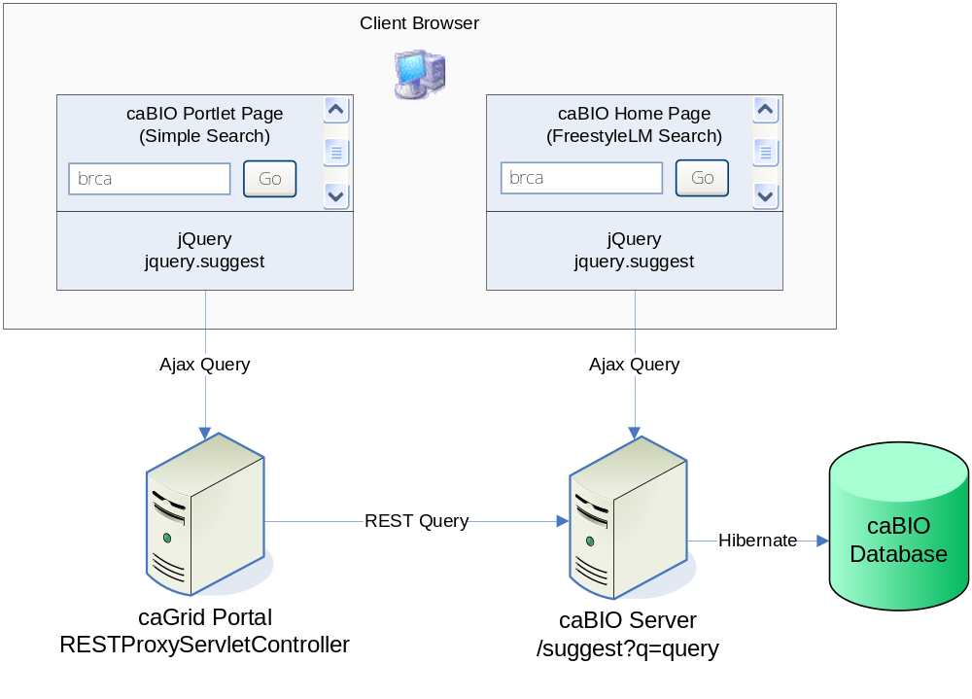
Figure 3: Client/Server Architecture for FreestyleLM Suggest

The server-side implementation will be a REST-style API located at http://cabioapi.nci.nih.gov/cabio43/suggest, which returns a plain text list of suggestions for any given query, specified with the “q” parameter (as mandated by the jquery.suggest library). This API will return the top 10 relevant matches for the search string. See Algorithms (Section 3.1.1) for more information about the Suggest REST API.

Data
A new class called Keyword (Figure 4) will be used to store the entire list of possible keywords returned for suggestion queries. This will simplify the implementation of the new REST API for suggestion queries, as well as allow for transparent access into the keyword list by users.

The Keyword class will be mapped to a KEYWORD table in the Oracle database. The population of this table is crucial to obtaining useful behavior from the suggestion feature. In particular, the scores stored in Keyword.score will be used to determine which results are suggested for any given prefix.

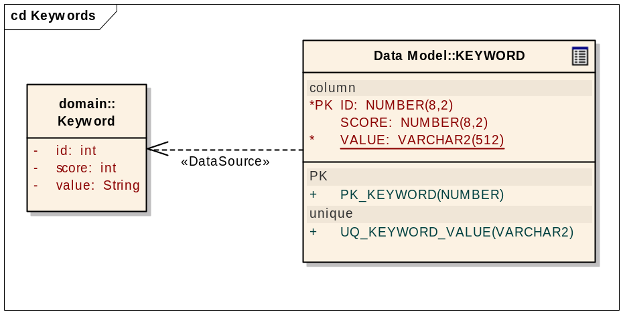
Figure 4: Class Diagram for new Keyword class

Keyword Loading

Data shall be loaded into the Keyword class from hand-picked attributes which constitute a useful set of values for auto-completion. For each attribute, the values will be lowercased and only distinct, non-null values will be considered. The score shall be determined by an algorithm which considers the number of associations to the object containing the keyword value.

Attribute | Associations Considered | # of values
DiseaseOntology.name | GeneFunctionAssociation, ClinicalTrialProtocol, Histopathology | 5810
Agent.name | GeneFunctionAssociation, ClinicalTrialProtocol, PathwayEntity | 2528
OrganOntology.name | Gene, Histopathology, Anomaly | 135
Gene.symbol | GeneFunctionAssociation, ArrayReporter, Histopathology | 22812
ProteinDomain.description | ArrayReporter | 1285
Pathway.name | Gene, Histopathology, Interaction | 1466
Protein.keywords | - | 653

Once each keyword value is scored within its attribute, the keywords are ordered and the ordinal is taken as the new score. Only then are the keywords from different attributes are combined. This effects a normalization across the attributes, so that values from each attribute are weighed evenly. This is important because the scores are not naturally meaningful outside of their attribute category. Finally the scores are inversed by subtracting them from the maximum score. This allows us to combine identical values and add their scores. Keywords which show up in multiple attributes are now scored quite a bit higher.

To visualize the normalization procedure, consider the attributes Agent.name and DiseaseOntology.name. Each keyword value is scored within each attribute, and ordered:

Agent Name | Gene Function Associations | Clinical Trial Protocols | Pathway Entities | Total | Ordinal
nsaids | 271 | 0 | 1 | 272 | 1
doxorubicin hydrochloride | 0 | 267 | 0 | 267 | 2
oestradiol | 266 | 0 | 0 | 266 | 3

Disease Name | Gene Function Associations | Clinical Trial Protocols | Pathway Entities | Total | Ordinal
melanoma | 7191 | 154 | 2 | 7347 | 1
metastasis | 6421 | 10 | 21 | 6452 | 2
large cell | 0 | 162 | 1 | 163 | 3

Now the attribute values are combined, and the scores are inversed:

Keyword | Ordinal | Score
Nsaids | 1 | 2
melanoma | 1 | 2
doxorubicin hydrochloride | 2 | 1
metastasis | 2 | 1
oestradiol | 3 | 0
large cell | 3 | 0

In this way, the keywords are ordered by popularity but each attribute gets representation. The scoring is not perfect, but small scale differences in score generally do not have a great deal of effect on the usability because any given search excludes the majority of the keywords.

Assumptions
This design assumes that the caBIO API featuring the Suggest functionality will be released before the caBIO Portlet with Suggest functionality. The Portlet will make use of the new auto-completion service in the caBIO API.

Dependencies
This implementation is dependent on the jQuery library with the jquery.suggest plugin.

Issues
The default behavior of the text boxes is overridden. Most modern browsers suggest past queries, so those will not be visible. This is unavoidable, but can be mitigated in the future by adding user preferences to turn off the FreestyleLM Suggest feature.

Third Party Tools
SQL will be used to populate the database with suggestion keywords. The jQuery library and plugins will be used on the client side to effect Ajax behavior.

Implementation Contents

Server
The caBIO server will run in the standard JBoss configuration. The caBIO Portlet will be deployed to the caGrid Portal production server.

Algorithms
The server-side implementation consists of a single servlet providing a REST API. For example:

Input | http://cabioapi.nci.nih.gov/cabio43/suggest?q=brca
Output | brca1  brca1-associated breast cancer  brca1-associated breast cancers  brca2

The Suggest API will query the database by utilizing a new class in the model called Keyword. The new class and its data loading are explained in the next section. This class will be queried for words beginning with the search string. For example, searching for “corti” may return both “cortical adenomas” and “human corticotropic adenoma (hca)” and, but not “deoxycorticosterone,” since the search term does not occur at the beginning of a word. This increases performance by constraining the search space and may also be more intuitive to the user, who naturally expects an auto-completion feature to only “complete” in a single direction, i.e. left-to-right.

Since a query for a shorter prefix may result too results to suggest (at the extreme, a single letter prefix may result thousands of results), the results must be ranked so that the most relevant may be suggested. The Keyword.score attribute will be used to sort the results, and only the top 10 will be suggested to the user.

This implementation allows for other applications to add this feature to their pages. An external application may do as the caBIO Portlet, and simply implement an Ajax proxy to the Suggest Servlet, or it may choose to implement their own backend to query the Keyword class directly.

Batch Processes
None expected.

APIs
No changes to the Java API are necessary. The new Suggest REST API will be a single servlet which does not interact with the caBIO REST API in any way.

Error Handling
Errors on the server side will be logged in the server log, and not propagated to the client. In these cases the client will simply not provide suggestions. This is so that errors in the auto-complete do not interfere with the ability to do a real search.

Database Changes
The user table named KEYWORD will be added to the set of end-user tables in the caBIO database. The load process requires 2 additional staging tables, STG_KEYWORD and STG_KEYWORD_AGG, as well as a view named STG_KEYWORD_NORM. These tables are used in the various transforms necessary for data aggregation and normalization, as per section 2.6.1.

Client
The client is a web browser viewing either the caBIO Home Page or the caBIO Portlet. Changes to the client pages are limited to the addition of a Javascript library and initialization code for the auto-completion event handling.

JSP/HTML
The HTML must be modified with the addition of a Javascript import for the jquery.suggest library, and its initialization code.

Servlet
A new servlet called the AutoCompletionService will be added to the caBIO server and exposed at the /cabio43/suggest URL pattern. The servlet’s behavior is described in the previous section 3.1.1.

Error Handling
The standard SDK Error Handling will be used. See the SDK Exception handling documentation for more information.

Security Issues
The keyword data is publicly available and does not require any security.

Performance
The performance of the server-side component is crucial since each suggestion query should return as the user types. A few guidelines will be followed to ensure good performance from the start:
- Ensure only a single database query is executed for each completion request
- Ensure the completion query runs quickly (column indexes, table sorting)
- Query for prefixes only
- Return results in a simple text format, without formatting to minimize client-side parsing time
- MRU Cache on the client side (provided by jquery.suggest)

Ideally, results should be returned and displayed as fast as the user can glance at them. In practice this means that a new result list should be displayed within less than half a second (500 ms) of the user typing a character. With the initial prototype, and ~35000 entries in the Keyword object, the average time to update the suggestion list is 100 ms. This level of performance should be maintained as the data and implementation evolve.

Internationalization
N/A

Installation / Packaging
The design assumes the standard caBIO installation and packaging.

Migration
N/A

Documentation Considerations
- This design document
- caBIO 4.2 Technical Guide
- SDK 4.1 Developer’s Guide
- jQuery documentation
- Liferay Portal documentation
  - http://www.liferay.com/web/guest/documentation/4_4/development
- caGrid Portal documentation
  - http://www.cagrid.org/wiki/Portal:2.0:Installation_Guide

Unit Testing

Test Guidelines
Unit tests can only be conducted on the server-side components of the implementation.

Test Cases
There will be a unit test for every attribute represented in the Keyword object. For each attribute, a value will be pulled out of the database at random and then its existence in Keyword verified.

Another test will make a simple request for auto-completing ‘a’ to the REST API and ensure 10 results are returned.

Data Exemplars
Top twenty terms in the Keyword object.

ID | SCORE | VALUE
1 | 1573 | tumor antigen
2 | 1529 | ion transport
3 | 1500 | leucine-rich repeat
4 | 1488 | homeobox
5 | 1371 | calmodulin-binding
6 | 1361 | flavoprotein
7 | 1343 | protease inhibitor
8 | 1322 | heparan sulfate
9 | 1318 | antioxidant
10 | 1316 | hydrogen peroxide
11 | 1310 | bromodomain
12 | 1301 | oncogene
13 | 1297 | nerve growth factor
14 | 1293 | vitamin d
15 | 1282 | selenium
16 | 1277 | lithium
17 | 1270 | heat shock protein 70
18 | 1267 | kringle
19 | 1247 | metachromatic leukodystrophy

DOCUMENT CONTROL
Change History
Content changes to this document from the previous to the current level are indicated by revision bars (|) unless a complete rewrite is indicated.

Table 2 – Implementation Specification Document Change Log
Version/Date | Approved By | Change Description and Explanation | D - Draft  A - For Review/ Approval  R - Re-Approval, Plan of Record Change
02/05/2009 | Konrad Rokicki | Initial revision | D
Note: If this document has been inspected, please indicate the inspection date that each version is based on in the “Change Description and Explanation” area. Entries in this log must be maintained for at least 3 years.

DOCUMENT APPROVAL
Approvers List
The individuals listed in this section constitute the approvers list for the Integration Test Plan document. Formal approval must be received from all approvers prior to the initiation of the next steps in the process.

Title | Name
Project Manager | Name
Development Manager | Name

Reviewers List
The individuals listed in this section constitute the reviewers list for the Master Test Plan document. Formal approval is not required from the reviewers, however, it is desirable to have all reviewers review and comment on the document. Reviewers may choose to concentrate on reviewing only those sections that are in their area of responsibility, rather than the entire document.

Title | Name
Solutions Manager | Name
Project Manager | Name
Test Manager | Name
Test Engineer | Name
Development Manager | Name
Technical Writer | Name
Client Support Analyst | Name
Internationalization Lead | Name
DBA | Name
Developer | Name
Developer | Name

END OF DOCUMENT

http://www.google.com/support/websearch/bin/answer.py?hl=en&answer=106230
http://cabioapi.nci.nih.gov/cabio42
http://cabioapi.nci.nih.gov/cabio42/indexSearch.jsp
http://cagrid-portal.nci.nih.gov/web/guest/community
http://plugins.jquery.com/project/suggest
We use the word “keyword” to denote any word or phrase suggested to a user in an auto-complete operation.
Associations to Target are not counted because all Agents associated with targets have null names.
http://jquery.com/
http://plugins.jquery.com/project/suggest

