[](http://www.brandsoftheworld.com/download/brand/10943.html)

Center for Biomedical Informatics and Information Technology

caBIG® Clinical Information Suite

QA Test Summary Report

Sprint: RC4-I2-S1

April 8, 2011

**Table of Contents**

Summary 3

i. QA Sprint Cycle 3

ii. Code Validation 3

iii. Specification Validation 3

iv. Defect Validation 3

v. Sprint Deliverables 4

Test Case Creation 5

Referral Management Business Capability 5

1. Referral Consult Service 6

2. Organization Registry Service 7

3. Provider Registry Service 8

4. Patient Registry Service 9

5. Medication List Service 10

6. Family History Service 11

7. Common Artifact Test Cases 12

Test Case Execution 14

Consolidated Test Execution Summary (Code Validation) 14

Consolidated Test Execution Summary (Specification Validation) 15

Defect Summary 16

Current (QA LOGGED) Issue Status 16

QA Issues Created this Sprint: 17

QA Issues Validated and Resolved this Sprint: 17

# Summary

## QA Sprint Cycle

* 1. Start: Mar 7, 2011
  2. Finish: Mar 18, 2011

## Code Validation

* + ESD delivered
    1. RC4-I1-S3 ESD tag on Mar 8, 2011
  + The artifacts from the Architecture drop of RC2-I3 was used in this tag
  + The following were delivered in the tags:
    1. 6 operations (createReferralOrder, withdrawReferralOrder , queryReferralOrderStatus, queryReferralResult , queryReferralOrder and reviseReferralOrder) from Referral Consult Service
    2. 1 operation (addOrganization) from Organization Registry service
    3. 1 operation (findProviderByExample) from Provider Registry service
    4. 1 operation (findPatientByExample) from Patient Registry service
    5. 1 mock service (retrieveMedication) from Medication List service
    6. 1 mock service (retrieveFamilyHistory) from Family History service
  + Regression testing was performed as follows:
    1. CI Automated Provision, Build, Deploy for all services.
    2. All Level 1 (smoke) tests executed for all services
    3. Level 2 and Level 3 tests (regression) executed for Referral Service
    4. Level 2 and Level 3 tests (automation implementation) progressed for Organization Registry Service
    5. All test cases affected by fixed defects and release notes were executed

## Specification Validation

* The specification/artifact documents for the following services were validated from the RC3-I3.1 Architecture drop
  + Referral Consult
  + Patient Registry
  + Provider Registry
  + Organization Registry
  + Lab Results
  + Security Authentication
  + Security Authorization
  + Security Federation

## Defect Validation

* 59 Defects were raised during this sprint
* 37 defects resolved/closed during this sprint

## Sprint Deliverables

**Test Summary Report**  
<http://caehrorg.jira.com/svn/CACIS/trunk/documents/QA/Test_Reports/caBIGClinicalInformationSuite_RC4I2S1_Test_Summary_Report.docx>

**Test Cases**<http://caehrorg.jira.com/svn/CACIS/trunk/documents/QA/Test_Cases/caBIGClinicalInformationSuite_TestCases_RC4I2S1.xls>

**Test Execution Report**[http://caehrorg.jira.com/svn/CACIS/trunk/documents/QA/Test_Cases/caBIGClinicalInformationSuite TestExecutionReport RC4I2S1.mht](http://caehrorg.jira.com/svn/CACIS/trunk/documents/QA/Test_Cases/caBIGClinicalInformationSuite%20TestExecutionReport%20RC4I2S1.mht)

**Soap Test Scripts**<http://caehrorg.jira.com/svn/CACIS/trunk/documents/QA/soapUI_test_scripts/caBIGClinicalInformationSuite_RC4I2S1_TestScripts.zip>

# Test Case Creation

## Referral Management Business Capability

Total test case distribution for this business capability

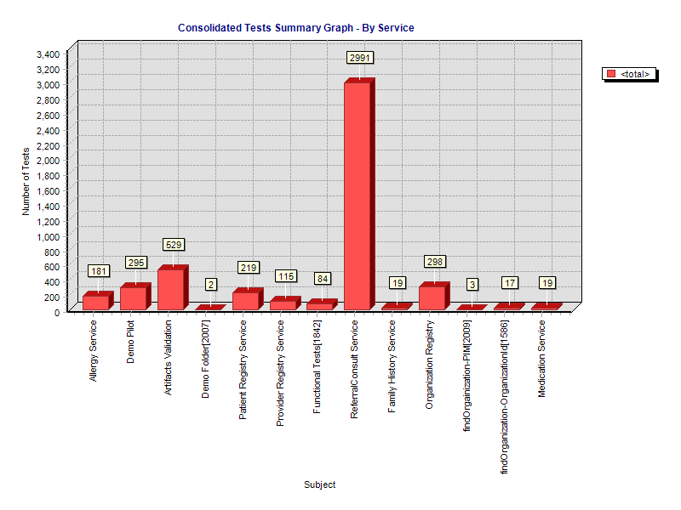

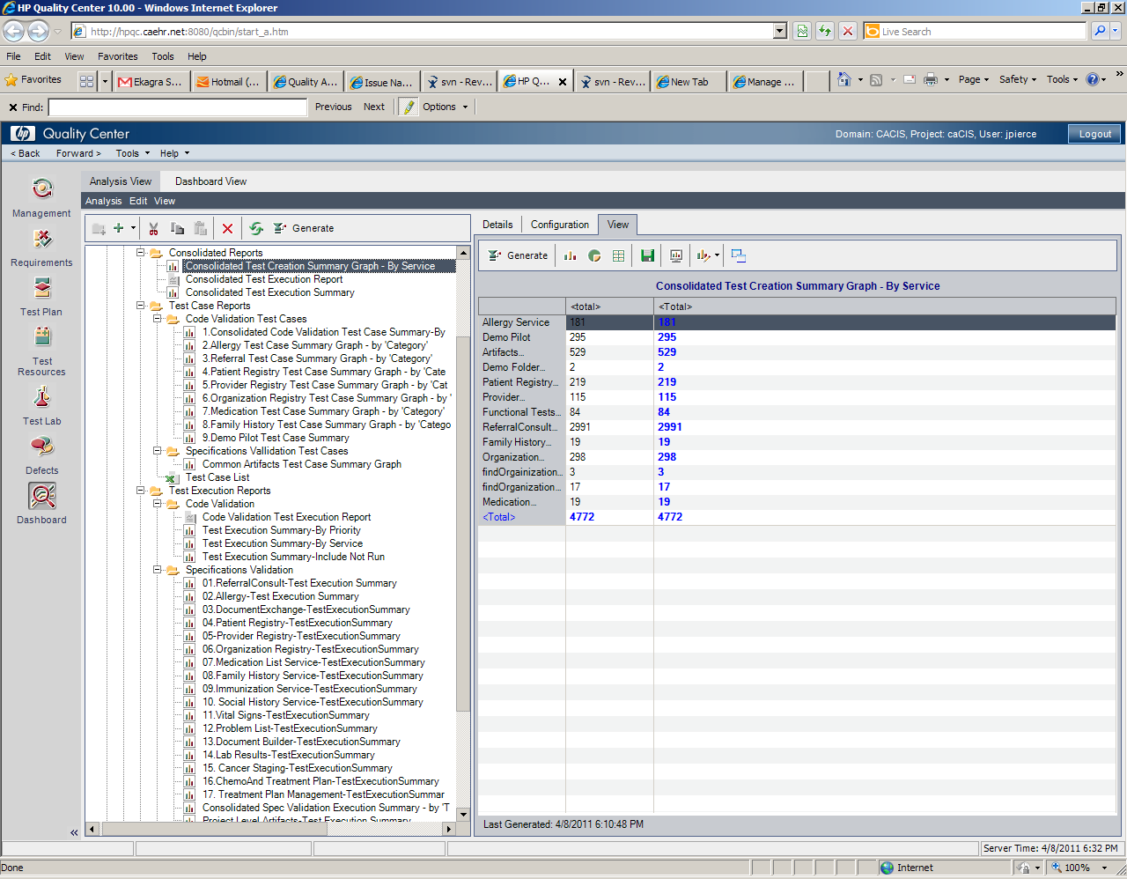

### Referral Consult Service

The test case distribution by category for this sprint is as follows:

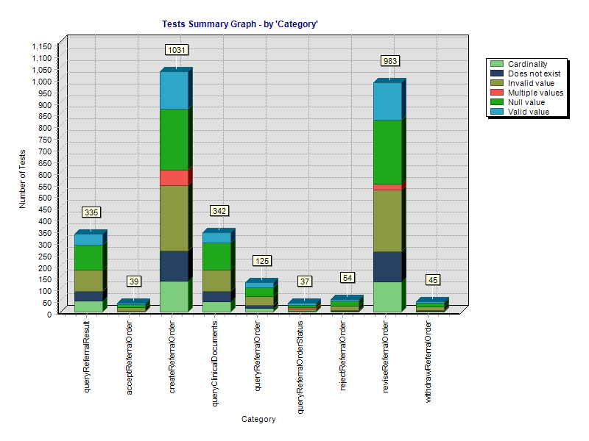

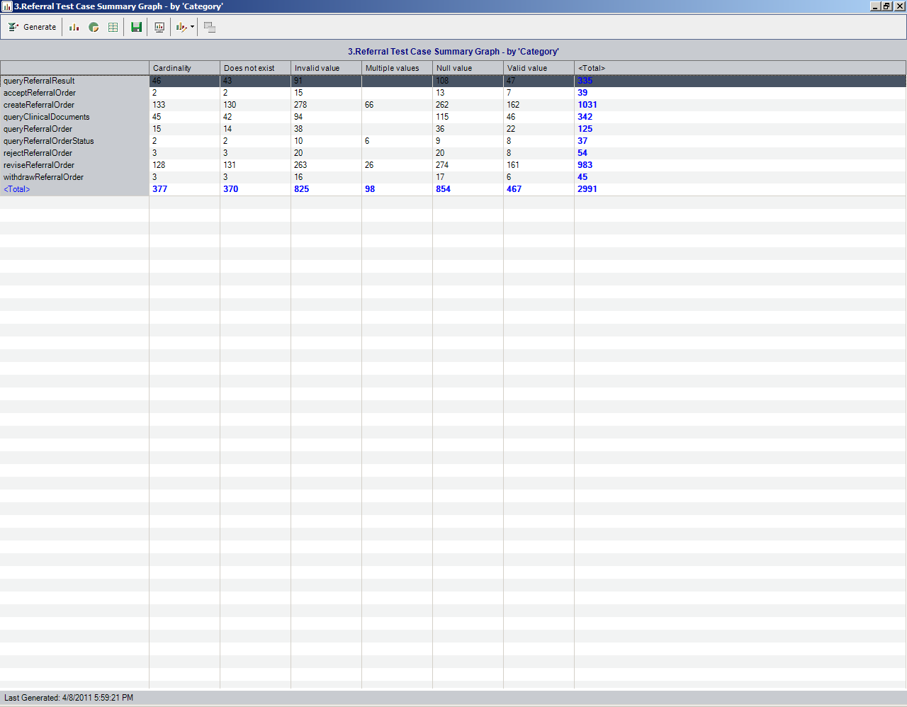

### Organization Registry Service

The test case distribution by category for this sprint is as follows:

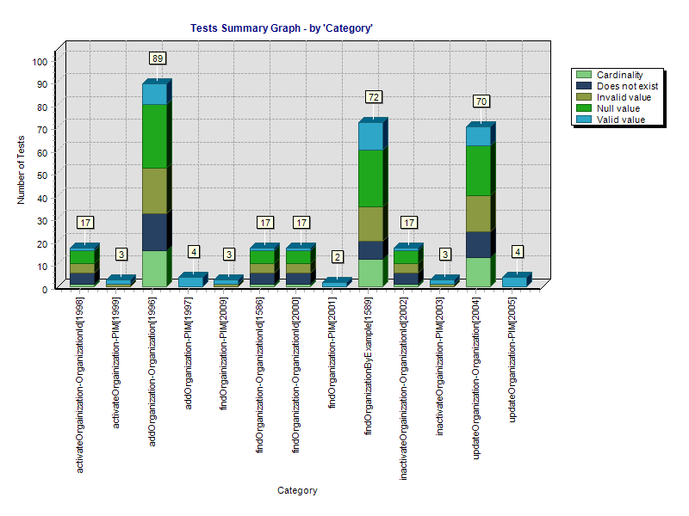

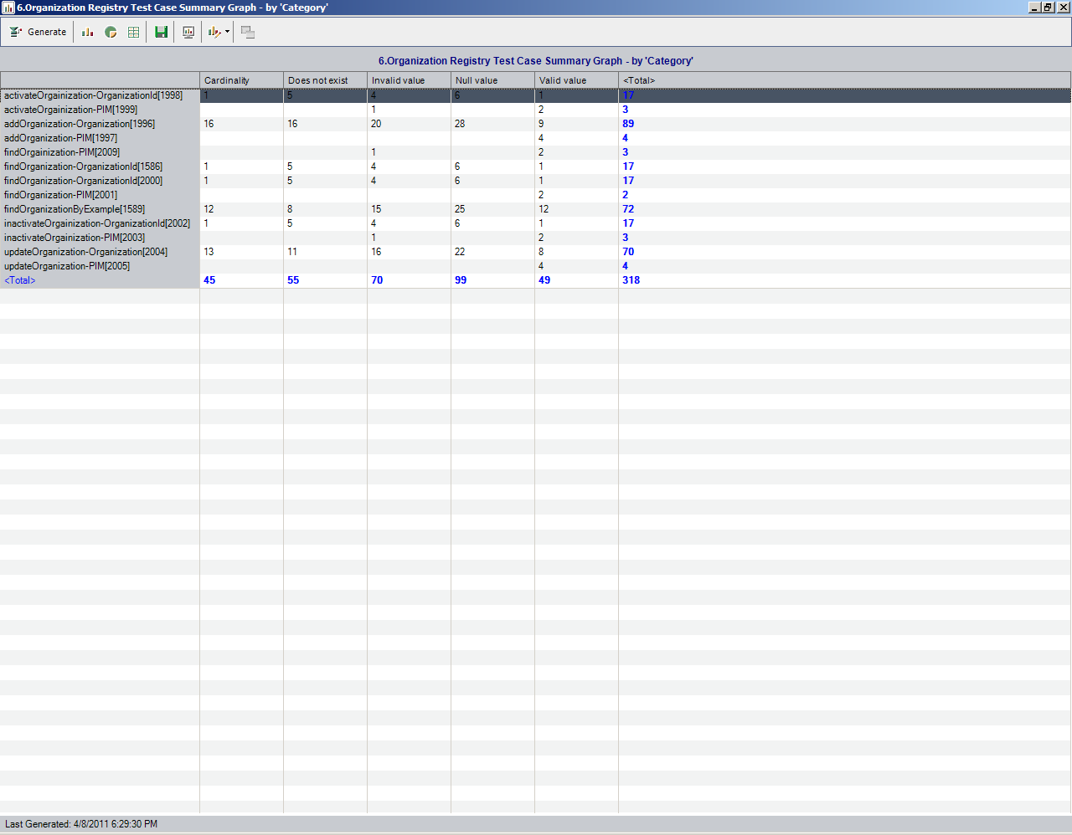

### Provider Registry Service

The test case distribution by category for this sprint is as follows:

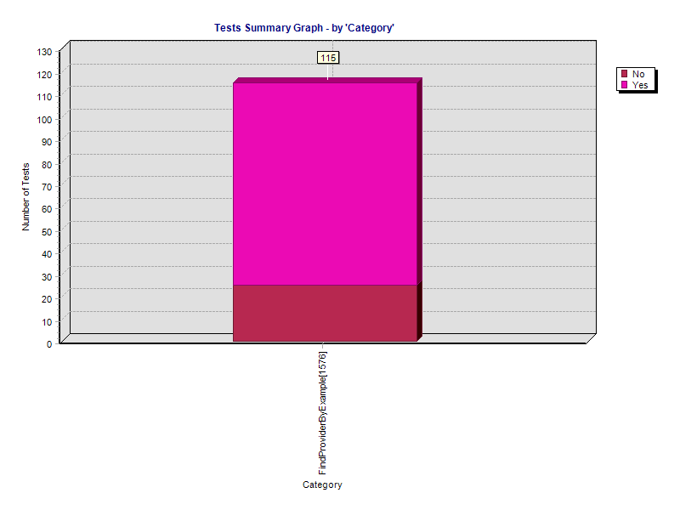

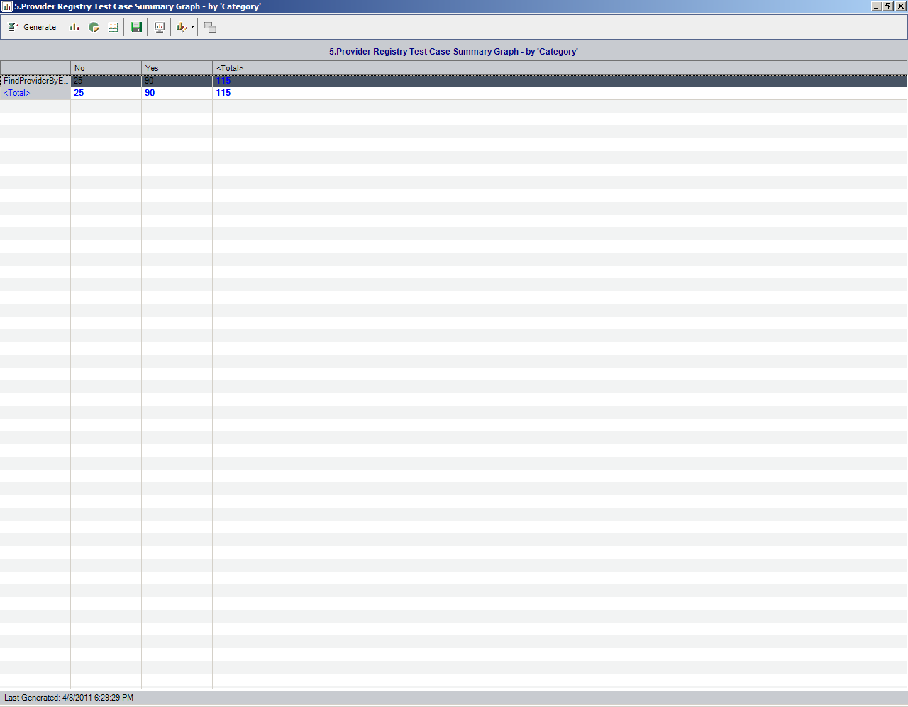

### Patient Registry Service

The test case distribution by category for this sprint is as follows:

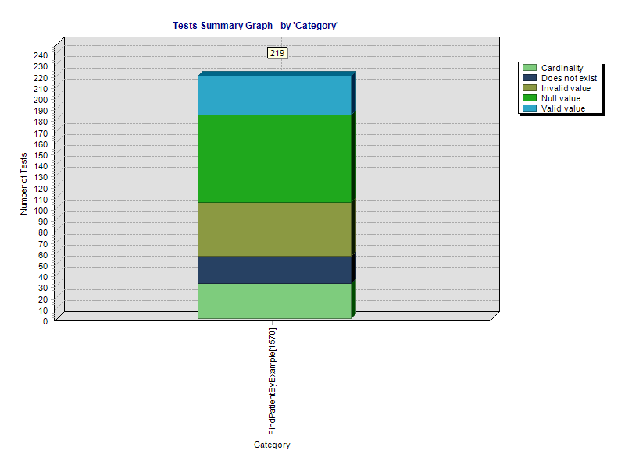

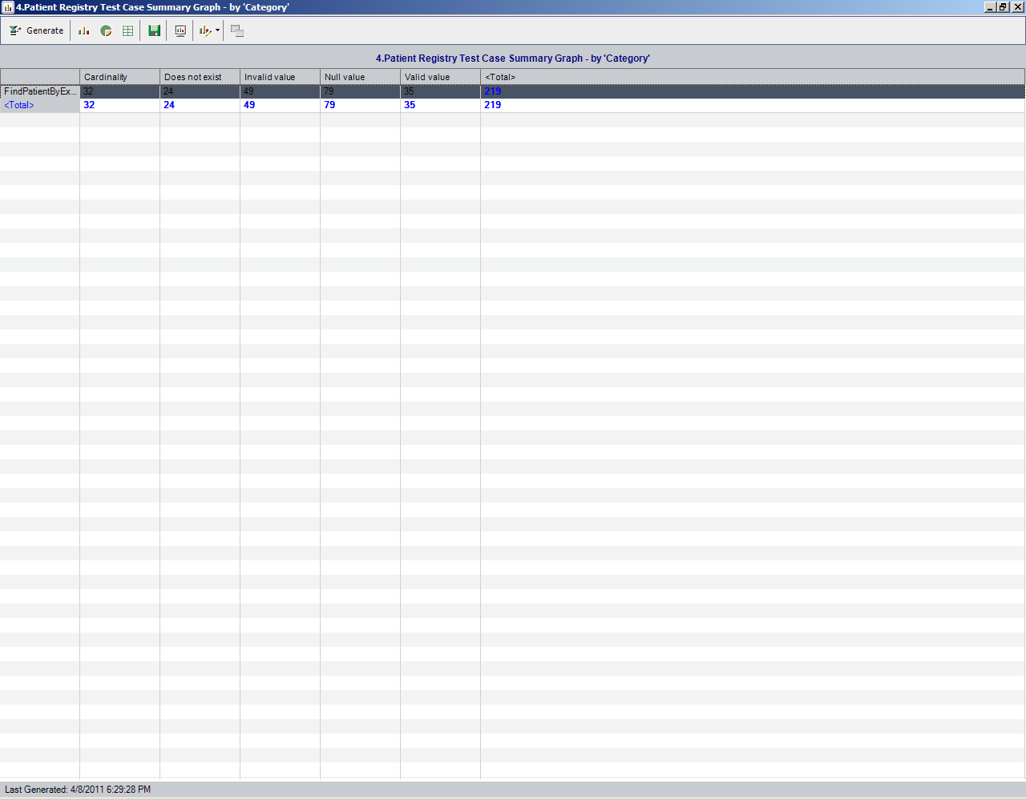

### Medication List Service

The test case distribution by category for this sprint is as follows:

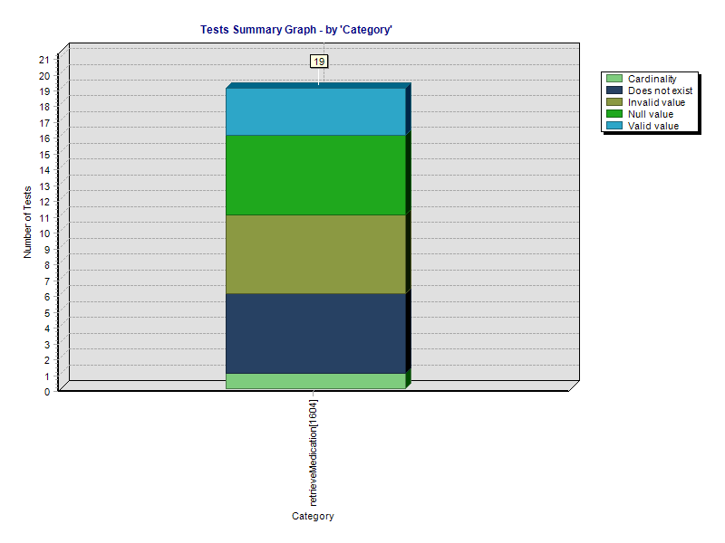

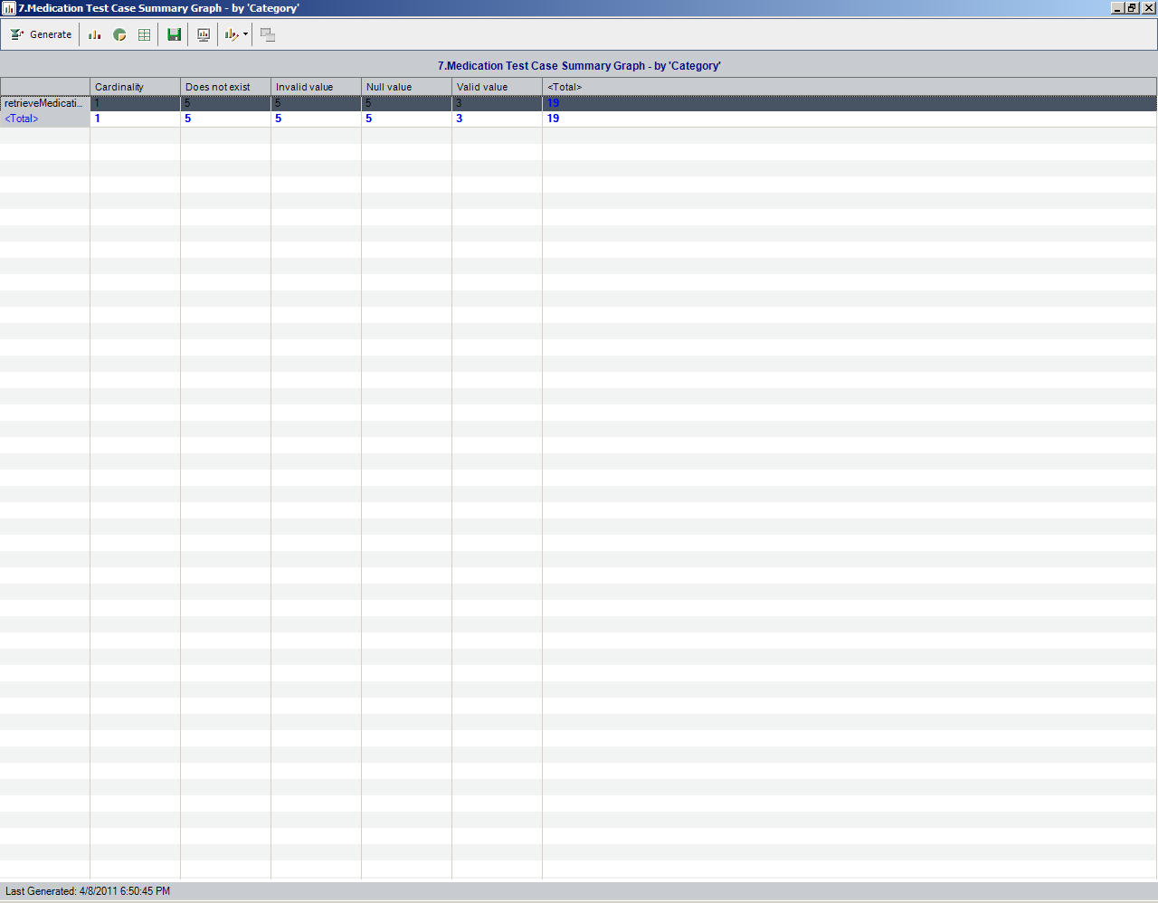

### Family History Service

The test case distribution by category for this sprint is as follows:

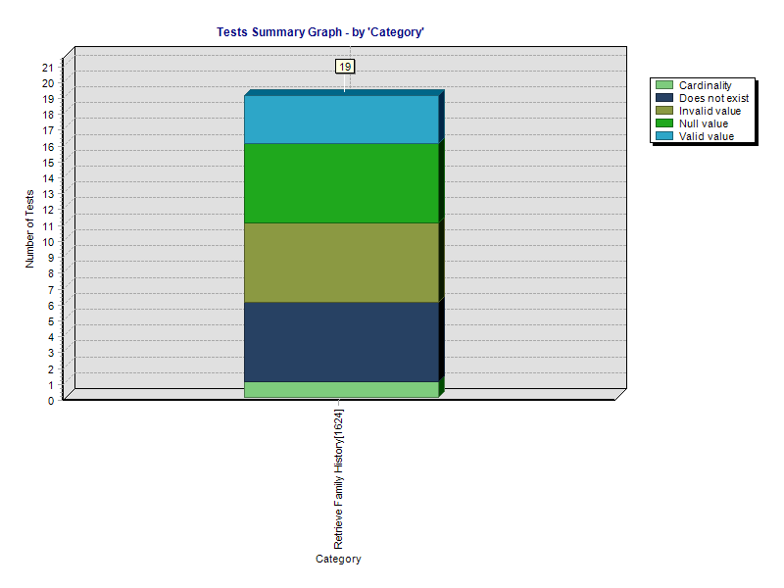

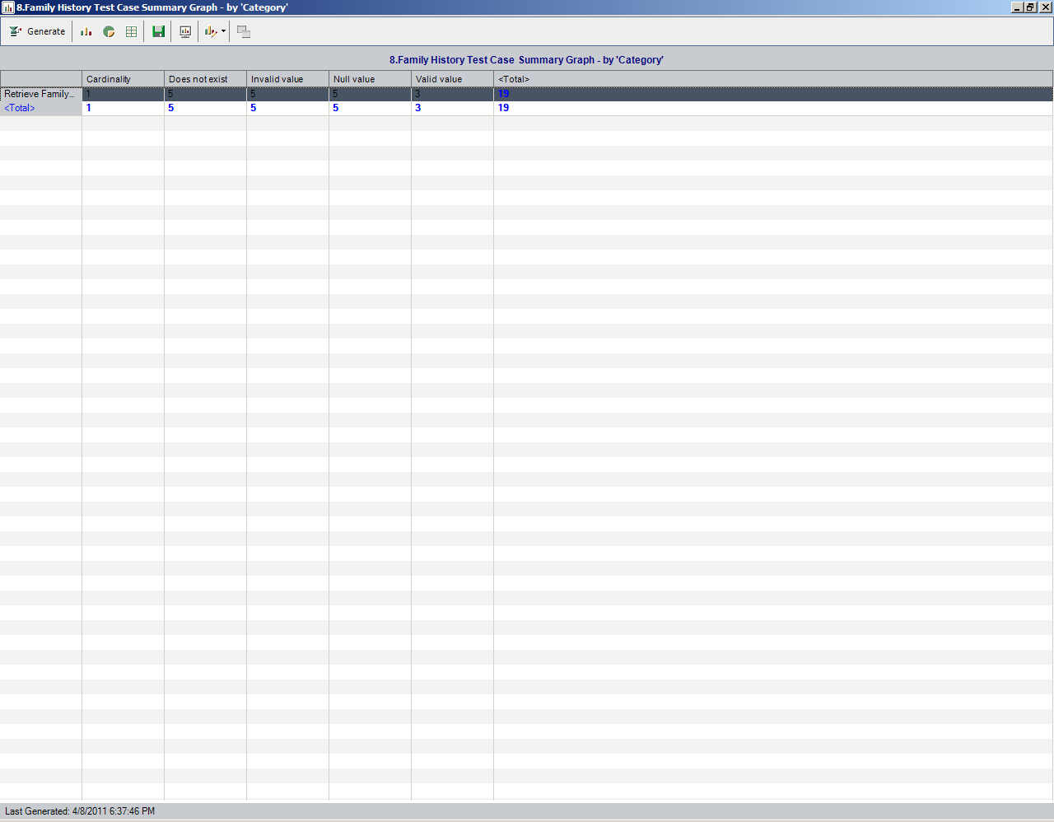

### Common Artifact Test Cases

The test case distribution by artifacts for this sprint is as follows

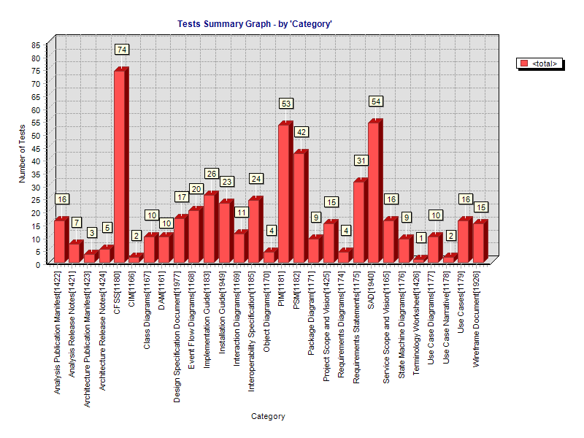

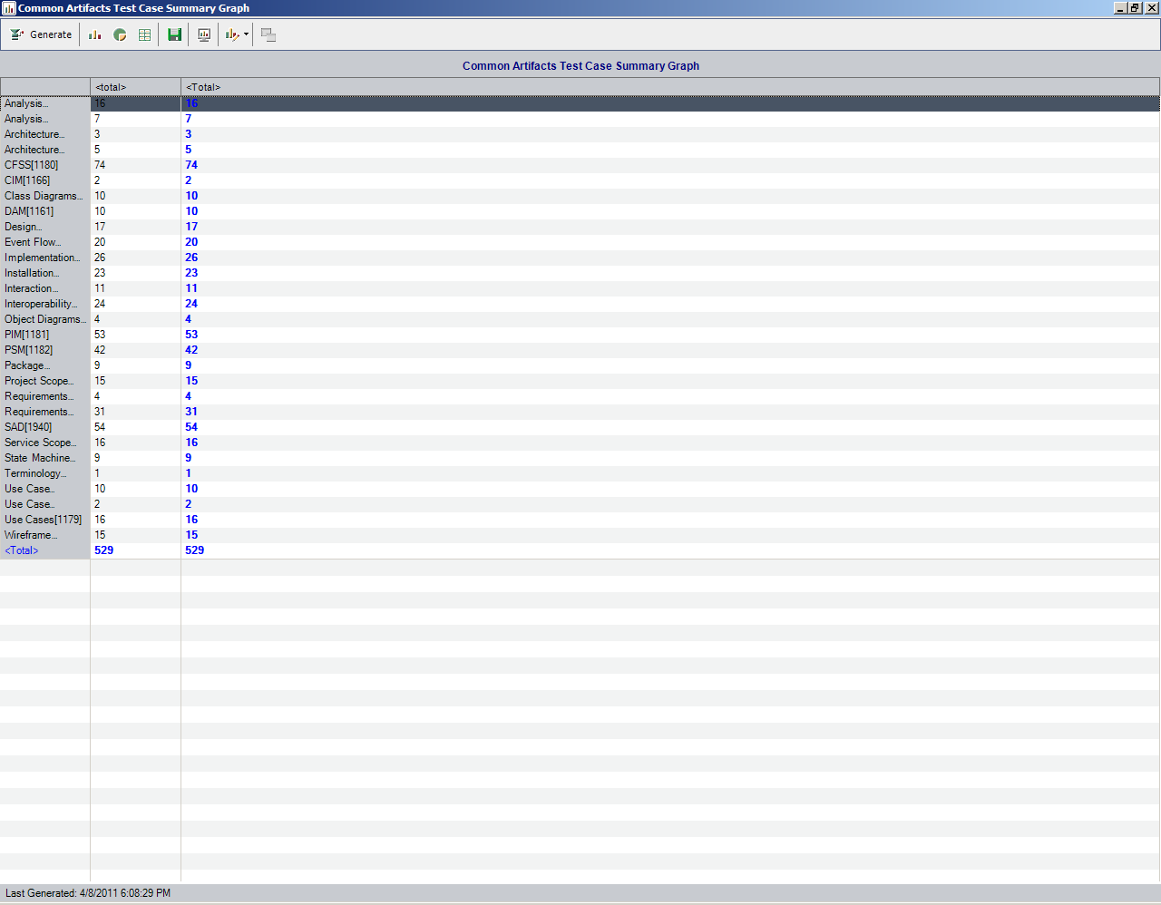

# Test Case Execution

## Consolidated Test Execution Summary (Code Validation)

The overall test execution summary (Referral Regression only) for this sprint:

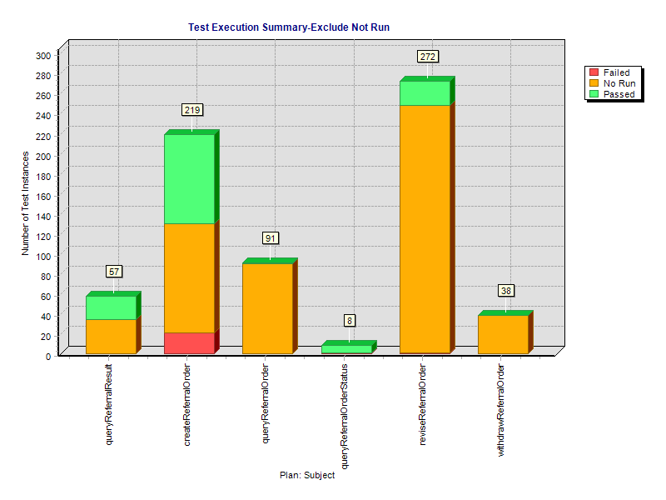

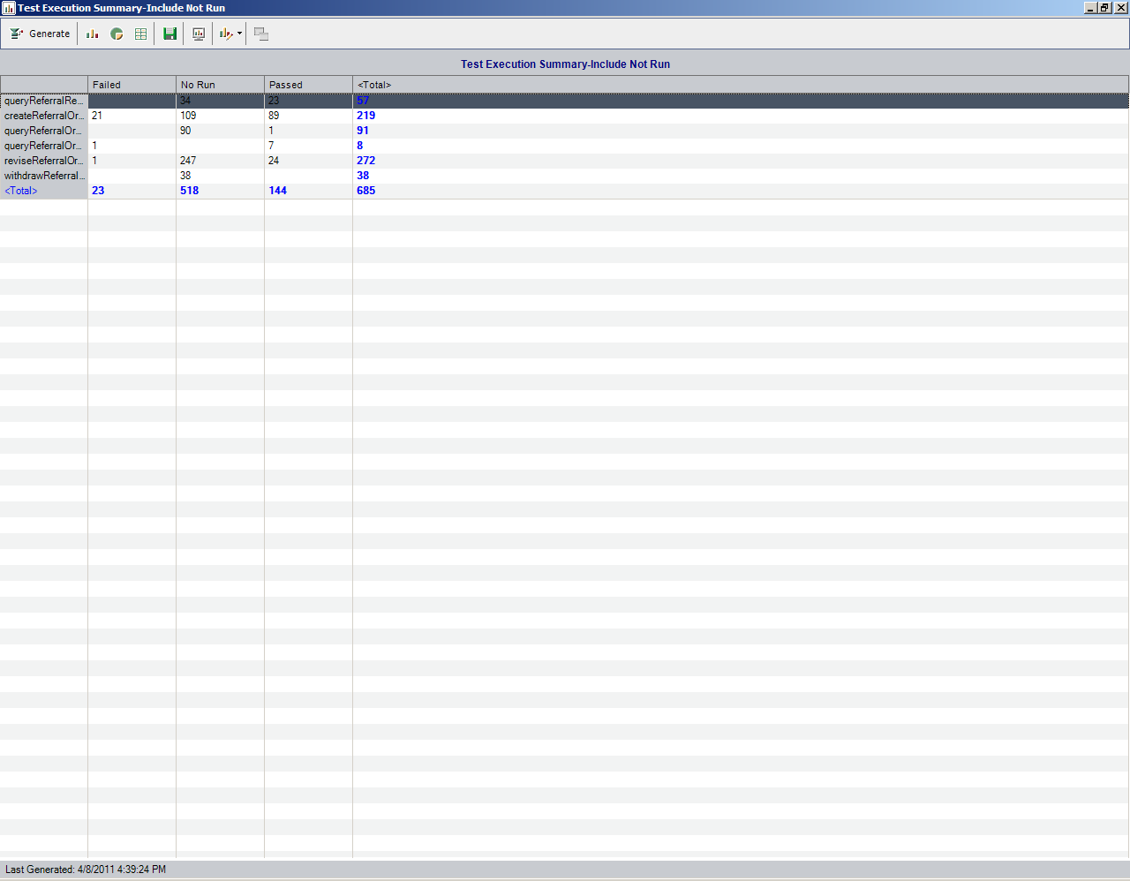

## Consolidated Test Execution Summary (Specification Validation)

The overall test execution summary for this sprint:

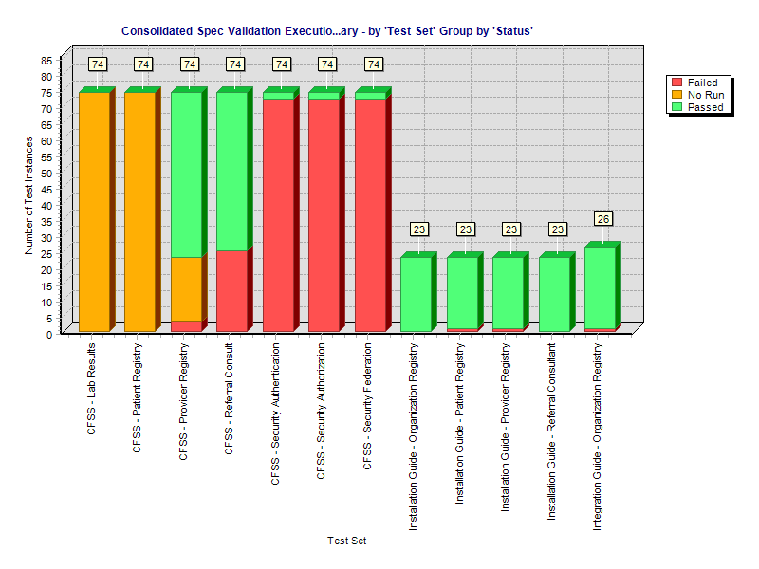

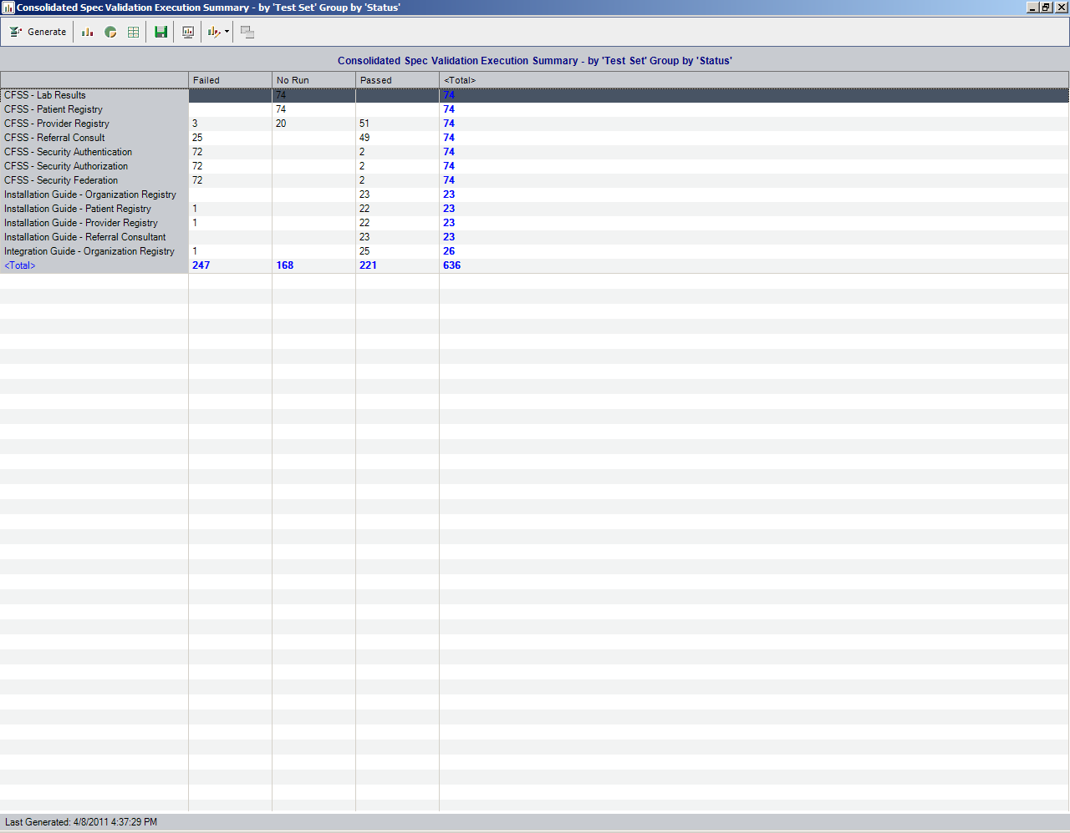

# Defect Summary

## Current (QA LOGGED) Issue Status

|  |  |  |  |  |  |  |
| --- | --- | --- | --- | --- | --- | --- |
| **Row Labels** | **Open** | **In Progress** | **Reopened** | **Resolved** | **Closed** | **Grand Total** |
| **Analysis** | **111** | **11** | **8** | **2** | **40** | **172** |
| Bug | 89 | 9 | 7 | 2 | 37 | 144 |
| Question | 22 | 2 | 1 |  | 3 | 28 |
| **Architecture** | **4** |  |  | **13** | **46** | **63** |
| Bug | 3 |  |  | 4 | 9 | 16 |
| Question | 1 |  |  | 9 | 35 | 45 |
| Task |  |  |  |  | 2 | 2 |
| **Continuous Delivery Operations** | **9** | **1** | **1** | **49** | **26** | **86** |
| Action |  |  |  | 3 |  | 3 |
| Bug | 2 |  | 1 | 24 | 12 | 39 |
| Improvement | 1 |  |  |  |  | 1 |
| New Feature | 1 |  |  |  |  | 1 |
| Question | 2 | 1 |  |  | 3 | 6 |
| Sub-task |  |  |  | 4 | 3 | 7 |
| Task | 3 |  |  | 17 | 8 | 28 |
| Task - Analysis |  |  |  | 1 |  | 1 |
| **Enterprise Services Development** | **32** |  |  | **7** | **142** | **181** |
| Bug | 31 |  |  | 7 | 135 | 173 |
| Documentation |  |  |  |  | 1 | 1 |
| Improvement | 1 |  |  |  | 1 | 2 |
| Question |  |  |  |  | 4 | 4 |
| Task |  |  |  |  | 1 | 1 |
| **Project Management Office** |  |  |  | **2** |  | **2** |
| Risk |  |  |  | 2 |  | 2 |
| **Grand Total** | **156** | **12** | **9** | **73** | **254** | **504** |

## QA Issues Created this Sprint:



## QA Issues Validated and Resolved this Sprint:

