[](http://www.brandsoftheworld.com/download/brand/10943.html)

Center for Biomedical Informatics and Information Technology

caBIG® Clinical Information Suite

QA Test Summary Report

Sprint: RC4-I2-S2

April 8, 2011

**Table of Contents**

Summary 3

i. QA Sprint Cycle 3

ii. Code Validation 3

iii. Specification Validation 3

iv. Defect Validation 3

v. Sprint Deliverables 4

Test Case Creation 5

Referral Management Business Capability 5

1. Referral Consult Service 6

Test Case Execution 7

Consolidated Test Execution Summary 7

Defect Summary 8

Current (QA Logged) Defect Status 8

QA Issues Created this Sprint: 8

QA Issues Validated and Resolved this Sprint: 9

# Summary

## QA Sprint Cycle

* 1. Start: Mar 21, 2011
  2. Finish: Apr 1, 2011

## Code Validation

* + ESD delivered
    1. ESD RC4-I2-S1 tag on March 23, 2011
    2. The following were delivered in the tag:
       1. Implement WSDL Changes for RC3-I3 –
          1. Provider Registry Query Service
          2. Implement Provider Registry Service (Management )
          3. Organization Registry Service ( Management & Query )
  + The artifacts from the Architecture drop of RC3-I3 was used in this tag
  + Implement Test Harness and Smoke Test for –
    1. Immunization Service
    2. Vital Signs
    3. Social History
    4. Allergy Service
  + Level 1, Level 2, Level 3 Test cases executed accordingly for –
    1. Referral Consult Service
       1. CreateReferralOrder
       2. QueryReferralOrder
       3. ReviseReferralOrder
       4. WithdrawReferralOrder

## Specification Validation

* RC4-I1 ARCH drop will be tested in the future QA sprints.

## Defect Validation

* 12 Defects were raised during this sprint
* 80 defects resolved/closed during this sprint

## Sprint Deliverables

**Test Summary Report**  
<http://caehrorg.jira.com/svn/CACIS/trunk/documents/QA/Test_Reports/caBIGClinicalInformationSuite_RC4I2S2_Test_Summary_Report.docx>

**Test Cases**<http://caehrorg.jira.com/svn/CACIS/trunk/documents/QA/Test_Cases/caBIGClinicalInformationSuite_TestCases_RC4I2S2.xls>

**Test Execution Report**[http://caehrorg.jira.com/svn/CACIS/trunk/documents/QA/Test_Cases/caBIGClinicalInformationSuite TestExecutionReport RC4I2S2.mht](http://caehrorg.jira.com/svn/CACIS/trunk/documents/QA/Test_Cases/caBIGClinicalInformationSuite%20TestExecutionReport%20RC4I2S2.mht)

**Soap Test Scripts**<http://caehrorg.jira.com/svn/CACIS/trunk/documents/QA/soapUI_test_scripts/caBIGClinicalInformationSuite_RC4I2S2_TestScripts.zip>

# Test Case Creation

## Referral Management Business Capability

Total test case distribution for this business capability

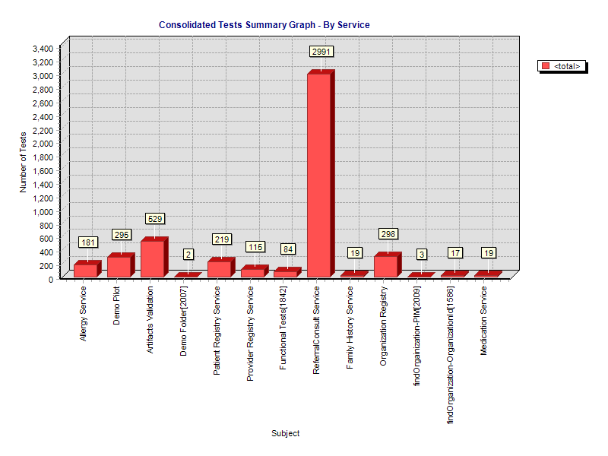

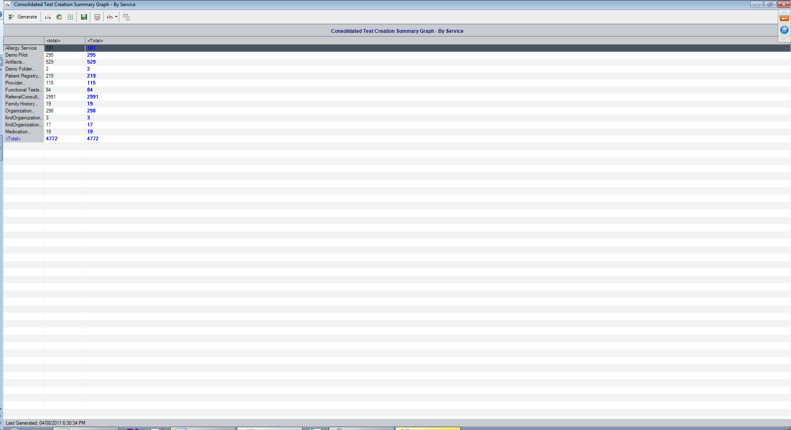

### Referral Consult Service

The test case distribution by category for this sprint is as follows:

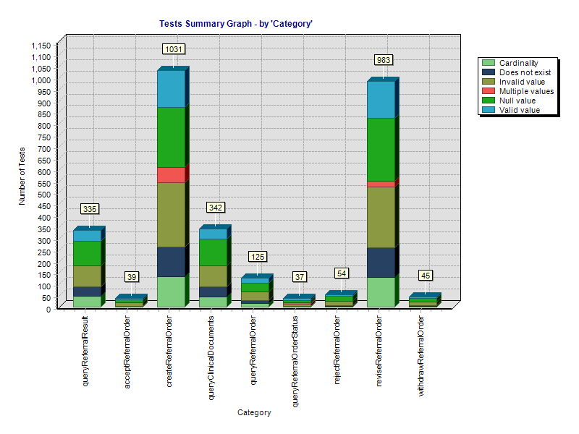

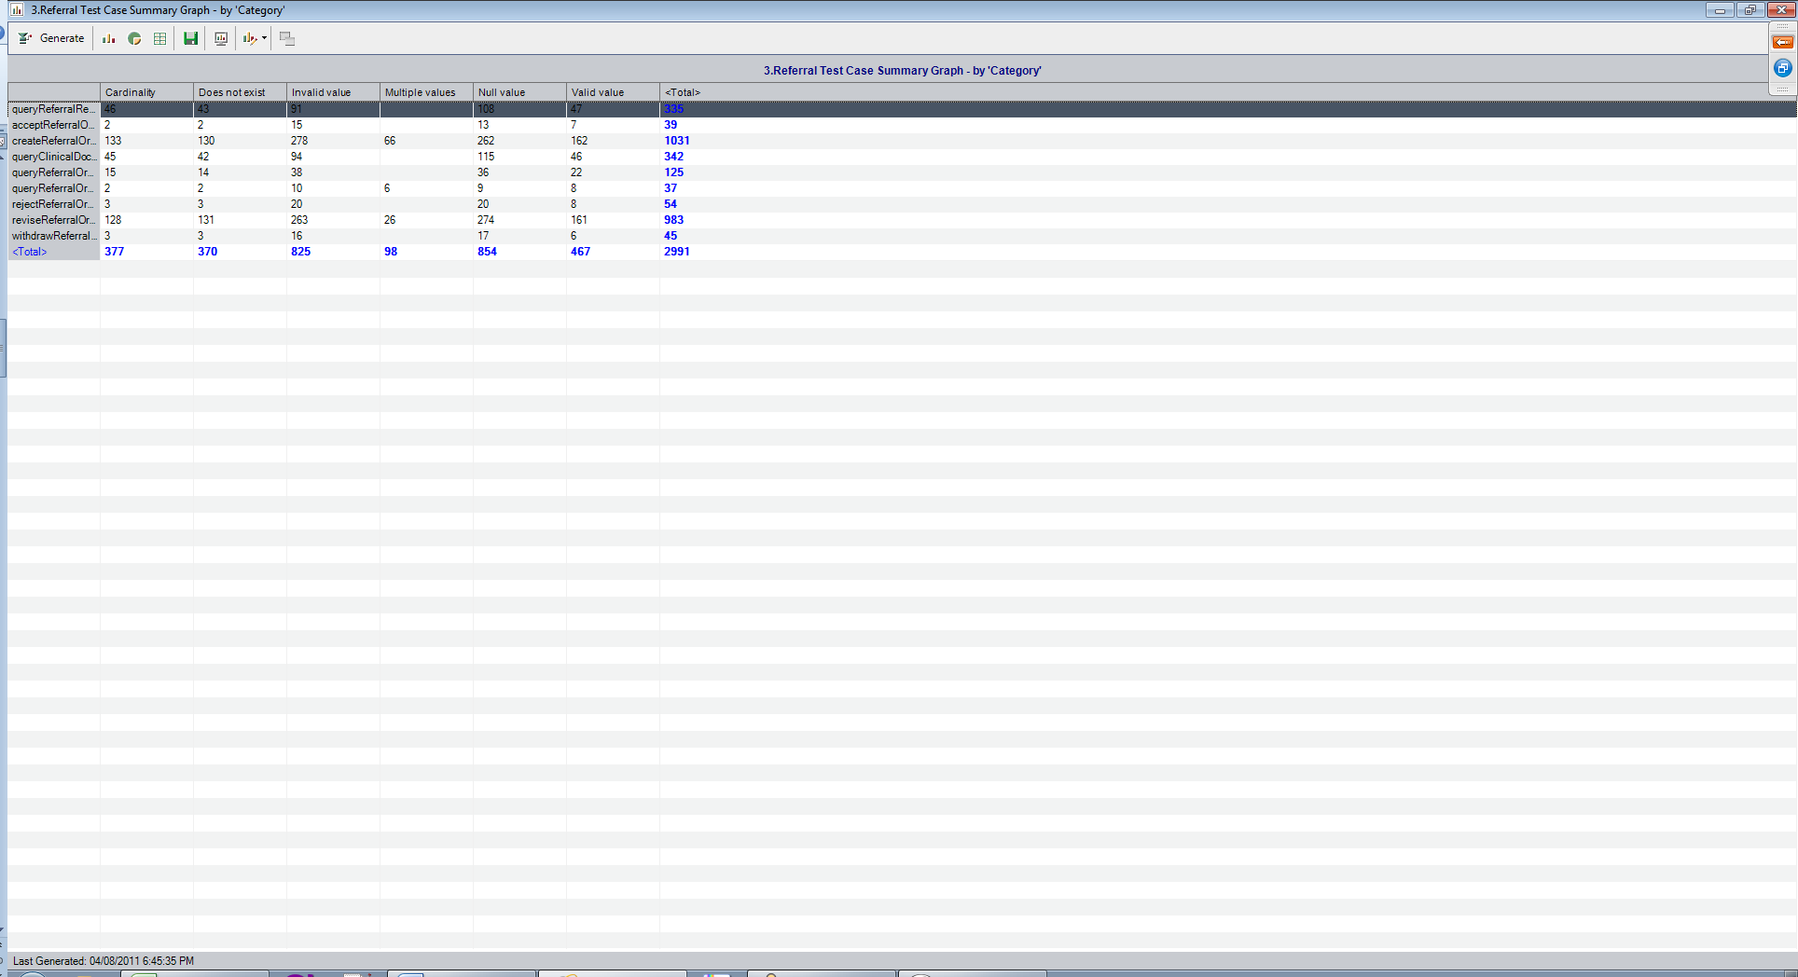

### 

# Test Case Execution

## Consolidated Test Execution Summary

The overall test execution summary for this sprint:

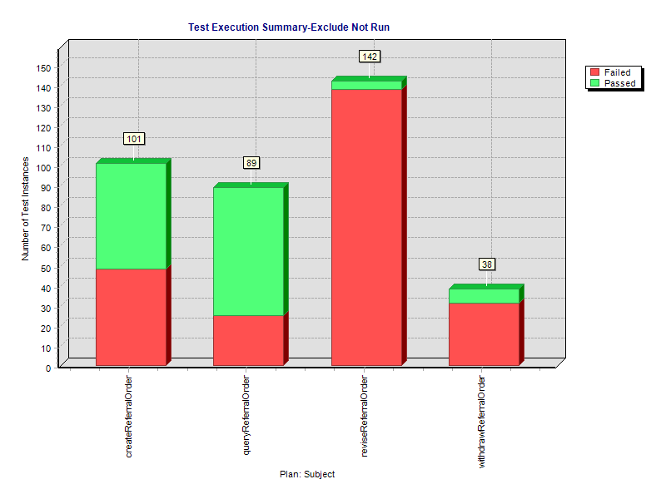

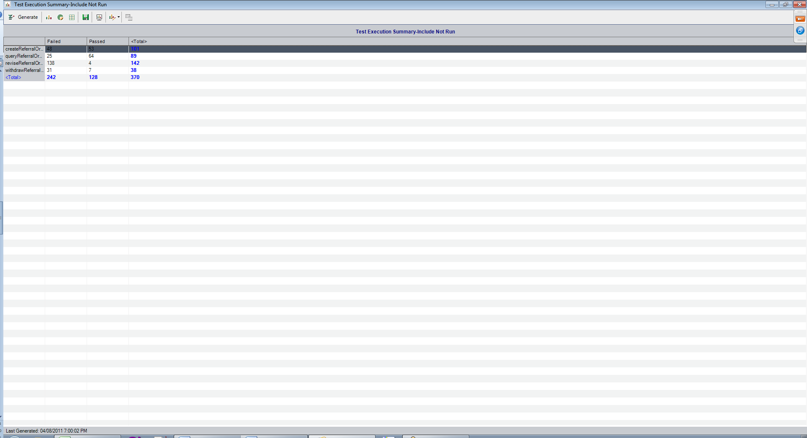

### 

# Defect Summary

## Current (QA Logged) Defect Status

|  |  |  |  |  |  |  |
| --- | --- | --- | --- | --- | --- | --- |
| **Row Labels** | **Open** | **In Progress** | **Reopened** | **Resolved** | **Closed** | **Grand Total** |
| **Analysis** | **111** | **11** | **8** | **2** | **40** | **172** |
| Bug | 89 | 9 | 7 | 2 | 37 | 144 |
| Question | 22 | 2 | 1 |  | 3 | 28 |
| **Architecture** | **4** |  |  | **13** | **46** | **63** |
| Bug | 3 |  |  | 4 | 9 | 16 |
| Question | 1 |  |  | 9 | 35 | 45 |
| Task |  |  |  |  | 2 | 2 |
| **Continuous Delivery Operations** | **10** | **1** | **1** | **51** | **26** | **89** |
| Action |  |  |  | 3 |  | 3 |
| Bug | 2 |  | 1 | 24 | 12 | 39 |
| Improvement | 1 |  |  |  |  | 1 |
| New Feature | 1 |  |  |  |  | 1 |
| Question | 2 | 1 |  |  | 3 | 6 |
| Sub-task |  |  |  | 4 | 3 | 7 |
| Task | 4 |  |  | 19 | 8 | 31 |
| Task - Analysis |  |  |  | 1 |  | 1 |
| **Enterprise Services Development** | **50** |  |  | **7** | **207** | **264** |
| Bug | 49 |  |  | 7 | 199 | 255 |
| Documentation |  |  |  |  | 1 | 1 |
| Improvement | 1 |  |  |  | 1 | 2 |
| Question |  |  |  |  | 5 | 5 |
| Task |  |  |  |  | 1 | 1 |
| **Project Management Office** | **1** |  |  | **4** |  | **5** |
| Risk | 1 |  |  | 4 |  | 5 |
| **Grand Total** | **176** | **12** | **9** | **77** | **319** | **593** |

## QA Issues Created this Sprint:



## QA Issues Validated and Resolved this Sprint:

