[](http://www.brandsoftheworld.com/download/brand/10943.html)

Center for Biomedical Informatics and Information Technology

caBIG® Clinical Information Suite

QA Test Summary Report

Sprint: RC4-I3-S1

May 8, 2011

**Table of Contents**

Summary 3

i. QA Sprint Cycle 3

ii. Code Validation 3

iii. Specification Validation 3

iv. Defect Validation 3

v. Sprint Deliverables 4

Test Case Creation 5

Summary Test Case Creation 5

Test Case Execution 6

Consolidated Test Execution Summary 6

# Summary

## QA Sprint Cycle

* 1. Start: Apr 4, 2011
  2. Finish: Apr 15, 2011

## Code Validation

* + ESD delivered ESD RC4-I2-S2 tag on April 5, 2011 which included:
    1. Organization Registry (Mock implementation, and design Tolven Strategy for Hierarchy Management:
       1. associateOrganizationAndParent()
       2. disassociateOrganizationAndParent()
       3. getChildOrganizations()
       4. getParentOrganization()
  + The artifacts from the Architecture drop of RC3-I3 was used in this tag
  + Implement Test Harness and Smoke Test for –
    1. Doc builder (Mock)
    2. Family History (Mock)
    3. Medication (Mock)
    4. Org Registry (Tolven)
    5. Patient Registry (Tolven)
    6. Provider Registry (Tolven)
  + Level 1, Level 2, Level 3 Test cases executed accordingly for –
    1. Org Registry
    2. Patient Registry
    3. Provider Registry

## Specification Validation

* New tests were developed for Org Registry

## Defect Validation

* 16 Defects were raised during this sprint
* 6 defects resolved/closed during this sprint

## Sprint Deliverables

**Test Summary Report**  
<http://caehrorg.jira.com/svn/CACIS/trunk/documents/QA/Test_Reports/caBIGClinicalInformationSuite_RC4I3S1_Test_Summary_Report.docx>

**Test Cases**<http://caehrorg.jira.com/svn/CACIS/trunk/documents/QA/Test_Cases/caBIGClinicalInformationSuite_TestCases_RC4I3S1.xls>

**Test Execution Report**<http://caehrorg.jira.com/svn/CACIS/trunk/documents/QA/Test_Cases/caBIGClinicalInformationSuite%20TestExecutionReport%20RC4I3S1.mht>

**Soap Test Scripts**N/A

# Test Case Creation

## Summary Test Case Creation

Total test case distribution

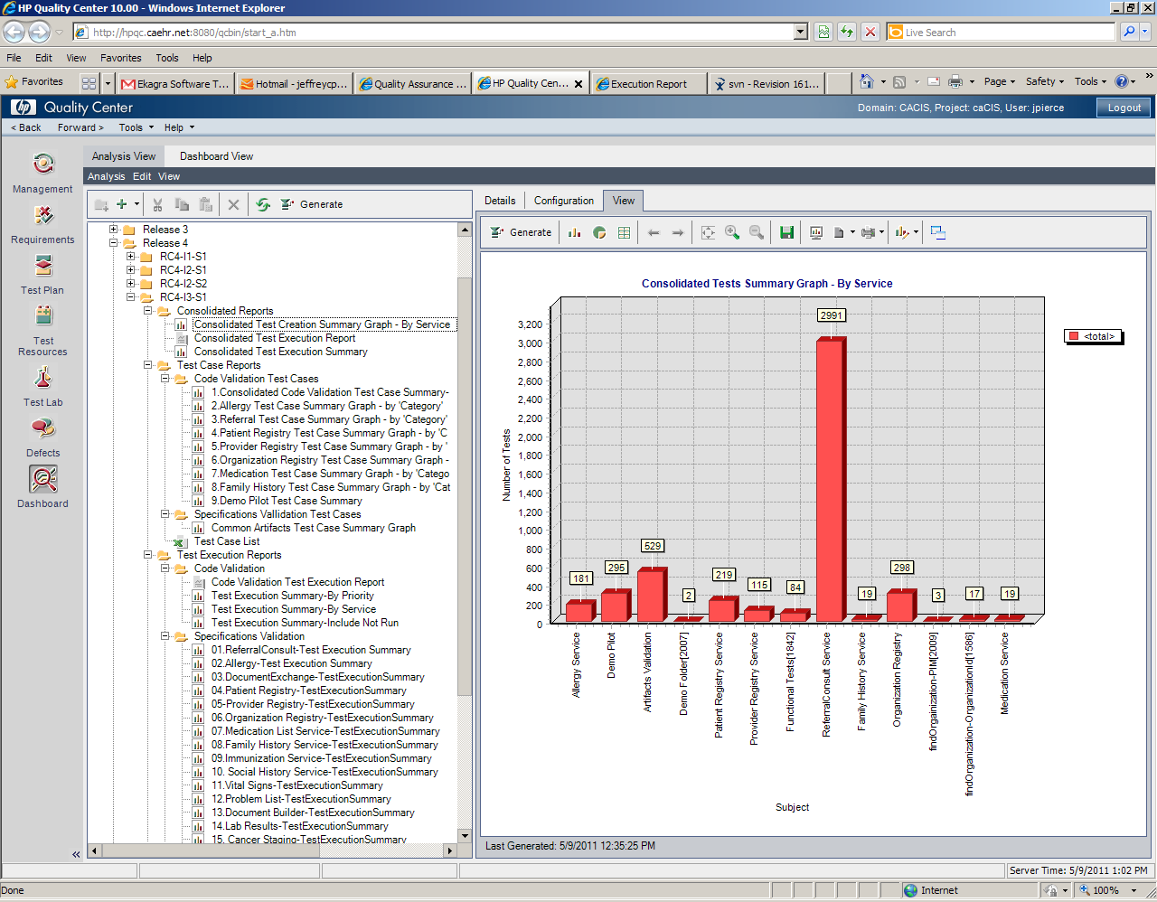

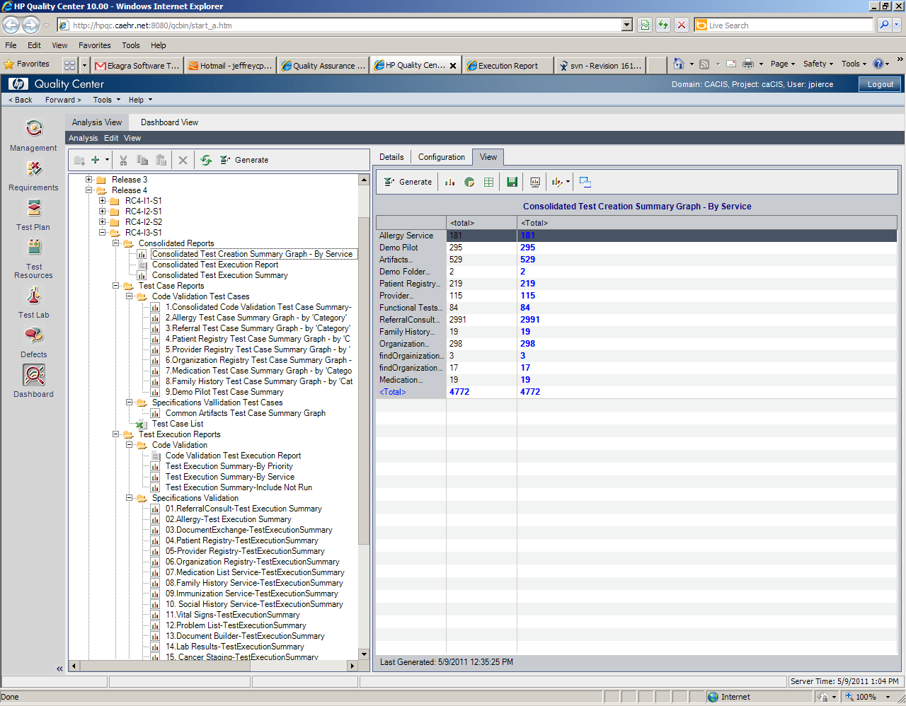

# Test Case Execution

## Consolidated Test Execution Summary

The overall test execution summary for this sprint:

