[](http://www.brandsoftheworld.com/download/brand/10943.html)

Center for Biomedical Informatics and Information Technology

caBIG® Clinical Information Suite

QA Test Summary Report

Sprint: RC5-I1-S2

June 6, 2011

**Table of Contents**

Summary 3

i. QA Sprint Cycle 3

ii. Test Case Development 3

iii. Code Validation 3

iv. Specification Validation 4

v. Defect Validation 4

vi. Sprint Deliverables 5

Test Case Creation 6

Summary Test Case Creation 6

Test Case Execution 7

Consolidated Test Execution Summary 7

# Summary

## QA Sprint Cycle

* + Start: May 16, 2011
  + Finish: May 31, 2011
  + Based upon ESD delivered RC4-Elaboration 1 tag (May 16) which included:
    1. SVN code refactoring to align with new project scope and Architecture
    2. Exchange CCD to/from Canonical Format Transformer
    3. NAV and Validation components.

## Test Case Development

835 new tests were developed for the following:

* + PCO Datatype Validations
    1. Diagnosis
    2. Intervention
    3. Outcome
    4. Patient
    5. Provider
  + Service Usability
    1. ShareCanonicalData
    2. ShareClinicalData
  + Architectural Component Implementation
    1. PCO
    2. Transcend
  + Field Mapping Tests
  + Compliance Tests
  + Performance Tests
  + Security Tests
  + Use Case Based Tests
    1. Capture PCO Entry
    2. End-To-End
    3. Receive Clinical Exchange Instance
    4. Render Internal Clinical Information
    5. Request Clinical Data Sharing
    6. Transform to Canonical Format
    7. Transform to External Clinical Exchange Format

## Code Validation

* + QA test Implementation and Execution included the following:
    1. CI / Test Automation Framework design and implementation
       1. Hudson project creation for Provision, Build, Deploy of new architecture
       2. ESD Trunk Build Support
       3. PCO Maven build
       4. Integration Platform
       5. Trim Creation
    2. Smoke Test Execution
       1. Provision Build and Deploy ESD Tag
       2. Verification of Trim Loader
       3. PCO Plug-in Deployment
       4. PCO Roundtrip (as delivered)

## Specification Validation

* + Architecture delivered Software Architecture Document (SAD)

## Defect Validation

* 14 Defects were raised during this sprint
* 11 defects resolved/closed during this sprint

## Sprint Deliverables

**Test Summary Report**  
<http://caehrorg.jira.com/svn/CACIS/trunk/documents/QA/Test_Reports/caBIGClinicalInformationSuite_RC5I1S2_Test_Summary_Report.docx>

**Test Cases**<http://caehrorg.jira.com/svn/CACIS/trunk/documents/QA/Test_Cases/caBIGClinicalInformationSuite_TestCases_RC5I1S2.xls>

**Test Execution Report**<http://caehrorg.jira.com/svn/CACIS/trunk/documents/QA/Test_Cases/caBIGClinicalInformationSuite%20TestExecutionReport%20RC5I1S2.mht>

**Soap Test Scripts**N/A

# Test Case Creation

## Summary Test Case Creation

Total test case distribution

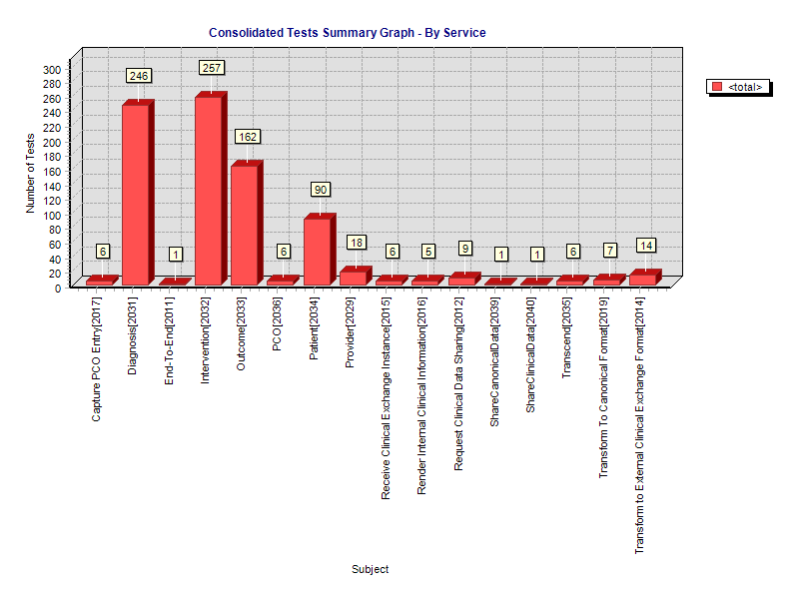

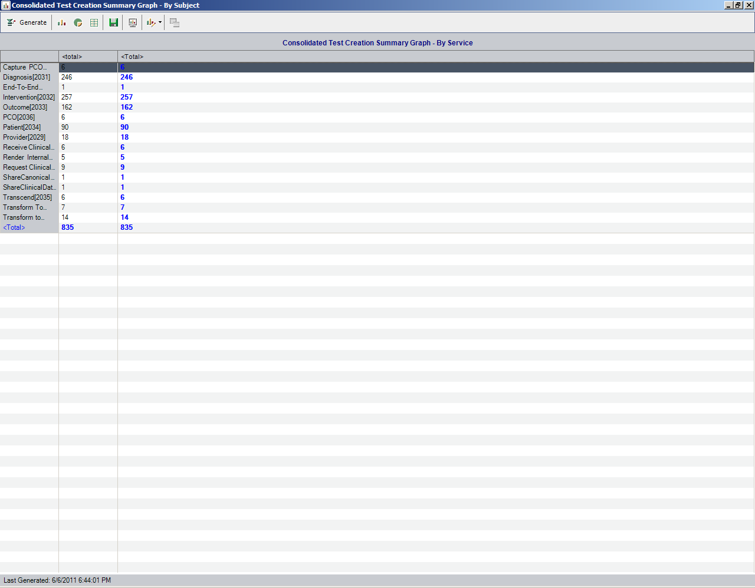

# Test Case Execution

## Consolidated Test Execution Summary

The overall test execution summary for this sprint:

