In Summary:
- CTRP 3.2 Release was deployed in Demo in September 8, 2010
- No code changes went into PODS for this release
- Regression testing of PODS was carried out on September 10, 2010
- This testing was done outside of the NIH firewall
- A total of 62 testcases were executed

The test case distribution over the three iterations is as follows:

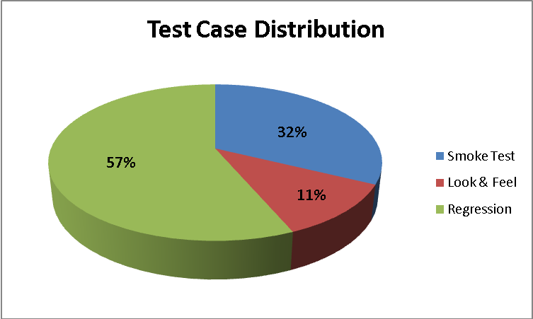

Category | Number of Test Cases
Smoke Test | 20
Look & Feel | 7
Regression | 35
Total | 62

The test case execution summary for the PODS CTRP Rel 3.2 Regression is as follows:

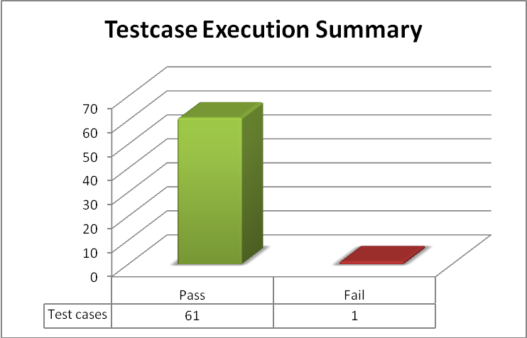

The defect for the PODS CTRP Rel 3.2 Regression is as follows
Key | Summary | Assignee | Reporter | Priority | Status | Resolution
ESD-455 | Error 403 page displayed when Registry user tries to create an account in Outcomes portal | Unassigned | Amrut Rao | Major | Open | UNRESOLVED

The deliverables are available at:

Test cases and Test execution sheet:
http://gforge.nci.nih.gov/svnroot/ent-services/tags/caEHR/ReleaseCycle2/Iteration3/QA/Sprint1/CTRP_32_PODS_Demo_TestCases.xls

Test Summary report:
http://gforge.nci.nih.gov/svnroot/ent-services/tags/caEHR/ReleaseCycle2/Iteration3/QA/Sprint1/32_CTRP_PODS_Demo_Test_Summary_Report.doc

Test Scripts:
http://gforge.nci.nih.gov/svnroot/ent-services/tags/caEHR/ReleaseCycle2/Iteration3/QA/Sprint1/32_PODS_Demo.rar

