CTRP 3.2 Release – PODS Regression
In Summary:
- A total of 62 testcases were executed
- 1 new defect was raised in the CTRP project

The test case distribution over the three iterations is as follows:

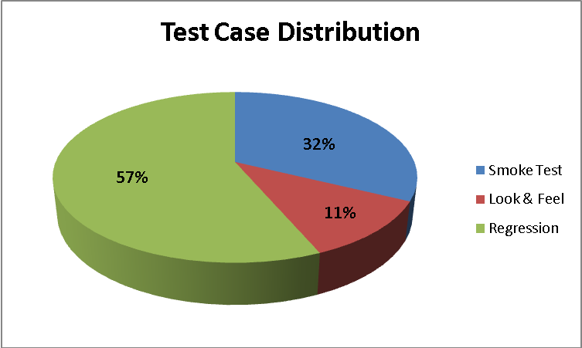

Category | Number of Test Cases
Smoke Test | 20
Look & Feel | 7
Regression | 35
Grand Total | 62

The test case execution summary for the PODS CTRP Rel 3.2 Regression is as follows:
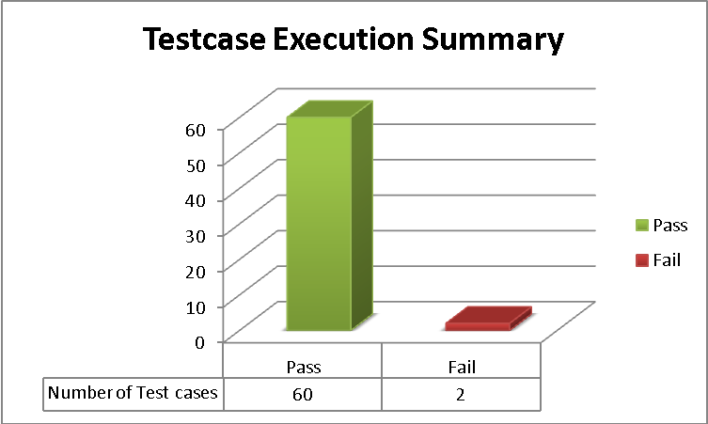

The defect for the PODS CTRP Rel 3.2 Regression is as follows
Key | Summary | Assignee | Reporter | Priority | Status | Resolution
ESD-455 | Error 403 page displayed when Registry user tries to create an account in Outcomes portal | Unassigned | Amrut Rao | Major | Open | UNRESOLVED

