In Summary:
- A total of 177 testcases were executed over the 3 release cycles
- A total of 11 defects were opened with 1 defect still Open.
- QA testing of the Credential Delegation Service was limited to verification of the Delegated Credential via the GAARDS UI tool and verification of the expiration of that Delegated Credential. Round-trip testing to HealthCIT and the Demo tier was performed in coordination with the SAIC team.

QA received 2 builds for this PODS-Short Suspense (PODS-SS) release:
Build | QA Server | Demo Server
M11 | 05/17/2010
MOD-1 | 05/20/2010 | 5/29/2010

The test case distribution over the three iterations is as follows:

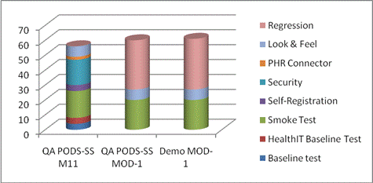

Category | QA PODS-SS M11 | QA PODS-SS MOD-1 | Demo MOD-1
Baseline test | 4 | 0 | 0
HealthIT Baseline Test | 4 | 0 | 0
Smoke Test | 18 | 20 | 20
Self-Registration | 4 | 0 | 0
Security | 17 | 0 | 0
PHR Connector | 2 | 0 | 0
Look & Feel | 7 | 7 | 7
Regression | 0 | 33 | 34
Grand Total | 56 | 60 | 61

The test case execution summary for the PODS-SS release is as follows:
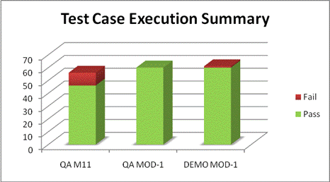

Releases | Pass | Fail
QA M11 | 46 | 10
QA MOD-1 | 60 | 0
DEMO MOD-1 | 60 | 1

The defects for the PODS-SS release are listed below.
Key | Summary | Assignee | Reporter | Priority | Status | Resolution
ESD-455 | Error 403 page displayed when Registry user tries to create an account in Outcomes portal | Unassigned | Amrut Rao | Major | Open | UNRESOLVED
ESD-390 | Stacktrace during Org/Person Lookup Selection | Igor Merenko | Amrut Rao | Minor | Closed | Incomplete
ESD-341 | Outcomes welcome header message displays Grid DN instead on username | Hannes Niedner | Amrut Rao | Minor | Closed | Fixed
ESD-338 | No 'Forgot Password' link on Login page | Unassigned | Amrut Rao | Major | Closed | Won't Fix
ESD-337 | Invalid Password Results In Loss of Authentication Svc Field | Brian Pickeral | Amrut Rao | Major | Closed | Fixed
ESD-336 | 403 error during self-registration of already existing user | Brian Pickeral | Amrut Rao | Major | Closed | Fixed
ESD-335 | Stacktrace in logs during Org lookup | Igor Merenko | Amrut Rao | Minor | Closed | Fixed
ESD-334 | All pop-up windows in Outcomes Portal do not have a close button | Brian Pickeral | Amrut Rao | Major | Closed | Fixed
ESD-333 | Error 404 during Org and Person Look-up | Brian Pickeral | Amrut Rao | Minor | Closed | Fixed
ESD-332 | Remove "Create an Account" link on Account Creation Page | Brian Pickeral | Amrut Rao | Minor | Closed | Fixed
ESD-331 | Outcomes header does not display Physician's First name | Hannes Niedner | Amrut Rao | Major | Closed | Fixed

A total of 11 defects were opened in this release. QA team has not found any show-stopper defects which would prevent the release of the PODS-SS build.

