In Summary:
- 105 test cases were created
- QA was prepared to test 4 operations (create, query, replace and revise) on the Referral Service. But the build contained only 2 operations (create and query)
- The sprint had a failure rate of 87%
- 2 defects were raised in this sprint
The test case distribution for this sprint is as follows:
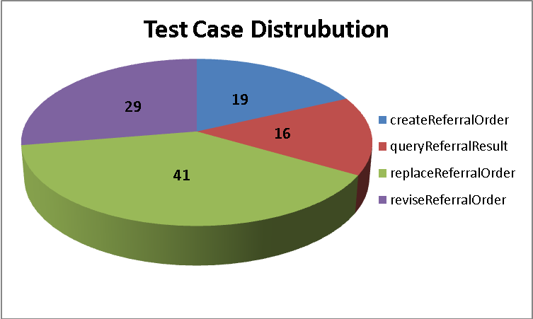
Categories | create | query | replace | revise
Behavior Description | 0 | 3 | 0 | 0
Exception Condition | 10 | 13 | 29 | 24
Input Validation | 4 | 0 | 4 | 5
Invocation | 0 | 0 | 1 | 0
Output | 3 | 0 | 6 | 0
Pre-Conditions | 1 | 0 | 0 | 0
Security Conditions | 1 | 0 | 1 | 0

The test case execution summary for the I2S1 release is as follows:
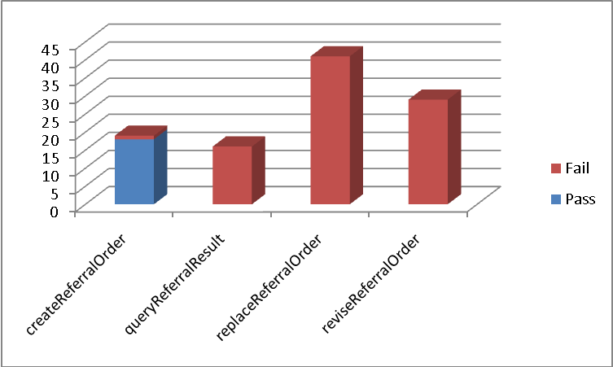

Operation | Pass | Fail
createReferralOrder | 18 | 1
queryReferralResult | 0 | 16
replaceReferralOrder | 0 | 41
reviseReferralOrder | 0 | 29

The defects raised in I2S1 are listed below:
Key | Summary | Status | Priority | Resolution | Assignee | Reporter | Issue Links
ESD-158 | replaceReferralOrder does not return new identifier in the reponse | Closed | Major | Won't Fix | Todd Parnell | Amrut Rao | QA-34, QA-28
ESD-157 | queryReferralResult returns an error | Closed | Major | Duplicate | Rama Ramakrishnan | Amrut Rao | ESD-186, ESD-135

