Release 1 Iteration 3 Sprint 2 – Test Report
In Summary:
- 882 test cases were created
- 2 operations (createReferral and withdrawReferral) were delivered to QA. QA tested the two operations only.
- The sprint had a failure rate of 20%
- 36 defects were raised in this sprint
The test case distribution for this sprint is as follows:
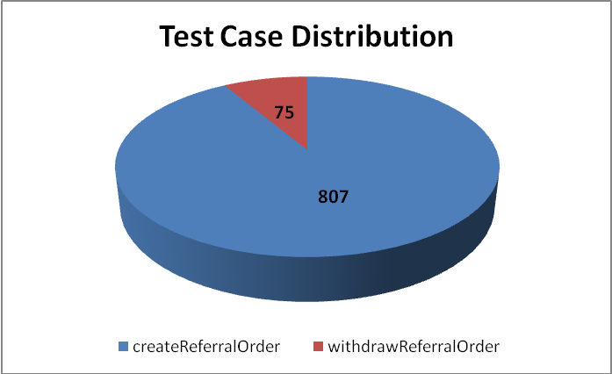
Conditions | createReferralOrder | withdrawReferralOrder | Grand Total
Valid Value | 176 | 15 | 191
Invalid Value | 198 | 17 | 215
Does Not Exist | 169 | 14 | 183
Null Value | 171 | 14 | 185
Multiple Values | 93 | 15 | 108
Total | 807 | 75 | 882

The test case execution summary for the I3S2 release is as follows:
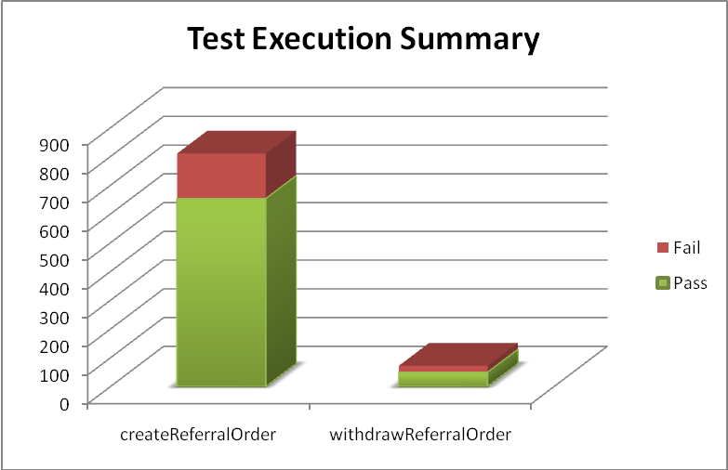
Operation | Pass | Fail | Total Executed
createReferralOrder | 654 | 156 | 810
withdrawReferralOrder | 50 | 22 | 72
Total | 704 | 178 | 882

The defects raised in I3S2 are listed below:
Key | Summary | Priority | Status | Resolution | Reporter
ESD-865 | referralOrder - pertinentInformation errors while validating cardinality | Minor | Open | UNRESOLVED | Pradeep Dharmavarapu
ESD-864 | II type boolean attribute: @displayable accepts 0 and 1 as possible values along with true and false | Minor | Open | UNRESOLVED | Pradeep Dharmavarapu
ESD-863 | Multiple instances of addr-part element error out due to 255 character constraint | Minor | Open | UNRESOLVED | Pradeep Dharmavarapu
ESD-848 | observationEvent.code - no values for any attributes, service does not generate any error | Minor | Open | UNRESOLVED | Pradeep Dharmavarapu
ESD-847 | administrativeGenderCode-codeSystemName incorrect values donot yield any errors in service response. | Minor | Open | UNRESOLVED | Pradeep Dharmavarapu
ESD-846 | Invalid values for valueSet OID donot cause errors | Minor | Open | UNRESOLVED | Pradeep Dharmavarapu
ESD-814 | Unconstrained valuesets in createReferral | Major | Open | UNRESOLVED | Amrut Rao
ESD-811 | patient.entitycreated column in database is not updated with timestamp when ever a new entityid is created new | Minor | Resolved | Fixed | Pradeep Dharmavarapu
ESD-778 | cardinality requirements in REPCMT000001USPatientCareProvisionRequest don't allow zero occurrences | Major | Closed | Fixed | Kevin Gann
ESD-763 | [0..1] Cardinality of Performer is not enforced in REPCMT000001USPatientCareProvisionRequest | Major | Open | UNRESOLVED | Kevin Gann
ESD-746 | ConcernEvent.value accepts values outside of valueset | Major | Open | UNRESOLVED | Amrut Rao
ESD-744 | Java Null Pointer Exception | Minor | Open | UNRESOLVED | Pradeep Dharmavarapu
ESD-740 | Javax Persistence RollbackException while validating representedOrganization name element combinations | Minor | Open | UNRESOLVED | Pradeep Dharmavarapu
ESD-738 | representedOrganization cardinality validation in payload | Minor | Open | UNRESOLVED | Pradeep Dharmavarapu
ESD-727 | Dozer Mapping Exception during QA validation | Minor | Open | UNRESOLVED | Pradeep Dharmavarapu
ESD-724 | ReferralOrder-performer-id does not exist validation | Minor | Open | UNRESOLVED | Pradeep Dharmavarapu
ESD-722 | Hibernate Transient Object Exception | Minor | Open | UNRESOLVED | Pradeep Dharmavarapu
ESD-719 | deceasedTime and birthTime validations | Minor | Open | UNRESOLVED | Pradeep Dharmavarapu
ESD-718 | org.hibernate.exception.SQLGrammarException: needs additional error message | Minor | Closed | Duplicate | Aviva Mordetsky
ESD-671 | SQLGrammarException when submitting payload. | Major | In Progress | UNRESOLVED | Kevin Gann
ESD-667 | Multiple entries of existing Patient, Provider and Referral Order data created by createReferral | Major | Open | UNRESOLVED | Amrut Rao
ESD-666 | Patient address fields should not be required | Major | Closed | Fixed | Kevin Gann
ESD-665 | Error message returned not indicating which field contains an invalid value. | Major | Closed | Fixed | Kevin Gann
ESD-664 | ActIntent.code attribute accepts nullFlavor value | Major | In Progress | UNRESOLVED | Amrut Rao
ESD-663 | No business validation done in createRefrerral operation | Major | Open | UNRESOLVED | Amrut Rao
ESD-622 | invalid data for provider does not cause exception it allows service to execute for withdrawReferralOrder | Major | Open | UNRESOLVED | Aviva Mordetsky
ESD-592 | Dozer Mapping Exception received for ActEncounterType and ActProcedureCategoryList valuesets | Major | Closed | Fixed | Amrut Rao
ESD-578 | Successful withdrawReferral returns a Marshalling Error referencing an unknown OID | Major | Closed | Fixed | Aviva Mordetsky
ESD-519 | Case of code used for ActCareProvisionRequestType differs from specifications | Major | Reopened | UNRESOLVED | Kevin Gann
ESD-515 | Mapping incorrect in patientCareProvisionRequest for code value | Major | Closed | Fixed | Kevin Gann
ESD-508 | sample payload for withdraw referral receive error that not complete | Major | Closed | Fixed | Aviva Mordetsky
ESD-497 | ERROR: column "telecom" cannot be cast to type "pg_catalog.varchar" | Major | Closed | Fixed | Kevin Gann
CDO-350 | Inability to reach directories during application deployment. | Major | Resolved | Fixed | Kevin Gann
ARCH-59 | Difference between PIM, RMIM and Terminology worksheet for values in lower and uppercase | Major | Open | UNRESOLVED | Aviva Mordetsky
ARCH-49 | Excel spreedsheet links give an error when used | Major | Resolved | Won't Fix | Aviva Mordetsky
ARCH-43 | reasonCode*: DSET<CD> CNE [0..*] < ActReason (reasonCode) | Major | Closed | Fixed | Kevin Gann

