Release 2 Iteration 1 Sprint 1 – Test Report
In Summary:
- ESD delivered RC1-I4-S1 build
- 1217 test cases were created
- 2 operations (createReferral and withdrawReferral) were delivered to QA. QA tested the two operations only.
- The sprint had a failure rate of 14%
- 18 new defects were raised in this sprint
The test case distribution for this sprint is as follows:
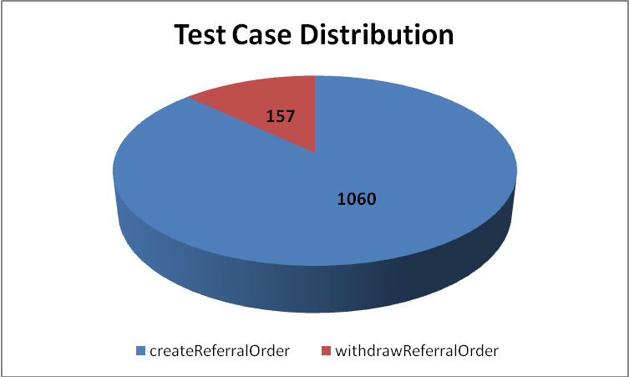
Condition | createReferralOrder | withdrawReferralOrder | Grand Total
Valid Value | 171 | 14 | 185
Invalid Value | 236 | 36 | 272
Does Not Exist | 163 | 14 | 177
Null Value | 238 | 64 | 302
Multiple Values | 91 | 15 | 106
Cardinality | 161 | 14 | 175
Total | 1060 | 157 | 1217

The test case execution summary for the I3S2 release is as follows:
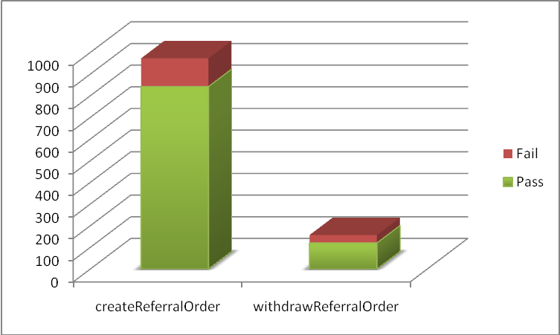
Operation | Pass | Fail | Total Executed
createReferralOrder | 842 | 130 | 972
withdrawReferralOrder | 120 | 36 | 156
Total | 962 | 166 | 1128

The defects for I4S1 are listed below:
Key | Summary | Reporter | Priority | Status | Resolution | Affects Version/s
ESD-885 | Release notes do not have Known Issues | Aviva Mordetsky | Major | Open | UNRESOLVED | I4S1  RC2-I1
ESD-869 | telecom cardinality [0..5] fails | Aviva Mordetsky | Major | Open | UNRESOLVED | I4S1
ESD-867 | patientPerson.firstName isn't allowed to be empty | Kevin Gann | Major | Open | UNRESOLVED | I4S1
ESD-865 | referralOrder - pertinentInformation errors while validating cardinality | Pradeep Dharmavarapu | Minor | Open | UNRESOLVED | I3S2  I4S1
ESD-864 | II type boolean attribute: @displayable accepts 0 and 1 as possible values along with true and false | Pradeep Dharmavarapu | Minor | Open | UNRESOLVED | I3S2  I4S1
ESD-863 | Multiple instances of addr-part element error out due to 255 character constraint | Pradeep Dharmavarapu | Minor | Open | UNRESOLVED | I3S2  Iteration 4  I4S1
ESD-847 | administrativeGenderCode-codeSystemName incorrect values donot yield any errors in service response. | Pradeep Dharmavarapu | Minor | Open | UNRESOLVED | I3S2  I4S1
ESD-846 | Invalid values for valueSet OID donot cause errors | Pradeep Dharmavarapu | Minor | Open | UNRESOLVED | I3S2  I4S1
ESD-837 | REPC_MT000003US.component2.pauseQuantity accepts incorrect values | Amrut Rao | Major | Open | UNRESOLVED | I4S1
ESD-823 | Mismatched error message for clusterIntent.code | Amrut Rao | Major | Open | UNRESOLVED | I4S1
ESD-820 | [0..*] Cardinality of ActIntent.reasonCode is not being enforced | Amrut Rao | Major | Closed | Cannot Reproduce | I4S1
ESD-819 | Mismatched error message for gov.nih.nci.caehr.domain.enums.AdministrativeGender | Kevin Gann | Major | Open | UNRESOLVED | I4S1
ESD-818 | Unable to create successfully on I4S1- hudson server ec2-67-202-32-251. with template payload that was successful previously | Aviva Mordetsky | Blocker | Closed | Won't Fix | I4S1
ESD-817 | ActIntent.code accepts negative integers | Amrut Rao | Major | Open | UNRESOLVED | I4S1
ESD-816 | SQLGrammarException: could not execute query submitting payload | Kevin Gann | Major | Open | UNRESOLVED | I4S1
ESD-814 | Unconstrained valuesets in createReferral | Amrut Rao | Major | Open | UNRESOLVED | I3S2  I4S1
ESD-811 | patient.entitycreated column in database is not updated with timestamp when ever a new entityid is created new | Pradeep Dharmavarapu | Minor | Resolved | Fixed | I3S2  I4S1
ESD-810 | javax.persistence.PersistenceException: org.hibernate.exception.SQLGrammarException: could not execute query | Pradeep Dharmavarapu | Minor | Open | UNRESOLVED | I4S1
ESD-808 | There was a problem persisting the referralOrder object message while sending payload. | Kevin Gann | Major | Closed | Cannot Reproduce | I4S1
ESD-802 | invalid OID for Healthproviderroletype does not cause error | Aviva Mordetsky | Minor | Open | UNRESOLVED | I4S1
ESD-801 | invalid codesystemname for provider does not cause error | Aviva Mordetsky | Minor | Open | UNRESOLVED | I4S1
ESD-800 | Dozer MappingException for Actintent.code | Amrut Rao | Major | Closed | Cannot Reproduce | I4S1
ESD-753 | sample payloads for withdraw referral for R1I4S1 tag | Aviva Mordetsky | Blocker | Resolved | Fixed | I4S1
ESD-752 | sample payloads for create referral for R1I4S1 tag | Aviva Mordetsky | Blocker | Resolved | Fixed | I4S1
ESD-746 | ConcernEvent.value accepts values outside of valueset | Amrut Rao | Major | Open | UNRESOLVED | I3S2  I4S1
ESD-744 | Java Null Pointer Exception | Pradeep Dharmavarapu | Minor | Open | UNRESOLVED | I3S2  I4S1
ESD-740 | Javax Persistence RollbackException while validating representedOrganization name element combinations | Pradeep Dharmavarapu | Minor | Open | UNRESOLVED | I3S2  I4S1
ESD-738 | representedOrganization cardinality validation in payload | Pradeep Dharmavarapu | Minor | Open | UNRESOLVED | I3S2  I4S1
ESD-719 | deceasedTime and birthTime validations | Pradeep Dharmavarapu | Minor | Open | UNRESOLVED | I3S2  I4S1
ESD-717 | createReferral is successful with statusCode=Completed | Brian Bell | Major | Open | UNRESOLVED | I4S1
ESD-667 | Multiple entries of existing Patient, Provider and Referral Order data created by createReferral | Amrut Rao | Major | Open | UNRESOLVED | I3S2  I4S1
ESD-664 | ActIntent.code attribute accepts nullFlavor value | Amrut Rao | Major | In Progress | UNRESOLVED | I3S2  I4S1
ESD-663 | No business validation done in createRefrerral operation | Amrut Rao | Major | Open | UNRESOLVED | I3S2  I4S1
ESD-622 | invalid data for provider does not cause exception it allows service to execute for withdrawReferralOrder | Aviva Mordetsky | Major | Open | UNRESOLVED | I3S2  I4S1
ESD-578 | Successful withdrawReferral returns a Marshalling Error referencing an unknown OID | Aviva Mordetsky | Major | Closed | Fixed | I3S2  Iteration 4  I4S1
CDO-350 | Inability to reach directories during application deployment. | Kevin Gann | Major | Resolved | Fixed | RC1-I3-S2
ARCH-59 | Difference between PIM, RMIM and Terminology worksheet for values in lower and uppercase | Aviva Mordetsky | Major | Open | UNRESOLVED | RC1 - IT3S2
ARCH-49 | Excel spreedsheet links give an error when used | Aviva Mordetsky | Major | Resolved | Won't Fix | RC1 - IT2S2  RC1 - IT3S1  RC1 - IT3S2
ARCH-43 | reasonCode*: DSET<CD> CNE [0..*] < ActReason (reasonCode) | Kevin Gann | Major | Closed | Fixed | RC1 - IT3S2

