Release 2 Iteration 1 Sprint 2 – Test Report
In Summary:
- This was a shortened sprint release due to the 4-day HL7 training.
- Testing was conducted on the RC2I1S1 ESD build delivered on July 26, 2010
- 1397 test cases were scheduled for testing
- 3 operations (createReferralOrder, withdrawReferralOrder and queryReferralOrderStatus) were delivered to QA.
- New feature testing was performed for queryReferralOrderStatus
- Regression testing was performed for createReferralOder and withdrawReferralOrder
- The sprint had a failure rate of 28%
- 7 new defects were raised in this sprint
The test case distribution for this sprint is as follows:
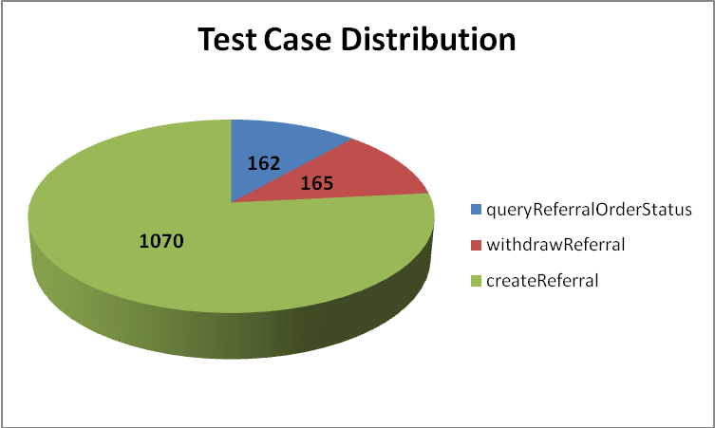
Category | queryReferralOrderStatus | withdrawReferralOrder | createReferralOrder
Cardinality | 21 | 14 | 162
Does not exist | 21 | 14 | 164
Invalid value | 35 | 39 | 237
Multiple values | 15 | 14 | 91
Null value | 45 | 70 | 242
Valid value | 25 | 14 | 174
Total | 162 | 165 | 1070

The test case execution summary for the sprint is as follows:
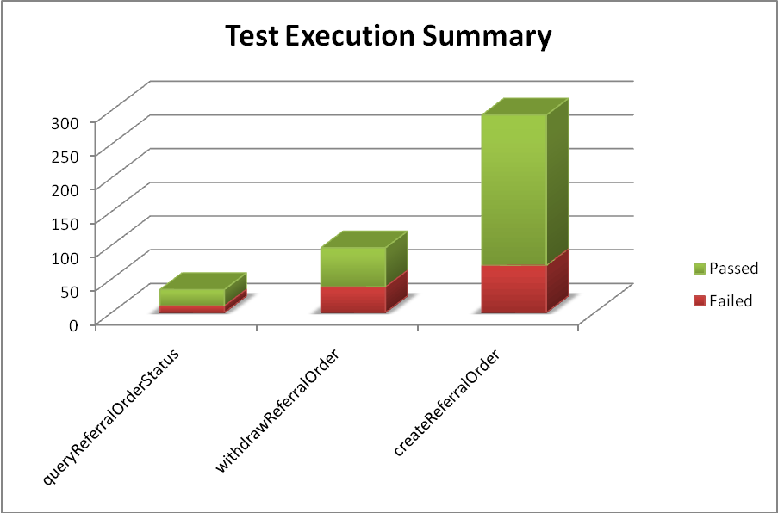
Operation | Failed | Passed | Total
queryReferralOrderStatus | 10 | 24 | 34
withdrawReferralOrder | 38 | 58 | 96
createReferralOrder | 70 | 223 | 293
Total | 118 | 305 | 423

The defects for this sprint are listed below:
Key | Summary | Reporter | Priority | Status | Resolution | Affects Version/s
ESD-897 | patientPerson-determinerCode accepts null value and returns no errors in response | Pradeep Dharmavarapu | Minor | Open | UNRESOLVED | RC2-I1-S1
ESD-892 | Cardinality not enforced in createReferral for REPC_MT000003US (A_TreatmentPlan) | Amrut Rao | Major | Open | UNRESOLVED | RC2-I1-S1
ESD-891 | Patient-classCode attribute accepts null values and no errors in response | Pradeep Dharmavarapu | Minor | Open | UNRESOLVED | Release 2  RC2-I1  RC2-I1-S2  RC2-I1-S1
ESD-890 | Patient element accepts nullFlavors - no errors generated | Pradeep Dharmavarapu | Minor | Open | UNRESOLVED | Iteration 4  I4S1  Release 2  RC2-I1-S1
ESD-888 | queryReferralOrderStatus - blank Soap Fault message returned when name qualifier = XXX | Brian Bell | Minor | Open | UNRESOLVED | RC2-I1-S1
ESD-887 | queryReferralOrderStatus - no business validation of enum values | Brian Bell | Minor | Open | UNRESOLVED | RC2-I1-S1
ESD-883 | No Errors for incorrect or invalid Cardinality of payload elements | Pradeep Dharmavarapu | Major | In Progress | UNRESOLVED | RC2-I1-S1

