In Summary:
- Testing was conducted on the RC2I1S2 ESD tag delivered on August 12, 2010
- 3 operations (createReferralOrder, withdrawReferralOrder and queryReferralOrderStatus) were delivered to QA.
- Regression testing was performed for createReferralOder and withdrawReferralOrder based on the Priority Levels:
  - All Level 1 test cases were executed
  - All Level 2 test cases were executed
  - Only Null Values Level 3 test cases were executed
- Since no new code changes went into queryReferralOrderStatus, this operation was not in scope for this sprint
- The sprint had a failure rate of 24%
- 20 new defects were raised in this sprint
The test case distribution by category for this sprint is as follows:
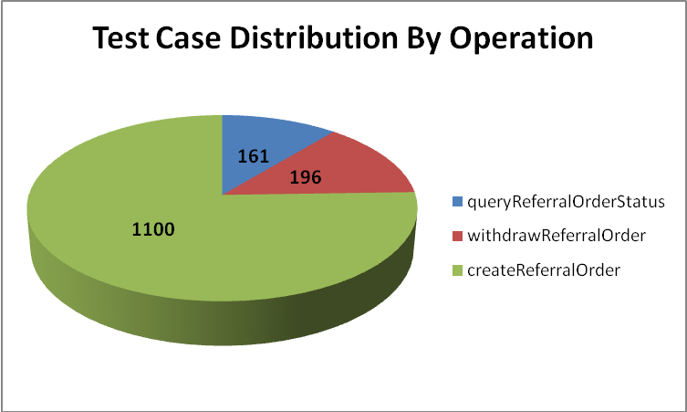
Category | queryReferralOrderStatus | withdrawReferralOrder | createReferralOrder
Cardinality | 21 | 14 | 158
Does not exist | 19 | 20 | 164
Invalid value | 35 | 39 | 236
Multiple values | 15 | 14 | 91
Null value | 47 | 94 | 280
Valid value | 24 | 15 | 171
Total | 161 | 196 | 1100

The test case distribution by priority for this sprint is as follows:
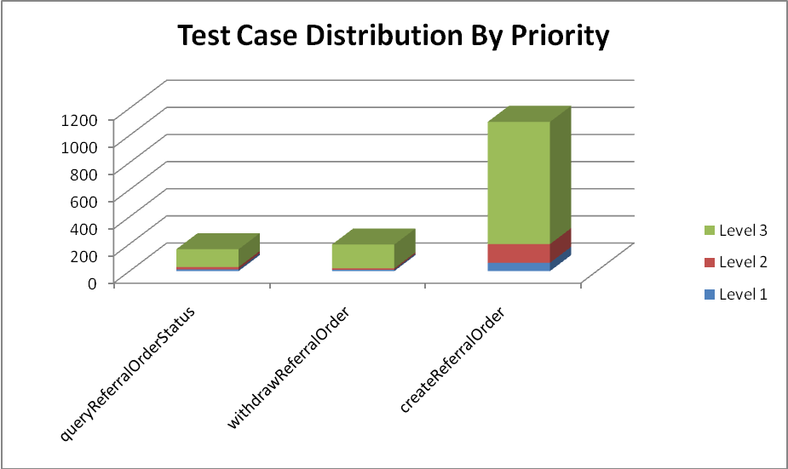
Operation | Level 1 (High) | Level 2 (Medium) | Level 3 (Low) | Total
queryReferralOrderStatus | 13 | 17 | 131 | 161
withdrawReferralOrder | 9 | 11 | 176 | 196
createReferralOrder | 61 | 138 | 901 | 1100
Total | 83 | 166 | 1208 | 1457

The test case execution summary for the sprint is as follows:
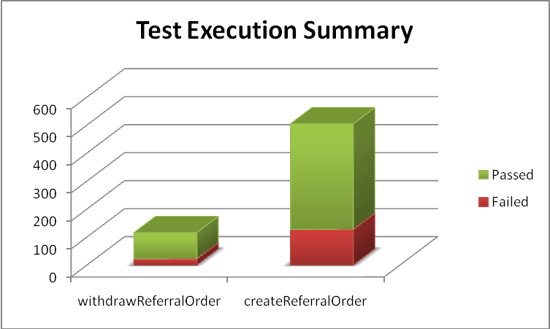
Operation | Failed | Passed | Total
withdrawReferralOrder | 22 | 93 | 115
createReferralOrder | 127 | 377 | 504
Total | 149 | 470 | 619

The defects for this sprint are listed below:
Key | Summary | Reporter | Priority | Status | Resolution
ESD-981 | nullFlavor for assignedOrganization and representedOrganization give an exception | Aviva Mordetsky | Major | Open | UNRESOLVED
ESD-979 | empty value for the value of a name does not cause an exception | Aviva Mordetsky | Major | Closed | Fixed
ESD-978 | createReferral provider-assignedEntity-id = nullFlavor=UNK receive exception | Aviva Mordetsky | Major | Open | UNRESOLVED
ESD-977 | No Null Value validation for classes/attributes in REPC_MT000003US in createReferral | Amrut Rao | Major | Open | UNRESOLVED
ESD-976 | No Null Value validation for fixed optional elements in REPC_MT000003US in createReferral | Amrut Rao | Major | Open | UNRESOLVED
ESD-974 | createReferral with null value for provider-assignedEntity-code is successful | Aviva Mordetsky | Major | Open | UNRESOLVED
ESD-973 | observationEvent-moodCode empty or null values do not generate any errors or exceptions in service response messages | Pradeep Dharmavarapu | Minor | Resolved | Fixed
ESD-972 | observationEvent-classCode empty or null values do not generate any errors or exceptions in service response messages | Pradeep Dharmavarapu | Minor | Resolved | Fixed
ESD-971 | patientPerson-subjectOf-typeCode null values are not validated as errors or exceptions in the service response message | Pradeep Dharmavarapu | Minor | Resolved | Fixed
ESD-970 | patientPerson-birthTime nullFlavor does not create any errors in service response message | Pradeep Dharmavarapu | Minor | Resolved | Fixed
ESD-969 | patientPerson-classCode accepts null value and returns no errors in response | Pradeep Dharmavarapu | Minor | Resolved | Fixed
ESD-968 | createReferral with null value for provider-assignedEntity/represented organiation-ID (displayable, scope, reliability) is successful | Aviva Mordetsky | Major | Resolved | Won't Fix
ESD-965 | Entering Null Value/nullflavor for ClassCode or determinerCode in provider does not cause exception | Aviva Mordetsky | Major | Resolved | Fixed
ESD-960 | Cardinality not enforced in createReferral for [1..1] | Amrut Rao | Major | Resolved | Fixed
ESD-959 | Payload with no administrativeGenderCode returns no exceptions or errors | Pradeep Dharmavarapu | Minor | Resolved | Fixed
ESD-957 | Validation doesn't appear to be checking on all tags and attributes in ReferralOrder | Kevin Gann | Major | Resolved | Fixed
ESD-955 | Code not in ENUM continues and eventually passes null to persistence and fails. | Kevin Gann | Major | Open | UNRESOLVED
ESD-954 | Mismatch between Arch artifacts and required implementation. | Kevin Gann | Major | In Progress | UNRESOLVED
ESD-952 | Constraint may not allow NULL for non-required address (ADXP) parts. | Kevin Gann | Major | Resolved | Fixed
ESD-942 | QuerryReferralStatus representedOrganization doesNotExist bugs | Aviva Mordetsky | Major | Open | UNRESOLVED
ESD-891 | Patient-classCode attribute accepts null values and no errors in response | Pradeep Dharmavarapu | Minor | Resolved | Fixed
ESD-890 | Patient element accepts nullFlavors - no errors generated | Pradeep Dharmavarapu | Minor | In Progress | UNRESOLVED
ESD-883 | No Errors for incorrect or invalid Cardinality of payload elements | Pradeep Dharmavarapu | Major | In Progress | UNRESOLVED
ESD-869 | telecom cardinality [0..5] fails | Aviva Mordetsky | Major | Resolved | Fixed
ESD-867 | patientPerson.firstName isn't allowed to be empty | Kevin Gann | Major | Open | UNRESOLVED
ESD-802 | invalid OID for Healthproviderroletype does not cause error | Aviva Mordetsky | Minor | Resolved | Duplicate
ESD-801 | invalid codesystemname for provider does not cause error | Aviva Mordetsky | Minor | Resolved | Won't Fix
ESD-740 | Javax Persistence RollbackException while validating representedOrganization name element combinations | Pradeep Dharmavarapu | Minor | Resolved | Fixed
ESD-622 | invalid data for provider does not cause exception it allows service to execute for withdrawReferralOrder | Aviva Mordetsky | Major | Open | UNRESOLVED

The deliverables for this Sprint are available at the below locations:
Test Cases - http://gforge.nci.nih.gov/svnroot/ent-services/trunk/caehr/documents/QA/Test_Cases/caEHR_TestCases_RC2I2S1.xls
Test Execution Report - http://gforge.nci.nih.gov/svnroot/ent-services/trunk/caehr/documents/QA/Test_Cases/caEHR_TestExecutionReport_RC2I2S1.mht
Soap Test Scripts - http://gforge.nci.nih.gov/svnroot/ent-services/trunk/caehr/documents/QA/soapUI_test_scripts/RC2I2S1_TestScripts.zip

