In Summary:
- Testing was conducted on the RC2I2S1 ESD tag delivered on August 23, 2010
- 3 operations (createReferralOrder, withdrawReferralOrder and queryReferralOrderStatus) were delivered to QA.
- Regression testing was performed for createReferralOder , withdrawReferralOrder and queryReferralOrderStatus based on the Priority Levels:
  - All Level 1 and Level 2 test cases were executed
  - All test cases affected by fixed defects and release notes were executed
- Testcases were created for reviseReferralOrder operation to be expected in next sprint
- 38 defects were fixed by ESD in this tag
- The sprint had a failure rate of 3.5%
- 15 new defects were raised in this sprint
The test case distribution by category for this sprint is as follows:
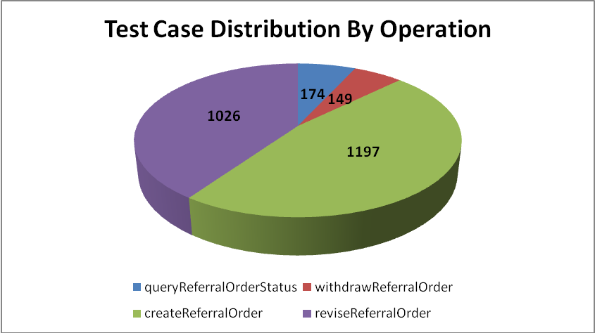
Category | queryReferralOrder Status | withdrawReferral Order | createReferral Order | reviseReferral Order
Cardinality | 21 | 14 | 160 | 146
Does not exist | 19 | 20 | 165 | 145
Invalid value | 48 | 21 | 316 | 266
Multiple values | 15 | 14 | 91 | 14
Null value | 48 | 65 | 292 | 308
Valid value | 23 | 15 | 173 | 147
<Total> | 174 | 149 | 1197 | 1026

The test case distribution by priority for this sprint is as follows:
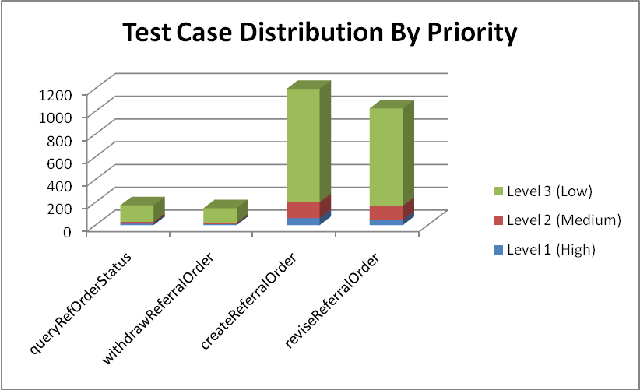
Operation | Level 1 (High) | Level 2 (Medium) | Level 3 (Low) | Total
queryRefOrderStatus | 13 | 15 | 146 | 174
withdrawReferralOrder | 9 | 11 | 129 | 149
createReferralOrder | 61 | 140 | 996 | 1197
reviseReferralOrder | 43 | 126 | 857 | 1026
Total | 126 | 292 | 2128 | 2546

The test case execution summary for the sprint is as follows:
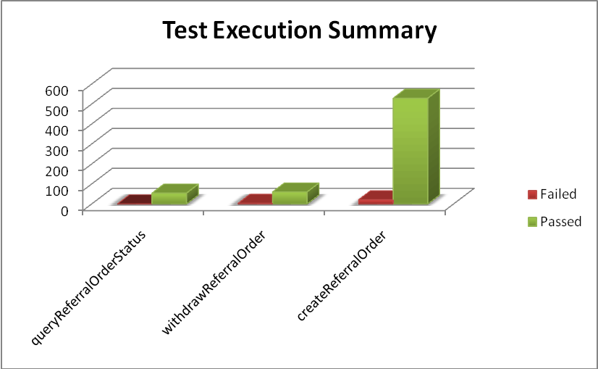
Operation | Failed | Passed | Total
queryReferralOrderStatus | 0 | 54 | 54
withdrawReferralOrder | 3 | 60 | 63
createReferralOrder | 21 | 529 | 550
Total | 24 | 643 | 667

The defects for this sprint are listed below:
Key | Summary | Reporter | Priority | Status | Resolution
ESD-1088 | sequence number access negative INT value. | Kevin Gann | Major | Open | UNRESOLVED
ESD-1086 | createReferralOrder - reason - statusCode="completed" fails | Brian Bell | Minor | Resolved | Fixed
ESD-1085 | soapFaultException being thrown for effectiveTime value. | Kevin Gann | Major | Resolved | Fixed
ESD-1072 | valueSet not being checked for validity in reasonCode | Kevin Gann | Major | Resolved | Fixed
ESD-1070 | soapFaultException being thrown for values outside of "fixed" value. | Kevin Gann | Major | Open | UNRESOLVED
ESD-1069 | REPC_MT000003US ClusterIntent appears to require CD (code) | Kevin Gann | Major | Open | UNRESOLVED
ESD-1066 | Mismatched Error Message for patient-patientPerson-administrativeGenderCode object having invalid values | Pradeep Dharmavarapu | Minor | Open | UNRESOLVED
ESD-1059 | REPC_MT000003US.ActIntent.reasonCode accepts incorrect codeSystem | Amrut Rao | Major | Open | UNRESOLVED
ESD-1056 | REPC_MT000003US.ClusterIntent.code returns an exception on nullFlavor | Amrut Rao | Major | Open | UNRESOLVED
ESD-1055 | REPC_MT000003US.component2.sequenceNumber returns an exception on nullFlavor | Amrut Rao | Major | Open | UNRESOLVED
ESD-1051 | concernEvent statusCode is not validated - REPC_MT000002US | Brian Bell | Minor | Resolved | Fixed
ESD-1050 | No exception returned when REPC_MT000003US.ClusterIntent.id has null value | Amrut Rao | Major | Open | UNRESOLVED
ESD-1048 | No exception is returned when Patient or Provider with II.root=caEHR OID is sent in createReferralOrder | Amrut Rao | Major | In Progress | UNRESOLVED
ESD-1045 | Empty patient-id element does not cause any error response message | Pradeep Dharmavarapu | Minor | Open | UNRESOLVED
ESD-1034 | provider-assignedEntity-code valueSet is not taking OID still taking name | Aviva Mordetsky | Major | Closed | Duplicate
ESD-940 | QuerryReferralStatus-provider-id or code-DoesNotExist | Aviva Mordetsky | Major | Closed | Fixed
ESD-883 | No Errors for incorrect or invalid Cardinality of payload elements | Pradeep Dharmavarapu | Major | Reopened | UNRESOLVED
ESD-869 | telecom cardinality [0..5] fails | Aviva Mordetsky | Major | Reopened | UNRESOLVED
ESD-848 | observationEvent.code - no values for any attributes, service does not generate any error | Pradeep Dharmavarapu | Minor | Closed | Fixed
ESD-819 | Mismatched error message for gov.nih.nci.caehr.domain.enums.AdministrativeGender | Kevin Gann | Major | Closed | Fixed
ESD-724 | ReferralOrder-performer-id does not exist validation | Pradeep Dharmavarapu | Minor | Closed | Fixed
ESD-667 | Multiple entries of existing Patient, Provider and Referral Order data created by createReferral | Amrut Rao | Major | Closed | Fixed

The deliverables for this Sprint are available at the below locations:
Test Cases - http://gforge.nci.nih.gov/svnroot/ent-services/trunk/caehr/documents/QA/Test_Cases/caBIGClinicalInformationSuite_TestCases_RC2I2S2.xls
Test Execution Report - http://gforge.nci.nih.gov/svnroot/ent-services/trunk/caehr/documents/QA/Test_Cases/caBIGClinicalInformationSuite_TestExecutionReport_RC2I2S2.mht
Soap Test Scripts - http://gforge.nci.nih.gov/svnroot/ent-services/trunk/caehr/documents/QA/soapUI_test_scripts/RC2I2S2_TestScripts.zip

